**Open House Leaderboard**

Style Guide

**Typography**

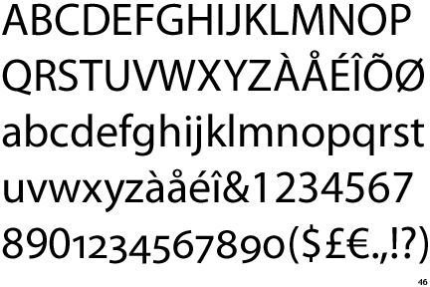 Myriad Pro

**Colors**

Primary:

Hex: #5a2b81

Secondary:

Hex: #919194