HIS 103- Milestone 1
CJ Mitchell
National Louis University
1/25/24
Prof Magda Giurcanu

The Mayan civilization was prosperous but is shrouded in mystery; a lot is known about them, but more is left unanswered, such as why they abandoned their cities and how the empire collapsed altogether. We will go over their religion, ingenuity, the height of their power, and finally, the society and culture of this lost civilization.
The Mayans worshiped many gods. Being people of a polytheistic religion, they had deemed that there had been many gods that made the world around them. They believed everything had souls, whether people, plants, or animals. They had been a people dedicated to the appreciation, fear, and reverence of their gods. The Mayan people were no strangers to sacrificing themselves to those they worshiped as they had performed such rituals daily, if not multiple times a day, by capturing rival settlements and villages to nourish their proclaimed gods and are extremest in their belief that the gods had kept them safe and blessed them due to it.

The Mayans believed all things to be sacred and to have come from the gods that the gods had created man from the three stages, first being mud, then wood, and finally maize and gods' blood, making some Mayans actually believe that they were not the god's final creation and destruction was imminent but contrary to that the Mayans didn’t believe that there was going to be an “end of the world” as they didn’t think that they were the end all be all and that in the event that they were going to be punished or destroyed that the gods would usher in a new era or even a new epoch of gods to replace that of the old.

Mayan culture has a multitude of scientific and cultural marvels that are still used to this day. The Mayans developed what would become modern astronomy by building devices that tracked the stars and how they moved through the sky. Through this, they also developed the calendar to keep track of the days with almost as much accuracy as the one currently in use today. The Mayans had many uses for the calendar, like recording birthdays, prophesying, and following rituals during different times of the year. It was important to them because religion and belief were their way of life, and the development of technology was one of the ways they chose to achieve their goals in pursuit of that.

The Mayans had been master builders of architectural marvels, not building pyramids on the scale of the Pyramids of Egypt but having many more built-in ornate and ceremonial fashions. The temples were used and worshipped as shrines for their gods, who were respected in their own right. Cities have been intentionally developed and had been planned to take advantage of site lines of the sky for their worship as some places in cities are specifically situated so that they could take advantage of specific celestial or solar events such as an eclipse or to mimic other phenomena. Sports and physical aptitude were important within their society, and one of the structures that are most commonly built in cities would be a court to play the game Pitz, a game they had created and had continued to play throughout their life and the empire's existence.
I feel as though the Mayans, although scientifically advanced for their time, had turned barbaric in the face of their religion as it seems to have become so enveloped in the culture that they became slaves metaphorically to it by having such a conviction of not only sacrificing people but displaying families and innocents in the process of the pursuit. They had been one of the earliest to start mapping the stars and planning for the future, but in that sane future in which they had been planning, they had met their downfall due to unrelated and unknown consequences of, if not their own action, then that of the world that they worshipped.

Paragraph 1: Paragraph 2:
Sundial Diety receiving nourishment (Sacrafices)
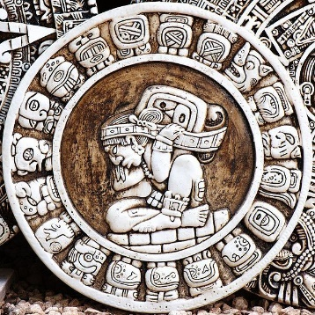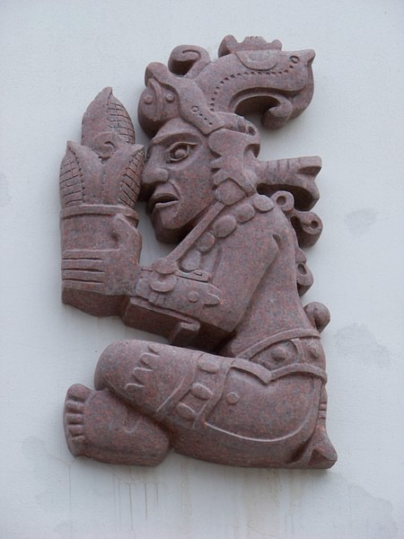
Paragraph 3: Paragraph 4:
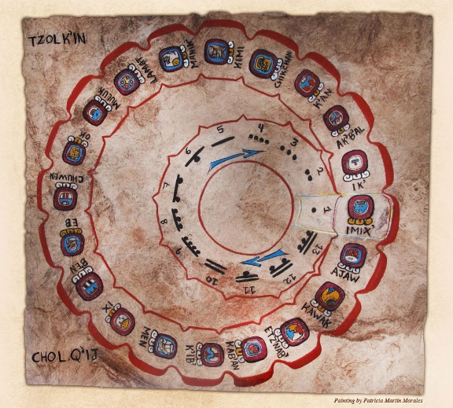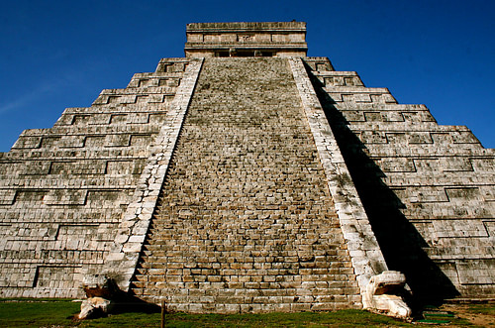
Calander Architecture

Works Cited
Gomez, M. C. (2015, July 29). Maya Religion. World History Encyclopedia. Retrieved from https://www.worldhistory.org/Maya_Religion
Cartwright, M. (2015, September 20). Maya Architecture. World History Encyclopedia. Retrieved from https://www.worldhistory.org/Maya_Architecture/
Mark, J. J. (2012, July 07). The Maya Calendar and the End of the World: Why the one does not substantiate the other. World History Encyclopedia. Retrieved from https://www.worldhistory.org/article/416/the-maya-calendar-and-the-end-of-the-world-why-the/
Mark, J. J. (2012, July 06). Maya Civilization. World History Encyclopedia. Retrieved from https://www.worldhistory.org/Maya_Civilization/
“The Calendar System.” - Sun, Corn and the Calendar, maya.nmai.si.edu/calendar/calendar-system. Accessed 29 Jan. 2024.

