CARLOS J. MOLINA · GRC CONSULTING
Gap Assessment Report
Custody Corp — ISO/IEC 27001:2022
Document | Gap Assessment Report — Custody Corp
Framework | ISO/IEC 27001:2022
Prepared by | Carlos J. Molina, GRC Consulting
Prepared for | Custody Corp (fictional exercise)
Date | September 16, 2026
Version | 1.0
Confidentiality | Internal / Client Use

1. Document Control
See cover page for document identification, versioning, and confidentiality classification.

2. Scope and Methodology
This report documents an ISO/IEC 27001:2022 Gap Assessment conducted for Custody Corp. The engagement covers the first seven of twelve artifacts in the SMCTR Certification Pathway (Scope → Map → Collect → Test → Report) — a Gap Assessment, not a certification audit and not ISMS implementation. It evaluates the organization's current information security posture against ISO/IEC 27001:2022, without pursuing certification within this engagement.
Scope: the Payroll System and Administrative System, as defined in the ISMS Core Document (Section 1, Organizational Context & Scope). Excluded: operations scheduling (no dedicated system exists), physical security service delivery, and client-facing systems (none currently exist).
Methodology: a 14-asset inventory was established in CISO Assistant, followed by a Statement of Applicability covering all 93 Annex A controls, three in-depth Risk Scenarios, a prioritized Gap Tracker, and governance documentation (ISMS Core Document) covering the 17 ISMS clauses relevant to a pre-operational ISMS.

3. Organizational Security Priorities
Before evaluating specific risks, Custody Corp's Vice Presidency established what the organization commits to protecting, and what level of risk it is willing to accept in pursuit of that commitment (see ISMS Core Document, Sections 2 and 4).
Principal commitments, applicable to both the Payroll and Administrative Systems: timeliness of processing (payroll disbursement and administrative transactions alike), accuracy of financial and personnel records, verifiability of transactions, and confidentiality of personnel and financial data.
Risk acceptance criteria: Low and Very Low risks require no mandatory action. Medium risk requires mitigation within 12 months. High risk requires mitigation within 30 days. Very High risk is unacceptable and requires immediate treatment. Vice Presidency is the sole authorized risk owner.
Every risk scenario and every priority selected in this report traces back to these two references — a control was elevated for deeper analysis only when it put one of these commitments at stake, on an asset the organization itself rated as high-value in the affected dimension (see Asset Inventory, Section 6). This is why R.03, though it originates from a privileged-access gap, spans both systems: the exposure and the commitment it threatens are identical on both sides.

4. Summary of Findings by Category
Of the 93 Annex A controls evaluated, results break down as follows:
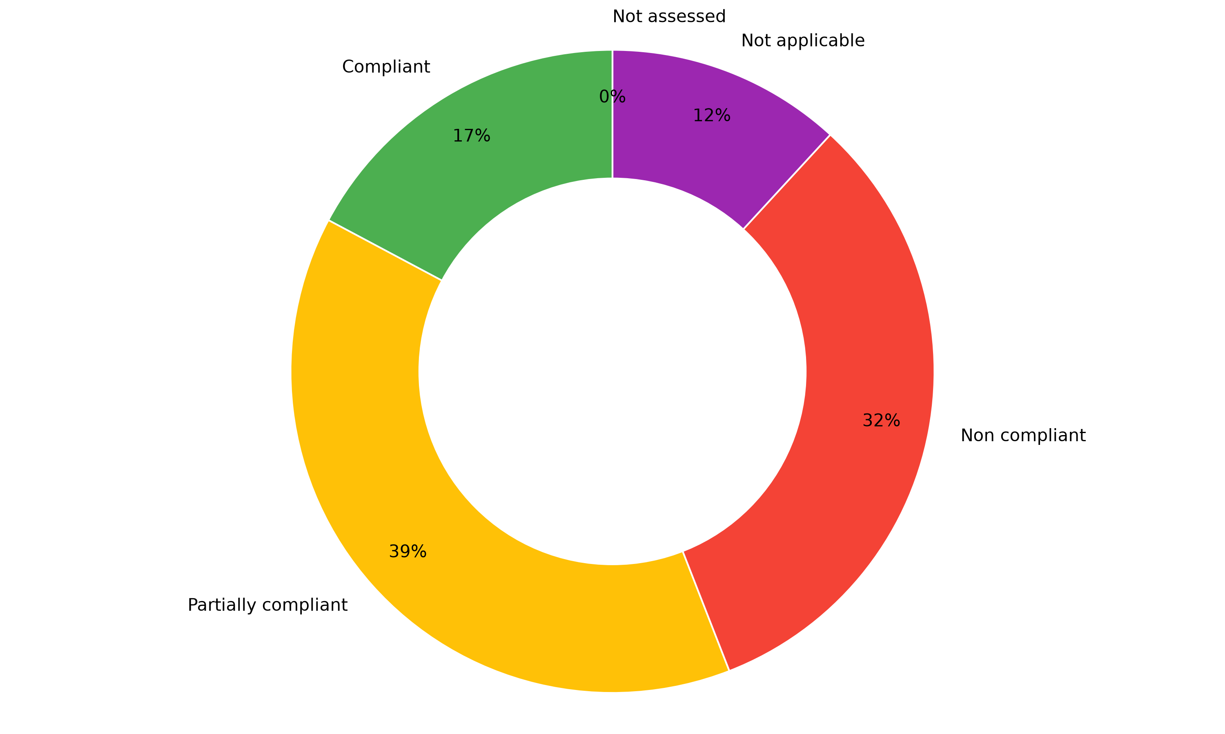
Compliant: 16 (17%) · Partially compliant: 36 (39%) · Non-compliant: 30 (32%) · Not applicable: 11 (12%)
The pattern across all four Annex A domains is consistent: Custody Corp is strongest in physical and operational controls native to a physical security business — perimeter security, camera monitoring, equipment siting, network segmentation — and weakest in formal information security governance: no documented policy, no privileged access governance, no encryption at rest, no formal incident classification process. This is not an unusual pattern for an organization that has grown on operational strength rather than dedicated IT investment, but it represents real, addressable exposure.
Across the Statement of Applicability, CISO Assistant's own drift analysis identifies 66 of 93 requirements as not yet fully compliant, consistent with the 66 items tracked in the Gap Tracker.

5. Risk Scenarios Identified
Three risk scenarios were developed in depth, selected using the criteria established in Section 3: each had to put a specific principal commitment at stake, on an asset with a high (3–4) security target rating in the affected dimension.

R.01 — Payroll Fraud via Unauthorized Modification of Payment Records
An insider with legitimate payroll access alters payment records for personal financial gain. Current risk: Medium (Probability) / Low (Impact). Existing controls — segregation of duties between payroll preparation and approval, and independent banking transaction validation — already mitigate this risk to an acceptable level. No further action proposed.

R.02 — Payroll System Unavailability at Critical Payment Date
A regional power interruption or hardware failure takes the Payroll System offline during a scheduled disbursement. Current risk: Medium (Probability) / High (Impact). A dedicated UPS and a shared cold standby server exist, but the restoration procedure has never been tested. Residual risk after the proposed control (a documented, tested restoration procedure) is projected to drop to Low / Medium.

R.03 — Unauthorized Disclosure of Unencrypted Data at Rest
A departing employee with privileged access copies unencrypted payroll or administrative data before leaving the organization. Current risk: Low (Probability) / Very High (Impact) — Medium overall. Two proposed controls — encryption at rest and formal privileged account governance — are projected to bring residual impact down to Very Low.
These three scenarios illustrate a consistent pattern: Custody Corp's existing controls perform well against risks with an established mitigation path (R.01), but gaps widen where the mitigating control depends on formal governance that does not yet exist (R.02, R.03).

6. Detailed Findings and Prioritization
Of the 66 Annex A controls not yet fully compliant, 17 carry meaningfully higher exposure — selected using the same criteria as the risk scenarios above: relevance to an assessed risk, and high security target ratings on the affected assets. Given current resourcing (one IT Manager and Vice Presidency, without dedicated security budget beyond this engagement), a first remediation cycle was scoped to seven priorities — the three technical controls directly tied to R.02 and R.03 above, three additional high-priority items requiring only personnel time and legal review, and one foundational, low-cost item (the information security policy itself).

Priority 1 (High) — directly tied to Risk Scenarios
- A.5.30, ICT continuity readiness — restoration procedure documented and tested. Target: 30 days. Owner: IT Manager.
- A.8.2, Privileged account governance — inventory, break-glass procedure, rotation, logging. Target: 90 days. Owner: IT Manager.
- A.8.24, Encryption at rest — commercial solution evaluated and deployed. Target: 6 months. Owner: IT Manager.

Priority 2 (High, low-cost) — contractual and policy content, pending legal counsel review
- A.6.5, Post-employment confidentiality obligations. Target: 90 days.
- A.6.6, Confidentiality/non-disclosure agreements. Target: 90 days.
- A.8.10, Data retention and deletion rules. Target: 90 days.

Priority 3 (Medium, foundational)
- A.5.1, Information security policy, approved and communicated. Target: 3 months.
The remaining 59 items are tracked in the Gap Tracker with an assigned owner and priority, for consideration in a second remediation cycle once progress on the first is reviewed (see Section 8).

7. Engagement Limitations
This assessment has known boundaries, documented here rather than left implicit.

Evidence coverage
Of the 82 applicable controls, 3 (3.7%) have formal evidence attached within CISO Assistant — two system-generated exports (asset inventory, risk assessment report) and one auditor site-observation memo. This is not solely a function of time constraints. A meaningful portion of the controls evaluated, particularly physical and personnel-related ones, have evidence that properly lives outside a GRC system by nature — a guard's presence, a background check file held by HR, a vendor contract — rather than as an uploaded document. Where evidence was captured, it followed standard audit practice: system-generated reports where the tool itself produces them, and a documented auditor-observation memo for a physically-verified control (A.7.1). Full evidence coverage was not attempted within this engagement's scope.

Governance clauses not assessed
This Gap Assessment covers the 17 ISMS clauses concerning governance design. Eight clauses — awareness training (7.3), operation of risk treatment (8.1–8.3), internal audit (9.2), management review (9.3), and improvement (10.1–10.2) — require an operating ISMS to produce evidence against, and are out of scope until Custody Corp moves beyond this diagnostic stage.

Second remediation cycle
59 of 66 identified gaps, including 11 rated High priority, remain unaddressed by the first objective-setting cycle, constrained by current resourcing. A second cycle is recommended once progress on the first is reviewed (see Section 8).

Certification track
This engagement does not constitute, and should not be represented as, progress toward ISO/IEC 27001:2022 certification. It corresponds to the first seven of twelve artifacts in the SMCTR Certification Pathway. Certification would require the remaining five — an Evidence Request List, a Control Owner Interview Guide, an Internal Audit Playbook, a Nonconformity and Corrective Action Tracker, and a Management Review Deck — none of which were performed here.

8. Conclusion and Next Steps
Custody Corp's information security posture reflects the profile common to organizations that have grown on operational strength rather than dedicated IT investment: physical and operational controls are solid — in several cases, genuinely strong — while formal information governance is largely undeveloped. Of the two risks analyzed in depth where existing controls fell short (R.02, R.03), both trace back to the same root cause: governance and testing that were never formalized, not a lack of underlying capability.
The seven priorities defined in this report (Section 6) are scoped to what current resourcing can realistically absorb — three technical fixes tied directly to assessed risk, three low-cost contractual items, and one foundational policy. None require new headcount or a dedicated security budget beyond the time already committed to this engagement.

Recommended next steps for Vice Presidency
1. Approve the seven objectives defined in Section 6 (grouped into three priority tiers), and the resourcing they imply.
2. Revisit this assessment in approximately 90 days to review progress and scope a second remediation cycle from the Gap Tracker's remaining 59 items.
3. Decide whether to pursue the remaining five artifacts of the SMCTR Certification Pathway (Evidence Request List, Control Owner Interview Guide, Internal Audit Playbook, Nonconformity Tracker, Management Review Deck) toward formal ISO/IEC 27001:2022 certification, or treat this Gap Assessment as the organization's current stopping point.
This report, together with its appendices, constitutes the complete record of the engagement to date.

9. Appendices
This report summarizes findings and conclusions drawn from the following complete artifacts, each maintained as an independent document and available in full:
1. Scoping Questionnaire — Custody Corp's initial diagnostic responses, completed prior to this engagement.
2. Certification Roadmap — the estimated timeline for the full SMCTR Certification Pathway, should Custody Corp choose to pursue it.
3. ISMS Core Document — governance documentation covering all 17 ISMS clauses relevant to a pre-operational ISMS: scope, policy, roles, risk methodology, the seven prioritized objectives, communication, and measurement.
4. Statement of Applicability — the complete applicability decision, justification, and implementation status for all 93 ISO/IEC 27001:2022 Annex A controls.
5. Gap Tracker — all 66 identified gaps, each with an assigned domain, priority, and remediation owner.
6. Asset Inventory and Risk Scenarios — maintained within CISO Assistant, covering 14 registered assets and three fully documented risk scenarios (R.01–R.03).

Auditor: Carlos J. Molina, GRC Consulting
Report date: September 16, 2026

