Craig Muth

11/19/2022

IT FDN 110 A Au 22: Foundations Of Programming: Python

Assignment 06

<https://github.com/cjmuth/IntroToProg-Python-Mod06>

TODO List - Read/Write using Functions, and the GitHub Repository

# Introduction

The goal of this project is to create a TODO list program, that will use functions to read data from an existing text file, allow the user to view the existing data, make changes, and save the data back to the text file.

A partial program has been provided to start from. All the necessary structure exists, but operational code has been omitted in several places so it will not run as it currently exists. So we will need to map the logic for the existing code, identify where it is lacking, and develop the logic and code to make it work.

# Designing the program

Examining the starter file, the logic flow looks like this - with areas where code is missing is indicated.

* Data
  + declare variables and constants
* Processing
  + class Processor
    - def read_data_from_file
      * open the file in read mode
      * loop through rows in data file
        + read data from file, splitting into discrete values
        + assign the discrete values to a dictionary
        + add dictionary to list_of_rows
      * when end of rows, close file
      * return list_of_rows to main program
    - def add_data_to_list
      * assign passed values to a dictionary
      * *MISSING CODE*
      * return list_of_rows to main program
    - def remove_data_from_list
      * *MISSING CODE*
      * return list_of_rows to main program
    - def write_data_to_file
      * *MISSING CODE*
      * return list_of_rows to main program
* Input/Output
  + class IO
    - def output_menu_tasks
      * print menu of options to screen
    - def input_menu_choice
      * get user option
      * return choice to main program
    - def output_current_tasks_in_list
      * loop through dictionaries in list_of_rows
        + print values to screen
    - def input_new_task_and_priority
      * *MISSING CODE*
    - def input_task_to_remove
      * *MISSING CODE*
  + call read_data_from_file
  + while true
    - call output_current_tasks
    - call output_menu_tasks
    - call input_menu_choice
    - if "1"
      * call input_new_task_and_priority
      * call add_data_to_list
        + pass values task, priority, table_lst
    - if "2"
      * call input_task_to_remove
      * call remove_data_from_list
        + pass values task, table_lst
    - if "3"
      * call write_data_to_file
        + pass values, file_name_str, table_lst
    - if "4"
      * exit program

Since both the processing and input/output sections include functions exchanging arguments with main program, instead of addressing the code section by section - we’ll pull the related pieces from each section. This will make it easier to understand how the values are passed around for each operation.

### Add a new task

When the user selects option 1, the program runs the following code

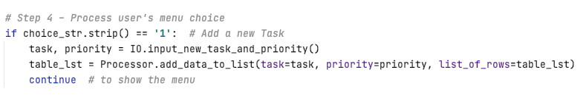***Figure 1: Menu option 1. Add a new task***

This instructs the computer to first run the function input_new_task_and_priority and assign the output to the variables task and priority. Looking at the pseudocode above, we can see this function is one of the areas that is missing code.

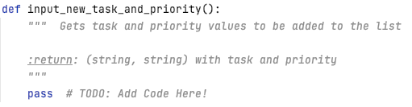

***Figure 2: Input new task***

Neither the call to the function, nor the function itself, show that values need to be passed to the function - but the call in the main program is assigning values to two variables. So the logic for this function should be:

* + Get new task description from user
  + Get priority of new task from user
  + Pass the user given values back to the main program

We use input statements to get values from the user, then the return statement is used to pass the values back to the main program (Ramos, Leodanis Pozo (n.d.). *The Python return Statement: Usage and Best Practices,* <https://realpython.com/python-return-statement/>) (External site).

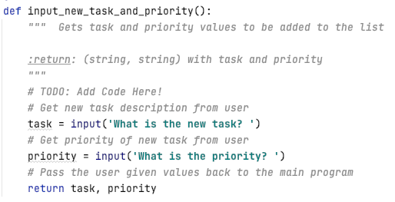

***Figure 3: Updated Input new task***

Now that we have values for the new task, the code calls the function add_data_to_list, this time

we are passing the values from the previous function, along with the existing value of variable table_list, and assigns the results back into the table_list variable.

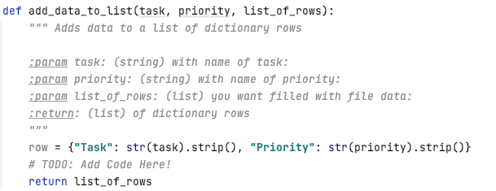

***Figure 4: Add data to list***

We see the function is designed to receive three parameters, and

* + Receive values from calling code
  + Assign task and priority to a dictionary
  + Add the dictionary to list_of_rows
  + Return list_of_rows to main program

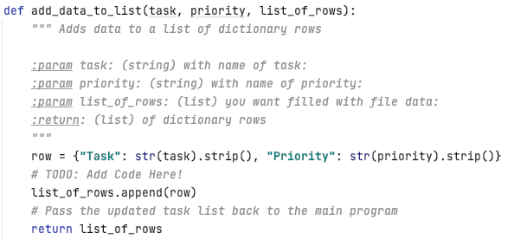

***Figure 5: Updated Add data to list***

### Remove an existing task

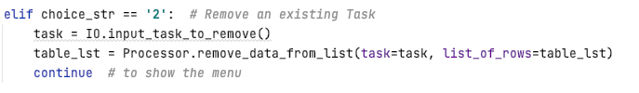

***Figure 6:***

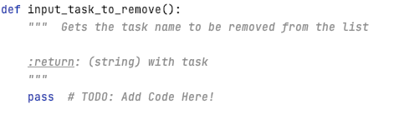

***Figure 7:***

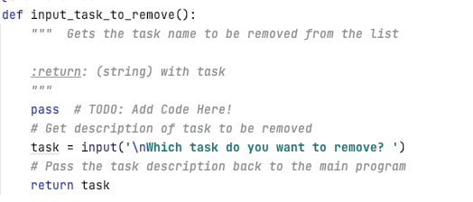

***Figure 8:***

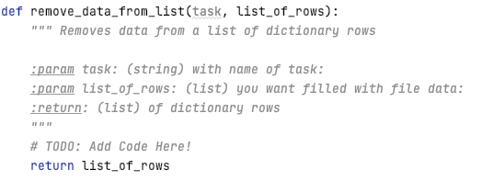

***Figure 9:***

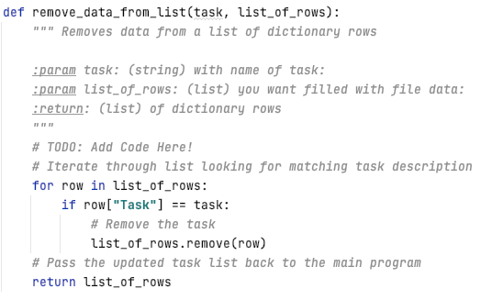

***Figure 10:***

### Save data to file

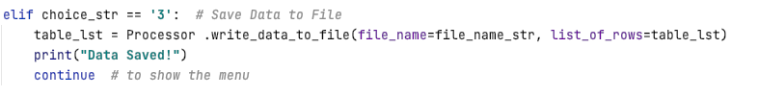

***Figure 11:***

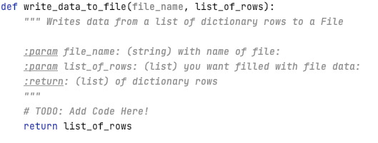

***Figure 12:***

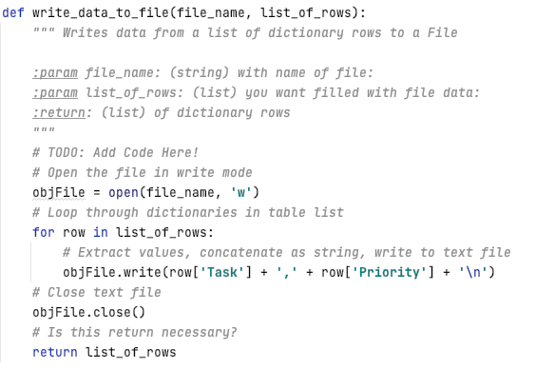

***Figure 13:***

# Running the program

### Executing the program in Pycharm:

### Executing in a Terminal window

# GitHub page

GitHub is a hosting site using version control software original developed by Linus Torvalds for his Linux

# Summary

In this project we created a program to interact with text file - reading data into memory, modifying it,