DOCUMENT
TEMPLATE
Craig Myles
15th October 2026

Sharing information
clearly
  - A document template for correspondence,
briefings and reports

Contents
Introduction and context 3
Main content 4
Closing sections 5
Charts and comparisons 6
Progress indicators 7
Callouts and key messages 8

Introduction and context
This template provides a consistent way to share information in a clear, readable document. It combines an illustrated cover with a contents page and spacious pages for the main text.
Begin each new document by explaining its subject, why you are sharing it and what the reader needs to understand or do. Include the background needed to make sense of the detail that follows.

Purpose and scope
State the purpose in a short opening paragraph. Explain what the document covers and include any limits that materially affect the reader. Name the intended audience where that helps establish the context.

The main message
After the context, give the main finding, proposal or request. Longer documents can include a short summary here before moving into the supporting explanation.
The structure is flexible. A briefing may explain a situation and the next decision; a proposal may set out an approach and its costs; a personal document may simply share information with someone.

Main content
Organise the main text into sections that suit the subject. Use short, connected paragraphs to explain the evidence, reasoning and implications. Let the content determine the length rather than filling a fixed number of pages.

Clear sections
Use descriptive headings and a shallow hierarchy. Keep each heading with the paragraph that follows it, and use lists only when they make a sequence or a set of related points easier to read.

Tables and supporting material
Use a table when the reader needs to compare the same attributes across several items. Keep longer explanations in prose and place captions close to their tables or images.
Component | Purpose
Paragraphs | Explain the situation, reasoning and implications.
Tables | Compare options, figures or repeated records.
Images and charts | Show relevant evidence or explain a relationship.
Table 1 Examples of content components
A useful detail should help the reader understand the subject or make a decision.

Closing sections
End in a way that matches the purpose of the document. An informational note may need only a short closing paragraph. A proposal or decision paper may need recommendations and next steps.

Recommendations and next steps
Explain what should happen and why. Include responsibilities, dates and commitments only when they are known. Do not add an action section to a document that is simply sharing information.

References
Where claims depend on source material, include descriptive links near the relevant text or a short reference list. Name supporting documents clearly so the reader can find the evidence.

Appendices
Place detailed calculations, technical information or lengthy supporting material in appendices when they would interrupt the main explanation. The main document should remain understandable on its own.
Remove any example sections that the finished document does not need. Replace the cover title, subtitle, author and date, then refresh the contents and page numbers before sharing the PDF.

Charts and comparisons
A column chart makes differences easy to compare. This example uses illustrative monthly completion rates to demonstrate the gradient bars and direct value labels.
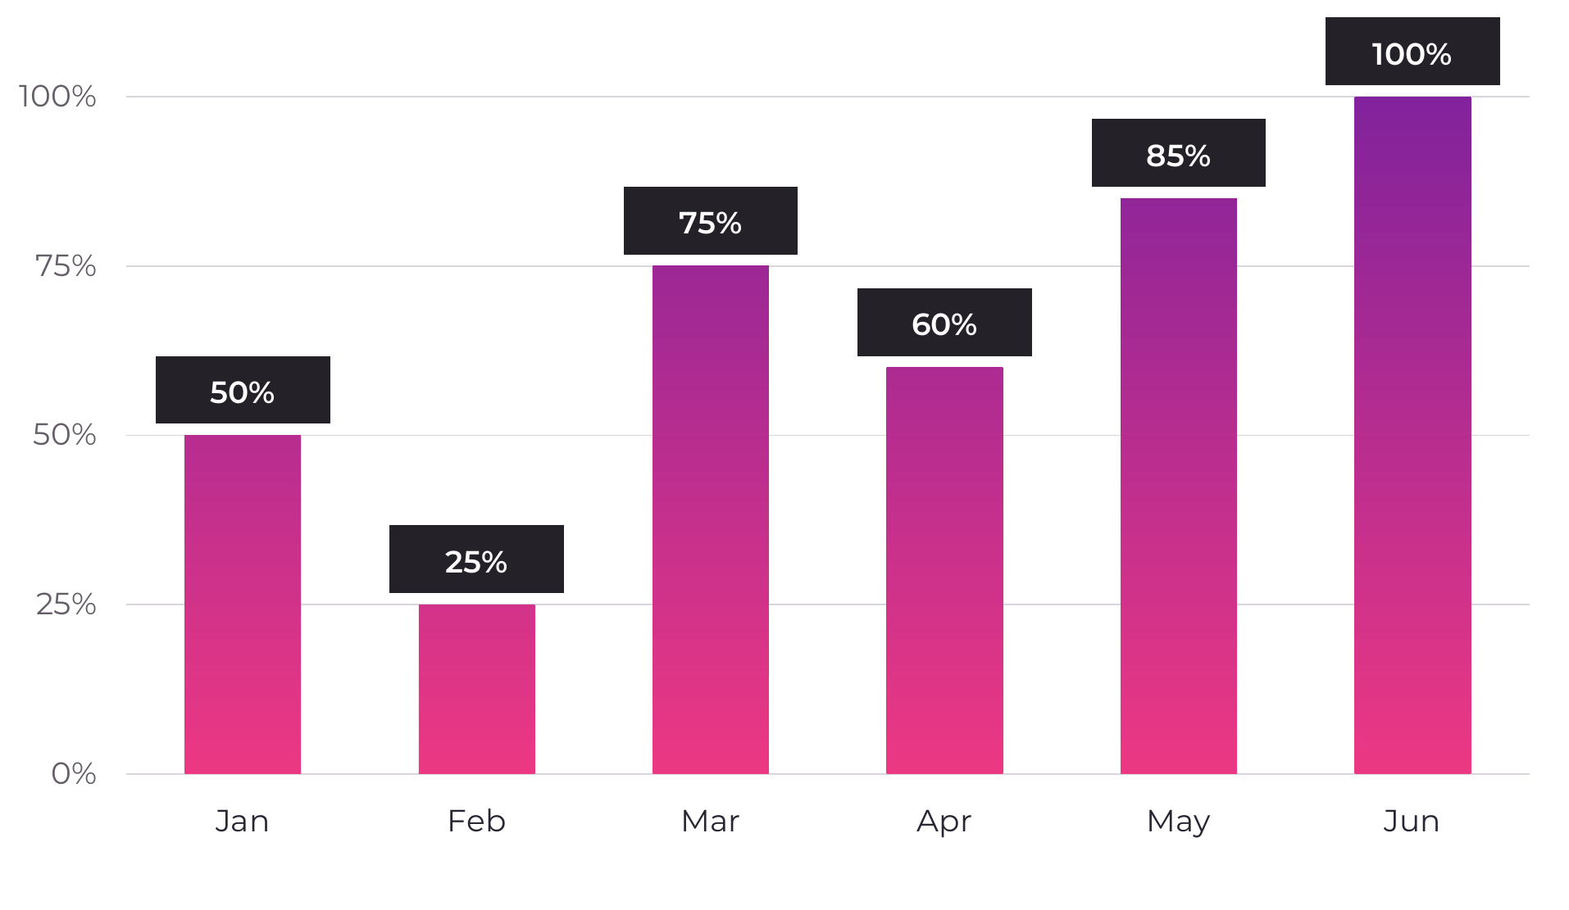
Figure 1 Illustrative completion rates. Example data only.

A clear reading order
 | Explain the comparison  Give the reader the subject, units and period before the chart.
 | Label the values  Show values directly and keep category labels easy to read.
 | State the implication  Follow the graphic with the conclusion the reader should draw.

Progress indicators
Percentage rings show a share of a defined total. These examples demonstrate four values, with the explanation kept beside each graphic.
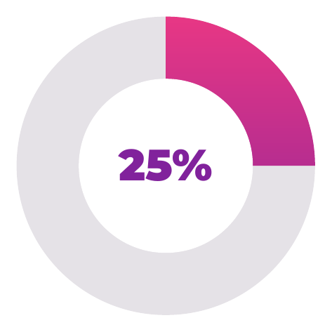 | One quarter  25 out of every 100 items are complete.
 | Half  50 out of every 100 items are complete.
 | Three quarters  75 out of every 100 items are complete.
 | Complete  All 100 items are complete; no grey remainder remains.
Figure 2 Illustrative percentages for layout demonstration.

Callouts and key messages
Coloured panels can highlight a finding, an action or a short message. Use them selectively so the main explanation remains easy to follow.
KEY FINDING
A short finding should explain what matters and why. Keep the supporting evidence in the surrounding text.

PURPOSE  Give the reader enough context to understand the document. |  | NEXT STEP  Make the requested action clear and specific.

A quieter supporting note
Use a pale purple note for useful supporting information that does not need the prominence of a saturated panel.

Quotations
A quotation card uses the same pink or purple treatment with white quotation marks and a clear speaker attribution. Use it only for a genuine sourced quotation; these message cards intentionally contain no invented quote.

CRAIG MYLES
Sharing information clearly
15th October 2026

