

SCFA Metabolomics Assay Final Report

Demo Short-chain fatty acid report

Abstract
Short Chain Fatty Acids (SCFAs), also known as volatile fatty acids, are organic fatty acids composed of 1-6 carbon atoms. The types and quantities of SCFAs mainly depend on the composition of intestinal microbiota, digestion time, host microbial metabolic flux, and the fiber content in the host’s diet, exerting different effects in the metabolic activities of different organs in the human body. Medium Chain Fatty Acids (MCFAs) are single-carboxylic saturated fatty acids with carbon chains ranging from 7 to 12, derived from the breakdown of dietary triglycerides. They serve as biomarkers in the diet and their own biological activity affects human health. Gas Chromatography-Mass Spectrometry (GC-MS) is currently the most widely used and thoroughly researched detection technology for short/medium chain fatty acids. It excels in sensitivity, stability, and separation performance. Our company has developed a targeted quantitative method for detecting 13 types of short/medium chain fatty acids using a gas quality platform with a single needle.

Experimental procedure
Schematic of the workflow is as follows:
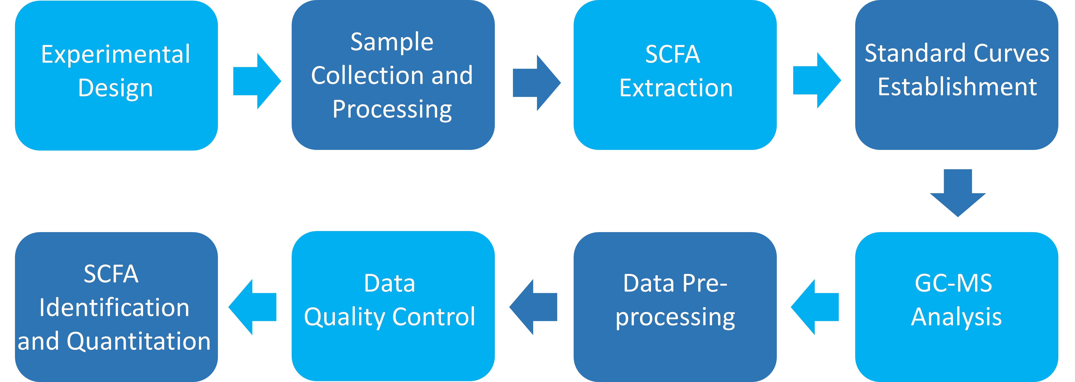
Figure : Flow chart of metabolomics analysis
The types of substances detected in this project are listed in the table below.
Table: List of compounds in the panel
Number | Compounds | Index
1 | Acetic acid | Acetate
2 | Propionic acid | Propionate
3 | Isobutyric acid | Isobutyrate
4 | Butyric acid | Butyrate
5 | 2-Methylbutyric acid | 2MBA
6 | Isovaleric acid | Isovalerate
7 | Crotonic acid | Crotonate
8 | Valeric acid | Valerate
9 | Isohexanoic acid | Isohexanoate
10 | Hexanoic acid | Hexanoate
11 | Heptanoic acid | Heptanoate
12 | Octanoic acid | Octanoate
13 | Decanoic acid | Decanoate
/data/ion_component.xlsx

Sample information
This project has 3 samples divided into 3 groups. Sample information is shown in the following table:
Table: Sample information table
Species | Tissues | MW_ID | Sample_ID
- | - | A | A
- | - | B | B
- | - | C | C
Original file path: Final report/0.data/sample_info.xlsx

Sample processing
Human fecal samples (~15-20 mg) were weighed into Bead Ruptor tubes (2 ml containing 2.8 mm ceramic beads, Omni International). Extraction solution (1 ml) consisting of 50% methanol (1:1 methanol: water) containing 10 µM each 2-ethyl-butyric acid, D3-acetic acid, D5-propionic acid, and D7-butyric acid (internal standards, all from Sigma), adjusted with sodium hydroxide to 25 mM, was added. A blank, with extraction solution but no sample, was also prepared.
Samples were homogenized using a Bead Ruptor 12 (Omni International) (setting 5.5, 30 s, 2 cycles, with cooling on ice between cycles), and centrifuged samples directly in Bead Ruptor tubes (4°C, 10 min, 13,000 rpm/ 18,000g). Portions (20 and 50 µl) of the supernatant were dried using a Speedvac centrifugal evaporator (Savant/ Thermo).
Dried samples were resuspended in 50 µl sodium hydroxide solution (25 mM). In parallel, a 25 mM NaOH blank and a range of 12 standards containing from 10 pmol up to 5 nmol equimolar amounts of 17 standards including 13 SCFA analytes and 4 internal compounds (listed below) (in 25 mM NaOH) were prepared.
Samples and standards were derivatized with the addition of 100 µl 2,3,4,5,6-pentafluorobenzylbromide (Sigma), 172 mM in acetone (Fisher GC grade), and incubation for 30 min at 60°C with shaking (650 rpm). After cooling to room temperature. 750 µl water and 60 µl chloroform was added. Tubes were vortexed briefly and centrifuged (10000 g, 5 min). The lower chloroform phases were transferred to GC-MS vial inserts for analysis.
Samples and standards were analyzed using a Thermo GC Trace 1610-TSQ 9610 MS (MS) with a Thermo TG-S5SILMS column (30 m x 0.25 i.d. x 0.25 μm). The GC-MS was programmed with an injection temperature of 250°C, 0.5 µl splitless injection volume. The GC oven temperature was initially 90°C for 2.5 min, rising to 150°C at 5°C/min, and to 280°C at 50°C/min with a final hold at this temperature for 2 min. GC flow rate, with helium as the carrier gas, was 1.2 ml/min. The GC-MS interface temperature was 300°C and ion source temperature was 200°C. A negative chemical ionization source was used with negative polarity and a methane flow of 1.25 ml/min. Mass fragments in the m/z range 43-400 were scanned. SCFA were quantified using the following ions: acetate, 59; D3-acetate, 62; propionate, 73; D5-propionate, 78; isobutyrate and butyrate, 87; D7-butyrate, 94; 2-methylbutyrate, valerate and isovalerate, 101; crotonate, 85; 2-ethylbutyrate, hexanoate and isohexanoate, 115; heptanoate, 129; octanoate, 143; decanoate, 171. Calibration was done in Chromeleon (Thermo), and metabolite amounts were adjusted for recovery of the deuterated internal standards for acetate, propionate and butyrate, or 2-ethylbutyrate for other SCFA.

Data evaluation

Standard curve
The standard solutions (0.01 nmol/mL, 0.02 nmol/mL, 0.05 nmol/mL, 0.1 nmol/mL, 0.2 nmol/mL, 0.5 nmol/mL, 1 nmol/mL, 2 nmol/mL, 5 nmol/mL, 10 nmol/mL, 20 nmol/mL, 50 nmol/mL) were employed in GC-NCI-MS for data collection, where a calibration curve was generated to establish the functional relationship between peak area and standard sample concentration. This calibration curve was then utilized to perform quantitative analysis of the sample target.
Table: Equation of calibration curve
Index | Name | RT | Equation
Acetate | Acetic acid | 5.38 | y = -62.3682350739208 * x^2 + 19476.5603533403 * x + 110488.539125503
Propionate | Propionic acid | 7.315 | y = -259.338736776546 * x^2 + 47301.6589650842 * x + 51756.9677425556
Isobutyrate | Isobutyric acid | 8.15 | y = 115815.371118614 * x^0.896141086023827
Butyrate | Butyric acid | 9.344 | y = 96329.6157939069 * x^0.889101815725758
2MBA | 2-Methylbutyric acid | 10.508 | y = 166359.764906198 * x^0.958843900975324
Isovalerate | Isovaleric acid | 10.712 | y = 150357.844638145 * x^0.964226908615627
Crotonate | Crotonic acid | 10.243 | y = 74684.4148013682 * x^0.945014070983808
Valerate | Valeric acid | 11.671 | y = 131132.175616482 * x^0.935826338471052
Isohexanoate | Isohexanoic acid | 13.127 | y = 147017.571963013 * x^0.999768930247744
Hexanoate | Hexanoic acid | 13.995999999999999 | y = 141346.305759957 * x^0.939507208187343
/0.data/equation.xlsx

Sample abundance
The integrated peak areas of all detected samples are plugged into the equation of the standard curve for calculation. Subsequently, these values are further incorporated into the calculation formula to determine the substance content in the actual samples. It’s worth noting that the calculation formula has been standardized into specific units, allowing for direct substitution of corresponding values to obtain the sample content. For instance, the content of Short Chain Fatty Acids in the sample (in nmol/mg) can be calculated as follows:
SCFAs abundance (nmol/mg) = c*R*V1/V2/m
Where: - c is the concentration value obtained by substituting the integration peak area ratio into the standard curve (nmol/mg).
-R: the recovery of the internal standard in the sample;
-V1: volume of extraction solution (μL);
-V2: volume of supernatant removed (μL);
-m: mass of the weighed sample (mg).
The metabolite ID, concentration and corresponding metabolite names of some metabolites detected in this experiment are shown in the following table:
Table: Statistical Table of metabolite quantity
Index | A | B
Heptanoate | 0.26793 | 0.2089
Octanoate | 0.0612 | 0.048631
Decanoate | 0.0137 | 0.0293
Acetate | 3.5428 | 5.5386
Propionate | 1.597 | 1.125
Isobutyrate | 0.9339 | 1.5575
Butyrate | 9.12581 | 11.1971
2MBA | 0.5907 | 0.8674
Isovalerate | 0.742621316 | 1.099264636
Crotonate | 0.07074 | 0.020338
Note:Concentration units is nmol/mg;N/A indicates that the substance was not detected in this project, possibly because the sample contains less than the instrument detection limit or because the sample does not contain the substance;Index: ID;Compounds: the names of metabolites;Class: English Classification of Substances;Q1 (Da): The molecular weight of the parent ion after the material has passed through the ion source;Molecular Weight: Relative molecular weight;Ion mode: Ionization mode (M+H is positively charged, M-H is negatively charged);Formula: the chemical formula of the compound;Sample columns: The amount of each substance in each sample;cpd_ID: ID information of metabolites in KEGG database;CAS: a unique numerical identification number for a substance;kegg_map: KEGG database signal path number
Original file path: Final report/0.data/*level.xlsx

Internal standards quality control
The coefficient of variation (CV) is the ratio of the standard deviation of the original data to the mean of the original data, which reflects the degree of data dispersion. The coeffecient of variations of internal standards in blank samples are used for the quality control. If the CV values of the internal standards are less than 0.2, it indicates that the experimental data is stable. High stability of the instrument provides important guarantees for the repeatability and reliability of the data.
Table: CV table of internal standard substances
Index | Blank_50μL | Blank_20μL | CV
IS_2EBA | 0.53 | 0.625 | 0.11632059603934546
IS_D3 acetate | 0.5700000000000001 | 0.725 | 0.16926880476280282
IS_D5 propionate | 0.52 | 0.625 | 0.1296877065931659
IS_D7 butyrate | 0.58 | 0.7 | 0.13258252147247768
/0.data/blank_result.xlsx

Sample quantification histogram
The results of sample content are grouped by statistics, and the statistical results are shown in the following table.
Table: Statistical results table
Index | Group | N | Mean
2MBA | C | 1 | 0.6703
2MBA | B | 1 | 0.8674
2MBA | A | 1 | 0.5907
Acetate | C | 1 | 5.1899
Acetate | B | 1 | 5.5386
Acetate | A | 1 | 3.5428
Butyrate | C | 1 | 14.769
Butyrate | B | 1 | 11.197
Butyrate | A | 1 | 9.1258
Crotonate | C | 1 | 0.094301
Note:Index is abbreviation of compound;N is the number of non-N/A data in the corresponding group;SD is standard deviation;SE is standard error;Content units nmol/mg
Original file path: Final report/1.Data_Assess/histogram/groups*.xlsx
The bar chart below shows the content difference of each substance in different groups.
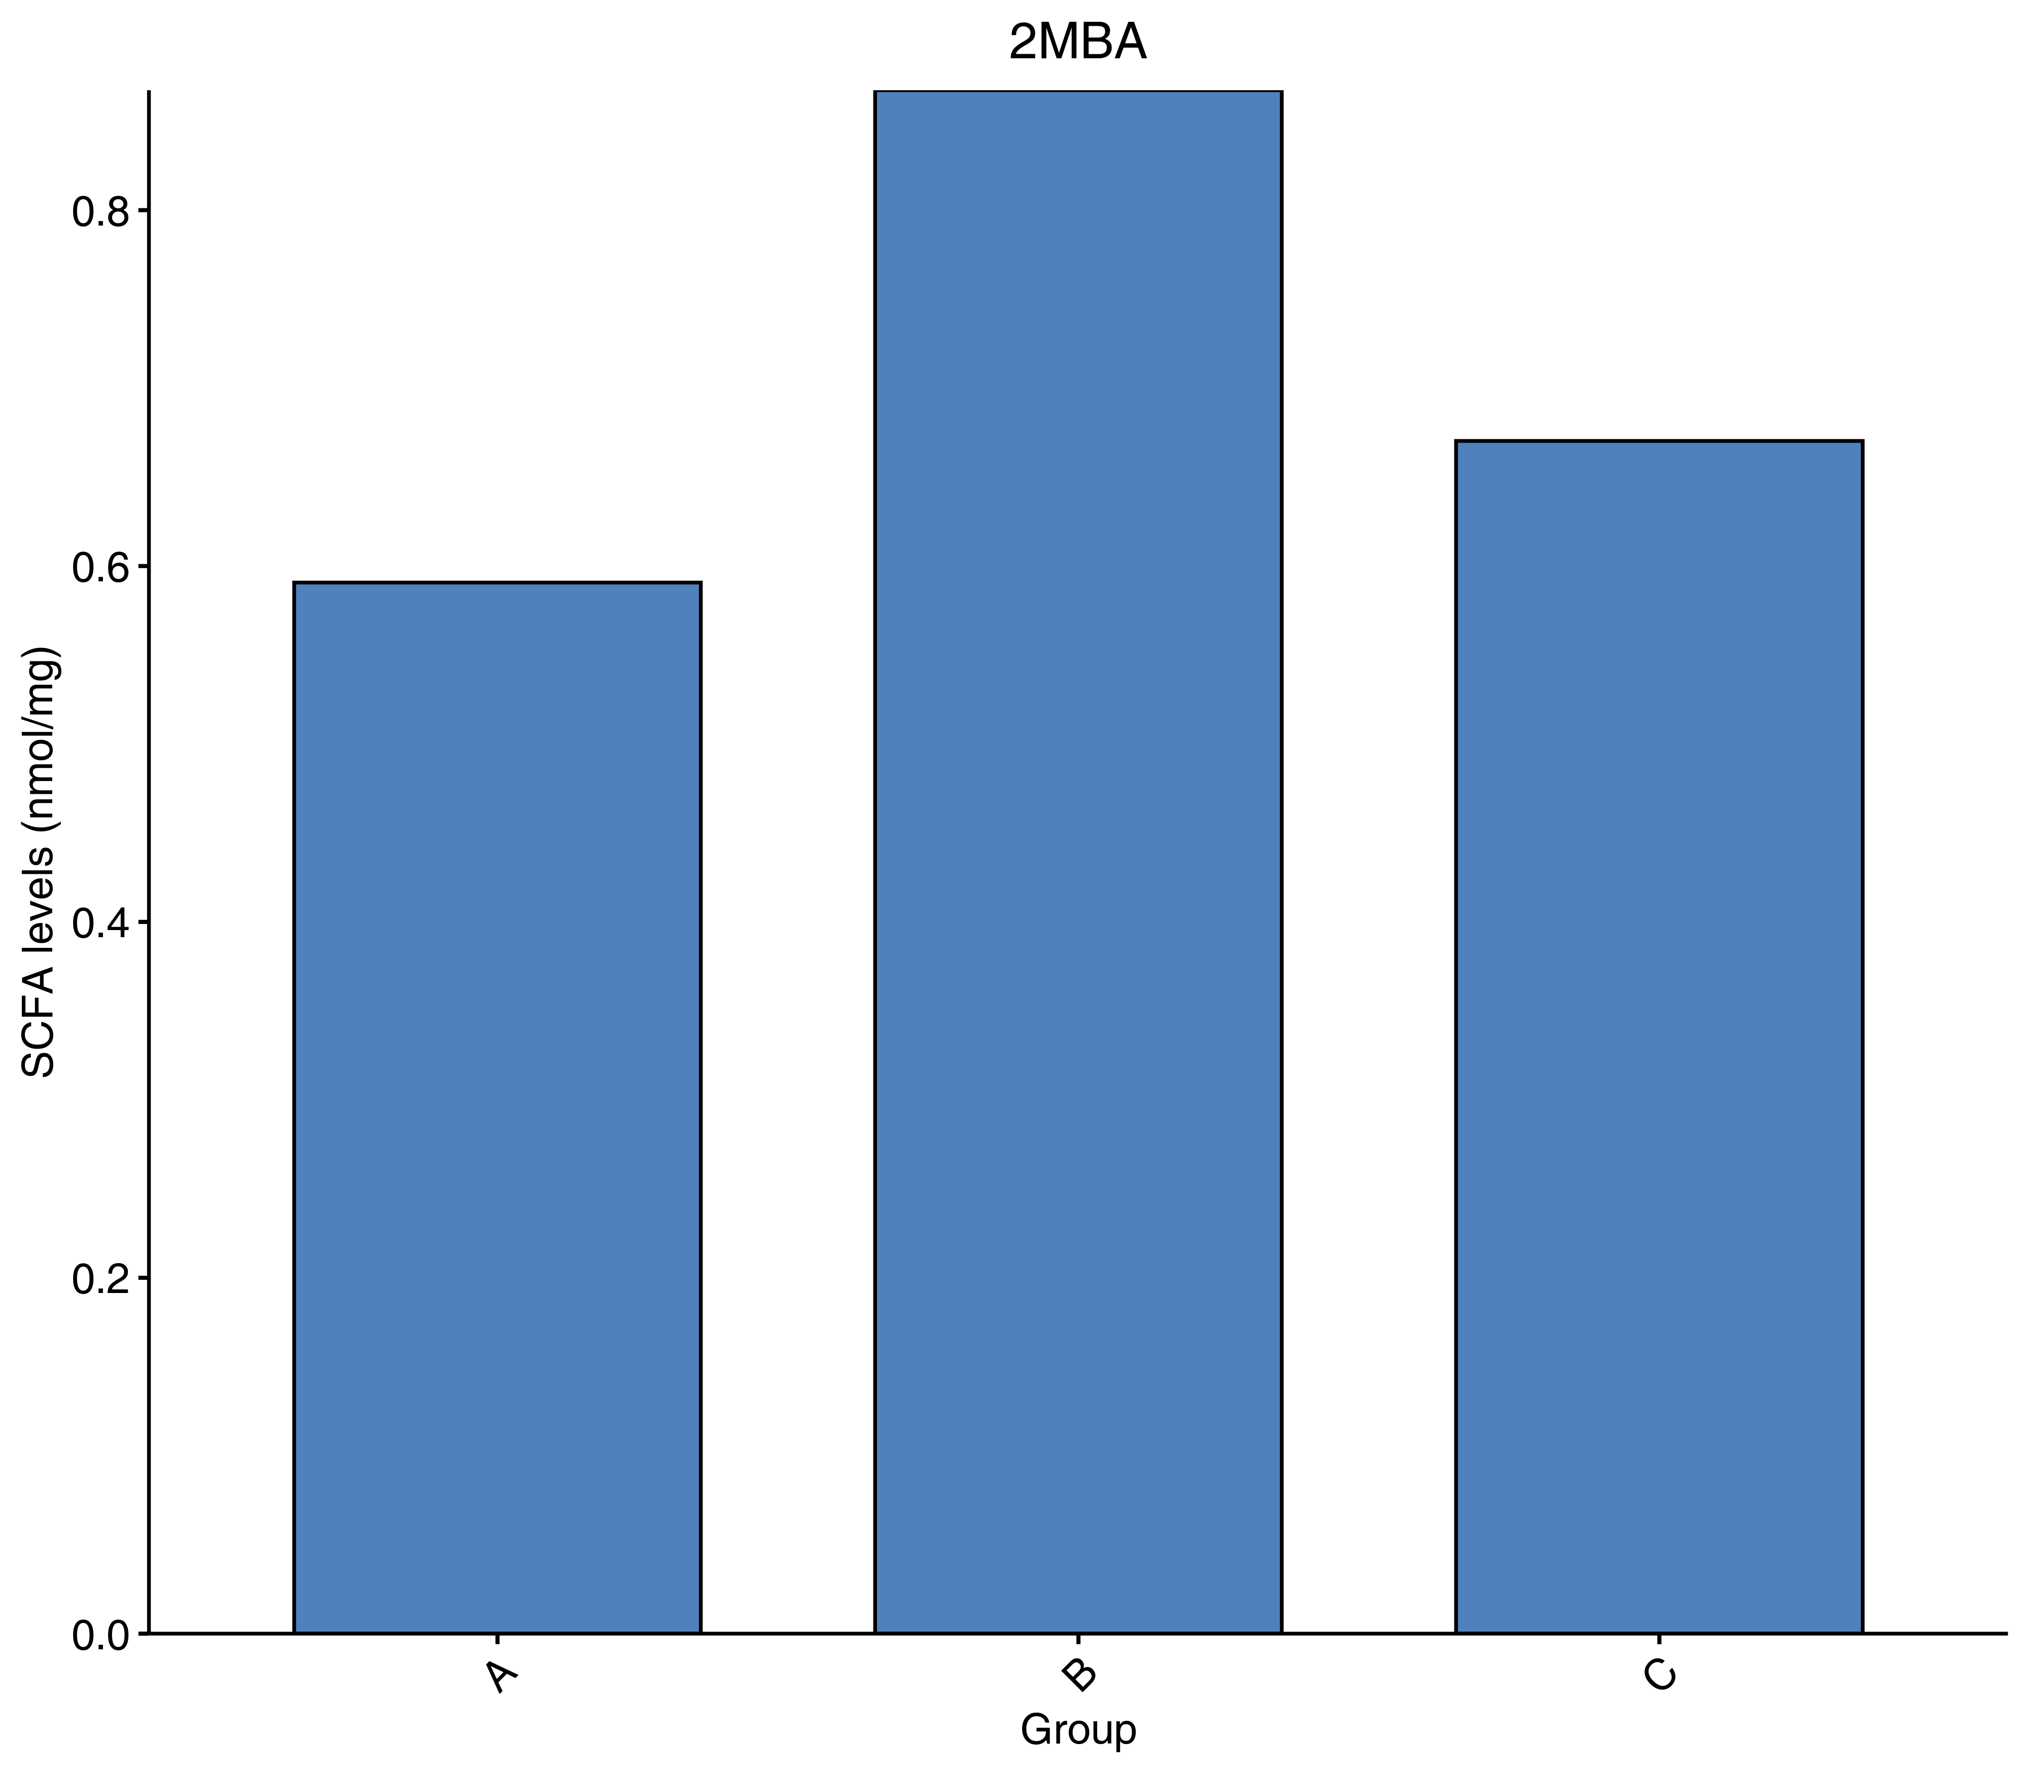
Figure : Sample content histogram
Note: The x-axis represents the sample groups, and the y-axis represents the metabolite content, while error bars represents standard deviations.
Original file path: Final report/1.Data_Assess/histogram/histogram_compounds/*.png

Analysis results

Differential metabolite screening
It is often necessary to combine univariate statistical analysis and multivariate statistical analysis for large high dimensional datasets such as metabolomics datasets to accurately identify differential metabolites. Univariate statistical analysis methods include parametric test and nonparametric test. Multivariate statistical analysis methods include principal component analysis and partial least square discriminant analysis. Based on the results of OPLS-DA (biological repetition ≥ 2), multivariate analysis of Variable Importance in Projection (VIP) from OPLS-DA modeling was used to preliminarily select differential metabolites from different samples. The fold-change and statistical significance (p-value) from univariate analysis can be used in conjunction to further identify differential metabolites. If biological replicates were < 3, differential metabolites are screened based on Fold Change value. If there were ≥ 3 biological replicates, VIP and P-values were used in combination to screen for differential metabolites. The detailed screening criteria is as follows:
For two sets of comparisons:
1.Metabolites with Fold Change ≥ 2 and Fold Change ≤ 0.5 were considered as significant and selected.
A partial result from the screening criteria is seen below:
Table: Screening results of differential metabolites
Index | Compounds | Type
Decanoate | Decanoic acid | down
Crotonate | Crotonic acid | up
Isohexanoate | Isohexanoic acid | down
Note:Index: ID;P-value: T-test;Fold Change: Log2FC;Type: Metabolite up or down regulation
Final report/2.Basic_analysis/Difference_analysis/group-ID*_vs_group-ID*/group-ID*_vs_group-ID*filter.xlsx.

Differential metabolite statistics
The number of different metabolites in each group is shown in the table below:
Table: Statistical table of differential metabolites
group name | All sig diff | down regulated | up regulated
A_vs_B | 3 | 2 | 1
Statistical table of differential metabolites:Final report/2.Basic_analysis/Difference_analysis/sigMetabolitesCount.xlsx;

Functional annotation and enrichment analysis of differential metabolites in KEGG database
KEGG (Kyoto Encyclopedia of Genes and Genomes) is a database that integrates compounds and genes into metabolic pathways. The KEGG database enabled researchers to study genes with their expression information and compounds with their abundances as a complete network.

Functional annotation of differential metabolites
Metabolites are annotated using the KEGG database, and only metabolic pathways containing differential metabolites are shown. Detailed results are found in the attached results. A portion of the results is shown below:
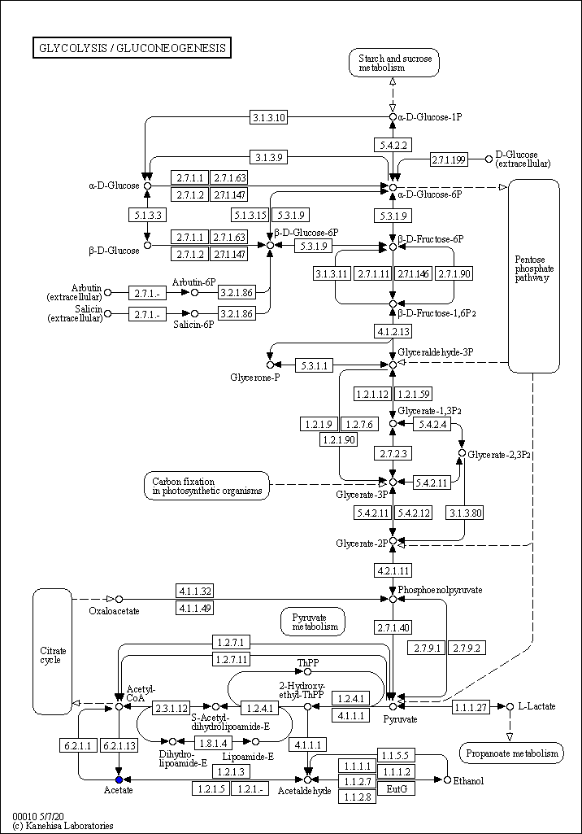
Figure : KEGG pathway of metabolites
Note: Red circles indicate that the metabolite content was significantly up-regulated in the experimental group; the blue circles indicate that the metabolite content was detected but did not change significantly; Green circles indicate that the metabolite content was significantly down-regulated in the experimental group. The orange circles indicate a mixture of both up-regulated and down-regulated metabolites.This allows searching for metabolites that may contribute to the phenotypic differences.
Final report/2.Basic_analysis/Difference_analysis/group-ID*_vs_group-ID*/enrichment/Graph/ko*.
Statistical analysis of KEGG database annotation of screened metabolites with significant differences. Some of the results are as follows:
Table: KEGG annotations for differential metabolites
Index | Compounds | Type | cpd_ID
Decanoate | Decanoic acid | down | C01571
Crotonate | Crotonic acid | up | C01771
Isohexanoate | Isohexanoic acid | down | -
Note:Index: ID;Compounds: the names of metabolites;Class: English Classification of Substances;The N/A values are filled with zeros;Fold_Change:Multiple of difference (Inf indicates infinity, since Fold_Change = mean in the experimental group/control group, and when the control group average is 0, Fold_Change is infinite, Inf indicates it);Log2FC: The difference multiple takes the logarithm base 2 (Inf is infinite, so is Log2FC when Fold_Change is infinite, -INF is negative infinity, and Log2FC when Fold_Change is 0);Type:Metabolites up or down regualation;cpd_ID: ID information of metabolites in KEGG database;kegg_map: KEGG database signal path number.
Table: Enrichment Statistics of KEGG annotations for differential metabolites
ko_ID | Sig_compound | compound | Sig_compound_all | compound_all
ko00061 | 1 | 2 | 1 | 8
ko01100 | 1 | 6 | 1 | 8
Note:Kegg_pathway: The name of the channel;ko_ID: The ko number of the pathway in the KEGG database;Sig_compound: The number of differential significant metabolites annotated by KEGG in this pathway;compound: The number of metabolites belonging to this pathway among the detected metabolites;Sig_compound_all: KEGG annotated to the difference in the number of significant metabolites;compound_all: The number of metabolites annotated by KEGG among all the measured metabolites;IndexList: The substance abbreviation of the substance of the differential significant metabolite that is annotated in this pathway, with “;” Connect;CIDList: The KEGG database number of the differences significant metabolites that are noted in this pathway are connected with “+”.
Final report/2.Basic_analysis/Difference_analysis/group-ID*_vs_group-ID*/enrichment/group-ID*_vs_group-ID*_filter_kegg.xlsx.
Final report/2.Basic_analysis/Difference_analysis/group-ID*_vs_group-ID*/enrichment/group-ID*_vs_group-ID*_KEGG.xlsx.

