

Abstract
Metabolomics is the study of all metabolites and their dynamics in a biological system by performing qualitative and quantitative analyses. The data is often used to study the metabolic basis of observed phenotypes, to understand the response mechanisms under different physical, chemical, or pathological conditions, and to evaluate safety of food and drugs.
Untargeted metabolomics is a common approach to metabolomics research. The main idea is to perform qualitative and quantitative analysis, and identify statistically significant differential metabolites between different groups.
（1）For this project, 6 samples were selected and divided into 2 groups for metabolomics study.
Table: Number of identified metabolites
- | All | T3_positive | T3_negative
Number of metabolites identified | 1176 | 287 | 889
Number of secondary metabolites identified | 983 | 159 | 824
Number of identified metabolites:Final_report/1.Data_Assess/metabolitesCount.xlsx
（2）The composition of metabolites is dependent on the sample that changes with experimental conditions. The metabolite composition ratio analysis examines the distribution of major metabolites in the samples. The following ring diagram shows the proportion of each metabolite class:

Figure : Ring diagram of metabolite categories
Note: Each color represents a category of metabolites, and the area of the color block indicates the proportion of that category.
Ring diagram of metabolite categories:Final_report/1.Data_Assess/*/Class_Count/*_Class_Count_Ring.*(If there are different ion modes, link to only one of them)
（3）Results of differential metabolite analysis:
Table: Number of differential metabolites
group | total | down | up
A_vs_B | 95 | 24 | 71
Number of differential metabolites:Final report/2.Basic_Analysis/Difference_analysis/sigMetabolitesCount.xlsx.

The experimental process
Ultra-performance liquid chromatography-tandem mass spectrometry (UPLC-MS/MS) is a technique used for accurate qualitative and quantitative analysis for various compounds. The main purpose of metabolomics analysis is to detect and identify metabolites with important biological significance by differentiate statistically significant differential metabolites between sample groups. The overall process is as follows:
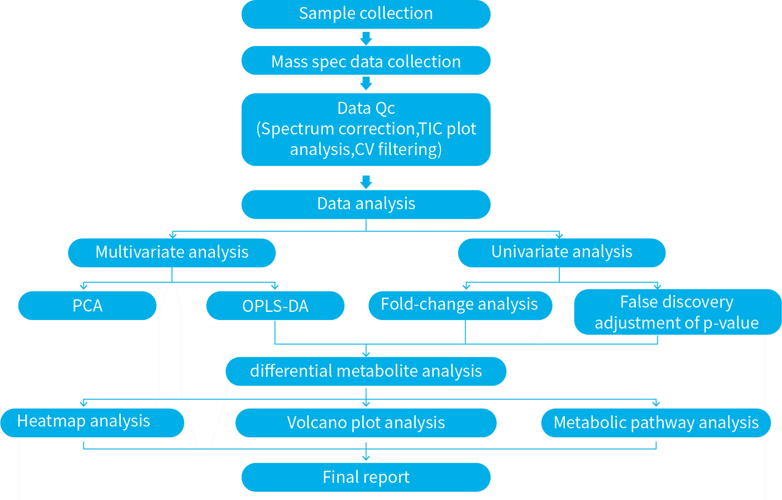
Figure : Flow chart of metabolomics analysis

Sample information
Each sample group and corresponding sample information are as follows:
Table: Table of sample information
Species | Tissue | Sample | Group
- | - | Plasma01 | A
- | - | Plasma02 | A
- | - | Plasma03 | A
- | - | Plasma04 | B
- | - | Plasma05 | B
- | - | Plasma06 | B
Table of sample information:Final report/1.Data_Assess/sample_info.xlsx

Reagents and instruments
Table: Information of reagents
Compound | CAS | Purity | Brand | Item No.
Methanol | 67-56-1 | more than 99.9% | Thermo Fisher | A452-4
Acetonitrile | 75-05-8 | 99.95% | Thermo Fisher | T001014000
Acetic Acid | 64-19-7 | more than 99.7% | Thermo Fisher | A35500
Ammonium formate | 540-69-2 | more than 99.0% | Sigma | 70221
Ammonium hydroxide solution(25%) | 1336-21-6 | - | Sigma | 543830
Formic Acid | 64-18-6 | 97.5-98.5% | Sigma | 00940
Standard | - | more than 98% | isoreag/TRC/TCI/Sigma | -
Table: Information of instruments
Name | Instrument | Brand | Address
Mass Spectrometer | TripleTOF 6600+ | SCIEX | California, USA
UHPLC | ExionLC AD | SCIEX | California, USA
Centrifuge | 5430R | Eppendorf | Hamburg, Germany
Vortex mixer | MI0101002 | HFour E's | Guangzhou, China
Electronic balance(1/100000) | AS60/220.R2 Plus | Radwag | Poland
Centrifugal concentrator | CentriVap | LABCONCO | Missouri Kansas, USA
Ultrasonic cleaner | CD-F15 | Olenyer | China
Pipette | Research plus | Eppendorf | Hamburg,Germany
Automatic workstation | Biomek i5 | Beckman Coulter | California, USA
Uniform-Seal Heat Sealer | FM 5200 | foodsaver | California, USA

Sample extraction process

Liquid samples class I
Samples stored at -80 °C was thawed on ice and vortexed for 10 s. 50 μL of the sample and 300 μL of the extraction solution (ACN : Methanol = 1:4, V/V) containing internal standards were mixed in a 2 mL microcentrifuge tube. The sample was vortexed for 3 min and then centrifuged at 12000 rpm for 10 min (4 °C). 200 μL of the supernatant was collected and placed in -20 °C for 30 min followed by centrifugation at 12000 rpm for 3 min (4 °C). A 180 μL aliquot of the supernatant was used for LC-MS analysis.

Chromatography-mass spectrometry acquisition conditions

Liquid phase conditions (T3)
Chromatographic column: Waters ACQUITY Premier HSS T3 Column 1.8 µm, 2.1 mm * 100 mm
Mobile phase A: ultrapure water (0.1 % formic acid added)
Mobile phase B: acetonitrile (0.1 % formic acid added)
Column temperature: 40 °C; Flow rate: 0.40 mL/min: Injection volume: 2 uL
Table: Elution gradient for T3
Time (min) | A (%) | B (%)
0.0 | 95 | 5
11.0 | 10 | 90
12.0 | 10 | 90
12.1 | 95 | 5
14.0 | 95 | 5

Mass spectrum conditions
Table: Mass spectrum conditions for AB Sciex TripleTOF 6600
Parameter | ESI+ | ESI-
Duration (min) | 14 | 14
IonSpray Voltage (V) | 5500 | -4500
Temperature (°C) | 550 | 450
Ion Source Gas1 (psi) | 50 | 50
Ion Source Gas2 (psi) | 60 | 60
Curtain Gas (psi) | 35 | 35
Declustering Potential (V) | 60 | -60
MS1 Collision Energy (V) | 10 | -10
MS2 Collision Energy (V) | 30 | -30
Collision Energy Spread (V) | 15 | 15
MS1 TOF Masses (Da) | 50~1000 | 50~1000
MS2 TOF Masses (Da) | 25~1000 | 25~1000
MS1 Accumulation time (s) | 0.2 | 0.2
MS2 Accumulation time (s) | 0.05 | 0.05
Candidate ions | 12 | 12

Data preprocessing
The original data file acquired by LC-MS was converted to mzXML format by ProteoWizard. Peak extraction, peak alignment and retention time correction were performed by XCMS program. The peaks with missing rate >50% in each group of samples were filtered. The blank values were filled with KNN, and the peak area was corrected by SVR method. The metabolites were annotated by searching the Bio’s in-house database, integrated public database, prediction database and metDNA. Finally, substances with a comprehensive identification score above 0.7 and a CV value of QC samples less than 0.3 were extracted, and then positive and negative mode were combined (substances with the highest qualitative grade and the lowest CV value were retained) to obtain the ALL_sample_data file.

Data evaluation

Quality control sample analysis
A quality control (QC) sample was prepared from a mixture of all sample extracts to examine the reproducibility of the entire metabolomics process. During data collection, one quality control sample was inserted for every 10 test samples.

Total ion current diagram
Reproducibility of metabolite extraction and detection process was assessed by analyzing overlapping total ion flow diagram (TIC diagram) from different QC samples. High overlapping rate of TIC diagrams indicates high stability of the instruments throughout the data acquisition process.
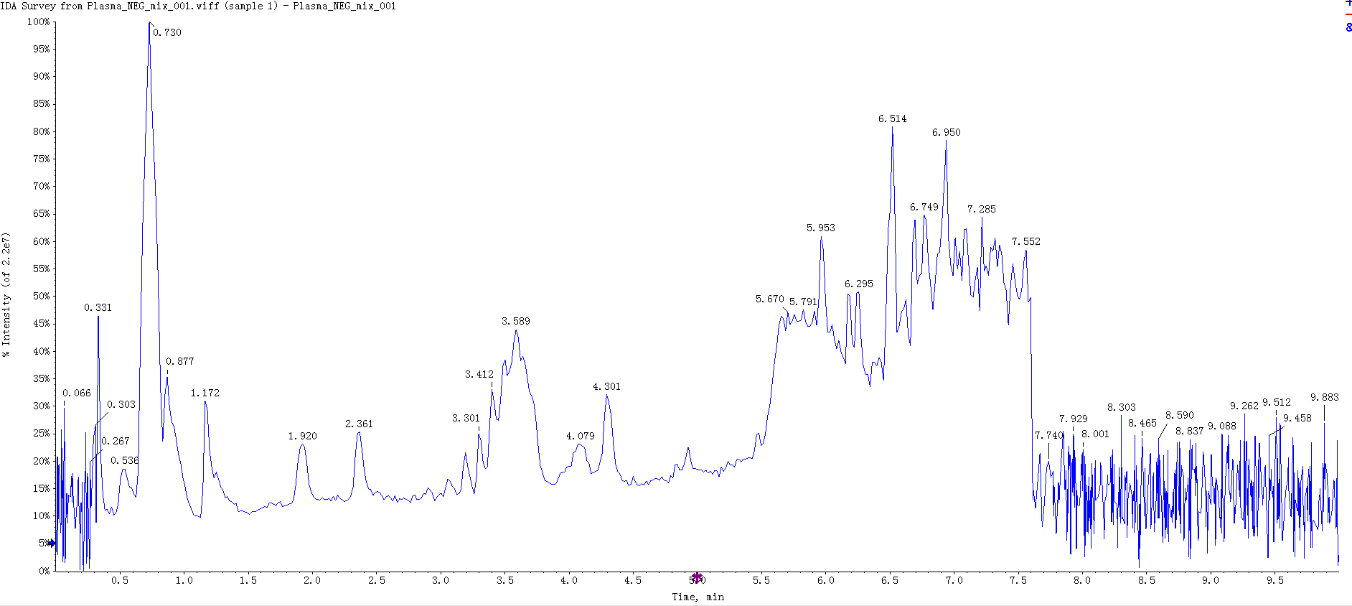
Figure : TIC overlap diagram detected by QC sample essence spectrum
Note: Superimposed spectrum from different QC samples. The results showed that the spectrum of total ion flow was highly consistent indicating that the signal stability was good when the same sample was detected at different times by mass spectrometry. N stands for negative ion mode and P stands for positive ion mode.
TIC overlap diagram detected by QC sample essence spectrum:Final report/1.Data_Assess/*/QC/*_*_QC_TIC.png(If there are different ion modes, link to only one of them)

Peak appearance of internal standards in blank samples
Blank samples were interspersed throughout the experiment, and their peaks can reflect whether there are compound residues from the detection process. The figure below shows that no obvious internal standard peaks were detected in the blank samples, indicating that possibility of cross-contamination between the samples is minimal.
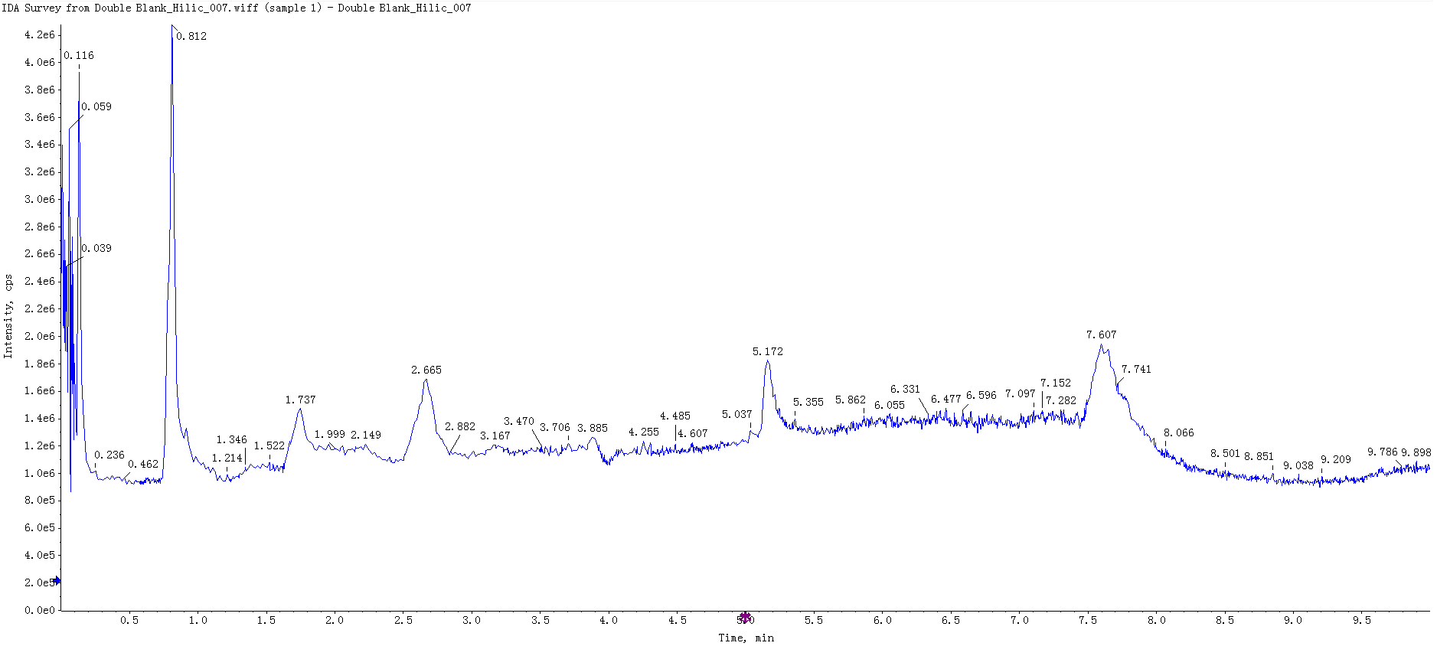
Figure : EIC diagram of internal label in blank sample
Note: The signals in the above EIC graphs are all noise peaks, and the internal standard substance has no obvious signal peaks at the corresponding time.
EIC diagram of internal label in blank sample:Final_report/1.Data_Assess/*/QC/*_*_BLANK_EIC.png(If there are different ion modes, link to only one of them)

Correlation analysis of QC samples
Pearson’s correlation analysis was performed on the QC samples. The higher the correlation between QC samples (| r | closer to 1) means that the stability of the entire detection process is optimal.
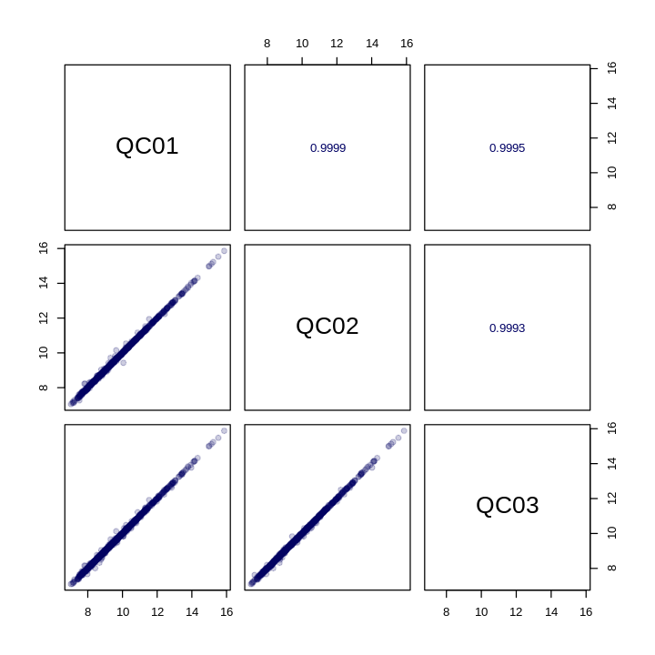
Figure : Plot of QC sample correlation
Note: The bottom left square of the diagonal line is the correlation scatter plot of the corresponding QC samples. The horizontal and vertical coordinates are the metabolite content (for Log processing), and each point in the plot represents one metabolite. The upper right square of the diagonal line is the Pearson correlation coefficient of the corresponding QC samples.
Plot of QC sample correlation:Final report/1.Data_Assess/*/QC/*_QC_correlation.*(If there are different ion modes, link to only one of them)

Stability of internal standards in QC samples
Internal standards with known concentrations were added to the QC samples for assessing variations between samples. The smaller the variation (CV ≤ 15%), the more stable the detection process and the higher the data quality.
Table: Stability of internal standards in QC samples
Index | Q1 (Da) | RT (min) | CV
MWS04187 | 208.1147 | 2.48 | 0.01683597
MWS04198 | 126.1458 | 4.96 | 0.03678997
MWS04174 | 135.0302 | 0.83 | 0.04473146
MWS2760 | 407.2442 | 6.23 | 0.05811097
Stability of internal standards in QC samples:Final_report/1.Data_Assess/*/QC/*_internal_standard.xlsx(If there are different ion modes, link to only one of them)

CV value distribution of all samples
The Coefficient of Variation (CV) value is the ratio between the standard deviation of the original data and the mean of the original data, which can reflect the degree of data dispersion. The Empirical Cumulative Distribution Function (ECDF) was used to analyze the frequency of compound CVs that is smaller than the reference value. The higher the proportion of compounds with low CV value in the QC samples, the more stable the experimental data. As a rule of thumb, the proportion of compounds with CV value less than 0.5 in the QC samples is higher than 85 % indicates that the experimental data is relatively stable. The proportion of compounds with CV value less than 0.3 in the QC samples is higher than 75 % indicates that the experimental data is very stable.
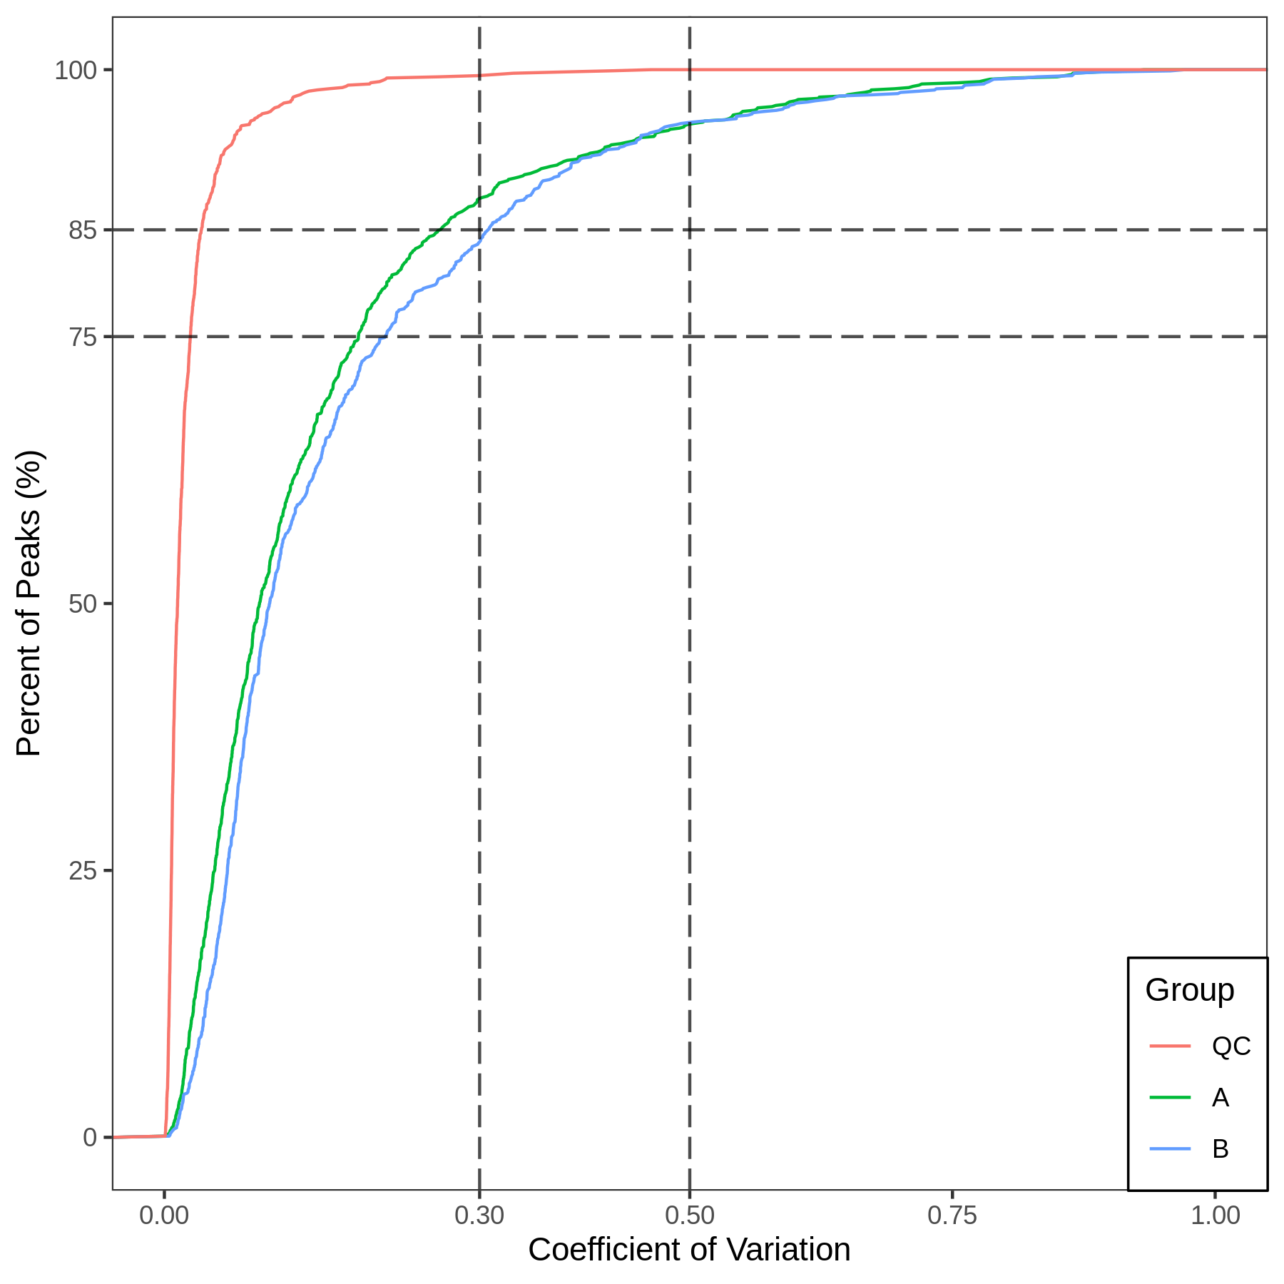
Figure : CV distribution of each group
Note: the X-axis represents the CV value, the Y-axis represents the proportion of metabolites with CV value less than a corresponding reference value. Different colors represent different sample groups. Mix indicates QC samples. The two dash lines on X-axis correspond to 0.3 and 0.5; the two dash lines on Y-axis correspond to 75 % and 85 % (If there is only one sample in the group, the CV value cannot be calculated).
CV distribution of each group:Final report/1.Data_Assess/*/QC/*_CV_ECDF.*(If there are different ion modes, link to only one of them)

Principal Component Analysis (PCA)

Principles of principal component analysis
Multivariate statistical analysis can simplify complex high-dimensional data while preserving the original information to the maximum extent by establishing a reliable mathematical model to summarize the characteristics of the metabolic spectrum. Among them, Principal Component Analysis (PCA) is an unsupervised pattern recognition method for statistical analysis of multidimensional data. Through orthogonal transformation, a group of variables that may be correlated are converted into a group of linear unrelated variables that are called principal components. This method is used to study how a few principal components may reveal the internal structure of between multiple variables, while keeping the original variable information (Eriksson et al., 2006). The first principal component (PC1) represents the most variable features in the multidimensional data matrix, PC2 represents the second most variable feature in the data, and so on. prcomp function of R software (www.r-project.org/) was used with parameter scale=True indicating unit variance Scaling (UV) for normalizing the data. See appendix for details of PCA calculation.

Principal component analysis of the sample populations
Principal component analysis (PCA) was performed on all the samples (including QC samples) to examine the overall metabolic differences between each group and the variation between samples within a group. QC is the Quality control sample mentioned above. PCA plot for the first two principal components is as follows:
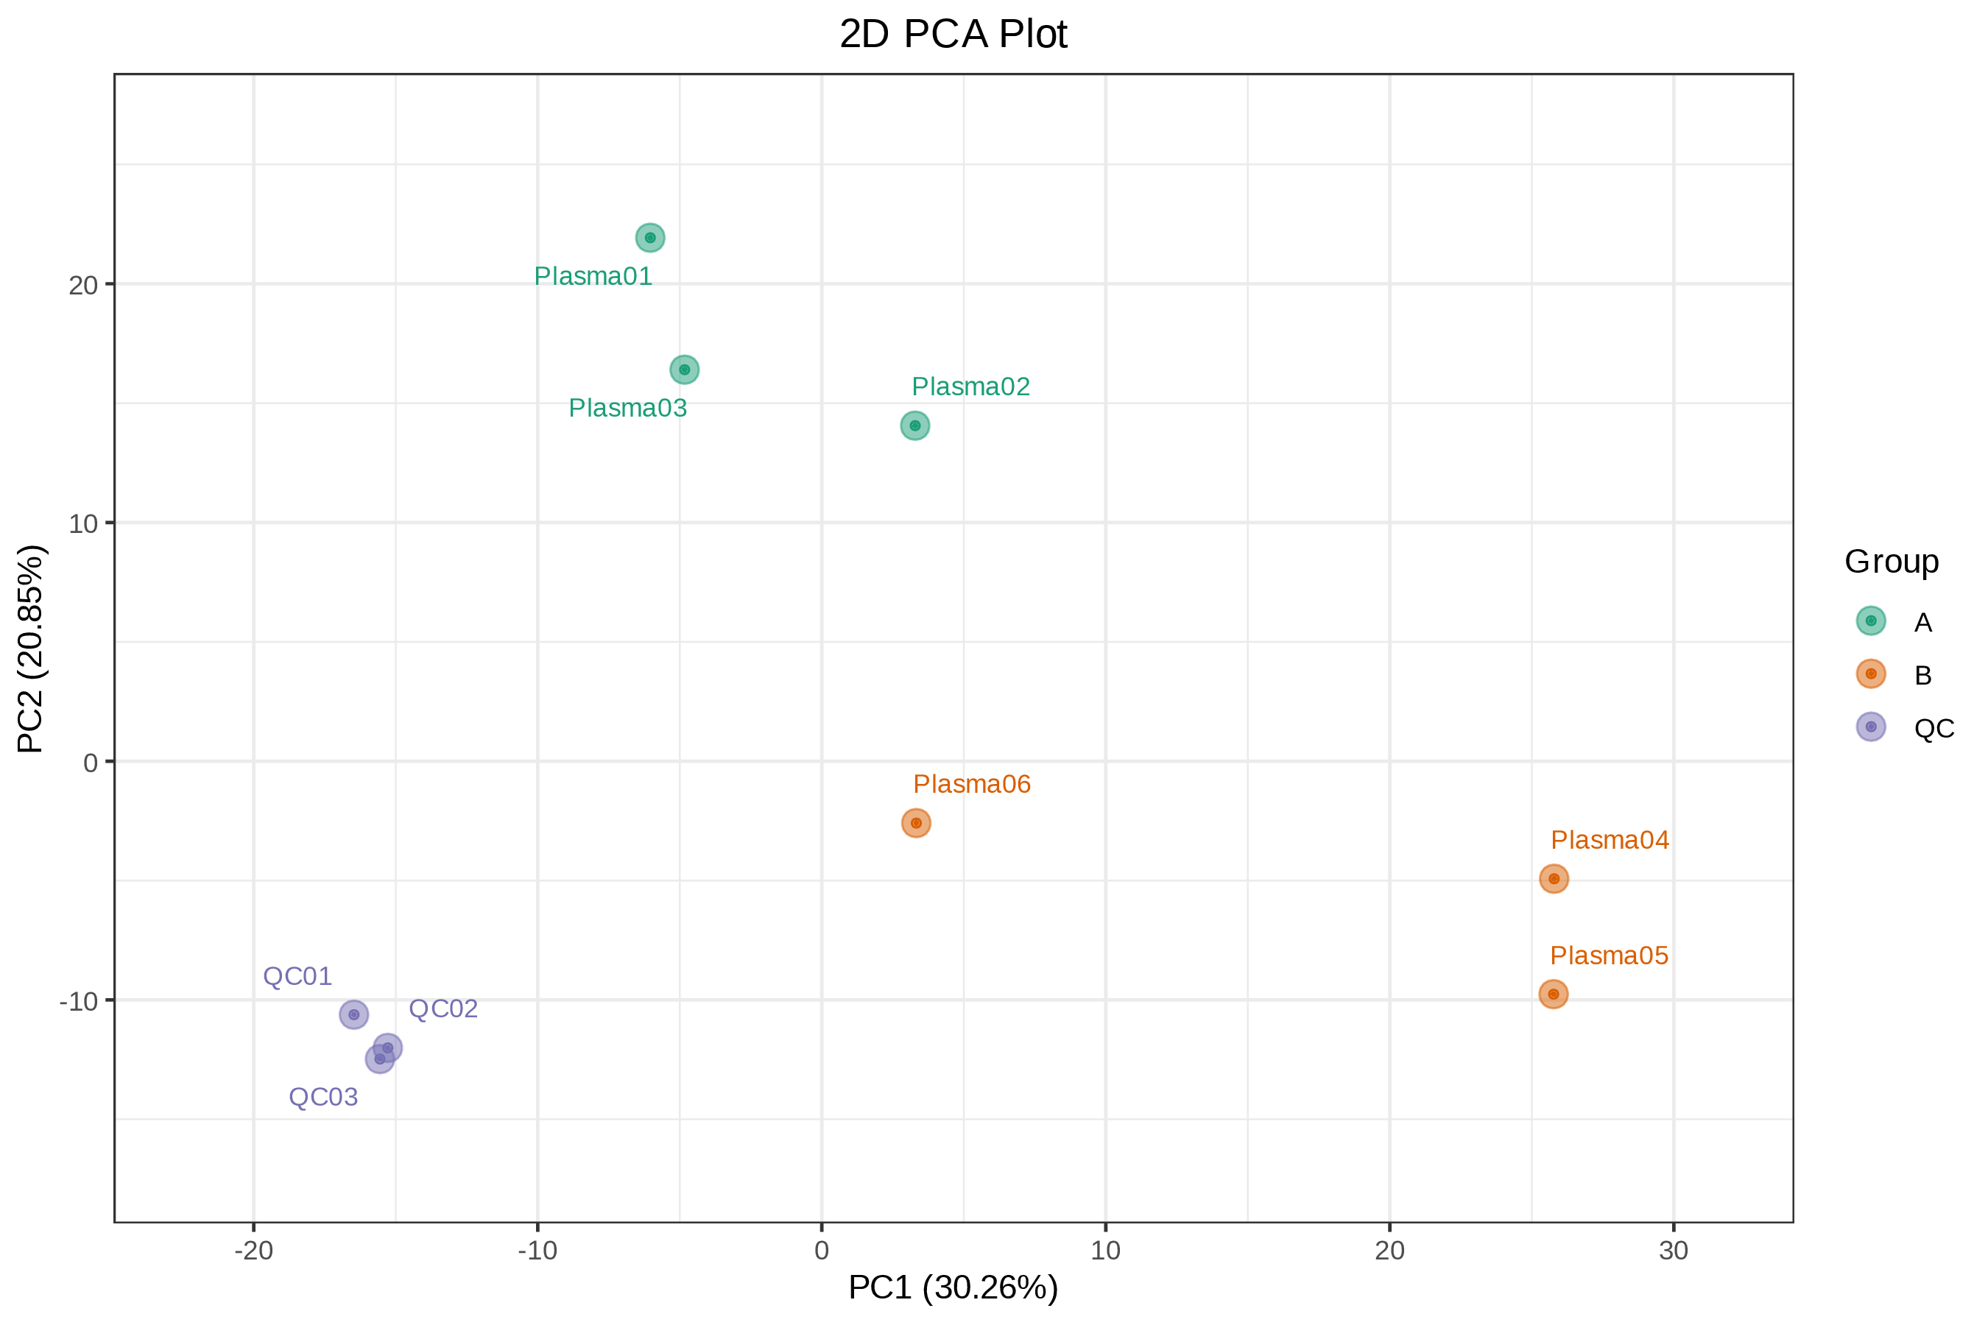
Figure : PCA score diagram of quality spectrum data of each group of samples and quality control samples
Note: PC1 represents the first principal component and PC2 represents the second principal component. Percentage represents the interpretation rate of the principal component to the data set. Each dot in the figure represents a sample, and samples in the same group are indicated in the same color.
Principal component analysis of population sample:Final_report/1.Data_Assess/*/pca/(If there are different ion modes, link to only one of them)

Principal component univariate statistical process control
We plotted the sample control diagram based on principle component analysis results. Each point in the control chart represents a sample, and the X-axis is the injection order of the sample. Due to changes in the instrument, the points on the chart may fluctuate up and down. Generally, PC1 of the QC sample should be within 3 standard deviations (SD) from the normal range.
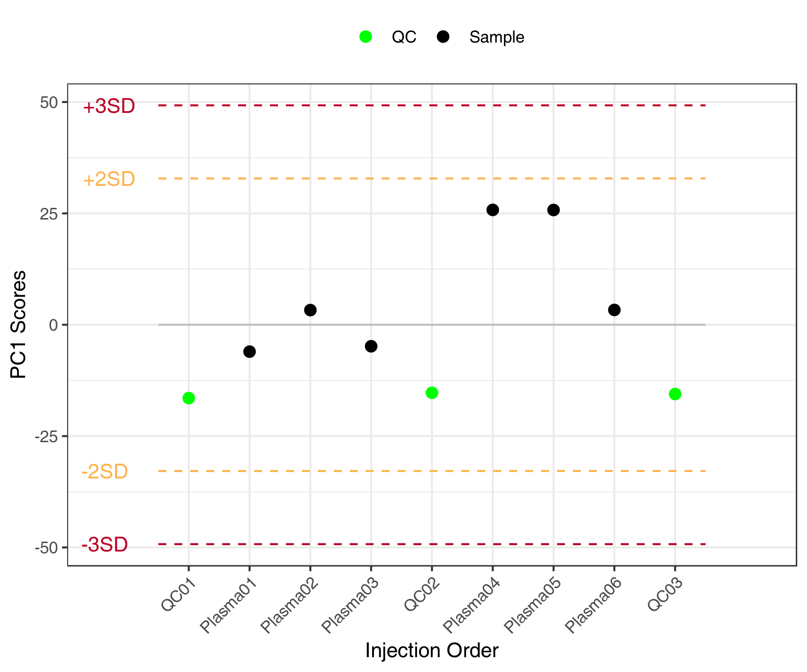
Figure : PC1 variation diagram of all the sample
Note: In the figure, the X-axis is the injection order of the sample, and the Y-axis reflects the PC1 value. The yellow and red lines define plus or minus 2 and 3 standard deviations respectively. The green dots represent QC samples and the black dots represent test samples.
PC1 control diagram of population sample:Final_report/1.Data_Assess/*/pca/*_PC1_QCC.*(If there are different ion modes, link to only one of them)

Hierarchical Cluster Analysis (HCA)

Principles of cluster analysis
Hierarchical Cluster Analysis (HCA) is a type of multivariate statistical analysis method. The samples are classified according to their features such that highest homogeneity is achieved between sample from the same group and highest heterogeneity is achieved between samples from different groups. In this report, the compound quantification data was normalized (Unit Variance Scaling, UV Scaling) and heatmaps were drawn by R software Pheatmap package. Hierarchical Cluster Analysis (HCA) was used to cluster the samples.

Hierarchical Cluster Analysis results
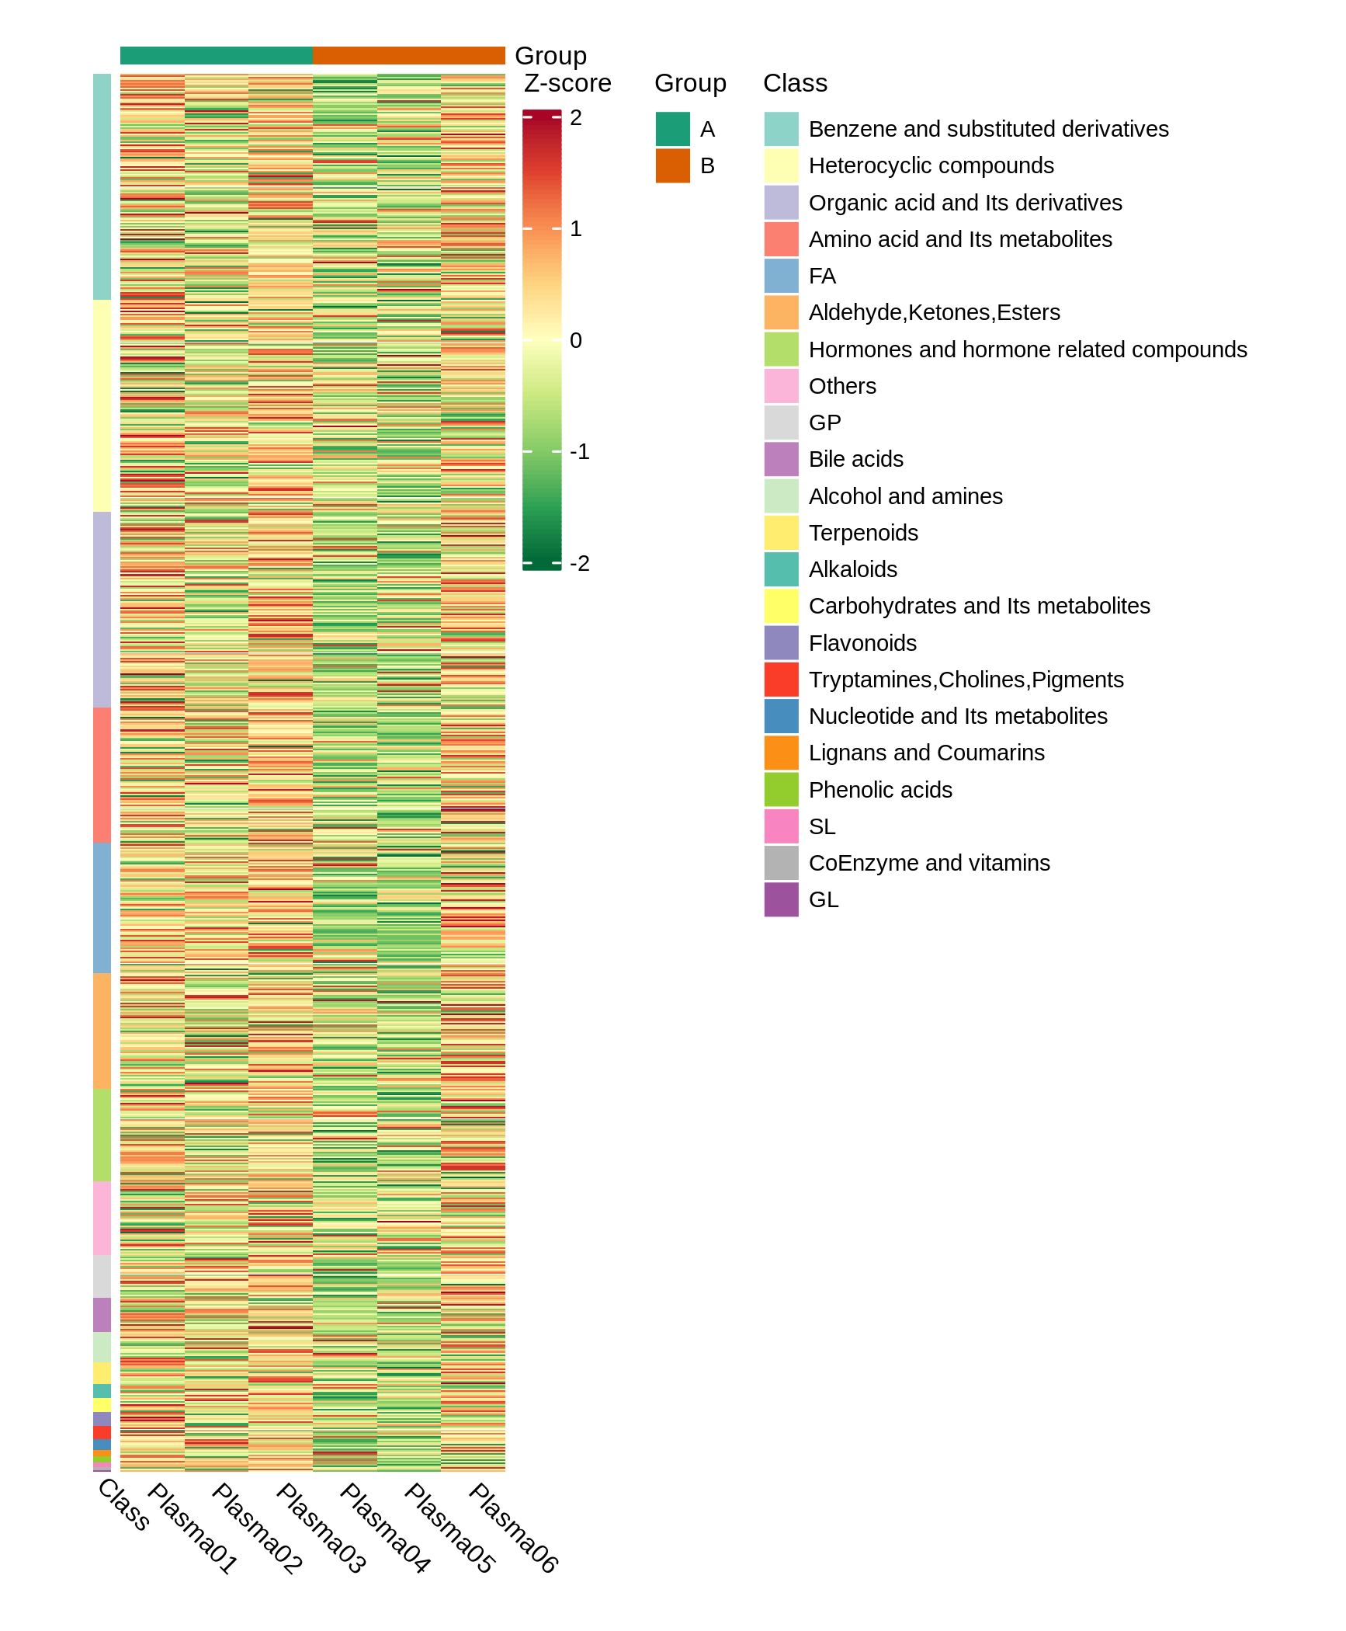
Figure : Sample clustering diagram
Note: X-axis indicates the sample name and the Y-axis are the metabolites. Group indicates sample groups. The different colors are the results after standardization of the relative contents (red represents high content, green represents low content). *_all_heatmap_class: Heatmap by metabolites classification, Class represents the first-level classification of metabolites. *_all_heatmap_col-row_cluster: clustering analysis is performed for both metabolites and samples, the clustering line on the left side of the figure is the metabolite clustering line, and the clustering line on the top of the figure is the sample clustering line. *_all_heatmap_row_cluster": clustering analysis is performed for metabolites only, the clustering line on the left side of the figure is the metabolite clustering line.
Clustering analysis result:Final_report/1.Data_Assess/*/heatmap/(If there are different ion modes, link to only one of them)

Analysis results

Principal component analysis of sample groups
Principal component analysis was first performed on each pair of sample groups to examine the degree of variation between different groups and between samples within the group.
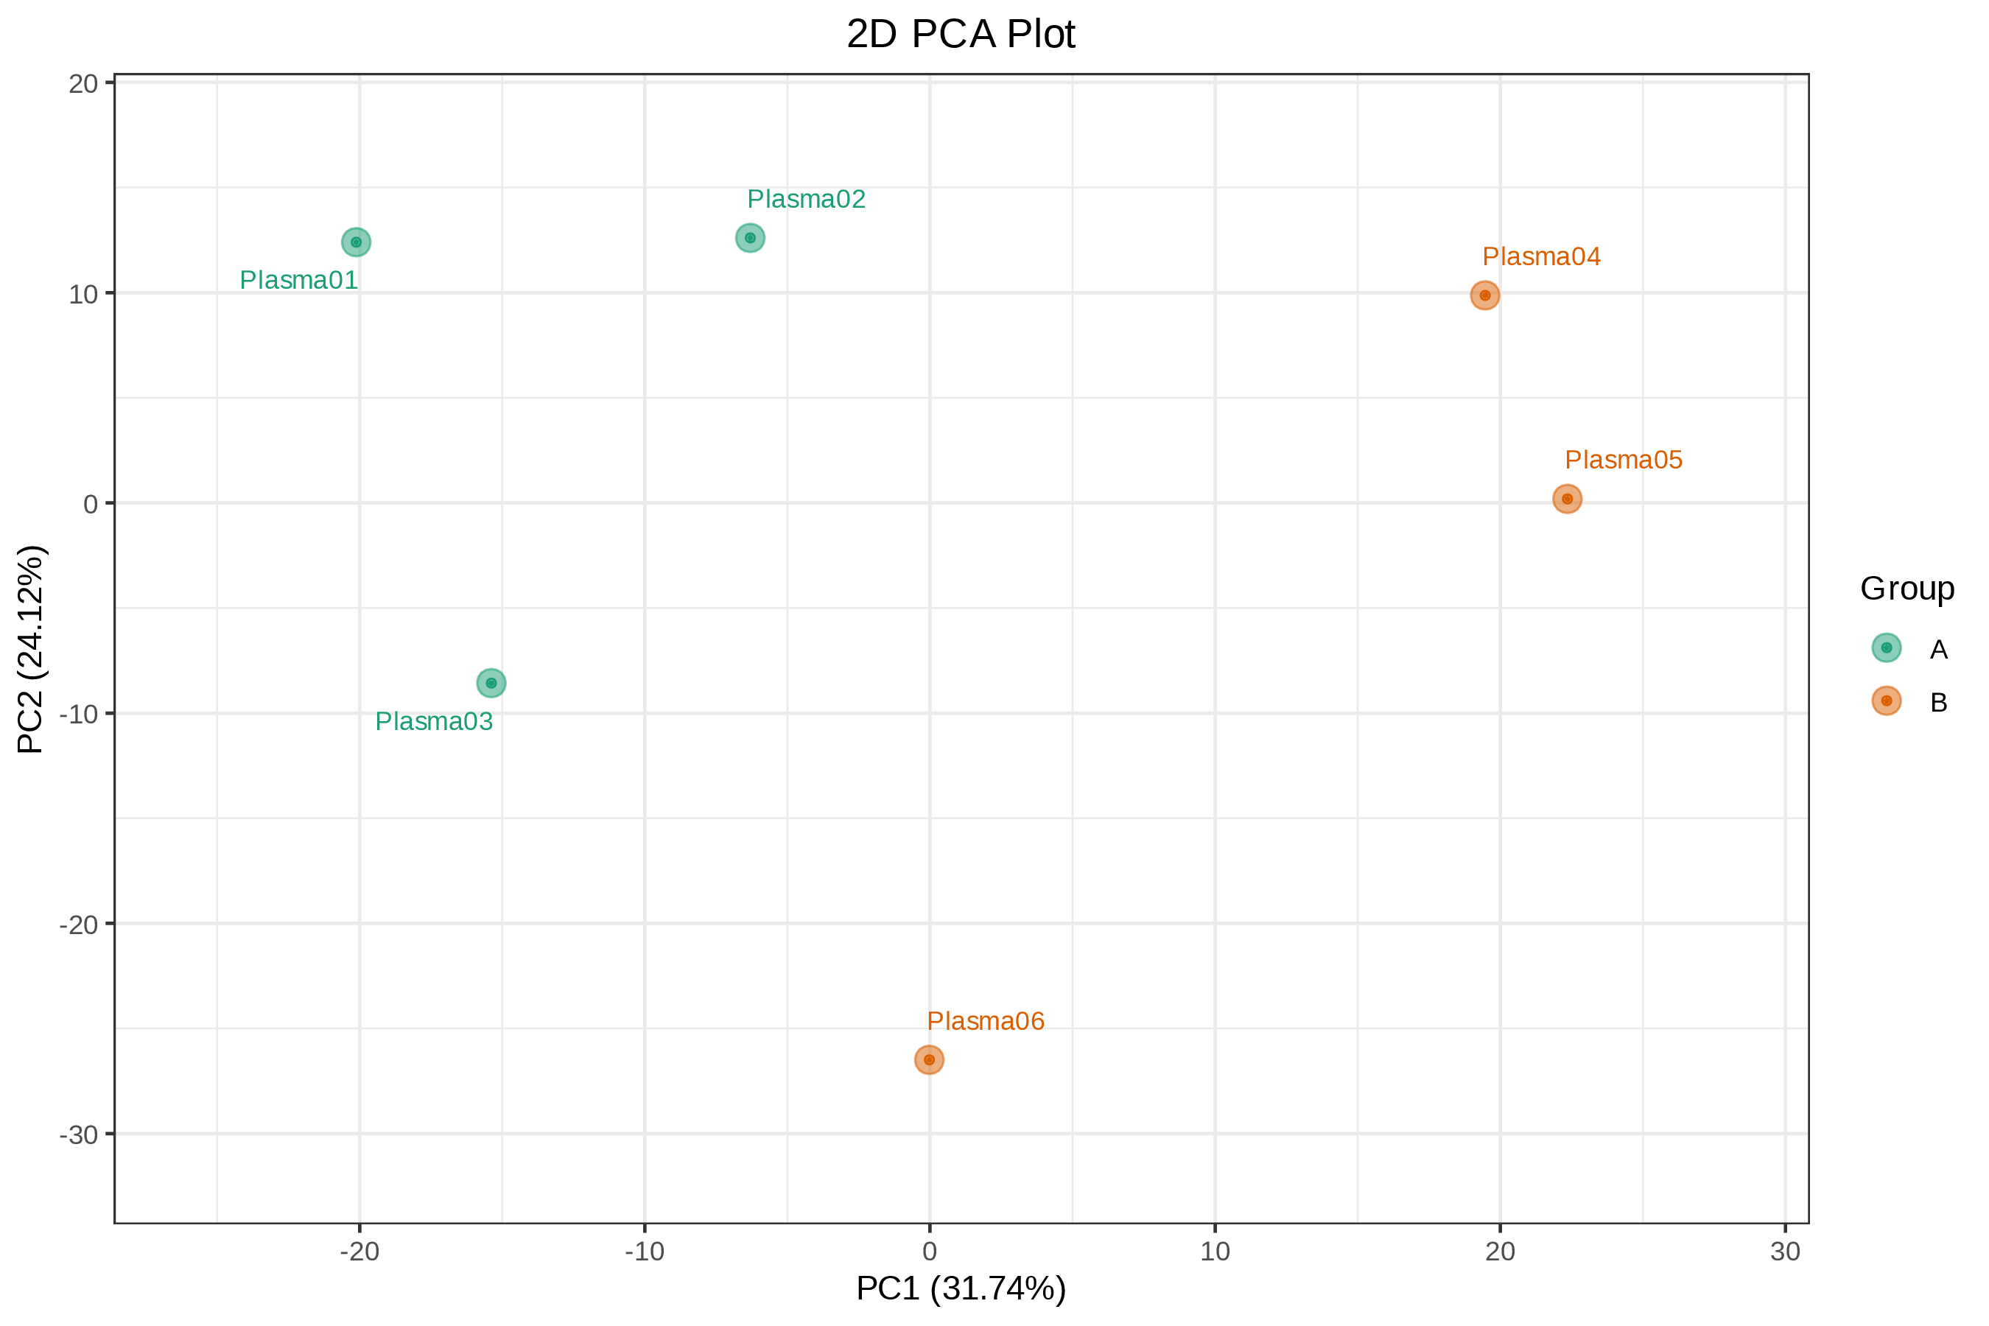
Figure : Principal component analysis of different groups
Note: Each group has a PCA plot, PC1 represents the first principal component, PC2 represents the second principal component, and the percentages on the axis represents the interpretation rate of the principal component to the data set. Each dot in the figure represents a sample, samples in the same Group are represented by the same color, and Group is a grouping.
The three-dimensional PCA result is shown in the figure below:
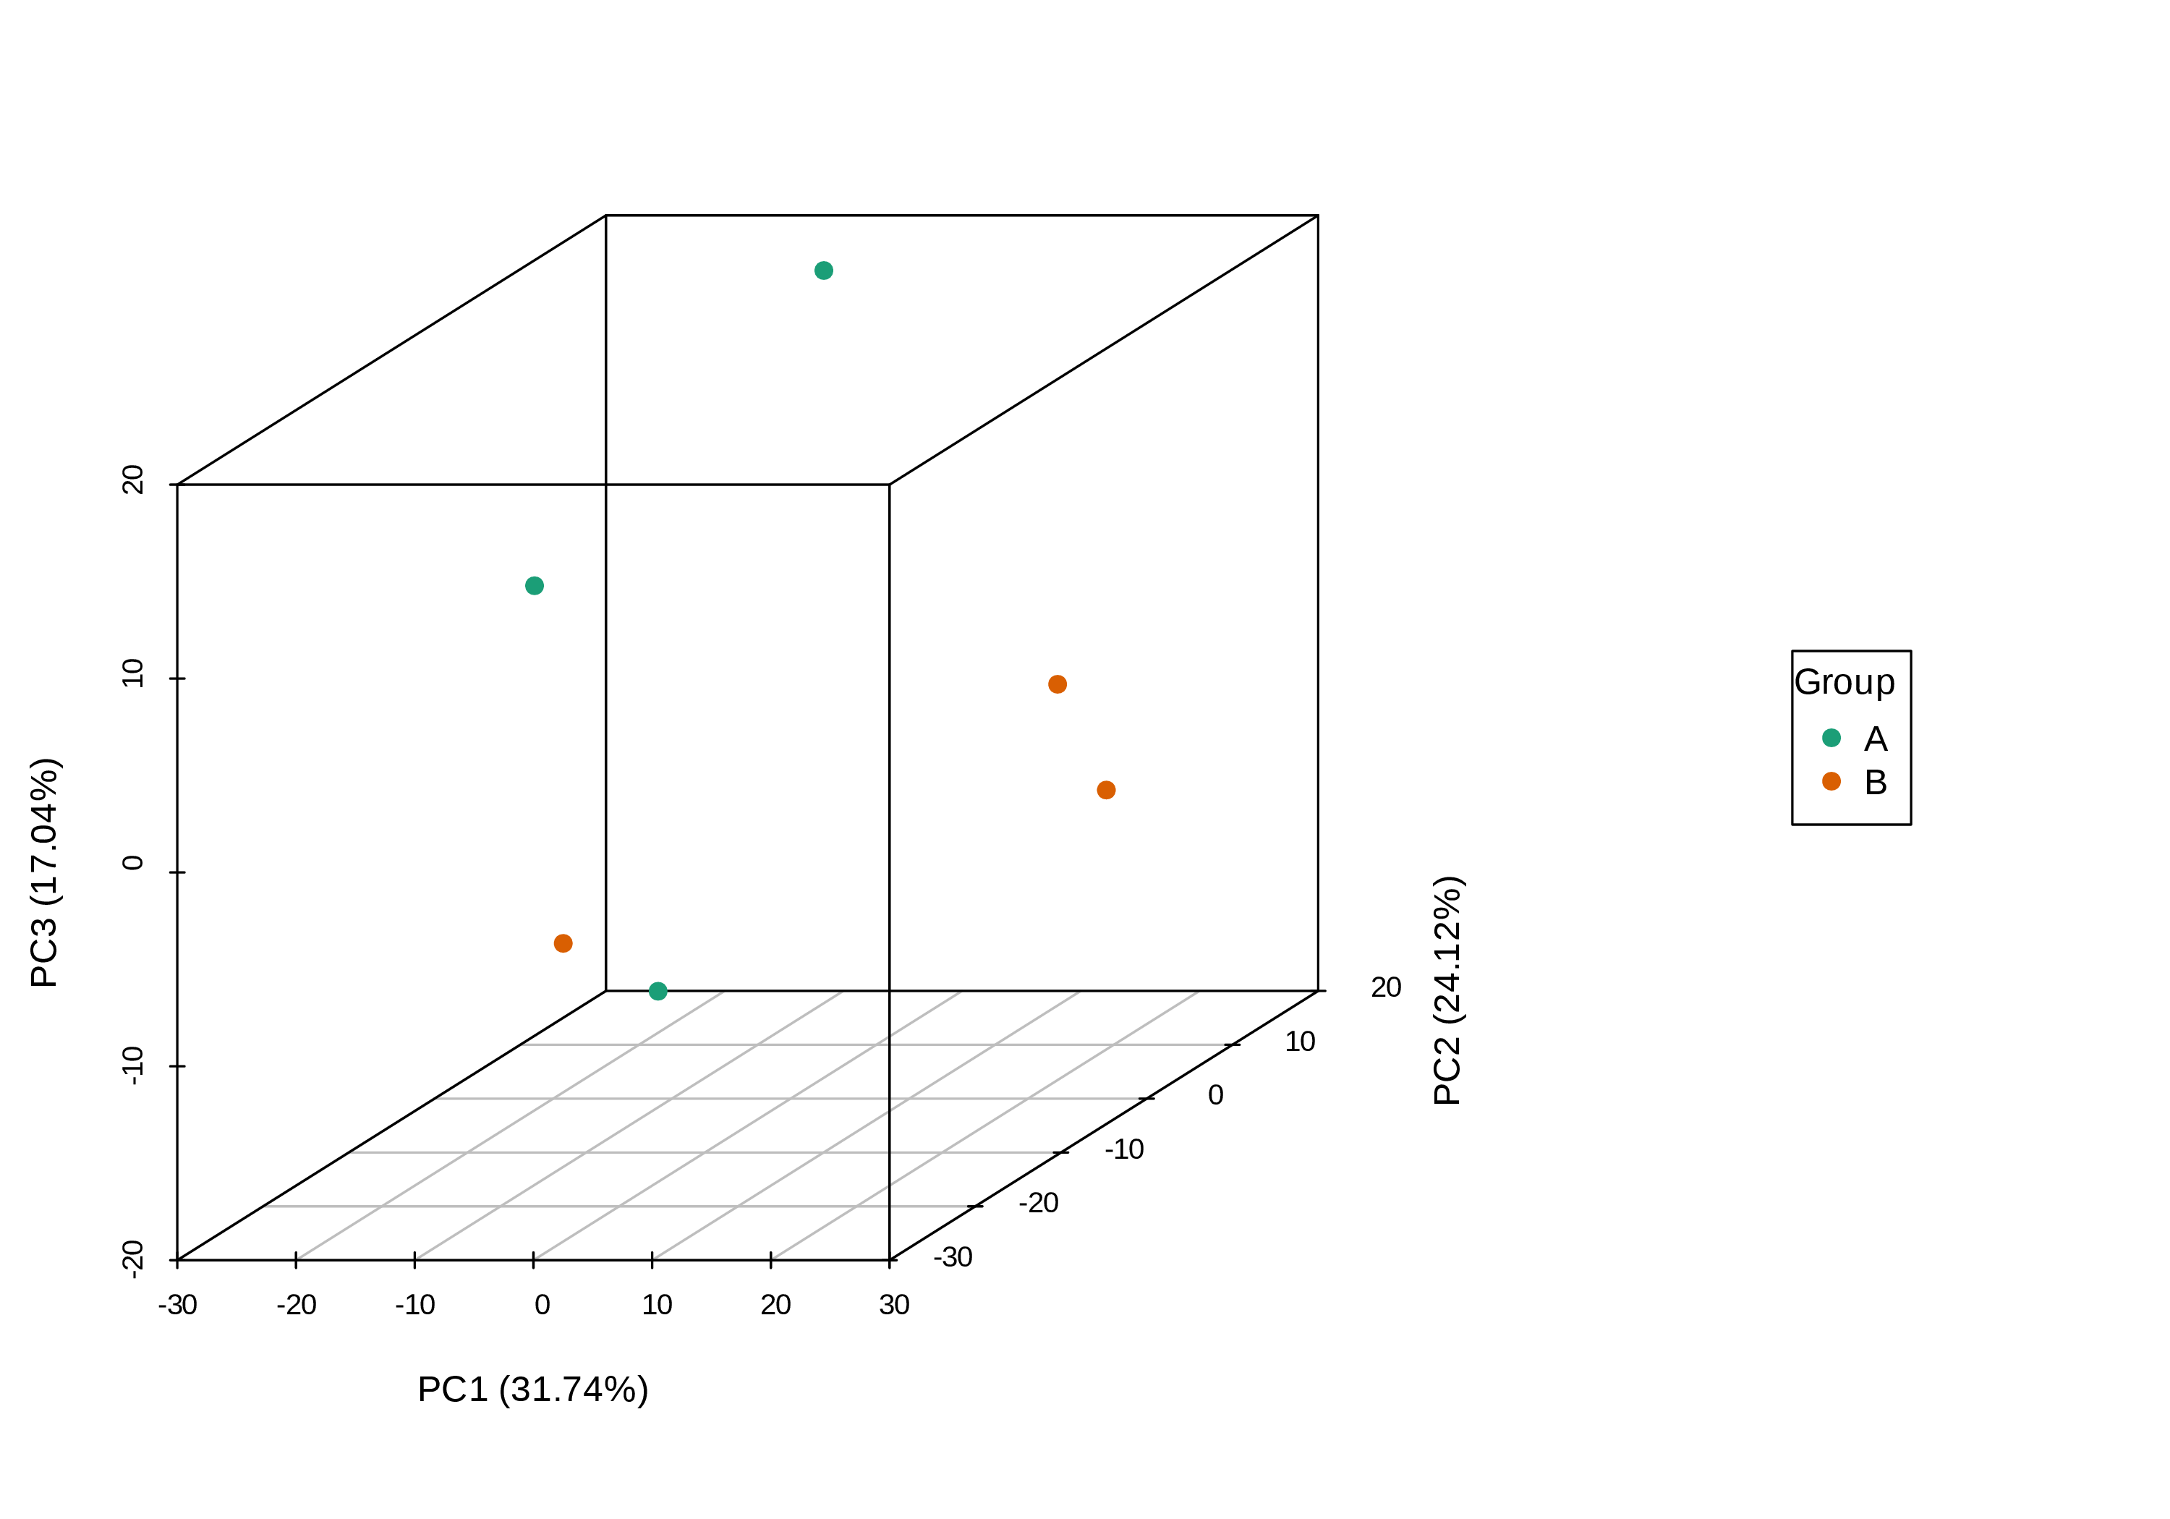
Figure : Three-dimensional PCA plot of different groups
Note: PC1 represents the first principal component, PC2 represents the second principal component, and PC3 represents the third principal component.
The explainable variation of the first five principal components is shown in the figure below:
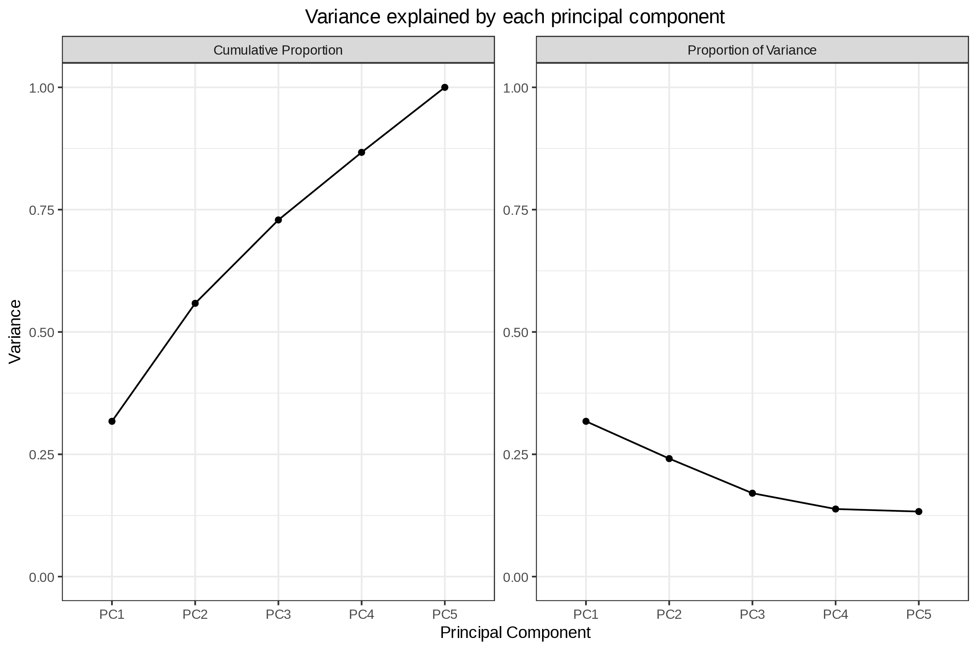
Figure : The explainable variation of the first five principal components
Note: The X-axis represents each principal component, the Y-axis represents the explainable variation, the left figure represents the cumulative explainable variation, and the right figure represents the explainable variation of each principal component.
Principal component analysis of different groups:Final_report/2.Basic_Analysis/Difference_analysis/*_vs_*/pca/

Discriminant Analysis by Orthogonal Partial Least Squares (OPLS-DA)
PCA analysis is often insensitive to variables with small correlation. In contrast, partial least squares-discriminant analysis (PLS-DA) is a multivariate statistical analysis method with supervised pattern recognition, in which components in independent variable X and dependent variable Y are extracted to calculate the correlation between components. Compared with PCA, PLS-DA can maximize the difference between groups and facilitate the search for differential lipids. Orthogonal partial least squares discriminant analysis (OPLS-DA) combines orthogonal signal correction (OSC) and PLS-DA method, which can decompose the x-matrix information into two types (1. information related to Y and 2. irrelevant information) and filter the differential variables by removing the irrelevant differences.
The OPLSR.Anal function in the R package MetaboAnalystR was used for this analysis. The following table shows a partial result from the OPLS-DA model:
Table: Partial results of OPLS-DA
Index | VIP
MW0009085 | 1.19170528
MW0009611 | 1.63698128
MW0139900 | 0.16279325
MW0054942 | 0.69256868
MEDP1315 | 0.89799368
MEDP1658 | 0.69636792
MW0055434 | 1.44479143
MW0126392 | 0.84303127
MW0125188 | 0.80074084
MEDL01942 | 1.71169189
MW0150710 | 1.34030988
MW0006357 | 0.57343255
MW0000158 | 0.15519362
MEDP1238 | 0.04499138
MW0111287 | 1.78541616
Partial results of OPLS-DA:Final_report/2.Basic_Analysis/ Difference_analysis/*_vs_*/*_info.xlsx
OPLS-DA model overview:Final_report/2.Basic_Analysis/Difference_analysis/*_vs_*/opls/*_OPLS-DA_model.*
OPLS-DA model summary table:Final_report/2.Basic_Analysis/Difference_analysis/*_vs_*/opls/*_OPLS-DA_summary.xlsx.

Principles of OPLS-DA model
During OPLS-DA modeling, the X matrix information is decomposed into information related to Y and information unrelated to Y. Among them, the variable information related to Y is the predicted principal component, and the information unrelated to Y is the orthogonal principal component (Thevenot et al., 2015).
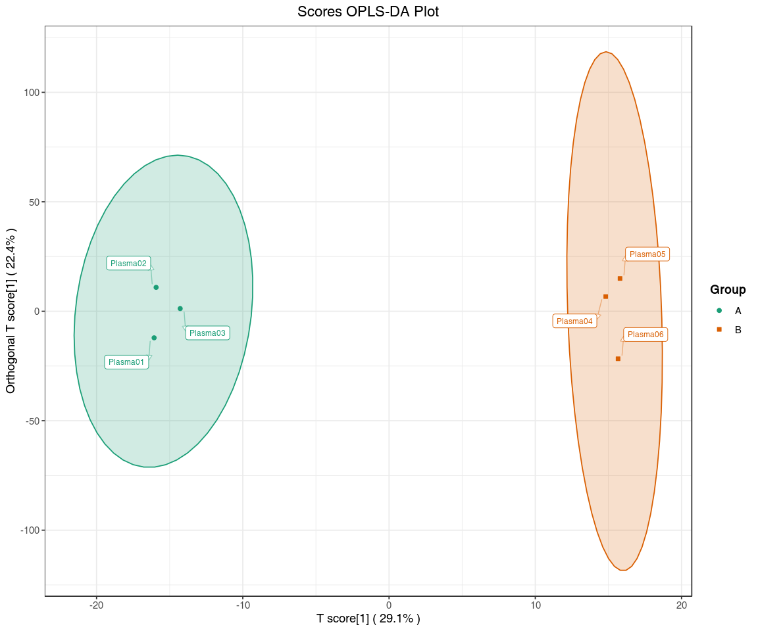
Figure : OPLS-DA score diagram
Note: The X-axis represents the predicted principal component, and the difference between groups can be seen in the horizontal direction. The Y-axis represents the orthogonal principal component, and the vertical direction shows the difference within the group. Percentage indicates the degree to which the component explains the data set. Each dot in the figure represents a sample, samples in the same Group are represented by the same color, and Group indicates sample groups.
OPLS-DA score diagram:Final_report/2.Basic_Analysis/Difference_analysis/*_vs_*/opls/*_OPLS-scorePlot.*.

OPLS-DA model validation
The prediction parameters of the evaluation model are R²X, R²Y and Q², where R²X and R²Y represent the explanatory rate of the model to X and Y matrix respectively, and Q² represents the predictability of the model. The closer these three indicators are to 1, the more stable and reliable the model is. Q² > 0.5 can be considered as an effective model, and Q² > 0.9 can be considered as an excellent model. The following figure shows the OPLS-DA validation plot with the horizontal coY-axis indicating the model R²Y, Q² values, and the vertical coY-axis is the frequency of the model classification effect. The model performs bootstrapping 200 times and if Q²’s P = 0.02, it indicates that the predictability of four random grouping models is better than that of the OPLS-DA model in the Permutation detection. If R²Y’s P = 0.545, it indicated that there were 109 random grouping models in the Permutation detection, whose explanation rate of Y matrix was better than that of the OPLS-DA model. In general, P < 0.05 is the best model.
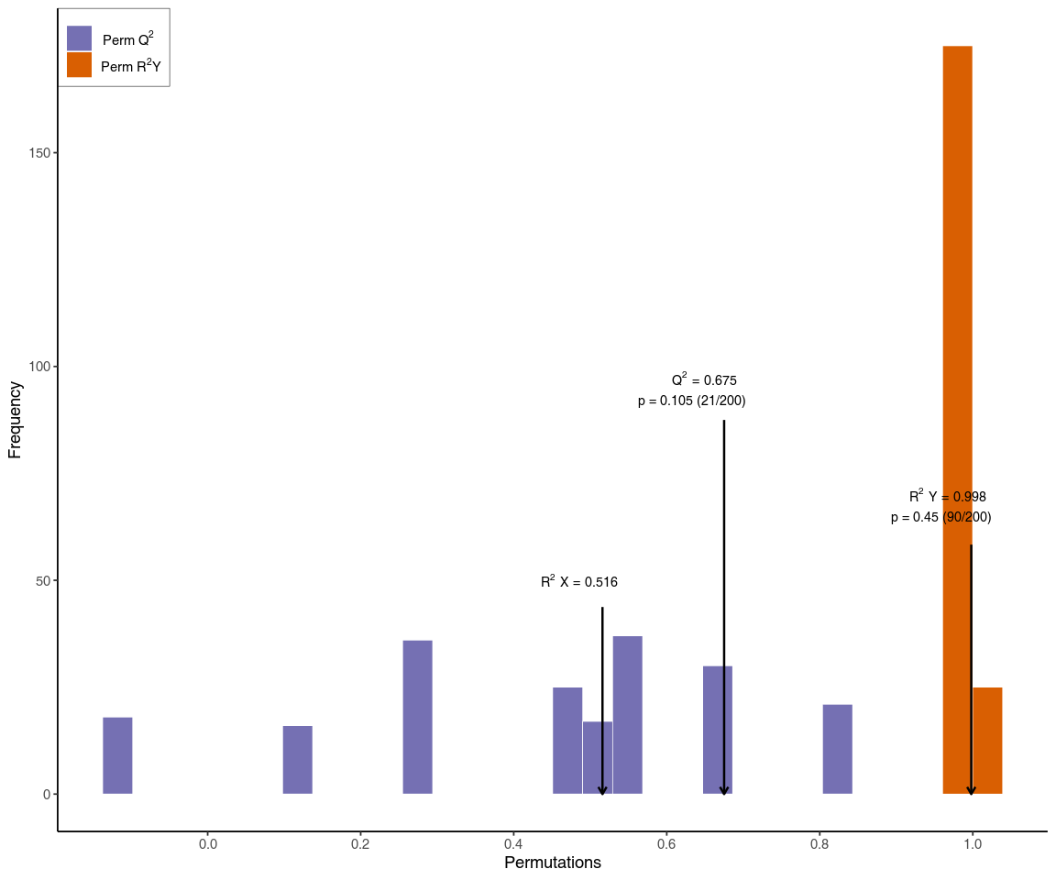
Figure : OPLS-DA verification diagram
Note: The orange color represents the R${}^{2}$Y of the random grouping model, the purple color represents the Q${}^{2}$ of the random grouping model, and the black arrows represent the values of R${}^{2}$X, R${}^{2}$Y, and Q${}^{2}$ of the original model.
OPLS-DA verification diagram:Final_report/2.Basic_Analysis/Difference_analysis/*_vs_*/opls/*_OPLS-DA_permutation.*

OPLS-DA S-plot
The figure below shows the OPLS-DA S-plot. The horizontal axis is the covariance between the principal components and metabolites, the vertical axis indicates the correlation coefficient between the principal components and the metabolites. The closer the points are to the top right corner or bottom left corner, the more significant the difference in metabolite abundance. Red dots indicate metabolites with VIP value > 1 and green dots indicate metabolites with VIP value <= 1.
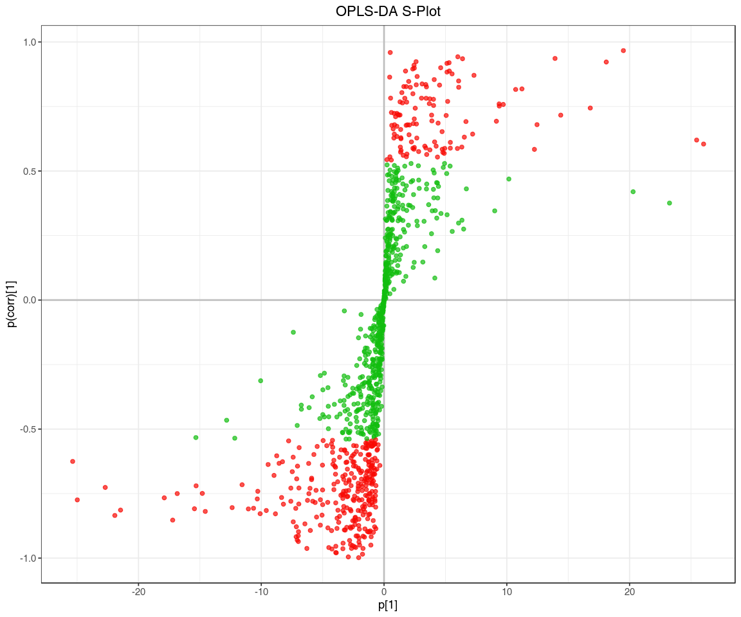
Figure : OPLS-DA S-plot
OPLS-DA S-plot:Final_report/2.Basic_Analysis/Difference_analysis/*_vs_*/opls/*_OPLS-DA_SPlot.*

Dynamic distribution of metabolite content differences
To show the overall metabolite abundance distribution in the samples, metabolites were sorted and plotted based on fold-change values from small to large. The distribution of the ranked metabolites is shown below with the top 10 up-regulated and top 10 down-regulated metabolites labelled.
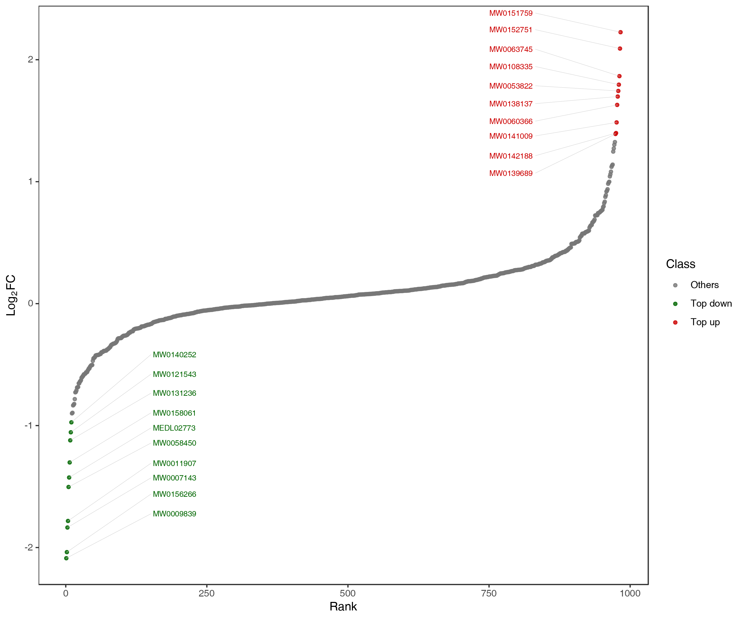
Figure : Dynamic distribution of metabolite content difference
Note: In the figure, the X-axis represents the rank number of metabolites based on FC value. The Y-axis represents the log${}_{2}$FC value. Each point represents a metabolite. The green points represent the top 10 down-regulated metabolites and the red points represent the top 10 up regulated metabolites.
Dynamic distribution of metabolite content difference:Final_report/2.Basic_Analysis/Difference_analysis/ *_vs_*/TopFcMetabolites/*_TopFcDistribution_*.*

Differential metabolite screening
It is often necessary to combine univariate statistical analysis and multivariate statistical analysis for large high dimensional datasets such as metabolomics datasets to accurately identify differential metabolites. Univariate statistical analysis methods include parametric test and nonparametric test. Multivariate statistical analysis methods include principal component analysis and partial least square discriminant analysis. Based on the results of OPLS-DA (biological repetition ≥ 3), multivariate analysis of Variable Importance in Projection (VIP) from OPLS-DA modeling was used to preliminarily select differential metabolites from different samples. Differential metabolites can further be screened by combining the P-value/FDR (when biological replicates ≥ 2) or FC values from univariate analysis. The screening criteria for this project are as follows:
1. Metabolites with VIP > 1 were selected. VIP value represents the effect of the differences between groups for a particular metabolite in various models and sample groups. It is generally considered that the metabolites with VIP > 1 are significantly different..
2. Metabolites with P-value < 0.05 (Student’s t test) were considered as significant differences and selected.
Partial results from the screening criteria is shown below.
Table: Screening results of differential metabolites
Index | Compounds | Type
MW0009611 | Pyridaben | down
MEDL01942 | Dibutyl phthalate | down
MW0111287 | Sphinganine | up
MW0003999 | 3-Formylsalicylic acid | down
MW0151759 | Ionomycin | up
MW0107415 | Lenticin | up
MW0122713 | 1-Oxazolo[4,5-b]pyridin-2-yl-9-octadecyn-1-one | up
MW0138954 | Methyl cinnamate | down
MW0146032 | Asp-Arg-Tyr | down
MW0156266 | Pyruvate oxime | down
MW0058450 | 1-(11Z-eicosenoyl)-2-hexadecanoyl-glycero-3-phosphoethanolamine | down
MW0127808 | (1R,16Z,24E,26E,28Z)-12-[1-(3,4-dihydroxycyclohexyl)propan-2-yl]-1,18-dihydroxy-19,30-dimethoxy-15,17,21,23,29,35-hexamethyl-11,36-dioxa-4-azatricyclo[30.3.1.0,]hexatriaconta-16,24,26,28-tetraene-2,3,10,14,20-pentone | up
MW0016356 | Canrenone | up
MW0009902 | Thenylchlor | up
MW0008833 | Naphthalene | up
Screening results of differential metabolites:Final_report/2.Basic_Analysis/Difference_analysis/*_vs_*/ *_vs_*_filter.xlsx

Bar chart of differential metabolites
The following figure shows the result of top 20 differentially expressed metabolites in each comparison with fold-change value shown as log₂ values.
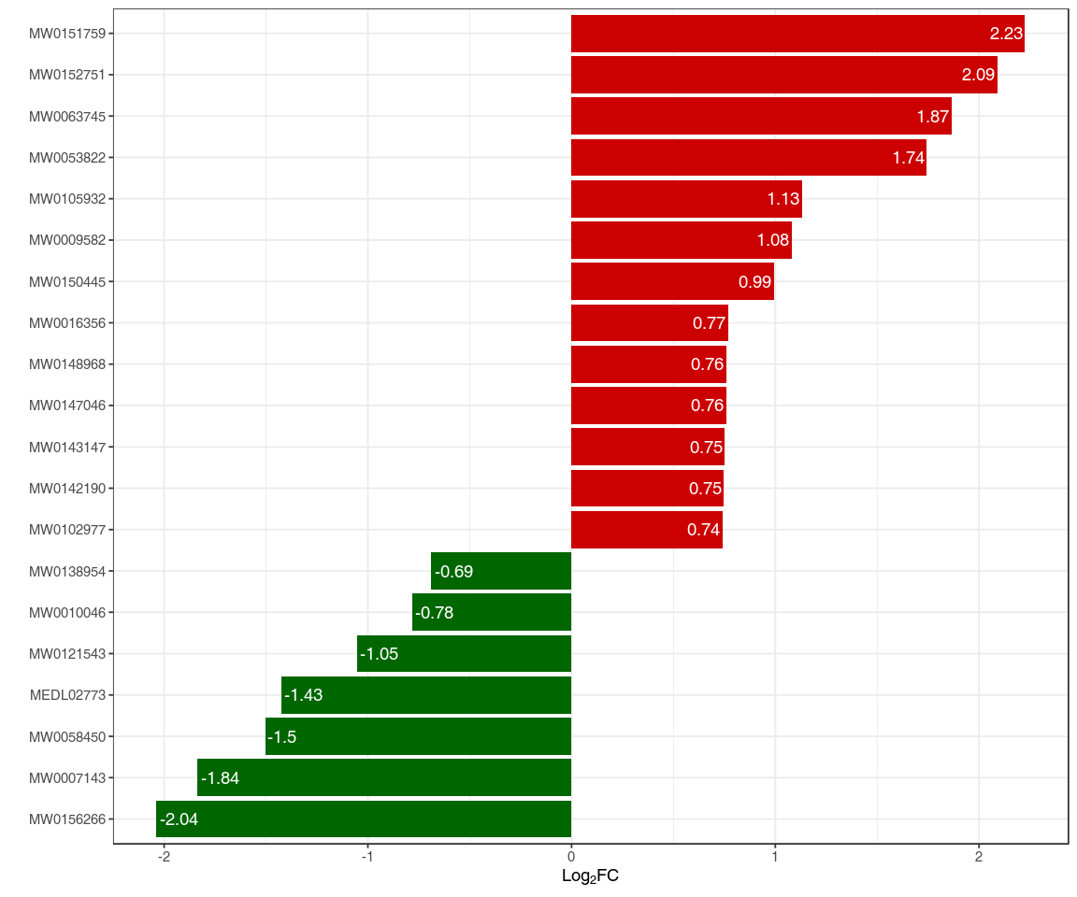
Figure : Histogram of multiple difference
Note: X-axis refers to log${}_{2}$FC values of top differential metabolites, the Y-axis refers to metabolites. Red bars represent up-regulated differential metabolites and green bars represent down-regulated differential metabolites.
Histogram of multiple difference:Final_report/2.Basic_Analysis/Difference_analysis/*_vs_*/TopFcMetabolites/ *_TopFcBarChart_*.*

Radar map of differential metabolites
The top 10 differential metabolites based on Fold-change were selected and plotted on the radar plot.
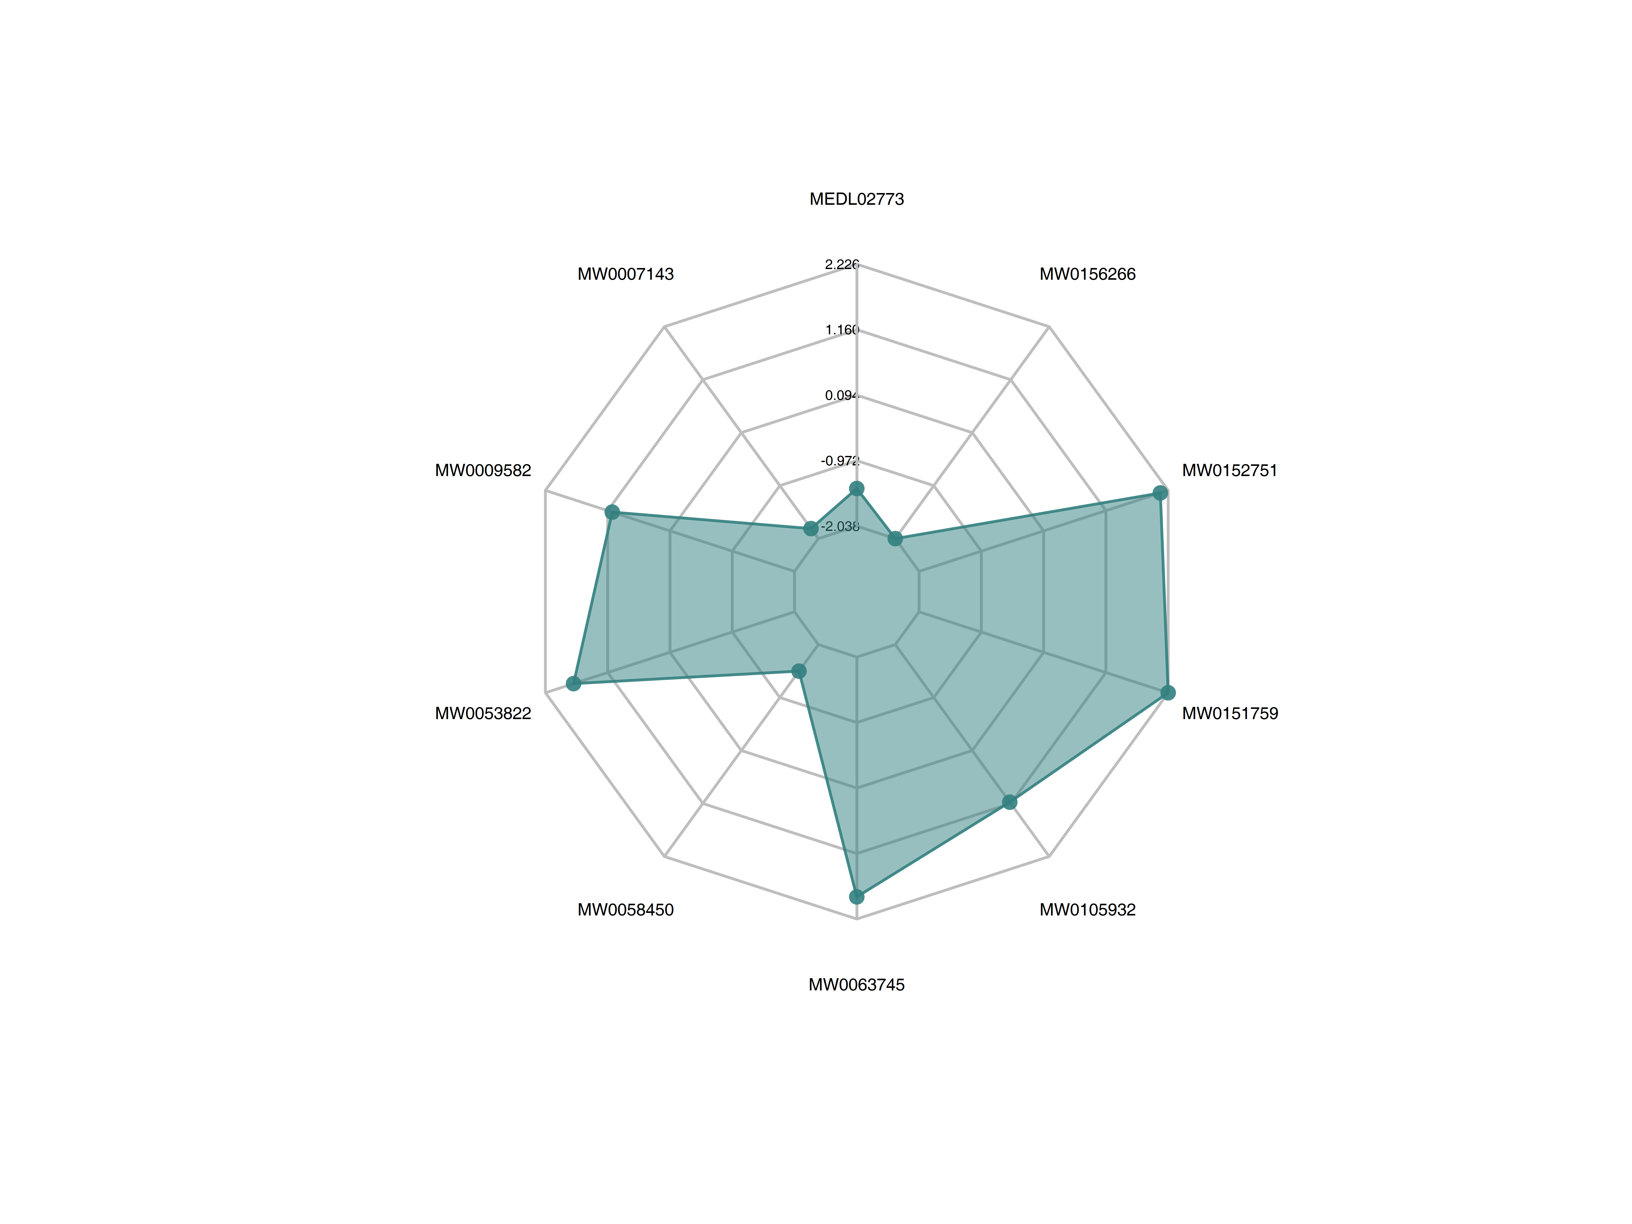
Figure : Radar map of differential metabolites
Note: The grid lines correspond to the log${}_{2}$FC. The green colored area are formed from the lines connecting the dots.
Radar map of differential metabolites:Final_report/2.Basic_Analysis/Difference_analysis/*_vs_*/ TopFcMetabolites/ *_TopFcRadarChart_*.*

VIP value map of differential metabolites
The top 20 metabolites with the largest VIP value from the OPLS-DA model were selected and plotted.
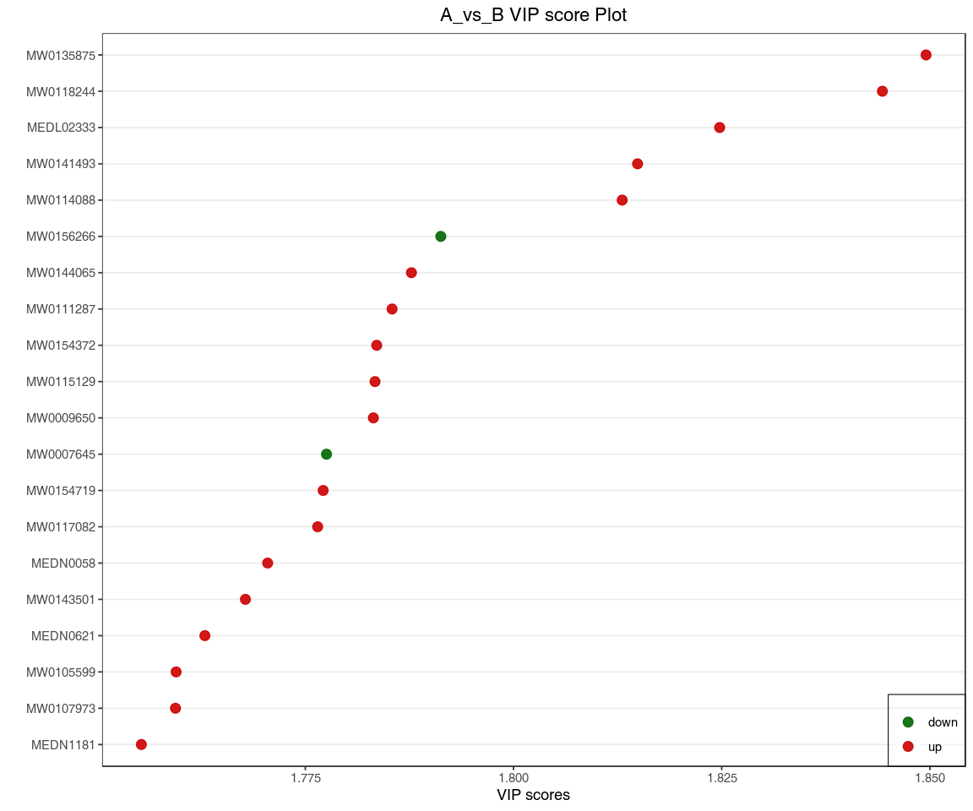
Figure : VIP values of differential metabolites
Note: The X-axis represents VIP values, and the Y-axis represents metabolites. Red dots represent up-regulated differential metabolites, and green dots represent down-regulated differential metabolites. Yellow represents metabolites with significant differences in three and more differential comparison groups.
VIP values of differential metabolites:Final_report/2.Basic_Analysis/Difference_analysis/*_vs_*/vipscore/ *_vipScore*.*

Volcano plot of differential metabolites
Volcano Plot is mainly used to show the relative differences and the statistical significance of metabolites between two groups. We provided the volcano plot of differential metabolites using different selection criteria for your consideration. The details of different selection criteria are described in the README document under the volcano plot directory. In addition, the attached results also provided an interactive web version of the volcano plot where you can examine the details of each metabolite.
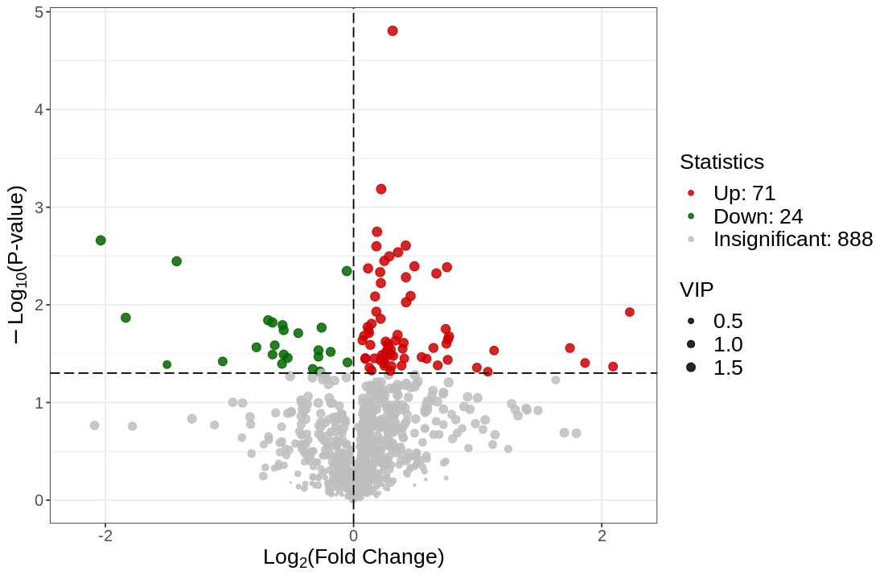
Figure : Volcano plot of differential metabolites
Note: Each point in the volcano plot represents a metabolite with green points represent down-regulated differential metabolite, red points represent up-regulated differential metabolite, and gray points represent the detected metabolites but show no significant differences. The X-axis represents the (log${}_{2}$FC) value of metabolites between two groups. The further away from 0 on the X-axis, the greater the fold-change between two groups. If the metabolites were screened using VIP + FC + P-value: the Y-axis will represent the the level of significant differences (-log${}_{10}$P-value), The size of each dot represents the VIP value.
Volcano plot of differential metabolites:Final_report/2.Basic_Analysis/Difference_analysis/*_vs_*/vol/*_vol.*

Hierarchical clustering tree
Hierarchical clustering was performed on different sample groups to form a clustering tree showing the similarity between samples. Samples in the same cluster have higher similarity.
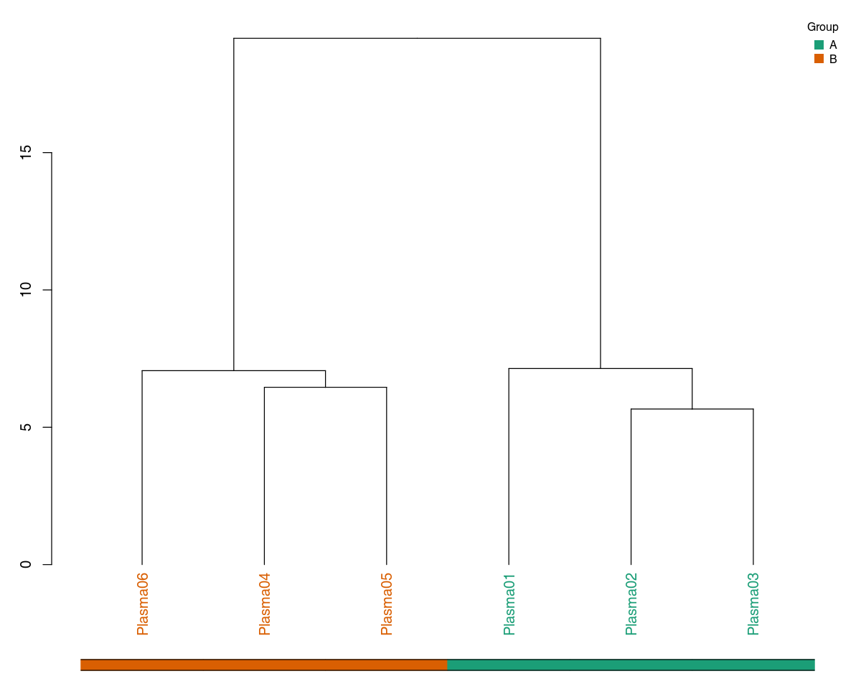
Figure : Hierarchical clustering tree
Note: Each row in the figure represents one sample. Samples with high similarity to each other are grouped into the same cluster.
Hierarchical clustering tree:Final_report/2.Basic_Analysis/Difference_analysis/*_vs_*/dendrogram/ *_dendrogram.*

Heatmap of differential metabolites
In order to observe the fold-change of differential metabolites more intuitively, we normalized the relative quantification using unit variance scaling (UV scaling, see appendix for details of calculation formula) and plotted on a heatmap using pheatmap in R.
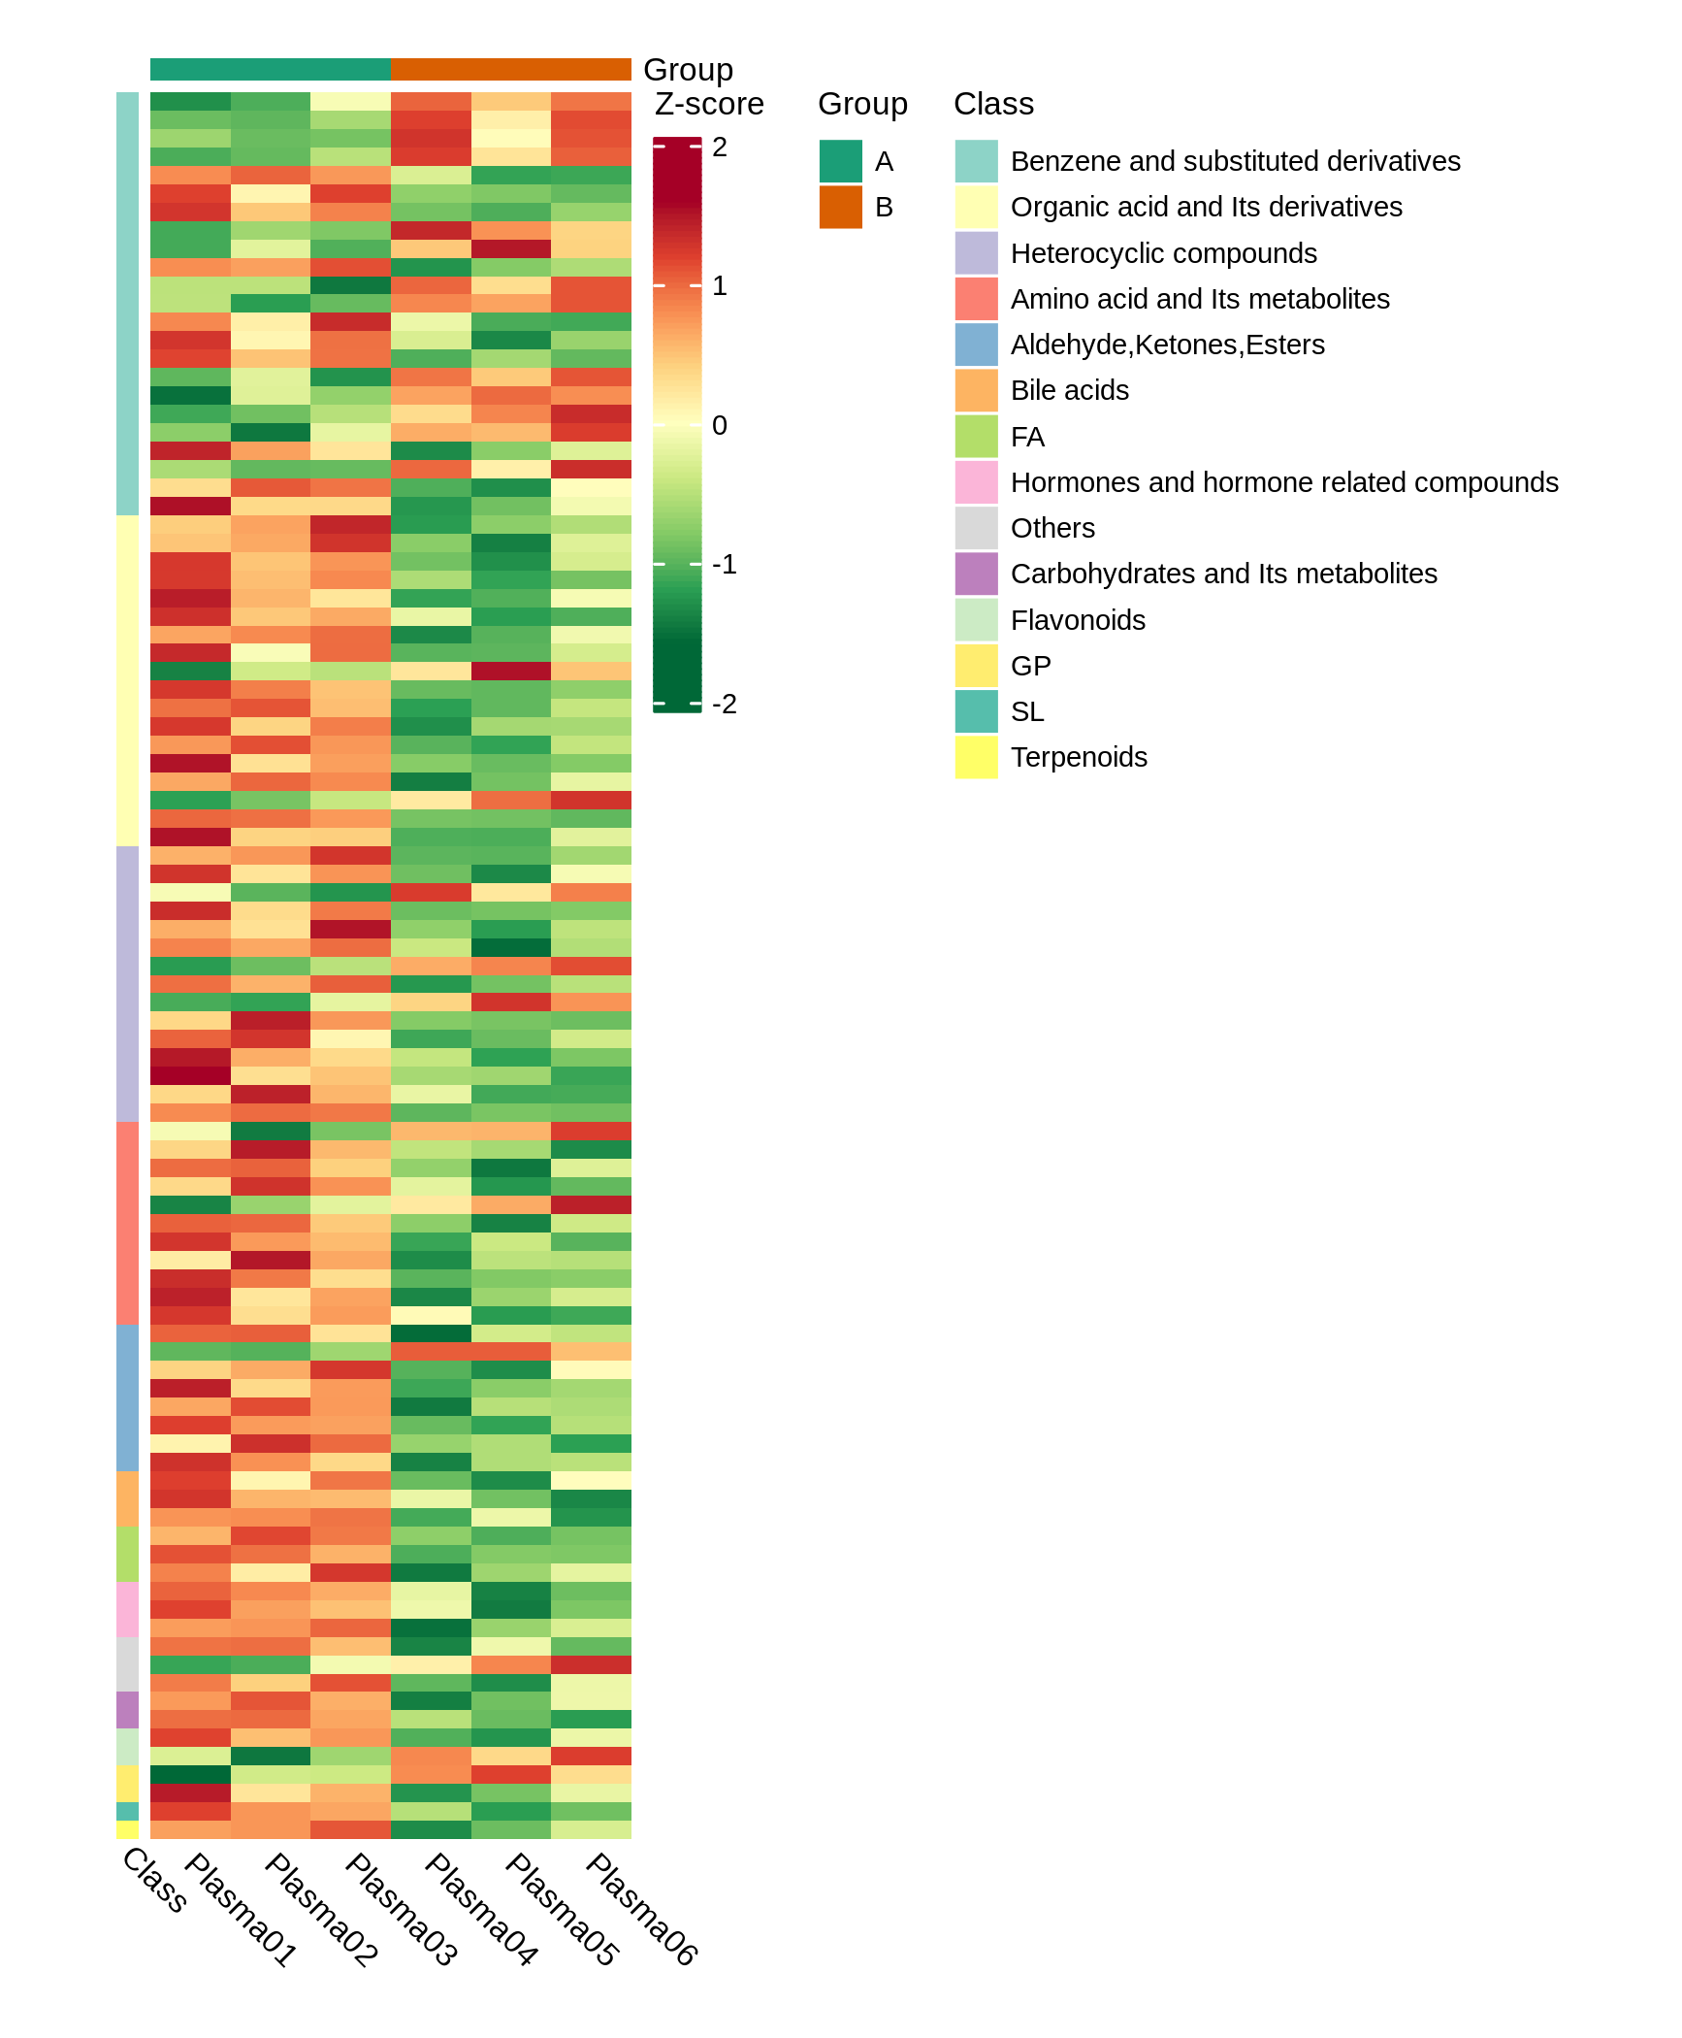
Figure : Cluster heatmap of differential metabolites
Note: The X-axis shows the name of the samples and the Y-axis shows the differential metabolites. Different colors in the heatmap represent the values obtained after standardization and reflects the level of relative quantification. The darker the red, the higher the quantification. In contrast, the darker the green, the lower the quantification. *_all_heatmap_class: Heatmap by metabolites classification, Class represents the first-level classification of metabolites. *_all_heatmap_col-row_cluster: clustering analysis is performed for both metabolites and samples, the clustering line on the left side of the figure is the metabolite clustering line, and the clustering line on the top of the figure is the sample clustering line. *_all_heatmap_row_cluster: clustering analysis is performed for metabolites only, the clustering line on the left side of the figure is the metabolite clustering line.
Heatmap of differential metabolites:Final_report/2.Basic_Analysis/Difference_analysis/*_vs_*/heatmap/

Correlation analysis of differential metabolites
Metabolites may act synergistically or in mutually exclusive relationships amongst each other.. The correlation analysis can help measure the metabolic proximities of significantly different metabolites. This analysis will help further understand the mutual regulatory relationship between metabolites in the biological process. Pearson correlation was used to perform correlation analysis on the differential metabolites identified based on the screening criteria described previously.
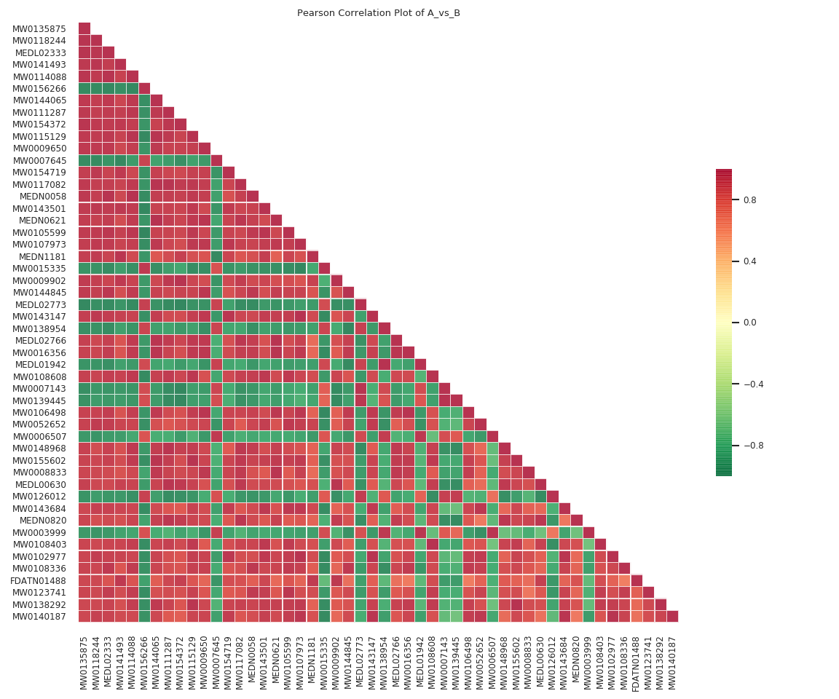
Figure : Heatmap of correlation of different metabolites
Note: The ID of the metabolites are shown on both horizontal and verticle axses. The colors represent the Pearson correlation coefficient (r) with the scale seen on the right (The darker the red, the stronger the positive correlation; the darker the green the stronger the negative correlation). If there are more than 50 differential metabolites, the figure will only show the top 50 metabolites based on VIP.
Original file path (The directory structure in positive and negative ion mode is the same, so only the files in positive ion mode are linked to):
Heatmap of correlation of different metabolites:Final_report/2.Basic_Analysis/Difference_analysis/*_vs_*/ cpdCorr/*_cpdCorr_*.*
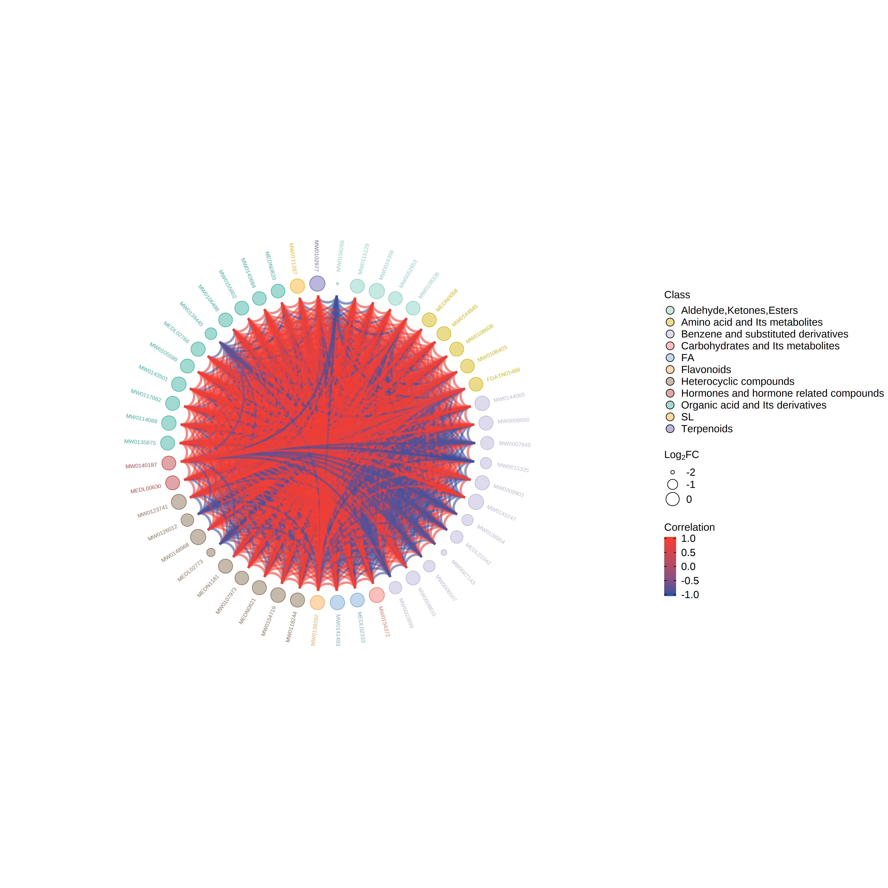
Figure : Chord diagram of differential metabolites
Note: The outermost layer shows the metabolite ID. The larger the point, the larger its corresponding log${}_{2}$FC value. The color for the first and second layer represent Level 1 metabolite classification. The chords in the inner most layer reflect the Pearson correlation between the connected metabolites. Red chords represent positive correlation and the blue chords represent negative correlation. If there are more than 50 differential metabolites, the figure will only show the top 50 metabolites based on VIP.
Chord diagram of differential metabolites:Final_report/2.Basic_Analysis/Difference_analysis/*_vs_*/cpdCorr/ *_cpdCorrCir_*.*
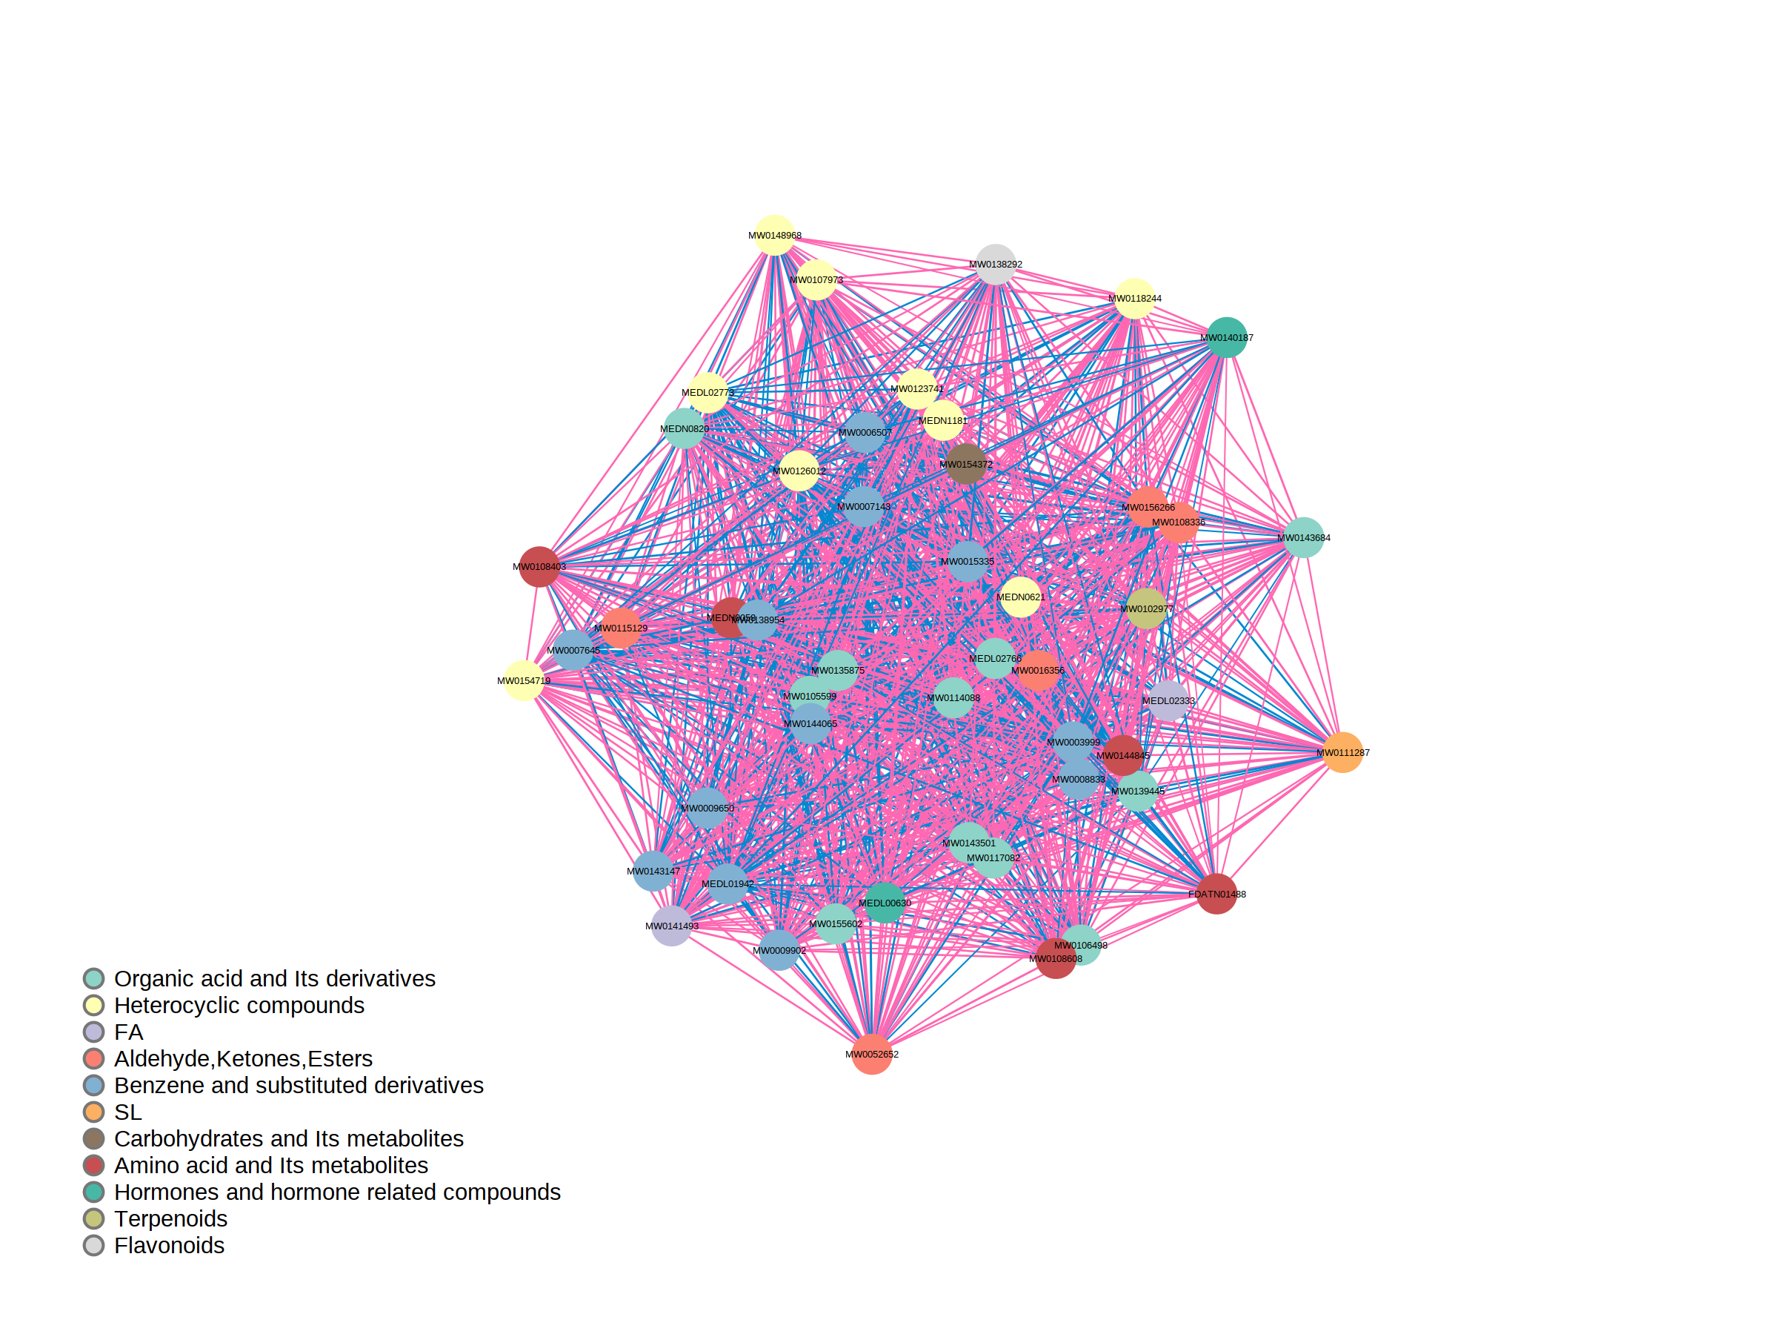
Figure : Correlation network diagram of differential metabolites
Note: The points in the figure represent the various differential metabolites, and the size of the points is related to the Degree of connection. The larger the point, the greater the Degree of connection, i.e. the more points (neighbors) connected to it. Red lines represent positive correlations and blue lines represent negative correlations. Line thickness represent the absolute value of Pearson correlation coefficient. The larger the |r|, the thicker the line. If there are more than 50 differential metabolites, the figure will only show the top 50 metabolites based on VIP.
Correlation network diagram of differential metabolites:Final_report/2.Basic_Analysis/Difference_analysis/ *_vs_*/cpdCorr/*_cpdCorrNet_*.*

Z-value map of differential metabolites
Z-score standardization normalizes the relative content of the differential metabolites by calculating Z-scores. The Z-score plot provides a very visual representation of the distribution of each differential metabolite across groups.
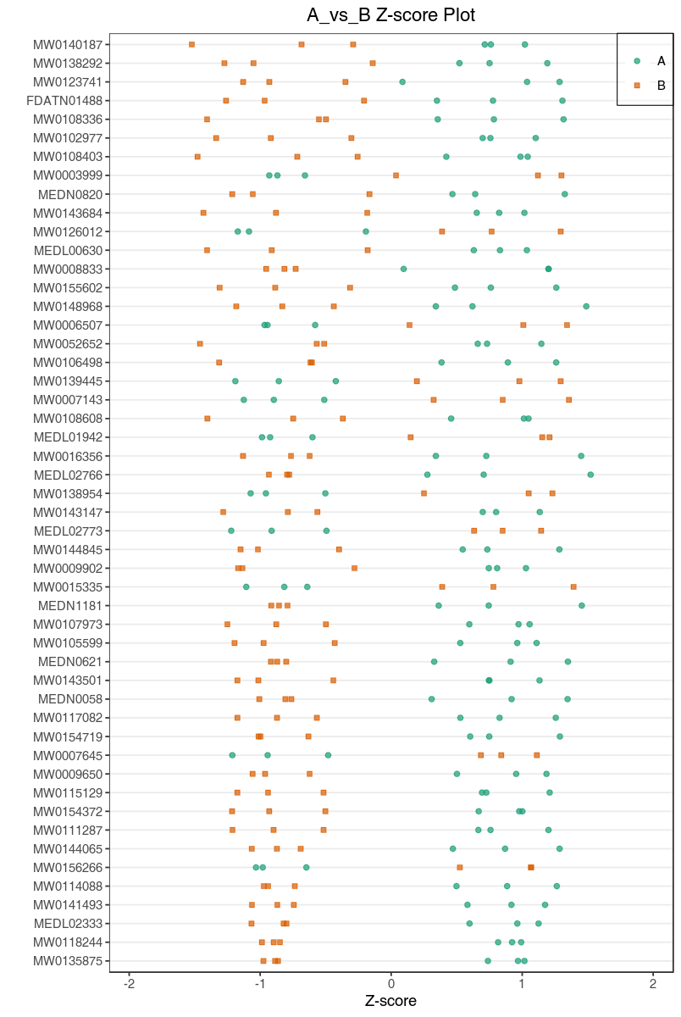
Figure : Z-value map of differential metabolites
Note: The X-axis represents the z-score and the Y-axis represents the differential metabolites. The colored dots in the plot represent samples of different groups. If there are more than 50 differential metabolites, the figure will only show the top 50 metabolites based on VIP.
Z-value diagram of differential metabolites:Final_report/2.Basic_Analysis/Difference_analysis/*_vs_*/ zScore/*_zScore*.*

Violin plot of differential metabolites
A violin plot is a combination of a box plot and a density plot, mainly used to show the data distribution and its probability density. The box shape in the middle indicates the interquartile range, the thin black line extending from it represents the 95% confidence interval, the black horizontal line right in the middle is the median, and the outer shape indicates the density of the data distribution.
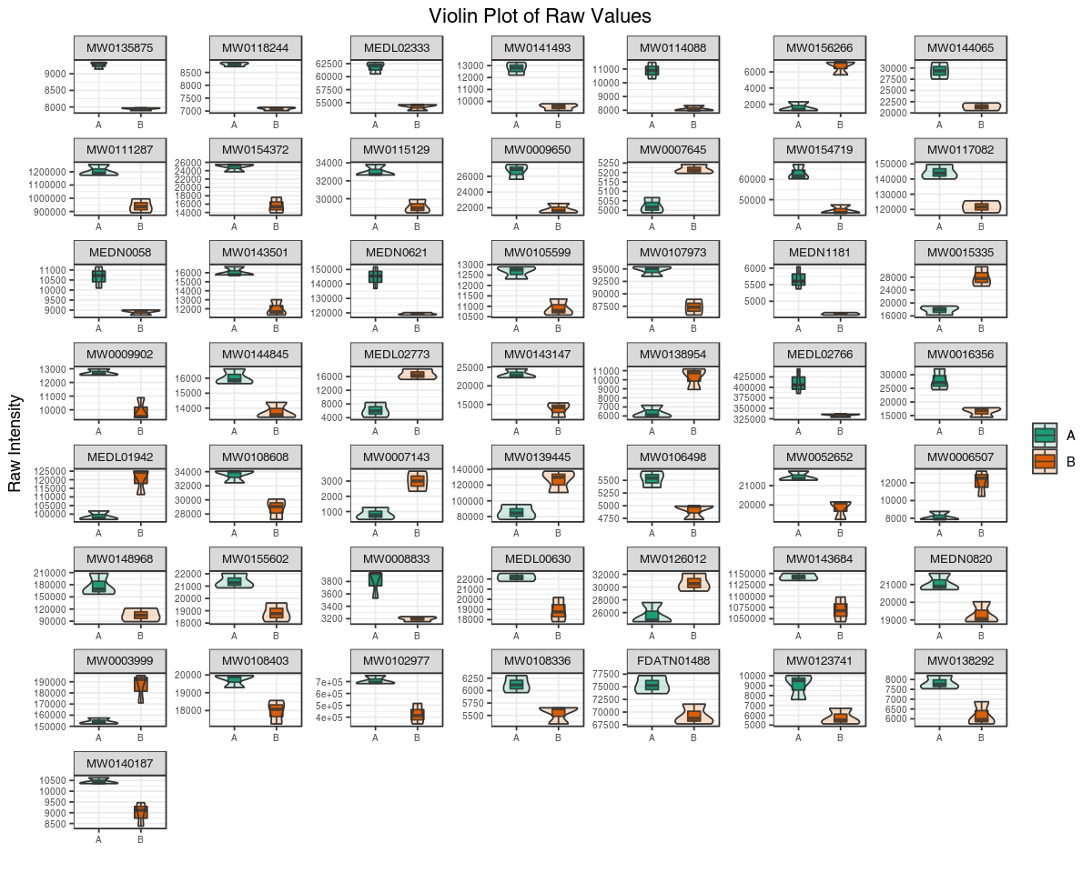
Figure : Violin plot of differential metabolites
Note: The horizontal coordinate is the grouping and the vertical coordinate is the relative content of the differential metabolites (raw peak area). If there are more than 50 differential metabolites, the figure will only show the top 50 metabolites based on VIP.
Violin plot of differential metabolites:Final_report/2.Basic_Analysis/Difference_analysis/*_vs_*/fullViolin/ *_fullViolin*.*
Violin plot of single metabolite:Final_report/2.Basic_Analysis/Difference_analysis/*_vs_*/fullViolin/singleViolin

K-Means analysis
K-means analysis is a method to examine the trend of relative quantification changes of a metabolite in different sample groups. K-means is performed based on the UV standardized relative quantification value.
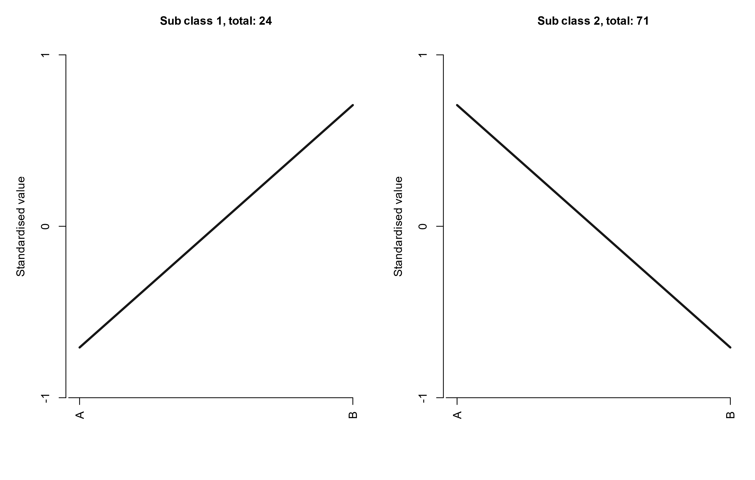
Figure : K-Means diagram of differential metabolites
Note: The X-axis represents the sample names and the Y-axis represents the standardized relative quantification. “Sub class” represents a group of metabolites with the same trend and the number represent the number of metabolites in this cluster.
K-means diagram of differential metabolites:Final_report/2.Basic_Analysis/kmeans/*_kmeans_cluster.*

Functional annotation and enrichment analysis of differential metabolites with KEGG database
KEGG (Kyoto Encyclopedia of Genes and Genomes) is a database that integrates compounds and genes into metabolic pathways. The KEGG database enabled researchers to study genes with their expression information and compounds with its abundances as a complete network.

Functional annotation of differential metabolites
Metabolites are annotated using the KEGG database (Kanehisa et al., 2000), and only metabolic pathways containing differential metabolites are shown. Detailed results are found in the attached results. A portion of the results is shown below:
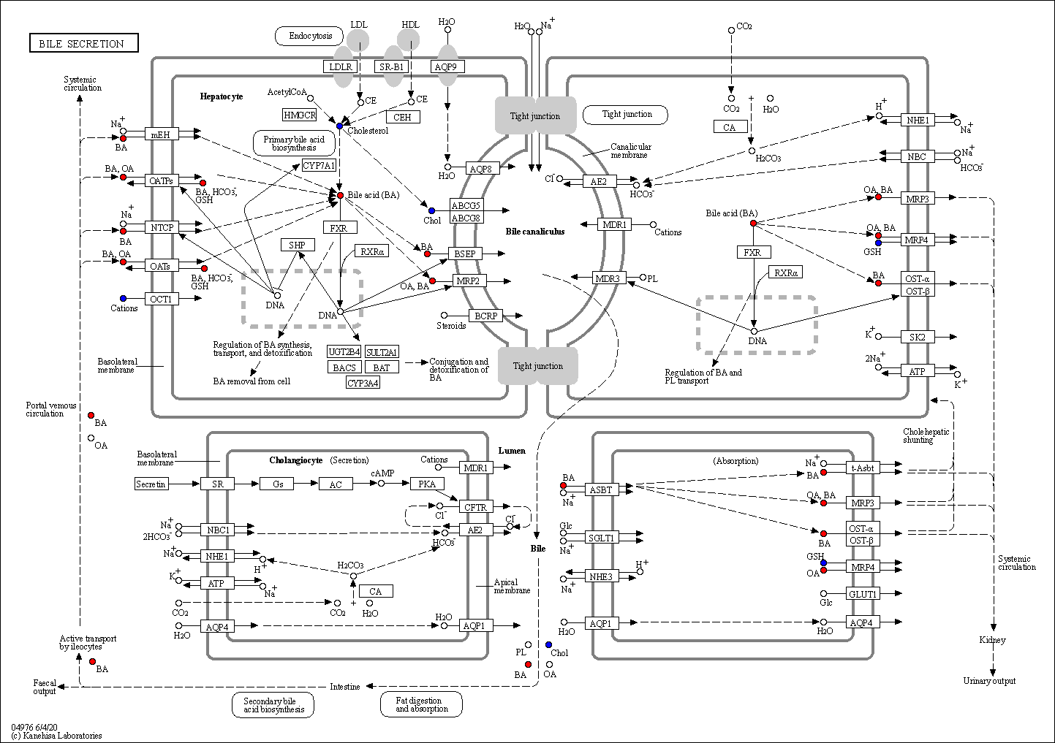
Figure : KEGG pathway of differential metabolites
Note: Red circles indicate that the metabolite content was significantly up-regulated in the experimental group; blue circles indicate that the metabolite content was detected but did not change significantly; green circles indicate that the metabolite content was significantly down-regulated in the experimental group; and orange circles indicate a mixture of both up- and down-regulated metabolites. This allows searching for metabolites that may contribute to the phenotypic differences.
KEGG pathway of differential metabolites:Final_report/2.Basic_Analysis/Difference_analysis/*_vs_*/ enrichment/Graph/ko*****
Statistical analysis of KEGG database annotation of screened metabolites with significant differences. Some of the results are as follows:
Table: KEGG annotations for differential metabolites
Index | Compounds | Type | cpd_ID
MW0009611 | Pyridaben | down | C18614
MEDL01942 | Dibutyl phthalate | down | C14214
MW0111287 | Sphinganine | up | C00836
MW0003999 | 3-Formylsalicylic acid | down | C13277
MW0151759 | Ionomycin | up | -
MW0107415 | Lenticin | up | C09213
MW0122713 | 1-Oxazolo[4,5-b]pyridin-2-yl-9-octadecyn-1-one | up | -
MW0138954 | Methyl cinnamate | down | C06358
MW0146032 | Asp-Arg-Tyr | down | -
MW0156266 | Pyruvate oxime | down | C02193
MW0058450 | 1-(11Z-eicosenoyl)-2-hexadecanoyl-glycero-3-phosphoethanolamine | down | -
MW0127808 | (1R,16Z,24E,26E,28Z)-12-[1-(3,4-dihydroxycyclohexyl)propan-2-yl]-1,18-dihydroxy-19,30-dimethoxy-15,17,21,23,29,35-hexamethyl-11,36-dioxa-4-azatricyclo[30.3.1.0,]hexatriaconta-16,24,26,28-tetraene-2,3,10,14,20-pentone | up | -
MW0016356 | Canrenone | up | -
MW0009902 | Thenylchlor | up | -
MW0008833 | Naphthalene | up | C00829
Table: Enrichment Statistics of KEGG annotations for differential metabolites
ko_ID | Sig_compound | compound | Sig_compound_all | compound_all
ko00600 | 1 | 5 | 20 | 202
ko01100 | 18 | 150 | 20 | 202
ko04071 | 1 | 5 | 20 | 202
ko00980 | 1 | 1 | 20 | 202
ko00051 | 1 | 3 | 20 | 202
ko00520 | 1 | 5 | 20 | 202
ko01250 | 1 | 5 | 20 | 202
ko04625 | 1 | 2 | 20 | 202
ko00230 | 1 | 5 | 20 | 202
ko04976 | 4 | 24 | 20 | 202
ko00130 | 1 | 2 | 20 | 202
ko00350 | 2 | 9 | 20 | 202
ko00360 | 1 | 12 | 20 | 202
ko00400 | 1 | 8 | 20 | 202
ko00730 | 1 | 3 | 20 | 202
KEGG annotations for differential metabolites:Final_report/2.Basic_Analysis/Difference_analysis/*_vs_*/ enrichment/*_filter_anno.xlsx
Enrichment Statistics of KEGG annotations for differential metabolites:Final_report/2.Basic_Analysis/ Difference_analysis/*_vs_*/ enrichment/*_KEGG.xlsx

KEGG classification of differential metabolites
The significant differential metabolites were classified based on pathway annotation. The results are as follows:
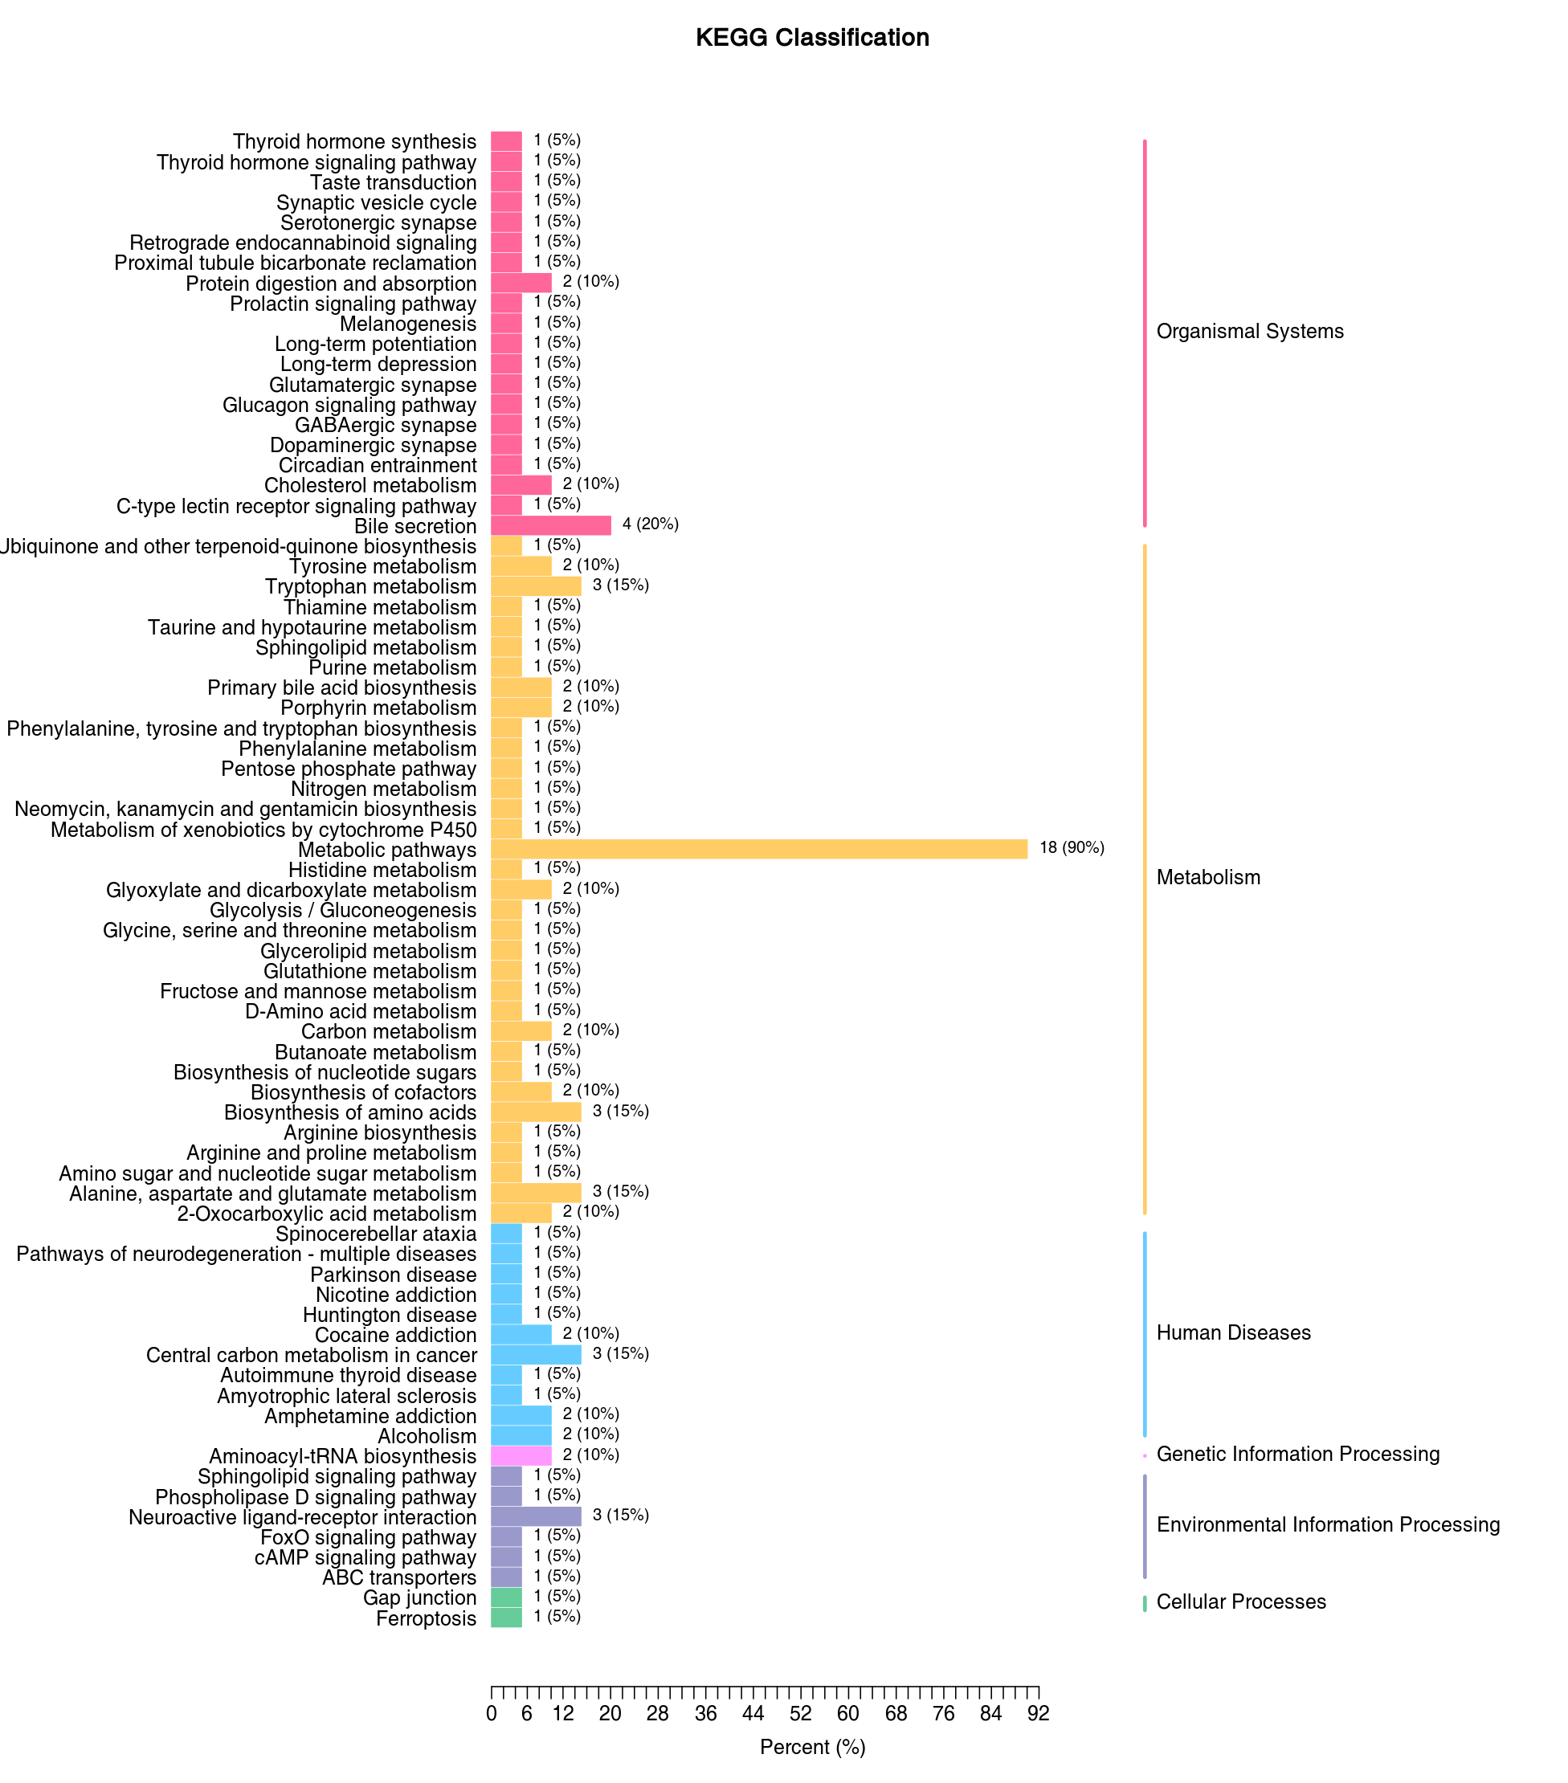
Figure : KEGG classification of differential metabolites
Note: the Y-axis shows the name of the KEGG pathway. The number of metabolites and the proportion of the total metabolites are shown next to the bar plot.
KEGG classification of differential metabolites:Final_report/2.Basic_Analysis/Difference_analysis/*_vs_*/ enrichment/*_KEGG_barplot.*

KEGG enrichment analysis of differential metabolites
KEGG pathway enrichment analysis was conducted based on the annotation results. We calculated the Rich Factor for each pathway, which was the ratio of the number of differential metabolites in the corresponding pathway to the total number of metabolites annotated in the same pathway. The greater the value, the greater the degree of enrichment. P-value is the calculated using hypergeometric test as shown below:
$$P=1−\sum_{i=0}^{m−1}{\frac{\left({M \atop i}\right)\left({N−M \atop n−i}\right)}{\left({N \atop n}\right)}}$$
N represents the total number metabolites with KEGG annotation, n represents the number of differential metabolites in N, M represents the number of metabolites in a KEGG pathway in N, and m represents the number of differential metabolites in a KEGG pathway in M. The closer the p-value to 0, the more significant the enrichment. The size of the dots in the figure represents the number of significantly different metabolites enriched in the corresponding pathway. The top 20 pathways in terms of P-value were selected for presentation from smallest to largest.
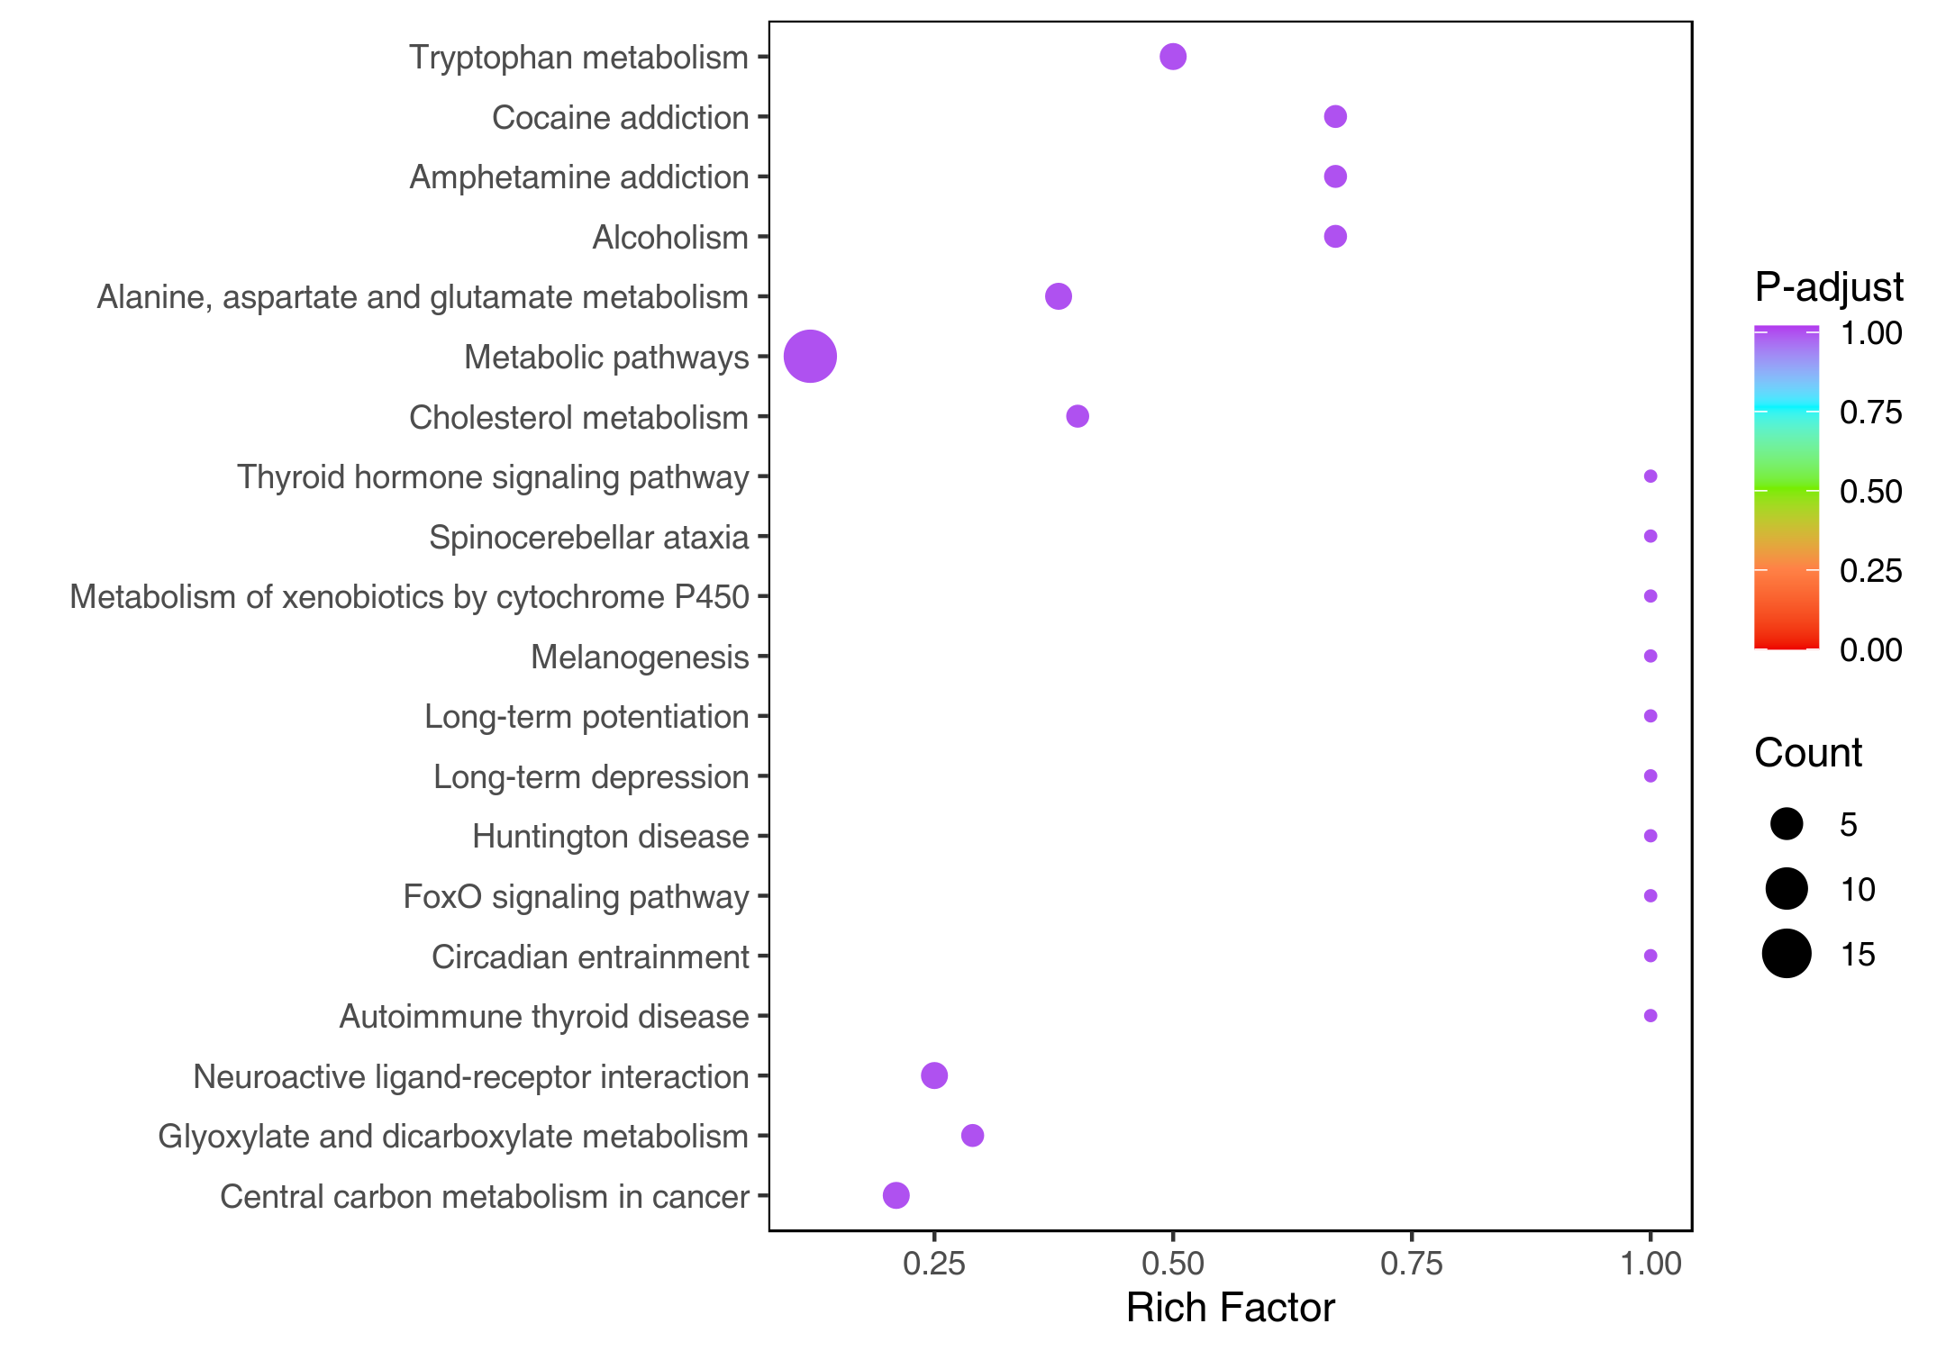
Figure : KEGG enrichment diagram of differential metabolites
Note: The X-axis represents the Rich Factor and the Y-axis represents the pathway. The color of points reflects the p-value. The darker the red, the more significant the enrichment. The size of the dot represents the number of enriched differential metabolites.
KEGG enrichment diagram of differential metabolites:Final_report/2.Basic_Analysis/Difference_analysis/ *_vs_*/enrichment/*_KEGG_Enrichment.*

Regulatory network of differential metabolites
Differential metabolites and their corresponding KEGG pathways were used to generate a regulatory interactions network. This analysis is only done for project with samples sourced from human, mouse or rat species.
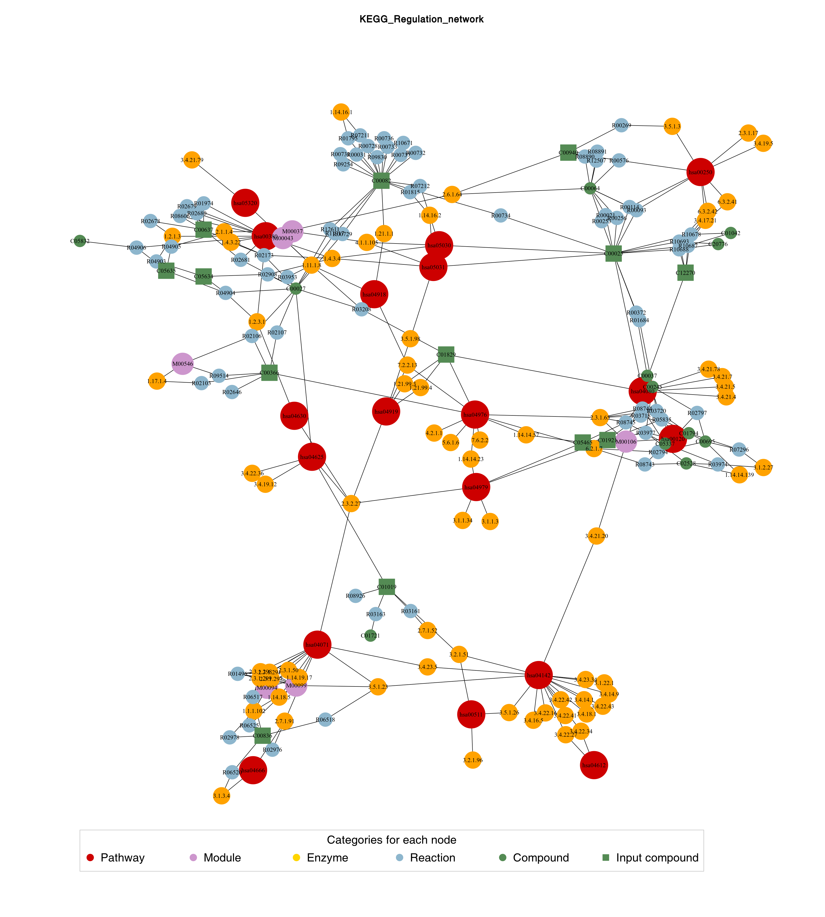
Figure : Diagram of the regulatory network of differential metabolites
Note: Red dots represent a metabolic pathway, yellow dots represent a substance-related regulatory enzyme, green dots represent a background substance for a metabolic pathway, purple dots represent a class of substance molecular modules, blue dots represent a substance chemical interaction reaction, and green squares represent the differential metabolites obtained in this comparison.
Diagram of the regulatory network of differential metabolites:Final_report/2.Basic_Analysis/Difference_analysis/ *_vs_*/enrichment/*_Regulation_network.*

Functional annotation and enrichment analysis with HMDB database

Functional annotation and enrichment analysis of differential metabolites in HMDB database
HMDB is a widely used database that has collected more than 40,000 endogenous metabolites and more than 5000 related protein or gene information. Records in this database links to external databases (such as KEGG, Metlin, Biocyc, etc.) and also contains mass spectra and NMR spectra data. The HMDB sub-database SMPDB also provides a detailed overview of human metabolism, metabolic disease pathways, and metabolite signaling and drug activity pathways.
Pathway enrichment analysis was performed only with the Primary Pathways. The results are as follows:
Table: SMPDB pathway enrichment for differential metabolites
primary_SMPDB_ID | P-value
SMP0000063 | 0.000148125918927988
SMP0000716 | 0.0112709317303563
SMP0000498 | 0.0924281142628515
SMP0000494 | 0.0924281142628515
SMP0000218 | 0.0924281142628515
SMP0000533 | 0.0924281142628515
SMP0000006 | 0.0924281142628515
SMP0000169 | 0.0924281142628515
SMP0000190 | 0.0924281142628515
SMP0000167 | 0.0924281142628515
SMP0000365 | 0.0924281142628515
SMP0000050 | 0.0924281142628515
SMP0000220 | 0.0924281142628515
SMP0000168 | 0.0924281142628515
SMP0000369 | 0.0924281142628515
The differential metabolites from the top 20 HMDB Primary Pathways pathways with P-value were annotated and visualized using the HMDB database. Detailed information about each group can be found in the corresponding data files. Partial results are shown below:

Figure : HMDB pathway map of differential metabolites
Note: Boxes with chemical structural formulas represent metabolites, red indicated that the metabolite content was significantly up-regulated in the experimental group, gray indicated that the metabolite content was detected but did not change significantly, green indicated that the metabolite content was significantly down-regulated in the experimental group, and blue represents metabolites in the pathway that were not detected in this experiment. The causes of phenotypic differences among study subjects were sought through metabolic pathways.
The top 20 HMDB Primary Pathways based on P-value ranking were chosen for Rich Factor plot. The Rich Factor is the ratio of the number of differential metabolites in the corresponding pathways to the total number of metabolites annotated to the same pathway. The higher the value is, the greater the degree of enrichment. The closer P-value is to 0, the more significant the enrichment is. The size of the dots in the figure represents the number of differential metabolites enriched into the corresponding pathway. The results are shown below:
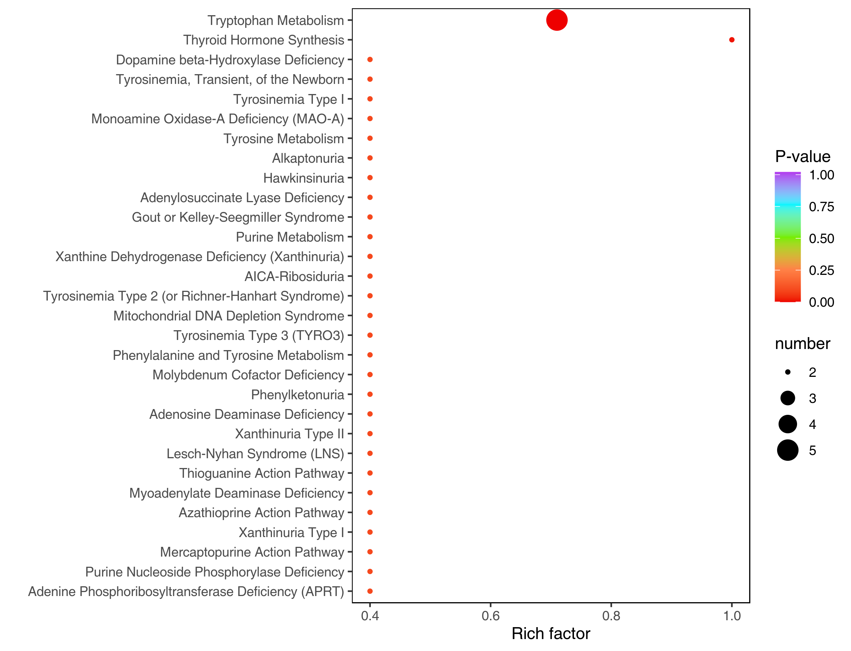
Figure : HMDB enrichment diagram of differential metabolites
Note: The X-axis represents the Rich Factor and the Y-axis represents the pathway. The color of points reflects the P-value. The darker the red, the more significant the enrichment. The size of the dot represents the number of enriched differential metabolites.
SMPDB pathway enrichment for differential metabolites:Final_report/2.Basic_Analysis/ Difference_analysis/*_vs_*/enrichment/*_SMPDB_primary.xlsx
HMDB pathway map of differential metabolites:Final_report/2.Basic_Analysis/Difference_analysis/*_vs_*/ enrichment/SMP_primary_pathway
HMDB enrichment diagram of differential metabolites:Final_report/2.Basic_Analysis/Difference_analysis/ *_vs_*/enrichment/*SMPDB_primary_Enrichment.*

MSEA enrichment analysis
Conventional enrichment analysis based on hypergeometric distribution relies on up- or down-regulated metabolites and tends to miss metabolites that are not significantly different but are biologically important. Metabolite set enrichment analysis (MSEA) does not require specifying a clear threshold for differential metabolites. The idea is to establish a series of metabolite sets, each representing a certain biological function, and identify metabolite sets that are significantly different.
Metabolite database from MetaboAnalyst (https://www.metaboanalyst.ca/) includes: (1) human metabolic pathways based on those found in the KEGG database: 84 KEGG pathway metabolic sets (kegg_pathway). (2) biologically significant disease-related metabolic sets for specific biological fluids: 339 blood metabolic sets, 384 urine metabolic sets, and 150 cerebrospinal fluid metabolic sets (csf). The results of the analysis were as follows:
Table: Table for MSEA enrichment analysis
name | P-value | foldEnrichment
Malnutrition | 0.008758 | 3.15790
Hypothyroidism, Congenital | 0.011322 | 4.15705
Cancer (Assorted) | 0.015514 | 4.01855
Hyperornithinemia With Gyrate Atrophy (Hoga) | 0.018257 | 3.83940
Alpha-1-Antitrypsin Deficiency (Aatd) | 0.019693 | 3.89950
Wilson Disease | 0.020746 | 3.85445
Hawkinsinuria | 0.021332 | 3.85665
Tyrosinemia Ii | Tyrosinemia Iii | Tyrosinemia, Transient, Of The Newborn | 0.021332 | 3.85665
Dimethylglycinuria | 0.027665 | 3.70605
Metabolites Affected By Diurnal Variation | 0.032146 | 3.61080
Glycogenosis, Type Vii. Tarui Disease | 0.037808 | 3.44530
Adenylosuccinase Deficiency | 0.039711 | 3.46570
Familial Lipoprotein Lipase Deficiency | 0.039711 | 3.46570
Gout | Phosphoribosylpyrophosphate Synthetase Superactivity | 0.039711 | 3.46570
Molybdenium Co-Factor Deficiency | 0.039711 | 3.46570
The top 50 metabolic sets based on P-value ranking are shown below:
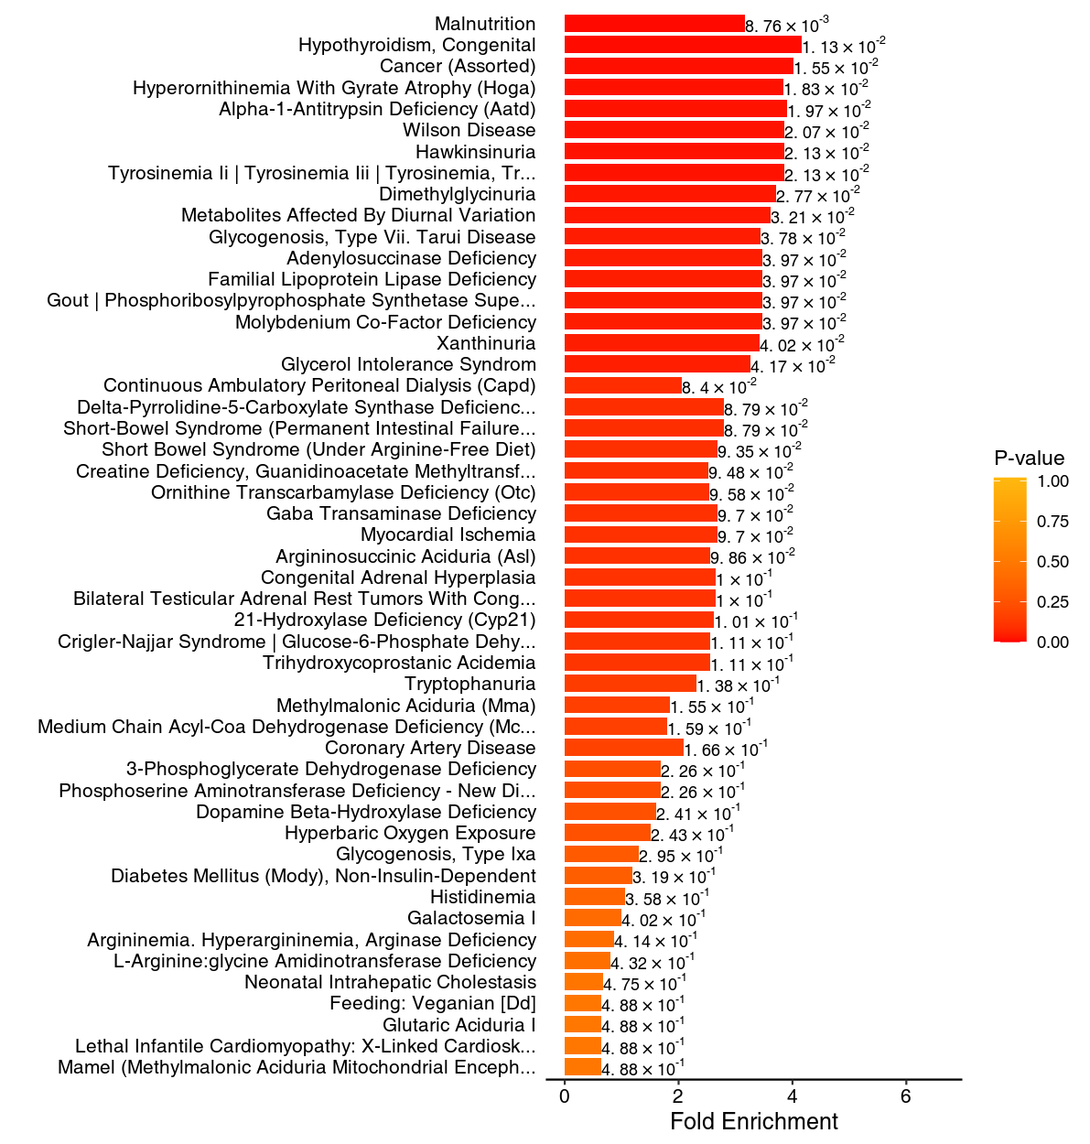
Figure : MSEA enrichment analysis graph
Note: The vertical coordinate indicates the name of the metabolic set (sorted by P-value), corresponding to the P-value of the labeled metabolic set; the horizontal coordinate indicates Fold Enrichment, the degree of enrichment; the color indicates P-value, the closer the P-value is to 0, the redder the color is, the more significant the enrichment is.
Table for MSEA enrichment analysis:Final_report/2.Basic_Analysis/Difference_analysis/*_vs_*/enrichment/ *_msea.xlsx
MSEA enrichment analysis graph:[Final\_report/2.Basic\_Analysis/Difference\_analysis/\*\_vs\_\*/enrichment/ *_msea.*](../2.Basic_Analysis/Difference_analysis/A_vs_B/enrichment)

Diseases association with differential metabolites
We annotated disease information according to the HMDB database for differential metabolites. Some of the results are shown below:
Table: Table of association between differential metabolites and diseases
CompoundName | KeggDiseases
Pyridaben | -
Dibutyl phthalate | -
Sphinganine | -
3-Formylsalicylic acid | -
Ionomycin | -
Lenticin | -
1-Oxazolo[4,5-b]pyridin-2-yl-9-octadecyn-1-one | -
Methyl cinnamate | -
Asp-Arg-Tyr | -
Pyruvate oxime | -
1-(11Z-eicosenoyl)-2-hexadecanoyl-glycero-3-phosphoethanolamine | -
(1R,16Z,24E,26E,28Z)-12-[1-(3,4-dihydroxycyclohexyl)propan-2-yl]-1,18-dihydroxy-19,30-dimethoxy-15,17,21,23,29,35-hexamethyl-11,36-dioxa-4-azatricyclo[30.3.1.0,]hexatriaconta-16,24,26,28-tetraene-2,3,10,14,20-pentone | -
Canrenone | -
Thenylchlor | -
Naphthalene | -
Table of association between differential metabolites and diseases:Final_report/2.Basic_Analysis/Difference_ analysis/*_vs_*/enrichment/*_sigDiseasesTable.xlsx

References
- L. Eriksson, E.J., N. Kettaneh-Wold, J.Trygg, C. Wikström, and S. Wold, Multi- and Megavariate Data Analysis Part I Basic Principles and Applications, Second edition Umetrics Academy:Sweden, 2006.
- Chen, Y., et al., RRLC-MS/MS-based metabonomics combined with in-depth analysis of metabolic correlation network: finding potential biomarkers for breast cancer. Analyst, 2009.134(10): p. 2003-11.
- Thévenot E A, Roux A, Xu Y, et al. Analysis of the Human Adult Urinary Metabolome Variations with Age, Body Mass Index, and Gender by Implementing a Comprehensive Workflow for Univariate and OPLS Statistical Analyses.[J]. Journal of Proteome Research, 2015, 14(8):3322-35.
- Kanehisa, M. and S. Goto, KEGG: kyoto encyclopedia of genes and genomes. Nucleic Acids Res, 2000. 28(1): p. 27-30.
- Viant M R, Kurland I J, Jones M R, et al. How close are we to complete annotation of metabolomes?[J]. Current opinion in chemical biology, 2017, 36: 64-69.
- Liang L, Rasmussen M L H, Piening B, et al. Metabolic dynamics and prediction of gestational age and time to delivery in pregnant women[J]. Cell, 2020, 181(7): 1680-1692. e15.

Appendix

List of software and versions
Table: Software used
Analysis | Software | Version
PCA | R (base package) | 4.1.2
Pearson Correlation | R (base package) | 4.1.2
Heatmap | R (ComplexHeatmap) | 2.9.4
OPLS-DA | R (MetaboAnalystR) | 1.0.1
Radar map | R (fmsb) | 0.7.1
Chord diagram | R (igraph; ggraph) | 1.2.11; 2.0.5
Correlation network diagram | R (igraph) | 1.2.11
Modulation network diagram | R (FELLA) | 1.2.0
In all the analyses of this project, two main approaches were taken to pre-process the data, which were calculated as follows:
（1）Unit variance scaling (UV)
Unit variance scaling (UV), also known as Z-score normalization / auto scaling, is a method of normalizing data based on the mean and standard deviation of the original data. The processed data conforms to a standard normal distribution with a mean of 0 and a standard deviation of 1.
Calculation method：
Original data centering divided by the standard deviation of the variable.
The formula is as follows：
$$x^{′}=\frac{x−μ}{σ}$$
µ is the mean value and σ is the standard deviation.
（2）Zero-centered (Ctr)
Calculation method:
Original data minus the mean value of the variable.
The formula is as follows：
$$x^{′}=x−μ$$

