For Lab items one and two, I already have a GitHub account, so I skipped them.

For item three, reading was all that was asked.

For item four one could refer someone to a more experienced individual if one doesn’t know for sure. One could also make sure to follow up with the person to make sure that they are satisfied and if not, help them further.

Items five and six were done in my virtual machine.

Items seven through nine are shown below in screenshots:

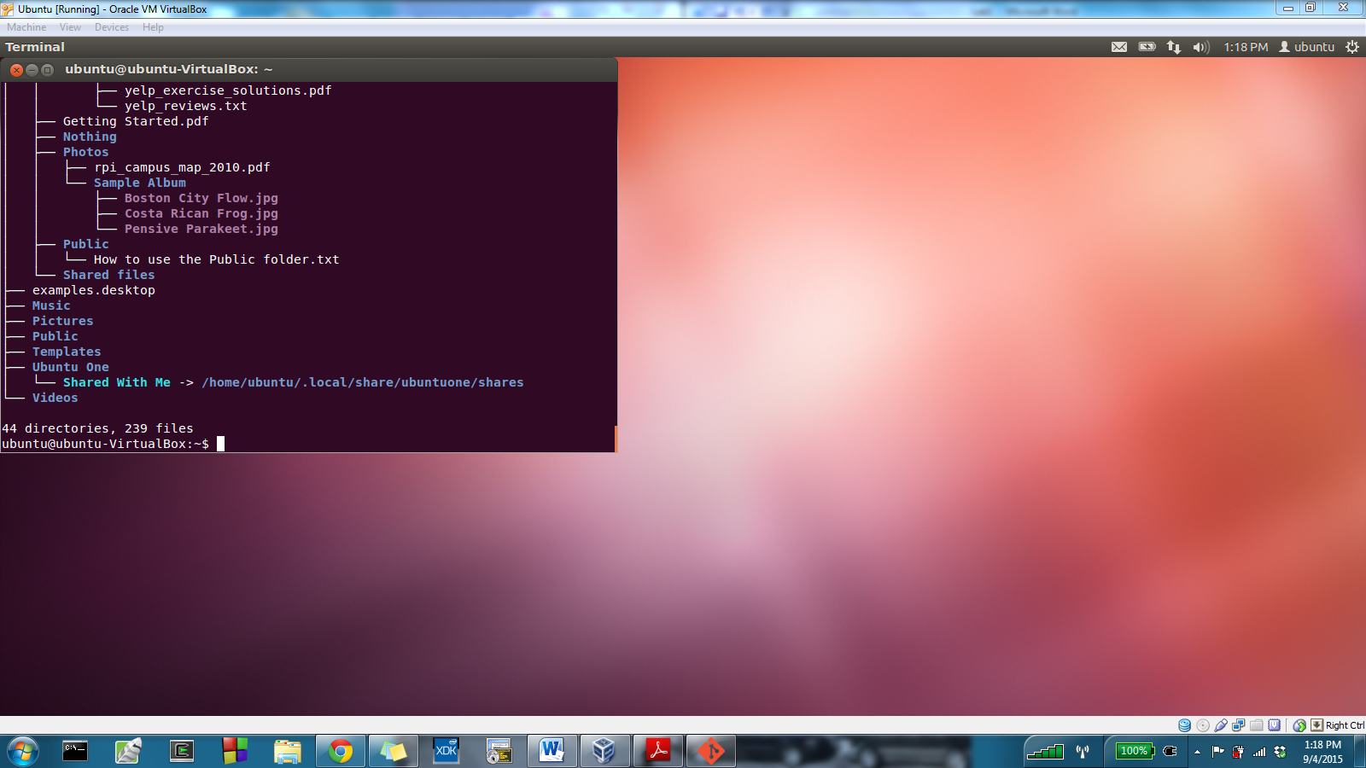

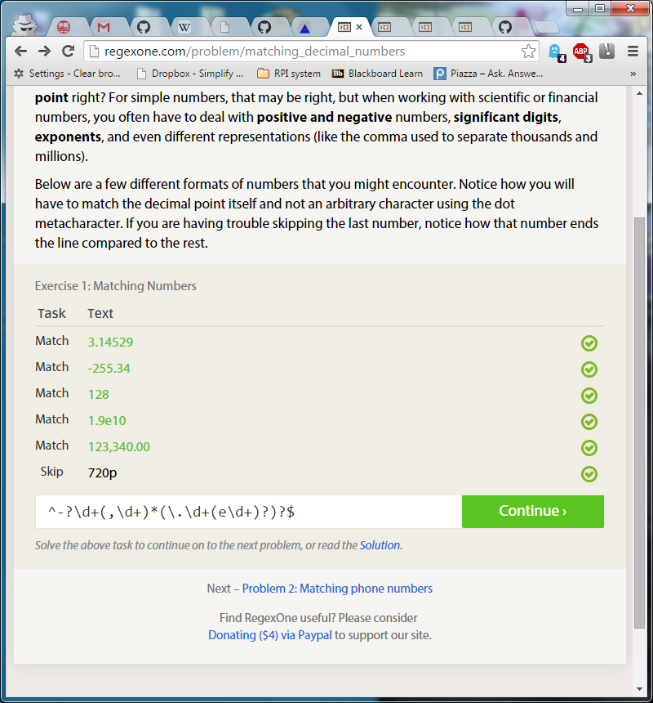

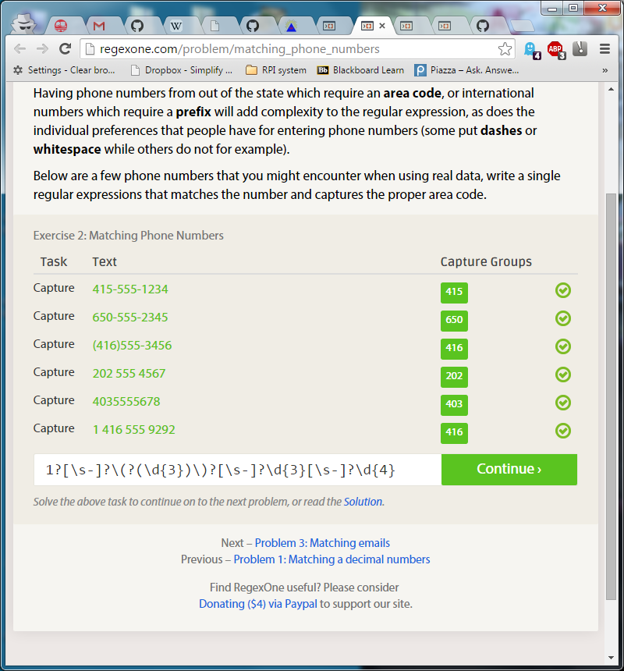

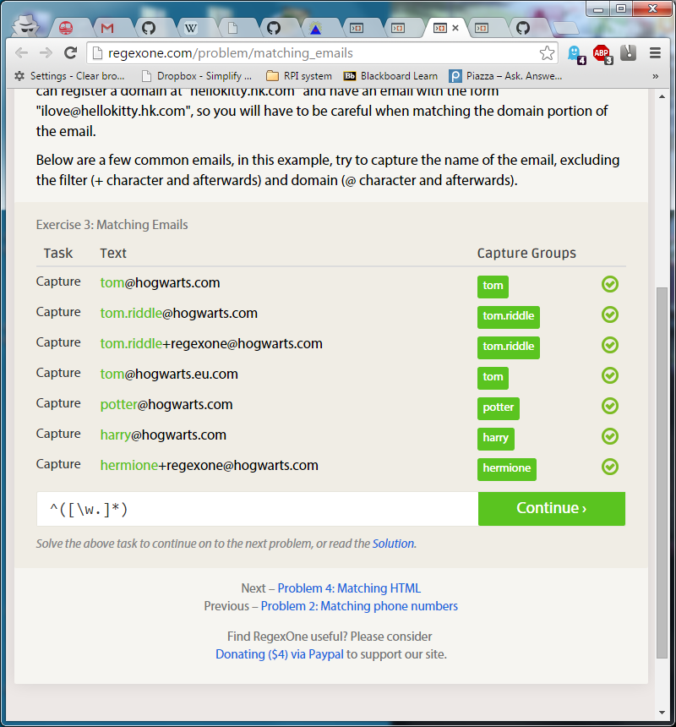

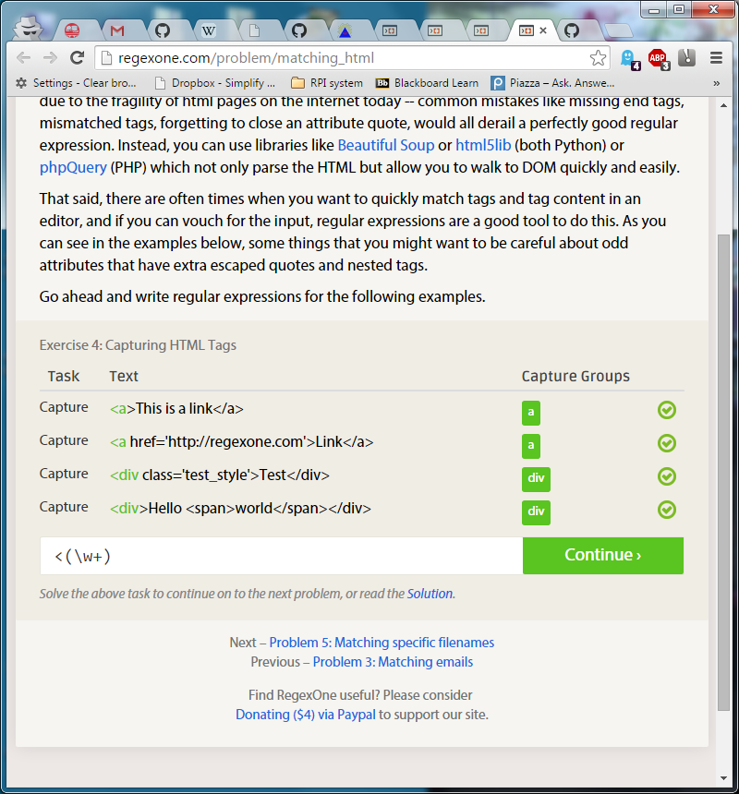

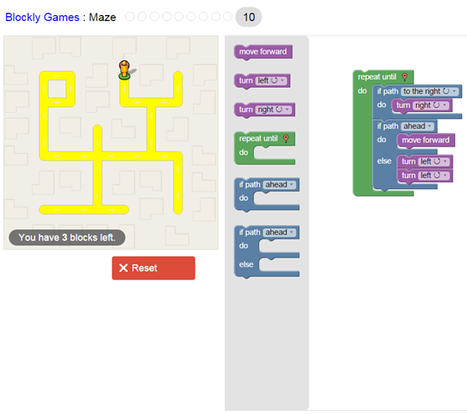

Item ten:

I am finding a problem or project that interests me by thinking about my other real life interests. For instance, I am in charge of the Table Tennis Club at RPI and we do not have a good website. That is a problem, so a good project to solve that problem would be to create a better website for the club. Next, I would think about what requirements and needs will end up creating specifications for the project. In the end, I would establish version control on GitHub for the website and work on making a schedule to work off of.