ASTRO

The Program For
Astrological Analysis

WINDOWS PROFESSIONAL
VERSION
Windows 95, 98, NT 4.0, ME,
2000 & XP

For Windows Computers Running Intel Processors

User Manual

Effective Date: July 1, 2006

© Copyright 1985, 1988-1994, 1999, 2006 By Christopher J. Noyes

BLANK PAGE

TABLE OF CONTENTS:

License For Use 4
Warranty 4
Support 4
New To Astrology? 5
Introduction to ASTRO 6
System Requirements to Run ASTRO For Windows 8
Notation Used in This Manual 9
Installing ASTRO For Windows 10
Starting Up ASTRO For Windows 11
Command Line Options 12
Quick Reference Guide 16
The File List Viewer 19
Viewing Graphic Files 21
Viewing Text Reports 25
Files Menu 27
Edit Menu 33
Entering Data 34
Compiling Charts 41
Folders 47
ASTRO Utilities 50
Managing Windows 52
Using Options 53
Appendix & Advanced
Reference Guides 64
Import file Format 65
TBT Text Builder Toolkit 70
Modifying the Text Source 78
Custom Reports 78
Handling Errors 87
Glossary of Astrological Terms 88
Glossary of Computer Terms 91
Cover Page Glyphs 92
Bibliography 94
Index 95

New Features in This Version
A number of new features and major changes have been introduced in this version of ASTRO For Windows including the following:

- All of the databases have been switched to tables in an Microsoft Access database, though owning Microsoft Access is not required.
- Transit Info has it’s own database table and those records are tied to the birth info record. There can be multiple transit info records for each birth
- Rectification information has its own table also linked to the birth info record.
- Relocation information also has it’s own table and is linked to the birth info, there can be multiple relocation entries for each person.
- Utility Importtool imports existing Astro for Windows Databases.
- Quick Daily transit information takes its data from the database, the entries used are configured in the options screen.
- No need for reindex or make popups.
- New births are automatically added and updated.
- Reports and texts are also stored in Access database tables.
- You can use one database for locations and one for text allowing the use of multiple texts and languages.
- Support for Solar Directed Charts using Degree for Year, Day for Year and Naibod methods
- New House systems: Tropocentric, Median House, Porphryx Houses
- Support for Harmonic Charts
- Support for Text in Fixed Stars and Arabic Parts.
- New Higher resolution planetary routines.
- Declination can now be displayed and calculated.
- In polar latitudes there are now options to keep the natural house or swap the house to keep the MC in the upper half of the carthwheel.
- Support for the major asteroids and transneptunians
- A New Grid report format, showing only the numberic data in a grid type format is calculated.
- A New Files Window is now used for the Grid Reports.
- Reports can now be done using an interpreted style or a numeric style report.
- There are separate report formats for Grid, internpreted and non-interpreted styles
- New Grid Viewer displays data in tabular format.
- HTML conversion and Grid Viewer make use of new codes to support generation of HTML table codes
- HTML export uses Word Processor Conversion Settings.
- Export to JPG and PNG graphic files.
- Charts can be organized by file folder, which can be assigned as a default, for viewing etc., and when reports are created they can be sent to various folders that are available, and facilities to create, rename and select working folder.
- Better midpoint aspects, and midpoints are available in a number of grid charts.
- Chart and Graphics Viewer programs which can be redistributed to your customers along with Astro’s chart files, which allow them to view on their computer the reports and graphics.
- Comment File now supports font styling (bold, italic , heading) , a tab editor and spell Checker.
- Cover Page File File now supports font styling (bold, italic , heading) , a tab editor and spell Checker and has a selector for graphic files.
- Chart Viewer Paragraph Editor File now supports font styling (bold, italic , heading) , a tab editor and spell Checker.
- Paste Information from the ACS Atlas Programs
- Lookup Longitude and Latitude based on a zip code
- Backup and Compress databases
- Reference Maps
- Support for the new Scroll Wheel mousse
- Select All Charts in Chart Windows
- Easier Configuaration for Daily Transit feature
- New Toolbar and File Open Dialog
- New Chart Wizard
New Text Builder Toolkit Program that is entirely Rewritten, which includes the following features:
- Imports Existing TBT .AST files into new database allowing modified texts to be merged into database.
- Can work with multiple Databases.
- Build for 32 Bit Windows From Scratch
- No memory limitations.
- No Need to compile text or charts, or convert.
- Text editors support font styling (bold, italic , heading) and a spell Checker.
- Help and Report Editors support a tab editor that works with mouse clicks.
- Special Array Type editor makes it easier to edit the array texts used with Astro.
- Changes are immediately saved to the database, so no data is lost if TBT crashes, but TBT will be much less likely to crash.
- Allows text to be entered for fixed stars and Arabic parts, midpoints, compatibility aspects, solar directed and harmonic charts.
- Edit all reporting formats.
LICENSE FOR USE
You have the right to use this package on any one computer at a given time. You may copy this package for installation, archival or for backup purposes only. This is copyrighted software, you may not give copies of it to anyone without my written permission. You may, though, provide other people with copies of the shareware trial package, that you probably used before you bought this software.
This does not give you the right to market charts produced with this program without my permission. If you use these charts as a part of a professional Astrology consulting service, there are no restrictions in charging for services.
Thanks

Christopher J. Noyes

WARRANTY
If I cannot to resolve any problems you have with ASTRO I will refund your money. You must return this manual and all disks and this manual that I shipped you when you registered.
While I have made every attempt to assure that ASTRO works properly, I am not responsible for any damage, loss of profit, or other losses caused by ASTRO.

SUPPORT
For technical support on ASTRO:
- Visit the Christopher J. Noyes Software Web Site at www.cjnoyessw.com
- Contact me on America On-Line using the ID CJNoyesSW.
- Contact me on the Internet using the E-Mail address support@cjnoyessw.com.
- Call me at (212) 662-4596. If I am not available, please leave a message, I will call you back as soon as I can.
- Contact me by Mail at the address below.
Christopher J. Noyes Software
244 West 103rd St., Apt 10
New York, NY 10025.

NEW TO ASTROLOGY?
To get the most out of this program you will need some understanding of astrology. ASTRO does provide some help in this area via the Astrology Help found in the Help menu, and the "Astrological Glossary" in the back of this manual. You will be more able to make use of this program if you do some background reading. I suggest the following reading material:

Instant Astrology. By Mort Gale. Published by Warner Books, New York, 1980.
Compendium of Astrology. By Rose Lineman and Jan Popelka. Published by Para Research, West Chester PA, 1984.
Parker's Astrology: The Essential Guide To Using Astrology in Your Daily Life. By Derek and Julia Parker. Published by Dorling Kindersley. First American Edition 1991.
The New A To Z Horoscope Maker and Delineator. By Llewellyn George. Revised and Expanded, Revised and Edited by Marylee Bytheriver. Published by Llewellyn Publications, St. Paul, Minnesota, Current version Copyright 1981.
These Are a few more books that may be good for users with any degree of experience with astrology or with ASTRO.
The Houses: Power Places of the Horoscope. Edited by Joan McEvers. Published by Llewellyn Publications, St. Paul, Minnesota, Copyright 1989.
Planets in Combination. By Lynne Burmyn. Published by ACS Publications, San Diego CA, Copyright 1985.
Progressions Directions and Rectification, or the Great Guessing Game...What Time Where You Born? By Zipporah Pottenger Dobyns. Published by T.I.A. Publications, Copyright 1975.
The Rising Sign--Your Astrological Mask. By Jeanne Avery. A Dolphin Book, Published by Doubleday, New York, Copyright 1982.
Astrological Assistance. By Saul P. Larner. Published By Prentice Hall, Englewood Cliffs, NJ, Copyright 1972.
The International Atlas, Second Edtion, World latitude, Longitudes and Time Changes. Compiled and Programmed by Thomas G. Shanks. Published by ACS Publications, San Diego, CA, Copyright 1985, 1988.
The American Atlas, Revised, US Latitudes and Longitudes. Time Changes and Time Zones. Compiled and Programmed by Thomas G. Shanks. Published by ACS Publications, San Diego, CA, Copyright 1978, 1987

INTRODUCTION TO ASTRO:

Background.
ASTRO was conceived of in 1985, when I was programming on a Commodore 128 computer. I started working on ASTRO out of curiosity mostly, and soon got deeply involved. I soon ported it over to the IBM PC when I discovered I couldn't get ASTRO to do what I wanted on the Commodore. The Commodore 128 had limited capabilities and limited tools available to develop programs.
The original Version of ASTRO that appeared on the IBM PC in early 1987 was good at some things, particularly its simplicity, speed, and ease of use. It did have some problems though. It particularly had problems for advanced astrologers and those people who were very new to computers. The original program also had problems, primarily in lack of accuracy and problems due to not following common astrological standards. It was good though for people who were really only casually interested in astrology.
I got so many reactions from more advanced astrologers that I decided to rebuild ASTRO from scratch and resolve most of their problems. This version of ASTRO is for all intensive purposes a brand new program. The only things that I kept were the text that ASTRO generated, the Astrology Help text, and some modes used.
This release is the Fifth major release of ASTRO. It breaks major ground and makes many improvements over earlier versions. I have introduced many new features and ironed out many other fine spots.

Why Use ASTRO?
ASTRO, The Program for Astrological Analysis, or ASTRO for short, is a powerful computer program. Where many astrological computer programs produce accurate results, they mostly produce just the numbers and the facts. They tell you very little about yourself or others. To find the information, you have to do much research into the 'delineation' or interpretation of the numbers and the signs.
ASTRO is different. I designed ASTRO to produce a textual type of output, consisting of the numbers, text interpreting the results into significant terms. ASTRO also provides a graphics cartwheel printout as well that helps in understanding the individual's
chart.
ASTRO is excellent for the new astrologer who really doesn't understand all the details in interpretation, and is seeking to learn more: more about others, more about themselves. ASTRO provides an excellent learning aid in the Astrology Help. I am not suggesting though that ASTRO can totally replace an excellent astrologer's delineation of a highly accurate chart. It can, though, provide an excellent starting point.
ASTRO is also excellent for the experienced astrologer. It can provide charts that rival those provided by hand or other computer systems.

Special Professional Version
This is a special professional version offering more features and capabilities than either the Deluxe
or Lite version, which are also still available. This program is compatible with charts created by either of the older programs.

Basic Capabilities.
ASTRO has an easy-to-use intuitive user interface. It is easy to use, and is much more powerful.
ASTRO has several built in databases. One for people's birth dates, times and places. The other is a database of locations, giving all the necessary data for approximately 1000 U.S. and Canadian cities and approximately 200 foreign cities.
The Professional version of ASTRO uses highly accurate routines to generate the planet positions, house cusps, and aspects. Planetary positions are accurate to within 1 minute of arc.
ASTRO Professional can generate the following chart types:
■ Natal charts.
■ Compatibility charts.
■ Transits charts.
■ Progression charts.
■ Solar and lunar return charts.
■ Relocation charts.
- Composite charts.
- Solar Directed Charts
- Harmonic Charts.
■ Fixed star charts.
■ Arabic points charts.
■ Transits of composite charts.
■ Astrological personality problem.
ASTRO supports all the major house cusp systems including:
■ Equal house.
■ Placidus.
■ Koch.
■ Companus.
■ Regiomontanus.
■ M-house.
- Morinus.
- Tropocentric Houses
- Meridian Houses
- Porphryx Houses
ASTRO also provides the following:
■ Decans.
■ Midheaven.
■ Moon's nodes.
■ Part of fortune.
■ Vertex.
■ East-point.
■ Midpoints.
■ Aspects to midpoints.
ASTRO also provides other important calculations and determinations. ASTRO also provides birth rectification, by which you can figure out basic houses, even if you don't know a person's exact time of birth.
Graphic cartwheels can also be copied to the clipboard and printed out to graphic files using the following formats. Several different orientations are provided.
■ BMP Windows 3.1 b&w & color bitmap files.
■ EPS color files.
■ GIF color files.
■ PCX B&W & color files
■ TIFF color & B&W Files.
- Microsoft WindowsTM WMF (metafile) b&w & color files
- Jpeg (JPG) color files.
- Portable Network Graphics (PNG) color files
With ASTRO Professional you can convert your reports to word processing files that you can import into your favorite word processor. File formats supported include:
■ Plain ASCII text file.
■ "Smart" or formatted ASCII.
■ WordStarTM 3.x.
■ WordStarTM 4.x.
■ WordPerfectTM 4.x.
■ WordPerfectTM 5.x.
■ XYWriteTM
■ Microsoft WordTM RTF.
- Lotus AMI ProTM.
- WWW Html files.
When Html files are created, tabbed sections are converted into tables.
You can also write comma delimited database files as well.
Many word processors are compatible with at least one of these file formats. Word processing formats retain all formatting information.
When Html
ASTRO creates reports that use bold and underscore capabilities of your printer, and screen, along with a numeric only report format, in case you only want the numbers.
The names of the files generated to the disk are kept in a file list stored on disk and in memory. You can select from many different charts that you may have calculated and kept on disk. You can mark these charts with comments when compiling, that can aid you in figuring out which chart to look at, print, convert, or view as a graphics-cartwheel.

SYSTEM REQUIREMENTS TO RUN ASTRO FOR WINDOWS:
Though ASTRO is a flexible system and can be run on many different type of system setups, it does have some requirements for hardware.

Computer and Windows.
ASTRO for Windows requires a computer with at least an Intel Pentium, computer with 64 megabytes of memory, Windows 95, 98, ME, NT4.0,2000 or XP.

Video.
ASTRO for Windows requires at least a VGA graphics adapters. ASTRO for Windows supports all graphics adapters which support Windows and provide at least 480 x 640 pixel 16 colors, 600x800 using 256 colors or better is recommended.
Printer.
ASTRO directly supports all printers that Microsoft Windows supports. graphics printing requires a printer with graphics capability supported buy Windows. Most 9-pin, 24-pin, ink-jet and laser printers are compatible with Windows. Either use a driver supplied with your printer or use one that is compatible supplied with Windows.

CONVENTIONS USED IN THIS MANUAL:
This section describes the conventions that are used in this manual.

ALL CAPS System command, or command line to type at the DOS command line.
A: Disk drive letter, or other device.
A:\<Directory Name>\<File> Path name.
.. Previous directory
. Current directory
\<Directory Name>\<File> Path name, beginning at root directory, or start of current disk drive.
FILENAME.EXT A file name can consist of up to eight letters, a '.' and a three letter extension.
'Key Name' A key on the keyboard to press.
{ALT} Hold down the ALT key on your keyboard.
{CNTL} Hold down the CNTL or Control key on your keyboard.
{SHIFT} Hold down the Shift key on your keyboard.
{Fn} A function key for example {F1} means press the F1 key at the top or left of your keyboard.
{ALT}+'A' Hold down the ALT key, and press the 'A' key on your keyboard.

INSTALLING ASTRO FOR WINDOWS:
Most people will probably can run the installation program and go. If you wish to, you can easily change the setup using the setup function found under the option menu.

UPGRADING

Upgrading from an Earlier Version of ASTRO.

The Text and databases are completely different from earlier versions of ASTRO for Windows. If you wish to use existing text sources that you have modified, you should use the new Text Builder Toolkit and import those sources into the database. If you have made changes to the birth and location databases, use the importtool utility program to import those databases in to the new database.

There is a special program called Import Tool that imports from Astrow’s Old system into the new system. If you want to import your charts into the new system, you need to manually copy the chart files (.OUT and .GRA) from your old Astro For Windows directory (usually C:\astrow) to your new directory (usually My Documents\Astro For Windows). You also need to completely re-configure the program because it cannot use the older program’s configuruation

STARTING UP ASTRO FOR WINDOWS:
You are ready to start using ASTRO For Windows.

Starting ASTRO.
To Start ASTRO from the Program Manager, click on the ASTRO for Windows Program group and restore it if it is not open. Then click on the ASTRO for Windows icon.

Finding Startup Files.
ASTRO then reads the file ASTRODAT.HIS (if it exists). This is the History file, data that was in the Data dialog boxes at the time that ASTRO quit last. Then ASTRO reads the file ASTRODAT.DEF (if it exists). This is the default data, and the program loads the file every time it starts. If you want certain chart information loaded every time ASTRO starts up save that information to the file ASTRODAT.DEF, using the Save or Save As menu commands in the File menu.
ASTRO expects to find its database in the database directory, (usually MyDocuments\Astro For Windows, usually named astrow.mdb).

COMMAND LINE OPTIONS:
These are the command line options that ASTRO allows. You can start ASTRO with any one command line options. You must separate the name ASTRO from your options with a space. Options begin with either a '/' or a '-', and you can type these in capital letters or non capital letters.

To Start ASTRO From within Windows
Click on the ASTRO for Windows Icon in the ASTRO For Windows
Group Box.

NEW USER INTERFACE FEATURES:
New user interface features were added to make ASTRO for Windows easier to learn and easier to use.

Toolbar.
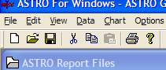
ASTRO for Windows has at the top left of its main window a toolbar. The left button (new file or blank document) starts a new chart using the new chart wizard described below. The File Open button uses the new file open dialog below. The save button exports a chart and the cut, copy, paste and print act as they do in other applications

File Open Dialog.

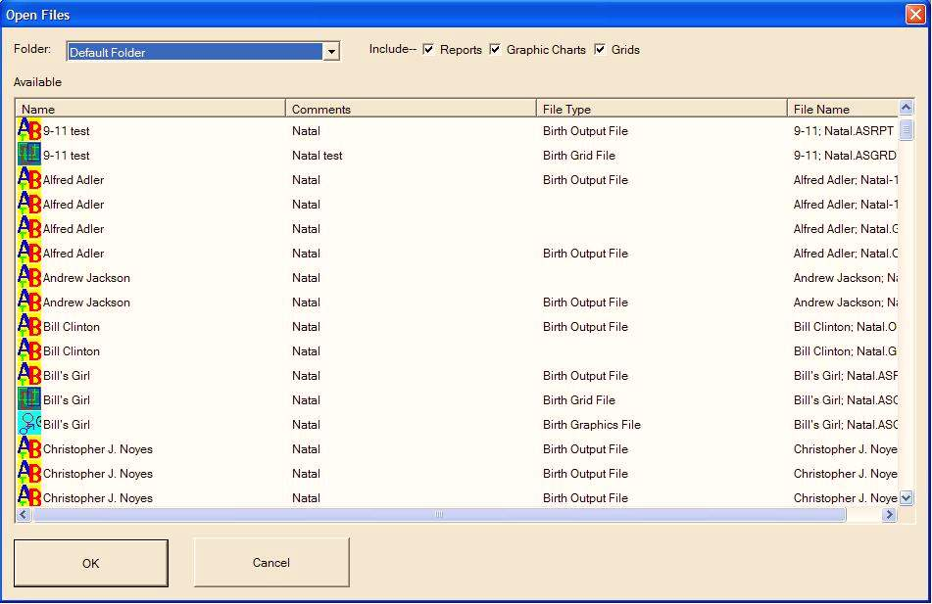

ASTRO for Windows has a new file open dialog that comes up with the file open button on the toolbar which will be easier to use than the traditional file management screens. This screen shows all the applicable files in your system of the applicable types. To open files, just click on the items in the left column and hit the OK button. If you want to select multiple files, hold down the control key and click on any that you want. You can sort the list by clicking on the column headers of the column you wish to have the files sorted by, for example to sort by comments, click on the comments header where it says Comments. If you have multiple folders setup, you can choose a folder to show. The checkboxes at the top allow you to filter by the type of file. If you wish to only Open reports, uncheck the grid and graphics files.

Chart Wizard.
ASTRO for windows has a new chart wizard, which can make it far easier for new users to compile new charts. Traditionally one had to go into the data menu and edit various data screens and then go to the compile menu and then open the charts to see them. This new wizard allows you to do all in one step. Choose the type of chart to do, enter person’s name and comments for the file list, and select a folder and hit the next button. The wizard will show all the necessary screens in sequence that you need to fill in and then compile the charts and opens them so you can view them. At the bottom of the screen are a set of buttons. If you can go back to a prior button, the back button will be enabled, if there is a next page that you need to go to you will see the next button enabled. When you are ready to compile your chart, the done button will be enabled. To compile the charts, hit the done button, to move forward and back use the Next and Back buttons

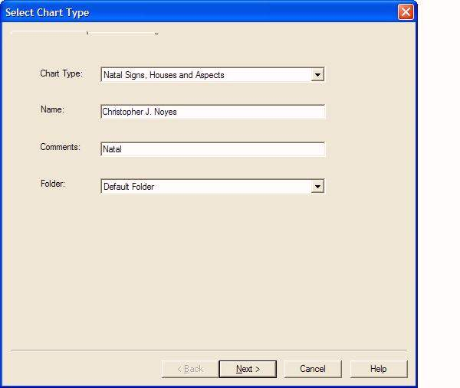

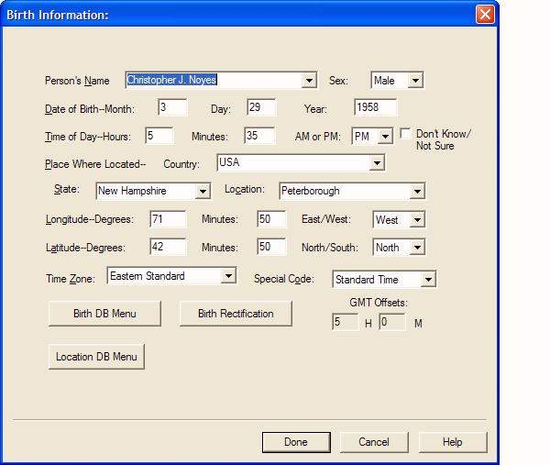

If you don’t know a person’s birth and don’t understand the ideas around Birth Rectification, you can just check the Don’t Know/Not sure checkbox and it will compile the chart with the default rectification for the chart type, which can be either Solar chart, or Ascendant equal to your sun, or Flat chart which makes the ascendant zero degrees Aries. You can configure this option in Options/Chart Options/(Your chart type) .

QUICK REFERENCE GUIDE
This is a quick step-by-step guide on how to use ASTRO for Windows for most of it's basic features.

How to Create a Birth (Natal) Chart.
How to create a Birth (Natal) Chart.
1. Choose the Data menu.
2. Choose the menu choice "Birth Info".
3. Fill in the information on the dialog box, using the location or birth database as applicable. See below for information. When finished, click on the "OK" button to complete.
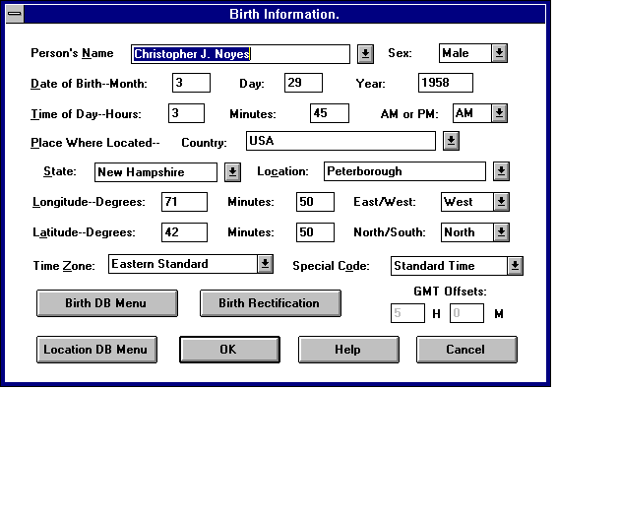
The Birth Information dialog box.
4. Choose the menu choice "Birth Rectification". If you know the person's birth, check the first question check box, then click on the "OK" button.
5. If you don't know the birth time, complete the dialog box, depending on how you want deal with the chart.
The rest of this dialog box is applicable only if you don't know the birth time.
Move over to the Compile menu. Choose a chart. For example, choose "Birth Signs, Houses & Aspects." Fill in the information about the chart.
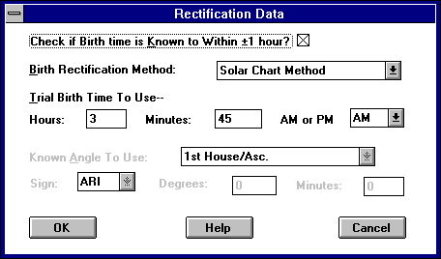
The Birth Rectification dialog box.
6. Move to the Compile menu. Choose a chart. For example, choose "Birth Signs, Houses & Aspects."
7. Fill in the information about the chart.
8. The chart is compiled.

How to create a Compatibility or Composite Chart.
1. Choose the Data menu.
2. Choose the menu choice "Birth Info".
3. Fill in the information on the dialog box about the first person, using the location or birth database as applicable. See below for information. When finished, click on the "OK" button to complete the dialog box.
4. Choose the menu choice "Birth Rectification". If you know the first person's birth, check the check box, then click on the "OK" button.
5. If you don't know the birth time, fill in the rest of the information on this dialog box, depending on how you want to deal with the chart.
6. Repeat the first five steps using the Compatibility Information dialog box and the Compatibility Birth Rectification dialog box for the second person.
7. Move to the Compile Menu.
8. Choose "Compatibility", or choose "Composite".
9. Fill in the information relating to the chart.
10. The chart is compiled.

How to create Transits Charts.
Use a transit chart to compare the planet locations during a given point of time, compared to an individual's birth. A transit chart is also referred to as a day-to-day chart.
1. Choose the Data menu.
2. Choose the menu choice "Birth Info".
3. Fill in the information on the dialog box, using the location or birth database as applicable. See below for information. When finished, click on the "OK" button to complete.
4. Choose the menu choice "Birth Rectification". If you know the person's birth time, check the first check box, then click on the "OK" button.
5. If you don't know the birth time fill in the rest of the information on this dialog box.
6. Choose the menu choice "Transits Info".
7. Fill in the information about the first date you wish to analyze. Rough location and time of day help to localize the chart and make it more exact. For this example we enter Monday's date and our present location.
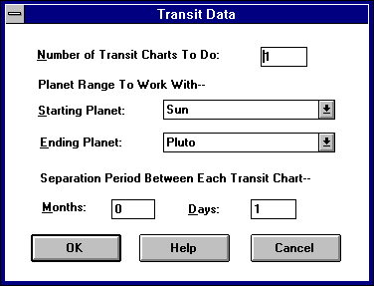
The Transits Data dialog box.
8. Choose the menu choice "Transits Data".
9. Fill in the number of charts to do. For this example we want to do seven charts, one for each day of this week.
10. Choose the starting planet to include. I suggest selecting the Sun. Choose the ending planet to include, since the outer planets don't move very often, don't include them. I suggest using Venus or Mars as the ending planet. The first chart will show all planets.
11. Enter the period between charts. In this example, we would enter zero months and one day, which will do seven charts, each one-day apart.
12. Move over to the Compile menu.
13. Choose "Transits." Fill in the information about the chart.

How to Create a Progression Chart.
1. Choose the Data menu.
2. Choose the menu choice "Birth Info".
3. Fill in the information on the dialog box, using the location or birth database. See below for information. When finished, click on the "OK" button to complete.
4. Choose the menu choice "Birth Rectification". If you know the person's birth, check the first check box, then click on the "OK" button.
5. If you don't know the birth time, you will need to fill in the rest of the information on this dialog box.
6. Choose the menu choice "Progression Data".
7. Choose the progression system. The most common is Secondary.
8. Enter the age (of the person) at which you wish to do the analysis, or click "Date Above is Target Date" and enter the exact date you want to use.
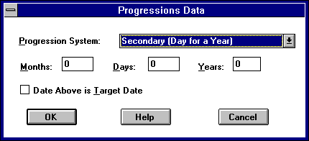
The Progressions Data dialog box.
9. Move over to the Compile menu. Choose "Progressions". Fill in the information about the chart

How to Create a Relocation Chart.
1. Choose the Data menu.
2. Choose the menu choice "Birth Info".
3. Enter a description for the location to associate it with the birth.
4. Fill in the information on the dialog box, using the location or birth database, see below for information, when finished, click on the "OK" button to complete.
5. Choose the menu choice "Birth Rectification". If you know the person's birth, check the check box for the first question, then Click on "OK" button.
6. If you don't know the birth time, you will need to fill in the rest of the information on this dialog box.
7. Choose the menu choice "Relocation Data".
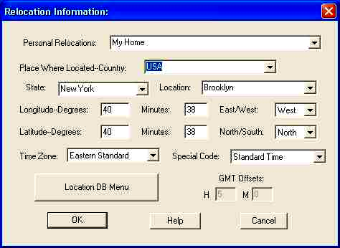
The Relocation Data dialog box.
8. Enter the person's new location data. This dialog box works exactly as the location portion of the birth dialog boxes.
9. Move over to the Compile menu. Choose "Relocation" Fill in the information about the chart

How to Get a Person's Information from the database.
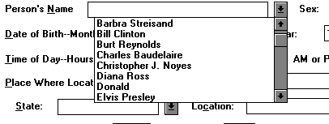
Birth Pop-up dialog box.
Combo Box (down arrow) Icon.
When in the Birth Info, Compatibility Info or Transits Info dialog box, and on the "Name" field, click on the combo box (down arrow) button at the right of the field, select the name you want from the list and click to select it.

How to Get Information From an Earlier Compiled Chart.
1. Select a file from the "ASTRO Reports" file list.
2. Go to the Utilities menu.
3. Choose "Read File Into Data".
3. Select the file you want to read.
4. The information will be put back into the dialog box that the information came from originally.

How to Copy Birth Info to Compatibility Birth Info or Compatibility to Birth Info.
While in the Birth Info or Compatibility Info dialog box, click on the "Birth DB Menu" button and select "Copy" from the menu. Go to the dialog box you wish to copy the data to, click on the "Birth DB Menu" button and select "Paste" from the menu.

How to Copy the Location Data to Another Dialog Box.
While in the Birth Info, Compatibility Info, Transits info or Relocation Data dialog box, click on the "Location DB Menu" button and select "Copy" from the menu. Go to the dialog box you wish to copy the data to, click on the "Location DB Menu" button and select "Paste" from the menu.

How to Find Longitude and Latitude in the US or Puerto Rico and you know the zip code
When in the birth information, compatibility information or transits information screen, click on the Location menu button and hit Lookup Zip Code and enter the zip code

How to Use the Computer ACS Atlas System with ASTROW
In the ACS Atlas program, lookup the information, and copy the information to the clipboard. When in the birth information, compatibility information or transits information screen, click on the Location menu button and hit Paste from ACS Atlas.

What do I do if I can’t find the longitude or latitude or know about the time zone
If you have access to the internet, leave the data entry screens and go to the utilities menu and choose Reference Maps, there you will find world maps., a time zone reference and a link to a lookup page. You can also pick a nearby location or estimate it.

THE FILE LIST VIEWER
This is a list of all the files that you have created. There are two file lists, one of graphic files, and one of text report files.
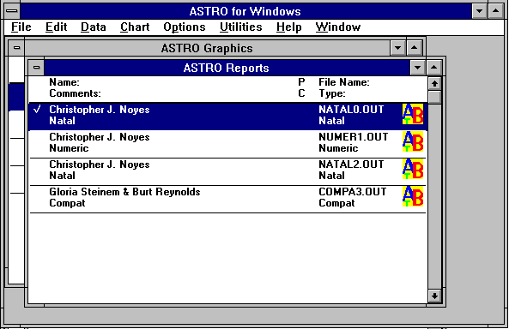

KEYS:
PAGEUP Go up one screen.
PAGE DOWN Go down one screen
DOWN Move the selection bar down one line.
UP Move the selection bar up one line.
HOME Go to the beginning of file list.
END Go to the end of file list.
ENTER View currently selected file.
or double click If selected file is a
with mouse. text report file, the text file viewer is started. If the selected file is a graphics file the graphics file viewer is started. Same as File menu View.
DELETE Erase a file. Same as Files menu KILL.
CTRL+INS Copy file to clipboard. Same as Files menu KILL.

SPACE BAR Select a file for
or mouse click multiple file operation. All files which are checked are selected.

VIEWING GRAPHIC FILES
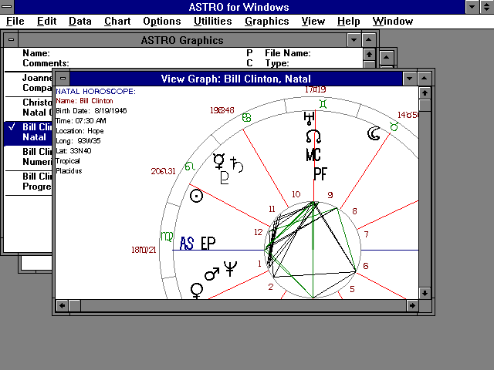

* Professional version only.
Use the Graphics menu to change the ways the information is displayed on the screen.
Go to the View menu to Zoom In, Zoom Out or have the wheel scaled to the size of the window.

KEYS:
PAGEUP Go up one screen.
PAGE DOWN Go down one Screen
DOWN Go down one line.
UP Go up one line.
HOME Go to the left of image.
END Go to the right edge of the image.
CTRL+HOME Go to the top image.
CTRL+END Go to the bottom of the image.
LEFT Scroll left.
RIGHT Scroll right.
CTRL+P Print. Same as Files menu command Print
The Following keyboard combinations have equivalents in the Graphics and View menus.

Transit chart operations
[ Go to Previous transit chart
] Go to Next transit chart.
= Go back to First transit chart.
House cusps operations:
< Decrease house cusps by one degree
> Increase house cusps by one degree.
@ Go back to basic house cusps.
View operations:
Num + Zoom In. Same as View menu command Zoom In.
Num - Zoom Out. Same as View menu command
Zoom Out.
Num * Zoom In. Same as View menu command Fit Window.
You can copy the image to the clipboard by Selecting the Edit menu and the Copy menu item.
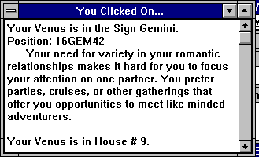
Graphics Popup
Double clicking on any planet, house or aspect glyph will bring up text telling you about that element of the chart. The same text is used that is used for the printed reports.
When working with compatibility charts, you may need to reverse the house cusps using Inner House Cusps to get the appropriate text.
When working with other two-wheel graphics and the house cusps are the natal house cusps, clicking on the birth planetary positions bring up natal text, and the other wheel the other text.
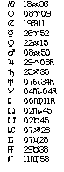 Planet Listing
On all Single wheel graphics, at the top right of the screen, a list of the planet positions is displayed.
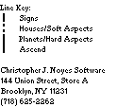 Key With Address
To set this up, go to the Options menu, advanced Optios choice.

Graphics Menu Commands.

Show Sign Names.
This menu command turns on or off the display of sign names in the graphics screen around the outside. If glyphs are being used, then glyphs will be used, otherwise the names will be used.

Show House Numbers.
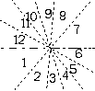
Inside house numbers.
This menu command turns on or off the display of house numbers in the graphics screen around the outside or in the middle.

Show House Degrees.
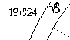
House degrees.
This menu command turns on or off the display of house degrees in the graphics screen around the outside of the cartwheel.
Show Aspects.
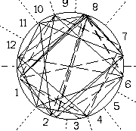
Aspect circle
This menu command turns on or off the display of aspect lines in the graphics screen in the middle of the wheel. Aspect lines are only shown in natal or relocated charts, where the charts are compiled with aspects.
Show Aspect Grid.
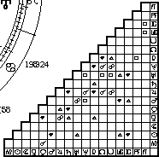
Aspect Grid.
This menu command turns on or off the display of an aspect grid. in the bottom right of the screen. An aspect grid are shown on any chart compiled with aspects which was compiled with this or a later version of ASTRO for Windows.

Page 23.
Use Next Chart.
Use Previous Chart.
Use First Chart.
Add when compiled with aspects, an aspect grid for each chart is displayed.

Use Glyphs.
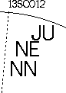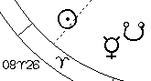
No glyphs. Use glyphs.
This menu command turns on or off the use of glyphs in the graphics cartwheel.
Show Sign Lines.
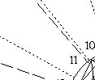
Dashed lines are sign lines,
dotted lines are house lines
This menu command turns on or off the display of sign lines in the graphics cartwheel.

Use Inner House Cusps.
Use Inner House Cusps.
This menu command selects which house cusps to display when displaying compatibility, or progressions cartwheels. When they are compiled with aspects, this menu command will also switch between multiple aspect grids.

Tick Wheel Options

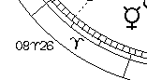

Sign Tick Wheel.
This menu command turns on of off the display of sign tick wheels. A sign tick wheel is an outer circle showing the signs, and uses the glyphs.

Decan Tick Wheel.
This menu command turns on of off the display of decan tick 2heels. A decan tick wheel is an outer circle, but inside the sign tick wheel, showing the decans of the signs.

Degree Tick Wheel.
This menu command turns on of off the display of degree tick wheels. A degree tick wheel is an outer circle, but inside the decan or sign tick wheel, showing the degrees.

House Numbers Outside.
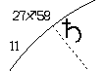
Plot outside. Plot inside.
This menu command selects whether to display the House Cusp Numbers outside the wheel or at the center of the wheel.

Plot Classic.
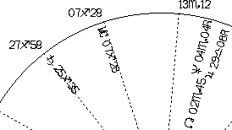
Plot classically.
his menu command selects whether to display the planets and sign degrees horizontally plotted approximately where they should be or display them on angles into the wheel.

Show Planet Degrees.
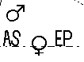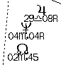
Don't show degrees. Show planet degrees.
This menu command turns on of off the display of planet degrees which will be plotted below the glyph, otherwise they are not plotted and the glyphs are plotted larger.

Use Next Chart.
When displaying transits charts, this menu command displays the next transit chart. If there are no more charts, the first is displayed. When compiled with aspects, an aspect grid for each chart is displayed.

Use Previous Chart.
When displaying transits charts, this menu command displays the previous transit chart. If the first chart
is being displayed, the last is displayed. When compiled with aspects, an aspect grid for each chart is displayed.

Use First Chart.
When displaying transits charts, this menu command displays the first transit chart. When compiled with aspects, an aspect grid for each chart is displayed.

Decrease House Cusps.
This menu command decreases house cusps by one degree. This is useful for rectification.

Increase House Cusps.
This menu command increases house cusps by one degree. This is useful for rectification.

Use Regular House Cusps.
This menu command reverts the house cusps to the ones that are stored in the graphics file. This is useful for rectification.

View Menu Commands

Zoom In.
When the graphics screen is not in fit window mode, this menu command zooms the graphics screen in and enlarges the graphics screen.

Zoom Out.
When the graphics screen is not in fit window mode, this menu command zooms the graphics screen out and reduces the graphics screen.

Fit Window.
This menu command turns on of off fit window mode. In fit window mode, the graphics screen is scaled to fit the window.

VIEWING TEXT REPORTS
Use this to view the text report files that ASTRO produces. If you wish to you can customize the colors and fonts that are used in the viewer.
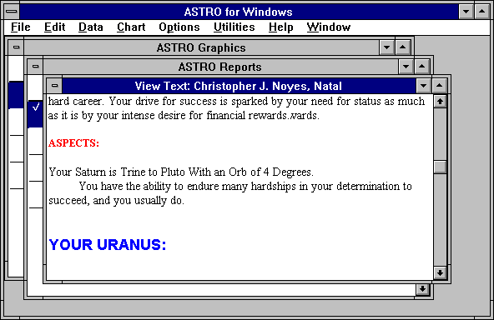

You can convert this report to text, print it, create a comment file or create a cover page from the Files menu.
In the Professional version, you can search for text in the report., see the Edit menu.

KEYS:
PAGEUP Go up one screen.
PAGE DOWN Go down one screen
DOWN Go down one line.
UP Go up one line.
HOME Go to the beginning of report.
END Go to the end of report.
LEFT Move cursor left.
RIGHT Move cursor right.
CTRL+P Print. Same as Files menu command Print.
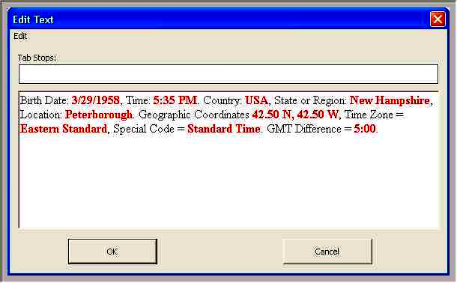
Text Editor Screen.
Text reports can be edited. Click with the mouse to select any paragraph, and click again to deselect it. If you double click any paragraph an editor will come up to edit that paragraph. You can make any changes you want to the text or formatting.

Changing Text Styles, Tabs and Spell Checking
If you can change the text styles in this editor, spell check and change tabs, using the tabs editor and the edit menu discussed in the Text Builder Toolkit Section.
KEYS
ENTER Insert a Paragraph at selection point.
DELETE Delete Selected paragraph
Edit Menu Commands.
Undo Undo the last edit.
Copy Copy the selected paragraph to the clipboard.
Cut Cut the selected paragraph and copy it to the clipboard.
Delete Delete the selected Paragraph.
If you want to move a paragraph, cut it to the clipboard and paste it where you want it.
To save the file, close the file from the File menu. If you have made changes, it will ask you if you want to save the file.

FILES MENU

New

File List
This menu command creates a new user file list. You can add files from the text or graphics file list. To add files to a user file list. Go to the file list, select the file, select Edit and Copy, move to the user file list, and choose Edit and Paste.

Cover Page
This menu command creates a new cover page for the file in the list that is selected.

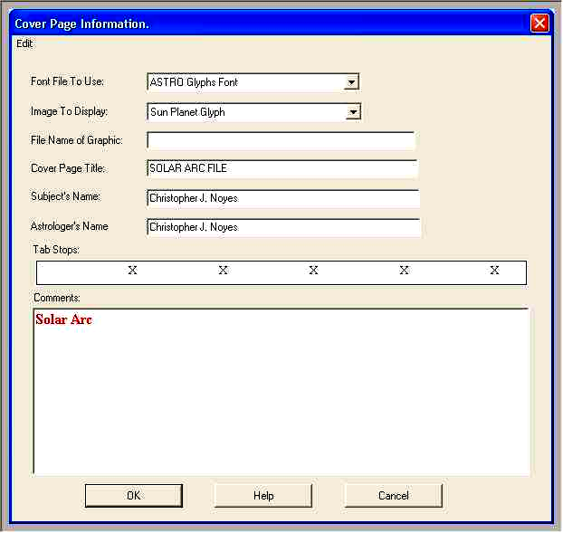
Cover Page Editor

Text Styling, Tabs and Spell Checking: This screen allows you to style the text in the comments text block and check spellking using the commands in the edit menu described in the Text Builder Toolkit section. You can also change the tabs using the tabs editor described in that section as well.
Font File to Use: ASTRO For Windows prints a large glyph at the top left of a cover page. Select the Font File to get the glyph from. ASTRO for Windows provides several fonts to get glyphs from. You can also select to use a graphics file or use a custom font and text.
Image to Display: Select the glyph that you want to display from the font.
File Name of Graphic: If you selected, "User File Graphic", fill in the file name here of the graphic file to use. BMP, PCX and TIFF files are supported.
If you selected "User Font and Characters", enter the font name, size in points, weight and style, and text as font\size\style\char set\text separated by '\' characters. Size is in points. Style is either 'I' for Italic, 'B' for Bold, 'N' for Normal. Char set is either 'A' for Windows ANSI, or 'X' for the Symbol character set, text is the text you want to print. for example
For Example: "Palatino\72 \I\A\wyx" indicates to print the letters "wyx" in 72 point Palatino Italic which is an ANSI font. or "MS Sorts\72 \N\X\o" indicates to print the letter "o" in 72 point MS Sorts which is a Symbol font.
Cover Page Title: This is the title of the cover page.
Subject's Names: This is the name of the subject that the report is for. This is derived from the file list. You can change this to whatever you want.
Astrologer's Name: This is the your name.
Comments: Enter your comments for this file. This works like Windows Notepad.

Comment File
This menu item creates a comment file and opens an editing screen for the file. This works like Windows Wordpad.
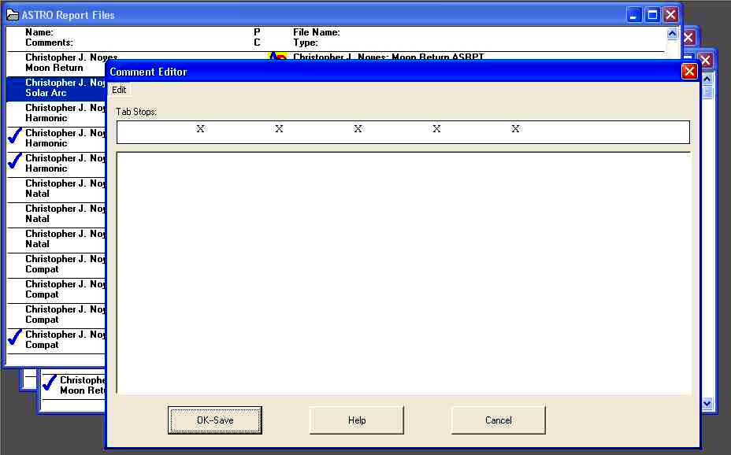
Text Styling, Tabs and Spell Checking: This screen allows you to style the text in the comments text block and check spellking using the commands in the edit menu described in the Text Builder Toolkit section. You can also change the tabs using the tabs editor described in that section as well.

Open

Birth Data
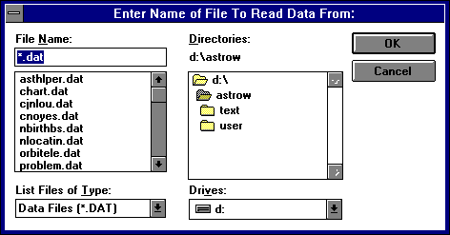
File Open dialog box.
This menu item opens an existing birth data file. You are prompted for a file name of a file to open.
NOTE: Don't attempt to load any file that you did not save with Files/ Save Birth Data. You may also load the file ASTRODAT.DEF or the file ASTRODAT.HIS.

File List
This menu item opens an existing user file list and prompts you for the name of an existing file name to open.

Cover Page
This menu item opens an existing cover page file or creates a new one.

Comment File
This menu item creates a comment file and opens an editing screen for the file. This works like Windows Notepad.

Close
This menu comand closes the current screen and the attached files. If the file has been changed and needs to be saved, you will be asked if you want to save them.

Save
Birth Data
This menu item saves the birth data in the dialog boxes to a file. This prompts you for a file name.
NOTE: If you want to have a set of data loaded into your system every time that ASTRO starts up, save it as ASTRODAT.DEF. You should save this to your user disk and directory, so don't use a path or disk. ASTRO saves the chart you were working on last in to the history file ASTRODAT .HIS, also in the user disk and directory.
File List
If you open an existing user file list, this menu item this saves the file list, otherwise ASTRO prompts you for a name for the file list.

Comment
If you are in a comment editor file, this menu item saves the file. Choose "Close" from the system menu.

Save As

Birth Data
This menu item saves the birth data in the dialog boxes to a file. This prompts you for a file name.

File List
If you have a User file list, this menu item prompts you for the name of a file list.

Export
This menu item exports the file in the file list you have selected. If you have selected a graphics file, a graphics file is exported. If you have selected a text file a text file is exported.
If you are in a graphics file viewer or in a text file viewer, the file that you are viewing is printed.
If you have checked multiple files and have the option in the Options menu "Print/Convert All Checked" checked this menu item converts all the files you selected.
This menu item prompts you for specific data about the file and prompts you for the file to write to.

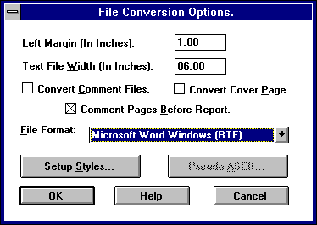
Text File Export dialog box.
To convert files to text, you can setup different file formats. If you are using Microsoft Word for Windows, use RTF which you can setup the fonts to use using the setup styles button.
You can convert a file to either ASCII, WordStarTM 3.x or 4.x, WordPerfectTM 4.x or 5.x, XYWriteTM, Microsoft WordTM RTF (Rich Text) or Lotus AMI ProTM format. You can also save ASCII and XYWrite files without any soft line breaks. You can rebreak the file easier when you read it into your word processor, since soft and hard line breaks are the same. These files are saved with all attributes intact.
NOTE: When you save files saved
in WordPerfect format, document default information such as printer, default font, or styles will not be saved to the file. This Information is written to the file when you save it from WordPerfect.
If you want font, printer and margin information saved to the file:
1. convert a file to WordPerfect format.
2. Edit the File in WordPerfect. format the file in WordPerfect so it is exactly the way you want it.
3. Insert at the start of the text the phrase ##START##.
4. Save the file.
5. Run the utility program, WP5TOHED, using the file you created and the file name ASTRODEF.WP5, using the command line WP5TOHED file ASTRODEF.WP5 {ENTER} (where file is your file name).
If ASTRO finds a file called ASTRODEF.WP5, this file is used as a header for your file. WP5TOHED takes a formatted WordPerfect 5.0 document and turns it into a header file. Your report will start where you inserted ##START## in the document. Everything after that is deleted.
Files saved in WordStar format do not have any font or printer setup information encoded in them. This information is added when the file is saved to the file when you save from WordStar.
You can setup fonts for files saved in Microsoft Word RTF or Lotus Ami Pro formats.
Files saved in XYWrite format have no printer, font, or setup information encoded in them. You may need to read and Insert a file into your default document to use it in XYWrite.
The files saved using this function are entirely unformatted without page breaks or headers. This file is, though, wrapped to whatever text width you wish, and has a left margin, making it easier for your word processing program to work with.
If you are converting to ASCII you can select between two different approaches. One is a plain ASCII, another is "smart" pseudo formatted ASCII. Most people prefer the plain ASCII. Plain ASCII has no formatting information. In "smart ASCII", the text Attributes are translated into strings that your can change from the "Word Processing Conversion dialog box".

The WWW HTML text converter also supports inserting files of text in HTML format into your reports at the head of the web page. If you are using style sheets and want to pick up the style for the standard text style surround your text with <DIV> and </DIV> tags. Add the following entry to your astrow.ini file where the directory and file name are the file that you want included. You can set this up in the Options/Advanced Options dialog
The WWW HTML text converter also supports inserting files of text in HTML format into your reports at the end of the web page. If you are using style sheets and want to pick up the style for the standard text style surround your text with <DIV> and </DIV> tags. Add the following entry to your astrow.ini file where the directory and file name are the file that you want included. You can set this up in the Options/Advanced Options Dialog.

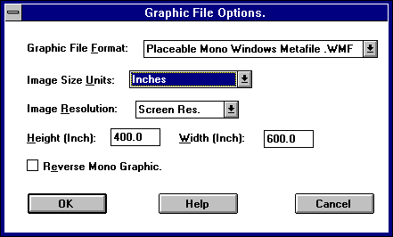
Graphic File Export dialog box.
To convert files to graphics, you can select a number of file formats, setup the size of the file (where applicable). If you are converting to a monochrome file, you can choose to reverse the file.

View
This menu item opens the viewer screen that corresponds to the type of the file in the file list you have selected.
Pressing {ENTER} in the file list screen or double clicking the mouse on the selected item has the same effect as selecting this menu item.

Edit
If you have selected a text file, when you chose this menu item, the file is exported to a text file and your selected editing program is opened with the file you selected.

Kill
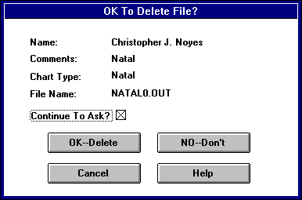
Kill File dialog box.
Selecting this menu item kills the file from the file list and deletes the file from your disk. The above dialog box asks you if you want to delete the files.
If you have checked multiple files and have the option in the Options menu "Print/Convert All Checked" checked this menu item kills all the files you selected.
If you are killing multiple file and uncheck "Continue To Ask" and press the "OK" button, all the files will be deleted. If you press the "No" or "Cancel" button, no files will be killed.
If you are killing multiple file and leave "Continue To Ask" checked, you will be prompted for each file.

Print
This menu item prints the file in the file list you have selected. If you have selected a graphics file, a graphics file is printed. If you have selected a text file a text file is printed.
If you are in a graphics file viewer or in a text file viewer, the file that you are viewing is printed.
If you have checked multiple files and have the option in the Options menu "Print/Convert All Checked" checked this menu item prints all the files you selected.
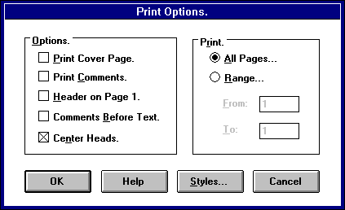
Print Options dialog box.
This menu item prompts you for specific data and options about the file.
You can select to print any range of pages

Page Setup

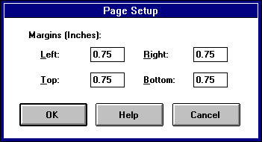
Page Setup dialog box.

Graphics
This menu item sets up the margins for printing of graphics.

Text
This menu item sets up the margins for printing of the text reports, comment files and cover pages.
Print Setup

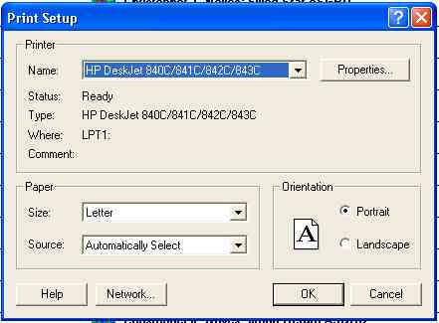
Printer Setup dialog box.

Graphics
This menu item lets you pick the printer that you use for printing graphics cartwheels. This can be a different printer or entirely different setup from the text.
Pressing the "Setup" button, opens your printer driver's setup dialog box which varies with printers.
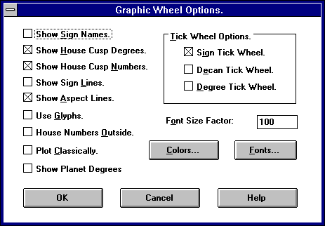
Graphics Options dialog box.
Pressing "Options" button, opens the Graphics Options dialog box which lets you customize the graphics printout.
Pressing the "Colors" button applies only to color printers and allows you to change the colors used. Clicking on the "Fonts" button, allows you to change the font used for the graphics cartwheels.

Text
This menu item lets you pick the printer that you use for printing text reports. This can be a different printer or entirely different setup from the graphics.
Print Options dialog box.
Pressing "Options" button, opens the Report Print dialog box which lets you customize the text printout.
Clicking on the "Styles" button, allows you to change the fonts for text printouts.

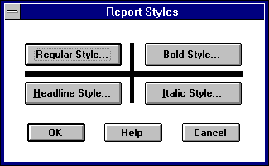
Report Styles dialog box.
Each button you press corresponds to a different font you can customize.

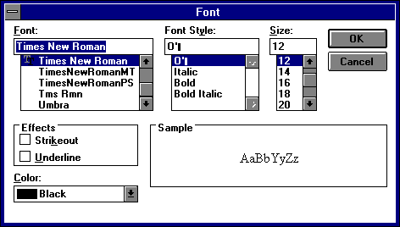

EDIT MENU
When you are in the file list viewer, comment file editor, text viewer or the graphic viewer, you can use the Edit menu to copy items and data to the clipboard or find text or items.

Undo
If you were in the file list viewer and chose cut or paste, the Undo menu item undoes the previous action.

Cut
In the file list viewer, you can delete a file from the file list or just delete the reference to it in this screen by selecting this menu item. You will be asked if you want to kill this file. If you do choose to delete the file, you will not be able to Undo this action.
Kill File dialog box.
If you choose not to kill this file, the file is eliminated from this list and the information on it is copied to the clipboard.
Copy
In the graphics viewer, this menu item copies the graphic image to the clipboard.
In the file list viewer, this menu item copies the reference to the file to the clipboard. You can use this to copy files to a user file list viewer.

Paste
In the file list viewer, this menu item pastes the reference to the file to the clipboard. You can use this to copy files to a user file list viewer.

Delete
In the file list viewer, you can delete a file from the file list or just delete the reference to it in this screen by selecting this menu item. You will be asked if you want to kill this file. If you do choose to delete the file, you will not be able to Undo this action.

Find
In the text viewer, this menu item can be used to find text in the viewer. The text viewer prompts you for the text you wish to find. If the text is found the viewer moves to
that text.
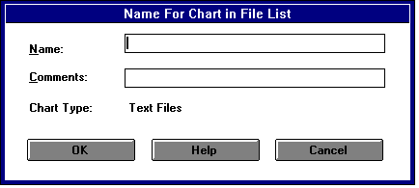
File Find dialog box.
In the file list viewer, this menu item can be used to find a file list entry in the viewer. You will be prompted for the information on the file. Fill in the information that you know. You can leave either the name or comments fields blank, and the search will be based on what you enter.

Next
This menu item repeats the Edit menu item Find, but does not prompt you for input.

Select All
In the File List Viewer, you can use this option to select all charts to print, convert or delete. You can clear this from the Utilities Menu

ENTERING DATA:
You will use the "Data" menu choices to enter information on the dates in question and other data for transits, progressions, returns, etc. Most of the questions asked and information you will need to enter are really self-explanatory. You can get information for each field by pressing {F1} or clicking the mouse or pressing on the Help button This is how to use these dialog boxes:

Important Information.
Should you have trouble at any time with ASTRO, there are several things that you should remember. The following table describes some useful information.
{F1} Get Help in any menu or data dialog box.
{ESC} or {ESCAPE} Back out of any dialog box or series of screens to the main menu. Also cancel any entry choice.
{ENTER} Close the screen as you had pressed the OK button.
{TAB} Move Down through fields.
{SHIFT}+{TAB} Move Up through fields

Database Fields.
In the "Info" type of field such as "Birth Info", several fields have databases attached. The first field (Person's Name) has a database of birth dates attached to that field.
Through that database, you can save the entire contents of this dialog box, by name, for whomever you wish to enter. The birth location (Country, State or Region, and Location) fields also have a database attached to them. This database has only the location data such as longitude, latitude, and time zone. You can instantly make use of these databases by using the combo box control while in the Name, Country, State, or Location fields.
In the case of the location fields, ASTRO will only read the data from the database once you have used the combo box on the location field itself. The location fields are "hierarchical". This means that first you select a country. Then ASTRO shows you all the states or regions available from that country. After you select that state or region, ASTRO displays all the locations in that region.

Finding Information in the Database.
The easiest way to find information in the database is with the combo box controls in the dialog boxes. You can select from any available choices with these controls.
You can also find partial data in the database by entering just part of it. If you were looking for a person's birth data and didn't quite remember the spelling of their last name you could enter what you remembered of the last name. Suppose you had "John MacNeil" in your database and wanted to find his data you could enter "John", "John M", or "John Mac" and might find the information. This depends on how many other entries are in the database that are similar.
NOTE: These databases do not allow more than one identical entry with the same key field.

Database Menus.

The Birth Menu.
In this version, the database menus are only existing for compatibility, the program will insert and update the database automatically when you hit the OK button.
The databases have menus that you can use to get information, add records, update records, and delete records. There is a database menu for the birth database and there is a menu for the location database.
To get to the birth database, click on the "Birth DB Menu" button. This database uses the person's name field as the key to the database. ASTRO uses this field to find the information you want.
If you indicate in the Birth Rectification dialog box, which you don't know the birth time, ASTRO saves the birth rectification information to the database as well. You can get to the appropriate rectification dialog box, by selecting the "Birth Rectification" button at the bottom of the dialog box.
To get to the location database, press on the "Location DB Menu" button. This database uses a combined key made up of the country, state and location fields. You will also notice at the bottom of the dialog box. A button marked "Location DB Menu". Pressing this button will select the database as well.
NOTE: You can get access the ACS Atlas from the Location Menu if you have the computerized ACS Atlas installed. You can also get longitude or latitude from a Zip code. There is also in the utilities menu a ;page of reference Maps.

The Birth Info dialog box.

Birth Info.
Use this dialog box to enter the main birth data needed for doing a birth or Natal horoscope. Enter the data on this dialog box that gives the person's name, sex, birth date and time, place of birth and geographic latitude and longitude as well as time zone and adjustment.
Combo box selection button.
Selecting a birth.
This field has two powerful databases attached to the Name, Country, State or Region, and Location fields. If you click on the down arrow key at the right side of the Name, Country, State, or Location fields, you will call up a list of available choices in the database. If you wish to add information to the databases, fill in the information on the dialog box. Then click on the "Birth DB Menu" button for the birth database menu or click on the "Location DB Menu" button for the location database menu.
This will bring up a menu. You can use these menus to add, delete and replace information in the databases. In order to update the lists that you see when you access them, you need to run "Make Pop-ups" in the Utilities menu.
If you are adding to the Birth Database, you can find "Make Popups" for the birth database brought up by clicking the "Birth DB Menu" button.
You can clear this dialog box so you can begin with a blank dialog box by clicking the "Birth DB Menu" button and choose the "Clear" menu choice.
It is important to know as much information about the person that you are going to analyze. You need to know birth time, date and place of birth. You also need to know the prevailing time zones being used at the time.
NOTE: Beware entering times around Noon and Midnight! Serious users will want to consult a reference such as The American Atlas or The International Atlas. These books are published by ACS Publications of San Diego, CA. These books contain exact birth location and applicable time zone data.
Use the Time Zone field to set the proper time zone for the person in question. Try to be as certain as possible. This is crucial and some locations differ from one year to another. In some locations, time zones change between town and county lines. If you don't know the time zone but do know the offset from GMT select "Other".
Use the Special Code field to set the proper special time code field. Try to be certain as daylight time changes from year to year, and is different between towns, counties and states. If you don't know this zone but you know how the GMT offset, choose "Other".
You can't alter the GMT offset unless Time Zone and Special Code fields are set to "Other".
If you did not select "Other" in the Time Zone and Special Code fields, ASTRO will fill in the GMT field for you. You won't be able to override this field unless you had set the Time Zone or Special Code fields to "Other". The adjustment for War Time, Daylight Saving Time, etc. is added to the basic GMT offset. Locations West of Greenwich are have positive GMT offsets, East, negative GMT offsets.
NOTE: Enter only the normal clock offset from GMT, such as Eastern Standard time is five hours from GMT. ASTRO makes the minor fine adjustments to GMT for you

Compatibility Info.
Use this dialog box to enter the data for your partner. The compatibility operation uses the birth info dialog box as well as this dialog box to get the information needed to do your compatibility chart. Enter the data on this dialog box to indicate the person's name, sex, birth date and time, place and geographic latitude of birth (of the partner) and longitude. You also need the time zone and adjustment. It is important to know as much information about the couple you are going to analyze. You need to know birth time, date and place of birth as well as the prevailing time zones being used at the time. See the Birth Info dialog box for more information.
You can clear this dialog box so you can begin with a blank dialog box by clicking the "Birth DB Menu" button and choose the "Clear" menu choice.
Transits Info.
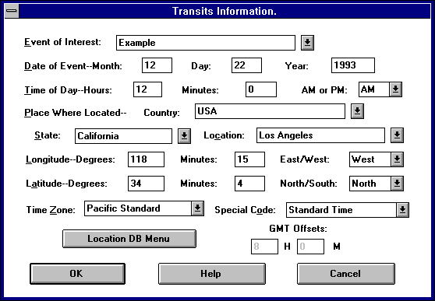
The Transits Info dialog box.
Transit charts compare the planet positions for a series of future dates to your birth planet positions, and tell you about the events at hand. The transit information is now stored in the database and can be retrieved and is tied to the person’s birth information by the person’s name, and the event name provides a way to select from multiple transit records.
Use this dialog box to enter the description for the event, the starting date and location for your transit computation. This operation uses your birth info and this dialog box to do the transits along with the Transits Data dialog box. Enter the data on this dialog box that shows place, date and time, place and geographic latitude and longitude, where you anticipate being, as well as time zone and adjustment. The information entered into this dialog box does not need to be as exact as for the above dialog boxes.
You can clear the location section of this dialog box by clicking on the "Location DB Menu" and selecting "Clear".
See the Birth Info dialog box for more information on this screen.
NOTE: This dialog box indicates a starting point for a series of transits. ASTRO calculates transits as a series of charts, a certain period apart.
Transits Data.
The Transits Data dialog box.
This dialog box is used with the Transits Info dialog box and the Birth Info dialog box to do transit chart. This dialog box allows the program to calculate a series of transit charts at one time for a specific period of time and a specific interval period. This will allow ASTRO to work with only a specific range of planets. The first chart though prints all planets.
The Sun, Moon, Mercury and Mars are personal planets and effect mostly your moods. Jupiter and Saturn are less personal and produce mostly long term inner urges. The Outer planets Uranus, Neptune and Pluto have global effects on the entire world. Pluto for example has been used to predict Earthquakes.
If you are doing transits one day apart, you will want to narrow your planet selection to Sun - Mars. If you are doing transits one week apart, you will want your planet range to be Sun – Mars. Progressions.
The Progressions Data dialog box.
Use this dialog box to enter information to do a Progression. Progressions are used to show how an individual's chart changes over the course of their life. ASTRO uses the Birth Info dialog box along with this Progression dialog box.
First select the Progression System. The most common is Secondary which offsets your birth one day for each year of life. ASTRO also supports tertiary and minor progressions.
If the field "Date Above is Target Date" is checked, the date fields indicate the date. The total number of years is calculated and the remainder is destroyed.
Otherwise the Months, Days and Years fields are used as an offset. If you want to match other programs, set Months and Days to zero and set the years field to the years to progress.
The effect of progressions
over a 16-month period, from four months before the time to one year after the time set. This is much like a transit, but it gives a more soft diffused picture.
You read Progressions like a natal chart, but you read them in addition to the natal chart. They are additional effects. Some say progressions show your karmic growth as your life progresses.
Birth Rectification.
The Birth Rectification dialog box.
Use this dialog box if you do not know the exact birth time of the person you are using for primary birth data. Enter what you do know, or select how to calculate the chart to get the best results, even though you don't have the exact information. If you know the exact birth time, you don't need this chart, so check the first check box and exit the dialog box by clicking the "OK" button.
If you don't know the exact birth time, you have several different choices. You can choose "Trial and Error". This means you try a given time and see how it fits the individual. Then you try it again till you get the result you want.
You can choose "Solar Chart" that sets your Ascendant and first house cusp to be the same as your sun sign.
You can choose "Flat Chart" which sets your Ascendant and first house cusp to be zero degrees of Aries. You can also try "Sunrise Birth time", and enter the best guess of the appropriate sunrise time. This is similar to "Trial and Error". This frequently works since many people are born near sunrise.
NOTE: If you are using Flat Chart or Solar Chart, you should use 12:00 AM (Noon) for the Trial Birth time.
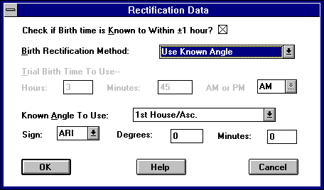
ASTRO supports a powerful rectification option. If you can figure out accurately the subject's Ascendant, Med. Coeli, Descendant or any house cusp, fill in the blanks and ASTRO will arrive at a close approximation of the birth time. The accuracy seems to be ±5 minutes of time. You may have to tweak the resulting time and retry it. You can find out the time ASTRO arrived at by looking at the trial field after ASTRO compiles the chart.

Compatibility Birth Rectification.
If you do not know the exact birth time of the person you are using for compatibility birth data, use this dialog box to enter what you do know or how to calculate the chart. This will help you get the best results even though you don't have the exact information. See the above material for more information.
Return Chart Data 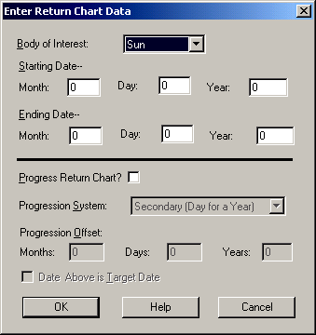
The Return Data dialog box.
The Return Chart Data dialog box is used to enter information for doing solar and lunar returns. A return shows the dates and times that the Sun or the Moon returns to the same place when you were born. These are considered to be powerful times.
The first thing you need to provide is the body (Sun or Moon) that you wish to do returns for. Next you need to provide a starting date and ending date for the returns. ASTRO will provide all returns that happen between these two dates.
ASTRO generates only dates and times. You can use these to generated transit charts to see the effect of these returns.
ASTRO can also progress a return chart. If you want the chart progressed, fill in the progression information as you would in the progression data dialog box described earlier.

Relocation Chart Data.
The Relocation Data dialog box.

The Relocation Chart Data dialog box is used to provide the information for relocating a chart. A Relocation chart takes your natal chart and moves the planets and house cusps to where they would be if you were born in another city or country. This type of chart can suggest where the subject might be best off. It will also show how the change from where you were born to where you are now has affected you.
The Relocation Chart Data dialog box works a lot like the Birth Info dialog box. The only difference is that you don't enter a person's name but you enter the description of the place relocated to, date of birth, time of birth, just the new location being considered. The relocation data is tied to the birth chart of the person and uses the description to identify different relocations

Solar Direction data
In the Solar Return Data screen, you enter the information to calculate the Solar Direction chart. In this screen, works like the progression data screen.
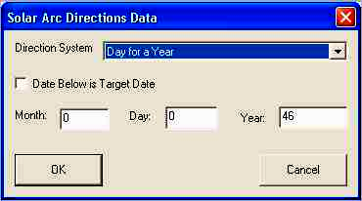
Harmonic Data.
In the Hamonic Data screen, you need to enter the multiplier number that planet degrees are multiplied by to arrive at the harmonic.
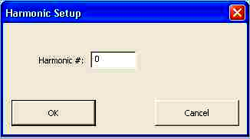

COMPILING CHARTS
Now that you have entered your data into the data dialog boxes are ready to compile a horoscope. With exception of the first choice, (default chart) they are grouped from simpler to more difficult in terms of data. The later charts produce more data and more text (with exception of the compatibility, transits, and progressions, returns, relocations or composite choices). The simpler ones may be better for a person with less experience in understanding astrology. With some practice and learning, most of the information on the charts will be useful.

The progressions, returns, relocations, and composite charts may be more useful for users who have more astrological background.
Certain aspects of these charts will be based on the Options dialog boxes in the Options sub menu. There is an option dialog box for each of the major chart types, though most of the information will be adequate without changing the data in these dialog boxes.
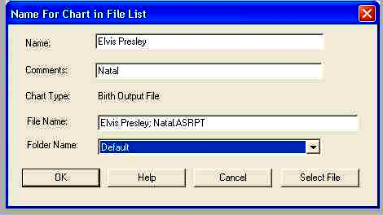
Filling in Information for a File.
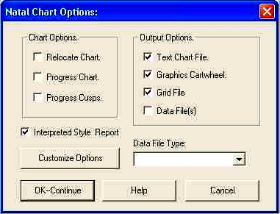
The Customization dialog box.
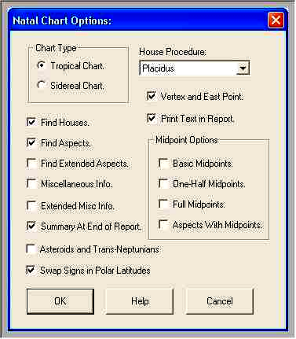
The Options dialog box.

With this version of ASTRO, the program also generates a grid report file, which can display the chart in a numeric grid form with the aspects and midpoints in a grid format. In the Professional program, you can choose whether to use an interpretive text style for displaying the chart data, which is more wordy, or a non-interpretive style which is much more terse which only gives the facts. Some reports may have facilities for text added that can be included in the report when turning on the interpretive style, for example the Fixed Star and Arabic Points reports.
With all these options, ASTRO asks you to fill in information to mark the file entry with for this chart. This information will help you identify this chart in the file listing. You may edit or change this information as you wish, with exception for the Type field, which is for your information only, and may not be changed.
Once you have compiled a chart, you can change the name and comment lines as well. This information will help you keep track of what you have on file.
You will notice that in most of these menu items, each menu item adds one or more options to it. One or more of the items that were options in the previous menu item, are now standard in the next menu item.
There are two choices that will produce a file that is more manageable in length. One produces a chart using Basic Midpoints. This gives you the most important midpoints. Second, in the option dialog box, you can select Half Midpoints Only and half as much information will be presented. For each pair of planets there is two midpoints, 180 degrees apart.

Default Chart.
This menu item produces a chart that directly reflects the contents of the options data. The chart that this menu item produces is a complete one, and I suggest that only advanced astrologers use it. You can customize this menu item by changing the options dialog box. The most powerful aspect of this menu item is that you can practically create a custom horoscope setup as your default treatment and use it as a default all the time if you wish.
NOTE: For this type of chart, you need to fill in the Birth Info dialog box and the Birth Rectification
dialog box.

Birth Signs Only.
This provides the least complex chart available. It provides only information on the individual planets locations in the zodiac at a given point in time. ASTRO also provides descriptive text about this information (you can turn this off from the options dialog box). You will also find a summary that you can turn off from the options dialog box as well.
NOTE: For this type of chart, you need to fill in the Birth Info dialog box and the Birth Rectification
dialog box.

Birth Signs & Houses.
This menu item provides all the information as does the previous one does, but adds the house information. This menu item provides the houses that each planet falls into, and descriptive text about each one. ASTRO also provides the coordinates of each house cusp. Also provided is information on which signs the various house cusps fall in, and text describing what each means to you.
NOTE: For this type of chart, you need to fill in both the Birth Info dialog box and the Birth Rectification dialog box.

Birth Signs, Houses & Aspects.
Use this menu item if you want to add aspects to your chart. This will produce aspects between all major points and produce text about each. You can also add other miscellaneous calculations into this type of printout from the options dialog box. This information is on top of all the information provided by the other two options.
When you choose to compile this chart, you will see a dialog box from which you can customize a chart. You can change the options, progress it, relocate it, and control the type of chart that ASTRO produces for it.
NOTE: For this type of chart, you need to fill in both the Birth Info dialog box and the Birth Rectification dialog box.

Complete Chart.
This menu item adds the miscellaneous calculations that are optional in the last section. In this selection, if midpoints are activated using the options dialog box, they will be used. No text is generated for the midpoints and midpoint aspects.
When you choose to compile this chart, you will see a dialog box with which you can customize this chart. You can change the options, progress it, relocate it, and control the type of chart that ASTRO produces for it.
NOTE: For this type of chart, you need to fill in both the Birth Info dialog box and the Birth Rectification dialog box.

Complete Chart With Basic Midpoints.
In this menu item, ASTRO adds the midpoints that were optional in the last section. The midpoints added in this menu item are only the Basic Midpoints, the most used ones between each, Ascendant/Med Coeli, North Node/South Node, and Med Coeli/Immum Coeli pair. Optional in this menu item are midpoint aspects, or aspects from a midpoint to another planet or angle.
When you choose to compile this chart, you will see a dialog box with which you can customize this chart. You can change the options, progress it, relocate it, and control the type of chart that ASTRO produces for it.
NOTE: no text is generated for the midpoints and midpoint aspects. For this type of chart, you need to fill in both the Birth Info dialog box and the Birth Rectification dialog box.

Complete Chart With Full Midpoints.
With this menu item, ASTRO steps up from the Basic Midpoints that were used in the last menu item to Full Midpoints. Midpoints are calculated for all bodies calculated. Optional in this menu item are midpoint aspects, or aspects from a midpoint to another planet or angle.
NOTE: No text is generated for the midpoints and midpoint aspects and only conjunct and square aspects with a maximum orb of one degree and 30' are considered.
For this type of chart, you need to fill in both the Birth Info dialog box and the Birth Rectification dialog box.

Numeric Chart.
This is like the Default Chart above with the exception that it displays only the numeric facts without any text. ASTRO displays this data in a more concise, exact notation. Some users may find this cryptic, though others may find useful. You can configure the output generated by this function from The Numeric Birth Options dialog box.
When you choose to compile this chart, you will see a dialog box with which you can customize this chart. You can change the options, progress it, relocate it, and control the type of chart that ASTRO produces for it.
NOTE: For this type of chart, you need to fill in both the Birth Info dialog box and the Birth Rectification dialog box.

Other Charts

Compatibility.
This menu item calculates a compatibility chart. ASTRO calculates the compatibility chart by comparing two full charts. This menu item calculates which house of one partner, the other's planets are located in, and vice versa. ASTRO also can generate aspects for compatibility charts.
It also calculates a special summary comparing the two individuals based on the summary. As with all the other menu items, ASTRO produces text describing the influences of all the information described.
When you choose to compile this chart, you will see a dialog box from which you can customize this chart. You can change the options, progress it, relocate it, and control the type of chart that ASTRO produces for it.
NOTE: For this type of chart, you need to fill in the Birth Info dialog box and the Birth Rectification dialog box for the main subject and Compatibility Info dialog box and Compatibility Rectification dialog box for the subject's partner.

Transits.
This menu item calculates a series of transit charts. ASTRO calculates the transit charts from the comparison of a birth chart and a transit chart. ASTRO calculates a series of charts based on a starting date and a date interval between that date and the next date. The dates and times in the Transit Info dialog box don't have to be as exact as the birth dialog boxes require. The time and exact latitude and longitude are optional, but they do help refine the data.
When you choose to compile this chart, you will see a dialog box with which you can customize this chart. You can change the options, progress it, relocate it, and control the type of chart that ASTRO produces for it.
NOTE: For this type of chart, you need to fill in the Birth Info dialog box and the Birth Rectification dialog box for the subject along with the Transits Info dialog box for the first date and Transits Data dialog box.

Progression.
This menu item calculates a chart that is offset one day for every year of life. As an enhancement to the standard progression procedure, ASTRO can calculate a progression based on years, months and days, not just years. This helps refine the starting and strongest points of a progressions' effects. Progressions effects last from four months before the date to one year after the date. ASTRO can do Secondary (one day for each year of life), Tertiary (one day for each lunar month of life) and minor (one lunar month for each year of life) progressions.
You can change the options of this type of report from the Progressions Options dialog box.
When you choose to compile this chart, you will see a dialog box with which you can customize this chart. You can change the options, relocate it, and control the type of chart that ASTRO produces for it.
NOTE: For this type of chart, you need to fill in the Birth Info dialog box, the Birth Rectification dialog box and the Progression Data
dialog box.

Solar Directed Chart Report.
Similar to a progression, this chart advances the birth time by some number of days, but this works slightly differently
NOTE: For this report, you need to fill in the Birth Info, Birth Rectification and Solar Direction Data.

Harmonic Chart Report
This report takes Birth positions and multiplies them by some multiplier called the Harmonic.
NOTE: For this report, you need to fill in the Birth Info, Birth Rectification and Harmonic Data.

Composite Chart Report.
A composite chart is the combination of the charts of two individuals. Midpoints between the planet positions of the two charts are taken. Aspects and house information are taken from them as though they were for an individual entity. This is similar in purpose to a compatibility report, though instead of reporting on two people the positions and interpretation are for a single entity.
You can customize this type of report from the Composite Options dialog box.
When you choose to compile this chart, you will see a dialog box with which you can customize this chart. You can change the options, progress it, relocate it, and control the type of chart that ASTRO produces for it.
NOTE: For this type of chart, you need to fill in the Birth Info dialog box and the Birth Rectification dialog box for the main subject. You also need to fill in the Compatibility Info dialog box and Compatibility Rectification dialog box for the subject's partner. You also need to fill in the Relocation Data dialog box as well.

Transits of Composite Chart Report.
A composite chart is the combination of the charts of two individuals. Midpoints between the planet positions of the two charts are taken. Aspects and house information are taken from them as though they were for an individual entity. This is similar in purpose to a compatibility report, though instead of reporting on two people the positions and interpretation are for a single entity.
This type of report shows transits, showing events that may happen to two individuals relationship, as though they were an individual.
You can customize this type of report from the Composite Transits Options dialog box.
When you choose to compile this chart, you will see a dialog box with which you can customize this chart. You can change the options, progress it, relocate it, and control the type of chart that ASTRO produces for it.
NOTE: For this type of chart, you need to fill in the Birth Info dialog box and the Birth Rectification dialog box for the main subject and Compatibility Info dialog box and Compatibility Rectification dialog box for the subject's partner. You also need to fill out a Transits Information dialog box and Transits Data dialog box. You also need to fill in the Relocation Data dialog box as well.

Relocation Chart Report
The Relocation Chart Report is much like your natal chart but it shows what happens to your positions and house cusps if you were to have been born or move to a new location. This is besides your natal chart and may suggest a better location to live in that will be compatible with the subject.
Generally only the ascendant, Med Coeli, Immum Coeli, Descendant and house cusps will change from the natal chart. If the location is substantially different, the moon may be different by a slight amount.
You can customize this type of report from the Relocation Options dialog box.
When you choose to compile this chart, you will see a dialog box with which you can customize this chart. You can change the options, progress it, and control the type of chart that ASTRO produces for it.
You need to complete the Birth Info dialog box, the Birth Rectification dialog box and the Relocation Data dialog box.

Specialty Charts

Returns.
A Return chart shows the dates and times that the sun or moon returns to the same degree and minute that it was when you were born. This type of chart gives your birth data and simply lists the return times and dates between two dates.
NOTE: To Compile this type of chart, you need to complete the Birth Info dialog box, the Birth Rectification dialog box, and the Return Chart Data dialog box.

Fixed Star.
This is like the Default Chart above with the exception that it displays only the numeric facts without any text. This report displays only the Fixed stars, the houses that they are in and the aspects that they make to your natal planets. There is no text available at this time for these. ASTRO displays this data in a more concise, exact notation. Some users may find this cryptic, though others may find it useful. You can configure the output generated by this function from The Fixed Star Options dialog box.
When you choose to compile this chart, you will see a dialog box with which you can customize this chart. You can change the options, progress it, relocate it, and control the type of chart that ASTRO produces for it.
NOTE: For this type of chart, you need to fill in Both the Birth Info dialog box and the Birth Rectification dialog box.

Arabic Points Chart Report.
This is like the Default Chart above with the exception that it displays only the numeric facts without any text. This report displays only the Arabic Points. Arabic Points are combinations of your other angles.
ASTRO displays the houses that they are in and the aspects that they make to your natal planets. There is no text available at this time for these.
ASTRO displays this data in a more concise, exact notation. Some users may find this cryptic, though others may find useful. You can configure the output generated by this function from The Arabic Points Options dialog box.
When you choose to compile this chart, you will see a dialog box with which you can customize this chart. You can change the options, progress it, relocate it, and control the type of chart that ASTRO produces for it.
NOTE: For this type of chart, you need to fill in both the Birth Info dialog box and the Birth Rectification
dialog box.

Heliocentric Chart.
This is like the Default Chart above with the exception that it displays only the numeric facts without any text. This report displays only the Heliocentric positions. The normal positions used in astrology are "Geocentric", meaning they assume an angle around the earth. These date from the days when people thought that the planets revolved around the earth. "Heliocentric" positions are the true positions relative to the Sun. Some astrologers make use of these and find these useful. There are no Houses, Aspects, or text available at this time for these.
When you choose to compile this chart, you will see a dialog box with which you can customize this chart. You can change the options, progress it, relocate it, and control the type of chart that ASTRO produces for it.
NOTE: For this type of chart, you need to fill in both the Birth Info dialog box and the Birth Rectification dialog box.

Astrological Problem Chart Report.
This is a special type of report that make interpretations easier. It compares a chart against a database of astrological problems caused by signs planets are in, angles, etc.
When you choose to compile this chart, you will see a dialog box with which you can customize this chart. You can change the options, progress it, relocate it, and control the type of chart that ASTRO produces for it.
NOTE: For this type of chart, you need to fill in both the Birth Info dialog box and the Birth Rectification dialog box.

Folders
Astro For Windows now organizes charts under folders. You can compile charts to specific folders and be able to choose which folder you wish to view. Folders are managed in terms of directories or file folders within your user directory. If you change the current folder, all charts by default will be compiled there and only those charts in that folder will be displayed, printed etc.

Create Folder
In this screen type the name of the Folder that you want to create
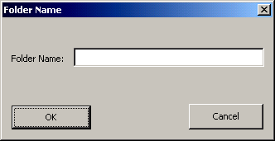
Rename Folder
In this screen, you select the folder you type in a new name for the folder, it must be a name that does not already exist under the user directory

Change Current Folder
This screen allows you to change the folder which all the charts are displayed fromm and saved to and converted, printed or otherwise worked with.
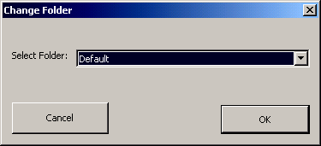

GETTING HELP
You can get help in any screen, dialog box, or menu item by pressing {F1} or clicking on the Help button in any dialog box. To get help on a menu item, select a menu item with the mouse and press {F1}.

Contents
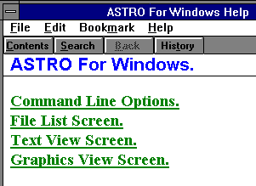
Help Contents
This menu item opens the ASTRO help file and selects the contents page.
To view the help, click the mouse on the underlined topic to view that text.
While in the help system, clicking the "Contents" button above will cause this screen to be displayed.
Clicking "History" allow you to view topics you viewed previously.
Clicking "Search" will bring up the dialog box on the right side of this page.
Search for Help on
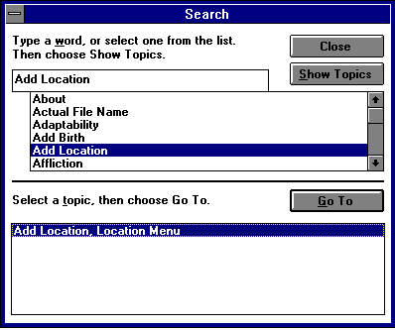
Search For Help on Dialog Box.
This menu item opens the ASTRO help file and opens the Search dialog box.
To use this dialog box, select a topic from the list, click "Show Topics", select the topic you wanted, press the button, "Go To".

How to Use Help
This menu item opens the help for WINHELP.EXE, the Windows Help program.

Astrology Help
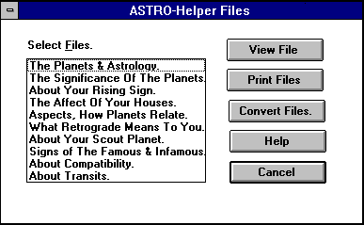
ASTRO-Helper Dialog Box

Astrology Help or ASTRO-Helper is a system of astrology topics that you can view, print or convert to text.

View File.
The Astro-Helper files are reference files on disk that you can use to learn basic astrological ideas.
This button will view the file that is selected or surrounded by a dotted line.

Print Files.
This allows you to print out the Astro-Helper files to your printer. This will allow you to print copies of these files to give to people you create charts for.
This button will print all the files that you select.

Convert Files.
This allows you to convert the Astro-Helper files to a file format you can use with your word processor. This will allow you to modify it or extend this file before printing copies of these files to give to people you create charts for.
This button will convert all the files that you select.

ASTRO UTILITIES
These are functions and utilities, which you can use to help you with ASTRO.

Read File Into Data.
This function allows you to read one of ASTRO's compiled files and get the original birth information back into the data dialog boxes. This function brings the information back into the dialog boxes that they were earlier associated with. It will not read natal birth data back into the compatibility dialog box.

Clear File List Selection.
This menu item clears the check marks in the file list. You can print, convert or kill all the files that are checked.

Edit File List Entry.
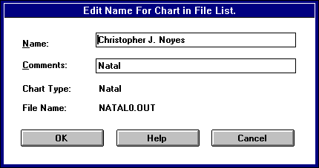
Edit File List Entry dialog box.
This menu item allows you to edit the name and comments in the file list. Select a file from the list, choose this menu item and you will edit the file name and comments and save it.
Rebuild File List.
If you have archived files off to other disks and now wish to use them again, this menu item will help. Copy your files to your user directory. Use this menu item to add the files to the file list. This menu item will scan for ASTRO For Windows and ASTRO DOS version 2.25+ file headers in all files in the User directory.

Sort File Listing.
If You have deleted files from the file list and wish to keep it around after you quit ASTRO and want it to be in order, use this function. This menu item sorts the file on the person's name on the chart, and places them in alphabetical order. Just select this menu item to run it.

Archive Charts.
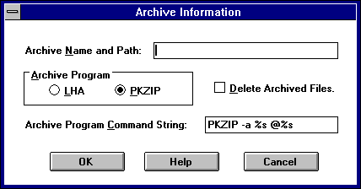
Archive and Unarchive Dialog Box.

This menu item archives all the checked files in the file list to a .ZIP or .LZH file. You must own a copy of PKZIP.EXE or LHA.EXE to use this function. This now supports WinZip 9.0's command line functionality, you will need to install WinZip 9.0 and the command line optional features to do this.

Archive Name and Path: This is the file name and path to the archive file that you want to use. If you do not put a path or disk letter, it will be archived to the User directory. You must enter a valid file name here, but you do not need to enter the file extension.
Archive Program: Select the program that you use for archiving files PKZIP supports the .ZIP file format and LHA supports the .LZH file format.
Delete Archived Files: If you check this box, once files have been added to the archive they will be deleted and killed from the file list.
Archive Program Command String: Generally leave this field alone unless you understand the program's command string. The first %s is replaced with the Archive file name. The second %s is replaced with a list of files to archive .

Unarchive Charts.
This menu item unpacks a .ZIP or .LZH type archive and inserts the contents into the file list. The fields in the dialog box operate the same as the archive charts operate.

Compress Database
This menu item compacts the database files and removes free and deleted records from it.

Backup Database
This menu item compacts the database files to a new name your original database i.e. astrow.mdb would besaved to astrowbackup.mdb. If you need restore the database, go into the astro for windows user/database directory, usually My Documents\Astro For Windows, rename astrow.mdb, something else, and rename, astrowbackup.mdb astrow.mdb

Reference Maps
If you have access to the internet, this option will bring you to some internet reference maps for longitude, latitude and time zone. It can also bring you to an internet longitude, latitiude, time zone lookup facility.

Today’s Planets
If you have the Astrological Calculators installed, this option will bring up the planets today program which will show you the current planets at this current moment.

Ephemeris
If you have the Astrological Calculators installed, this option will bring up the ehphemeris program which will show you a month’s display of the planetary positions.

MANAGING WINDOWS
The Windows menu lets you manage ASTRO's windows.

Arrange.
This menu command rearranges the icons for the minimized windows in ASTRO For Windows

Cascade
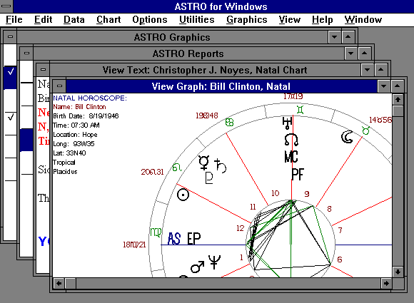
This menu command cascades all the windows on the screen overlapped.

Tile
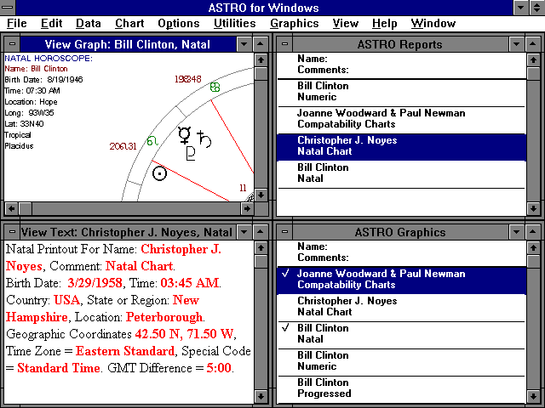
This menu command Tiles all the windows on the screen. Tiling windows makes them all visible, but smaller so they all can fit on the screen at the same time.

Graphic Files
You won't see this menu command unless you have closed the "ASTRO Graphics" file list viewer. This menu item reopens the "ASTRO Graphics" file list viewer.

Text Reports
You won't see this menu command unless you have closed the "ASTRO Reports" file list viewer. This menu item reopens the "ASTRO Reports" file list viewer.

USING OPTIONS
Use these dialog boxes to change the setup and defaults that ASTRO uses when horoscopes are created. You can also use the Options menu items to change disk and directory choices, and other options.
You can setup options for each major type of horoscope independently. You can setup many different types of characteristics to customize or setup a default type of setup.

Setup.
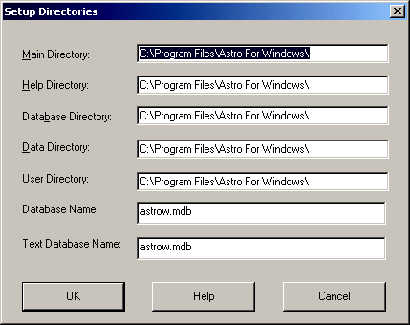
The Setup dialog box.

This dialog box allows you to customize disk and directory usages.
The Program Directory is where ASTRO itself, and the utility programs are found. These files end with .EXE and .DLL.
The Help Directory is where the help file and the Astro-Helper files are found. These files end with .HLP.
The Database directory is where the database files are located. These are files for the Birth and Location database. These files end with .DAT, .NDX and .LST.
The Data Directory is where the files that produce ASTRO's text is found. These files end with .TXT, .NDX, .TBL, .ORB or .DAT. Note there is one .NDX file for every .TXT file of the same main name.
The User Directory is where the charts that ASTRO compiles are written. If you convert a file to a text file, or print to a disk file, ASTRO writes that file to the user directory unless you say otherwise. When You save and load the birth data, you save and load from this directory unless you say otherwise.
The Database Name is the Access Database that is used for text sources and the birth and location database.
Text Database Name is the Access Database that is used for generating the reports, this can be different to support alternate texts.

Word Processor Conversion Setup.
The Word Processor Conversion dialog box.
This dialog box allows you to customize the way ASTRO converts files to word processing and ASCII. The following strings don't have any effect on word processing conversion other than ASCII conversions.
Conversion. This is your default standard word processing conversion. Pick one that your favorite word processor supports. This will most likely either be one of the two WordStar types, one of the two WordPerfect Choices, Microsoft Word, or several types of ASCII. Many Windows Based word Processors will accept .RTF
type files as well.
If you are using ASCII, you can eliminate the soft line breaks and only have the paragraph/hard line breaks in the file. Using this setting, may make reformatting easier, once it gets into your word processor.
Column Width. This is the width, in inches and hundredths of an inch. You would enter a 6-1/2 inch width as 6.50. When converting to certain word processors, this will be based on 10 pitch or 10 characters per inch. Setting the column width to 6.50, the column width would be 65 columns.
NOTE: The file conversion does not concern itself with fonts. If You are using a laser printer you should set the font, provide settings and reformat the document once you are in your word processing program.
Left Indent. This is the width, in inches and hundredths of the left margin. You would enter a 1 inch left margin as 1.00. When converting to certain word processors, this will be based on 10 pitch or 10 characters per inch.
If you have 8-1/2" wide paper, and want a one inch margin and the text to be 6-1/2 inch wide, you would set these two fields as suggested here. This will give you a one inch right margin.
Print Cover Page. If you check this check box, cover pages are printed if they exist.
Print Comment Page. If you check this check box, comment pages are printed if they exist.
Print Comment before Text Page. This sets the default that the printing dialog box is set to when you select files to print. If you check this check box, ASTRO prints the comments before the chart and after a cover page.

Setup Styles.
Report Styles dialog box.
If you choose this button and you are using Microsoft RTF as your conversion for Word For Windows for example, you can customize the fonts that are used. Each button corresponds to a font you can change.

Pseudo ASCII.
Most people will choose to use the Plain ASCII conversion. The Pseudo ASCII conversion converts the Bold, underline codes to specific strings that you can specify.
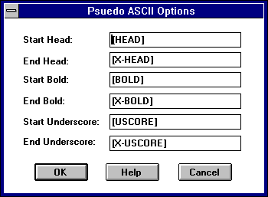
The Pseudo ASCII dialog box.
Start String. This string marks the start of main heads in the file.
End Head String. This string marks the end of main heads in the file. This must turn off what the previous command turned on.
Start Bold String. This string marks the start of bold face in the file.
End Bold String. This string marks the end of bold face in the file. This must turn off what the previous command turned on.
Start Underscore String. This string marks the beginning of underscore or italics.
End Underscore String. This string marks the end of underscore or italic started above function.

Graphic Options
The Graphics Options dialog box.
This dialog box sets up how a default cartwheel is displayed. It also sets up how a cartwheel is printed
In these fields, check a box to turn on an option, depending on how you want these options dealt with.
Show Sign Names. This turns on or off display of the sign Names around the dialog box. When glyphs are used, these symbols are displayed as glyphs. This is more useful for beginners, particularly if only the signs are displayed.
This option may also not want to be used because it clutters up the dialog box when combined with the house cusp number and house cusp degrees.
House degrees.
Show House Cusp Degrees. This turns on or off display of the degrees of each house cusp. These are placed at each house cusp. This will be useful for most people knowledgeable about astrology.
Inside house numbers.
Show House Cusp Numbers. This turns on or off display of the house numbers. These are placed midway between each pair of house cusp. This is useful and one of the more used options.
Aspect circle.
Show Aspect Lines. In a natal or numeric chart which was compiled using compile natal chart signs, houses and aspects or greater, or you compiled default chart with aspects turned on, lines showing the aspects will be drawn in the middle of the dialog box. These are useful for seeing the types of aspects involved.
If the chart does not have any aspects, the inner aspect circle won't be drawn and no aspects will be drawn.
No glyphs. Use glyphs.
Use Glyphs. This switches between the use of the classical astrological glyphs and two and three letter abbreviations for the signs and planets. The glyphs display more neatly and cleanly, and once you know all the signs, this is the way to display charts. A novice can use the abbreviations until they are comfortable and switch over to the glyphs.
Dashed lines are sign lines,
dotted lines are house lines.
Show Sign Lines. Shows or hides the display of the sign divisions on the dialog box. If a novice and you are only displaying the planets in the signs you will want this option.
Plot outside. Plot inside.
House Numbers Outside. Checking this option will place the House numbers outside the circles. In multiple wheel charts, you may want to choose this option. You may also want this option to produce charts that match earlier charts produced by ASTRO.
Plot classically.
Plot Classically. Checking this option causes the planets glyphs, and degrees to be plotted on a diagonal the same as the degrees.
Don't show degrees. Show planet degrees
Show Planet Degrees. If you check this option the plane degrees will be plotted below the glyph, otherwise they are not plotted and the glyphs are plotted larger.
Tick Wheel Options.
Sign Tick Wheel. If you check this option, an outside wheel is drawn with the sign glyphs.
Decan Tick Wheel. If you check this option, an outside wheel is drawn with ticks marked for the sign decans, inside the sign tick wheel if shown and outside the degree tick wheel is shown. A decan is 10 degrees.
Degree Tick Wheel. If you check this option, an outside wheel is drawn with ticks every degree depending on resolution. On the dialog box ticks are shown every 3 degrees.

Graphic Colors.
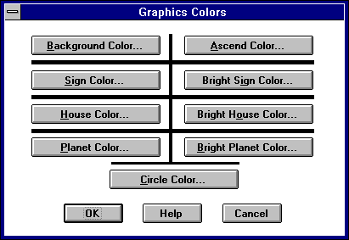
The Graphic Colors dialog box.
To use this dialog box, click on a button corresponding to the color you wish to customize. click on the "OK" or cancel button once finished.
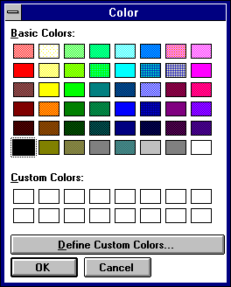
Colors dialog box.
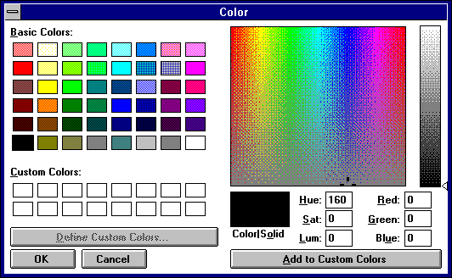
Custom Color Section of Colors dialog box.
Background Color. Black. This is for the general background color .
Signs Color. Green or Dashed. This is the color that the actual sign division lines are drawn in.
Houses Color. Red or Dotted. This is the color that the house division lines, are drawn in.
Planets Color. Light Grey. This is the darker color for the planets. This is not used at this time.
Circles Color. Dark Grey. This is the color used for the circles themselves.
Ascend Color. Bright Yellow or dot-dashed. This is the color used for the Ascendant line and glyph.
Bright Signs Color. Bright Green. This is the bright color for the sign division lines. This is the color that the sign names are printed in.
Bright Houses. Bright Red. This is the color that house numbers and house data when displayed are printed in.
Bright Planets. White. This is the color that the individual planet glyphs and their accompanying positions are displayed with.

Graphic Fonts.
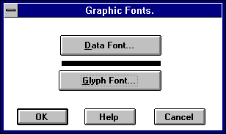
Graphic Fonts dialog box.
The Graphic Fonts dialog box allows you to customize the fonts that are used for the graphics. Just select the font. The size is scaled to fit.
Click on the button corresponding to the font you wish to change.
You can in all cases customize the data font which is used for the name, data, and chart labels.
If you provide your own glyph font or you don't wish to use glyphs, you can provide a font for glyphs.

Graphic File Conversion.
Graphic File Conversion dialog box.
This dialog box allows you to setup how graphic files are converted.
Graphic File Format: This is the file format that you want to use.
Image Size Units: This is the units that you want to use for your graphic file. If you know you are going to place it in a document and want and area 5 x 7.5" you might pick inches, otherwise you would probably pick dots.
Image Resolution: This is the resolution of the image. If an image is created to fit a specific resolution, it will print sharper.
Height: This is the height of the image in units.
Width: This is the width of the image in units.
Reverse Mono Graphics: If you choose a mono b&w 2 color graphic file, you can choose to reverse the image depending on what you need or want. When you reverse, all black will be white and white will be black.

Viewer Setup.
Viewer Setup dialog box.
Pressing one of the buttons will bring up a dialog box that will allow you to set the font, size, style and color for the text report viewer dialog box.

Editor Setup.
The Editor Setup dialog box lets you setup the word processor that you want to use to edit your reports with ASTRO professional.
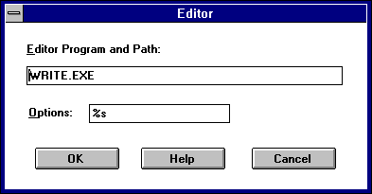
Edit Setup dialog box.
Editor Program and Path: Enter the disk, directory and program name of the word processing program you wish to use. WRITE.EXE comes with Windows and does not need a path. ASTRO For Windows works well with Word For Windows and other word processing software.
Options: This is the option string needed to open a file from the command line. For many word processors this is %s which is the file and path of the file to edit.

Customize Orbs.
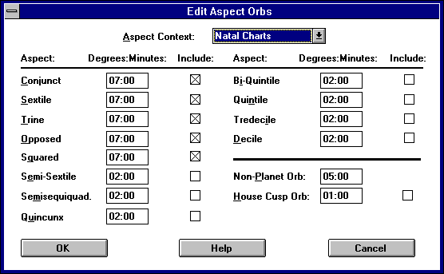
The Customize Orbs dialog box.

This dialog box allows you to setup custom orbs or change the orbs that the program uses to give you results that you expect. ASTRO uses a separate set of data for each type of chart.
If you don't consider yourself an expert astrologer, I would suggest leaving these as they are.
You can select the type of chart that you want to edit.
Aspect Context. This is the Type of Chart that the aspects will apply toward. If you expect the data that you have entered to be saved, you must press the "OK" button and reenter this dialog box before selecting a different context. When you come into this dialog box, you should select a Context before changing data.
Degrees and Minutes. These are the degrees and minutes of Orb. A seven degree orb says to consider an aspect seven degrees before that degree and seven degrees after.
Include. This says whether to Make use of this aspect when calculating charts.
Non Planet Orb. This is the Orb used for Ascendant, Coeli, Im Coeli, etc.
House Cusp Orb. This is the orb used when considering Aspects to House Cusps.
Include House Cusps. Indicates whether aspects to house cusps are considered.

Chart Options
The Customization dialog box.
The Options dialog box.
Natal.
Use this dialog box to setup the options used by the Compile menu default birth chart selection. This selection also affects various aspects of other birth charts. For the most part, though, you won't have to change any of these options except to setup a default chart.
You may wish to change some of these once you have experience with ASTRO to customize it to your personal preferences. These are a few of the more important options and what they mean to you.
You will have the option often when running the program to change the options on the fly as you work when at the compile menu.
ASTRO handles these dialog boxes using two layers. The top layer deals with the more basic issues. These are more likely to change when you compile charts. The lower layer represents things that you probably won't change so often.

Options.
Relocate Chart. If This option is checked and there are house cusps generated in this chart, ASTRO will relocate the chart, using the data in the Relocation Data dialog box.
Progress Chart. If this option is checked, ASTRO will progress based on the contents of the Progression Data dialog box.
Progress Cusps. This option applies most to progression reports but may apply to any progressed report. If you checked, the house cusps that the report's houses are based on will be progressed, otherwise they will be the natal cusps.

Output Files:
This section allows you to control the types of files generated.
Text Chart Files. If you are trying to generate output only for graphics or a database application you will want to uncheck this option, otherwise check it.
Graphics Chart File. If you want to view a graphics cartwheel, you will want this, check the option. With some charts this won't matter if they don't generate graphics data.

Grid File. Astro now generates astrological grids as well as text and graphics. These use special grid report formats.
Data File(s). Use this option for database applications. If this options is checked, the below option will apply.
Data File Type. This only applies if the above option is checked. For most purposes, "Comma Delimited is the best choice. Binary data is a proprietary format designed for future programs. If you want to write a program to analyze data, I can provide you with the format of this file.
Interpret Report. You can turn on and off the interpretive styles of any report and switch from the interpretive style to a data style, which for some charts may make it easier to read for some people, each uses a different report format
Default Options Used.
Tropical or Sidereal Zodiac. You will probably not change this option. Most western astrologers work with Tropical charts. Some european or eastern astrologers use a Sidereal zodiac. In a Sidereal chart, the first degree of Aries corresponds to the star constellation Aries. In a Tropical chart, the first degree of Aries corresponds to the vernal equinox, or the first point of spring. Over time, the relationship between the star constellation Aries and the vernal equinox has changed. Currently these two systems are off about 24 degrees and it is always changing. ASTRO uses "Fagan's Ayanasma" in making this calculation.
NOTE: This option is for experts only. Don't select the Sidereal option unless you know that you want it.
House Procedure. There are many different ways of calculating your house cusps. This option allows you to select one of the more popular systems. ASTRO supports Equal House, Placidus, Koch, Regiomontanus, Campanus, Morinus, and M-House systems. Placidus is the most popular for general purpose astrology, but fails at high latitudes, where you may want to use another. The Equal House system is the simplest, and often used, but may not produce accurate results. See an astrology text for more information on house division techniques.
Find Houses. Self explanatory. Determines if ASTRO will find house cusps.
Find Aspects. Self explanatory. Determines if ASTRO will find planetary aspects.
Find Extended Aspects. If This options is not checked then the Customize Aspect Orbs dialog box is used to find if a certain aspect is checked. If this options is checked, all possible aspects are considered. Using the Customize Aspect Orbs dialog box will probably be the first dialog box to work with if you want to change aspects.
Summary at End of Report. If this options is checked, a report is placed at the end of the report, summarizing numbers of different trends and tells you what they mean.
Miscellaneous Calcs. If this options is checked, ASTRO will calculate several different miscellaneous values such as decanates of signs, critical degrees, and anaretic degrees.
Extended Misc. Calcs. If this options is checked, ASTRO will display more miscellaneous information about a position including duad, navasma, Whether a planet is in 'fall', it's 'home' sign, decan and duad rulers, etc.
Vertex and East Point. If this option is checked, ASTRO will calculate the Vertex and East Point for the chart in question. These angles are highly theoretical in nature. No text on these is available.
Midpoint Options.
These are advanced options for which there is no text available.
Basic Midpoints Only. This option produces midpoints between the Ascendant/Coeli, North Node/ South Node and Coeli/ Immum Coeli pairs.
Half Midpoints Only. With each pair of bodies or angles, there are two midpoints, each 180 degrees apart. This option does the equivalent of Full Midpoints below, but only does the main half of the midpoint pair.
Full Midpoints. This option produces midpoints between all major angles in the chart you are compiling. This option produces a lot
of text.
Aspects With Midpoints. This Option produces aspects between the midpoints produced by both selections above and the planets. Note that there may be no aspects or very few since only conjunctions, and squares are considered, and only a one degree 30 minute maximum orb is allowed.
Generate Graphics Data. If this options is checked, this option produces graphics data to run using the graphics cartwheel option.
For more Information about these options. See the section "Compiling a Chart". You can get more information on each option from the help system.

Polar Swap. You can use this option to move the Swap the sign of the MC and IC in polar latitudes. Turning on this option, keeps the MC in the upper half of a cartwheel.

Asteroids. This version of ASTRO adds the capability to include the major asteroids in the chart.

Compatibility.
Use this menu item to setup the options used by the Compile menu compatibility chart selection. The options operate as they do in the birth options menu item but you won't get midpoints as this operation doesn't support midpoints.
Transits.
Use this menu item to setup the options used by the Compile menu transits chart selection. The options operate as they do in the birth options menu item , but you won't get midpoints, as this operation doesn't support midpoints.

Progressions.
Use this dialog box to setup the options used by the Compile menu progressions chart selection. The options operate as they do in the birth options dialog box, but you won't get midpoints, as this operation doesn't support midpoints.

Solar Directed.
Use this menu item to setup the options used by the compile menu solar directed chart selection. The options are identical to the ones that you use for the birth options menu item.

Harmonic.
Use this menu item to setup the options used by the compile menu harmonic chart selection. The options are identical to the ones that you use for the birth options menu item.

Composite.
Use this menu item to setup the options used by the compile menu composite chart selection. The options are identical to the ones that you use for the birth options menu item.

Composite Transits.
Use this menu item to setup the options used by the Compile menu transits of composite chart selection. The options are identical to the ones that you use for the birth options menu item.

Relocation.
Use this menu item to setup the options used by the Compile menu relocation chart selection. The options are identical to the ones that you use for the birth options menu item.

Fixed Stars.
Use this menu item to setup the options used by the Compile menu fixed star chart selection. The options are identical to the ones that you use for the birth options menu item.
Arabic Parts.
Use this menu item to setup the options used by the Compile menu arabic parts chart selection. The options are identical to the ones that you use for the birth options menu item.

Numeric.
Use this menu item to setup the options used by the Compile menu numeric chart selection. The options are identical to the ones that you use for the birth options menu item.

Quick Daily Transits
ASTRO For Windows has the ability to do a transits chart for Up-to 2 persons each day when your computer starts up each day. For this to happen there needs to be an icon in your Startup Group. This is handled when you install the program. If you choose not to do it you can run this option manually as an icon is placed in your program group labeled Quick Daily Transits. If for some reason, you did not choose this option, and want it now, you should rerun the installation program.
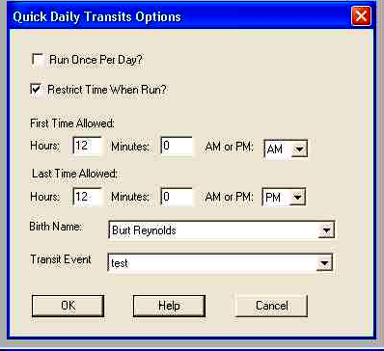
The program then automatically calculates a transits file generating a graphics file and a text file. This file is Not saved in your file list so you don't have to delete it. These files are kept until you close them.

In this version, in the Quick Daily Transits Options, you configure the name that you want and the transit event as found in the birth info and transits info database. The file no longer has to be saved to support this.

If for some reasons you need to limit when The Quick Daily Transits might start up use the Quick Daily Options Dialog Box. You can find this in Options Menu, Quick Daily Options
Checking on Run Once Per Day only starts up Quick Daily Transits once per day or 24 hour period, no matter how many times your computer is restarted. This can help to minize the nuisance value of Quick daily transits starting multiple times a day if you just have to reboot your computer for some reason. If you check on Restrict Time when Run you can use the First time Allowed and Last Time Allowed to specify a time range when Quick Daily Transits Can start up. This does not specify When it Does start up, only when it Can start up. If for some reason ASTRO in Quick Daily Transits mode does start up when it should not, it will promptly shut down before calculating a chart.

Miscellaneous Items
Chart Header and Disclaimer Capabilities.
For those of you generating charts for sale, ASTRO for Windows can now automatically include a Header file and a disclaimer file. when ASTRO computes a text report, it automatically looks for the file HEADER.TXT in your ASTROW directory and Copies the file into the top of the Report. If you want material discribing your company, or wish to put a disclaimer at the top of the report file this is an excellent way to do this automaticall. When ASTRO For Windows finishes generating a text report it looks for the file DISCLAIM.TXT in your ASTROW directory and Copies the file into the end of the Report.

These files are is AST type files similar to the files that you generate with TBT or Text Builder Toolkit and can be maintained with TBT. These files can be up to 1000 bytes in length. They should only have paragraph endings. These files are formatted the way an ASTRO report is formatted. These files can use { and } to mark bold and < and > to mark Italic or Underscore. Headings can be surrounded with [ and ]. See the section in the manual "Modifying the Text Source"

APPENDIX

& ADVANCED

REFERENCE GUIDES

IMPORT FILE FORMAT
If you choose File Open Birth Data, you can import a specially formatted text file as well as a binary file. You can create this file in certain types of programs.

The file format is as follows:
the first item in any type of data record is a two letter code followed by the data. This two letter code indicates the type of data that follows. There can be one of each type of record in a file.
NOTE: the punctuation is very important and must be used as shown.
This is an example of a file. In the example the two letter codes are highlighted in bold:
BD "Christopher J. Noyes", M, 3/29/1958, 3:45 AM
BL "USA", "New York", "Brooklyn", 72W45, 40N45, 0, 5, 0
BR NO, 1, 12:00 AM

TYPES:
BD--BIRTH DATA
Format:
"Name", Sex, Mo/Day/Year, Hrs:Min AMPM
Explanation:
Name is the person's name surrounded by Double Quote (") marks. Sex is either Male, Female, M, or F. Mo is the month of birth, Day is the day of birth, and Year is the year of birth including the century, these are separated by '/'. Hrs is the hour, and Min are the minutes separated by a ':', either AM or PM follows.
Example:
BD "Christopher J. Noyes", M, 3/29/1958, 3:45 AM
BL--BIRTH LOCATION
Format:
"Country", "State", "Location", ddWmm, ddNmm, Usezone, Zone, Spec
Explanation:
The field Country is the country in double quotes ("). The field State is the country in double quotes. The field Location is the country in double quotes. ddWmm is the longitude formatted with either W or E in the middle indicating East or West, for example 20W45. ddNmm is the latitude formatted with either N or S in the middle indicating North or South, for example 40N45. Usezone is either 0 or 1. If Usezone is 1, Zone is the Time Zone number (see below), and Spec is the Special Code number (see below). If Usezone is 0, then Zone is GMT offset hours, and Spec is the GMT offset minutes.
Example:
BL "USA", "New York", "Brooklyn", 72W45, 40N45, 0, 5, 0
Time Zones:
1. Eastern Atlantic.
2. Atlantic Standard.
3. Eastern Standard.
4. Central Standard.
5. Mountain Standard.
6. Pacific Standard.
7. Hawaii.
8. Greenwich Mean Time.
9. Western European.
10. Eastern Europe.
11. Eurasia.
12. China.
13. Japan.
14. Indochina.
15. New Zealand.
16. East Australia.
17. South Australia.
18. West Australia.
19. India.
20. Samoa.
21. International Date Line.
22. Other.
Special Codes:
0. Standard Time.
1. War Time.
2. Daylight Savings.
3. Double British Summer.
4. Summer Time.
5. Winter Time.
6. Other.

BR--BIRTH BASIC RECTIFICATION
Format:
Known, System, Hours:Mins AMPM
Explanation:
The Field Known is either YES or NO. System is one of the rectification systems shown below. Hours is the trial birth Hours, and Mins is the trial birth minutes followed by AM or PM. If the rectification system is 4, then a BX record must follow or default values will be used.
Example:
BR NO, 1, 12:00 AM
Rectification Systems Are:
0. Solar Chart Method.
1. Flat Chart Method.
2. Sunrise Birth-Time.
3. Trial & Error.
4. Use Known Angle.

BX--BIRTH EXTENDED RECTIFICATION
Format:
angle, sign, degrees, minutes
Explanation:
The field Angle is the angle number (see below) which you know, Sign number (see below) is the sign of that angle, Degrees is the degrees of the angle, and Minutes are the minutes of that angle. The more exact your information is, the more exact the chart will be.
Example:
BX 0, 10, 18, 16
Angles:
0. 1st House/Ascendant.
1. 2nd House.
2. 3rd House.
3. 4th House/IC.
4. 5th House.
5. 6th House.
6. 7th House/Desc.
7. 8th House.
8. 9th House.
9. 10th House/MC.
10. 11th House.
11. 12th House.
12. Ascendant.
13. Descendant.
14. Medium Coeli/Midheaven.
15. Immum Coeli/Nadir.
Signs:
0. Aries.
1. Taurus.
2. Gemini.
3. Cancer.
4. Leo.
5. Virgo.
6. Libra.
7. Scorpio.
8. Sagittarius.
9. Capricorn.
10. Aquarius.
11. Pisces.
CD--COMPATIBILITY/
COMPOSITE BIRTH DATA
Format:
"Name", Sex, Mo/Day/Year, Hrs:Min AMPM
Explanation:
Name is the person's name surrounded by Double Quote (") marks. Sex is either Male, Female, M, or F. Mo is the month of birth, Day is the day of birth, and Year is the year of birth including the century, these are separated by '/'. Hrs is the hour, and Min are the minutes separated by a ':', either AM or PM follows.
Example:
CD "Christopher J. Noyes", M, 3/29/1958, 3:45 AM
CL--COMPATIBILITY/
COMPOSITE BIRTH
LOCATION
Format:
"Country", "State", "Location", ddWmm, ddNmm, Usezone, Zone, Spec
Explanation:
The field Country is the country in double quotes ("). The field State is the country in double quotes. The field Location is the country in double quotes. ddWmm is the longitude formatted with either W or E in the middle indicating East or West, for example 20W45. ddNmm is the latitude formatted with either N or S in the middle indicating North or South, for example 40N45. Usezone is either 0 or 1. If Usezone is 1, Zone is the Time Zone number (see BL), and spec is the Special Code number (see BL). If Usezone is 0, then Zone is GMT offset hours, and Spec is the GMT offset minutes.
Example:
BL "USA", "New York", "Brooklyn", 72W45, 40N45, 0, 5, 0
CR--COMPATIBILITY/
COMPOSITE BASIC BIRTH
RECTIFICATION
Format:
Known, System, Hours:Mins AMPM
Explanation:
The Field Known is either YES or NO. System is one of the rectification systems shown below. Hours is the trial birth hours, and Mins is the trial birth minutes followed by AM or PM. If the rectification system is 4, then a BX record must follow or default values will be used.
Example:
BR NO, 1, 12:00 AM
Rectification Systems Are:
0. Solar Chart Method
1. Flat Chart Method
2. Sunrise Birth-Time
3. Trial & Error
4. Use Known Angle
CX--COMPATIBILITY/ COMPOSITE EXTENDED
BIRTH RECTIFICATION
Format:
Angle, Sign, Degrees, Minutes
Explanation:
The field Angle is the angle number (see BX) which you know, Sign number (see BX) is the sign of that angle, Degrees is the degrees of the angle, and Minutes are the minutes of that angle. The more exact your information is, the more exact the chart will be.
Example:
CX 0, 10, 18, 16
TD--TRANSITS DATA
(Start Date)
Format:
"Event", Sex, Mo/day/year, hrs:min AMPM
Explanation:
Event is the person's name surrounded by double quote (") marks. Sex is either Male, Female, M, or F and is ignored in this case. Mo is the month in question, Day is the day in question, and Year is the year in question including the century, these are separated by '/'. hrs is the hour, and min are the minutes separated by a ':', either AM or PM follows.
Example:
TD "Today", M, 2/12/1992, 4:00 PM
TL--TRANSITS LOCATION
Format:
"Country", "State", "Location", ddWmm, ddNmm, Usezone, Zone, Spec

Explanation:
The field Country is the country in double quotes ("). The field State is the country in double quotes. The field Location is the country in double quotes. ddWmm is the longitude formatted with either W or E in the middle indicating East or West, for example 20W45. ddNmm is the latitude formatted with either N or S in the middle indicating North or South, for example 40N45. Usezone is either 0 or 1. If Usezone is 1, Zone is the Time Zone number (see BL), and Spec is the Special Code number (see BL). If Usezone is 0, then zone is GMT offset hours, and Spec is the GMT offset minutes.
Example:
BL "USA", "New York", "Brooklyn", 72W45, 40N45, 0, 5, 0
TA --TRANSITS DATA
(Transit Count, Offset and Planets)
Format:
Count, start, End, Months, Days
Explanation:
Count is the number of transit charts. Start is the starting planet number (see below). End is the ending planet number. Months is the number of months to offset each chart, and Days is the number of days to offset each chart
Example:
TA 7, 1, 5, 0, 1
Planet Numbers You Can Use Are:
0. Ascendant.
1. Sun.
2. Moon.
3. Mercury.
4. Venus.
5. Mars.
6. Jupiter.
7. Saturn.
8. Uranus.
9. Neptune.
10. Pluto.
11. North Node.
12. South Node.
13. Medium Coeli.
14. Immum Coeli.
15. Part Of Fortune.
16. Vertex.
17. East Point.
RD -- RETURN DATA
Format:
Planet, Smonth/Say/Syear, Emonth/Eday/Eyear, Prog
Explanation:
Planet is either 0 for the Sun or 1 for the Moon. Smonth is the starting month, Sday is the starting day, and Syear is the starting year for the series of returns. Emonth is the ending month, Eday is the ending day, Eyear is the ending year. Prog is either YES or NO indicating to progress the return dates. If Prog is Yes, then a RP record must follow.
Example:
RD 0, 1/1/1991,
1/1/1993, NO

RP--RETURN PROGRESSION DATA
Format:
System, Year, Month, day, Target
Explanation:
System is a number indicating the progression system (see below). Years is years to progress, Months is months to progess and Days is days to progess. Target is either Yes or NO. If Target is YES then Months, Days and Years is a date, otherwise it is an offset.These are separated by a comma and a space as indicated below.
NOTE: this record is only used, and is required, if you choose YES in the progress field in the Return Data (RD) record.
Example:
RP 0, 40, 0, 0, NO
Progressions systems are:
0. Secondary (day for a year).
1. Tertiary (day for a lunar month).
2. Minor (lunar month for a year).
RL--RELOCATION DATA
Format:
"Country", "State", "Location", ddWmm, ddNmm, Usezone, zone, spec
Explanation:
The field Country is the country in double quotes ("). The field State is the country in double quotes. The field Location is the country in double quotes. ddWmm is the longitude formatted with either W or E in the middle indicating East or West, for example 20W45. ddNmm is the latitude formatted with either N or S in the middle indicating North or South, for example 40N45. Usezone is either 0 or 1. If Usezone is 1, zone is the Time Zone number (see BL), and Spec is the Special Code number (see BL). If Usezone is 0, then Zone is GMT offset hours, and Spec is the GMT offset minutes.
Example:
BL "USA", "New York", "Brooklyn", 72W45, 40N45, 0, 5, 0
PD--PROGRESSION DATA
Format:
System, Year, Month, Day, Target
Explanation:
System is a number indicating the progression system. Years is years to progress, Months is months to progess and Days is days to progess. Target is either Yes or NO. If Target is YES then Months, Days and Years is a date, otherwise it is an offset. These are separated by a comma and a space as indicated below
Example:
PD 0, 40, 10, 20
Progressions Systems Are:
0. Secondary (day for a year).
1. Tertiary (day for a lunar month).
2. Minor (lunar month for a year).

TBT TEXT BUILDER TOOLKIT
TBT for Windows or Text Building Toolkit, is a Windows based system which contains all the tools you need to edit, modify, add, and your text for use with ASTRO for Windows.
TBT contains editing screens that allow you to edit ASTRO's text easily and quickly. You can also convert old text files.
TBT uses the same user interface that ASTRO For Windows uses so it should be easy to use. This version is totally different from the earlier version, all text is stored in an Access database in uncompressed form. The editors all have Font, Color and Size styling allowing you to see what you get and format the results so they look good. They also contain a spell checker, making it easy to make sure your texts are error free. There is also a point and click tab editor that allows you to modify tab settings, simply with a click of the mouse

Edit Text Sources
These menus allow you to edit the text sources so they can be used in all your reports the way you want.

Selecting Text Items
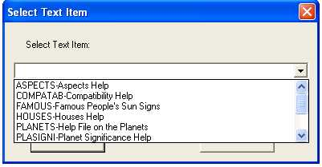
In order to edit texts, you need to select the type of text that you will be editing. With this dialog box, click on the down arrow and pull down the list and select what you want to edit and hit ok.

Edit Menu
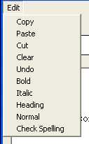
In every editing screen, at the top left there is a menu, that if you click where it says edit, you can spell check, cut, copy, paste and change the style of the text. In all but the check spelling choice, you need to have a text selected to use these choices

Tab Stop Editor
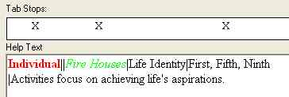
On certain editors where there are tab stops stored with the text, you can change the tab stops simply by right clicking with the mouse on the point where you want to set or clear a tab, an X indicates a tab stop. To enter tabs into the text you need to enter a | mark.

Changing Styles of Text
If you click and drag with the mouse over text and select it you can make text, bold, italic or heading style, from the edit menu.

Spell Checking
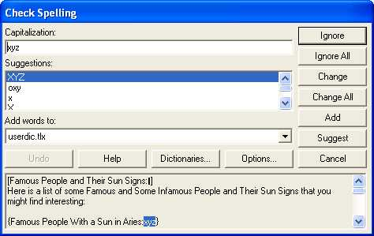
If you click on Spell Checking in the Edit menu a spell checker will be started on your text, if there are any spelling issues, this dialog box is presented, it works like spell checkers found in many programs.

Help Text
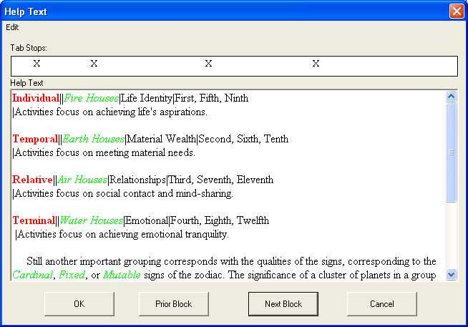
Astro For Windows's AstroHelper text is stored in chunks, each with corresponding tab stops. You can cycle through the chunks by hitting next block to get to the next and prior to get back, the text is saved before moving to a new block.

Regular Text
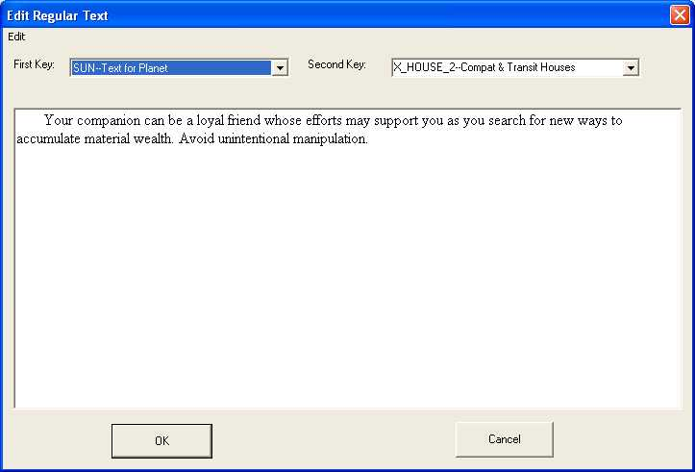
This screen allows you to edit planet, house, decan, house in sign and summary texts. To Use this screen, pull down the first key selector and select the first key, then in the second key pull down the matching key, if text is found for this combination, it is brought into the editor. If you have text in the editor when you change a selection or hit ok, the text will be stored in the database. If you only change one, key but not the other, the matching item if found will be loaded. You can also style and spell check from the edit menu.

Aspect Text
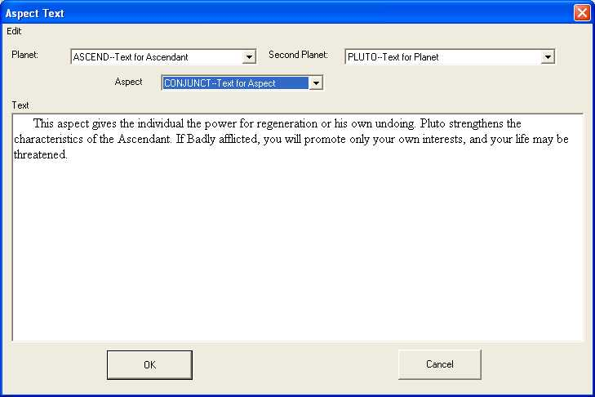
This screen is used to edit the Aspect and Midpoint Text. To use this screen, pull down the planet selector and select the first key, then in the second planet pull down the matching key, then the aspect selector (the aspect selector is also used for midpoint signs), if text is found for this combination, it is brought into the editor. If you have text in the editor when you change a selection or hit ok, the text will be stored in the database. If you only change one, key but not the other, the matching item if found will be loaded. You can also style and spell check from the edit menu.

Report Text
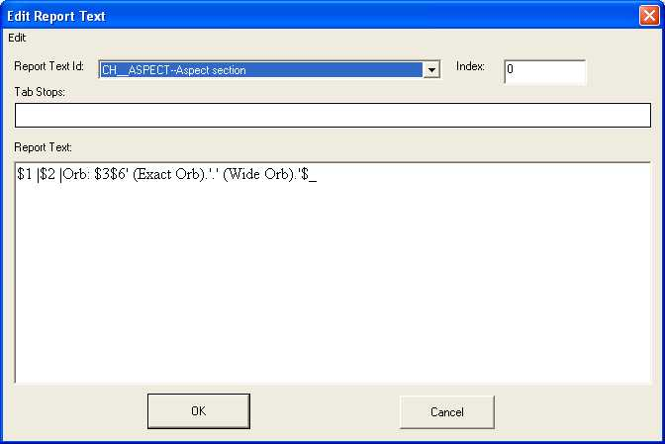
The Report Text Editor is used to edit report strings. This screen can be used to edit normal report items (those using index of 0) and array items (index greater than 0). Editing array items is easier in the Array Item Editor though. If you are editing normal report items, pull down the Report Text Id selector, leave index at 0 and the text item will be loaded in the editor. You will need to look at the section on the report text language for the codes that are used in this editor, which are by type. If there are tab stops for the text item, you can change these in this field. You can also style and spell check your text. When you change the selector, index or hit the ok button, the text will be saved to the database and the new one loaded.

Array Text Items
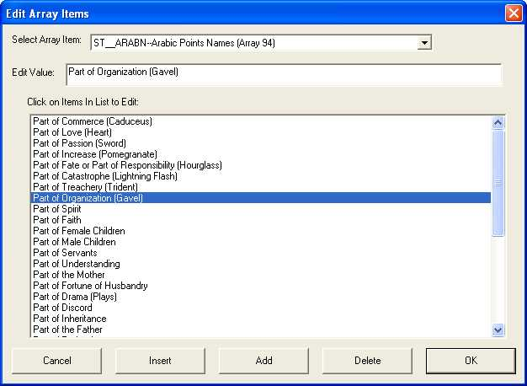
The Array Text Item Editor is used to individual items of a text item (which used to be report text with array index greater than 0). With this editor, pull down the Select Array Item selector, all of the items will be loaded into the list with the label (Click on Items in List to Edit). Go into that list select each item you want to edit and the text is moved to the Edit Value field where you can change it. If you change the item, the one you are editing will be saved and the new one loaded to the Edit Value field. If you want to Add a new item to the end of the List, Click Add and enter the value in Edit Value. If you want to Insert an Item in a particular position, highlight where you want the item entered and hit Insert. If you want to delete an item, click on the item and click on Delete. When you change the Select Array Item, or it the ok button, the data will be saved to the database and the new one loaded. There is no support for styling or spell checking, this can be done in the Report Text Editor.

Import
This feature allows you to import into TBT your old TBT text files. Updated text source materials are provided so you can merge the new materials into the existing source text. This feature imports the old TBT .AST files into the database. If you have made no changes to the text source don't use this. If you have an old copy i.e. pre 1.25 of TBT that you have modified source materials, merge your old files into the new files supplied before importing as, the newer files have new information

Selecting Files to Import
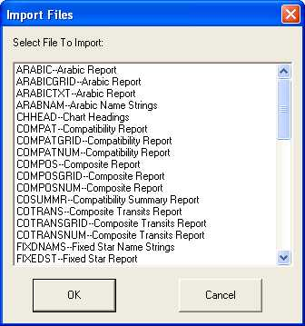
This screen allows you to select the text files to import. If you want to select one, click on the item, if you want to select multiple, hold down the control key while clicking on the items that you want. To select a range, click on the first one holding down the shift key, and then click on the last one.

Planet/House Text File
This imports text into the database for the planet house, sign, house sign and summary texts.

Aspect Text File
This imports text into the database for the aspect and midpoint texts.

Report Text File
This imports text into the database for the report text and array item texts. If you have made changes, make sure to merge your changes into the source text files provided because there have been substantial changes made for this release.

Options
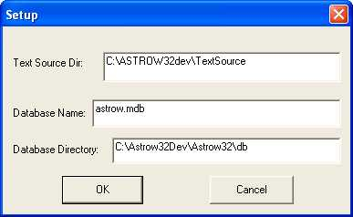
This screen allows you to setup the options used by TBT for imports and database settings. Unless you are supporting multiple text databases don't change the database directory or Database name. The text source directory should be the directory that you have your preexisting .AST files in.

CUSTOM REPORTS
You create Custom reports in the same manner as interpretation text files. The exception is that you encode specific variables in the files that show where ASTRO prints information and in what format.
You can use TBT to edit the reports as well. See the information on TBT for more information on editing reports with TBT.

NOTE: It will be much easier and much less troublesome if you start with one of the base report files that came with ASTRO when you create reports. This way sections won't be left out. If you wish to omit a section just have it print nothing. All report sections must be present.
The format of the report files is the same as the text files. There are a few minor differences though. If the first character in a line is a '@' the line is a comment. If a character is a '$', then the next character, show that specific data is placed there. This is called a variable. The character following can be either a capital letter or a normal letter.
If you want a '$' to print in your report, use "$$" or two '$' marks. If you want to cause a line break, and you want the line to stay together with the ones following it, use "$_", followed by a hard line break. ASTRO ignores the hard line break. Note if a '$' is found at the end of a line without any other character following it, processing of this section is stopped. You can use this if you have specific stuff that only occurs following one result (true or false) of some type of boolean string (see below).
You can change how ASTRO outputs certain variables. If an ASTRO variable outputs text string, preceding it with "$^", makes the variable output in all capital letters. There are two different number treatments. Numbers are either filled out to a specific number of digits or field width, or they are not filled out. Certain numbers are filled out with one or more spaces to the left of the number. Others are filled out with one or more zeros to the left of the number. If you want a number filled out to its proper width such as the minutes in a degrees and minutes printout, precede it with "$^". In some cases variables are provided so a number can be output in any number of ways.
There are two very special types of variables. These are especially powerful variable types and deserve special note.
One is a Boolean string variable. A Boolean variable tests if a condition is true or false. A Boolean string variable prints a specific string if the variable is true, and a different one if the variable is false. For example: $A|True|False|, '|' are delimiters. If the Variable '$A' is true, then "True" is printed out. If the variable "$A" is not true, or false, then "False" is printed. The delimiter is not printed. Make sure the delimiter is not in your string. Two delimiters without anything in between them indicate an empty printout string.
NOTE: Beware! Make sure not to include a delimiter in your text between the delimiters. For example if you chose the ''' as a delimiter, be sure you don't need to use the ''' in the text you wanted to output, otherwise choose another character. The
'|' is usually a good choice unless you need to embed tabs in your string. Otherwise, use another character. Your delimiter can change throughout a report, but must be the same through a single usage.
Like the Boolean string variables, the multiple-choice string variable prints out different strings depending on different conditions. Delimiters are used like the Boolean string type. The only difference is that there are more than two strings printed. Usually there are three or four. For example: $A|Direct| Retrograde|Still| In this case which is used to printout the state of planetary motion, if $A represents direct motion, "Direct" is printed out. if retrograde, then "Retrograde" is printed out, etc.
The specific variables printed out depends on the type of the report section handled. Each has specific types of output. Each report section will use the same variable names, but the uses will be different.
Tabs are entered into the report using the tabs command, Once tabs are defined in a report, once the printing routines see the '|' or tab character in a text stream where it is not a delimiter, the text is tabbed over to the next tab. Tabs are adjusted to take advantage of additional width available on a printout or screen. Tabs are adjusted to take advantage of the specific device being printed or viewed on.
In general you should place tabs in the first place where required, unless you need to override them. You can have any number of tabs commands.
NOTE: excessive tabs commands will slow down decompression of the file when viewing or printing.
For example if you wanted special tabs for the Aspects, put the tab command in the head before the aspects; that way it will be output only once, rather than in the aspect printout where it would be printed out each time an aspect is printed.
The format of the tabs command is TABS|tabwidth|tabcount|tab1|tab2|...|tabn| where the '|' is the delimiter and can be any non numeric character.
Tabwidth is the maximum width required to display the tabbed section out properly. If the width of the printout is more than this width, the tabs will be spaced out to fill the tabwidth at the tabs, so tabs are not necessarily fixed but will be consistant in a printout. Tabcount is the number of tabs. The tabs are expressed in columns, these are converted to the units required by a printer, screen or word processor.
NOTE: tabn indicates the last tab, and ... indicates the tabs which are not shown.
For example TABS|60|3| 10|20|30| sets up 3 tabs, the maximum width needed is 60, number of tabs is 3, and tabs are set at 10 columns, 20 columns, and 30 columns.
You can cancel all tabs by typing DEFTABS. This is equivalent to TABS|60|0|.
For more information on how to construct reports, look at the default reports that come with the program. These are an excellent example of how to use these features.

REPORT SECTIONS:
These are sections of the report files. They are indicated by the '#' sign followed by a name for that section. These sections are like the keys in the text source files. Each section marker must start a new line. Only the sections in the default report files are used. There is a global file that the program uses. This is made up of the files CHHEAD, MONTHSTR, STRINGS, and GENDER. When the report is being processed, if a section is not found in the report specific file, the program will attempt to find it in the global file. If one is found in the report specific file it will override the global one.

TABLE HANDLING:
In sections of the reports where tabs are used, in order to have them appear formatted in HTML output, reports use new table codes, which when not output as HTML, use the standard tabbing functionality. The code @TB starts a table section and ends a table section (corresponding to <table><tr> and </td></tr></table> in html). @TR ends a table row and starts a new one (corresponding to </td></tr><tr><td> in HTML). Tabs are replaced with </td><td>. If the output is not HTML, standard tabbing is used, these translations are only used between $TB and $TB combinations, the case of the codes is not significant, i.e. @tb is equivalent to @TB

REPORT VARIABLES:
The following is a listing of the specific report sections and the variables that are used in creating reports. In places you will see 0 fill. This indicates that this is a number, which if there are less than the specified number of digits, the missing digit will be a 0. for example 6 would be formatted as 06. Space fill uses spaces to fill out a fixed width. In general, it is better not to fill out numbers except using 0s. If you need a specific format use tabs where possible.

HEADERS & TITLES

TITLE:
This is a General title string used by all the reports.
Section: CHH_TITLE, CHS_SUMMARY_TITLE
Variables:
$1 Usually the first person's name.
(String #1).
$2 In compatibility and composite, the second person's name.
$3 The Comment Entered for the file.
$4 First name. (String #1).

BIRTH DATA:
This section is used to print out each individual's birth.
Section: CHH_BIRTH
Variables:
$1 The Person's Name. (String #1).
$2 Date Formatted using format appropriate for the country.
$3 Time Formatted using format appropriate for the country.
$4 Country Name.
$5 State Name.
$6 Location Name.
$7 Latitude Degrees.
$8 Latitude Minutes 0 fill.
$9 N for North, S for South.
$A Boolean String: |North|South|
$B Longitude Degrees.
$C Longitude Minutes 0 fill.
$D W for West, E for East.
$E Boolean String: |West|East|
$F Time Zone String.
$G Special Code String.
$H GMT offset hours Space fill.
$I GMT offset minutes Space fill.
$J GMT offset hours 0 fill.
$K GMT offset minutes 0 fill.
$L Sidereal time formatted as Hours:Minutes:Seconds
$M Sidereal hours 0 fill.
$N Sidereal minutes 0 fill.
$O Sidereal seconds 0 fill.
$P Month String.
$Q Month # Space fill.
$R Day # 0 fill.
$S Year # 0 fill.
$T First name. (String #1).
RETURN TITLE:
This is a General title string used by all the reports.
Section: CHR_TITLE, CHR_RETURN_HD
Variables:
$1 Usually the first person's name.
$2 Boolean String |Sun|Moon|.
$3 The Comment Entered for the file.
$4 First name. (String #1).

RETURN HEADER:
This section prints out all the header information
Section: CHR_RETURN_DATA
Variables:
$1 String #1 (see above).
$2 Starting date in appropriate format.
$3 Ending date in appropriate format.
NOTE:The Following only print if the report is Progressed. Boolean Strings should have a blank second (or false) parameter as shown.
$4 Boolean String |Progressed||
$5 Years Progressed Space fill.
$6 Boolean String |Years,||
$7 Months Progressed Space fill.
$8 Boolean String | months, and||
$9 Days Progressed Space fill.
$A Boolean String | days. Progression System is: ||
$B Multiple Choice Progression system |Secondary|Tertiary| Minor|
$C Years Progressed 0 fill.
$D Months Progressed 0 fill.
$E Days Progressed 0 fill.
$F Boolean String |.||
The Following prints the Person's first Name Only.
$G First Name.
The Following prints the planet name.
$H Boolean String |Sun|Moon|.
RECTIFICATION HEADER:
This is the rectification information for the header. This is only printed if the birth time is not known.
Section: CHH_RECT
Variables:
$1 String #1 (see above).
$2 Rectification System String.
$3 Trial Birth time in format.
$4 Boolean String |Based on Angle:|| prints only if the "Use Known Angle" is chosen for the rectification system
$5 String Name for the Angle.
$6 Boolean String | Using || prints only if the "Use Known Angle" is Chosen.
$7 Angle String formatted as Degrees Sign Minutes such as 30AQU10.
$8 Boolean String |.|| prints only if the "Use Known Angle" is Chosen.
$9 First name. (String #1).

PROGRESSIONS HEADER:
This is the progressions information for the header. This is only printed if a chart is progressed.
Section: CHH_PROG
Variables:
$1 String #1 (See Above)
$2 Years to Progress Space fill.
$3 Months to Progress Space fill.
$4 Days to Progress Space fill.
$5 Multiple Choice Progression System |Secondary|Tertiary| Minor|
$6 Years to Progress 0 fill.
$7 Months to Progress 0 fill.
$8 Days to Progress 0 fill.
$9 First name. (String #1).

ASPECT PRINTOUT:
This Section prints out the information for each aspect
Section: CH__ASPECT, CH__MID_ASPE
Variables:
$1 Planet's Name.
$2 Aspect Name.
$3 Second Planet's Name.
$4 Orb in degrees Space fill.
$5 String #1 (Person's Name).
$6 First name. (String #1).
$7 Multiple Choice String |Exact Orb|Not Exact Orb|Wide Orb|.
$8 Boolean String |Progressed |Natal|.
$9 String #2 (Person's Name).
$A First name. (String #2).

TRANSIT HEADER:
This header that prints out the transits data in a transits report.
Section: CHT_TRANS_PARAM
Variables:
$1 Number of transits.
$2 Start Planet Name.
$3 End Planet String.
$4 Interval Months Space fill.
$5 Interval Days Space fill.
$6 String #1 (See above).
$7 First name. (String #1).
TRANSIT ID:
This is a header that identifies the data for the transit.
Section: CHT_TRANS_ID
Variables:
$1 Transit Number Space fill.
$2 Date formatted.
$3 Month Space fill.
$4 Day 0 fill.
$5 Year 0 fill.
$6 Month String.
$7 String #1
$8 String #2
$9 First name. (String #1).

CHART DATA

RETURN ITEM:
This is how each return date is printed out.
Section: CHR_RETURN_ITM
Variables:
$1 String #1 (see above)
$2 Return date formatted for country.
$3 Return time formatted for country.
$4 Planet Name.
$5 Return Number.
$6 First name. (String #1).

HOUSE CUSP PRINTOUT:
These are the house cusps printed in two columns side by side.
NOTE: $1 and $2 are used to print all odd house cusps, $3 and $4 print all even house cusps.
Section: CH__HOUSE_CS
Variables:
$1 House Cusp # Space fill.
$2 House Cusp in DDSIGMM format such as 18AQU36
$3 House Cusp # (house+1) Space fill.
$4 House Cusp (house+1) in DDSIGMM format such as 18AQU36

HOUSE SIGNS:
This prints out the sign that each house cusp is in and various information about each one.
Section: CH__HOUSE_HEAD
Variables:
$1 House Number Space fill.
$2 Degrees Space fill.
$3 Sign Name.
$4 Boolean String Is it a Cusp of a Sign? |Yes|No|.
$5 Boolean String Is it a Cusp of a Sign? |Yes|No|.
$6 Boolean String Is it a Cusp of a Sign? |Yes|No|.
$7 Sign Name of the Cusp.
$8 Name of the house Number, i.e. "Sixth"
TROPICAL/SIDEREAL AND HOUSE MODE INFORMATION:
This header prints the house mode and whether the chart is tropical or sidereal.
Section: CHH_TS_HOUSE
Variable:
$1 String #1 (see above).
$2 Boolean String |Sidereal|Tropical|.
$3 House Mode String Name.
$4 First name. (String #1).

RELOCATION DATA:
This section is printed out if a chart is relocated.
Section: CHH_RELOC
Variables:
$1 The Person's Name. (String #1).
$2 Country Name.
$3 State Name.
$4 Location Name.
$5 Latitude Degrees.
$6 Latitude Minutes 0 fill.
$7 N for North, S for South.
$8 Boolean String: |North|South|.
$9 Longitude Degrees.
$A Longitude Minutes 0 fill.
$B W for West, E for East.
$C Boolean String: |West|East|.
$D Time Zone String.
$E Special Code String.
$F GMT offset hours Space fill.
$G GMT offset minutes Space fill.
$H GMT offset hours 0 fill.
$I GMT offset minutes 0 fill.
$J Sidereal time formatted as Hours:Minutes:Seconds
$K Sidereal hours 0 fill.
$L Sidereal minutes 0 fill.
$M Sidereal seconds 0 fill.
$N First name. (String #1).

PLANET ENTRY:
Used to printout the sign that a planet is in.
Note: this is broken up into two sections. CH__PLANET prints first, followed by text, then CH__MISC followed by text for decan.
Section: CH__PLANET, CH__MISC
Variables:
$1 Planet name of the first planet.
$2 Degrees Space fill.
$3 Minutes 0 fill.
$4 Sign Name.
$5 Boolean String |On A Cusp Between|Not On a Cusp|.
$6 Boolean String |On A Cusp Between|Not On a Cusp|.
$7 Boolean String |On A Cusp Between|Not On a Cusp|.
$8 Sign Name for the cusp sign name (Only prints if on a cusp).
$9 Degrees of Planet formatted ddSIGmm i.e. 18AQU36.
$A Motion String Retrograde, Direct, Still.
$B Multiple Choice String |Direct |Retrograde|Still|.
$C Boolean String |Miscellaneous Info|No Miscellaneous Info|.
$D Boolean String |Miscellaneous Info|No Miscellaneous Info|.
$E Decan number name, i.e. First.
$F Boolean String |Critical Degree|Not a Critical Degree|.
$G Boolean String |Critical Degree|Not a Critical Degree|.
$H Boolean String |Anaretic Degree|Not an Anaretic Degree|.
$I Boolean String |Anaretic Degree|Not an Anaretic Degree|.
$J String #1 (see above).
$K String Name.
Depends on the type of report.
Progressions: Name of Month.
Transits: Date Formatted.
Arabic Points: Arabic Point Name.
Fixed Stars: Fixed Star Name.
Heliocentric: Heliocentric Planet Name (prints Earth instead of Sun).
$L Month number of transit date Space fill.
$M day number of transit date 0 fill.
$N Year number of transit date 0 fill.
$O Month Name of transit date.
$P String #2 (see above).
$Q The first person's First name.
(String #1).
$R The second person's First name.
(String #2).
$T The Planet number
$U The Sign Number
$V Degrees of Longitudes
$W Declination Degrees With Sign 0 Fill
$X Declination Degrees with Sign Space Fill
$Y Declination minutes 0 Fill
$Z Declination minutes Space Fill

EXTENDED PLANETARY DATA ENTRY:
This is extended data about a planet.
Section: CH__PLAN_EXT
Variables:
$1 Decan number.
$2 Decan number name, i.e. First.
$3 Planet name of the Decan Ruler.
$4 Boolean string |Decan Sub-Ruler|No Sub-Ruler|.
$5 Boolean string |Decan Sub-Ruler|No Sub-Ruler|.
$6 Planet name of the Decan Sub-Ruler.
$7 Navasma number.
$8 Navasma number name i.e. Sixth.
$9 Navasma sign name.
$A Duad number.
$B Duad number name i.e. Sixth.
$C Duad ruling planet name.
$D Boolean string |Duad Sub-Ruler |No Sub-Ruler|.
$E Boolean string |Duad Sub-Ruler|No Sub-Ruler|.
$F Planet name of the Duad Sub-Ruler.
$G Boolean string |Combust|Not Combust|.
$H Boolean string |Combust|Not Combust|.
$I Boolean string |Home|Not Home|.
$J Boolean string |Home|Not Home|.
$K Boolean string |Detriment|Not Detriment|.
$L Boolean string |Detriment|Not Detriment|.
$M Multiple choice string |Exalted Exact Degree|Exalted|Not Exalted|.
$N Multiple choice string |Exalted Exact Degree|Exalted|Not Exalted|.
$O Multiple choice string |Fall Exact Degree|Fall|Not Fall|.
$P Multiple choice string |Fall Exact Degree|Fall|Not Fall|.
$Q Boolean string |Planetary Ruler|Not Planetary Ruler|.
$R Boolean string |Planetary Ruler|Not Planetary Ruler|.
$S Planet ruler name.
$T String #1 (see above).
$U The first person's First name.
(String #1).

PLANET HOUSE:
Used to printout the house that a planet is in. You may notice duplicate Boolean string variables for the same variable, these are there to help you construct complicated expressions.
Section: CH__PLAN_HOUSE
Variables:
$1 Planet name of the first planet.
$2 House number Space fill.
$3 Number name for house i.e. Sixth.
$4 Boolean String |On a House Cusp|Not on a House Cusp|.
$5 Boolean String |On a House Cusp|Not on a House Cusp|.
$6 Boolean String |Sign is Intercepted|Sign is Not intercepted|.
$7 Boolean String |Sign is Intercepted|Sign is Not intercepted|.
$8 String #1 (see above).
$9 String #2 (see above).
$A The first person's First name.
(String #1).
$B The second person's First name.
(String #2).

MIDPOINT PLANET:
Used to printout the sign that a midpoint is in.
Section: CH__MID_PLANET
Variables:
$1 Planet name of the first planet.
$2 Planet name of the second planet.
$3 Degrees Space fill.
$4 Minutes 0 fill.
$5 Sign Name.
$6 Boolean String |On A Cusp Between|Not On a Cusp|.
$7 Boolean String |On A Cusp Between|Not On a Cusp|.
$8 Boolean String |On A Cusp Between|Not On a Cusp|.
$9 Sign Name for the cusp sign name (Only prints if on a cusp).
$A Degrees of midpoint formatted ddSIGmm i.e. 18AQU36.
$B String #1 (see above).
$C The first person's First name.
(String #1).

MIDPOINT HOUSE:
Used to printout the house that a midpoint is in. You may notice duplicate Boolean string variables for the same variable, these are there to help you construct complicated expressions.
Section: CH__MID_HOUSE
Variables:
$1 Planet name of the first planet.
$2 Planet name of the second planet.
$3 House number Space fill.
$4 Number name for house i.e. Sixth.
$5 Boolean String |On a House Cusp|Not on a House Cusp|.
$6 Boolean String |On a House Cusp|Not on a House Cusp|.
$7 Boolean String |Sign is Intercepted|Sign is Not intercepted|.
$8 Boolean String |Sign is Intercepted|Sign is Not intercepted|.
$9 String #1 (see above).
$A The first person's First name.
(String #1).
SUMMARY REPORT DATA:
These sections are used in the compatibility summary and natal summary.
NOTE: Variables followed by (1) are used in the natal summary. These variables are also used in the compatibility summary but for the person whose birth data is in the Birth Info Screen. Variables followed by (2) are used in the compatibility for the person whose birth data is in the Compatibility Birth Info Screen.

SCOUT PLANET:
Used to printout the scout planet in the natal summary only.
Section: CHS_SCOUT_PL
Variables:
$1 String #1 (see above).
$2 String #2. (see above)
$3 The planet name for the Scout Planet.
$4 First name. (String #1).
$5 First name. (String #2).

COUNT OF GENDERS:
Prints out the count of genders.
Section: CHS_GENDER_COUNT
Variables:
$1 String #1 (see above).
$2 String #2 (see above).
$3 Masculine Count Space fill #1.
$4 Feminine Count Space fill #1.
$5 Partner's Masculine Count
Space fill #2.
$6 Partner's Feminine Count
Space fill #2.
$7 First name. (String #1).
$8 First name. (String #2).

COUNT OF ELEMENTS:
Prints out the count of elements.
Section: CHS_ELEMENT_COUNT
Variables:
$1 String #1 (see above).
$2 String #2 (see above).
$3 Fire Count Space fill #1.
$4 Earth Count Space fill #1.
$5 Air Count Space fill #1.
$6 Water Count Space fill #1.
$7 Partner's Fire Count Space fill #2.
$8 Partner's Earth Count Space fill #2.
$9 Partner's Air Count Space fill #2.
$A Partner's Water Count Space fill #2.
$B First name. (String #1).
$C First name. (String #2).

COUNT OF QUALITIES:
Prints out the count of qualities.
Section: CHS_QUALITIES_COUNT
Variables:
$1 String #1 (see above).
$2 String #2 (see above).
$3 Cardinal Count Space fill #1.
$4 Fixed Count Space fill #1.
$5 Partner's Mutable Count Space fill #1.
$6 Partner's Cardinal Count Space fill #2.
$7 Partner's Fixed Count Space fill #2.
$8 Partner's Mutable Count Space fill #2.
$9 First name. (String #1).
$A First name. (String #2).

COUNT OF HEMISPHERES:
Prints out the count of hemispheres.
Section: CHS_HEMISPHERES_COUNT
Variables:
$1 String #1 (see above).
$2 String #2 (see above).
$3 North Count Space fill #1.
$4 South Count Space fill #1.
$5 East Count Space fill #1.
$6 West Count Space fill #1.
$7 Partner's North Count Space fill #2.
$8 Partner's South Count Space fill #2.
$9 Partner's East Count Space fill #2.
$A Partner's West Count Space fill #2.
$B First name. (String #1).
$C First name. (String #2).

COUNT OF FUNCTIONAL HOUSES:
Prints out the count of houses functionalities.
Section: CHS_FUNCTIONAL_COUNT
Variables:
$1 String #1 (see above).
$2 String #2 (see above).
$3 Individual Count Space fill #1.
$4 Relative Count Space fill #1.
$5 Temporal Count Space fill #1.
$6 Terminal Count Space fill #1.
$7 Partner's Individual Count Space fill #2.
$8 Partner's Relative Count Space fill #2.
$9 Partner's Temporal Count Space fill #2.
$A Partner's Terminal Count Space fill #2.
$B First name. (String #1).
$C First name. (String #2).

COUNT OF MODAL HOUSES:
Prints out the count of house modalities.
Section: CHS_MODAL_COUNT
Variables:
$1 String #1 (see above).
$2 String #2 (see above).
$3 Cadent Count Space fill #1.
$4 Angular Count Space fill #1.
$5 Succedent Count Space fill #1.
$6 Partner's Cadent Count Space fill #2.
$7 Partner's Angular Count Space fill #2.
$8 Partner's Succedent Count
Space fill #2.
$9 First name. (String #1).
$A First name. (String #2).

COUNT OF ASPECTS:
Prints out the count of aspects.
Section: CHS_ASPECT_COUNT
Variables:
$1 String #1 (see above).
$2 String #2 (see above).
$3 Conjunct Count Space fill #1.
$4 Sextile Count Space fill #1.
$5 Trine Count Space fill #1.
$6 Opposition Count Space fill #1.
$7 Squared Count Space fill #1.
$8 Semisextile Count Space fill #1.
$9 Semisesquequadrate Count
Space fill #1.
$A Semisquare Count Space fill #1.
$B Quincunx Count Space fill #1.
$C Biquintile Count Space fill #1.
$D Quintile Count Space fill #1.
$E Tredecile Count Space fill #1.
$F Decile Count Space fill #1.
$G Septile Count Space fill #1.
$H Partner's Conjunct Count Space fill #2.
$I Partner's Sextile Count Space fill #2.
$J Partner's Trine Count Space fill #2.
$K Partner's Opposition Count
Space fill #2.
$L Partner's Squared Count Space fill #2.
$M Partner's Semisextile Count
Space fill #2.
$N Partner's Semisesquequadrate Count
Space fill #2.
$O Partner's Semisquare Count
Space fill #2.
$P Partner's Quincunx Count Space fill #2.
$Q Partner's Biquintile Count Space fill #2.
$R Partner's Quintile Count Space fill #2.
$S Partner's Tredecile Count Space fill #2.
$T Partner's Decile Count Space fill #2.
$U Partner's Septile Count Space fill #2.
$V First name. (String #1).
$W First name. (String #2).

COUNT OF SIGNS:
Prints out the count of planets in each sign.
Section: CHS_SIGN_COUNT
Variables:
$1 String #1 (see above).
$2 String #2 (see above).
$3 Aries Count Space fill #1.
$4 Taurus Count Space fill #1.
$5 Gemini Count Space fill #1.
$6 Cancer Count Space fill #1.
$7 Leo Count Space fill #1.
$8 Virgo Count Space fill #1.
$9 Libra Count Space fill #1.
$A Scorpio Count Space fill #1.
$B Sagittarius Count Space fill #1.
$C Capricorn Count Space fill #1.
$D Aquarius Count Space fill #1.
$E Pisces Count Space fill #1.
$F Partner's Aries Count Space fill #1.
$G Partner's Taurus Count Space fill #1.
$H Partner's Gemini Count Space fill #2.
$I Partner's Cancer Count Space fill #2.
$J Partner's Leo Count Space fill #2.
$K Partner's Virgo Count Space fill #2.
$L Partner's Libra Count Space fill #2.
$M Partner's Scorpio Count Space fill #2.
$N Partner's Sagittarius Count
Space fill #2.
$O Partner's Capricorn Count
Space fill #2.
$P Partner's Aquarius Count Space fill #2.
$Q Partner's Pisces Count Space fill #2.
$R First name. (String #1).
$S First name. (String #2).

COUNT OF HOUSES:
Prints out the count of number of planets in each house.
Section: CHS_HOUSE_COUNT
Variables:
$1 String #1 (see above).
$2 String #2 (see above).
$3 House #1 Count Space fill #1.
$4 House #2 Count Space fill #1.
$5 House #3 Count Space fill #1.
$6 House #4 Count Space fill #1.
$7 House #5 Count Space fill #1.
$8 House #6 Count Space fill #1.
$9 House #7 Count Space fill #1.
$A House #8 Count Space fill #1.
$B House #9 Count Space fill #1.
$C? House #10 Count Space fill #1.
$D House #11 Count Space fill #1.
$E House #12 Count Space fill #1.
$F Prtnr's House #1 Count Space fill #1.
$G Prtnr's House #2 Count Space fill #1.
$H Prtnr's House #3 Count Space fill #2.
$I Prtnr's House #4 Count Space fill #2.
$J Prtnr's House #5 Count Space fill #2.
$K Prtnr's House #6 Count Space fill #2.
$L Prtnr's House #7 Count Space fill #2.
$M Prtnr's House #8 Count Space fill #2.
$N Prtnr's House #9 Count Space fill #2.
$O Prtnr's House #10 Count Space fill #2.
$P Prtnr's House #11 Count Space fill #2.
$Q Prtnr's House #12 Count Space fill #2.
$R First name. (String #1).
$S First name. (String #2).

PROBLEM CHART REPORTS:
The problem reports are a special case in that all these sections are processed with the same variables, but, only certain variables are useable in certain sections. If you use variables that aren't supported in those sections, you will either get garbage, or incorrect results.

PROBLEM CHART SECTIONS
Prints out information about an item reflecting a problem.
Sections: CHPR_HOUSE, CHPR_ASPECT, CHPR_SIGN, CHPR_SIGN_HOUSE,
CHPR_HSE_CUSP_SIGN, CHPR_PLAN_HOUSE, CHPR_PLAN_SIGN, CHPR_RESULT.

Variables:
$1 Planet Name
Used with All Sections except: CHPR_RESULT
$2 2nd Planet's Name where applicable.
Used With Sections: CHPR_ASPECT, CHPR_PLAN_HOUSE, CHPR_PLAN_SIGN
$3 House Number where applicable. # fill.
Used with sections: CHPR_HOUSE, CHPR_SIGN_HOUSE, CHPR_HSE_CUSP_SIGN, CHPR_PLAN_HOUSE
$4 Aspect String Name such as Conjunct.
Used With Section: CHPR_ASPECT
$5 Sign String Name such as Aries.
Used With Sections: CHPR_SIGN, CHPR_PLAN_SIGN, CHPR_HSE_CUSP_SIGN
$6 House Number String, such as Fifth, where applicable.
Used With Sections: CHPR_HOUSE, CHPR_SIGN_HOUSE, CHPR_HSE_CUSP_SIGN, CHPR_PLAN_HOUSE
$7 Result String From Table Keyed by ST_PROBRES.
$8 Boolean string | and || Used to separated problems which require multiple tests combined with and, such as Sun is In Aries and Moon Squares Pluto.
$9 Boolean string | and || Used to separated problems which require multiple tests combined with and, such as Sun is In Aries and Moon Squares Pluto .
$A The person's name. (String #1).
$B The first person's First name.
(String #1).
$C The Comment Entered for the file.

Meaning and Usage of Sections and Variables:
CHPR_HOUSE (Planet) ____ is in (House) ____ (and)
CHPR_ASPECT (Planet) ____ is (Aspect) ____ to (Second Planet) ____ (and)
CHPR_SIGN (Planet) ____ is in (Sign) ____ (and)
CHPR_SIGN_HOUSE (Planet) ____ is in (Sign) ____ and (House) ____ (and)
CHPR_HSE_CUSP_SIGN (House) Cusp ____ is in (Sign) ____ (and)
CHPR_PLAN_HOUSE (Planet) ___ and (Second Planet) ___ are in (House) ___ (and)
CHPR_PLAN_SIGN (Planet) ___ and (Second Planet) ___ are in (Sign) ____ (and)
CHPR_RESULT Resulting in (Problem) ____

HANDLING ERRORS
There are several different levels of errors that may occur when using ASTRO. There are several internal errors, such as 'Screen Errors' that may occur. If these occur, you will be asked to report them to 'Technical Support'.

Minor Data Entry Errors.
If you make an error when entering data, the system will beep and you will see a message in the prompt area which will tell you about the error.

Other Errors and Warnings.
If a minor error occurs while you are using ASTRO, a box will popup on the screen and will describe it for you. You will be asked to press any key to continue. You will see at the top left of that box a title saying either 'A Note From ASTRO...' which is an extremely minor situation, 'Warning!' is a minor situation that you may need to be warned about, and 'Error!!' is an error situation of a more serious nature.
the program or rebooting your system.

System Errors.
File or Directory Does Not Exist! Check to make sure that the directories and files that this message concerns exist, copy them from your master diskette, or verify that the information on the setup screen is accurate. Check the setup screen.

No Space Left on Drive! Delete files on that drive to make room, or switch to a new disk or drive.

Not Enough Files in CONFIG.SYS, need at least 12! Check the Installation information. This program requires a minimum of 12 files in the CONFIG.SYS, but 20 is suggested. You can find this file on your boot disk in the root or '\' directory. This file can be edited with a word processor that can work with ASCII files.

GLOSSARY OF ASTROLOGICAL TERMS

Affliction. An outdated term that describes either a difficult aspect (i.e. Squared or Opposition), or a placement of a planet or angle in a sign that does not suit it, (i.e. Mars in Pisces). Also describes a relationship with a "Malefic", such as Saturn.
Air Signs. Aquarius, Gemini, or Libra. These signs are generally associated with air. The air signs are usually connected with communication and the intellect.
Angles. Refers to the Major angles in a chart. Includes: the Ascendant or Rising Sign, the Descendant, which is opposite the Ascendant, the Coeli or Midheaven, and Immum Coeli, which is opposite the Coeli.
Angular Houses. The first, fourth, seventh, and tenth houses. These houses are generally connected with the Cardinal signs and Cardinal Qualities.
Ascendant. The point of the zodiac that falls on the eastern horizon at the time of your birth. This is the same as the first house cusp and describes your personality and character and how you relate to your world.
Aspect. An angular relationship between two planets, angles, etc. These relationships are based on harmonics or multiples. The major aspects are Conjunct, Trine, Sextile Squared, and Opposition, though there are many intermediate minor aspects. The first three aspects are generally considered to be beneficial and the last two considered to be difficult, though the more difficult aspects can act as teachers and help you to learn and grow.
Astrologer. A professional who practices astrology.
Benefic. Planets and aspects that were thought to give positive influences. Traditionally Jupiter and Venus are the two Major Benefics in that order, though Mercury and the Moon are also considered Benefic. Conjunct, Sextile, and Trine aspects are also considered Benefic.
Cadent. The third, sixth, ninth and twelfth houses. These are ruled by Mutable Signs, and are generally associated with the Mutable Qualities.
Campanus. Thirteenth century mathematician and astrologer who devised the Campanus House System.
Cardinal Signs. The signs Aries, Cancer, Libra and Capricorn. These fall at the Cardinal Points of the Zodiac, with Aries beginning at the "Vernal Equinox" or first point of Spring, or the beginning of the Zodiac. These signs are generally associated with action and beginnings. They are also associated with initiatory and dynamic actions.
Composite Chart. A Chart for two people which is created by taking their planet positions and taking the midpoints between. Represents the relationship.
Conjunction. An aspect formed when two angles or planets are at roughly the same angle (usually within 8 degrees).
Critical degrees. 13, and 26 degrees of Aries, Cancer, Libra and Capricorn. 9, and 21 degrees in Taurus, Leo, Scorpio and Aquarius. Also 4 and 17 degrees in Gemini, Virgo, Sagittarius, and Pisces. Comes from the Hindus. Thought to be a sensitive point that strengthens the power of the sign.
Cusp. A line dividing the houses or signs. When dealing with signs it represents a gray area where the individual may be affected by both signs.
Decan, Decanates. A division of the signs into 10 degrees each of which is subtly different from one another due to the different rulers involved.
Descendant. The angle that is exactly across from the Ascendant. It is the cusp of the seventh house. Your descendant relates to your marriage and partnership and interaction with others.
Earth Signs. The signs Taurus, Virgo and Capricorn. These signs represent "Earthly" qualities such as stability, responsibility, and practicality.
East Point. The angle which is rising over the eastern horizon at the earth's equator at any time. Occasionally used for Compatibility analysis.
Easy Aspect. A harmonious aspect such as Conjunct, Trine, or Sextile.
Ecliptic. The apparent path that the sun would take if it actually rotated around the earth.
Elements. Air, Water, Earth and Fire.
Equal House System. The system that takes the first house being the Ascendant and dividing the remaining 11 houses into equal 30 degree slices. The M-House system starts with the Coeli or Midheaven being the cusp of the 10th house and dividing the other 11 houses as equal 30 degree slices.
Feminine Signs. Earth and water signs. Feminine refers to receptivity, not gender.
Fire Signs. Aries, Leo, and Sagittarius. These signs are considered fiery, passionate, and spontaneous.
Fixed Signs. Taurus, Leo, Scorpio, and Aquarius. These signs are associated with fixed and stable emotional characteristics.
Flat Chart. A chart in which the first house is set at degrees Aries. Frequently used when the birth time and therefore the Ascendant is not known.
Greater Benefic. Jupiter. Assumed to bring your major blessings.
Greater Malefic. Saturn. Assumed to be the cause of evil in your life.
Hard Aspects. Inharmonious aspects. Generally considered to be Squared, and Opposition, and others. Aspects when the energies do not always help.
Harmonious Aspects. Conjunct, Sextile, and Trine. Also referred to as Easy aspects.
House. A section of the zodiac, mathematically defined, which represents a particular area
of life.
Immum Coeli. The bottom of the heavens. The fourth house cusp in non-equal or Quadrant house system. Represents The family relations and home life.
Intercepted Sign. A sign that falls between two adjacent house cusps, but neither of those house cusps are in that sign.
Koch. Dr. Walter Koch, a German astrologer who founded the Koch House System or Birthplace House System.
Locality Chart. See Relocation Chart.
Malefic. An old term used to refer to planets or aspects thought to cause harm. It usually refers to the planet Saturn and Mars. Minor Malefics are also Uranus, Neptune and Pluto.
Masculine Signs. Air and Fire Signs. Those signs are suggested to manifest aggressiveness, sometimes referred to as Positive signs.
Medium Coeli, . Coeli, MC. The Midheaven. Taken to be the point directly overhead in the chart. In an unequal chart it is the cusp of the tenth house. This describes your career and public ambitions and your relations with superiors.
Mutable Signs. The Signs Gemini, Virgo, Sagittarius, and Pisces. Signs associated with adaptability and flexibility.
Node. The point of interception between a planet's orbit and the ecliptic.
Opposition. An aspect representing an angular difference of 180 degrees or a situation where two planets are directly across a chart from each other. Generally causes difficulty and discord.
Orb. The difference between an exact aspect and the actual aspect. It also describes the maximum difference where an aspect still takes place.
Part of Fortune. Arabian part most commonly used by astrologers. Found by subtracting Sun's position from the sum of Ascendant and Moon positions in degrees. Suggests fortunate circumstances.
Placidus. Spanish Monk, Placidus de Tito, 17th century. Creator of the Placidus House System. Most commonly used house system today.
Planet. From Greek "Planetes" or the wanderer. Describes any body that appears, from the Earth, to move.
Progressions. Term used for advancing planets and house cusps from birth to a second point in time. Usually 1 day for each year of life.
Rectification. Correction for inexact birth-time.
Regiomontanus. German Astrologer 15th century who devised the Regiomontanus House System.
Relative Houses. Houses 3, 7, and 11. Associated with the Air Signs.
Relocation Chart. A Chart for which the house cusps have been changed to be where they would be if the individual had been born in another location. See Locality Chart.
Retrograde Motion. Apparent Backward Motion, thought to cause difficulty in a person's chart.
Return Chart. A Chart Which shows the time that a particular body returns to the position where it was when you were born.
Rising Sign. Another word for Ascendant.
Sextile. An aspect with a difference of 60 degrees. A generally helpful and 'Positive' aspect.
Sidereal Time. Time in relation to the fixed stars, rather than clock time.
Sidereal Zodiac. A zodiac based on the placement of the stars, not the Vernal Equinox. It is used in Easter, Hindu or Verdic Astrology.
Signs. Division of the zodiac into twelve equal divisions, related to the constellations.
Square. Aspect with a difference of 90 degrees. Generally causes difficulty and discord.
Succedent Houses. Houses 2, 5, 8 and 11. Associated with the Fixed Signs.
Temporal Houses. Houses 2, 6, 10. Usually associated with the Earth Signs.
Terminal Houses. Houses 4, 8, and 12. Associated with the Water Signs.
Transit. Aspects or angles between, the position on any given day and the positions on a person's birth chart.
Trine. An aspect with a difference of 120 degrees. A generally helpful and positive aspect.
Tropical Zodiac. Zodiac that follows the path of the Sun. The First point of Aries corresponds to the Vernal Equinox, not an actual star position. Also called a Philosophical zodiac
Vertex. A point in the Western section of the Zodiac that indicates the intersection of the Prime Vertical and the Ecliptic. Sometimes associated with fate and wish fulfillment.
Water Signs. Signs Cancer, Scorpio, and Pisces. Signs which represent receptivity, sensitivity, and the emotions.
Zodiac. From the Greek Zodiakos, meaning circle of animals, or zoo.

GLOSSARY OF COMPUTER TERMS

ASCII. An anacronym representing a Standard of defining which codes represent what characters. ASCII code number 64 represents 'A'.
ASCII FILE. A File containing only characters from the ASCII character set. Also referred to as "Generic" and "Text Only". A text file containing no control characters.
BIOS. A Set of ROM chips in your computer storing instructions on how to do basic operations. Means literally "Basic Input Output System".
Bit. Smallest Unit of storage in a computer. Capable of recording only 1 or 0.
Byte. Unit of Storage in a computer. Generally 8 bits wide. Capable of recording a character, or a number from 0 to 255, or -128
to 128.
Directory. An area of a disk that stores information about the files that are stored on that disk.
Escape Key. Key on your keyboard used to back out or "Escape" out of a section of a program. Usually marked "ESC".
Extended Memory. Memory above the 640k limit of DOS, available only on AT and compatible computers in a special mode that is accessed by special software such as RAM-Disks and Windows.
File. A collection of bytes stored on your disk.
Function Key. The keys on your keyboard marked "F1" to "F10" or "F12". The F1 key is used for help, F10 for completing screens, and F2 calls up popup screens where available. Keys F3 and F4 are used for databases in the birth screens.
Hard Disk. An extremely high density disk that may be permanently located in your computer. Stores from 1 billiion or (Giga) bytes up to 300 gigabytes in most commonly used computers.
Key. A Field used by a database to find information.
Kilobyte, Kbyte or K. 1024 bytes. The closest measurement used to one thousand bytes. From Kilo meaning thousand.
Megabyte or MB. 1024 Kilobytes. Approximately one million bytes. From Mega meaning million.
Memory. The chips in your computer used to store this program and the data that is uses when in operation..Windows should have at least 64 MB of memory
Path. Your disk may be setup with different levels of directories. The path is the direction that the disk takes to find your file in a given directory. Different levels of directories are separated with '\' marks.
Path Environment Variable. The DOS environment variable used by DOS to find an executable program. You can set this one by entering the command line PATH C:\DIR; C:\DIR\PATH, using whatever directories you were using separating different directory paths using the ';' mark.
RAM. Rapid Access Memory. The chips in your computer used to store this program while it operates.

ROM. Read Only Memory. The chips used in your computer used for the BIOS. Information in these chips is permanent and can't be reprogrammed.
VGA, Video Gate Array. A video adapter for IBM compatible computers.
Able to show 640x480 and better graphics in 256 of approximately 100,000 available colors. Usually attached to an Analog Monitor that is capable of displaying these colors.

BIBLIOGRAPHY

Duffett-Smith, Peter, Practical Astronomy With Your Calculator. Cambridge, UK: Press Syndicate of the University of Cambridge, 1979, 1981.
Duffett-Smith, Peter, Astronomy With Your Personal Computer. Cambridge, UK: Press Syndicate of the University of Cambridge, 1985.
Erlewine, Michael, Manual of Computer Programming for Astrologers. Tempe, AZ: American Federation of Astrologers, Inc., 1980.
Filby, John and Filby Peter, The Astrologer's Companion. Wellingsborough, Northhamptonshire England: The Aquarian Press, 1986.
Gale, Mort, Instant Astrology. New York, NY: Warner Books, Inc., 1980.
George, Llewellyn, Revised and edited by Marylee Bytheriver, The New A To Z Horoscope Maker and Delineator. St. Paul, MN: Llewellyn Publications, 1981.
Lineman, Rose and Popelka, Jan, Compendium of Astrology. West Chester PA: Para Research, Inc., 1984.
Michelson, Neil F., The Koch Book of Tables. San Diego, CA: ACS Publications, Inc., 1985.
Michelson, Neil F., The American Book of Tables. San Diego, CA: ACS Publications, Inc., 1976.
Parker, Derek and Julia, The New Compleat Astrologer. London, England: Mitchell Beazley International Ltd., Harmony Books a division of Crown Publishing, New York, 1971, 1975, 1981, 1984.
Quigley, Joan, Astrology for Adults. New York, NY: Holt, Rhinehart & Winston, Inc., 1969.
Pottenger Dobyns, Zipporah, Progressions Directions and Rectification, or the Great Guessing Game...What Time Where You Born? T.I.A. Publications, 1975.

INDEX

' 40
$ 75
$^ 75
$_ 75
{ALT} +B 31
{F2} 32
{F3} 32
{F6} 32
'|' 75
Angular Houses 85
Arabic Parts Report Option Screen 58
Arabic Points 41
Ascendant 85
ASCII 26, 88
Aspect 52, 85
Aspects 39, 77, 81
Aspects With Midpoints 57
ASTRODAT.DEF 11, 25
ASTRODAT.HIS 11, 25
ASTRODEF.WP5 26
Astrological Problem 42
Background Color 53
Basic Midpoints Only 57
Binary data 56
Birth 32
Birth Data 62, 76
birth database 31
Birth Info. 32
Birth Location 62
Birth Option Screen 56
Bold Off String 51
Bold On String 51
Boolean String 75
Bright Houses 54
Bright Planets 54
Bright Signs Color 54
Cadent. 85
Campanus 56
Campanus. 85
Cardinal Signs 85
Chart Option Screens 55
CHH_TITLE 76
CHS_SUMMARY_TITLE 76
Circles Color 54
clear screen 32
Column Width 51
Comma Delimited 56
Compatibility 40, 57, 63
Compatibility Info 33
Compatibility Option Screen 57
Complete 39
Composite 38, 40, 41
Composite Chart 85
Composite Report Option Screen 57
Composite Transits Report Options Screen 58
CONFIG.SYS 84
Conjunction 85
Control Strings 51
Conversion 51
Copy Birth Info 15
Critical degrees 85
Cusp. 85
Data File Type 56
Data File(s) 56
Database Fields. 31
Database Menus. 31
databases 32
Decan 85
Decanates 85
Default Options Used 56
Delimiter 75
Directory 88
Earth Signs 85
East Point. 85
Elements 80, 85
Equal House 56
Equal House System 85
Error! Bookmark not defined. 7
Extended Memory 88
Extended Misc. Calcs 57
Feminine Signs 86
File or Directory Does Not Exist! 84
Find Aspects 57
Find Houses 57
Finding Information in the Database. 31
Finding Other Important Files. 11
Fire Signs 86
Fixed Signs 86
Fixed Star Option Screen 58
Flat Chart 34, 86
Full Midpoints 57
Functional Houses 81
Future 33
Genders 80
Generate Graphics Data 57
geocentric 42
Glyphs 52
GMT 33
Graphics 57
Graphics Chart File 56
Half Midpoints Only 57
Hard Disk. 88
Head Off String 51
Head On String 51
Heliocentric 42
Hemispheres 81
House Cusp 52, 78
House Procedure 56
Houses 39, 82
Houses Color 54
How To Do A Birth (Natal) Chart. 13
How To Do Transits Charts. 13
Immum Coeli 86
Intercepted Sign 86
Key 88
Kilobyte 88
Koch 56, 86
Left Indent 51
Locality 86
lunar returns. 35
Masculine Signs 86
MC 86
Medium Coeli 86
Memory 88
M-House 56
Midnight 32
Midpoint Options 57
midpoints 39
Midpoints 39, 57, 80
Minor Data Entry Errors 84
Miscellaneous Calcs 57
Modal Houses 81
Mutable Signs 86
Natal 32
No Space Left on Drive! 84
Node 86
Noon 32
Not Enough Files in CONFIG.SYS, need at least 12! 84
Numeric 40
Numeric Report Option Screen 58
Opposition 86
Options 56
Orb 86
Output Files 56
Part of Fortune 86
Path Environment Variable 88
Path. 88
Placidus 56, 86
Planets 78
Planets Color 54
Prediction. 33
Print Astro-Helper Files 46
Print Comment before Text Page 51
Print Comment Page 51
Print Cover Page 51
Printers 7
Problem 42, 82
Problem analysis 42
Progress Chart 56
Progress Cusps 56
Progression 40
Progressions 34, 38, 40, 65, 77, 86
Progressions Option Screen 57
Qualities 80
Rapid Access Memory 88
Read File Into Birth Data 47
Read Only Memory 88
Rectification 31, 62, 77, 86
Rectification. 34
Regiomontanus 56, 86
Relative Houses 86
Relocate Chart 56
Relocation 41, 78
Relocation Chart 86
Relocation Report Option Screen 58
Relocations 35, 38, 41
report files 75
Requirements
Printer 7
Video 7
Retrograde Motion 86
Return 35, 65, 78
Return Chart 86
Return title 77
Returns 38, 77
Rich Text 26
Rising Sign 86
ROM 88
RTF 26, 51
Scan For Files Not in List 47
Scout Planet 80
Setup Screen 50
Sextile 86
Show Aspect Lines 52
Show House Cusp Degrees 52
Show House Cusp Numbers 52
Show Sign Lines 52
Show Sign Names 52
Sidereal 78
Sidereal Time 86
Sidereal Zodiac 56, 86
Sign Color 53
Signs 39, 81, 87
Signs, Houses & Aspects. 13
solar and lunar returns. 35
Solar Chart 34
Sort File Listing 47
Special Code 32
Square 87
Step-by-step guide 13
Succedent Houses 87
Summary 80
Summary at End of Report 57
Synastry 33
Tabs 75
Temporal Houses 87
Terminal Houses 87
Text Chart Files 56
The Data Directory 50
The Database directory 50
The Help Directory 50
The Program Directory 50
The User Directory 50
Time Zone 32
Titles 76
Transit 87
Transits 13, 33, 40, 41, 64, 78
Transits Info. 33
Transits of Composite 41
Transits Option Screen 57
Trine 87
Tropical 78
Tropical or Sidereal Zodiac 56
Tropical Zodiac 87
Underscore Off String 51
Underscore On String 51
Use Glyphs 52
variable 75
Vertex 87
Vertex and East Point 57
VGA 88
Video Gate Array 88
View Astro-Helper Files 46
Water Signs 87
Word Processor 50
WordPerfect 26, 51
WordStar 26, 51
WP5TOHED 26
XYWrite 26

