This is a sample document

Page 1 is pretty unexceptional.

This is page 2, it has some images.

This is a tuxedo cat:



While this is George Clooney in a tuxedo:

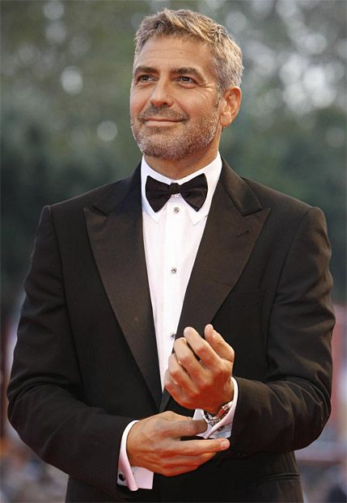

This is the last sentence on page 2.

This is the beginning of page 3; it has tables.

This is a table of the color sequence for wire conductors in a cable.

|  |
| --- |
| Black |
| White |
| Red |
| Green |
| Orange |
| Blue |

Thank you for reading this simple document.