FYP Dissertation
Minimax vs Monte Carlo Tree Search in Tic-Tac-Toe and Connect 4
By Ciaran O’Connor
Contents
Ethical Declaration 5
Abstract 5
1. Research Context (Background): 6
1.1 Minimax Algorithm 6
1.2 Monte Carlo Tree Search Algorithm 8
1.3 Other Studies – AlphaZero 9
1.4 Conclusion 10
2. Analysis and Design 11
2.1 Analysis 11
2.1.1 Requirements Gathering Process 11
2.1.2 Use cases 12
2.1.3 Functional Requirements 14
2.1.4 Non-Functional Requirements 14
2.1.5 Software Requirements 15
2.1.6 Hardware Requirements 15
3. Design 15
3.1 Hardware design 15
3.2 Software design 16
3.2.1 Wireframe 16
3.2.2 Prototype 18
3.3 Systems Architecture 20
3.4 Database Design 20
3.5 Conclusion 21
4. Implementation 21
4.1 Tools and Technologies used 21
4.1.1 Hardware 22
4.1.2 Software 22
4.2 Environment configuration 22
4.3 Database Implementation 22
4.4 Drivers 22
4.5 Feature implementation 23
4.5.2 General pages: 27
4.5.3 Game-Mode Implementation: 30
4.5.4 Monte Carlo Tree Search (MCTS) Implementation: 37
4.5.5 Statistics & Comparison: 40
4.6 Challenges faced 45
4.7 Conclusion 45
5.1 Testing 45
5.2 Testing of Non - Functional Requirements 46
5.2.1 Performance 46
5.2.2 Usability 51
5.2.3 Security 51
5.2.4 Availability 52
5.3Non-functional Requirements Test Cases 52
5.4 Findings of Non-Functional Testing 55
5.4.1 Performance 56
5.4.2 Usability 56
5.4.3 Security 56
5.4.4 Availability 57
5.5 Testing of Functional Requirements 57
5.5.1 AI Move Accuracy 57
5.5.2 Other Functional Areas: 57
5.6 Functional Requirements Test Cases 57
5.7 Findings of Functional Testing 60
5.8 Test Data 61
5.8.1 AI Move Performance Data 61
5.8.2 User Login Test Data 63
5.8.3 Usability Feedback Data 63
5.9 Summary of Findings 64
5.9.1 Non-Functional 64
5.9.1.1 Performance: 64
5.9.1.2 Usability: 64
5.9.1.3 Security: 64
5.9.1.4 Availability: 64
5.9.1.5 Functional 65
5.10 Conclusion 65
Bibliography 66

Ethical Declaration
I declare that this project and document is wholly my own work except where I have made
explicit reference to the work of others. I have read the Department of Information
Technology Final Year Project guidelines and relevant institutional regulations, and
hereby declare that this document is in line with these requirements.
I have discussed, agreed, and complied with whatever confidentiality or anonymity terms
of reference were deemed appropriate by those participating in the research and dealt
appropriately with any other ethical matters arising, in line with the LIT Research Ethics
Guidelines for Undergraduate and Taught Postgraduate Programmes policy document.

Abstract
This dissertation explores the comparative performance of Minimax and Monte Carlo Tree Search (MCTS) algorithms within the games of Tic-Tac-Toe and Connect 4. The project aimed to assess both functional and non-functional requirements by developing an application that implements both algorithms at varying difficulty levels. Through comprehensive testing, AI move statistics and resource usage were tracked to evaluate performance, while usability, security, and availability were also examined.
The results reveal clear distinctions between the two algorithms: Minimax, known for its structured and deterministic approach, consistently made decisions within milliseconds, whereas MCTS, with its more dynamic and probabilistic strategy, demonstrated greater flexibility but required significantly more computational resources, especially at higher difficulties. Usability testing gathered feedback on the app’s interface and functionality, identifying areas for improvement, such as smoother navigation and clearer feedback during gameplay. Security tests focused on Firebase authentication, assessing password strength requirements and login restrictions.
Ultimately, this research highlights the balance between AI complexity and system performance, offering insights into how heuristic AI strategies impact game dynamics. The findings contribute to a deeper understanding of these algorithms' practical applications and provide a foundation for further development of AI-driven game applications.

1. Research Context (Background):
The field of heuristic AI aims to explore different ways of enhancing decision-making in games, heuristic meaning the AI is a problem-solving type of AI. One of these methods used for games when there aren't many possible moves, like Tic-Tac-Toe, is the Minimax algorithm. For games with more moves, like Connect Four, Monte Carlo Tree Search (MCTS) would be more suited as it uses a random simulation of possible outcomes. Which algorithm works better in terms of efficiency and adaptability to various games is a topic of dispute and is what I hope to find out between these two games.

1.1 Minimax Algorithm
This algorithm first assumes each player plays optimally, recursively going through the game tree using two values: a max and min. It follows a depth-first search of the tree with max looking for the maximum score and min the minimum score. I will be using example trees from GeeksforGeeks to explain in detail.
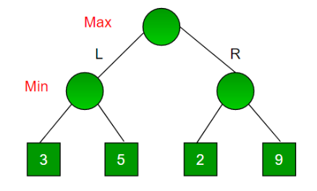
Fig 1.1.1
Starting from the top, the max goes first on the left side, followed by the min who has to choose between 3 or 5. Choosing 3, it takes that back up one node.
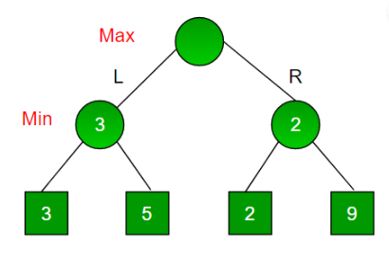
Fig 1.1.2
This is repeated on the right side of the tree, resulting in 2 being brought up with a final max choosing between the two numbers.

That’s how the algorithm works at base but there is an optimisation called Alpha-Beta pruning that can be done where two more values are added. Alpha starting at -Infinity and beta at +Infinity, both of which will keep track of the smallest and largest values found.
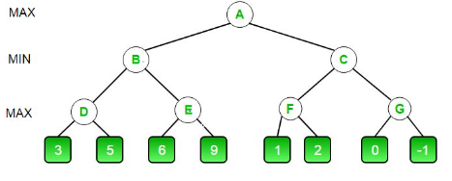
Fig 1.1.3
Starting in the bottom-left alpha notes 3 to see if the condition of beta<=alpha is true. As this is false due to beta being +INF the max is instead gotten: 5, becoming the value of node D. Beta notes that number and goes down to node E. Alpha notes 6 and the condition beta<=alpha now becomes true as 5<=6 meaning it breaks and doesn’t check 9 at all, taking 6 to node E. Min now chooses for node B & A to become 5.

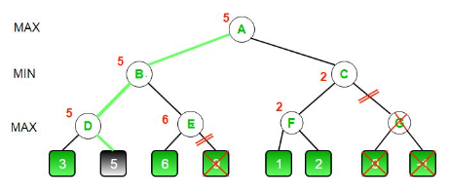
Fig 1.1.4
The method is repeated on the right side but with updated alpha/beta values. Resulting in this method saving a lot of computational power by cutting potentially whole sections of the tree from the search as seen with node G. Minimax still has with its drawbacks as even with pruning it can struggle with more complicated games.

1.2 Monte Carlo Tree Search Algorithm
MCTS is suited to more complex games as it performs simulations and uses random samples in tree searching to attain its optimal move meaning it doesn’t search all possibilities and instead focuses on more promising paths. It achieves this using a 4-stage process: selection, expansion, simulation and backpropagation.
The algorithm starts with a selection process by choosing a starting point via this formula:
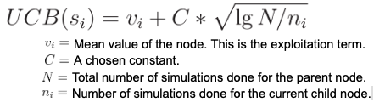
Fig 1.2.1
This formula gives an estimated highest value node. Then in the expansion stage a new child node is added that was also found from the formula, followed by a simulation where moves are chosen until a certain state is reached, be it predetermined i.e. 3 moves or until a win/loss is found. Lastly in the backpropagation stage once its value is determined the result is brought back up the tree to be used in the selection phase.
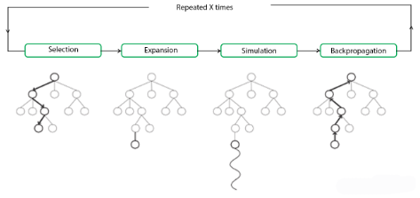
Fig 1.2.2
How many simulations are done is up to the implementer and the more that are done the more time and resources are needed.

1.3 Other Studies – AlphaZero
Another AI that I’ve researched is the chess AI AlphaZero made by DeepMind – owned by Google, this is a much more advanced AI used for chess which has deep neural networks which allow for self-play reinforcement learning. This means that the AI learns over time which strategies are more effective than others purely by playing against itself i.e. trial and error, in the case of this particular AI the creators say “it played 44 million games in the first 9 hours”.
In comparison heuristic AI uses already known strategies and hard coded rules to follow which can only go so far. AlphaZero’s decision making has 2 models, one that predicts the next best move and one that judges the current game board to find its winning potential. This overall not only results in a more competent AI but a faster one too as there isn’t a tree to search through, instead being replaced by the AI’s own experience.
The flexibility that the repeated pattern-recognition style gives allows for the AI to potentially and in the case of chess become the best at said game, with the modern AI’s for chess such as Stockfish being regarded as near unbeatable by even top players.

1.4 Conclusion
This review has covered how the AI’s being used in this project work functionally and how they both differentiate themselves from each other. It also explored a third external AI AlphaZero that was implemented into the game of chess by Google to highlight that there are much more complicated methods that achieve better performance, both in the gameplay and in the system performance.
Minimax with its depth-first searching of game trees ensures it will eventually get the best possible result but with the caveat of taking much more time to do so, time which only increases with the game complexity that its used for. This can be mitigated if the optimisation of alpha-beta pruning is implemented but there are still fundamental limits to the method that this may not be able to overcome.
The Monte Carlo (MCTS) method of tree searching in contrast should be better able to handle these more complex games where Minimax may struggle. This is due to a difference where instead of searching almost every single option available, MCTS will instead find the more valuable options and use them to simulate what the games state would look like in the future if these options were taken. It then uses the result from these simulations to begin its backpropagation stage to see which of these options was the most valuable. This allows for much faster decision making but it doesn’t come without its own cost, variance, as due to using random sampling to begin its simulations there can be a result of inconsistent move quality where a straightforward deep search wouldn’t miss.
I aim to compare these two AI types in both the game of Tic-Tac-Toe and in Connect 4 to see which is better able to perform not just in their move quality but also in their time spent decision-making and how much resources are used to reach those decisions. The strengths and weaknesses of these methods will be highlighted at different levels of difficulty by adjusting depth of Minimax and the amount of simulations of MCTS alongside the difference in game scope they will both face.
This study should contribute to the ongoing discussion of the effectiveness of Heuristic AI in different games and conditions so that which AI when looking to implement these AI you have a clearer idea of how better suited each may be.

2. Analysis and Design
In this chapter I will be covering the requirements and design of my FYP project – Minimax vs. Monte Carlo Tree Search (MCTS). The overall projects design will have to accommodate implementing these two AI methods along with the two games they’ll be used in, Tic-Tac-Toe and Connect 4.
This app is for anyone from people who’ve never played these games to those who have. The goal is to compare the performance of the Minimax algorithm to MCTS’s in regard to the two games. The key features will be; User login/registration, Playable games of Tic-Tac-Toe and Connect 4, functional AI for Minimax and MCTS algorithms in these games and metric results from matches played. This app can be used at any time the user wishes and their user/match details will be stored within firebase for when they return. The app will be playable on android phones only and installed using an APK of the project created by android studio. Lastly the base reason for this FYP is to see how these two heuristic AI algorithms stack up against each other and which is more suited for the complexity levels different games may have. It also provides an opportunity to see if adding AI to these games also adds to the overall user experience and enjoyment.
I will detail how I acquired my requirements, what they are as functional and non-functional, the design the app will have, and the software/hardware that will be needed.

2.1 Analysis

2.1.1 Requirements Gathering Process
In order to find out what the requirements for this app was I researched other, similar games that also implemented AI found on the google play store. I also researched and compared different AI implementations in my literature review, specifically the likes of AlphaZero used in chess.
An example app that proved valuable in gathering insights was Chess Free by AI Factory Limited. This app integrates various AI difficulty levels into chess to create increasingly challenging gameplay. The app offers a simple, intuitive interface that allows users to choose between AI and human opponents and adjust the AI’s strength.

2.1.2 Use cases
1. Use Case: Register User
Actors: User, System
Description: A new user registers for an account on the app.
Preconditions: The user is on the registration screen and has internet access.
Flow of Events:
  - The user navigates to the registration screen.
  - The user enters their desired username, email, and password.
  - The system checks if the username is already taken and if the email format is correct.
  - If the inputs are valid, the system creates a new user account in Firebase.
  - The system redirects the user to the login screen.
Postconditions:
  - A new user account is created in the system.
  - The user is able to log in with their new credentials.

2. Use Case: User Login
Actors: User, System
Description: A user logs into the system
Preconditions: The user must have registered an account in the system. The system must be connected to Firebase for authentication.
Flow of Events:
  - The user opens the app and navigates to the login screen.
  - The user enters their username and password.
  - The system sends the credentials to Firebase for validation.
  - If the credentials are correct, the system grants access to the user’s account.
  - If the credentials are incorrect, an error message is displayed to the user.
Postconditions:
  - The user is logged into the app if credentials are correct.
  - The user remains on the login screen if credentials are incorrect.

3. Use Case: Game Setup (Selecting Algorithm)
Actors: User, System
Description: The user selects which game to use for the AI (Minimax or MCTS) for the game.
Preconditions: The user must have logged into the system and be on the game setup screen.
Flow of Events:
  - The user navigates to the game setup screen.
  - The user is presented with an option to select between PVP or PVAI
  - The user selects one of the two options
  - The user is then presented with an option to select between Tic-Tac-Toe or Connect 4
  - The user selects one of the two games.
  - The system confirms the selection and plays the selected game.
Postconditions:
  - The game is configured to use the selected AI algorithm.
  - The user is redirected to the game board screen.

4. Use Case: Playing the Game
Actors: User, AI (Minimax or MCTS), System
Description: The user plays a game against the AI using the selected algorithm.
Preconditions: The user has selected an algorithm and is on the game board screen.
Flow of Events:
  - The game starts with an empty game board.
  - The user takes their turn by selecting a spot on the board to place their piece.
  - The system updates the board with the user’s move.
  - The AI calculates and places its piece on the board using the selected algorithm (Minimax or MCTS).
  - Steps 2 to 4 repeat until the game ends with either a win/loss or draw.
Postconditions:
  - The game board reflects the moves of both the user and the AI.
  - The game ends with either a win, loss, or draw.

5. Use Case: View Game Results
Actors: User, System
Description: The user views the metrics of the game (win/loss/draw) after completing a match.
Preconditions: The user has completed a game (either a win, loss, or draw).
Flow of Events:
  - The game ends with a result (win/loss/draw).
  - The user selects the metrics option.
  - The system displays the game metrics to the user.
  - The user can choose to play again or return to the main menu.
Postconditions:
  - The game metrics are displayed to the user.
  - The user is either redirected to the main menu or the game restarts.

2.1.3 Functional Requirements
- App needs to be able to play both Tic-Tac-Toe and Connect 4 from start to finish with all the rules of each game being followed.
- There needs to be user login/registration implemented
- Needs to have implemented both the Minimax algorithm and the Monte Carlo Tree Search (MCTS) for these games. Both AI need the option of adjusting the difficulty as well via pruning and simulation count respectively.
- There needs to be a metrics page that tracks the performance of the ai after a game is played, showing results of its performance and resource usage.
- A user interface should be in place so users can easily choose if they’re playing an ai, which kind, its difficulty, in what game mode and to see the AI metrics.

2.1.4 Non-Functional Requirements
- To have the performance of each AI’s move-making to be done in a reasonable timeframe so users aren’t stuck waiting for their turn.
- The UI needs to be intuitive so the user doesn’t get lost or frustrated when trying to switch games or AI
- The app should be made in a way so that the potential for future AI or games can be added to the available options.

2.1.5 Software Requirements
The software requirements for this app are;
- Android studio is the IDE used in the app’s creation
- Kotlin language, this includes Jetpack compose for the UI of the app
- Android API level of 35 or higher, most phones should meet this

2.1.6 Hardware Requirements
The hardware requirements for this app are;
- A phone with a mid-range processor for the AI calculations
- At least 3gb of ram for the smooth operation of the AI alongside the UI

3. Design

3.1 Hardware design
The app will be designed to fit most phone screen sizes, outside of that there is no hardware design necessary.

3.2 Software design

3.2.1 Wireframe
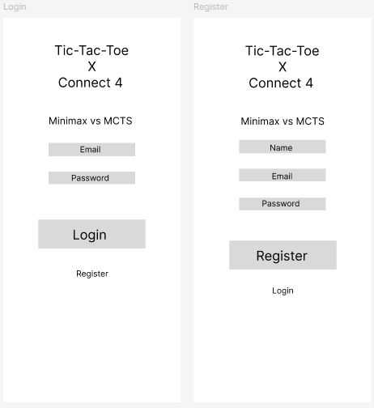
Fig 3.2.1.1
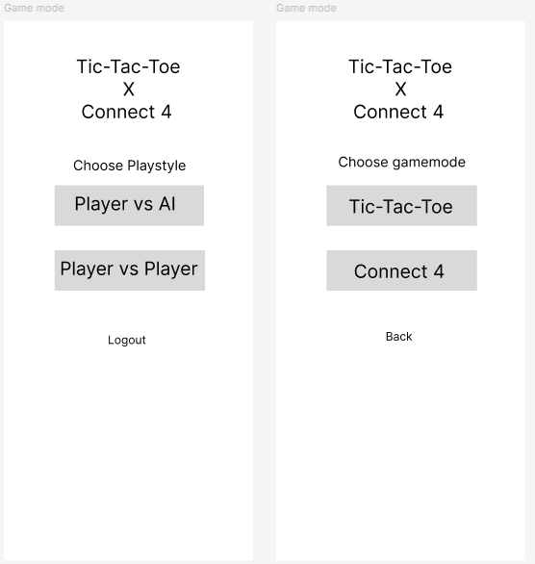
Fig 3.2.1.2
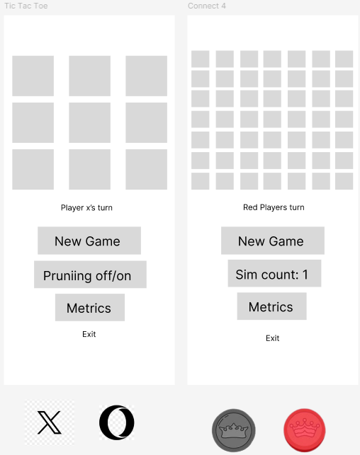
Fig 3.2.1.3

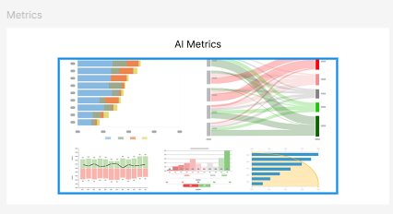
Fig 3.2.1.4

This Figma design shows two pages for user login and registration, after which the user will be taken to game mode selection pages. Here they will choose whether to play against another person or to try their hand against the AI. Following that they’ll choose which game with the option of changing the AI’s difficulty at any point. Below the game pages are the pieces that will be used for each game respectively.
The page the game is played on will also have a link to the metrics page which will detail the stats of the AI based of the games that have been played so far, these stats will include the time per decision, resources used etc.
These pages however were just the initial wireframes, in the below images I have made a second iteration of them.

3.2.2 Prototype
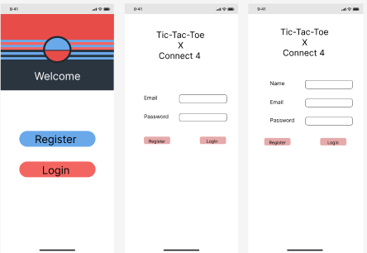
Fig 3.2.2.1
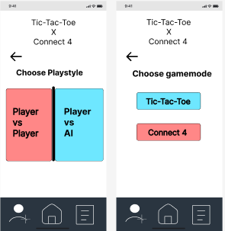
Fig 3.2.2.2
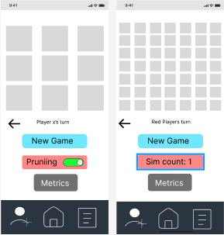
Fig 3.2.2.3
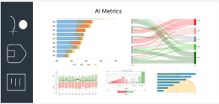
Fig 3.2.2.4

3.3 Systems Architecture
This project will have the following;
A frontend built using Jetpack Compose from Kotlin/Android studio, following the Figma design outline above. This gives the user an easy, intuitive interface to interact with as well as allowing for backend calls to be made upon certain button being pressed.
The backend will be the implementation of the AI algorithms; Minimax and MCTS. It will handle the games states and the AI’s moves on top of handling the user authentication that is required before using the application.
Lastly a database for storing user details used during authentication as well as potentially the metric results gained from when games are played with the AI algorithms. This would allow the user to see results from previous matches and compare them to newer ones.

3.4 Database Design
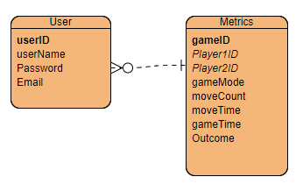
Fig 3.4.1
The database design is rather simple, needing only a user table for logins and metrics table to enable the stat comparisons. The userID in the user table is a primary key with it being referenced as a foreign key in the Metrics table as Player1ID and Player2ID. The metrics table then has gameID has its primary key.
The metrics table will track information like; game mode, number of moves, time per move average, length of the game and lastly its outcome (win, loss or draw)

3.5 Conclusion
In this chapter I have now outlined the fundamental requirements and design for this heuristic AI project. Both functional and non-functional requirements as well as the hardware and software needs should all allow for an effective implementation of both the Minimax and MCTS algorithms so that they can be compared.
The overall design places an importance on scalability and performance so that more AI’s or games can be compared without having hefty resource demands alongside it. This allows for a structured environment to test the capabilities of both AI and to compare them to one another, making it so the best AI for the game can be deduced.

4. Implementation
The Implementation chapter details the process of translating the design of the project into a functional system. This chapter provides detailed explanations of the tools, technologies, environment configuration, feature implementation, and challenges encountered during development of the project. It serves as a guide to understand how the theoretical aspects of the design were translated into a functional system.

4.1 Tools and Technologies used
The project utilized various tools and technologies to meet the requirements and ensure efficient development. These include:
- Android Studio and the Kotlin language for Android app development.
- Jetpack Compose for UI elements such as game boards and menu navigation.
- Firebase for Login and Sign-up features
- Figma for UI/UX prototyping.
- Tehras library used for charts in statistic comparisons

4.1.1 Hardware
Project supports the grand majority of available android phone versions. There is no version for IOS devices however so an Android phone is needed for use.

4.1.2 Software
Android studio and the Kotin coding language were primarily used as I have had a lot of recent experience developing simpler android apps and found the overall workflow to be more fluid than other methods.

4.2 Environment configuration
Installed Android Studio and configured SDK to version 34 with a minimum of 24 for Kotlin-based Android development.
Added required dependencies in the build.gradle file, such as Firebase for login-sign-up and the Tehras library for displaying the statistic comparisons between the two AI models, Minimax and MCTS.

4.3 Database Implementation
No persistent database was required, as this project focused on real-time algorithm comparison
Instead, a simple in-memory data structure was implemented for real-time gameplay data. Used 2D arrays for the game boards as well as data classes for recording AI moves alongside the associated stats, such as the pruning level of Minimax/Simulation count of MCTS.

4.4 Drivers
No specific drivers are necessary for this project as the logic and algorithms run without external hardware requirements.

4.5 Feature implementation
Firebase Login/Registration:
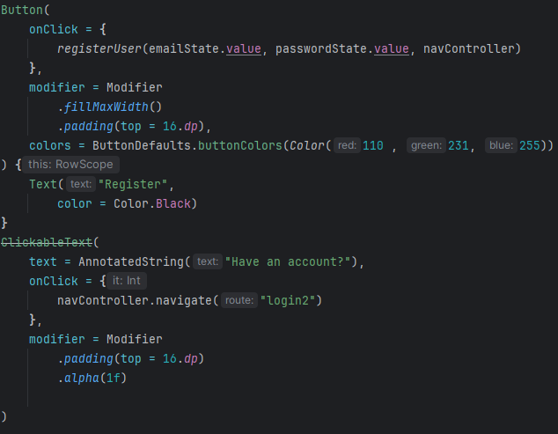Fig 4.5.1
This button triggers the registerUser method, using the emailState and passwordState variables manage user login credentials which registerUser uses to create a new user account through firebase authentication, using navController to direct users to the GameMode page upon doing so with clickable text to instead redirect users to the login page if they already have registered. The Modifier portions of the button and text are purely for styling purposes, ensuring proper display regarding spacing with other UI elements and adding specific colours where needed.
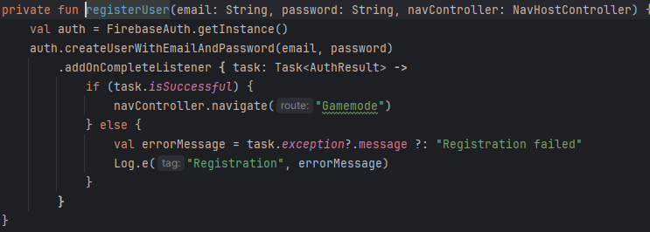Figure 4.5.2
Register user method that uses Firebases (google authentication) to create the account. Displaying an error message if it fails.
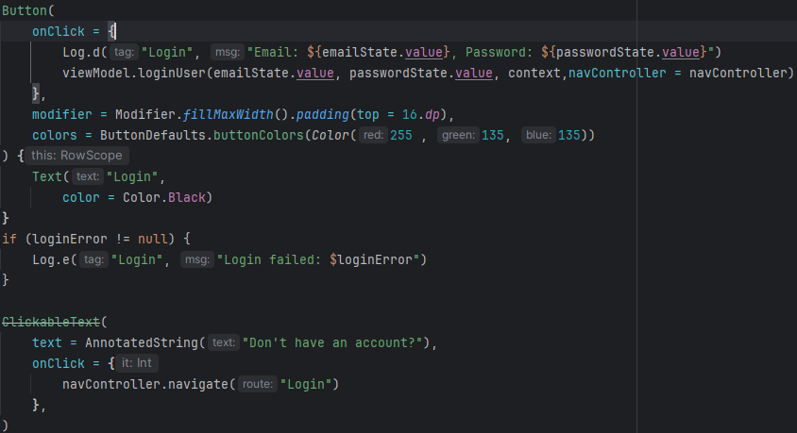Figure 4.5.3
Login button as well as ”Have an account?” text, if the user taps it they are taken to the register page shown in figure 1.
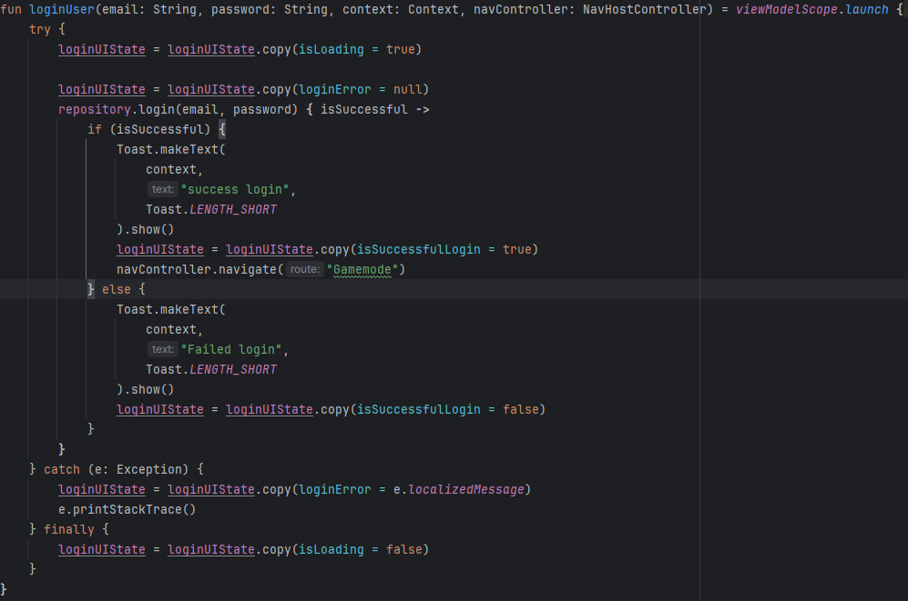Figure 4.5.4
This method displays small ”toast” messages if the login is successful or if there's any errors with the information entered. Calls repository.login with the users details, which interacts with Firebase to validate the user's credentials. Loading (LoginUIState) flags navigate the user to the Gamemode page if the login is successful.
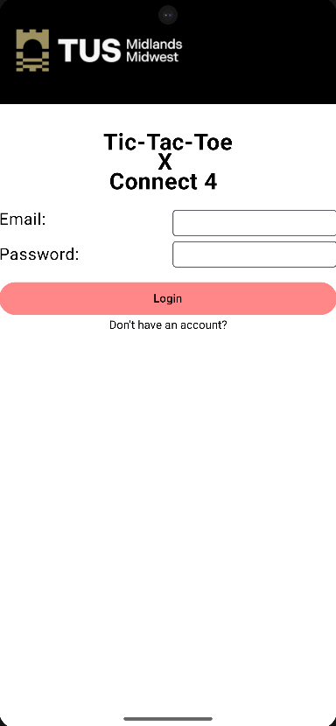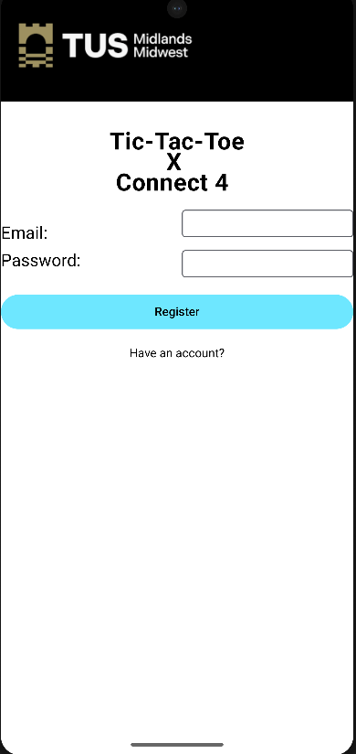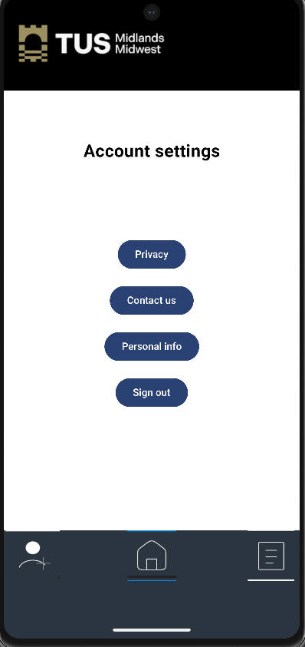
Figure 4.5.5 – 4.5.7
Pages for login/signup and for account options where users can sign out using Firebases auth.signOut() method

4.5.2 General pages:
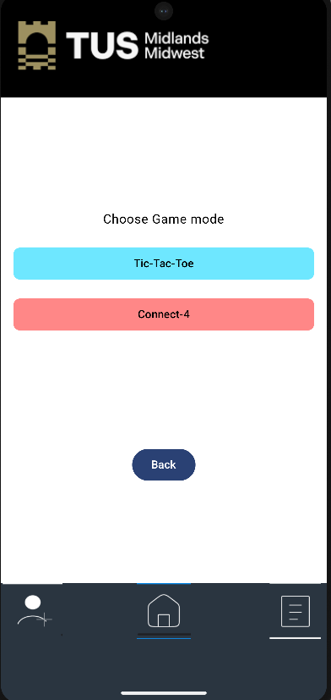
Figure 4.5.2.1
Once signed in, users are taken to the above GameMode page that has two buttons to choose which game to play:
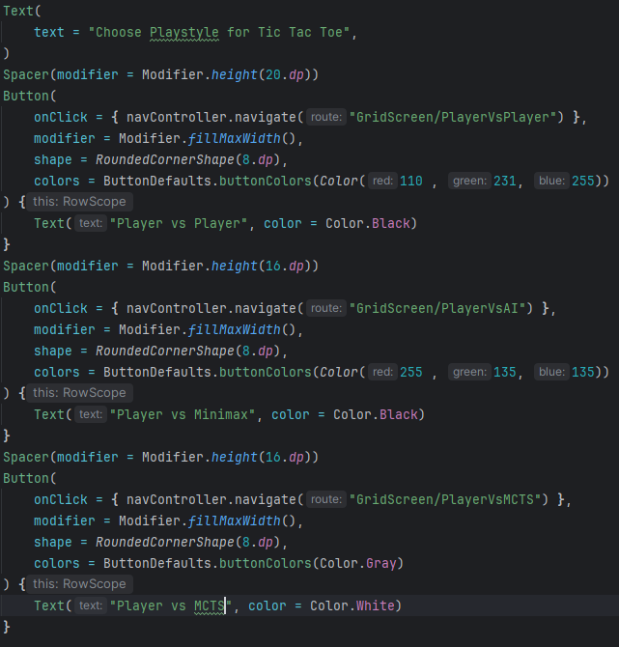
Figure 4.5.2.2
On the Playstyle page(Tic-Tac-Toe's version) users choose what way to play their chosen game, PVP or PVAI. Each choice navigates to the games board page, taking in the users choice as a variable to modify how the board page appears and functions.

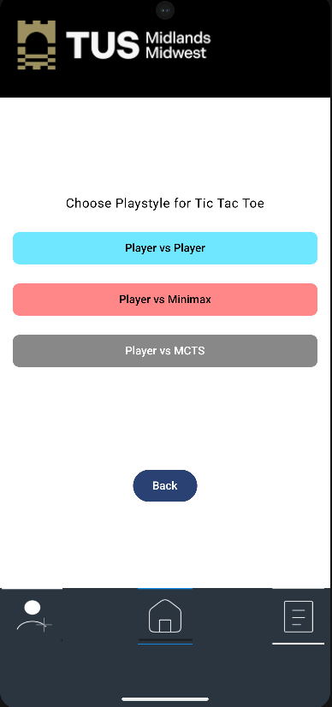
Figure 4.5.2.3
If the user chose Player vs Player for example:
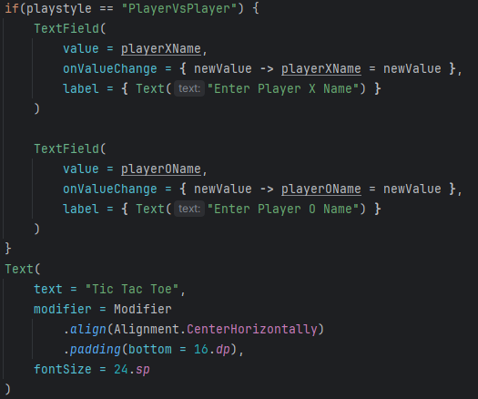
Figure 4.5.2.4
The naming fields for each player on the board (Gridscreen) page become visible. The variable for dictating this(playstyle) is used in the navigation like so:
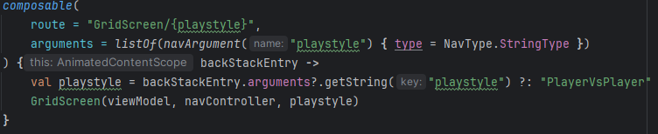Figure 4.5.2.5
the route takes in the playstyle variable as a navigation argument, defaulting to PVP if the user somehow got to the page without a selection.

4.5.3 Game-Mode Implementation:
A visual representation of the game boards made using Jetpack Compose with two options for playing either game.
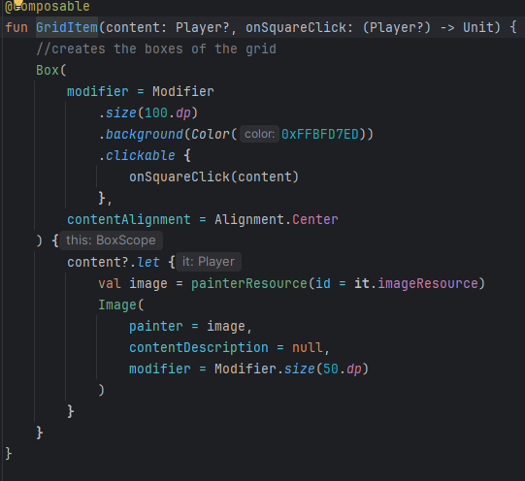
Figure 4.5.3.1
GridItem is the function that creates and display the UI boxes of the board, each box being tied to the onSquareClick method with specific size and alignment.
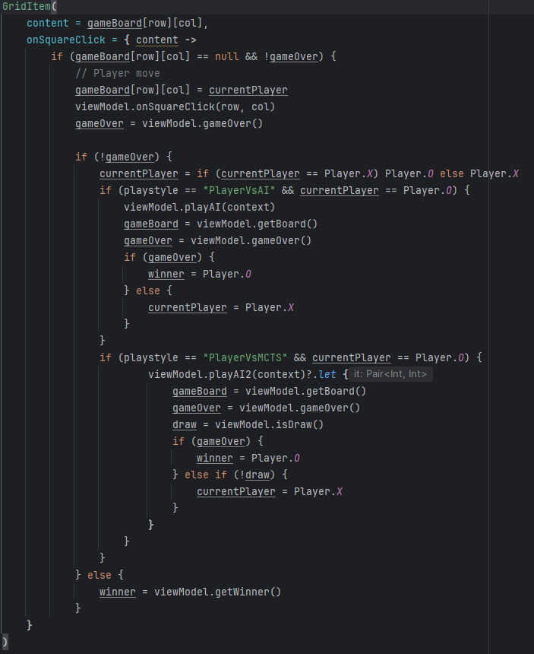
Figure 4.5.3.2
Its usage here also housing the logic needed for both the player and AI to place pieces.
onSquareClick is triggered when a user clicks on a square. It first checks if the selected square is empty and if the game is not over. If both conditions are met, the current player's piece (X or O) is placed on the board and the viewModel.onSquareClick function is called to update the game state followed by a check for game over. If the game is in Player vs. AI mode (either Minimax or MCTS) and it is the AI's turn, the relevant AI move function (viewModel.playAI for Minimax or viewModel.playAI2 for MCTS) is called. The board is updated with the AI's move, and the game over state is re-checked. The current player is then switched back to the human player. Finally, if and when the game is over, the viewModel.getWinner() function is used to determine if there is a winner.
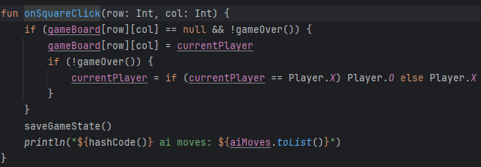Figure 4.5.3.3
The viewmodel onSquareClick checks if the space is empty and the game isn’t over, placing the piece and saving the game state while doing some logging used for tracking the moves the ai has made throughout the round.
Minimax Implementation: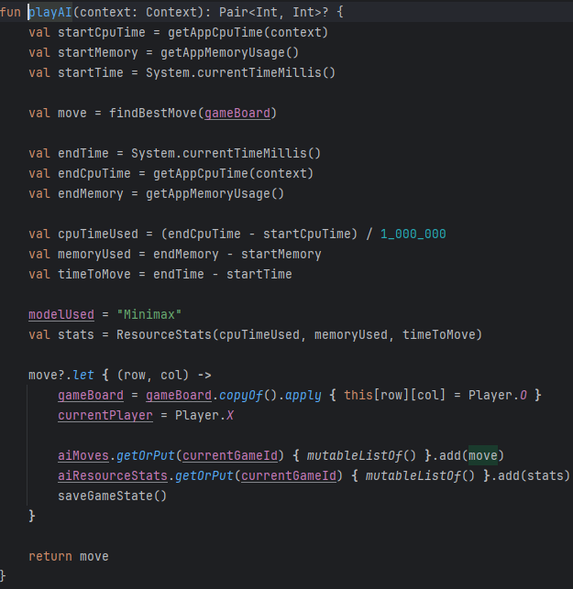Figure 4.5.3.4
This particular method is for the Minimax AI in the tictactoe viewmodel, calling the findBestMove function which sets the ai in use and tracks various other statistics for later display. At the end the game state is saved and the function returns the chosen move as a Pair<Int, Int> (see first line) representing the row and column, or as null if no move is possible.
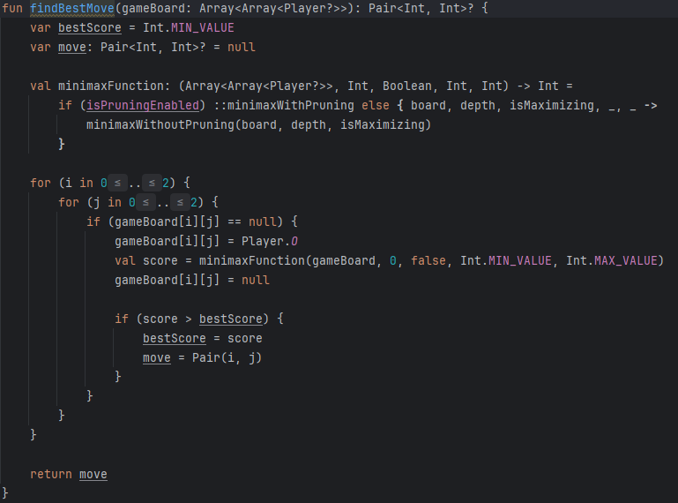
Figure 4.5.3.5
findBestMove takes the current game board as input and returns the coordinates (row and column) like before. It initializes variables to track the best score found so far and the corresponding move, followed by dynamically selecting which Minimax function to use: either minimaxWithPruning (if pruning is enabled on the board page) or minimaxWithoutPruning.
It iterates through all empty cells on the board and for each one empty, it tentatively places the AI's mark (Player.O), calls the selected Minimax function to evaluate the resulting board state, and then immediately undoes the move. If the score returned by the Minimax function is higher than the current bestScore, the bestScore and the corresponding move are updated. Finally, the function returns the coordinates of the best move found, or null if no move is possible.
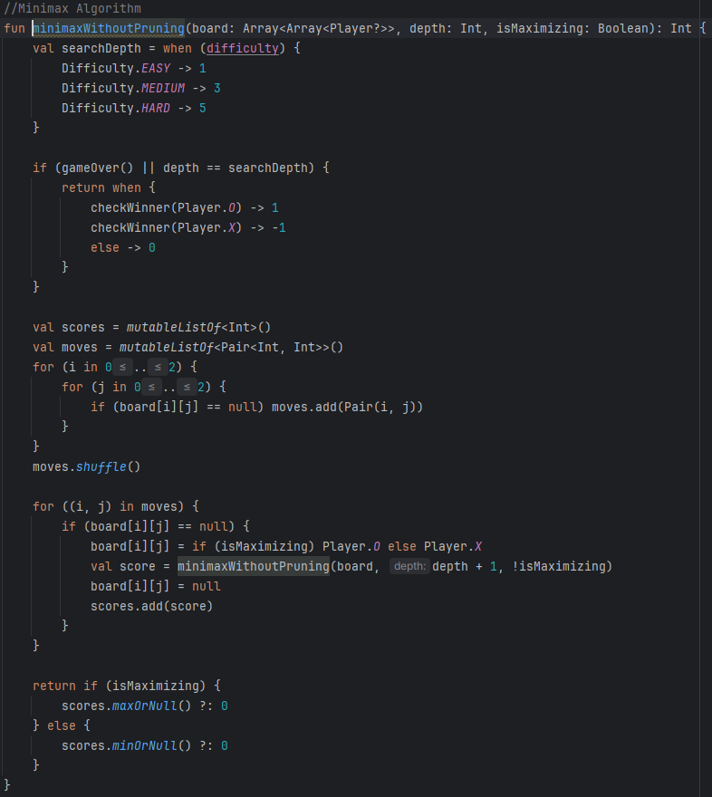
Figure 4.5.3.6
Takes in the current game board, the current search depth, and a boolean isMaximizing flag as input. The isMaximizing flag indicates whether the current player is trying to maximize their score (AI) or minimize the opponent's score (human). If the game is over or the maximum search depth is reached, the function returns a score evaluating the board state: 1 for an AI win, -1 for a human win, or 0 for a draw.
Otherwise, it generates all possible moves and shuffles them to add variability. The scores from the recursive calls are collected, and the function returns the maximum score if the current player is maximizing, or the minimum score if minimizing.
Alpha-Beta Pruning is also available as an option to further optimize search tree exploration, eliminating unnecessary branches.
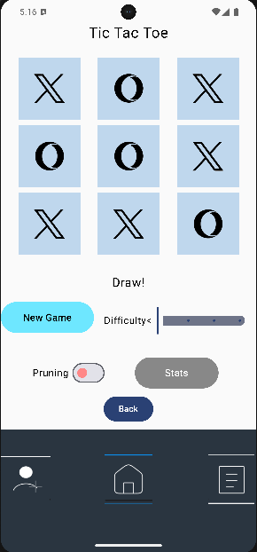
Figure 4.5.3.7

4.5.4 Monte Carlo Tree Search (MCTS) Implementation:
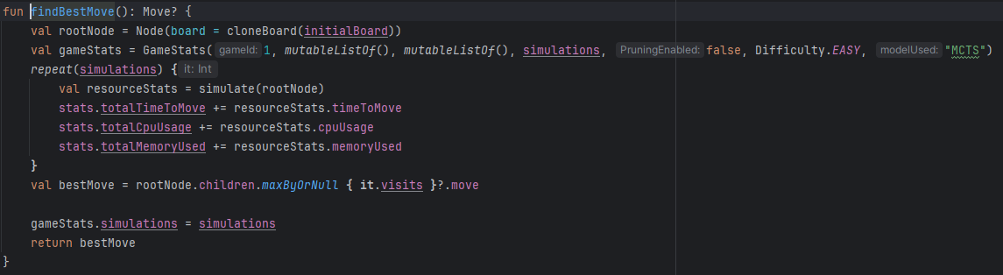
MCTS is implemented the same until in the MCTS class:

Figure 4.5.4.1
The findBestMove starts by initalising the rootNode with the boards state using tree nodes that represent different game states, with child nodes for possible moves. Calls the Simulate method equal to the number of simulations the user has set while tracking related stats, returning the bestMove it finds from doing so.

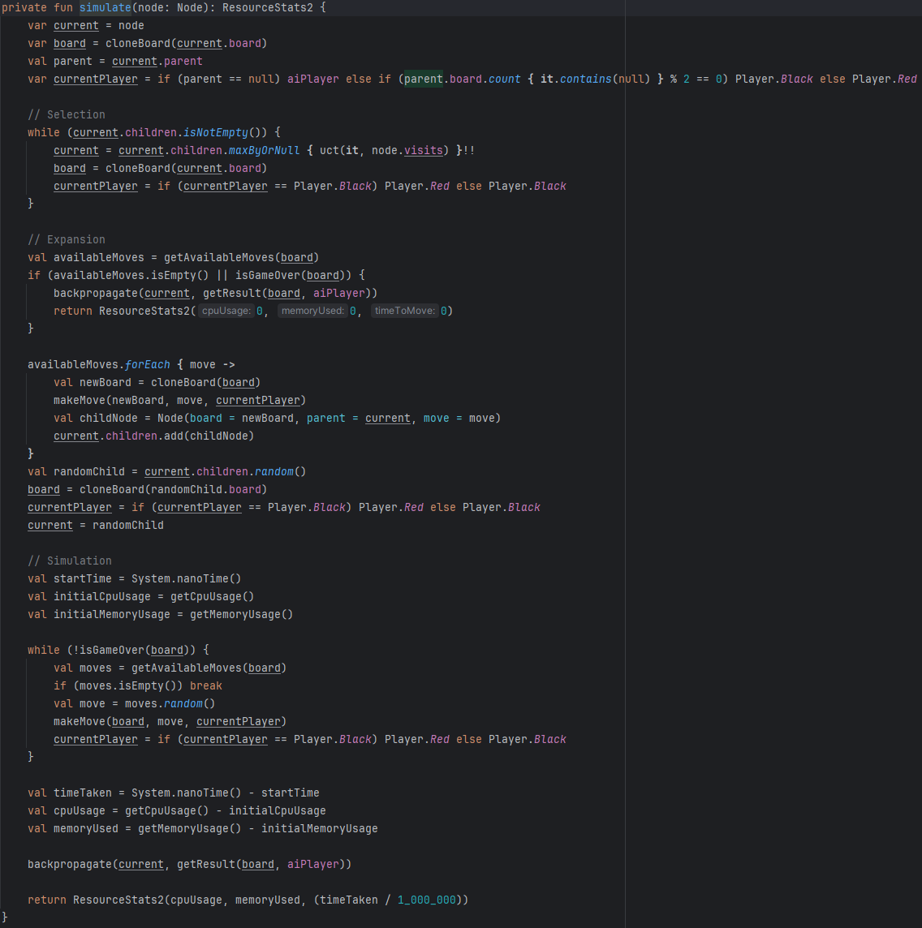
Simulate method called in findBestMove

Figure 4.5.4.2
Encapsulates the Selection, Expansion, Simulation, and Backpropagation phases of MCTS.
The Selection phase involves traversing the tree from the given node to a leaf node(bottom node) by repeatedly choosing the child node with the highest UCT (Upper Confidence Bound or win) value. During Expansion, if the selected node is not a terminal node (the game is not over and there are available moves), new child nodes representing the possible moves are added to the tree. The Simulation phase starts from the expanded node (or the selected leaf node if no expansion occurred). It simulates a game by making random moves until a terminal state is reached. Resource usage (CPU, memory, and time) is tracked during this rollout. Lastly the Backpropagation phase updates the statistics of the nodes visited during the Selection and Expansion phases, using the result of the simulation to guide future move selection.
These are all done repeatedly equal to the value the user as set on the difficulty slider, ranging from 100-3000 sims for Minimax and 100-8000 for Connect 4.
When on the higher end of the available sim count (8000) the AI moves can take almost 3 seconds per move from being almost instantaneous at 100.
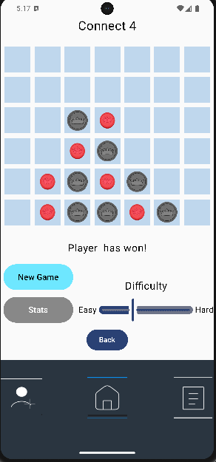
Figure 4.5.4.3
Very similar logic is used when the ai’s are implemented in the other game modes, main difference coming from taking into account the different board size when deciding its move.

4.5.5 Statistics & Comparison:
The moves of either model are tracked as well as the resource values they use such as memory and cpu usage or the time taken to make said moves.
These stats can be viewed independent to the game they came from in a plain text format or the comparison between the two games and models used in said games on various charts can be viewed.
Comparison graphs where the last models used per game are shown along with the option to reset the current stats:
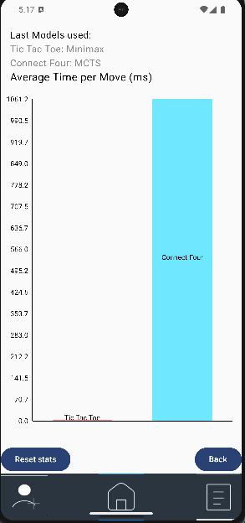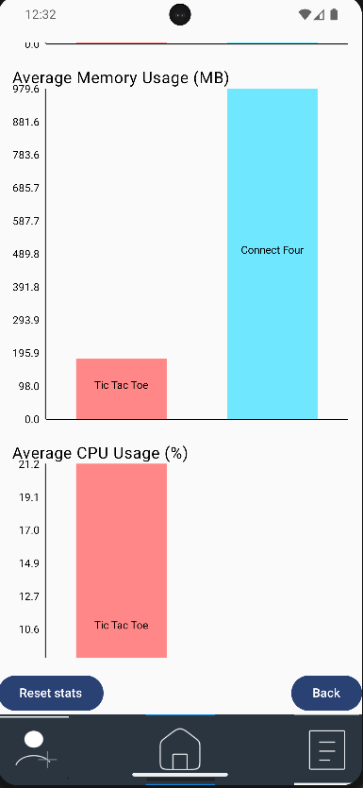
Figure 4.5.5.1 and 4.5.5.2

Individual game stats shown in plain text:
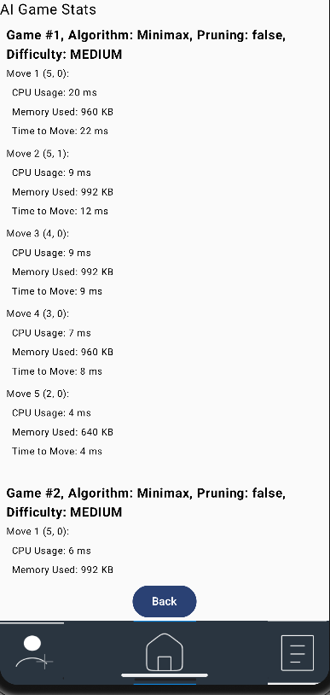
Figure 4.5.5.3
Code for above pages:
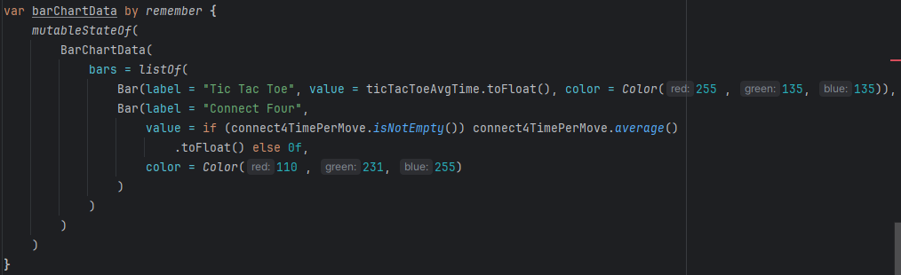Figure 4.5.5.4
The BarChartData variable is used for figure 5. It has a Bar outlined for each gamemode with the value it represents being the average time spent per move in said game.
These values are stored and retrieved from the respective viewmodel and are displayed with specific colours that match the theme of the app.
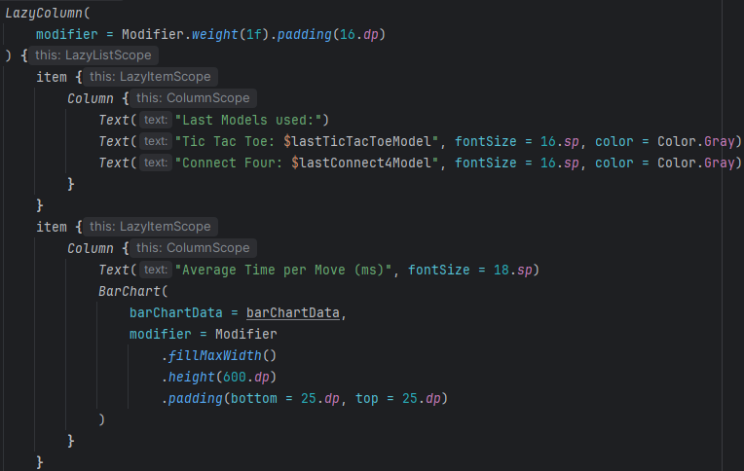Figure 4.5.5.5
This lazyColumn (which allows that portion of the page to be scrollable) has each of the different graphs, each in their own column. The BarChart is declared and simply referenced as it has already been laid out above, the whole process being repeated for each graph and its data.

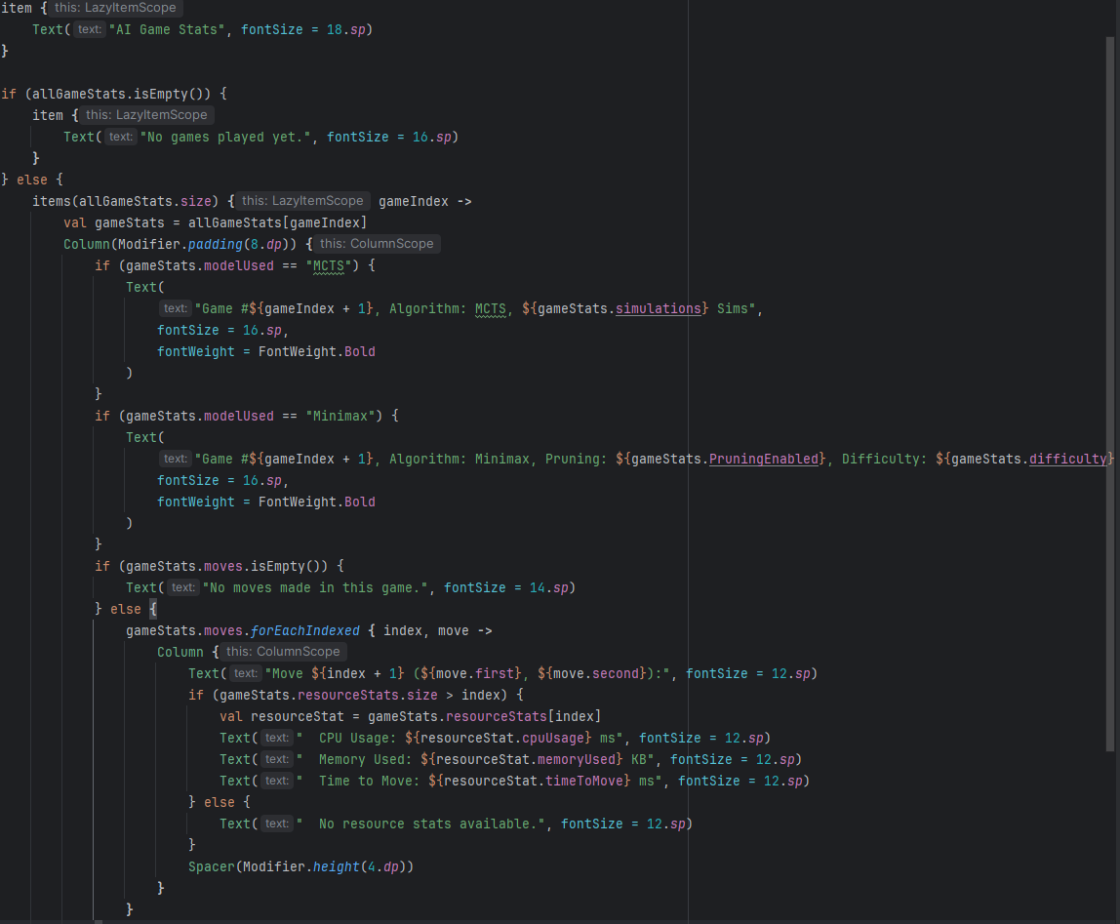

Figure 4.5.5.6
This figure represents the raw text display of the data and allows for display of which particular model was used during the round played for either game. It differentiates which model by using the modelUsed stat that was tracked previously and displays that model's difficulty level as well as the resources it used on each move they made.

4.6 Challenges faced
MCTS with a high simulation count caused delays, especially in Connect Four. Required tuning the maximum number of simulations available to achieve reasonable performance and to avoid app hanging/crashing.
Fixing any issues related to AI move quality particularly with MCTS proved to be difficult as there were multiple failure points possible at each stage that could lead the AI to not properly simulate the game state as it went through the tree nodes. This would lead to player moves being ignored or obvious game-winning moves not being played.
There was also difficulty trying to initially use googles library for charting the statistics, the dependencies required weren’t recognised by the IDE and after trying different variations of the dependency I opted to instead switch to the Tehras library for simple and easy charting of the gathered data.

4.7 Conclusion
This chapter has given the technical details of the implemented project, which started from the bottom-up with Figma designs and ended with a deployable android application.
The implementation process successfully delivered a platform to compare the Minimax and MCTS algorithms in both Tic-Tac-Toe and Connect 4 to where one may shine and where the other may fall flat in its overall performance.

5.1 Testing
This chapter will cover how the application performs both in relation to the device its run on and to its users. The functional and non-functional requirements tested will be shown alongside the results of such testing.
The main method of testing the application was done using the black-box testing method. This is where the tester interacts with the app just like a user would be expected to, having no knowledge of the code running it. This allows for fast testing coverage of the apps features and has a higher chance of discovering more unique bugs that a scripted test may not find.

5.2 Testing of Non - Functional Requirements

5.2.1 Performance
Below are screenshots of the statistics the app already tracks of each game with its main respective AI algorithm. The games played followed mostly the same outcome and showcase the difference in performance the difficulty settings make.
AI move stats – Tic-Tac-Toe – Easy(search depth of 1) with no pruning:
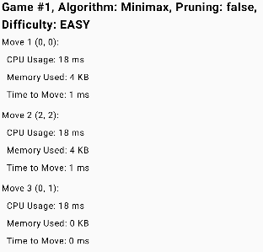
Fig 5.2.1
AI move stats – Tic-Tac-Toe – Easy with pruning:
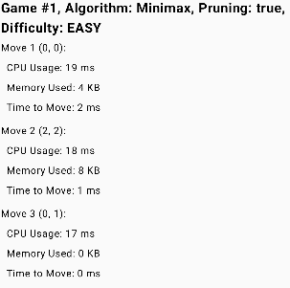
Fig 5.2.2
AI move stats – Tic-Tac-Toe – Hard(search depth of 5) with no pruning:
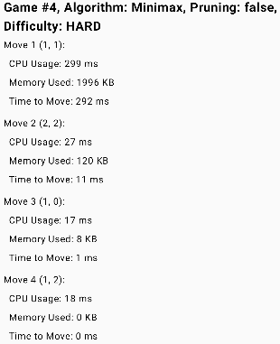
Fig 5.2.3

AI move stats – Tic-Tac-Toe – Hard with pruning:

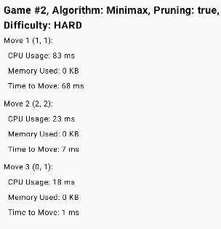
Fig 5.2.4
AI move stats – Connect 4 – Easy:
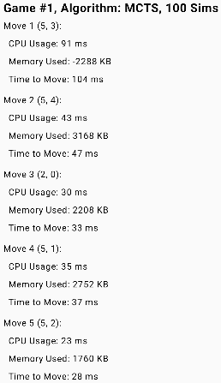
Fig 5.2.5
AI move stats – Connect 4 – Medium:
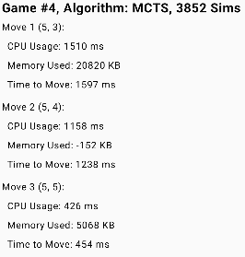
Fig 5.2.6

AI move stats – Connect 4 – Hard:
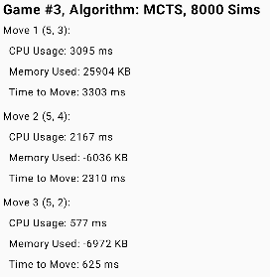
Fig 5.2.7
Graphs:
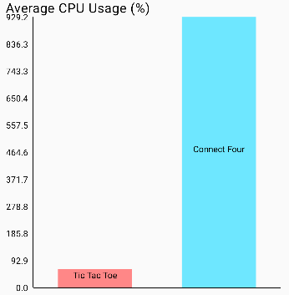
Fig 5.2.8
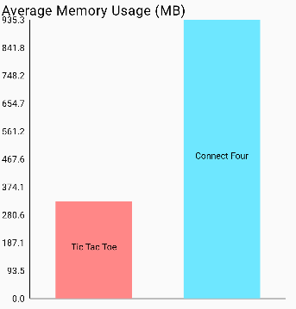
Fig 5.2.9
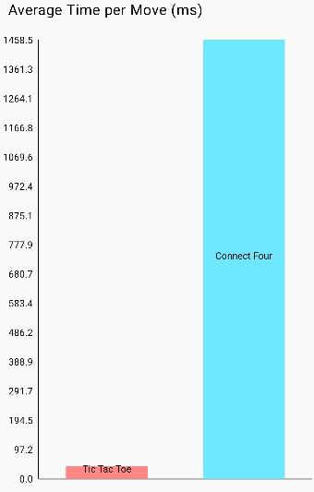
Fig 5.2.10

5.2.2 Usability
User testing was conducted to gauge whether the UI was effective in leading users where they wanted to go. Each user was given the app and a basic description of what it was intended for, otherwise not being guided. The results of this can be seen in section 5.4

5.2.3 Security
This app doesn’t place a large emphasis on user account safety as there is no sensitive information within each account.
Test case 04 in section 5.3 below goes over the security testing conducted.

5.2.4 Availability
Firebase login is the only availability constraint the app has and therefore doesn’t require testing, if the user has internet and Firebase is up and running then they will be able to use the app.

5.3Non-functional Requirements Test Cases
Test Case Name | Minimax Move Speed
Test Case ID | 01
Test Priority | High
Test Executed By | Ciaran O’Connor
Date of Test Execution | 6/02/2025
Description/Summary of Test | Measures the time taken for the Minimax AI to make a move at different difficulty levels.
Pre-Condition | Start a Tic-Tac-Toe game against Minimax AI.
Inputs | Select "Easy" (depth 1) and record time. Repeat for "Hard" (depth 5).
Post-Condition | "Easy" should take <100ms; "Hard" should take <1s.
Status (Fail/Pass) | Pass
Notes/Comments/Questions: | How does performance differ on high-end vs. low-end devices?

Test Case Name | Minimax Slider Behaviour
Test Case ID | 02
Test Priority | Medium
Test Executed By | Ciaran O’Connor
Date of Test Execution | 6/02/2025
Description/Summary of Test | Check if the Minimax difficulty slider visually updates when adjusted.
Pre-Condition | Navigate to one of the playstyle pages and choose Minimax
Inputs | Move the slider from Easy → Hard and back, observe if the UI updates.
Post-Condition | Slider should visually update in real time as it is moved.
Status (Fail/Pass) | Fail
Notes/Comments/Questions: | Currently, the slider only updates after a move is placed or a new game started

Test Case Name | MCTS AI Move Speed
Test Case ID | 03
Test Priority | High
Test Executed By | Ciaran O’Connor
Date of Test Execution | 6/02/2025
Description/Summary of Test | Measure the time taken for the MCTS AI to make a move at different difficulty levels.
Pre-Condition | Start a Connect 4 game against the MCTS AI
Inputs | Select Easy mode (100 simulations), make a move, and record AI response time, repeat for Hard (8000) simulations
Post-Condition | MCTS should take <4 seconds to make a move on Hard and <150ms on easy.
Status (Fail/Pass) | Pass
Notes/Comments/Questions: | Could MCTS be optimised to reduce TTM on Hard to below 3 seconds?

Test Case Name | Login Password Strength
Test Case ID | 04
Test Priority | High
Test Executed By | Ciaran O’Connor
Date of Test Execution | 6/02/2025
Description/Summary of Test | Ensure a secure password policy for user accounts.
Pre-Condition | Navigate to the Register page.
Inputs | Enter various weak passwords such as “123456” and “password”
Post-Condition | Firebase should reject weak passwords and accept strong ones.
Status (Fail/Pass) | Fail
Notes/Comments/Questions: | Authentication only restricts passwords to be at least 6 characters long.  Future work should include forcing more complexity to passwords such as capitals, numbers and special characters.

Test Case Name | Winning Message
Test Case ID | 05
Test Priority | Medium
Test Executed By | Ciaran O’Connor
Date of Test Execution | 6/02/2025
Description/Summary of Test | Check if the game correctly displays whether the AI or player has won.
Pre-Condition | Start a match against the AI.
Inputs | Win or lose a game against the AI
Post-Condition | The winning message should clearly specify who won.
Status (Fail/Pass) | Fail
Notes/Comments/Questions: | Current version displays a blank “Player Wins!” leftover from PVP mode where the name of said player would be in the middle. This is blank as no names can be entered in PVAI.

5.4 Findings of Non-Functional Testing
From the graphs and stats in section 5.2 its clear that overall, MCTS uses far more resources than Minimax does, especially comparing their hard difficulties where MCTS takes multiple seconds a move compared to Minimax’s milliseconds.

5.4.1 Performance
Move times with Minimax significantly improved with pruning, going from 292ms to 68ms on move 1 of Hard difficulty. Chosen difficulty on MCTS majorly impacted TTM (time to move), going from similar ms per move as Minimax on Easy to just above 3 seconds for move 1 on Hard. For both AI’s the TTM gradually decreased as less possible moves were available to where on MCTS – Hard, the final moves were around 500ms.

5.4.2 Usability
Throughout the user testing conducted this was the feedback collected:
- Overall UI of the application could be made smoother and more fluid, both in page-to-page navigation and in potential animation.
- Slider on the Minimax algorithm doesn’t update as it is interacted with, instead requires a move to be placed/new game started for the visual to catch up.
- Input fields on the register/login pages hide both the email and password entered with no option to show.
- Message displayed for winning in AI games doesn’t specifically display if the AI or player won.
- Bottom menu cuts off some of the buttons in the PVP (player vs player) pages.
- Player names for Tic-Tac-Toe don’t work
- Difficulty sliders could use more description
- Minimax slider is Hard-Easy instead of Easy-Hard

5.4.3 Security
Firebase authentication requires a valid email address with the @ symbol with and the password requires minimum 6 characters.
There is no email verification and no password reset of which, no capital letters or numbers are necessary which could result in weaker passwords being used.
If the wrong credentials are used the standard android “login failed” toast message is displayed, no error message is displayed for incorrect register details.

5.4.4 Availability
Users will be unable to login if they have no network connection but there are no availability restrictions otherwise meaning if the user goes offline after login, they will still be able to use all of the app’s features.

5.5 Testing of Functional Requirements
This section covers testing of the apps main features and ensuring that they function as expected.

5.5.1 AI Move Accuracy
How well the AI’s performed when playing and whether the moves they placed were valid were tested to ensure that the cases of missed wins or not preventing opponent wins were minimised.
This was done by playing many matches against the AI, trying various move orders that were both natural and unexpected. This was to try and catch edge cases were the user played odd moves.

5.5.2 Other Functional Areas:
Game board Interaction such as clicking on a board space properly registering moves and switched turns, followed by game outcome detection where the game correctly identified wins and draws. The game state was also tested to ensure it was saved if the user left the page.
Ensuring the app's pages transitioned smoothly between game mode selection, AI selection, and statistic comparison.

5.6 Functional Requirements Test Cases
Test Case Name | UI Navigation Between Screens
Test Case ID | 05
Test Priority | High
Test Executed By | Ciaran O’Connor
Date of Test Execution | 6/02/2025
Description/Summary of Test | Ensure that users can navigate between different screens without issues.
Pre-Condition | App is open.
Inputs | Press on “Connect 4” button from main screen, verify it takes the user to the Playstyle page. Repeat for Tic-Tac-Toe  Press on Menu icons and verify they take users to their respective pages; account, home and stats.
Post-Condition | All screens navigate as expected.
Status (Fail/Pass) | Pass
Notes/Comments/Questions: | No crashes or unexpected behaviour

Test Case Name | AI Move Calculation - Minimax (Tic-Tac-Toe)
Test Case ID | 02
Test Priority | High
Test Executed By | Ciaran O’Connor
Date of Test Execution | 7/02/2025
Description/Summary of Test | Ensure Minimax AI makes valid moves in Tic-Tac-Toe.
Pre-Condition | Start a Tic-Tac-Toe game against Minimax AI.
Inputs | Player makes a move. AI turn is triggered.
Post-Condition | AI makes a valid move within a reasonable time.
Status (Fail/Pass) | Pass
Notes/Comments/Questions: | Minimax correctly placed a move based on its calculations and difficulty settings.

Test Case Name | AI Move Calculation - MCTS (Connect 4)
Test Case ID | 03
Test Priority | High
Test Executed By | Ciaran O’Connor
Date of Test Execution | 7/02/2025
Description/Summary of Test | Ensure the MCTS AI makes a valid move in Connect 4
Pre-Condition | Start a Connect 4 game against the MCTS AI.
Inputs | Player makes a move. AI turn is triggered.
Post-Condition | AI makes valid moves within a reasonable time period
Status (Fail/Pass) | Pass
Notes/Comments/Questions: | MCTS correctly placed a move based on its calculations and difficulty settings.

Test Case Name | Game Statistics - Tracking
Test Case ID | 04
Test Priority | High
Test Executed By | Ciaran O’Connor
Date of Test Execution | 7/02/2025
Description/Summary of Test | Ensure stats gathered from played games are correctly logged in the stats pages.
Pre-Condition | User has navigated to one of the VS. AI game pages
Inputs | Play at least 1 game of either mode against the AI
Post-Condition | The stats from the games(s) played such as difficulty played on and AI move order are correctly tracked.
Status (Fail/Pass) | Pass
Notes/Comments/Questions: | These stats are tracked and compared correctly with graphs.

5.7 Findings of Functional Testing
From the functional testing done the following was found:
- UI navigation works as expected taking users to the intended pages with the option to go directly back a page.
- AI move validity was successful for each AI in its main game. They did not play perfect however even on the highest difficulties, for example: MCTS sometimes wont pick up on game ending moves the user can make or certain starting play patterns by the user can almost guarantee a win (i.e. Placing all 4 user pieces in one of the far-most sides).
- The game stats logged while playing were successfully tracked in the singular and comparative stat pages. It specifies the game-mode, AI, difficulty and the move history.

5.8 Test Data
Test data was collected from both functional and non-functional tests, including AI performance metrics, user authentication attempts, and usability feedback.

5.8.1 AI Move Performance Data
The app tracks AI move times and computational resources for both Minimax and MCTS. Below is an example of recorded test data:
Game | Algorithm | Difficulty | Avg Move Time (ms) | Simulations / Search Depth
Tic-Tac-Toe | Minimax | Easy | 2 | Depth 1
Tic-Tac-Toe | Minimax | Hard | 15 | Depth 5
Tic-Tac-Toe | MCTS | Easy | 40.2 | 500 Sims
Connect 4 | Minimax | Medium | 65.3 | 3852 Sims
Connect 4 | MCTS | Hard | 1200.7 | 8000 Sims

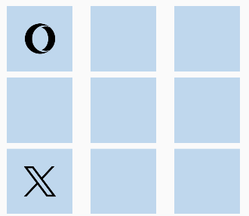
Fig 5.8.1
Above is one of the sample boards used in testing AI move validity. The first move is X in the bottom-left, followed by the AI’s in the top-left.
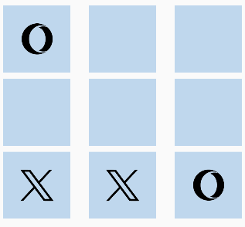
Fig 5.8.2
The next user move was to the bottom-middle where the AI responded by blocking the win, placing its piece bottom-right.
This testing was repeated for each difficulty of each AI and more data on the individual stats of these moves can be seen in the figures included in section 5.2.

5.8.2 User Login Test Data
User authentication was tested with different email and password combinations, for example:
Test Case | Input Email | Input Password | Expected Outcome | Result
Valid login | user@example.com | Password123 | Success | Pass
Invalid email format | userexample.com | Password123 | Error message | Pass
Incorrect password | user@example.com | WrongPass | Error message | Pass
Short password (5 chars) | user@example.com | Pass | Error message | Pass

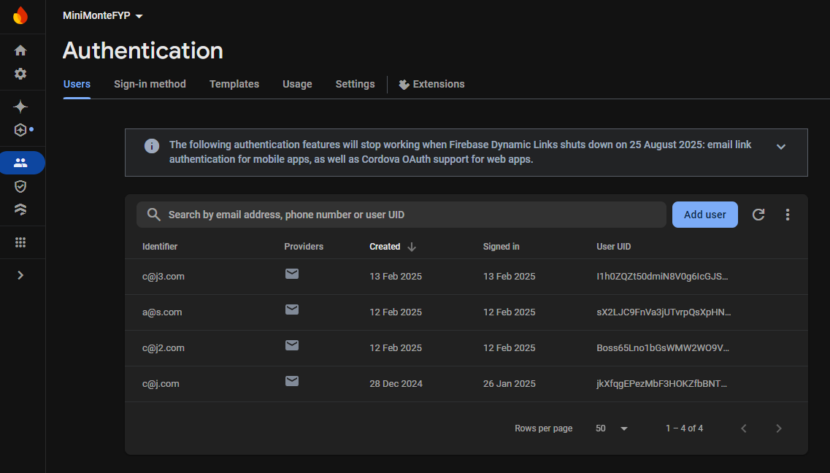
Fig 5.8.1
These are the actual users present in the Firebase console.

5.8.3 Usability Feedback Data
Collected from manual testing and user feedback:
Issue | Impact | Notes
Difficulty slider doesn't update immediately | Minor | Fixing would improve UI responsiveness
Win message does not specify AI vs Player | Medium | Could confuse users about game results
Bottom menu cut off in PvP mode | Medium | Impacts usability on some devices
Login page fields hide input | Minor | Adding a "show password" option would help

5.9 Summary of Findings
Below is a summary and recap of the main findings:

5.9.1 Non-Functional

5.9.1.1 Performance:
Minimax consistently outperforms MCTS in speed, especially at higher difficulty levels. MCTS takes significantly longer (milliseconds vs multiple seconds) due to its simulation-based approach. Pruning in Minimax also further reduced move time considerably.

5.9.1.2 Usability:
The user interface is functional, but some elements could be improved (e.g., sliders updating in real-time, clearer win messages). Minor navigation issues were reported, such as cut-off buttons in PvP mode.

5.9.1.3 Security:
The Firebase authentication system works correctly, enforcing basic email and password validation. However, passwords do not require capital letters or numbers, potentially allowing weak passwords.

5.9.1.4 Availability:
The app requires an internet connection for authentication, meaning users cannot log in offline. All other features function correctly once logged in.

5.9.1.5 Functional
Overall core gameplay functions as expected, with both Minimax and MCTS algorithms making legal moves. The difficulty settings correctly adjust AI behaviour to reduce move errors and consider more options. To this end MCTS seemed to outperform Minimax when it came to the larger game state of Connect 4. Minimax was more prone to missing user winning moves and wouldn’t block them as a result where MCTS would.
User authentication functions, including login, registration, and basic error handling for invalid inputs. Game state updates and UI interactions work as expected, but player names in Tic-Tac-Toe are not being displayed correctly.

5.10 Conclusion
The testing process covered both functional and non-functional aspects of the application, revealing key insights into AI performance, app usability, security, and availability. The results demonstrate that the Minimax and MCTS algorithms function correctly, with Minimax proving to be significantly faster, especially at higher difficulties with the caveat being its more likely to miss out on opponents winning moves.
Non-functional testing revealed that while the user interface is generally functional, there are minor usability issues that could be improved, such as UI responsiveness, clearer difficulty settings, and real-time updates for sliders. Security testing confirmed that Firebase authentication is implemented correctly, but password requirements could be strengthened to improve account security.
The functional testing confirmed that all core game mechanics, AI behaviours, and authentication features work as intended, ensuring that users can play Tic-Tac-Toe and Connect 4 against AI opponents of varying difficulty levels. Some minor UI bugs, such as the missing player names in Tic-Tac-Toe, were identified but do not critically impact gameplay.
Overall, the application meets its core functional requirements and provides a working AI opponent for both games. Future improvements could focus on enhancing UI clarity, optimizing MCTS performance, and strengthening security policies to ensure a smoother user experience.

6. Dissertation Conclusion
The goal of this project was to compare two heuristic AI algorithms; Minimax and Monte Carlo Tree Search (MCTS) using the games Tic-Tac-Toe and Connect 4 for comparison. Both algorithms were implemented and tested across various difficulty levels to assess their performance in terms of move time, resource usage, and efficiency.
The results revealed significant differences between the two algorithms. Minimax, with its deterministic approach and depth-limited search performed efficiently in Tic-Tac-Toe. In contrast MCTS while being inherently more flexible and capable of handling complex game scenarios, showed higher compute costs particularly at higher difficulty levels.
Testing then highlighted areas for improvement in the application’s user interface and security features with feedback suggesting smoother transitions between pages, clearer descriptions for difficulty sliders and stronger password validation for security.
This project has contributed to a deeper understanding of how these AI algorithms operate and their respective strengths and weaknesses in strategic gameplay. However there are several methods for future work that could build on this project such as optimising MCTS via progressive screening or parallelization, adding more heuristic ai’s to compare or more games to test them on and lastly using Firebase to store users game history, potentially using these stored games to more easily comparer different conditions when playing.
Overall, the project has met its objectives of comparing two well-established AI algorithms in the context of strategic games, providing valuable insights into their performance and practical applications.

Bibliography
​​Aradhya, A. L. (2023, January 16th). Minimax Algorithm in Game Theory | Set 4 (Alpha-Beta Pruning). Retrieved from https://www.geeksforgeeks.org/: https://www.geeksforgeeks.org/minimax-algorithm-in-game-theory-set-4-alpha-beta-pruning/
​Arsd College. (2020). Mini-Max Algorithm in Artificial Inelligence. New Delhi, India: ASRD College.
​Chess.com. (2017+, Unknown Unknown). Alpha-Zero chess engine. Retrieved from Chess.com: https://www.chess.com/terms/alphazero-chess-engine
​Radke, P. (2023, July 20th). Monte Carlo Tree Search: A Guide. Retrieved from https://builtin.com/: https://builtin.com/machine-learning/monte-carlo-tree-search
​Roy, R. (2023, May 23rd). ML | Monte Carlo Tree Search (MCTS). Retrieved from https://www.geeksforgeeks.org/: https://www.geeksforgeeks.org/ml-monte-carlo-tree-search-mcts/
​​(AI Factory Limited). (2024, 10, 14). Chess. Retrieved from play.google.com: https://play.google.com/store/apps/details?id=uk.co.aifactory.chessfree&hl=en_IE​​
​​Delapouite. (n.d.). Conway Game of Life Glider icon. Retrieved from Game-icons.net: https://game-icons.net/1x1/delapouite/conway-life-glider.html
​Google. (n.d.). Firebase Console. Retrieved from console.firebase.google.com: https://console.firebase.google.com/u/0/
​Tehras. (2018, 1 19). tehras/charts. Retrieved from Github: https://github.com/tehras/charts

