HDB Resale Solutioning of ETL pipeline

(January 2012 to December 2016)

Version 1.0

Action | Name, Designation | Date
Author by | Joe Chinnappan (Senior IT Architect, Data Management) | 20/07/2026
Reviewed by:

Version | Effective Date | Summary of Changes | Author
0.1 | 26 Aug 2025 | Initial Draft | Joe Chinnappan

Table of Contents
1 Requirement 4
2 Objective 4
3 Dataset Extraction 4
4 Dataset Cleaning 4
5 Dataset Transformation 5
6 Dataset Loading 5
7 Data Profiling 6
8 Post Verfication 6
9 Recommendation for additional validation 7
10 Pre request before execution 7
11 Global Variables 8
12 Architectural Design and Solutioning 9
13 Potentially Anomalous Resale Prices 10

1 Requirement
The requirement, the Data Engineering Team is responsible for building a repeatable Python-based ETL pipeline that prepares HDB resale flat transactions (January 2012 to December 2016) for the Data Science Team to perform price trend analysis and forecasting.

2 Objective
Design and implement a Python-based ETL pipeline to:
- Extract HDB resale flat datasets (Jan 2012 to Dec 2016).
- Clean and standardize the data.
- Transform the data into an analytics-ready format.
- Store the curated dataset for downstream Data Science consumption.
- Support automated and repeatable execution.

3 Dataset Extraction
Following are the source data from HDB in csv format. Total 92,544 are scope of Extraction, after extraction 92,544 are stored in combined.csv file

File Name | Scope of Extraction | Number of Records
ResaleFlatPricesBasedonApprovalDate19901999.csv | N | N/A
ResaleFlatPricesBasedonApprovalDate2000Feb2012.csv | From Jan 2012 | 3,188
ResaleFlatPricesBasedonRegistrationDateFromMar2012toDec2014.csv | Y | 52,203
ResaleFlatPricesBasedonRegistrationDateFromJan2015toDec2016.csv | Y | 37,153
ResaleflatpricesbasedonregistrationdatefromJan2017onwards.csv | N | N/A

4 Dataset Cleaning
As part of the Data cleansing, following activities were performed
- Missing Values,
- Duplicates &
- Formatting & Data Validation.

Validation Rules
Field Name | Validation Rule | Invalid Records | Observation
month | Valid Date in Format YYYY-MM | 0
town | Alphabetic Characters | 2744 | Failed for KALLANG/WHAMPOA  Note: As of now ignored as it is valid Town  Can be handled by  "^[A-Z\s\-'/.&]+$"
flat_type | Alphanumeric Characters | 0
flat_model | Alphanumeric Characters | 0
storey_range | Format NN TO NN | 0

5 Dataset Transformation
Following Data Transformation were performed
- Recomputed the based on the Lease_Period in terms of Years and Months ( 99 years – (today- lease_commence_date), assume that HDB lease is 99 years
- If any duplicate based on all columns have the exact same value, except for the resale price take the higher price and discard other records
- Additional column for Resale Identifier based on the section “Data Transformation Requirements”.
- Additional column for Hash value this identifier column using an irreversible hashing algorithm based on lambda hashlib.sha256

6 Dataset Loading
After Dataset Transformation is completed, all the required fields loaded into the final Dataset, hdb_with_resale_identifier_hashed.csv for Data analysts’ team.

7 Data Profiling
For data profiling used Sweetviz library. Sweetviz is an open-source python library that generates beautiful, high-density visualizations to kickstart EDA with a single line of Code. Sweetviz is taken as an inspiration from Pandas-Profiling. Data Profiling report is stored in Data_Profiling_Report_HDB.html.
The 2 main functions of the reports are
- Analyze the data
- Compare the data

8 Post Verification

8.1 Record Count Reconciliation
Description | Record Count | Output File Name
Original Rows From Jan 2012 to Dec 2016 | 92,544 | Combined.csv
Duplicates Rows | 273 | duplicate_records.csv
Original Rows, after removing Duplicate | 92,271 | cleaned.csv

Test Data for Field Level validation
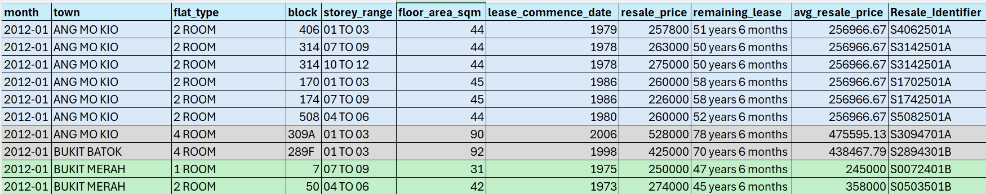

8.2 Field Level validation
- Field: month
Month Data, 2012-01 follows format YYYY-MM format.
- Field: Storey-range

Storey-range Data, 01 TO 03, follows format NN TO NN format.
- Field: Remaining lease
Lease-commence date Is 1979,
Remaining-lease is 99 years-(2026 July – 1979 Jan) = 51 years 6 months
- Field : avg_resale_price
Based on the 3 fields month(2012-01),town(ANG MO KIO) & flat_type(2 ROOM).
avg_resale_price=SUM(resale_price)/Number of Resale House
(257800+263000+275000+260000+226000+260000)/6 = 256,966.67
- Field : Resale_Identifier

First character is “S is S4062501A
Next 3 digits is Block number 406 is S4062501A
Next 2 digits of avg_resale_price is = 256,966.67 is S4062501A
Next 2 digits is Month(01) is S4062501A
Last Digit 1st character of tow n(ANG MO KIO) is S4062501A

- Field : Block number in Resale Identifier
Additional verification if Block has Character and Block Number less than 3 digits.

Block | Resale_Identifier
309A | S3094701A
289F | S2894301B
7 | S0072401B
50 | S0503501B

9 Recommendation for additional validation
- Drop records with missing resale_price
- Validate Resale Price Range like resale_price < 50000 & resale_price > 2000000
- Validate Remaining Lease remaining_lease_years <= 0 or remaining_lease_years > 99
- Flat Type Validation like valid_types in (
'1 ROOM', '2 ROOM', '3 ROOM','4 ROOM', '5 ROOM','EXECUTIVE', 'MULTI-GENERATION')

10 Pre request before execution
- Create Folder C:\HDB_Project(Root Folder)
- Create Folder “datasets” under C:\HDB_Project(To store all 5 .csv HDB Dataset files)
- Create Folder “output under” C:\HDB_Project\datasets (to store output data files)
- Copy the all the input .csv files in C:\HDB_Project\datasets\
- Run the Python script HDBProjectResale.py
- Following output files will create in C:\HDB_Project\datasets\output\.
Sequence of the File Creation | File Name(.csv) | Objective of the files
1 | combined | Combining all the records from HDB .csv files for the month from '2012-01'(Jan 2012)  to '2016-12'(Dec 2016)
2 | duplicate_records | Duplicate Records from '2012-01'(Jan 2012)  to '2016-12'(Dec 2016)
3 | Cleaned | Clean Records after removing duplicate Records from '2012-01'(Jan 2012)  to '2016-12'(Dec 2016)
4 | validation_report | Number of records violates Validation Rules
5 | invalid_records | Contains invalid records which violates Validation Rules
6 | cleaned_hdb_data | Clean data with additional recalculating remaining_lease in terms of Year and Month
7 | hdb_with_resale_identifier | Clean data with additional recalculating resale_identifier
8 | hdb_with_resale_identifier_hashed | Clean data with additional recalculating resale_identifier hashed value
9 | Data_Profiling_Report_HDB.html | Contains the Data Profiled details

11 Global Variables

Following are the Global variables used in the Python Program

Variable Name | Variable Value | Description
folder | C:\\HDB_Project\\datasets | To keep all the HDB .csv Files
output_folder | C:\\HDB_Project\\datasets\\output | To store the output files
start_date | 2012-01 | To store the start Year and Month of the Extraction
end_date | 2016-12 | To store the end Year and Month of the Extraction

12 Architectural Design and Solutioning
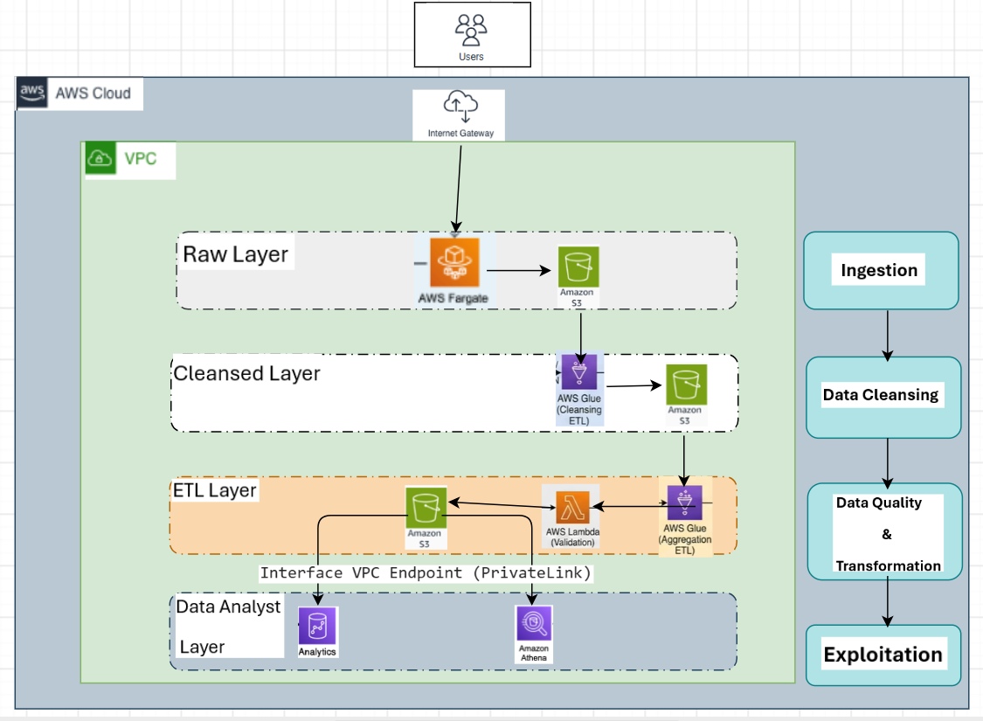
12.1 Data Ingestion Requirements
1) Batch data ingestion from data.gov.sg. this design support large files transmission (e.g. > 100 MB)
Fargate provides:
- Elastic scaling
- Better support for large file transfers
2) This VPC acts as a controlled buffer between the public internet and HDB's internal platform.

12.2 Data Exploitation Requirements
Query output reaches securely to Athena through Interface VPC Endpoint (Private Link).

Potentially Anomalous Resale Prices

- Analysis based on the Sum of Sales against Towns
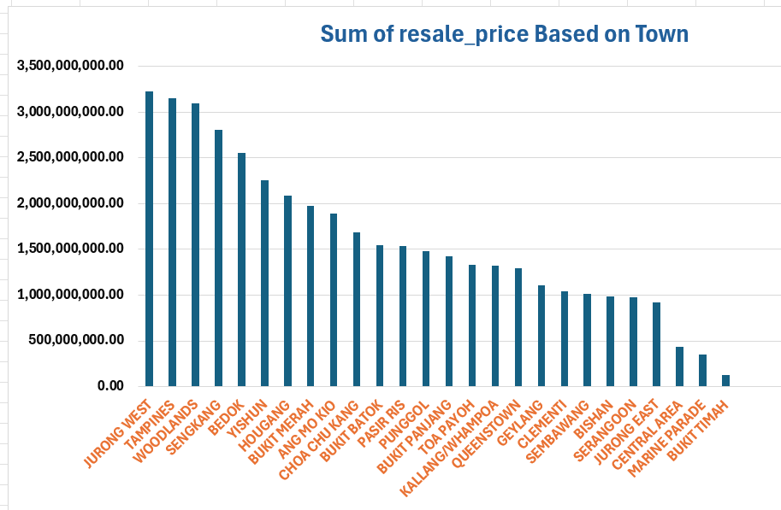
Based on the analysis, top 3 Resale Price are
- Jurong West
- Tampines
- Woodlands
Based on the analysis, Bottom 5 Resale Price are
- Bukit Timah
- Marine Parade
- Central Area
Conclusion: Most of the people are selling the house in outer area of Singapore except Bukit Timah not in the central region.
- Analysis based on the Sum of Sales against each year for Top 5 Towns.

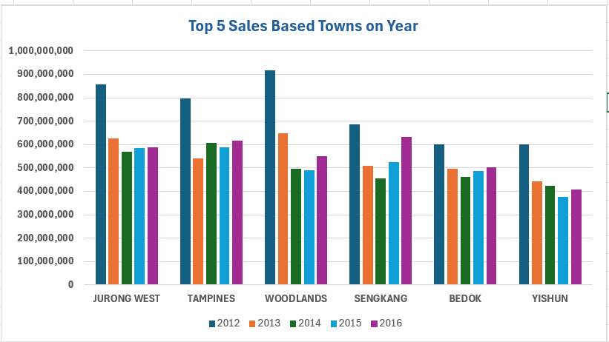
Conclusion: Comparing the sales from 2012 to 2016. Sales is more in all the Towns in 2012. Remaining years there is no major sales fluctuation

- Analysis based on the Sum of Sales Price based on Flats.

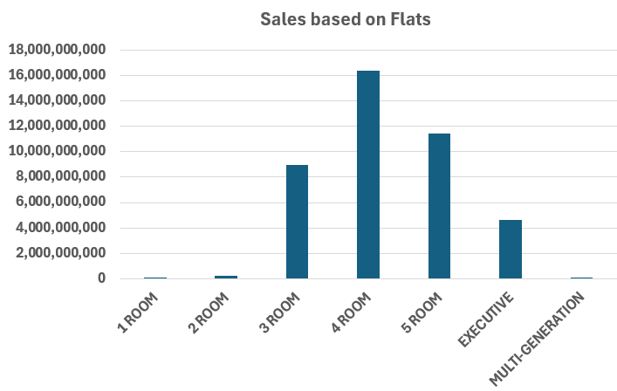
Conclusion: Based on the Flats, maximum sales prices are in the order 1) 4 Rooms 2) 3 Rooms and 3) 5 Rooms

