*NB - The supporting evidence (i.e. traceroute outputs etc) are provided in output.txt.

Exercise 1 – nslookup
- Ip Address of www.cnn.com: 151.101.29.67
- No multiple addresses for www.cnn.com
- Multiple addresses for cnn.com (perhaps addresses for namespace servers).
- 127.0.0.1 is the address of localhost (i.e. our host machine)

Exercise 2 - Use ping to test host reachability
Are the following hosts reachable? Reachability was checked using ping.

Host | Reachable | Reason (If not reachable)
www.unsw.edu.au | Yes | -
www.getfittest.com.au | No | ping: cannot resolve www.hola.hp: Unknown host  - This domain is not reachable from the web as well.  - A whois lookup suggests the domain is registered. So perhaps the namespace servers are not pointing to the correct host machines.
www.mit.edu | Yes | -
www.intel.com.au | Yes | -
www.tpg.com.au | Yes | -
www.hola.hp | No | ping: cannot resolve www.hola.hp: Unknown host  - A whois lookup suggests this domain is not registered. The hp tld was banned by ICANN. So perhaps that domain name has been mistaken for www.holahp.com.
www.amazon.com | Yes | -
www.tsinghua.edu.cn | Yes | -
www.kremlin.ru | No | Request timeout for icmp_seq 0  - This domain is reachable from the web (ie. I was able to send a http request)  - This suggests that ICMP packets are blocked by the host.
8.8.8.8 | Yes | -

Exercise 3 - Use traceroute to understand network topology
- Running a traceroute to www.columbia.edu
  - There are approximately 23 routers between workstation and the host.
  - Of those 23 routers, there are 4 UNSW routers.
  - Two routers, where packets suspected to cross over the Pacific Ocean, are routers 8 & 9 (i.e. et-0-0-0.pe1.a.hnl.aarnet.net.au & et-2-1 0.bdr1.a.sea.aarnet.net.au)
- Running a traceroute to the following websites: (i) www.ucla.edu (ii) www.u-tokyo.ac.jp and (iii) www.lancaster.ac.uk
  - Paths to these three destinations diverge on the following router:
    - et-2-1-0.bdr1.a.sea.aarnet.net.au
  - After doing a whois lookup on the above router, we can see it’s owned by AARNet Pty Ltd. This router is located in Melbourne Australia.
  - The number of hops doesn’t seem to have any correlation with how far away the host is located. The number of hops to each destination is exactly the same (i.e. 30 hops). Website (i) is located in Los Angeles, California and website (ii) is located in Tokyo, Japan and website (iii) is located in Scotforth, Lancashire, UK. However, if the number of hops were to be correlated, we should have seen website (iii) to have the largest number of hops.
- Running traceroute to and from the following servers: (i) 202.150.221.170 (ii) 129.94.8.59.
  - The reversed path doesn’t go through the exact same forward path.
  - There have been some observed common routers between the forward and the reverse path, however they’re not the exact same routers. For example:
    - bundle-ether13.chw-core10.sydney.telstra.net
    - bundle-ether12.ken-core10.sydney.telstra.net
  - The routers above are on different subdomains and have different IP addresses, however they’re presumably provided by the same host (i.e. Telstra). Perhaps the reason for this has to do with the switching mechanism and the router determined it was best to go through a different node. There are many reasons for this including the need to reduce queue delay.

Exercise 4 - Use ping to gain insights into network performance
- Physical distances from UNSW to each of the following destinations.
  - http://www.uq.edu.au
    - 734.59 km
    - T = (734.59 x 1000) / (3 x 10⁸ m/s) = 2.44863 ms
    - Min RTT (size 50 bytes): 16.597 ms
  - www.tu-berlin.de
    - 16123.11 km
    - T = (16123.11 x 1000) / (3 x 10⁸ m/s) = 53.7437 ms
    - Min RTT (size 50 bytes): 307.374 ms
  - www.uws.edu.au
    - 5.91 km (City campus, where server seems to be hosted using IP Locator)
    - T = (5.91 x 1000) / (3 x 10⁸ m/s) = 0.0197 ms
    - Min RTT (size 50 bytes): 1.464 ms

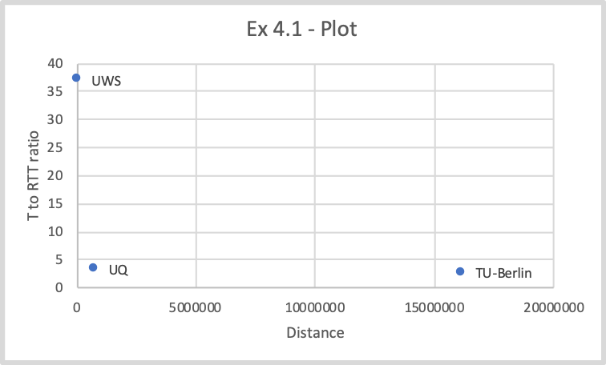
  - This plot represents distances on the x-axis and the shortest possible time to minimum round-trip time (packets of 50 bytes) ratio on the y-axis.
  - The Y-values will always be greater than or equal to 2 as T is the time it takes for a single trip to the destination whereas the round trip to and from the destination (i.e. at least 2T).
  - The round-trip time also includes various types of delays such as propagation, processing, queueing and transmission delay.
- The delay to each destination varies overtime due to several non-deterministic factors (i.e. Queuing delay).
- www.epfl.ch
  - By sending a ping request and getting the IP address the domain is pointing to, we see that it’s using Cloudflare (presumably to mask the IP). This doesn’t give us any useful information.
  - After doing a whois lookup on the host, we see that the domain was purchased by The Swiss Education & Research Network.
  - It’s hard to conclude the actual location where the server is being hosted due to the relevant security measures the webmaster has taken, by using Cloudflare’s DNS services.
  - I tried to examine the RTT, but because they’re using Cloudflare’s CDN services as well, the result is also inaccurate as Cloudflare points me to the nearest node on the delivery network.
- Which of the following delay’s rely on the packet size and which do not: propagation delay, transmission delay, processing delay and queuing delay?
  - Propagation delay -> doesn’t rely on the packet size as it represents the delay of each bit being propagated through a particular physical medium.
  - Transmission delay -> does rely on the packet size as it’s essentially the time it takes the router to push out each packet (i.e. transmit all bits of each packet)
  - Processing delay -> does rely on the packet size if the algorithm used to generate and check the checksum relies on the packet body. Otherwise processing delay is delay based on figuring out which router to send the packet to and doesn’t rely on the packet size.
  - Queueing delay -> doesn’t rely on the packet size.

Appendix

Ex4 Graphs
TU-Berlin Delay Graph
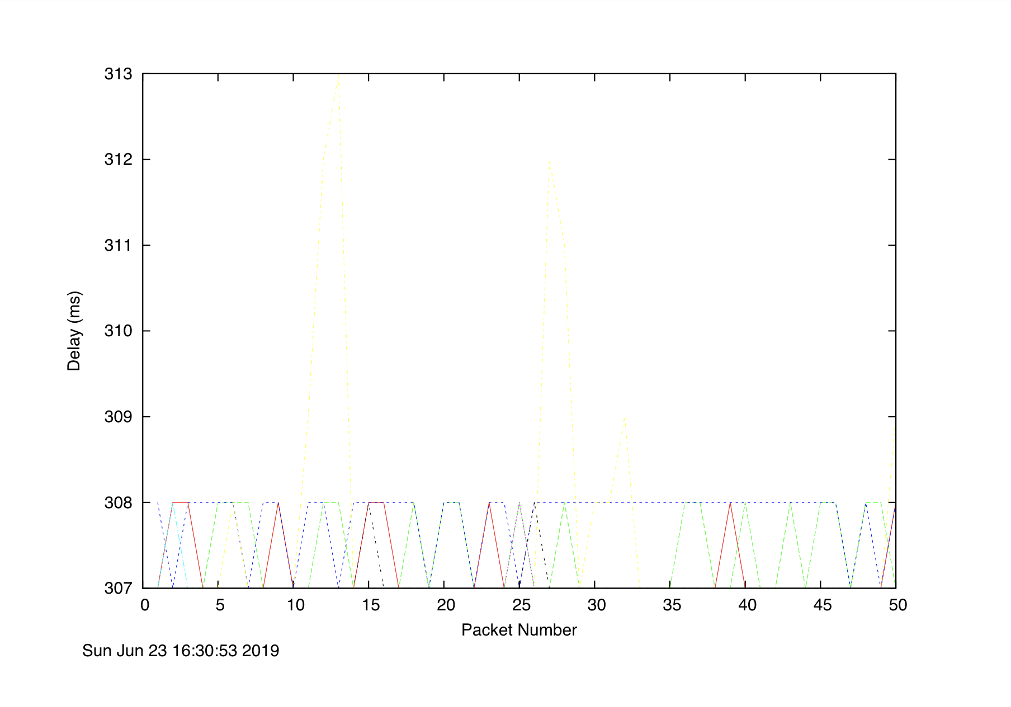
UQ Delay Graph

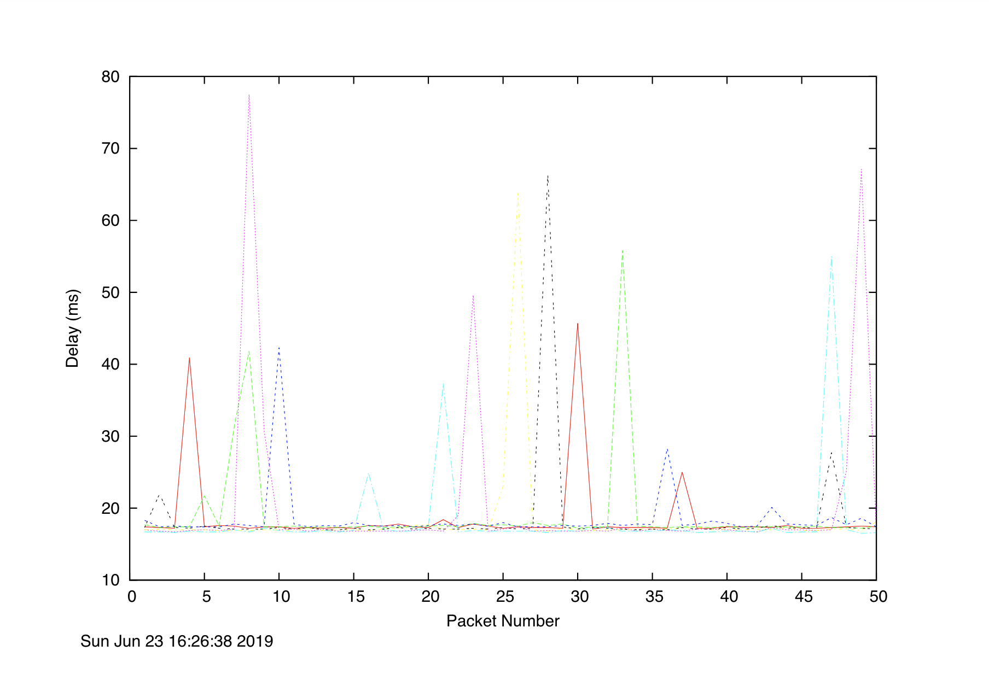
UWS Delay Graph
