Conversions
TB => GB => MB => KB => B
- Multiply by 1024 to go down (i.e. increase accuracy)
- Divide by 1024 to go up (i.e. generalise)
s => Ms
- Multiply by 1000 to go down (i.e. increase accuracy)
- Divide by 1000 to go up (i.e. generalise)

Introduction

What is the Internet?
- Globally connected network of networks that uses TCP/IP to transmit data over various media.
  - “Network of Networks”
  - Interconnected ISPs
- Protocols – Control sending and receiving of messages.
- Internet Standards – Formal definition of these protocols.
  - RFC – Request for comments
  - IETF – Internet Engineering Task Force

Protocols
- Define Format & Order of messages sent and received among network entities, and actions taken on message transmission receipt.
- Human Vs Network Protocol
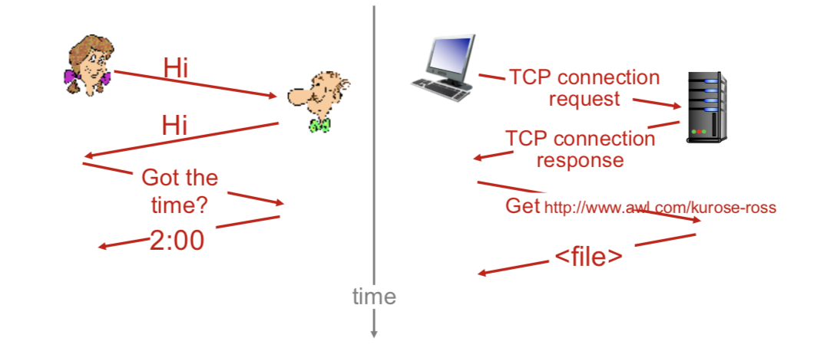

Network Edge

End Systems
- Consist of devices that are connected to the end of the network
  - Clients & Servers

Access Networks/Physical Media
- Wired, wireless communication links
- Properties
  - Bandwidth (Bits per second)
  - Shared OR Dedicated?
- DSL – Digital Subscriber Line
  - Existing telephone line to central office DSLAM (DSL Access Multiplexer).
    - Data over DSL -> Internet
    - Voice over DSL -> Telephone Net
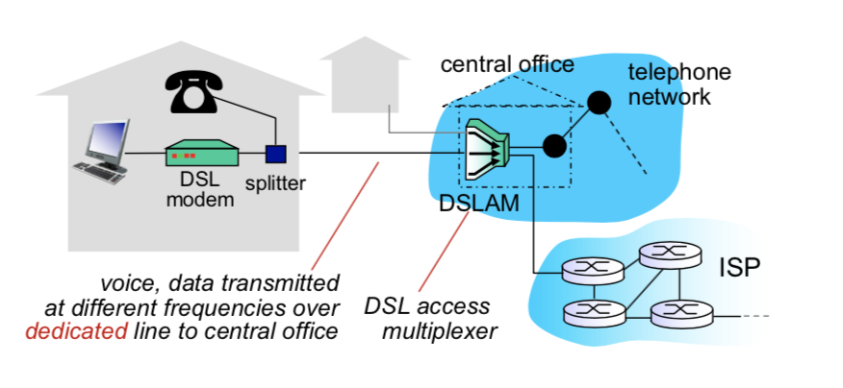
  - Closer to DSLAM, faster the speeds
  - ADSL – Asymmetric Digital Subscriber Line
    - < 2.5 Mbps Upstream
    - < 24 Mbps Downstream
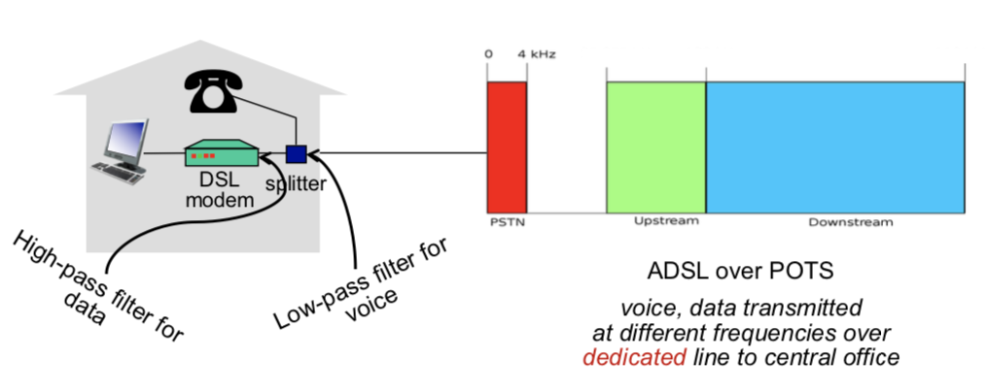

  - SDSL – Symmetric Digital Subscriber Line
  - Frequency Division Multiplexing: different channels transmitted in different frequency bands.

Network Core
- Interconnected routers (network of networks)

Delay, Loss, Throughput in Networks
Bandwidth – “Width” of the link ~ Number of bits sent per unit of time (bps)
Types of delays

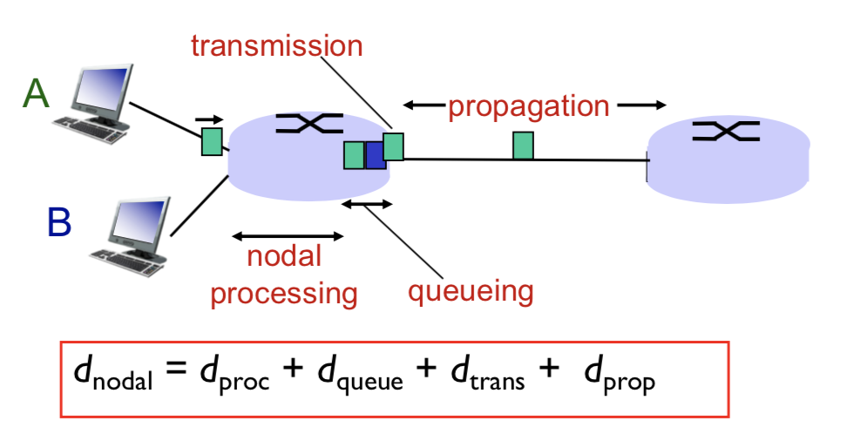
- Propagation Delay = d/s
  - Where
    - d: length of physical link
    - s: propagation speed in medium (~2x10⁸ m/sec)
  - Caused by length of the link
  - Time to travel along the link (seconds)
- Transmission Delay = L/R
  - Where
    - L: packet length (bits)
    - R: link bandwidth (bps)

- Queueing Delay a
  - 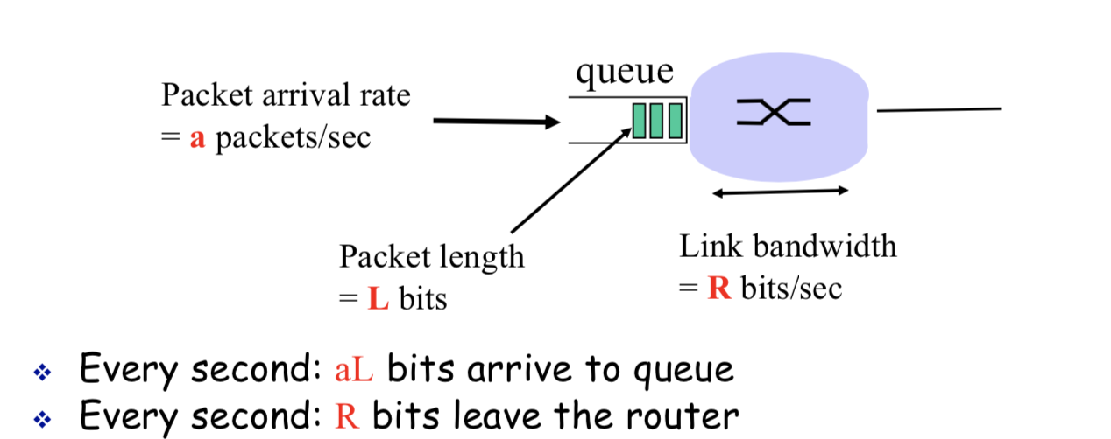
  - aL/R ~ Traffic Intensity
- Processing Delay
  - How long it takes to

Protocol Layers, Service Models

Application Layer

Principles of Network Applications

Web and HTTP

Electronic Mail
SMTP: Push protocol

DNS
- Local name servers are used to cache commonly visited domains.
- TTL is part of a DNS record and tells the local name server how long to hold it in cache.
  - After expiry, the local name server has to query the root & TLD servers again, in case the IP address changes.
- Google DNS (8.8.8.8): Good because it likely has a bigger cache and can reduce number of DNS queries send to root and TLD DNS servers.

P2P Applications

Video Streaming and Content Distribution Networks (CDNs)

Transport Layer

Transport-Layer Services

Multiplexing and Demultiplexing

UDP – Connectionless Transport
- Good for when reliability not required and usually used for small messages (I.e. Instant messaging clients).

Principles of Reliable Data Transfer

TCP – Connection-Oriented Transport
- Used when reliability is needed (I.e. during large file transfers).

Segment Structure

Reliable Data Transfer

Flow Control Mechanism

Connection Management

Principles of Congestion Control

TCP Congestion Control

