1.

#-------------------------------------------------------------------------------

# Name: daughterdecay

# Purpose:

#

# Author: Claire Joyce

#

# Created: 25/09/2014

#-------------------------------------------------------------------------------

#!/usr/bin/env python

from numpy import *

from math import *

import matplotlib.pyplot as plt

import numpy as np

N1=1000

N2=0

t=0

t_stop=60

t1=input("t1")

t2=input("t2")

h=input("val time step h")

k1=math.log(2,math.e)/t1

k2=math.log(2,math.e)/t2

plt.title("Heun's Method of Solution")

plt.xlabel("time t")

plt.ylabel("N(t)")

def f1(N1):

return -k1*N1

def f2(N1,N2):

return k1*N1-k2*N2

while t<t_stop:

plt.plot(t,N1,"bo")

plt.plot(t,N2,"r+")

N1_end=N1-k1*N1*h # use euler to find the val of N1 at end of interval

N2_end=N2 + (k2*N1 - k2*N2)*h # use euler to find the val of N2 at end of interval

N2=N2+(f2(N1,N2)+f2(N1_end,N2_end))*h/2.0

N1=N1+(f1(N1)+f1(N1_end))*h/2.0

t=t+h

a=N1_end/N1

b=N2_end/N1

c=N2_end*k2

print "When t=60s:\na=",a,"\nb=",b,"\nc=",c

plt.show()

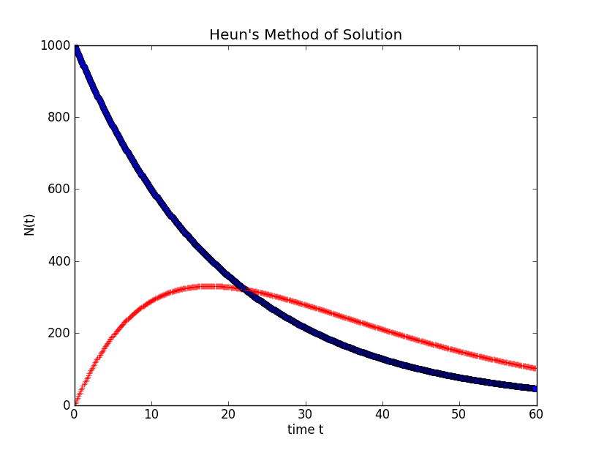

2.

#-------------------------------------------------------------------------------

# Name: temperatures

# Purpose:

#

# Author: Claire

#

# Created: 25/09/2014

#-------------------------------------------------------------------------------

#!/usr/bin/env python

from math import *

import matplotlib.pyplot as plt

from numpy import *

Ti=input("Initial temp of apt (F): ")

r=0.1

t=input("Time period (hours): ")

t0=0

dt=0.1

x=[]

yI=[]

yS=[]

E=[]

def f(xt):

return 92.-10.*sin(2.*math.pi*(xt+3.)/24.)

def g(xt):

TS=f(xt)

return TS+(Ti-TS)*math.e**(-r*xt)

#TA=g(xt)

#T=(Ti-TS)/TS

plt.xlabel("time t")

plt.ylabel("Temp")

while t0<t:

# tm=T+(-r*(T-g(t))*dt/2.)

# T=T+(-r*(tm-f(t))*dt/2.)

x.append(t0)

yI.append(g(t0))

yS.append(f(t0))

plt.plot(t0,f(t0),"bo")

plt.plot(t0,g(t0),"r+")

t0+=dt

for i in range(0,len(yS)):

for j in range(0,len(yI)):

if(yI[j]==yS[i]):

E.append(x[j])

maxy=max(yI)

print "Maximum temp inside= ",maxy

print "Temps equal at time(s): ",E, "h"

print "Inside leads for 40 hours."

plt.show()

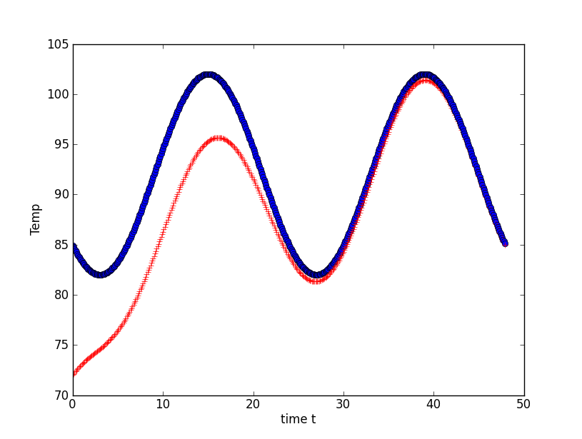

3.

#-------------------------------------------------------------------------------

# Name: wort

# Purpose:

#

# Author: Claire Joyce

#

# Created: 25/09/2014

#-------------------------------------------------------------------------------

#!/usr/bin/env python

from math import *

import matplotlib.pyplot as plt

from numpy import *

t0f=212

t0c=100

tsf=70

tsc=21

m=40

s=1200

h=12

c=4200

q=-3600

T=100

dt=0.1

t=0

def f(T):

return (q-h*s*(T-tsc))/(m*c)

plt.xlabel("time s")

plt.ylabel("Temp C")

while (T>=40):

plt.plot(t,T,"bo")

endT=T+f(T)*dt

T+=(f(T)+f(endT))*dt/2.

t=t+dt

print "Time= ",t," s"

plt.show()

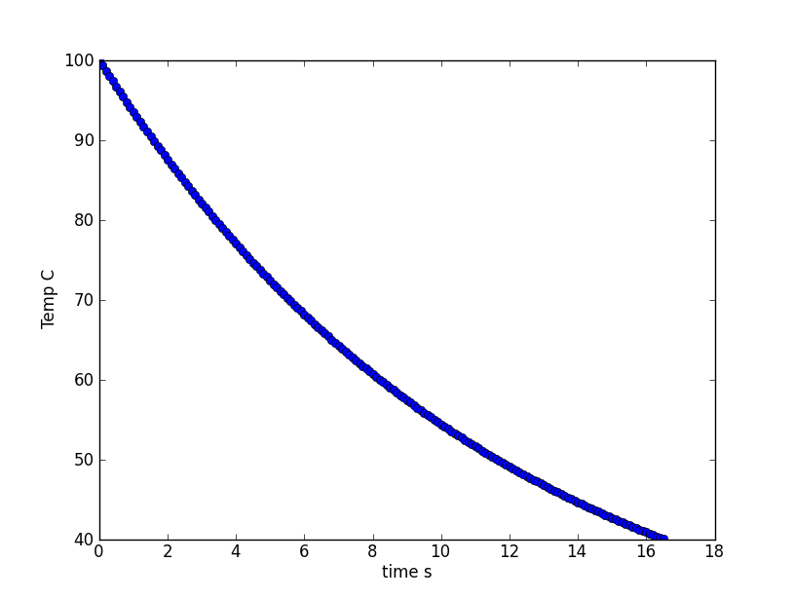

4.

#-------------------------------------------------------------------------------

# Name: coldmedication

# Purpose: solve diff eq for amount of cold meds in blood stream and GI as it goes through GI & bloodstream

#

# Author: Claire

#

# Created: 25/09/2014

#-------------------------------------------------------------------------------

#!/usr/bin/env python

import matplotlib.pyplot as plt

from numpy import *

from math import *

#Initialize vals

t=0

tstop=120

h=0.01

I=0

x=0

y=0

k1=0.6931 #dissolving constang

k2=0.231 #clearing constant

xend=0

yend=0

def Rx(x,I): #calc rate of absorption into GI

return I-k1*x

def Ry(x,y):

return k1*x-k2*y

plt.axis([0,tstop,0,7])

while t<tstop:

if t%6 <= 6.5%6:

I=12.

else:

I=0

yend=y+Ry(x,y)*h #use euler to get end point

y+=(Ry(x,y)+Ry(xend,yend))*h/2.0

xend=x+Rx(x,I)*h

x+= (Rx(x,I)+Rx(xend,I))*h/2.0

plt.plot(t,x,"b+")

plt.plot(t,y,"r+")

t+=h

plt.xlabel("time h")

plt.ylabel("drugs mg")

plt.show()

#The graph shows that the medication in the GI and Bloodstream

#will spike with each pill taken, and then decrease gradually until more medecine is taken.

#The medecine must be taken about every six hours to maintain an effective amount.

#Michael will be asleep in physics class from the cold medicine.

