BUG REPORT
Monthly Price Not Reflected on the Listings Dashboard
Reported by: Carmen Palsario Date: July 16, 2026

Summary
Monthly price set during listing creation displays as $0.00 on the listings dashboard, despite being correctly stored and shown on the public listing page.

Environment | staging.whereipark.com
Severity | Medium
Area | Listings Dashboard — Monthly Price column

Preconditions
- User is signed in with a valid account
- At least one listing exists with a monthly price configured (e.g. set to $121.00 during the Create Listing wizard)

Steps to Reproduce
1. Sign in to staging.whereipark.com
2. Navigate to /listings
3. Observe the Monthly Price column in the listings table

Expected Result
The Monthly Price column displays the price set during listing creation (e.g. $121.00).

Actual Result
The Monthly Price column shows $0.00 for all listings, regardless of the price configured.

Evidence
Screenshots show $0.00 for "1015 Folsom" on the dashboard, while the listing detail page at /parking/san_francisco/1015-folsom-2 displays $121.00 /mo as the correct price. The data is stored correctly — only the dashboard display is incorrect.
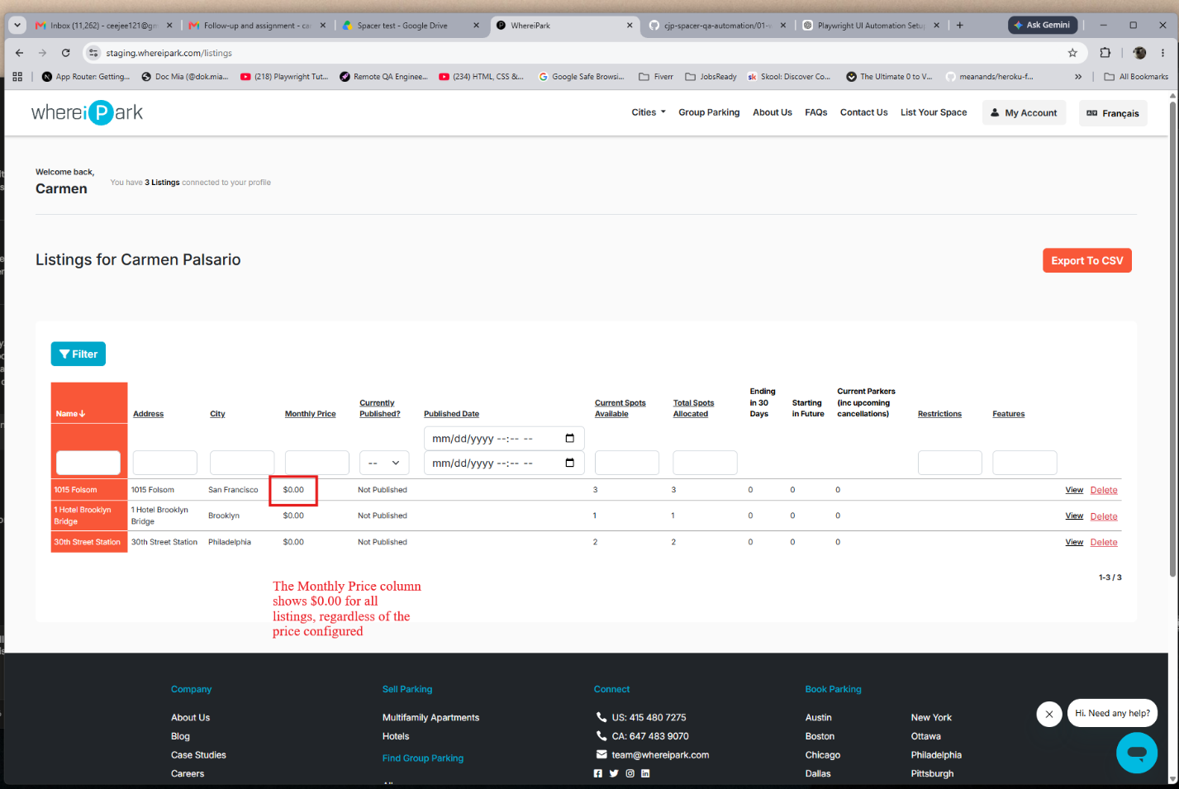
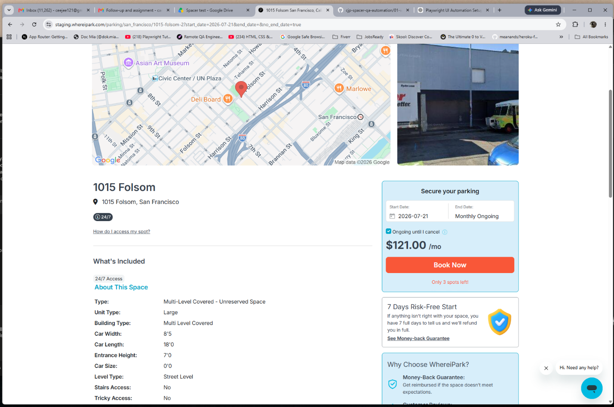

Impact
- Listing owners — see a misleading dashboard that makes every listing appear unpriced, which may cause confusion or erroneous re-editing of prices.
- Support and ops teams — relying on the dashboard to audit pricing would get inaccurate data.
- Trust — a host new to the platform who sets a price and immediately checks the dashboard would reasonably assume the price was not saved.

Severity Justification
Rated Medium: data is not lost (the listing detail page shows the correct value), but the dashboard misrepresents it in a way that is visible to every logged-in host. No booking or financial data is corrupted, but the UX impact is significant for host confidence.

