1. 优化tomcat内存配置

bin/IMG_256catalina.sh

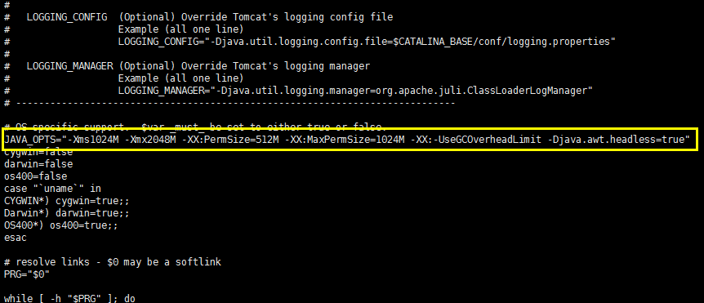

JAVA\_OPTS="-Xms1024M -Xmx2048M -XX:PermSize=512M -XX:MaxPermSize=1024M -XX:-UseGCOverheadLimit -Djava.awt.headless=true"

1. 配置ngin文件

Nginx.conf

|  |
| --- |
| #user nobody;  worker\_processes 1;  #error\_log logs/error.log;  #error\_log logs/error.log notice;  #error\_log logs/error.log info;  #pid logs/nginx.pid;  events {  worker\_connections 1024;  }  http {  include mime.types;  default\_type application/octet-stream;  #log\_format main '$remote\_addr - $remote\_user [$time\_local] "$request" '  # '$status $body\_bytes\_sent "$http\_referer" '  # '"$http\_user\_agent" "$http\_x\_forwarded\_for"';  #access\_log logs/access.log main;  sendfile on;  #tcp\_nopush on;  #keepalive\_timeout 0;  keepalive\_timeout 65;  #gzip on;  include /var/tomcat/nginxHosts/\*;  } |

1. 创建nginx的子server文件目录

/var/tomcat/nginxHosts

1. 配置nginx执行脚本

权限：chmod u+x \*.sh

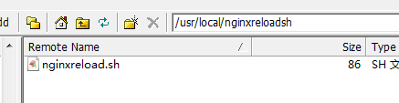

1. 配置server.xml文件，端口等