Assembly Basics Segment Regs Perserving/Restoring Regs IA32/Irving Instructions Conditions and Loops
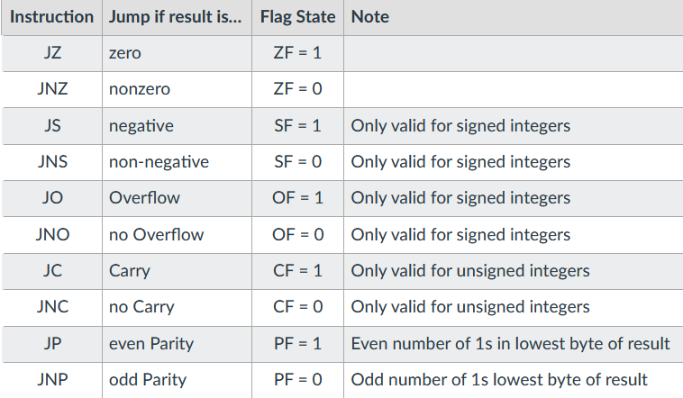
Almost 1:1 with ML Compiler 16-bit registers that point to Common to use push/pop to store ADD: (dest, src) reg/reg, reg/imm, mem/reg,
→ Assembly → Assembler segments of mem 16 bits wide reg values and restore later (procs mem/imm, reg/mem. Desc: adds two signed
(MASM) → ML opcodes. CISC In protected mode, CS points and loops) Must pop regs in the or unsigned integers.
use micro for each code, RISC to beginning of code seg where reverse order pushed. Important SUB: (dest, src) reg/reg reg/mem mem/reg
runs direct. Hardware ISA works prgm is currently exectued is to not skip over pop statements. reg/imm mem/imm Desc: subtracts src from
w/OS to convert ML to Obj is stored. DS reg points to start PUSHAD: pushes all 8x 32bit GPRs dest. Works for signed and unsigned ints.
Files.Linker catches err, links of data seg where data defined onto stack in order of EAX (C, D, B) INC: (dest) reg/mem Desc: adds 1 to reg
into single exe → loader reads by the prgm when compiled cur value of ESP, EBP, ESI, and or mem operand. Does not affect carry flag.
exe into MMU at current exe lives. SS points to stack seg EDI. POPAD: pops all 8x bit GPRs DEC: (dest) reg/mem Desc: adds 1 to reg
address. where runtime stack is stored. In reverse order of PUSHAD. or mem operand, does not affect carry flag.
IA-32 Arch/Exe Env Instruction Pointer PUSHA/POPA: same as above MOV: (dest, src) reg/reg, mem/reg, reg/mem
Protected mode: each prgm EIP reg contains offset of the but for the 16-bit sub-registers for mem/imm, reg/imm Desc: copies data from src
rserved linear addr space of 4gb, next instruct to be executed. each GPR. PUSHFD/POPFD: to dest, dest then = src. Must match in size, LOOP: (dest) decrements ECX by 1 then checks
no access for other pgms. All Adding EIP to CS would be push and pop 32-bit EFLAGS reg EIP cannot be dest. ECX for zero, if zero, loop terminates, program
addresses are 4 bytes/one dword. addr of next instruct to be exec. into and out of stack. Good bec. MOVSB/SW/SD: “copy string”, copies value from executes immediately after LOOP statement, if not
Registers 8x 32-bit general regs Can’t be directly accessed, but MOV can’t copy EFLAGS. one mem location (ESI) into another mem location zero, JMPs to dest code label.
6x 16-bit segment regs, 1x 32bit is modified by procs like JMP Procedures (Procs) (EDI). If direction flag clear, esi/edi increments, CMP: compares dest to src through implied subtraction
status/control reg (EFLAGS) and CALL/RET. Helpful for when using a top- if set, esi/edi are decremented. ECX stores count (dest – source), then sets status flags. No modified ops
1x 32-bit instr pointer reg (EIP) Runtime Stack (RTS) down design approach. Has for length of source. MOV esi, OFFSET src. and result not stored. Use SUB to keep result. If src is
General Registers LIFO/FILO – stack operations pre-conds/inputs and post-conds MOVSX: copy with sign extend (reg32, reg/mem8) imm, it is sign extended to dest ops length. Important
EAX: implied operand in ALU must reference the top of the /outputs. Main proc should be (reg32, reg/mem16) (reg16, reg/mem8) flags: zero flag, carry flag and (for signed) overflow flag.
ops. EDX: implied extension of stack. Runtime stack is local to mostly a list of CALLs to other copies signed value from a smaller src to a larger
EAX when ALU results overflow the program space, managed by procs. Ex. Format: dest. Sign extends this value into the high bits of a
past 32-bits. ECX: used as a cpu. Stores locals, proc params, myProc PROC 16/32bit register. MOVZX same as MOVSX but Jcond – Conditional Jump
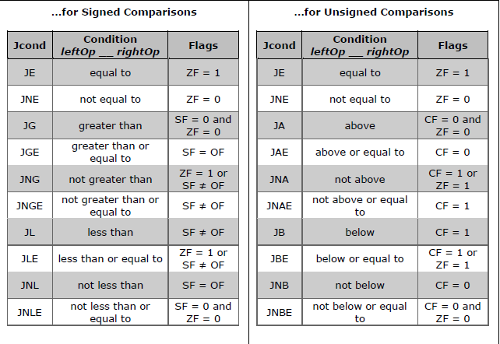
counter for ops like LOOP and retr addrs. SS holds addr of the ;… zero-extends (ensures leading bits are set to zero
REP ESI: used by mem trasfer to start of the stack seg, ESP points RET ;return to calling proc after converting unsigned int value to dest higher
store source addr, EDI used for to the top of the stack (the most myProc ENDP bits.
dest addr (should use only for recent value pushed). Finite Call procedure: 1. push EIP MUL: multiplies unsigned ints. Dest is implied
these purposes) ESP – stack space, shares space with heap, (addr of instruction imm after call) Does not perserve sign. Result must be returned
pointer, should always point to top pushing when flow causes onto system stack 2. jump to in reg 2x size src operand (AL → AX)
of RT stack. Do not use for overflow. beginning of named proc. 3. call DIV: mov dividend to EAX, set EDX to zero
“general purpose”. EBP: used by PUSH RET to return to calling proc. to clear high dividend, MOV divisor to EBX,
HLLs to point to base of stack Only needs to specify source, Important: calling REC simply then “DIV EBX”, quotient stored in EAX,
frame. Not for general purpose. then that value is pushed to the pops from the top of stack and stores remainder stored in EDX.
Subregs: allows acces to subset of stack. Can push mem, reg, addr that into EIP. A missaligned stack IDIV: used for signed division. Returns a quotient
bits on register. Omit E for lower16 offset, or imm literal. If 16-bit will pop the wrong thing into EIP and a remainder, remainder always same sign as di.v
bits. For A/B/C/D, omit X and use operand: 2 is sutract from ESP. and you won’t end up back at the (same registers DIV)
H for bits 8-15 and L for bits 0-7 If 32-bit operand: 4 is subtract calling proc. IMUL: multiplies signed ints. Sign extends high
(high and lowbytes). From ESP. After subtract, op bit of lower half of porduct into upper half of product. IMUL multiplier: behaves same as MUL JCX, JECXZ: Jump if (CX, ECX) = 0
Status Register (EFLAGS) is coppiedat loc pointed to by IMUL dest, multiplier: dest is multiplicand and src jcxz/jecxz destinationLabel
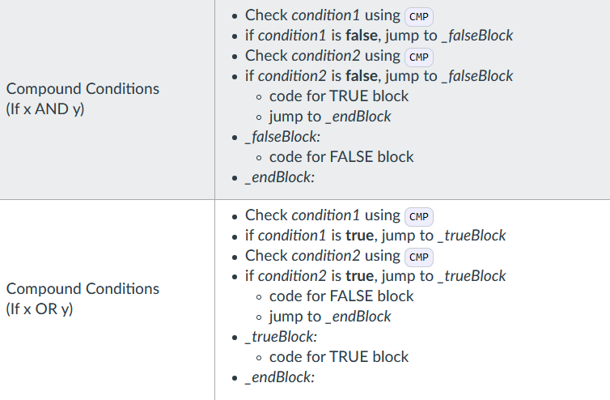
This reg is saved if cpu is interrupt that new ESP addr. Note: as is multiplier, product is truncated to len of dest.
or suspended. Each bit in register is things are pushed, ESP addr IMUL dest, multiplicand, mult: all specified,
considered a “flag”. Carry Flag is decremented, thus lower product truncd to len of dest.
(CF/CY) set if APU generates carry addrs are higher on stack, and CDQ: doubles size of operand in AX or EAX
or borrow out of the result MSB. higher addrs are lower. depending on size by means of sign ext. and
Parity Flag (PF/PE) set if LSByte POP stores results in reg DX:AX or EDX/EAX, where
of result contains an even number Copies value at top of stack sign bit is stored in E/AX and every bit pos stored
of 1 bits. Aux Flag (AF/AC) set if (value at ESP) into dest and in E/DX
binary artihmetic op generates a then increments ESP by size “Sign Extend”: def: increase the number of bits
carryor borrow out of bit 3. Zero of dest. op. Doesn’t remove of a binary number while perserving the number’s
Flag (ZF/ZR) set if result is zero. val from stack, just dereferences. sign.
Sign Flag (SF/PL) set to the MSB Stack Allignment AND dest, src: dest and src must be same size, iter
of the result (sign bit of a sign Very important to maintain. through bits, if both bits have value 1, set dest bit 1
integer) Overflow Flag (OF/OV) using diff sized operands else set dest bit to 0. Always clears overflow/carry
used in 2’s comp arith, set if result things can break: ex. Push 2 flags. Sign/Zero/Parity set according to dest result.
is too large (pos) or too small (neg) bytes and pop 4 bytes will store OR dest, src: same as AND but if at least one bit
to fit in dest operand i.e.an overflow good bytes but then store what ever has value of 1, sets dest bit to 1. XOR: if both bits
condition. the next two bytes on the stack are the same, result bit in dest is 0, if not both, result is 1.
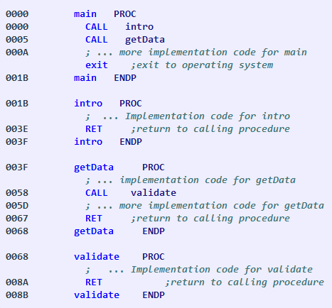
were, causing data corruption.

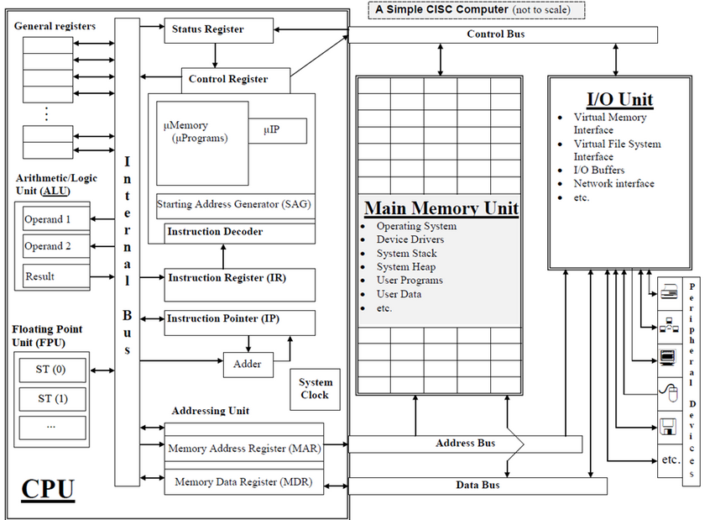
Decimal → Signed Binary:
(1) Get positive binary representation
(2) Invert all bits (3) add 1 to result.
Signed Binary → Decimal:
(1) Invert all bits (2) Add 1 to result
(3) Convert to decimal (4) add neg
sign if original MSB was 1
Binary Subtraction:
(1) Sign extend subtracted value (2)
Get 2C of subtracted value (3) Pad first value
(4) Add two values (5) Toss the MSB
Signed Hex 2’s Comp:
(1) Get absolute hex value (2) Subtract
each digit from F (3) Add 1 to get result
---------------------------------------------------------
Big endian: MSByte stored first in memory,
LSByte stored last. Little endian (IA32):
LSByte stored first, MSByte stored last.
Endianess only impacts byte ordering, nor bit
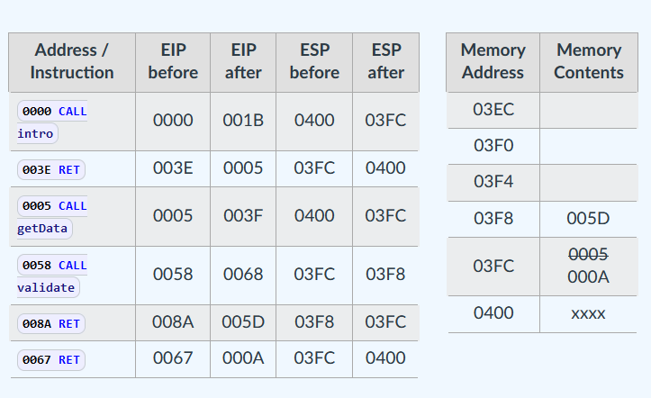
order and not arrays. Big endian = human
Data Access Procedure: (1) Speficy addr to be read by placing on addr readable, easy sign check, no network conversion.
bus (2) Trigger a mem read by asserting the cpu’s read pin (3) Wait one clock Little endian = simpler typecasting, parity checks.
cycle for data copy to data bus (4) Move data to its destination operand for ----------------------------------------------------------
processing. Converting Decimal to Fraction:
Instruction Execution Cycle: (1) Fetch instruction from program .3125 * 2 = 0.625 (first fractional bit)
space using IP (1a) Increment IP after fetch (2) Decode opcode (2a) Fetch ….
Operands if necessary (3) Execute (3a) Store Operands if necessary. .5 * 2 = 1.0 (last fractional bit)
--------------------------------------------------------------
Real4: 32-bits, 1 sign bit, 8exp bits, 23 mantissa bits
Real8: 64-bits, 1 sign bit 11exp bits, 52 mantissa bits
Real10: 80 bits, 1 sign bit, 15exp bits, 64 mantissa bits

Encoding IEEE 754: (1) Check sign for sign bit. (2)
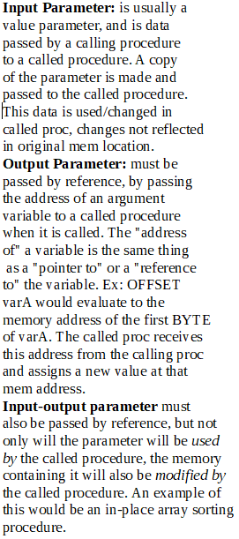
convert to bin. sicentific notation (shift decimal left)
and record exponent. (3) Extract and zero-pad norm.
mantissa to 23 bits. (4) Add the exponent to 127 and
convert to binary. (5) Concat sign bit, biased exp, norm
mantissa. (6) convert to hex.

Decoding IEEE 754: (1) Convert hex to bin. Extract the
components, sign bit, biased exp, norm mantissa.
(2) convert biased exp from bin to dec and debias by
subtracting 127 from it. (3) Front pad norm mantissa
with “1.” and drop trailing zeros (don’t remove anything
else). (4) If exp positive, shift binary point right num times
equal to exp. (5) Convert bin to dec. (6) assign neg sign if
sign bit was 1.

