IN3005: Computer Graphics using OpenGL
Christy Quinn – abmd642

Table of Contents
1. Overview........................................2
1.1. Prototype..................... 2
1.2. Keyboard Controls..... 2
1.3. Assets……………… 2
2. Basic Objects................................3
3. Rollercoaster Track......................3
4. Layout of Scene...........................4
5. Model Loading..............................4
6. Camera Functions........................4
7. Lighting.........................................5
8. Advance Rendering.....................5
9. Reflection.....................................6
1. Overview
The rollercoaster simulation is set in an artic mountainous scene, it is themed to not be realistic but have a cartoon appearance. The rollercoaster dips and dives through mountains only inhabited by penguins, which it passes by.

1.1 Prototype
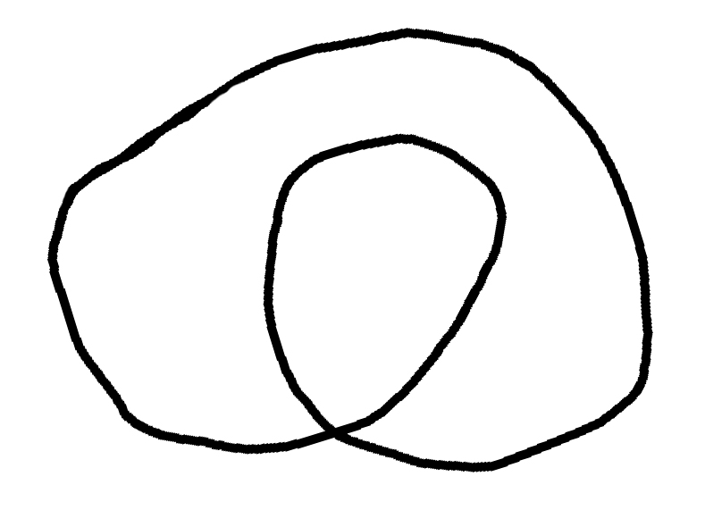.

1.2 Keyboard Controls

Camera controls:
- 1 – First person view
- 2 – Side view
- 3 – Birds eye view
- 4 – Free view
- 5 – Billboard view

Lighting controls:
- ‘L’ – Toggle night/day time

1.3 Assets
All models edited and textured by Christy Quinn

- Skybox downloaded http://www.redsorceress.com/skybox.html
- Penguin model http://www.turbosquid.com/3d-models/blender-penguin/497636
- Billboard model http://www.turbosquid.com/3d-models/3d-billboard-advertising-poster-model/314407
- Cart model http://moodle.city.ac.uk/mod/resource/view.php?id=1147459
- Heightmap http://bit.ly/ZRVzWr
- Terrain http://www.cgtextures.com/texview.php?id=42429
- Strtk.hpp - http://www.partow.net/programming/strtk/index.html
2. Basic Objects
Skybox
Replaced the skybox texture with a toon shaded style mountain skybox, this was to fit the theme.

Ground
Replaced the ground texture with a snow textures, this was to fit the theme.

Basic Objects
Create a circle class that was used sampled and used in combination with GL_TRIANGLES to create the supports of the rollercoaster (which are open ended cuboid.

Create a quad class created from two triangles using GL_TRIANGLES; this was used as the screen for the billboard.

Texture Coordinates and Normals
Texture coordinates and normal were mostly implemented through a mesh class that most basic objects used. The mesh class used a face vertex mesh methodology to work out what triangles the vertices were on and in turn find the normal of each vertex.

Some exceptions to this were for the Skybox and Quad where the texture coordinates were defined implicitly so that they would stretch across the given object.

Lighting was done pre-object using a utility class, Lighting, this enabled me to set the material reflectance and intensity easily per object.

3. Rollercoaster Track
Creating the Track
The track was created in several stages:
- A spline was created using a selection of control points, this spline looped
- A set of sampled points was then collected from the spline using a set distance between the points.
- At each of these sampled points a local frame was created using the next point in the list.
- Circles with a 5 sample points where then created at each sampled point using the frame of that sample point to orientate it correctly.
- Using the points from the circles primitives were created all along the track.

Rendering the Track
The track was rendered using a toon shader and a solid colour texture to darken the colour of the track and pink lighting to make it stand out from the scene.
4. Layout of Scene
Placement of Objects
All objects placed on the terrain used a method from the terrain to get its height at that point and place the object there. This meant all objects that should be touching the ground are. Objects were rotated, scaled and transformed, through manipulation of the modelview matrix, to fit the prototype design.

4. Model Loading
Models Loaded
The models used in the scene where as follows:
- The rollercoaster cart – this was edited and textured to fit the theme. The wheels were taken off and the bottom was made to look more like a sledge.
- Penguins – these were textured simply with white and black so that the toon shader could apply colour without distorting the colour theme.
- Billboard – used in combination with a quad to display a first person view of the rollercoaster.
Repeated Models
The penguin model was repeated randomly throughout the scene this was done as follows:
- An origin was given for the colony to be created around.
- Using a nested for loop x and z values with random separation were acquired for each models location.
- A similar technique was used to determine the models rotation and scale.
- Using these values the model was rendered multiple times around the origin with a random orientation and scale.

5. Camera Functions
At each sampled point along the spline that was used to create the track there was a frame describing its local coordinate system in terms of tnb. Using these values instead of xyz enabled me to place the camera in the required locations.
- First person – the camera was moved up the b axis. The view was set to be looking along the t axis.
- Side view – the camera was moved up the n axis to put it out to the side of the cart. The view was then set to be the carts position.
- Top view – the camera was moved high above the scene based on the origin. The view was then set to be the origin of the rollercoaster.

6. Lighting
Day/night time was implemented through the utility class, Lighting, that enabled you to set a general light intensity for all objects being rendered by that shader. Day time had an intensity of 1.0f and night time of 0.1f; this was so that some of the scene was still visible at night (moon light).

Spotlights
Two spotlights are turned on when it is night time, the first was to slight up one of the colonies of penguins that were placed near the track so you could see the as the cart went round, this spotlight was coloured a dark blue. The other spotlight was implemented to mimic a headlight and placed at the front of the cart with its direction and position based on the carts local coordinate system.

7. Advance Rendering
Toon Shader
The toon shader was implemented in the fragment shader, an object is toon shaded if the flag “toonify” was set to true. A toon shader works by limiting the colours used to give a blocky effect and the outlining objects to give the final cartoon appearance. In my implementation this is accomplished through first using the Blinn Phong lighting model to first determine the fragments colour. An outline fragment is then determined by the dot product of the eye and vertex normal; if it is orthogonal then it is an outlining fragment. Finally the edge colour (either 0 or 1 dependent on the outcome of the dot product) is combined with the colour returned from the Blinn Phong equations in the following equation which limits the colour to one of the set levels.

fragment_colour = vec4((floor(light_colour.rgb * levels) / levels) * edge_mask, light_colour.w);

Render to Texture
Render to texture was used to give a TV effect in the simulation; the scene was rendered from the first person view and then rendered to texture and displayed on a billboard allowing you to “watch the ride”. This was accomplished through the use of a frame buffer object, first the fbo was created to fit the screen size and a depth buffer added so that the rendered scene would be displayed with the correct z-index. The fbo was then bound and the scene rendered to it with the camera set to be following the cart. Next the fbo was unbound and the camera returned to where it should be and the scene was rendered as normal with the exception of the fbo binding its texture before the billboard is rendered so that the texture is rendered to the quad of the billboard.
8. Reflection
Strengths
The main strength in my mind is the overall coherent theme of the simulation that was designed around a fondness of toon shading. Toon shading allowed all aspects to stand out even without texturing and in some cases look better than when textured.

All code was also written in such a way that it was easily reusable throughout the project for example the circle class was used in several places as a method of creating sample points for basic objects.

Weaknesses
The main weakness throughout the project was the use of textures, this was down to lack of knowledge until the end. Which meant that allot of the aspects of the simulation were designed without textures in mind where it could of benefited.

Accomplishments
In the time given I think I have given every aspect of every task some form of implementation and overall am very happy with the final product. If it wasn’t for other obligations I would of implements a blur effect and probably attempted shadows!

Expansion
If I was to expand this it would probably be in the direction of a game, when creating the rollercoaster I implements a Garry’s mod style spline gun. This created a spline around the points that I specified while flying around the scene. This could easily be expanded so that points could be edited. The other obvious expansion would be the implementation off realistic physics which would improve the feel of the simulation infinitely.

