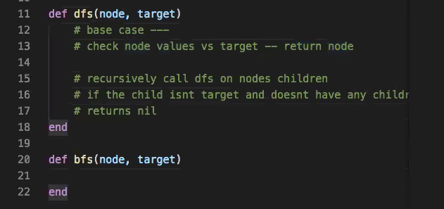
We might have to initialize for each step and call these methods on instances
To refer to the children – @children[1..-1].dfs(node, target)
parent =

