**Introduction**

Rhode Island oyster farms, like all forms of aquaculture, are plagued by biofouling species that degrade product quality and incur enormous costs over time. The native sea urchin Arbacia punctulata demonstrates potential to reduce the amount of biofouling at low cost to the farmer. By varying sea urchin densities (0, 2, 4, and 8 individuals / cage) in oyster bags with a constant oyster population within each bag (50 oysters / bag), we can observe the differences in biofouling coverage, urchin quality, and oyster quality after a 12 week period. Metrics of interest of urchin quality include urchin growth and gonad index (GI%) (calculation: gonad weight / wet weight * 100) at the end of experiment. Metrics of interest for oyster quality include shell growth rate, determined by measuring shell length at the beginning and end of experiment. Biofouling is ranked 1-4, where 1 = clean and 4 = heavily fouled; it is assumed that all bags begin the experiment clean because they are new, equivalent to "1".

**Methods**

In this experiment, the primary treatment class is the urchin density, secondary class is seawater depth. We will assume that depth has little to no influence on response variables in this analysis due to the relatively small difference between depths; therefore, neither the graphical aides nor the analyses subsequent the first account for depth as a factor. However, in case it does have an influence, the first analysis will investigate whether depth has an influence on biofouling.

We chose an Analysis of Variance (ANOVA) test for this experiment. Our explanatory variables are categorical in nature; urchin density is our independent variable and our covariate is depth. The response variables biofouling, GI%, test diameter growth, and shell length growth, are continuous in nature. As the experiment has equal sample sizes for each factor level (four replicate bags for each urchin density, and eight cages for each depth), we can confidently say that the sampling distribution of the test statistic is robust. A post-hoc analysis using Tukey's Honest Significant Difference will identify individual treatment levels with significantly different means.

This analysis requires a dataset in long form, arranged such that treatment cages are in rows and data collected for each row is found in the columns. Data collected includes: mortality, biofouling end rank, test diameter at start of experiment and test diameter at end of experiment, shell length at start of experiment and shell length at end of experiment, and GI%. This dataset assumes GI% calculations have already been performed on the raw data.

In order to support our assumptions that determine our decision to use an ANOVA test, we checked that our response variables have approximately similar variances using an F-test for equality of variances at P>0.05, where if P>0.05 we can assume the variances are similar. Between biofouling rank and shell length growth, biofouling rank and GI%, and shell length growth and GI% we found no significant differences in variance.

We also assume that all response variables are independent of one another. There are many reasons to believe this not to be the case. Biofouling reduces the availability of food in oyster cages in two ways: competing for available food and crowding the cage, reducing the availability of food, oxygen, and causing buildup of ammonia via excretion. Additionally, the change in test diameter may be correlated with GI%. Smaller, younger sea urchins tend to have a greater percentage of body weight devoted to GI%, and they tend to grow at a faster rate than larger, older sea urchins.

The independence of our response variables is tested using a pairwise correlation. A Kendall coefficient of correlation was chosen due to the small sample size and biofouling ranking data is ordinal in nature. We found no correlation between biofouling rank and oyster shell growth rate, nor between GI% and test diameter growth rate. Therefore, ANOVA will be conducted between urchin density and all above variables.

**Analysis**

For an example dataset with realistic values, our analysis found that urchin density had a statistically significant effect on biofouling ranking. Significant differences were found between 0 and 4 urchins, 0 and 8 urchins, and 2 and 8 urchins. No difference was found between densities of 0 and 2 or 2 and 4 (Table 1; Figure 1). As biofouling ranking is an ordinal variable and the sample size is small, the distributions are disproportionately skewed to the upper bound. Type II error due to low sampling size may have resulted in lack of significant difference found between 0-2 and 2-4 density factors.

**Table 1. Results, Urchin Density vs. Biofouling**

Statistically significant differences between urchin density and biofouling rank.

**Figure 1.**

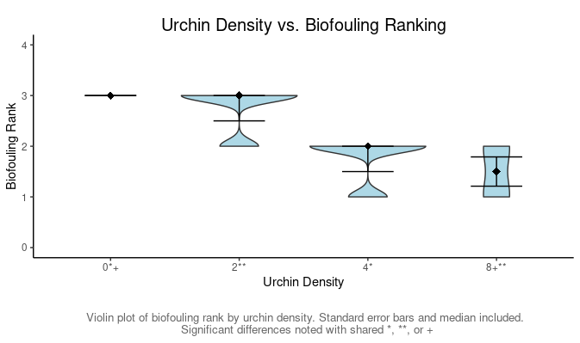

Significant results were also found for urchin density and mortality rate between all densities and 8 sea urchin stocking density.

**Table 2. Results, Urchin Density vs. Mortality**

**Figure 2.**

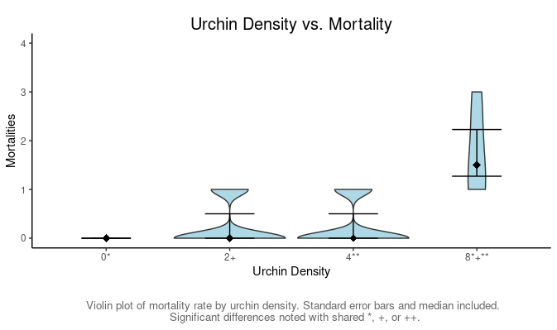

Like Figure 2, we see disproportionate skew to the lower bound and nonsignificant results between 2-0 and 4-0 are likely due to Type II error.

No other significant results were found. Covariate analysis was conducted between depth and biofouling ranking with non-significant results. As this divided the population of cages into two equal groups, this had the largest sampling size and the lowest possibility of a Type II error.

Lack of significant results when it is known that differences in variables exist point to Type II error. The dataset was constructed with deliberate biases; GI% was lowered for 8 urchin density cages and end of study shell length was increased. For these factors, p-values found using Tukey’s HSD were lower than their cofactors, but non-significant (e.g., p < 0.2 vs. 0.8).

In conclusion, this analysis demonstrated that our experimental design can capture strong patterns in data but weak correlations will escape notice easily due to Type I error. A revised experimental design is advised with at least one additional replicate at each depth to increase the statistical power. Follow-up experiments should be conducted amongst cofactors with unusually low, but non-significant p-values after post-hoc analysis is complete.