You’re going to use the SOGWaM Simple Online Groundwater model to test the sensitivity of a model system to different parameters.

1. To begin, open SOGWaM, which can be found at <https://cjrusson.github.io/SOGWaM/>.
   1. Click  to begin.
2. First you will build a “base case model”
   1. On the “Basic” tab:
      1. Decide if you want your model to be cross sectional view or map view.



* + 1. Choose a reasonable domain size and, if you are in map view, a reasonable grid thickness. This model is 2d, so that is the thickness of the unconfined aquifer.

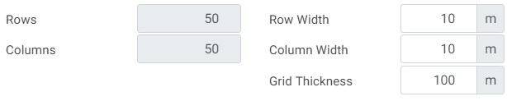

* + 1. Choose a reasonable recharge rate (you will raise and lower this later, so choose a moderate value)

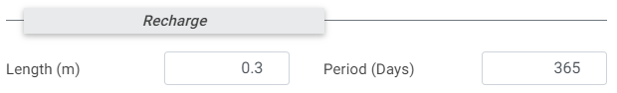

* + 1. Choose “Sand” as a moderate soil type.
  1. On the “Constant Heads” tab:
     1. Add two constant head objects “objects” to generate flow in the domain.
     2. Click simulate
     3. Take a screenshot of the results, put this in a Word document as your “base case – no well” and give it a caption that describes the model.
  2. On the “Wells” tab:
     1. Add a well “Object” at a reasonable location with a reasonable pumping rate.
     2. Click simulate
     3. Take a screenshot of the results, put this in a Word document as your “base case”. Give it a caption that describes the model and draw a cartoon that shows what your model represents.

1. Perform a sensitivity study on 3 parameters.
   1. Each parameter should have two new simulations, in each of which the parameter is varied from your base-case model. Capture a screen shot of each new simulation and include them in your document.
   2. The parameters you could vary include:
      1. Basic Tab: Model thickness (if in map view), Recharge rate, Sediment type/heterogeneity
      2. Constant Head Tab: Location/size/number of objects, Elevation(s)
      3. Wells Tab: Location/number of wells, Pumping rate(s), Extraction/injection
   3. Each sensitivity study should have at least three images (the base case and two additional) and should include a short caption describing the effect of varying that parameter on your model. Between the images and the caption I should be able to understand what you did and what it tells you.
   4. *Example sensitivity study:*

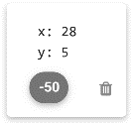🡪 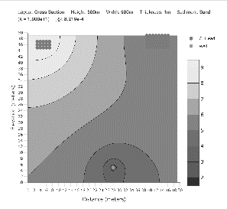, 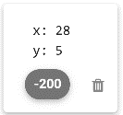🡪 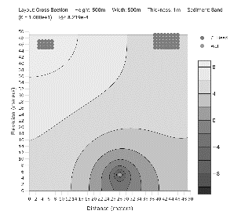,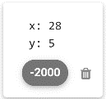 🡪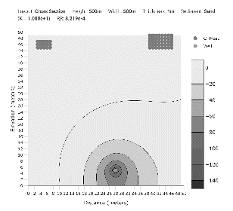

*Example caption: Changing pumping rate increases the cone of depression and causes flow between rivers to change to flow from rivers to well.*