**JAVA/ECLIPSE DEV SETUP GUIDE**

Table of Contents

**I.** **Software Requirements:** 2

**II.** **Installation Setup:** 2

**III: Use Eclipse to install Apache Tomcat server using the Server Installed Runtimes preference page:** 5

**IV: Set up LAT code in Eclipse** 6

**V: Testing Your Setup** 10

Prepared by: Chrystal Sander

Date Written: 04/28/2016

Date Updated: 05/04/2016

Document Version Number: 1.0

# **Software Requirements:**

1. Oracle Java Runtime Environment: JRE6
   1. Can unzip “jre6.zip” to C:\Program Files\Java
2. Apache Tomcat 6.0.18 or equivalent
   1. Can unzip “apache-tomcat-6.0.18.zip” to C:\apache-tomcat-6.0.18
3. Eclipse: 3.4.1 or equivalent
   1. Can unzip “eclipse.zip” to C:\eclipse
4. Access to LAT database
5. LAT code base

# **Installation Setup:**

1. Copy JRE6 on local machine:

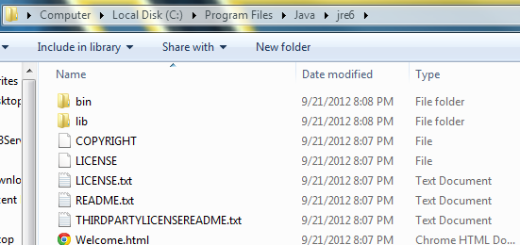

1. Copy Apache Tomcat on local machine: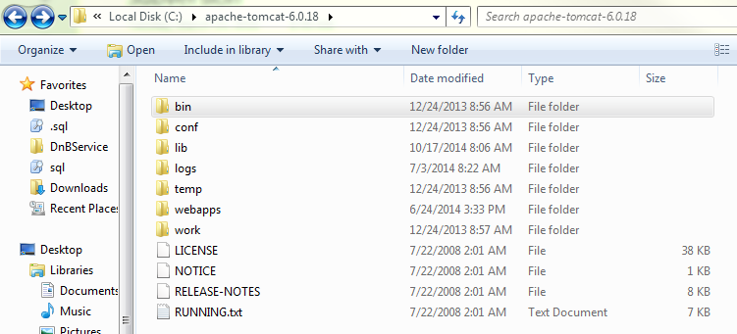
2. Install Eclipse to local machine including file structure similar to the following: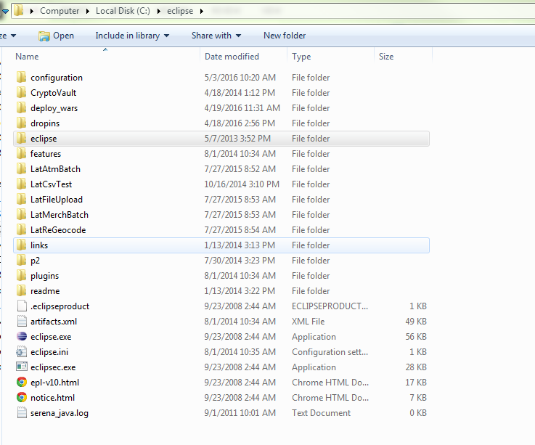

# **III: Use Eclipse to install Apache Tomcat server using the Server Installed Runtimes preference page:**

1. Start the Eclipse WTP workbench:
2. Open Window -> Preferences -> Server -> Installed Runtimes to create a Tomcat installed runtime:

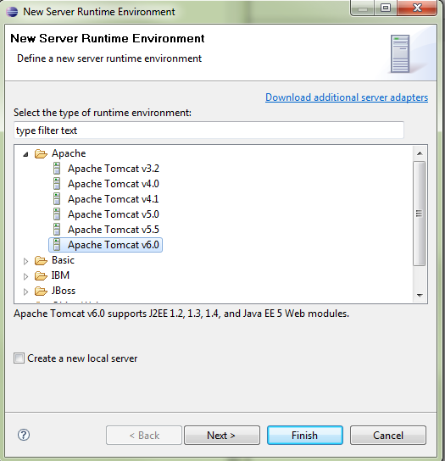

1. Click **Next** , and fill in your **Tomcat installation directory** :

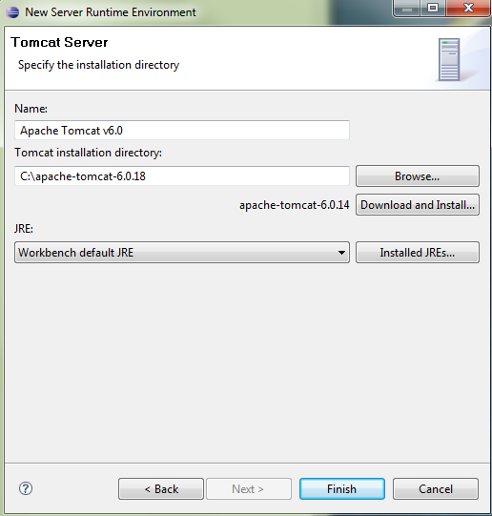

1. Ensure the selected **JRE** is a full JDK and is of a version that will satisfy Apache Tomcat. If necessary, you can click on **Installed JREs...** to add JDKs to Eclipse.
2. Click **Finish** .

# **IV: Set up LAT code in Eclipse**

You can set up your workspace and perspective according to your preference (<https://courses.cs.washington.edu/courses/cse143/12su/eclipse_tutorial/setup_workspace.shtml>).

However, if you have difficulty starting, then you can open up the specific code base and use that. Configuration issues specific to your machine will arise and those will have to be dealt with accordingly (“.classpath”,”.project” files, etc.) This is a typical folder setup:

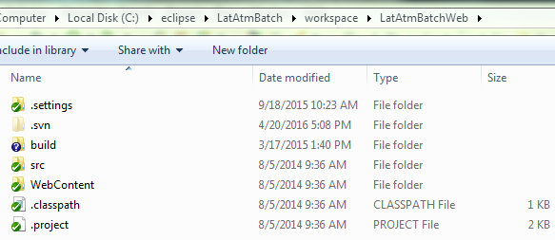

Application specific configuration files should be in //apps_01/webapps:

# **V: Testing Your Setup**

Once your workspace is setup, you can test the installation by running the code in debug mode:

1. Make sure that you have logged into the dev/stage firewall.
2. Open Eclipse project, navigate to a starting servlet file, and set a breakpoint on the main run() method:

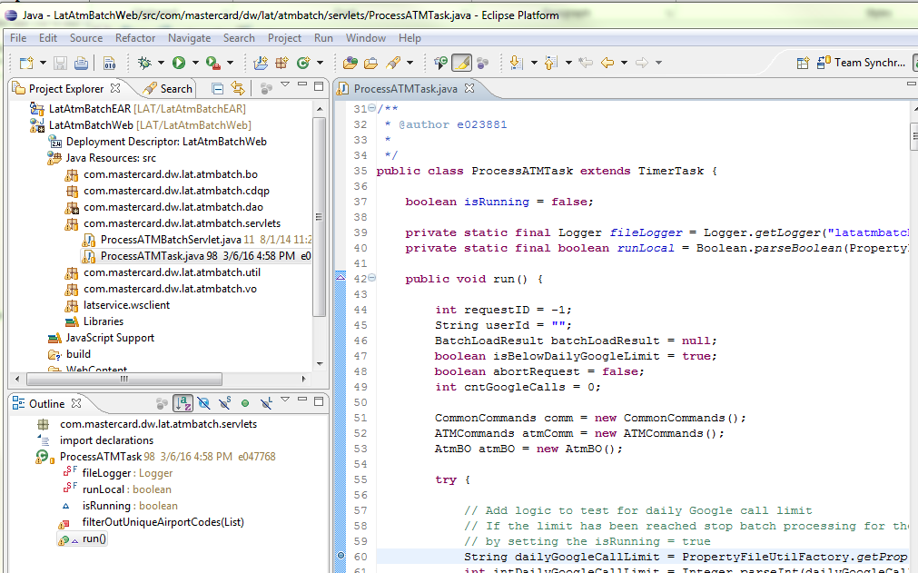

1. Click the debug button and select file to start your debug session:

--screenshot removed--

1. Please note that it is not uncommon for the following screen to appear:

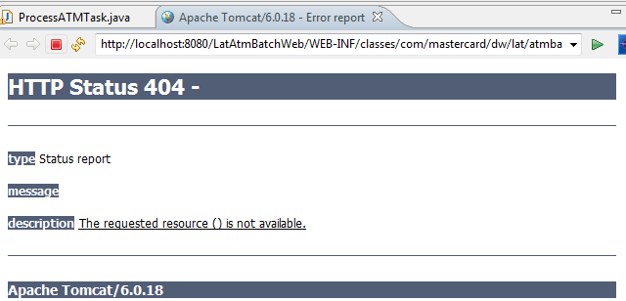

1. You should be able to ignore as you wish and continue to your code. If all is working, then your code should hit the breakpoint:

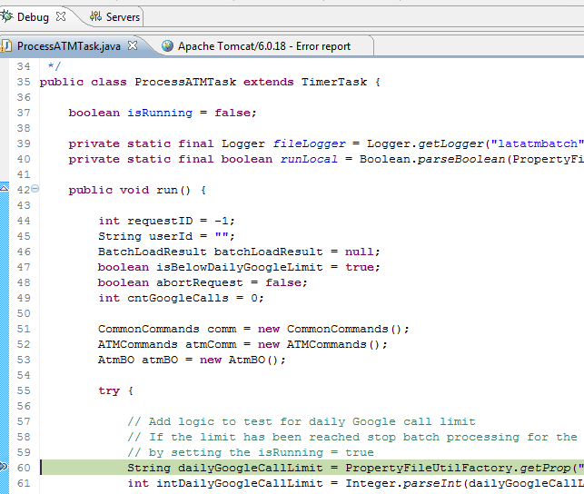

1. Continue walking through code to test that database connections and other configuration items are working.