Teapot demo from Motion Fit SDK v5.1 compiled with Visual Studio 2012

1. Issues faced:
   1. Got this error: error LNK2026: module unsafe for SAFESEH image.

This happens when lib files are compiled by an older version of visual studio

To solve this go to Configuration Properties -> Linker-> Advanced.

At the last line, change "Image Has Safe Exception Handlers" from Yes to No

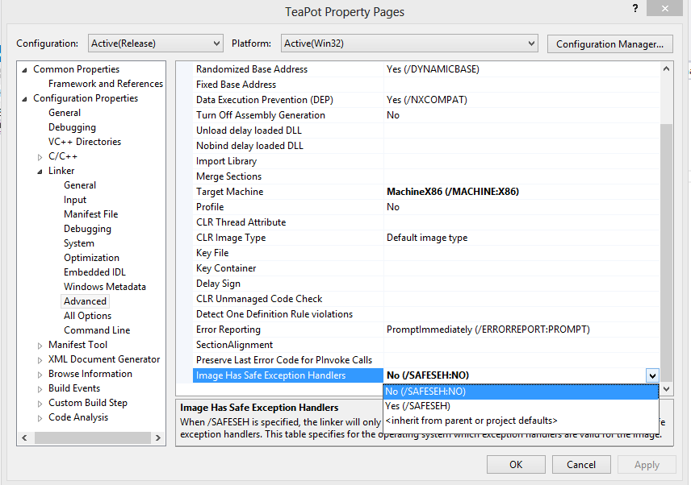

* 1. COM port needs to be set in source code

To solve this to the following in the main:

// Change the Port number based on your device COM port

const char* port_number="13";

SIOSetCom(atoi(port_number),(MLU32)115200);

/*

if (argc == 2)

{

SIOSetCom(atoi(a),(MLU32)115200);

}

else

{

printf("Please assign the com port number!!\r\n");

while(!_kbhit())

{

Sleep(5000);

}//while

}

*/

**Main.cpp**

Main() Initializes the open Gl, then calls DemoDisplayMain() function to create Teapot.

TeaPotDisplay() is used to rotate the teapot and getQuatData() function gets quaternion packets from the board.