
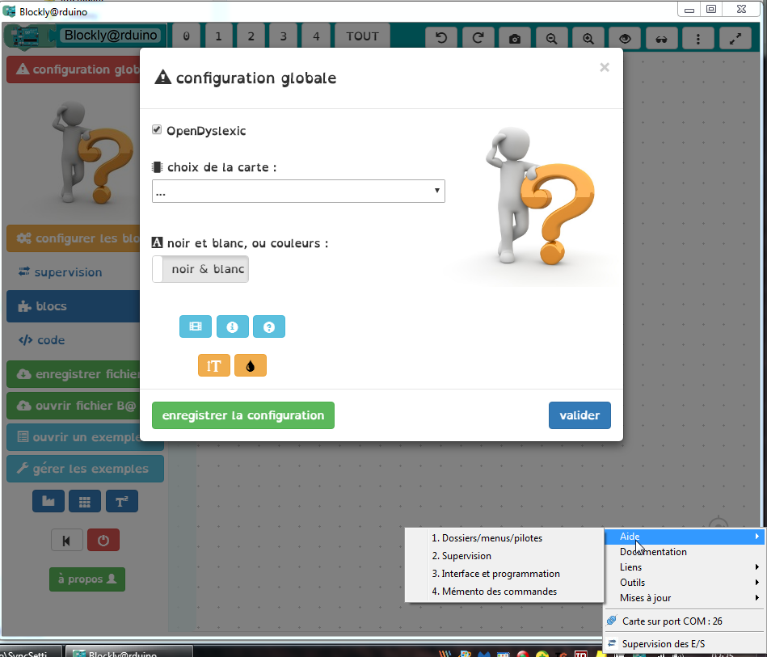
Blockly@rduino ‘All In One’ 1
Documentation 1
Dossiers / folders 2
Barre des tâches / Tray icon 3
Bibliothèques / Libraries 3
FirmataPlus 4
Configuration 5
Outils / Tools 6
Interface 7
Téléversement / upload 8
CLI 9
STM32, ESP8266, ESP32, Wemos D1 Mini, Webduino, etc 10
Blockly@rduino portable
Arduino Command Line
Blockly@rduino
Communication

Dossiers / folders
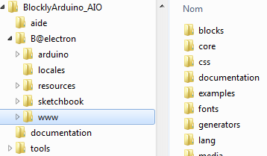
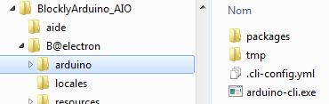
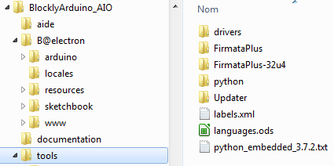
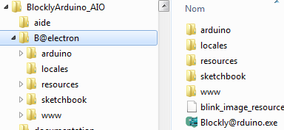
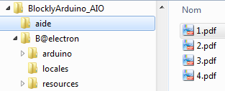
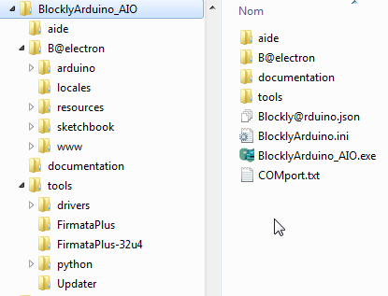
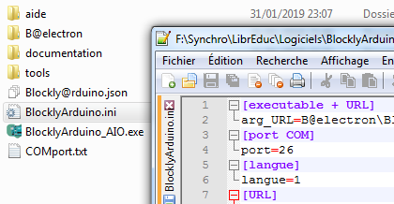

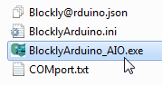
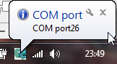
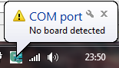

Barre des tâches / Tray icon

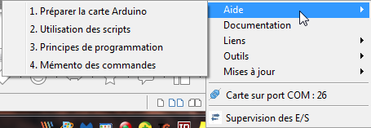
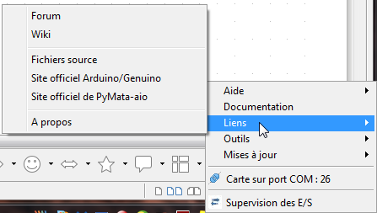
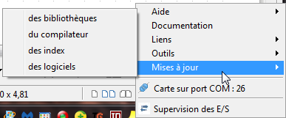
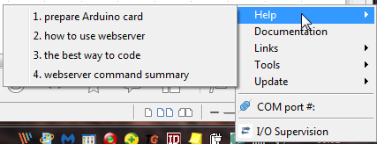
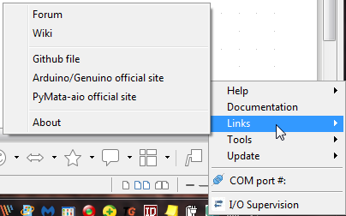
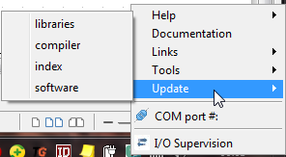

Bibliothèques / Libraries
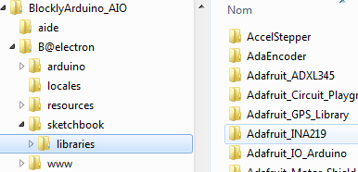

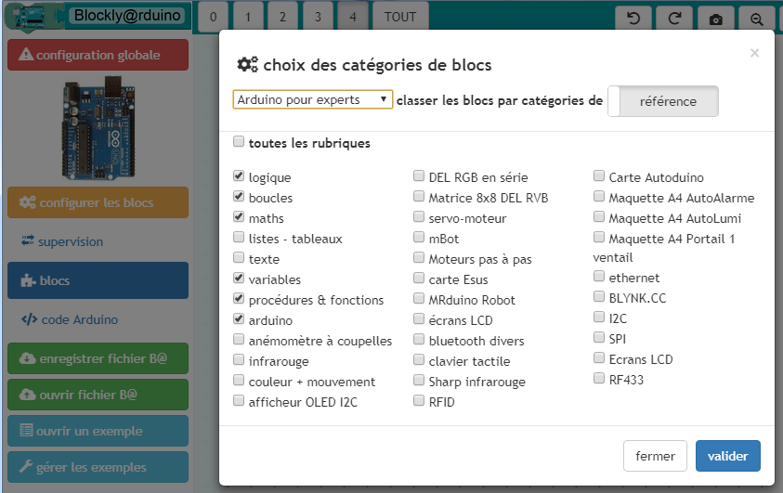
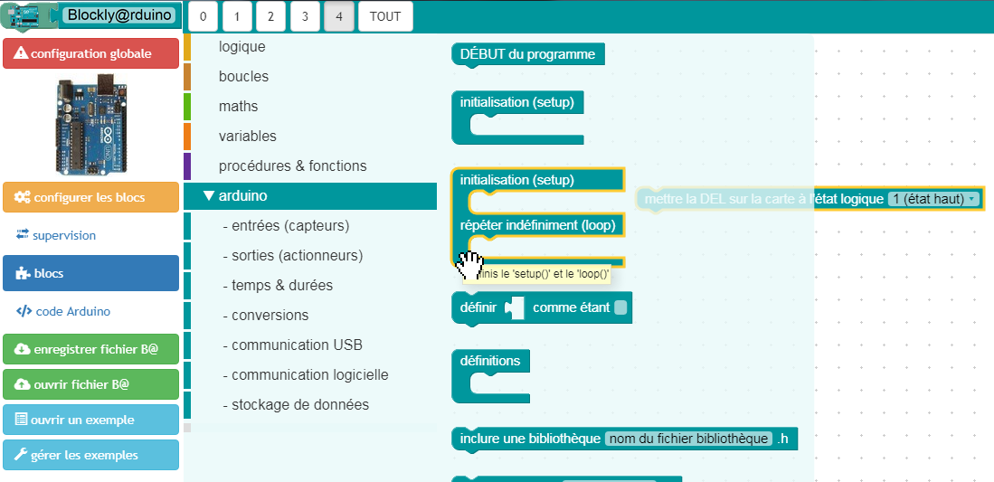
FirmataPlus
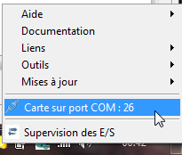
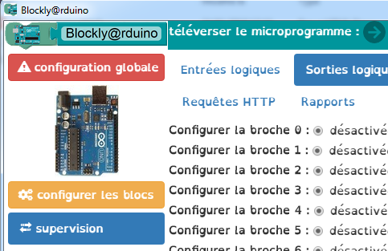

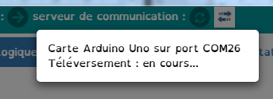
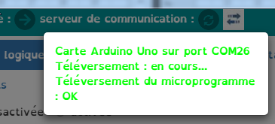


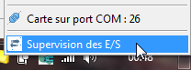
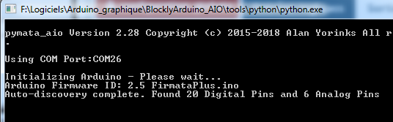

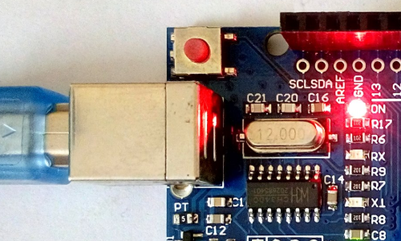
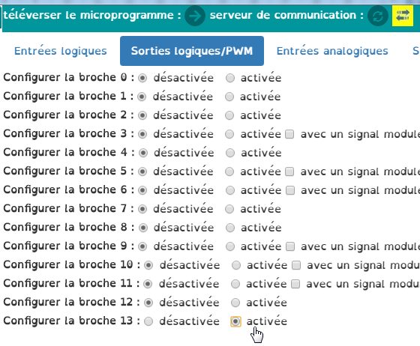



Configuration
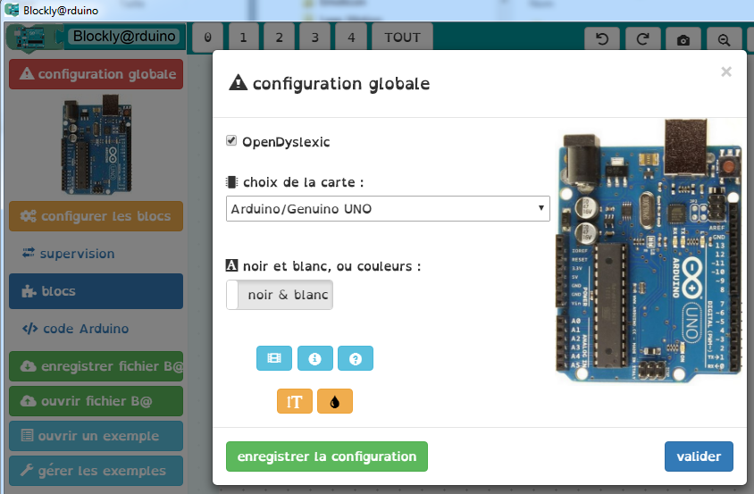

Outils / Tools
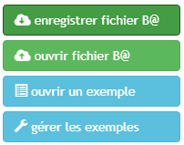

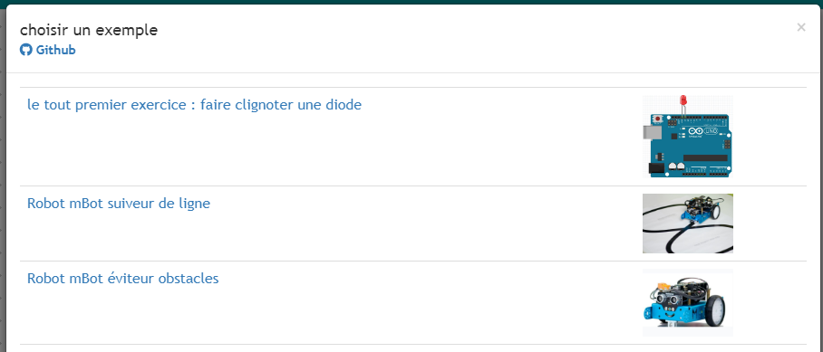
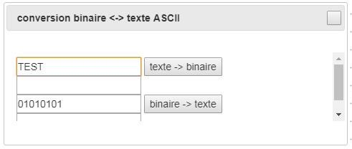
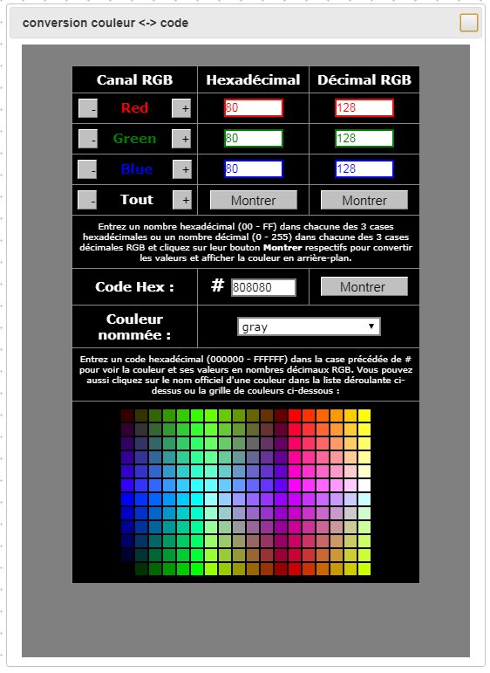
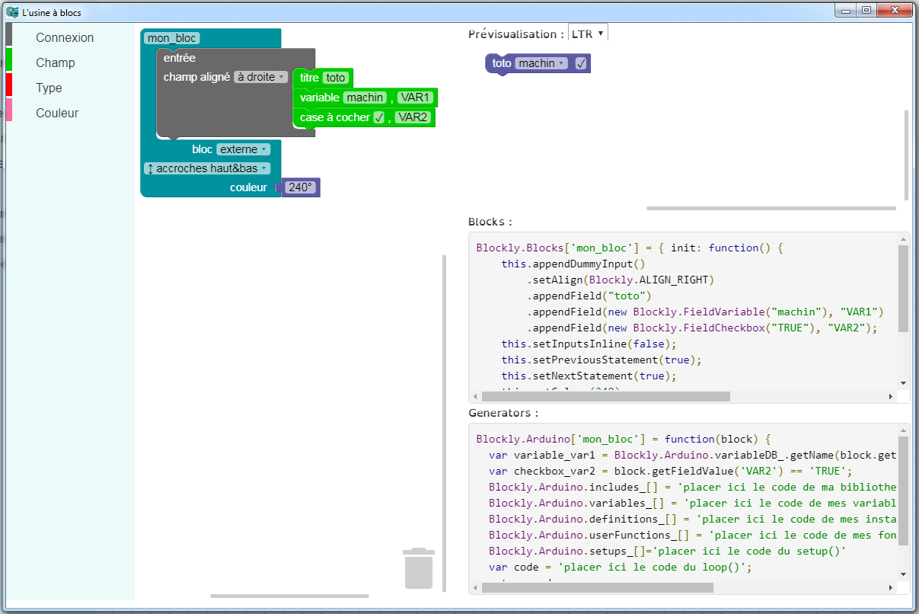

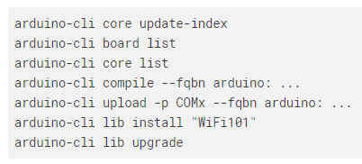
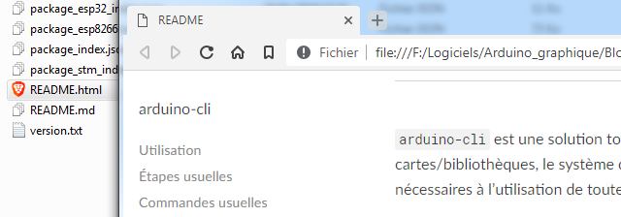
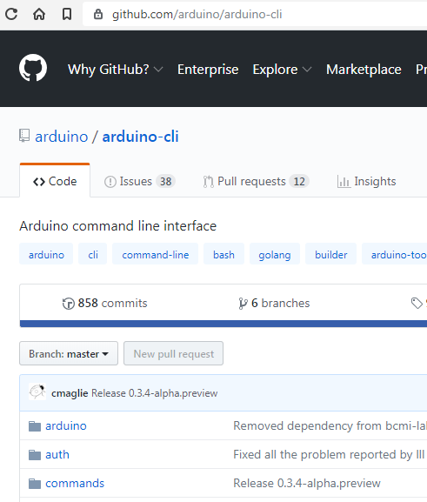
Interface

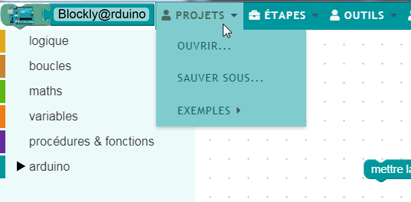

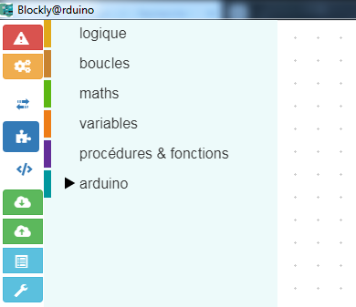

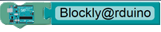


Téléversement / upload
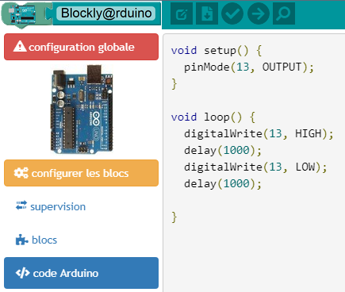

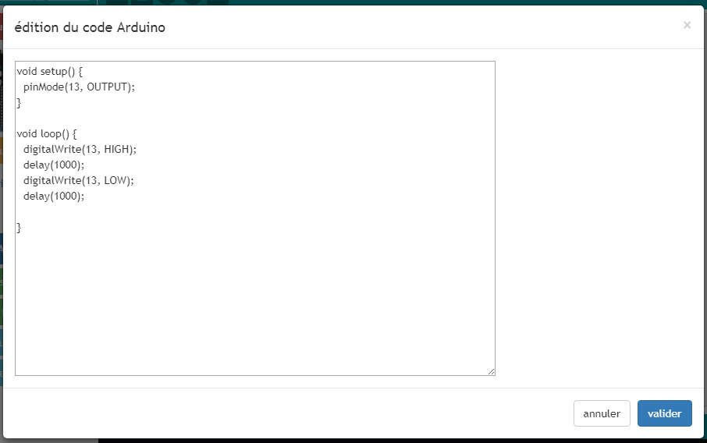
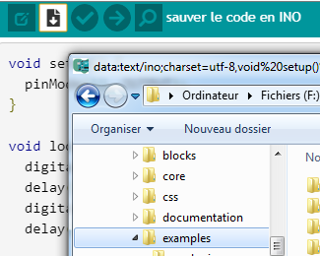
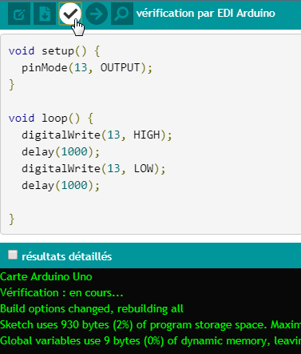
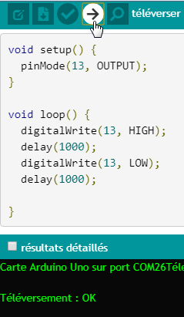
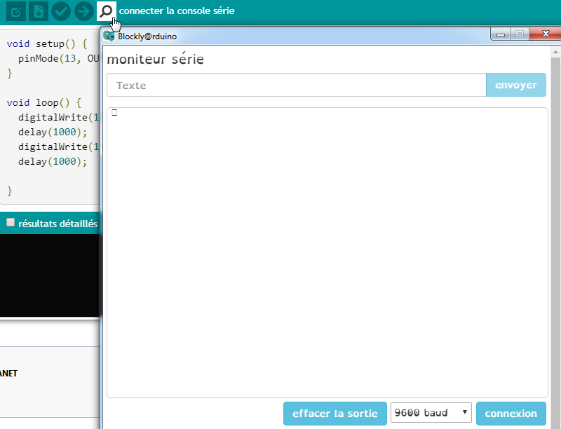

CLI
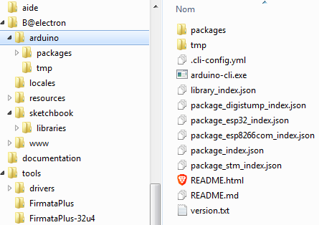
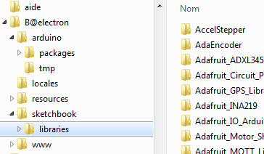

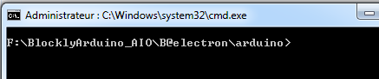

https://github.com/arduino/arduino-cli

STM32, ESP8266, ESP32, Wemos D1 Mini, Webduino, etc
# arduino-cli core update-index
Updating index: package_index.json downloaded
Updating index: package_esp8266com_index.json downloaded
Updating index: package_stm_index.json downloaded
Updating index: package_esp32_index.json downloaded
Updating index: package_digistump_index.json downloaded

# arduino-cli core search arduino
Searching for platforms matching 'arduino'

ID Version Name
Intel:arc32 2.0.4 Intel Curie Boards
arduino:avr 1.6.23 Arduino AVR Boards
arduino:megaavr 1.6.24 Arduino megaAVR Boards
arduino:nrf52 1.0.2 Arduino nRF52 Boards
arduino:sam 1.6.11 Arduino SAM Boards (32-bits ARM Cortex-M3)
arduino:samd 1.6.20 Arduino SAMD Boards (32-bits ARM Cortex-M0+)
arduino:samd_beta 1.6.25 Arduino SAMD Beta Boards (32-bits ARM Cortex-M0+)
arduino:stm32f4 1.0.1 Arduino STM32F4 Boards
esp8266:esp8266 2.5.0 esp8266
littleBits:avr 1.0.0 littleBits Arduino AVR Modules

# arduino-cli core install esp8266:esp8266
Downloading esp8266:esptool@2.5.0-3-20ed2b9...
esp8266:esptool@2.5.0-3-20ed2b9 downloaded
Downloading esp8266:xtensa-lx106-elf-gcc@2.5.0-3-20ed2b9...
esp8266:xtensa-lx106-elf-gcc@2.5.0-3-20ed2b9 downloaded
Downloading esp8266:mkspiffs@2.5.0-3-20ed2b9...
esp8266:mkspiffs@2.5.0-3-20ed2b9 downloaded
Downloading esp8266:esp8266@2.5.0-beta3...
esp8266:esp8266@2.5.0-beta3 downloaded
Installing esp8266:esptool@2.5.0-3-20ed2b9...
esp8266:esptool@2.5.0-3-20ed2b9 installed
Installing esp8266:xtensa-lx106-elf-gcc@2.5.0-3-20ed2b9...
esp8266:xtensa-lx106-elf-gcc@2.5.0-3-20ed2b9 installed
Installing esp8266:mkspiffs@2.5.0-3-20ed2b9...
esp8266:mkspiffs@2.5.0-3-20ed2b9 installed
Installing esp8266:esp8266@2.5.0-beta3...
esp8266:esp8266@2.5.0-beta3 installed

#

