**Gyro-chair How To Guide**

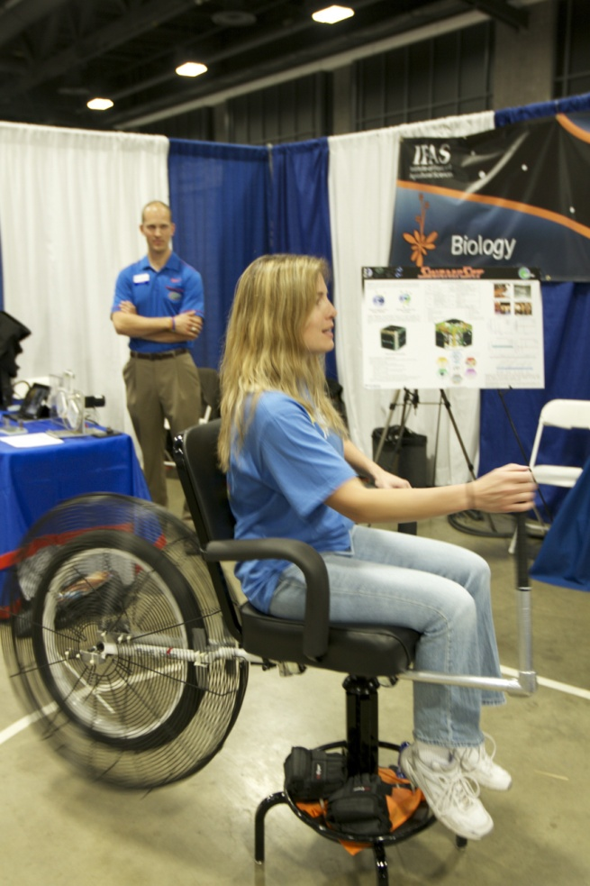

Figure 1- Assembled chair

Figure 1 is basically what you want to achieve with the chair assembled. To do this successfully, take a look at the following parts:

|  |  |
| --- | --- |
| IMG_3307.JPG  Figure 2- Seat | IMG_3310.JPG  Figure 3- Base |
| IMG_3309.JPG  Figure 4- Wheel | IMG_3301.JPG  **3**  **2**  **1**  Figure 5- Ball Bearing Set |

Let’s look at the Seat in more detail:

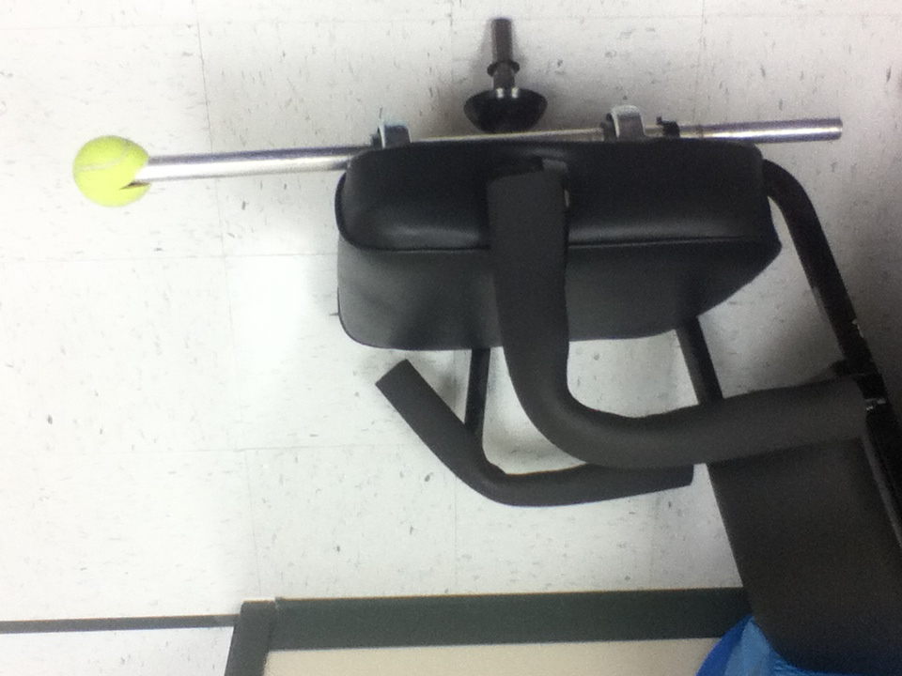

**Pipe insulation foam over arm rest.**

**Gimbal Arm, back.**

**Gimbal Arm, front.**

**Shaft of the Seat.**

Figure 6- Seat with labeled parts

Note the insulation pipe foam, this to provide comfort on the Seat as the arm rests are made of metal. If replacement foam is needed, you can buy more at Lowes in the plumbing section.

The Ball Bearing Set can be found in the brown box with pen writing saying “To SSG for Gyro-chair.” The Ball Bearing Set goes on the shaft of the Seat in order as numbered in Figure 5. There is no difference between the two aluminum rings so you do not have to worry as to which one of those is number 1, just that these need to sandwich the bearing. Clean the ball bearing using a piece of newspaper then, each piece of the Ball Bearing Set must be lubricated with the silver WD-40 can found with the gyro-chair supplies. It is recommended you lubricate over a piece of newspaper to avoid staining the floor/carpet underneath.

Next, use the same WD-40 to lubricate the inside of the sleeve of the Base as indicated in Figure 7. It is recommended that you use newspaper under the base during lubrication to avoid staining floors/carpets.

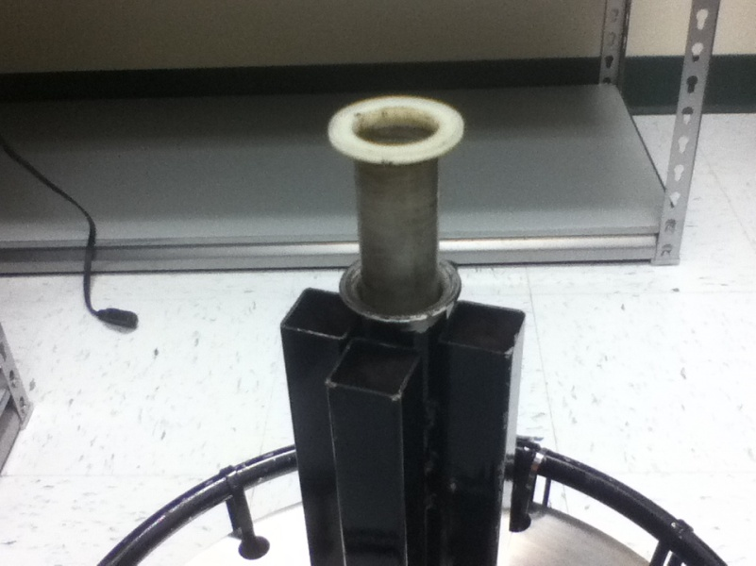

**WD-40 in here.**

Figure 7- Sleeve of the base

Once each of the parts is lubricated, insert the shaft of the Seat with the Bearing Set on the shaft into the Base. Give the seat a soft spin in both directions to move the lubrication around.

Next, attach the handle bar (Figure 8) to the front of the Gimbal Arm. This requires the use of a small hex key (Allen wrench) that can probably be borrowed from the lab.

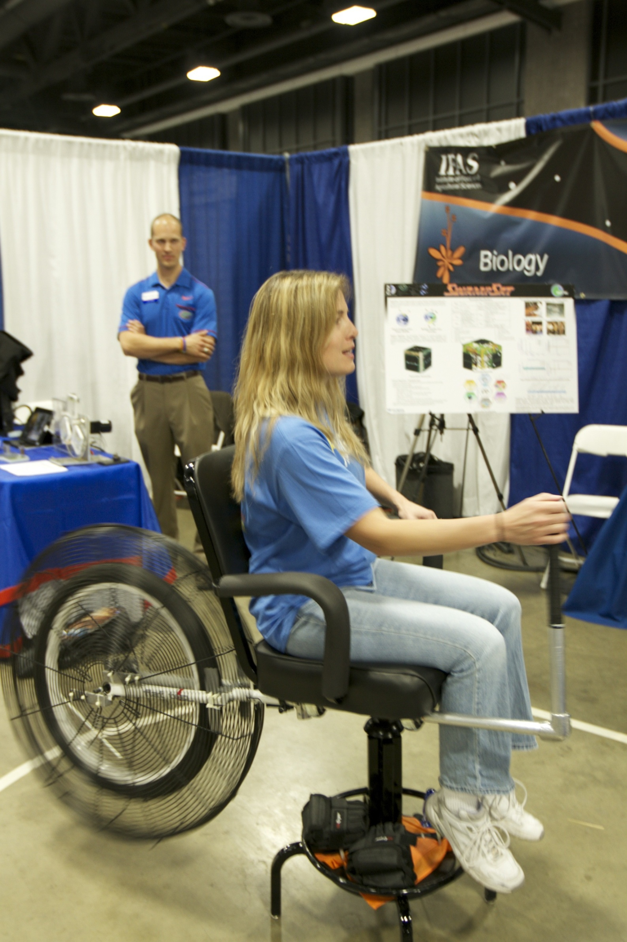

Figure 8- Handle Bar (has a black Wilson tennis racquet grip).

Next, attach the Wheel to the back of the Gimbal Arm. The easiest way to do this is by having one person hold the handle bar while another person wiggles the Wheel into position. Make sure that the Wheel is pushed as far unto the Gimbal Arm as it will go to avoid the weight distribution causing the chair to fall over. (Do not lubricate at all) Use the black seat post clamp to tighten the Wheel into place; use a wrench to hold the nut and tighten to the maximum tightness before closing the clamp. This will prevent the Wheel from slipping.

Notice that there is a black plastic piece with a wire attached to the Wheel (Figure 9), this is the holder for the cycle-computer used to measure the speed of the Wheel. The cycle-computer can be found in the brown box with pen writing saying “To SSG for Gyro-chair.” Use tape to attach the wire along the Gimbal Arm **loosely**; we do not want this wire breaking. Attach the holder to the Gimbal Arm towards the front, facing upward so that it can be read. Place the cycle-computer in the holder.

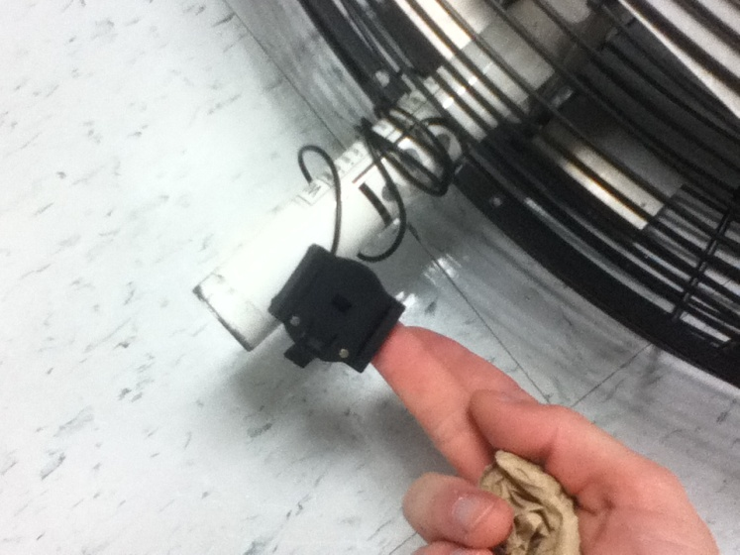

Figure 9- Cycle-computer holder/mount

The gyro-chair is now ready for operation. Use the hex key that can be found in the brown box with pen writing saying “To SSG for Gyro-chair.” Attach the key to a drill (an 18V cordless drill works well) and spin the wheel by the machine screws.

**Disassembly and Storage:**

Follow the assembly instructions in reverse order to safely disassemble the gyro-chair. Clean the Ball Bearing Set of lubricant **before** storage in the box; newspaper should work fine.

When storing the gyro-chair do not place the Wheel on top of the Seat. The Wheel is heavy and the cage will damage the foam on the arm rests and the leather of the Seat.

**\*\*\*\*\*IMPORTANT\*\*\*\*\***

If you have any questions about the set up and operation of the gyro-chair, contact:

Moises Rivero

[moarivero@gmail.com](mailto:moarivero@gmail.com) (Put gyro-chair in the subject line)

If immediate response is needed, call or text: (863) 604-9792

I will respond as soon as I have a free moment.