Introduction

The appeal of laser communication over convention RF systems has been that they require a less mass, less power, take up less space, require a smaller antenna, frequencies do not need to regulated, more resent to interference, and more difficult to intercept. [2011 randd] Because of this, laser communications are ideal for spacecraft leading people to research laser communication for satellites for decades.

The first successful bi-directional laser communication between land and satellite was with ETS-VI in august of 1994 over a distance of 35,000 km. [GtS LC] Follow up experiments were conducted with OICETS and ARTEMIS which were the first to demonstrate inter-satellite communication in 2005. [randd] OICETS was also the first to conduct bi-directional laser communication between the ground and low earth orbit in 2008 with a 50Mbps link. [GtS LC]In Japan, the National Institute of Information and Communication Technology (NICT) have begun to develop a laser communication system for nano-satellites called small optical transponder (SOTA). However, even this system would weight 5.3 kg with a power draw of up to 22.8W for a 10Mbps link. [randd]

Because the lasers need to be precisely aligned to establish a link, either the whole satellite must be maneuvered or the communication system attached to a gimbal system. The main issues with laser communication on cubesats are the constraints resulting from gimbal system. A gimbal system for cubesats would be difficult to develop, such as the control motion gyroscope that the first Swampsat team has still to test. This system alone thought, requires half the space of a 1U cubesat and increases power requirements.

There is a technique that predates the invention of the laser that allows for optical communication with little to no pointing requirements. [pat ref] This is the idea of a modulating retroreflector (MRR), a type of which is illustrated in figure 1. This results in an asymmetric optical link that only requires a single light source. This is done by modulating the incoming laser and then reflecting it back at the source. MRRs still provide benefit of functioning as a traditional retroreflector. This means that they can also be used for determining relative position. This includes being used for traditional satellite laser ranging purpose in addition to communication. It has also been proven that an array of them can be used for determining orientation of the spacecraft. [intersat]

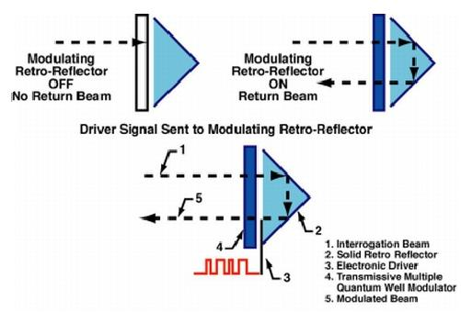

Figure 1 [site1]

The Naval Research Lab (NRL) has done extensive research into MRRs using multiple quantum wells (MQW) as a means to establish laser communication with platforms that could not support traditional laser communication system. [2010 conference] MQWs have shown success in encoding light for fiber optics. [site] This type of MRR, compared to a micro-electro-mechanical system (MEMS) based MRR, is its smaller, requires significantly less voltage, can operate at greater distances, has higher bandwidth, and can also function as a receiver. However, MEMS based MRRs are cheaper, require less wattage, and have a greater field of view. [need to find] Another type of MRR utilizes ferroelectric liquid crystal devices, but they have a limited speed and lack robustness. [site]

MQW based MRRs have established links as fast as 45Mbps [cateye] and as far as 16km [cheesabeak] using very small, robust, and low power MRRs. There were plans to place several 1cm diameter 130mW MRRs on the ANDE satellite which was launched in December of 2006, prior to both the mentioned accomplishments. [hardware detail] There were to establish a 10Kbps optical link, with a max data rate of 1Mbps during testing, over a distance of 400km. [hardware detail] However, no information could be found on the success of this system. In fact, the NASA’s webpage on ANDE omits the MRRs from the satellite. [NASA page]

“MRRs open up FSO [free space optical] communications to platforms previously unable to use it, such as nano-satellites.” [intersat] This technology could greatly benefit cubesats by reducing the cost, size, and power requirements of a cubesat’s communication system, all of which are limited on cubesats. Even the MRRs proposed for ANDE would be an improvement over current cubesat RF communications which typically are between 1200 and 9600 bps [SMAD], while being smaller and requiring as much as an order of magnitude less power than the RF equivalent. [site] But MQWs have a theoretical modulation rate as high as a THz, though the actual MQW modulation rate is limited by several other factors including current technical limitations. [pat]

However, the benefits of this technology are not limited only to low earth orbit (LEO) nano-satellites. These systems can be adjusted to meet different demands. For example, where a LEO cubesat may utilize a cube-corner retroreflector to take advantage of the large field of view, a satellite that is further out or has more attitude control may utilize a larger and more expensive cat-eye retroreflector which has a smaller field of view, but which also provides greater bandwidth, range, and can support multiple different links. [2010 con]

Payload

Our payload will be a MRR modeled after the one proposed for ANDE. This will consist of a 12.5 mm solid cube corner retroreflector, a layer of MQW on top of that, a thin sheet of glass to protect the MQW, and driver electronic. A photo of a NRL 12.5mm cube corner model is shown in figure 2. At this time we are looking at a single MRR since the cost cannot be properly estimated, though we believe a single 12.5 mm MRR will be less than or equal to commercial transponders of equal bandwidth designed specifically for cubesats. Ideally the MQW will be pixelated (using several smaller MQWs instead of a single MQW) which will reduce the power consumption and impact of any defects and increase the shutter speed. [site]

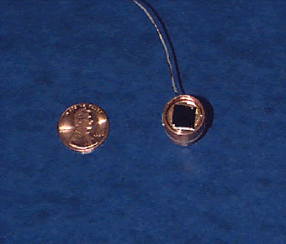

Figure 2 [site]

However, our ability to do this will depend on our ability to obtain MQWs that meet our needs and which option is cheaper. The NRL has been constructing their own MQWs for their MRRs because large enough MQWs that meet their needs are not sold commercially. [site] We most likely will have to contact the NRL to obtain their assistance in this project, primarily in obtaining the MQWs.

Though we are currently looking as using a 12.5mm solid cube corner retroreflector, it may be necessary to utilize a larger aperture. This will be addressed in the detail design report when a formal link budget is calculated for the system. However, similar sized retroreflectors have been successfully used for the purpose of laser ranging on LEO satellites. [ANDE result]

Also once the link budget is calculated and the intensity of the light that will hit the transponder found, it will be determined if an ampere amplifier is needed to intensify the signal the MQW is receiving from the ground. It should be noted though that since the optical signal passes through the MQW twice (once entering and once exiting the retroreflector) that it will have a higher gain than a traditional photodiode. [site] Although a separate unbiased low-noise photodiode [that] will be utilized as will to determine the efficiency of the MQW or if it proves difficult to receive a quality signal with the MQW while it is modulating the laser. This photodiode also allows for redundancy, which may allow for a one way link should the MRR fail. We suspect that this may not be needed anyways since it was proven that a commercial one watt laser from earth is visible from the international space center. [news article]

The MRRs intended for ANDE required at least a 10 volt bias [hardware], but the NRL has since then developed one that only requires a 5 volt bias [powerpoint], which is easily obtainable on a cubesat. Those intended for the ANDE satellite also only required 130mW. [hardware]It may also be possible to adjust the bandwidth of the connection with the MRR in-orbit, which will also change the power requirements in proportion to the change in bandwidth. [cateye]

This technology is believed to be able to easy survive use on a satellite. Its robust nature makes it suitable for the stresses experienced during launch. It has been proven to function even after experiencing the radiation equivalent of over 14,000 years in LEO, which is far greater than the lifespan of any satellite. [interspace] Though MQWs can withstand temperatures as high as 500°C, their properties are susceptible to temperature changes. [pat] A temperature change of ±12°C will result in 10% change in the efficiency of the MQW at the intended wavelength. [pat] However, this can be controlled by controlling the voltage bias. [pat] A temperature sensor will be utilized to ensure the MQW remains within a certain range during scheduled contact periods.

The MRR can be utilized as a normal retroreflector in space as well. This means that satellite laser ranging (SLR) data, for purposes such as orbit modeling, can still be gained from the cubesat even if a bi-directional optical link cannot be established. Though the wavelength would have to be either at or above the wavelength the MQW was intended for in order for the light to retroreflected, so not all SLR stations may be compatible with this satellite. This means that our primary payload is able to function as a secondary payload that will continue to function should the primary fail.

Ground Station

Since ground to satellite optical communication is relatively new, it may be necessary for us to construct our own if we cannot get the support of a ground based optical communication station to support us. This may be difficult since the MQW will have a specific operating wavelength. Ideally we will be able to work with the Air Force Maui Optical Station (which has successfully demonstrated the ability to produce a 1064nm laser capable of being reflected from a mirror in LEO and with a measurable return in the early 1990s during the Mirror Relay Experiment [yes]) or the NRL Midway Research Facility, both of which were intended to be used for the MRR experiment on ANDE and may still retain the capabilities to perform a similar experiment. [hardware] The optimal wavelength for the MQW used will be based on the wavelength that will be utilized.

However, we should consider the possibility that these facilities either no longer have the capability or are able to assist us. If this is the case then we will have to construct our own ground station. By utilizing one of the larger telescopes here at the university, either a 12 or 12.5 inch reflector, it may be possible to construct a low cost station that is capable of meeting our needs.

We would be required to obtain a laser that will work with the MQW. A commercial one watt laser has been proven to be visible from LEO. We are currently looking at continuous one watt 980nm laser with adjustable divergence [that] and a 20X beam expander [that] to further reduce the divergence. Since beam expanders also make the laser beam wider, this will also increase the safety of the system. This setup will cost under $800, excluding mounting, and will have a beam divergence between 1 and 103 arcseconds. The laser can be modulated either through modulating the power that it is receiving or by using another MQW shutter should the other method not allow for the desired bandwidth.

The telescope will be modified to allow for an avalanche photodiode, which typically cost between $100 and $200 [that], to be placed on the eyepiece. By monitoring the delay between when the ground laser signal was sent and when it was received, traditional SLR data can be obtained. It has been demonstrated that different modulation schemes can be used on the same laser without affecting the signal, so it will be possible to filter out and analyze the two signals separately. [Intersat] The telescope will further be modified to allow for gimbal system to allow for the precision pointing need to establish the link.

Software will have to be written for the gimbal system for it to locate and track the cubesat. In order to ensure the a optimal link, we will utilize a method developed by the NRL for potentially using MRRs to tag and identify LEO object launched by nontraditional means, such as by railguns. [site] This system will have the laser following a grid pattern over the area predicted to contain the MRR. Once the laser hits the MRR and the ground detects the return, it will continue with a smaller grip around were the MRR is now predicted to be based off the location of the return signal. Figure 3 and 4 illustrates this concept. This continues until a stable link is established and ensures that a strong link is established.

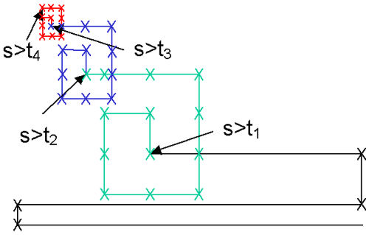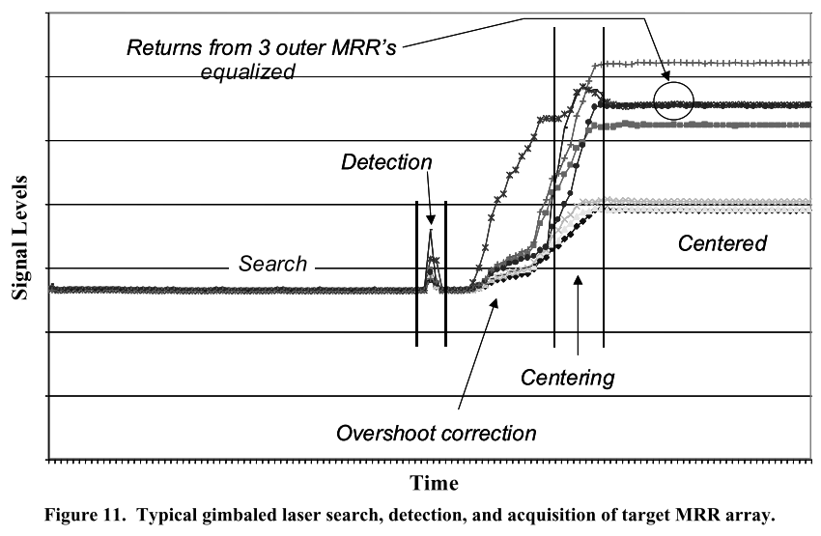

Figure 3 theoretical search pattern [site] Figure 4 signal strength during search pattern [something]

Since the cubesat will also carry a traditional radio transponder, a ground station will be needed for this as well. UF currently has the facilities needed for traditional radio communication with cubesats that can be utilized for this aspect of communication with the satellite.

Orbit

Since the laser must travel to and from the system in order to establish a link, distance has a greater impact on the link budget than it would have in a conventional optical link. [site] However, the further the larger the orbit, the greater the communication window. This means that a balance must be found that will insure a strong link and a large enough window to receive significant data to show the practicality of the system.

We believe that following an orbit similar to ANDE [ANDE] will provide the best balance. This is because NASA believed that they would be able to establish a link with the MRR at this range and this is our only reference point we have to study. This would be an orbit of roughly 400km and an inclination large enough for the satellite to pass over our ground station. However, a polar orbit will be best for mapping of the earth’s magnetic field.

With an orbit modeled after ANDE of 400km and 51.6° inclination, we will have an average communication window of 95 seconds with ranges between 13 and 121 seconds.

Attitude Control

To reduce cost, complexity, and risk of failure, passive magnetic attitude stabilization (PMAS) will be used for attitude control. Though PMAS are not very accurate, precision alignment is not necessary for the cubesat since pointing requirement are based on the properties of the retroreflector, which will have a large enough field of view (~45° for the ANDE MRR) to allow for little attitude control.

Another advantage of PMAS is that it does not rely on the cubesat’s electronics. This means that if the electronics onboard the cubesat were to fail the PMAS will continue to function. Normally this would mean nothing if the satellite itself was not functioning, but our cubesat will have another component that functions independently of the onboard electronics. The retroreflector, though not it MQW, will continue to function should the onboard electronics fail. This means that even if the cubesat’s electronics fail, laser ranging data can still be determined. This reduces the likelihood of a complete mission failure.

The PMAS will consist of a permanent magnet to align the satellite with the earth’s magnetic field [master]. The magnet will have to be aligned so that as it is passing over the ground station it will point the MRR in the general direction of the ground station. The angle will be determined when a ground station is determined.

Since the PMAS will only align the cubesat with the earth’s magnetic field, hysteretic rods will be used to dampen oscillation and prevent rotation around the magnetic axis [master]. They function by switching polarity in response to the change in the magnetic field exerted on them [PMAC]. This results in a conversion of angular momentum into heat. [master]

Attitude Determination

Although we are using PMAS which does not require any form of attitude determination to function, our cubesat will still possess some form of attitude determination. The purpose of the attitude determination will be to monitor the impact of orientation on the link and to determine if there is an orientation issue that is preventing a link from being established. If this is the case then it may still be possible to establish a link by placing a ground station where the MRR is directed at earth since the cubeast will change orientation as it moves through Earth magnetic field.

A one-axis HMC1001 and a two-axis HMC1002 will be used for determining satellite orientation as well as providing high resolution (~26 microgauss) magnetic readings. A higher resolution sensor can also be obtained, though these are simple and cheap (~$50 for both of them) components which can be utilized in a space environment. This data could be used to create an accurate map of the earth’s magnetic field. The RAX cubesat demonstrated the ability to get high precision magnetic reading from a cubesat using PMAS with an average error compared to the International Geomagnetic Reference Field (IGRF) that was less than 1.5X the resolution of the magnetometer once calibrated to take into account the PMAS. This could help with updating the IGRF since they are looking at an uncertainty of between 100 and 50 microgauss resolution [IGRF]. Combining the magnetic readings with the accurate orbit information gained by the laser ranging can help to provide an accurate model. However, this will depend on the project budget.

Communication

We will utilize two separate communication systems. The MRR will provide primary communication with the satellite. However, since this is the test payload we must consider the possibility of not being able to establish a link with the MRR. As such we will utilize a secondary RF communication that will be used if a link cannot be established with the MRR to try and determine and possible fix what went wrong with the MRR.

Our RF communication system will consist of a modified VX-3R transceiver handheld radio and a TinyTrak4 to allow the radio to transmit data over the amateur radio frequency bands, which will cost about $250. The University of Hawaii has used this system before and has been nice enough to post some instructions on how to perform the necessary modifications. [UH] This will provide a limited half-duplex connection with the cubesat. However, this is all that is needed for it to serve its purpose.

The VX-3R will also be further modified to reduce weight and allow for us to attach our own antenna. The antenna will be based off the Swampsat design in which the antenna is stored in the cubesat and then released once in orbit.

*Freespace Photonics Communications Office*; U.S. Naval Research Lab; <http://www.nrl.navy.mil/fpco/index.php>

N.G. Creamer et al; *Inter-Spacecraft Optical Communication and Navigation Using Multiple Quantum Well Modulating Retroreflectors*; U.S. Naval Research Lab; 2003; <http://www.nrl.navy.mil/research/nrl-review/2003/space-research/creamer/>

Peter G. Goetz et al; *Multiple quantum well-based modulating retoreflectors for inter- and intra-spacecraft communication*; U.S. Naval Research Lab; 2006; <http://www.nrl.navy.mil/fpco/pubs/06-1226-2171.pdf>

G. Charmaine Gilbreath et al; *Modulating Retro-reflectors for Space, Tracking, Acquisition and Ranging using Multiple Quantum Well Technology*; U.S. Naval Research Lab; 2002; <http://www.nrl.navy.mil/fpco/pubs/02-1221.1-1521.pdf>

W.S. Rabinovich et al; *Cat’s eye quantum well modulating retro-reflectors for free-space optical communication;* U.S. Naval Research Lab; 2003; <http://www.nrl.navy.mil/fpco/pubs/03-1226-0047.pdf>

<http://www.dhgate.com/1w-980nm-infared-laser-module-adjustable/p-ff808081360aa52201361015bac52ca7.html>

<http://www.beam-expander.com/products/20X-Beam-Expander-405%252d1064nm-%252d-47mm-Output.html>

<http://www.edmundoptics.com/electro-optics/detector-components/avalanche-photodiodes/2646>

<http://www.edmundoptics.com/electro-optics/detector-components/silicon-detectors/1305?ref=related-products>

*Low Power MEMS Retroreflectors for Optical Communication;* Boston Micromachines Corporation; 2010; <http://www.dtic.mil/dtic/tr/fulltext/u2/a520738.pdf>

Peter G. Goetz et al; *Modulating Retro-reflector Lasercom Systems at the Naval Research Laboratory*; U.S. Naval Research Lab; 2010; <http://www.dtic.mil/cgi-bin/GetTRDoc?AD=ADA535717>

Morio Toyoshima et al; *Research and development of free-space laser communications and quantum key distribution technologies at NICT;* National Institute of Information and Communications Technology; 2011; <http://ieeexplore.ieee.org/stamp/stamp.jsp?tp=&arnumber=5783667>

Morio Toyoshima et al; *Ground-To-Satellite Laser Communication Experiments;* National Institute of Information and Communications Technology; 2008; <http://ieeexplore.ieee.org/stamp/stamp.jsp?tp=&arnumber=4607894>

*Relay Mirror Experiment (RME)*; GlobalSecurity.org; 2011; <http://www.globalsecurity.org/space/systems/rme.htm>

*A Flashing Success;* Don Pettit; 2012; <http://blogs.airspacemag.com/pettit/2012/03/a-flashing-success/>

William Rabinovich; *Modulating Retro-reflector Links for High Bandwidth Free-Space Lasercomm;* U.S. Naval Research Lab; 2009; <http://www.onr.navy.mil/~/media/Files/Funding-Announcements/BAA/09-018_Amendment_0002c.ashx>

Andrew C Nicholas, Ted Finne, Mark A Davis; *Atmospheric Neutral Density Experiment Risk Reduction (ANDE-RR) Flight Hardware Details*; U.S. Naval Research Laboratory Space Test Program; 2007; <https://docs.google.com/viewer?a=v&q=cache:K6EQDYqcupcJ:ilrs.gsfc.nasa.gov/docs/anderr_hw.pdf+ANDE+flight+hardware+detail&hl=en&gl=us&pid=bl&srcid=ADGEESiqKPaRh4pQ-TI-HIZMyqgVvU6_yzdDrkGWQHyUqcwB4ps0uX_90AW6pP-camzxVmOB4Ylq-F2bYEolUlUeiQEWmY5yhc5cb0PxivUya4RHWHxjpFMSqipaxwweOMdx34sTUBoB&sig=AHIEtbThQLDLZNbPJ39wxhpjcxotfBQbUA>

William S. Rabinovich et al; *45-Mbit/s cat’s-eye modulating retroreflector*; U.S. Naval Research Lab; 2007; <http://webcache.googleusercontent.com/search?q=cache:Dp5WhievqlsJ:citeseerx.ist.psu.edu/viewdoc/download;jsessionid%3DCF247298282532EB9AC4890C5388BDA9?doi%3D10.1.1.118.8395%26rep%3Drep1%26type%3Dpdf+chesapeake+bay+modulating+retro+reflector&hl=en&gl=us>

Mark Plett et al; *Free-space optical communication link across 16 kilometers over the Chesapeake Bay to a modulated retroreflector array*; U.S. Naval Research Lab; 2008; <http://opticalengineering.spiedigitallibrary.org/article.aspx?articleid=1088814>

*Space Test Program-H2-Atmospheric Neutral Density Experiment (STP-H2-ANDE)*; NASA; 2012; <http://www.nasa.gov/mission_pages/station/research/experiments/STP-H2-ANDE.html>

A.C. Nicholas et al; *The Atmospheric Neutral Density Experiment (ANDE) And Modulating Retroreflector In Space (MODRAS): Combined Flight Experiments For The Space Test Program;* U.S. Naval Research Lab; <http://cddis.nasa.gov/lw13/docs/papers/target_nicholas_1m.pdf>

David T. Gerhardt, Scott E. Palo; *Passive Magnetic Attitude Control for CubeSat Spacecraft;* University of Colorado; <http://lasp.colorado.edu/home/csswe/files/2012/06/Gerhardt_SSC10_PMAC.pdf>

Vincent Francois-Lavet; *Study of passive and active attitude control systems for the OUFTI nanosatellites*; University of Liege; 2010; <http://vincent.francois-l.be/OUFTI_ADCS_2010_05_31.pdf>

[*The International Geomagnetic Reference Field: A “Health”* Warning; noaa; 2010; http://www.ngdc.noaa.gov/IAGA/vmod/igrfhw.html](The%20International%20Geomagnetic%20Reference%20Field:%20A%20“Health”%20Warning;%20noaa;%202010;%20http://www.ngdc.noaa.gov/IAGA/vmod/igrfhw.html)

Dennis D. Dugay; *KUMU A’O CUBESAT TELECOMMUNICATION SUBSYSTEM INTEGRATION AND TESTING*; University of Hawaii; <https://docs.google.com/viewer?a=v&q=cache:eznv_9DqbqwJ:www.spacegrant.hawaii.edu/reports/18_FA07/DDugay_FA07.pdf+VX-1R+hawaii+cubesat&hl=en&gl=us&pid=bl&srcid=ADGEESi1wy05cvxp_c462Rf3ZYAhJHXWJPG7i9H5CgFJ9jrAOgqdzj1ylCUwVTJXYXYcdLVu4zHsSvbfhzMtZathhd35iN_fZXDExY3wAO8Szs-WvuJ5G_7bEEN3HxisQeNAVG9ngNI2&sig=AHIEtbQfiCUk31ob56Pw344DibO4WGgFwA>

Gilbreath et al, *Modulating retroreflector using multiple quantum well technology*; patent; 2000; <http://www.google.com/patents?id=_EkGAAAAEBAJ&printsec=abstract&zoom=4#v=onepage&q&f=false>