TACoBell IR Dashboard Gadget

Contents

Purpose 3

Installation 4

Installation Issues 5

Windows Gadget Platform Not Installed 5

Windows Sidebar Not Enabled 5

Enabling and Disabling the Gadget 7

Disable Gadget 7

Enable Gadget 7

Usage 9

Position the Gadget 9

Displaying Large Window Size 9

Displaying Small Window Size 10

Always On Top of Other Windows 11

Transparency of Gadget When Not Active Window 12

Example - Always on top and 100% opacity 12

Example - Always on top and 80% opacity 12

Example - Always on top and 60% opacity 13

Example - Always on top and 40% opacity 13

Example - Always on top and 20% opacity 13

Options 15

Smaller Width 16

Example - Default smaller width setting of 450 16

Example - Smaller width setting of 800 17

Smaller Height 17

Example - Default smaller height setting of 105. 17

Example - Smaller height setting of 255 17

Clip Small Width 18

Example - Clip Small Width enabled and default Smaller Width of 450 18

Example - Clip Small Width disabled and default Smaller Width of 450 19

Example - Small window with default settings Clip Small Width enabled, Smaller Width = 450, Smaller Height = 105 19

Example - Small window with Clip Small Width disabled, Smaller Width = 800, Smaller Height = 190 19

Larger Width 20

Example - Default larger width setting of 1350 20

Example - Larger width setting of 1900 21

Larger Height 21

Example - Default larger height setting of 420 21

Example - Larger height setting of 600 22

Uninstalling 23

# Purpose

A Windows Sidebar gadget designed to display the GTAC EMEA TACoBell IR Dashboard in a minimal window and avoid the overhead and wasted screen real estate with displaying the TACoBell IR Dashboard in an internet browser window such as Internet Explorer.

For visual comparison the same TACoBell IR Dashboard showing an IR needing ICB is displayed in both the gadget and Internet Explorer. The gadget is shown on top and is considerably smaller:

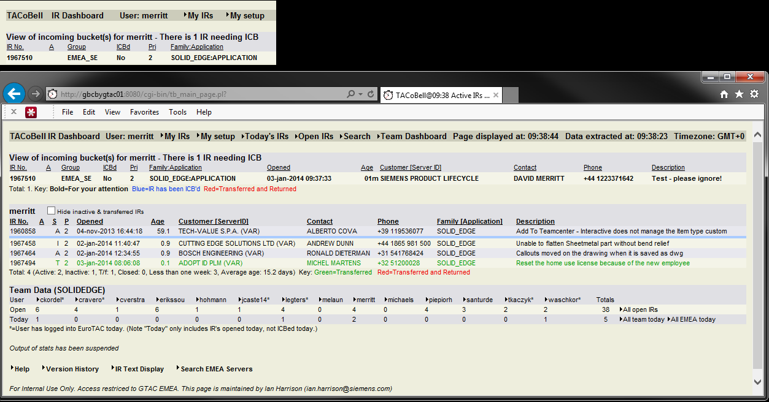

By developing a Sidebar gadget the features offered by gadgets can be implemented providing user interaction not typically associated with displaying the TACoBell IR Dashboard in an internet browser window, including window can be pinned to always be on top of other windows, have opacity when not actively viewed, being quickly expanded and shrunk, not being accidentally closed when exiting out of an internet browsing session, etc.

# Installation

To install from Windows Explorer double-click on the provided TACoBell_IR_Dashboard.gadget file:

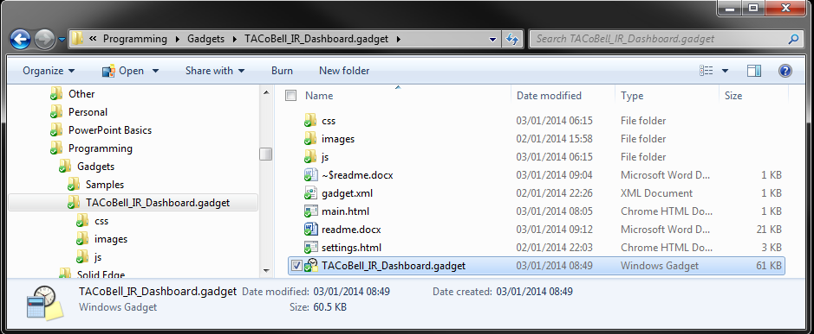

Or you can double-click on the embedded gadget file:



You will be presented with a "Desktop Gadgets - Security Warning". This is normal and expected behaviour. Select "Install":

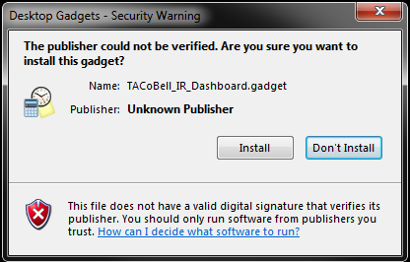

The TACoBell IR Dashboard gadget should now be installed and visible on your desktop:

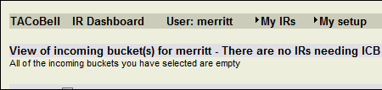

## Installation Issues

There are two common known issues when attempting to use Windows Sidebar gadgets.

### Windows Gadget Platform Not Installed

If the gadget does not successfully run you may need to first install the Windows Gadget Platform. To install the Windows Gadget Platform select Control Panel -> Programs -> Programs and Features -> Turn Windows features on or off:

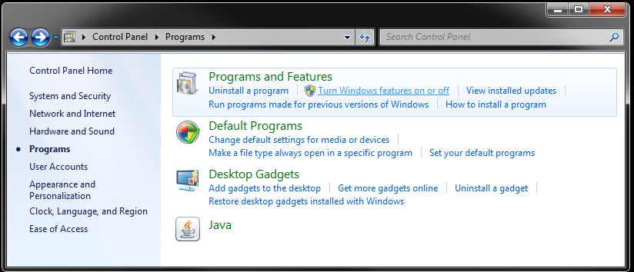

In the "Windows Features" window check the "Windows Gadget Platform" and select "OK":

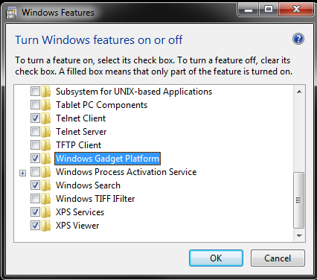

### Windows Sidebar Not Enabled

If after installing the Windows Gadget Platform the gadget will still not successfully display you may have to implement the following registry tweak to enable the Sidebar to display:

[HKEY_LOCAL_MACHINE\SOFTWARE\Microsoft\Windows\CurrentVersion\Sidebar\Settings]

"SidebarDockedPartsOrder"="0x1,0x2,0x3,0x4"

"AllowElevatedProcess"=dword:00000001

A registry file allowing you to quickly implement this tweak has been embedded for your convenience:



# Enabling and Disabling the Gadget

Upon initial installation of the gadget the gadget is automatically enabled.

## Disable Gadget

To disable the gadget either hover over the gadget and select the "Close" icon or right-click over the gadget and select "Close gadget":

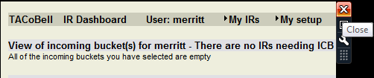

Or

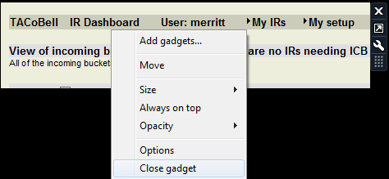

## Enable Gadget

Once installed, you can enable the gadget at any time by simply accessing the Gadgets window. Anywhere in an open area in your Windows desktop right-click and select "Gadgets":

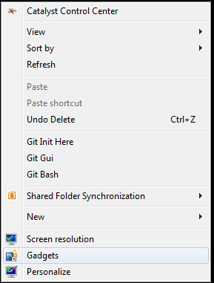

The Gadgets window is displayed. Simply double-click on TACoBell IR Dashboard to open and display the gadget on your desktop:

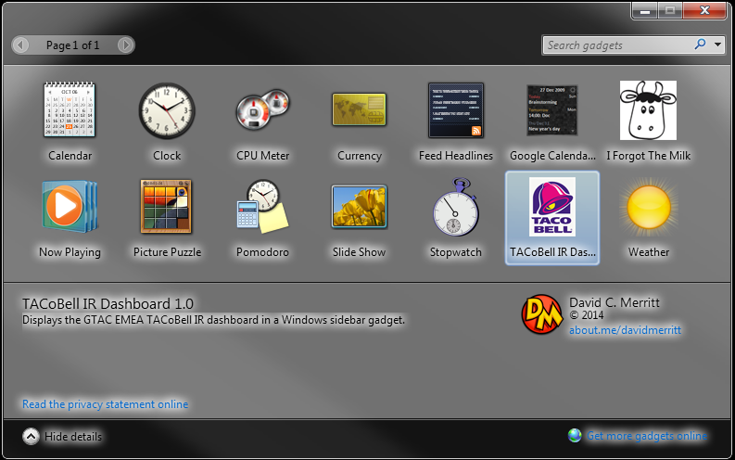

# Usage

Because this is a Windows Sidebar gadget all of the functionality typically associated with gadgets is available.

## Position the Gadget

The gadget can be positioned anywhere on the desktop. To position the gadget hover over the gadget, select the "Drag gadget icon" and position the icon where desired:

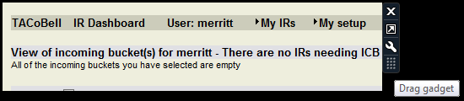

Note that because this is a gadget when positioning near the edges of the display the gadget may auto-snap to the display edge.

## Displaying Large Window Size

By default the gadget will start in a smaller window with the TACoBell IR Dashboard window clipped to the top left hand corner of the dashboard such that only the IRs needing ICB are displayed:

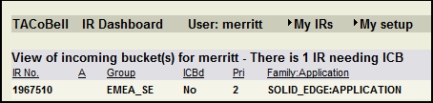

You can quickly enlarge the window by using the gadget functionality "Larger size". Either hover over the gadget and select the "Larger size" icon or right-click over the gadget and select Size -> Large size:

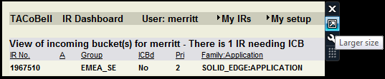

Or

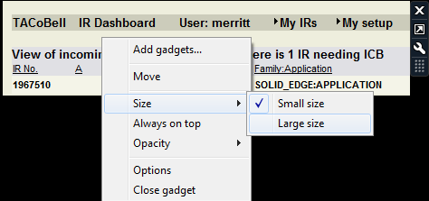

The gadget window size is now increased such that you can easily see the entire TACoBell IR Dashboard:

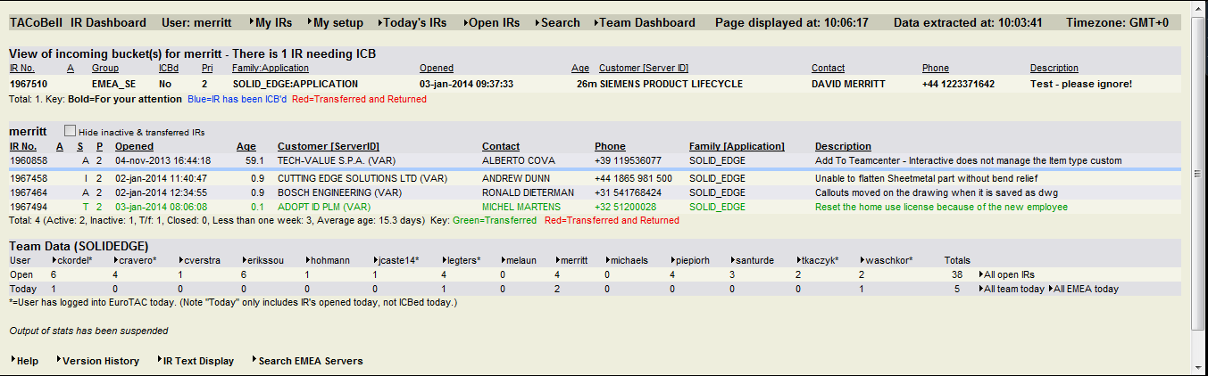

The overall size of the large window can be configured in the gadget Options.

## Displaying Small Window Size

Once the gadget window size has been set to the larger size you can quickly set the gadget back to the smaller window size. Either hover the gadget and select the "Smaller size" icon or right-click over the gadget and select Size -> Small size:

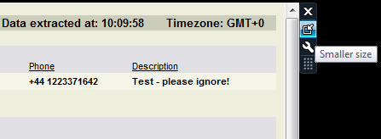

Or

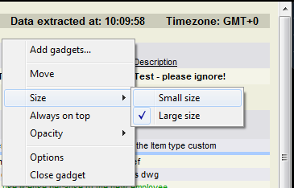

The overall size of the small window can be configured in the gadget Options.

## Always On Top of Other Windows

The gadget can be configured to remain on top of all other windows.

By default the gadget is *not* configured to remain on top of other windows.

Right-click over the gadget and select "Always on top":

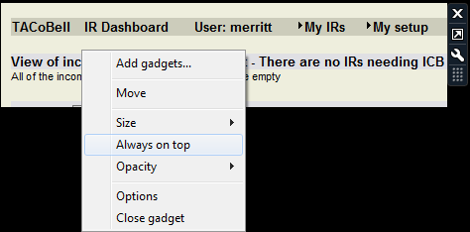

Always on top can be disabled by right-clicking over the gadget and select "Always on top" again:

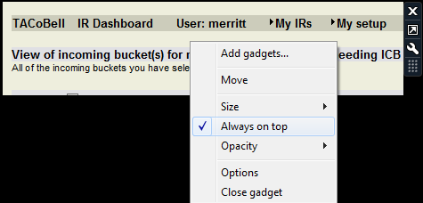

## Transparency of Gadget When Not Active Window

The transparency or opacity of the gadget can be controlled when the gadget is not the active window.

By default the gadget has 100% opacity.

To control opacity right-click over the gadget, select "Opacity" and then select the level of opacity desired:

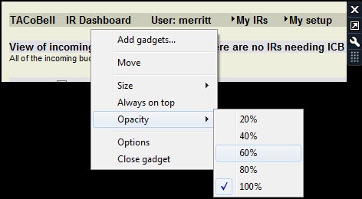

The "Opacity" setting can be combined with the "Always on top" setting to configure the gadget such that it is always visible on your desktop but doesn't have such a noticeable appearance when working on other applications. In the examples below you can see the effect of having "Always on top" enabled at different opacity levels.

Example - Always on top and 100% opacity:

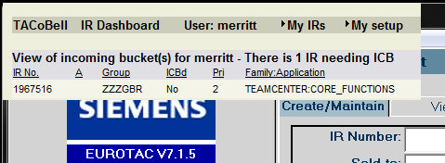

Example - Always on top and 80% opacity:

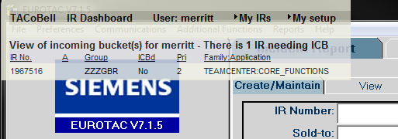

Example - Always on top and 60% opacity:

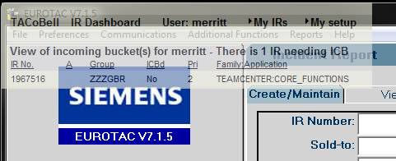

Example - Always on top and 40% opacity:

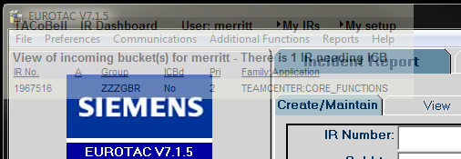

Example - Always on top and 20% opacity:

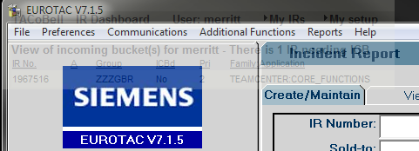

Note that the TACoBell IR dashboard settings still work when displayed within the gadget. Therefore if you have your TACoBell set up to show popups when calls require ICB you could set the opacity of the gadget to the lowest setting of 20% such that it is barely visible. With popups enabled when an IR requires ICB then a new Internet Explorer window would popup informing you that an IR needed ICB. This would effectively configure the TACoBell dashboard and gadget such that it is unnoticeable until such time that an IR requires ICB.

# Options

There is a minimal set of options provided to control the size of the small and large windows of the gadget.

Note that the small and large window sizes have been configured by default for a screen display resolution of 1920 x 1080. You may need to change the small and large screen sizes to better suit your personal preferences and/or screen resolution.

To change the options either hover over the gadget and select the "Options" icon or right-click over the gadget and select Options:

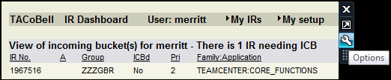

Or

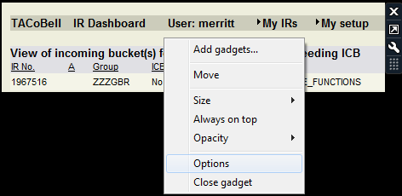

The Options window is displayed:

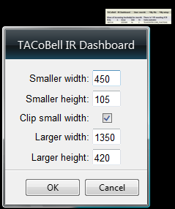

Change the desired options; select "OK" to save the changed options and to return to the gadget display.

Select "Cancel" to ignore any changed options, reset the options to their last saved values and to return to the gadget display.

## Smaller Width

The "Smaller width" setting controls the size in pixels of the width or x direction of the smaller window:

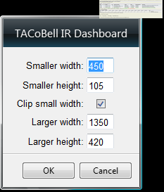

Example - Default smaller width setting of 450. Note that just enough of the dashboard is displayed to allow seeing that an IR requires ICB:

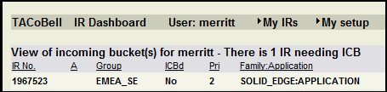

Example - Smaller width setting of 800. Note more of the dashboard selections and IR to ICB is visible compared to the example above:

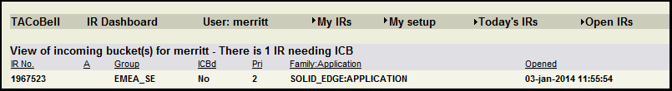

## Smaller Height

The "Smaller height" setting controls the size in pixels of the height or y direction of the smaller window:

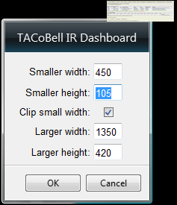

Example - Default smaller height setting of 105. Note that just enough of the dashboard is displayed to allow seeing that an IR requires ICB:

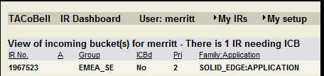

Example - Smaller height setting of 255. Note that it is possible to see both the IRs needing ICB and IRs in your bucket:

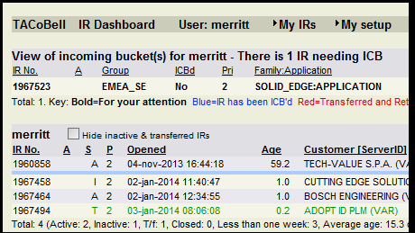

## Clip Small Width

The "Clip Small Width" setting controls how the IR Dashboard is displayed within the small window of the gadget:

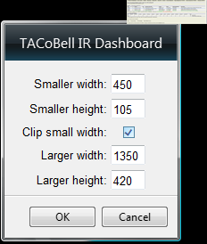

With "Clip Small Width" enabled the dashboard is effectively "clipped" to only show the upper left hand corner of the dashboard and the remainder of the dashboard cannot be seen in the small window. To see the rest of the dashboard you must toggle to the large window.

With "Clip Small Width" disabled the dashboard is shrunk or wrapped to fit the entire dashboard into the small window space. If the entire dashboard cannot be displayed in the small window scrollbars are available to scroll and view the remainder of the dashboard within the small window.

Example - Clip Small Width enabled and default Smaller Width of 450. Note there are no scrollbars available to view the rest of the dashboard:

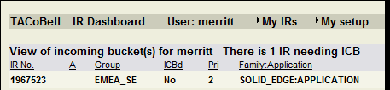

Example - Clip Small Width disabled and default Smaller Width of 450. Note that the dashboard columns are shrunk to fit the window and scrollbars are available to view the rest of the dashboard.

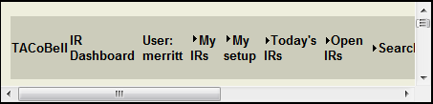

By disabling the Clip Small Width and changing the Small Width and Small Height sizes the small window can be configured to show IRs needing ICB and associated information differently than the default small window settings.

Example - Small window with default settings Clip Small Width enabled, Smaller Width = 450, Smaller Height = 105. Note that only enough of the dashboard is visible to allow monitoring of IRs needing ICB and that the rest of the IR information or dashboard is not viewable:

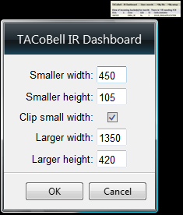

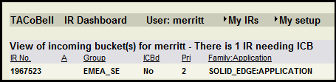

Example - Small window with Clip Small Width disabled, Smaller Width = 800, Smaller Height = 190. Note that enough of the dashboard is displayed to allow monitoring of IRs needing ICB, the complete IR information is visible and that the remainder of the dashboard can be viewed by using the scrollbars:

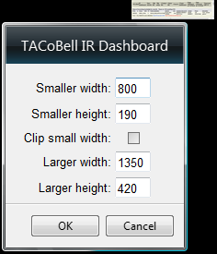

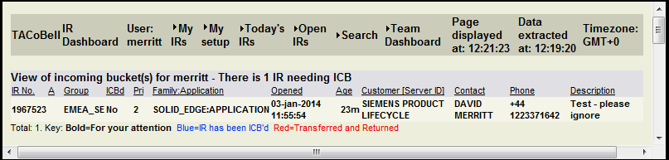

## Larger Width

The "Larger width" setting controls the size in pixels of the width or x direction of the larger window:

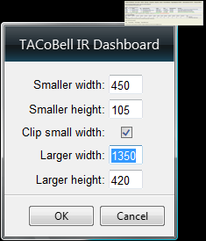

Example - Default larger width setting of 1350:

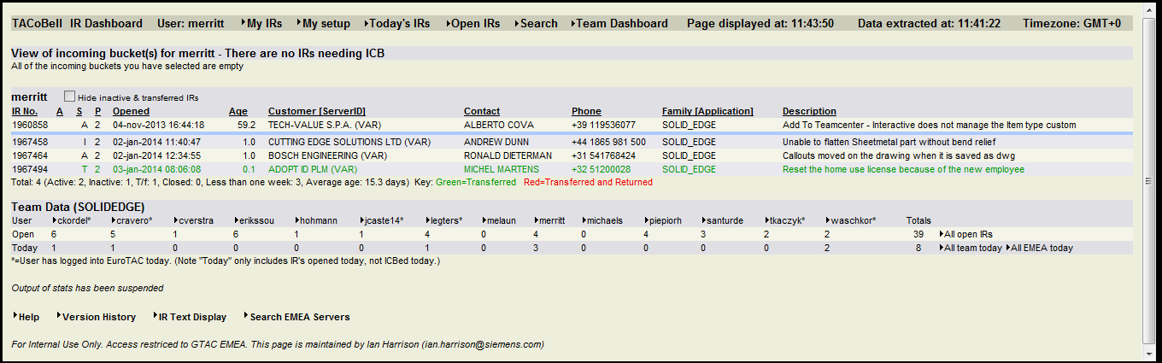

Example - Larger width setting of 1900. Note the spacing between columns is increased compared to the smaller larger width setting above:

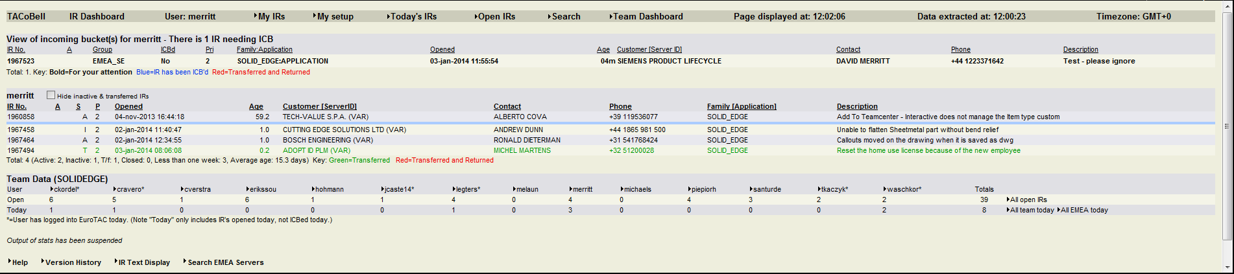

## Larger Height

The "Larger height" setting controls the size in pixels of the height or y direction of the larger window:

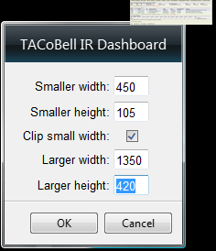

Example - Default larger height setting of 420. Note there is an active vertical scrollbar indicating more information on the dashboard:

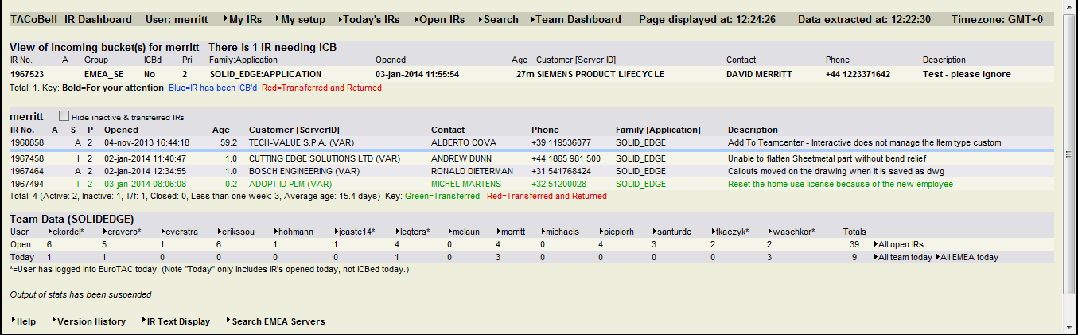

Example - Larger height setting of 600. Note there is no active vertical scrollbar and more whitespace at the bottom of the dashboard:

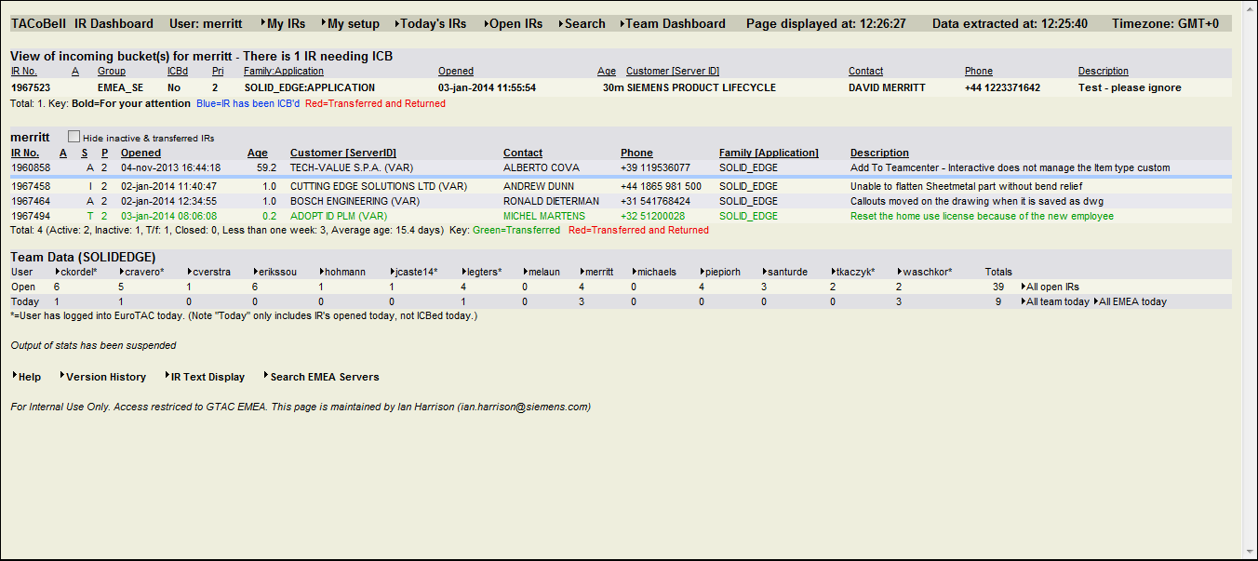

# Uninstalling

Anywhere in an open area in your Windows desktop right-click and select "Gadgets":

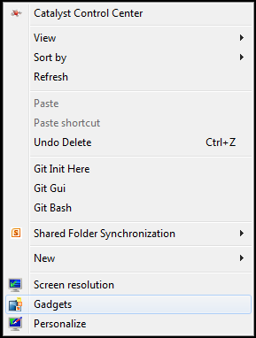

Right-click on the TACoBell IR Dashboard and select Uninstall:

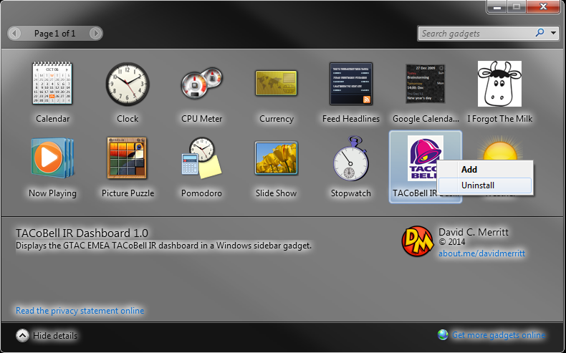

When prompted to uninstall select "Uninstall":

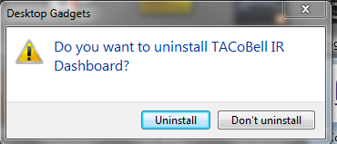

The gadget has now been uninstalled. To use the gadget again you must reinstall following the Install instructions.