

Dynamics 365 Healthcare Accelerator

Installation Guide

Contents

Installing the Dynamics 365 Healthcare Accelerator 2

Dependencies 2

Acquire Prerequisite Files 2

Manually Import Main Solutions 2

Import Additional Solutions 2

References 2

How to Manually Import Main Solutions 2

How to Import Additional Solutions with Configuration Migration Tool 3

# Installing the Dynamics 365 Healthcare Accelerator

## Dependencies

If you are installing this version as part of an upgrade from a prior Healthcare Accelerator version, please see the Important Upgrade Considerations document to assist.

This version is not compatible with version 1.8.1.0. Attempts to install version 2.2.3.x on top of 1.8.1.0 will be unsuccessful.

## Acquire Prerequisite Files

* To import the Main Solutions, acquire the following managed solution files:
  + Dynamics365ElectronicMedicalRecords_2_2_3_x_managed.zip
* To import the Additional Solutions, you’ll need to acquire the Configuration Migration Tool and following data files:
  + Configuration Migration Tool folder
  + Healthcare Sample Data - DataPackage.zip

## Manually Import Main Solutions

For a list of all entities and attributes, find the Healthcare Reference Guide amongst the included documentation. To import, follow steps in the “Manually deploy Main Solutions” section below. *Complete Dependencies, in section below, prior to installing solutions. Solutions must be installed in the following order:

1. Dynamics365ElectronicMedicalRecords
   1. This solution contains the entities, forms, and views used across the accelerator. This solution does not have any dependencies on the Sales module, so no connection to Contact, Account, Opportunity or Lead is made.

## Import Additional Solutions

These solutions contain Sample Data for the Healthcare Common Solution, Patient Portal, Physician Portal and Marketing Solution. To import, follow steps in the “Import Additional Solutions with Configuration Migration Tool” section below.

1. Healthcare Sample Data
   1. The Sample Data package contains sample records to help understanding the data model. This package depends on the Sales package being installed.
   2. Use Configuration Migration Tool to import Patient Portal - DataPackage.zip

# References

## How to Manually Import Main Solutions

To manually import a main solution:

1. Navigate to <https://make.powerapps.com/home> > Select your Environment > Click Solutions in left-hand Navigation.
2. Click Import button in ribbon.
3. Click Choose File button and select managed solution zip file.

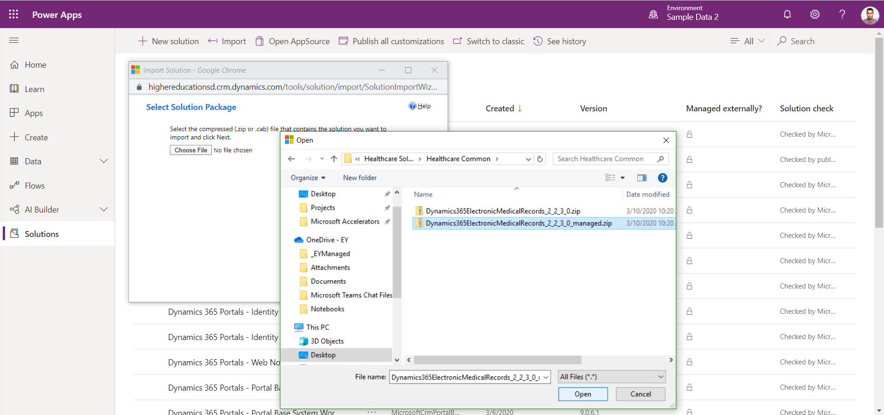

1. Click Open button.
2. Click Next through all steps and then Import.
3. **Note:** Dynamics365ElectronicMedicalRecords solution may take up to an hour to install, the rest only a couple minutes.

## How to Import Additional Solutions with Configuration Migration Tool

To Import an additional solution using the Configuration Migration Tool:

1. Open “Configuration Migration Tool” folder (**Note:** Make sure folder is on Desktop so directory name is short).
2. Right click “downloadlatest.ps1” and click “Run with PowerShell”, Type 'A', click ENTER and wait for it to complete.
3. Open the new “Tools” folder, then “Configuration Migration”, and run “DataMigrationUtility”.
4. To Import:
   1. Select “Import Data”.
   2. Connect to the org to import the data to.
   3. Select the appropriate data zip file (should be named “DataPackage.zip”).
   4. Perform the import.