Prediction of aflatoxin nonconformity in foods using regulatory testing records and meteorological time-series data

Young Jin Cheon¹, Sanggoo Cho¹, Seung Yong Cho² and Yujin Na³

¹, Korea
²Department of Food Sciences and Technology, Sangmyung University, 31066, Cheonan, Republic of Korea
³Korea

Running title: Aflatoxin nonconformity prediction in foods

Send correspondence to: Yujin Na.

ABSTRACT
A risk-prediction framework for aflatoxin nonconformity in foods was developed by integrating 80,883 aflatoxin testing records from the Laboratory Information Management System (LIMS) of the Ministry of Food and Drug Safety (MFDS), Republic of Korea, with 10 meteorological variables collected for the 50 days before each test date. Under an identical evaluation protocol (stratified five-fold cross-validation with pooled out-of-fold predictions, class-weighted training for the imbalance of 316 positive records corresponding to 0.39% of the dataset, and decision thresholds selected only on validation data), a hybrid deep learning model combining a one-dimensional convolutional neural network, bidirectional long short-term memory, and an attention mechanism was compared with two gradient-boosting algorithms, XGBoost and CatBoost, tuned under an equal search budget. CatBoost achieved the highest pooled F2-score (0.301; precision 0.837, recall 0.259), followed by XGBoost (0.292); both exceeded the deep learning model (F2-score 0.240) in every fold. Selecting the top 20% of records ranked by CatBoost predicted probability captured 49.4% of nonconforming cases. These findings suggest that linking regulatory testing records with domestic meteorological data can support risk-based aflatoxin screening and inspection prioritization.

Key Words: Food safety, Hazard prediction, Hazard agent, Aflatoxin, Predictive model

INTRODUCTION
Mycotoxin contamination is a major food safety hazard that can occur in cereals, nuts, spices, dried foods, and processed foods made from these raw materials when conditions favorable for the growth of toxigenic fungi and toxin production are met. Recent increases in mean temperature and changes in precipitation patterns associated with climate change may increase the likelihood of toxigenic fungal growth during production, harvest, storage, and distribution. In addition, the production of mycotoxins, including aflatoxins, can vary according to the temperature and humidity conditions to which foods and raw materials are exposed during these stages (Medina et al., 2017; Medina et al., 2014).
Aflatoxins are representative mycotoxins produced by several fungal species, including Aspergillus flavus. They comprise several structurally related compounds, including aflatoxins B1, B2, G1, and G2. Among them, aflatoxin B1 (AFB1) is classified as a Group 1 carcinogen with sufficient evidence of carcinogenicity in humans (Claeys et al., 2020). Acute exposure to high concentrations of aflatoxins can cause severe hepatotoxicity, and population-level consumption of contaminated foods may lead to outbreaks of aflatoxicosis (Kamala et al., 2018). Because of their toxicological significance, aflatoxins are considered priority targets in the management of mycotoxins in foods.
Aflatoxin contamination is strongly influenced by environmental conditions. The growth of the producing fungus A. flavus and AFB1 biosynthesis are sensitive to temperature and water activity, and both can be promoted when favorable high-temperature conditions coincide with high water availability (Al-Zaban, 2023). Conversely, low relative humidity during storage can suppress fungal growth and toxin production by maintaining water activity below critical levels (Gong et al., 2024; Villers, 2014). Insufficient rainfall, high-temperature and drought stress, and storage temperature–humidity conditions can also alter the physiological status of raw materials, thereby affecting the establishment of A. flavus and subsequent toxin production (Medina et al., 2014). Therefore, meteorological time-series data preceding the testing date, including temperature, humidity, precipitation, sunshine duration, and soil moisture, may serve as proxy environmental signals reflecting conditions that could influence aflatoxin risk during storage and distribution.
However, meteorological conditions alone cannot fully explain aflatoxin nonconformity. The risk may also be influenced by food category, raw material characteristics, moisture content, packaging and storage conditions, distribution environment, and timing of testing. Dried agricultural commodities and their processed products, including nuts, cereals, and spices, may be particularly susceptible when exposed to warm and humid storage conditions. Thus, predicting vulnerable samples requires the joint consideration of environmental signals and sample-level information available from regulatory testing records.
Aflatoxin contamination can occur during raw material production as well as post-harvest storage and distribution. Once nonconformity is detected in a final product, the timing and cause of contamination are often difficult to determine. Because aflatoxins are difficult to remove sufficiently through ordinary processing or cooking, management approaches that rely only on detection after contamination has occurred and subsequent recall have inherent limitations (Bullerman and Bianchini, 2007; Kabak, 2009). Thus, aflatoxin control should shift toward risk-based management, in which inspection resources are prioritized for samples with a higher likelihood of contamination.
Previous studies on aflatoxin risk prediction have mainly focused on specific crops or raw agricultural commodities, such as maize and peanuts, and have used production and storage conditions, meteorological data, soil information, and satellite-derived variables to estimate contamination risk (Branstad-Spates et al., 2023; Castano-Duque et al., 2025; Castano-Duque et al., 2022). These studies indicate that environmental and commodity-specific information can support the early estimation of aflatoxin risk. Their findings also provide a rationale for extending data-driven risk management to regulatory testing systems by combining accumulated testing records with environmental information to identify vulnerable samples and prioritize inspection resources.
In regulatory practice, however, aflatoxin nonconformity is not limited to specific raw agricultural commodities. It can also occur in processed foods made from susceptible raw materials. Therefore, preventive management requires a prediction system that extends beyond crop- or commodity-specific models and can identify high-risk samples across diverse food categories. Regulatory testing programs continuously accumulate information on food type, testing purpose, testing date, and testing location. Learning vulnerability patterns from these records can support more efficient, risk-based inspection planning across the food supply.
Accordingly, this study used actual aflatoxin testing records accumulated in the Laboratory Information Management System (LIMS) of the Ministry of Food and Drug Safety (MFDS), Republic of Korea, to reflect historical patterns of nonconformity. Meteorological conditions preceding the testing date were also incorporated as predictive inputs, serving as proxy environmental signals for potential exposure during storage and distribution. In the dataset constructed for this study, only 316 of 80,883 aflatoxin testing records were classified as nonconforming, corresponding to 0.39% of the total dataset. Thus, predicting aflatoxin nonconformity represents a highly imbalanced binary classification problem.
To address this challenge, this study developed a hybrid deep learning model that jointly uses pre-testing meteorological time-series data and sample-level regulatory testing information to predict the probability of aflatoxin nonconformity. Given this class imbalance, the model was trained using imbalance-aware strategies and evaluated for its ability to support risk-based prioritization of food samples for aflatoxin inspection.

MATERIALS AND METHODS

Data
This study used aflatoxin testing records accumulated in the Laboratory Information Management System (LIMS) of the Ministry of Food and Drug Safety (MFDS), Republic of Korea, from 2015 to 2025, together with daily meteorological observation data. Meteorological data were obtained from the Agricultural Weather Information Service of the National Institute of Agricultural Sciences, Rural Development Administration, and the Automated Synoptic Observing System (ASOS) operated by the Korea Meteorological Administration.
The LIMS is an electronic system used to manage and store regulatory testing information, including conformity and nonconformity decisions. Each testing record contains information on the tested item, food product name, testing date, test result, and the addresses of the manufacturing or processing facility and testing laboratory. The binary outcome was defined based on the regulatory decision recorded in the LIMS, with nonconforming records treated as positive cases.
The addresses of the manufacturing or processing facilities and testing laboratories were geocoded into latitude and longitude coordinates using the address-to-coordinate conversion API provided by the Korean Public Data Portal. The resulting coordinates were incorporated into the analytical dataset as spatial information and used to link each testing record with meteorological observations.
Food product names were standardized according to the food classification system of the Korean Food Code. To reduce the granularity of the categorical variable and represent broader food-category characteristics, 745 individual food item names were regrouped into 44 primary food categories.
Daily meteorological data were linked to each testing record based on geographic coordinates. Nine daily meteorological variables were obtained from the Agricultural Weather Information Service: mean temperature, maximum temperature, minimum temperature, relative humidity, mean wind speed, maximum wind speed, precipitation, solar radiation, and soil moisture. Daily sunshine duration was additionally obtained from ASOS, yielding a total of 10 meteorological variables.
Because meteorological observations were provided at the monitoring-station level, each testing record was matched to the nearest weather station using a KD-tree nearest-neighbor search based on geographic coordinates. Spatial interpolation was not applied. If meteorological data from the nearest station were unavailable, the next nearest station was used. Missing values in the daily meteorological data were handled sequentially by backward filling, forward filling, and zero imputation. After duplicate records were removed and preprocessing was completed, 80,883 records were included in the final analytical dataset. Among them, 316 records were classified as nonconforming, corresponding to 0.39% of the total dataset.

Input features
The model inputs consisted of time-series and tabular features (Table 1). The time-series input was constructed from 10 daily meteorological variables during the 50 days preceding the testing date. For each testing record, these data were represented as a 50 × 10 matrix. Each meteorological variable was standardized using the mean and standard deviation calculated from the training set.
The tabular input included testing purpose, primary food category, and three derived meteorological indicators calculated for the 7-day period immediately preceding the testing date. These indicators were the number of days with temperatures favorable for toxin production, defined as days with a daily mean temperature of 25-35°C (Al-Zaban, 2023); the number of low-humidity days, defined as days with relative humidity below 60%; and the maximum consecutive dry days, defined as the longest sequence of days without precipitation. The latter two indicators were included to represent dry or drought-related conditions, as water availability and drought stress are known to influence A. flavus growth and AFB1 production (Medina et al., 2014; Villers, 2014). Categorical variables were one-hot encoded, and derived numerical variables were standardized using the training-set mean and standard deviation.
To supplement categorical risk information under class imbalance, target-mean encoding was additionally applied to the combinations of testing purpose and primary food category (Micci-Barreca, 2001). To reduce instability in sparse categories, m-estimate smoothing was applied, with the smoothing parameter m set to 20 (Cestnik, 1990; Pargent et al., 2022). To prevent information leakage during five-fold cross-validation, all standardization parameters and target-mean encoding values were calculated using only the training subset within each fold and then applied to the corresponding validation and test subsets. The resulting fold-wise feature set was shared identically by all models compared in this study.

Cross-validation and leakage prevention
Model performance was evaluated using stratified five-fold cross-validation to preserve the class distribution in each fold (Berrar, 2025; Szeghalmy and Fazekas, 2023). In each iteration, four folds were used as the development subset, and the remaining fold served as the test subset. The development subset was further divided into training and validation subsets, resulting in approximately 65% training, 15% validation, and 20% testing data in each iteration. The same five splits, generated once with a fixed random seed, were reused for all models compared in this study, so that every model was trained, validated, and tested on identical records in each fold.
For each iteration, the model was trained on the training subset. Early stopping was performed based on validation PR-AUC, with a patience of 10 epochs. PR-AUC was used for early stopping because it is threshold-independent and informative under severe class imbalance, whereas the F2-score depends on a predefined threshold and may be unstable when calculated from a small number of positive cases in the validation subset (Davis and Goadrich, 2006; Prechelt, 2012; Saito and Rehmsmeier, 2015). The decision threshold was then selected by maximizing the F2-score on the validation subset (Cawley and Talbot, 2010). The model was optimized using Adam, with a batch size of 256 and a maximum of 50 epochs (Kingma and Ba, 2014). The same early-stopping metric and threshold-selection rule were applied to all models compared in this study.
After model training, early stopping, and threshold selection, predictions were generated for the corresponding test subset, which was not used for model training, early stopping, or threshold selection. Predictions from the five test subsets were pooled to form a single out-of-fold (OOF) predictions to form a single prediction set covering all records. These pooled OOF predictions were used as the primary basis for performance evaluation. Fold-wise metrics were also reported as mean ± standard deviation to assess variability across folds (Forman and Scholz, 2010).
To prevent information leakage, all data-dependent preprocessing steps, including standardization, target-mean encoding, m-estimate smoothing, and oversampling, were performed using only the training subset within each iteration. The validation and test subsets were transformed using parameters and encoding values derived from the corresponding training subset. Threshold selection and early stopping were performed using only the validation subset, whereas the test subset was used only for OOF prediction generation.

Handling class imbalance
To address the class imbalance in the dataset, threefold oversampling of the positive class and weighted binary cross-entropy were jointly applied during model training. The positive class consisted of nonconforming records, which accounted for only 0.39% of all records. This oversampling was applied only to positive records within each training subset by generating two augmented copies per positive record (Buda et al., 2018). Because excessive imbalance correction may increase the risk of overfitting or distort the original outcome distribution, oversampling was limited to this threefold expansion of the positive class (He and Garcia, 2009; van den Goorbergh et al., 2022). The validation and test subsets were not oversampled.
Weighted binary cross-entropy was used as the loss function to further reduce bias toward the majority class. The positive class weight was calculated as the ratio of negative to positive records in the training subset within each iteration, thereby assigning a larger penalty to misclassification of rare nonconforming records (Elkan, 2001; King and Zeng, 2001). For the gradient-boosting models described below, the same negative-to-positive ratio was applied through the scale_pos_weight parameter.

Time-series augmentation
For each positive record, defined as a nonconforming record, in the training subset, two augmented copies were generated. The time-series input was a 50 × 10 matrix consisting of 10 daily meteorological variables over the 50 days preceding the testing date. Three transformation methods were applied for augmentation: scaling, jittering, and time shifting (Iwana and Uchida, 2021; Wen et al., 2021).
Scaling was performed by randomly sampling a multiplier between 0.95 and 1.05 for each meteorological variable and applying it to all 50 daily values of that variable (Um et al., 2017). Jittering was applied by adding random noise with a standard deviation of 0.02 to each value in the time-series matrix (Um et al., 2017). Time shifting was performed by shifting the 50-day sequence along the temporal axis by up to ±2 days (Le Guennec et al., 2016). Empty positions generated by time shifting were filled by replicating the nearest edge value rather than using circular padding, to avoid artificially connecting distant time points within the 50-day sequence.
For derived numerical tabular features, random noise with a standard deviation of 0.02 was added during augmentation (Bishop, 1995). Categorical variables, including testing purpose and primary food category, were kept unchanged. Through this procedure, two augmented copies were generated for each positive record, increasing the number of positive records in each training subset threefold. The same augmented training subsets were used by all models compared in this study.

Models compared
The deep learning model was a hybrid neural network with two input branches that jointly processed the meteorological time-series and the tabular features and combined the two branch outputs to predict the probability of aflatoxin nonconformity. The time-series branch applied two Conv1D layers (64 filters each; kernel sizes of 7 and 3; same padding) to the 50 × 10 matrix to extract local temporal patterns (Kiranyaz et al., 2021), followed by two BiLSTM layers with 64 and 32 hidden units to model bidirectional temporal dependencies (Hochreiter and Schmidhuber, 1997; Schuster and Paliwal, 1997) and an attention layer that assigned higher weights to time points contributing more strongly to the prediction (Bahdanau et al., 2015). The tabular branch processed the tabular features through two dense layers with 64 and 32 hidden units. The two branch outputs were concatenated and passed through additional dense layers, with a final sigmoid activation outputting the predicted probability. Considering the limited number of positive records (n = 316), the model capacity was kept relatively small, and batch normalization, dropout (rate = 0.1), and L2 regularization were applied to the major hidden layers (Alzubaidi et al., 2021; Bejani and Ghatee, 2021). The model was implemented using TensorFlow/Keras, and the overall architecture and main hyperparameters are presented in Table 2.
Two gradient-boosted decision-tree algorithms, XGBoost (Chen and Guestrin, 2016) and CatBoost (Prokhorenkova et al., 2018), were trained on exactly the same folds and preprocessed features under the identical protocol. Because tree ensembles take a single feature vector per record, the 50 × 10 meteorological matrix was flattened into 500 values and concatenated with the 39 tabular feature columns, yielding 539 input features per record; no additional feature engineering was applied. Class imbalance was handled with the same negative-to-positive weight through the scale_pos_weight parameter of both libraries, and the positive-class time-series augmentation described above was applied unchanged. Each model was trained with up to 4,000 trees, and early stopping monitored validation PR-AUC with 300 stopping rounds, a conservative setting chosen to prevent premature termination, because improvement signals arrive infrequently at a 0.39% positive rate. The decision threshold was then selected by maximizing the F2-score on the validation subset, identically to the deep learning model.
The hyperparameters of both boosting algorithms were tuned with an identical budget and procedure using the Tree-structured Parzen Estimator (TPE) algorithm (Bergstra et al., 2011) implemented in Optuna (Akiba et al., 2019). For each algorithm, 60 trials over nine hyperparameters were first screened on the internal validation subset of the first fold, and the five best configurations were then re-evaluated on the internal validation subsets of all five folds; the configuration with the highest mean validation F2-score was selected, with validation PR-AUC used only to break ties. The search objective thus matched the primary evaluation metric, whereas early stopping within each trial retained validation PR-AUC (with up to 2,000 trees and 200 stopping rounds during the search), as in the deep learning model. At no point did the search access the test folds; every selection step used validation data only (Cawley and Talbot, 2010). The search spaces and selected values are listed in Table 3.
The deep learning model was not subjected to an equivalent automated search; its configuration was instead developed through targeted comparisons of kernel size and convolutional depth, described in the Results and Discussion section. This asymmetry follows the standard tuning practice of each model family: gradient-boosted trees are conventionally tuned by Bayesian optimization over a moderate number of trials (Bergstra et al., 2011; Akiba et al., 2019), and such tuned ensembles serve as the reference configuration for tabular data (Grinsztajn et al., 2022). Two safeguards were added so that the comparison would not merely reflect the difference in search effort. First, every tuning decision used validation data only, so the larger number of trials could not exploit the test folds (Cawley and Talbot, 2010). Second, a fixed-hyperparameter control arm was trained for both boosting algorithms without any search, at commonly used values shared by the two libraries (learning rate 0.03, depth 4, subsample 0.8, column sampling 0.5, minimum data per leaf 5, L2 regularization 2.0). Conversely, the kernel size of the deep learning model was selected by comparing pooled out-of-fold performance across candidates, a criterion that, unlike the boosting search, had access to test-fold outcomes; the budget asymmetry therefore does not operate solely in favor of the boosting models.

RESULTS AND DISCUSSION

Deep learning architecture selection and ablation
In the time-series branch of the deep learning model, the Conv1D layers were used to extract local temporal patterns from the 50-day meteorological sequence (Kiranyaz et al., 2021). To determine the final Conv1D configuration, the kernel size of the first Conv1D layer and the number of Conv1D layers were compared.
Among the 5-, 7-, 9-, and 15-day kernels, the 7-day kernel achieved the highest pooled F2-score (0.240), with a precision of 0.226 and a recall of 0.244 (Table 4). Although the 9-day kernel produced a slightly higher recall (0.253), its lower precision (0.174) resulted in a lower F2-score (0.232). Therefore, the 7-day kernel was adopted in the final model. The higher F2-score of the 7-day kernel suggests that local meteorological patterns within an approximately weekly time window contained useful information for predicting aflatoxin nonconformity.
The second Conv1D layer used a smaller kernel size of 3 to recombine and refine adjacent temporal features extracted by the first layer. This design was intended to learn progressively more abstract local time-series representations while limiting the accompanying increase in trainable parameters, consistent with the general principle of hierarchical representation learning in deep neural networks (LeCun et al., 2015).
Table 4The number of Conv1D layers was then evaluated by comparing models with 0, 1, 2, and 3 Conv1D layers under the same cross-validation framework (Table 5). Removing all Conv1D layers and directly feeding the raw 50-day meteorological sequence into the BiLSTM layer resulted in the lowest performance, with a pooled F2-score of 0.149 and a PR-AUC of 0.055. In contrast, adding one Conv1D layer increased the F2-score to 0.221, and the two-layer configuration achieved the highest F2-score of 0.240. Adding a third Conv1D layer did not further improve the F2-score and slightly reduced precision from 0.226 to 0.215. Therefore, the two-layer Conv1D configuration was adopted in the final model, suggesting that convolutional extraction of local meteorological patterns before BiLSTM processing was beneficial, whereas deeper convolutional stacking provided no additional gain.

Cross-validated performance comparison
The predictive performance of the three models was evaluated and compared using pooled out-of-fold predictions generated from the same stratified five-fold cross-validation. Because the dataset contained only 316 positive records, pooling the out-of-fold predictions was appropriate for assessing performance over the entire dataset while making efficient use of the limited number of positive cases. Motivated by reports that gradient-boosted tree ensembles match or outperform deep learning on tabular data (Grinsztajn et al., 2022), the two boosting models were evaluated as direct alternatives to the deep learning model under the identical protocol, rather than through a separate screening procedure; differences between models therefore reflect the algorithms and their tuning, not differences in data, folds, preprocessing, or threshold rules.
The deep learning model achieved a pooled F2-score of 0.240, ROC-AUC of 0.674, PR-AUC of 0.106, precision of 0.226, and recall of 0.244 (Table 6). The fold-wise F2-scores ranged from 0.215 to 0.272 (mean ± standard deviation, 0.240 ± 0.028), indicating that the overall performance was not disproportionately driven by the result of a single fold. Under the identical protocol, both tuned boosting models exceeded this performance (Table 7; the pooled precision–recall curves are shown in Fig. 1). CatBoost achieved the highest pooled F2-score (0.301), with a precision of 0.837, recall of 0.259, and PR-AUC of 0.247, followed by XGBoost with a pooled F2-score of 0.292 (precision 0.868, recall 0.250, PR-AUC 0.252). The advantage over the deep learning model was consistent across folds: the fold-paired F2 difference was +0.051 ± 0.046 for XGBoost and +0.061 ± 0.031 for CatBoost, and each boosting model outperformed the deep learning model in all five folds (Fig. 2).
In contrast, the two boosting algorithms were not distinguishable from each other under the equal search budget: the fold-paired F2 difference between CatBoost and XGBoost was +0.009 ± 0.017, smaller than the fold-level variability of either model alone (standard deviations of 0.017 and 0.024), so the ranking between the two boosting algorithms should not be over-interpreted. The fixed-hyperparameter control arms showed that the boosting advantage was not created solely by the search: without any tuning, XGBoost already exceeded the deep learning model (pooled F2-score 0.278 vs. 0.240), whereas fixed-hyperparameter CatBoost did not (0.235). For CatBoost, the fixed configuration lay outside the region preferred by the search; tuning lowered its ROC-AUC (from 0.736 to 0.695) while reducing false positives from 335 to 16, indicating that the improvement came mainly from better transfer of validation-selected thresholds to the test folds rather than from improved overall ranking. Finally, the positive-class augmentation was not the source of the boosting advantage: an ablation without augmentation changed the XGBoost pooled F2-score by less than fold-level variability (0.293 without vs. 0.292 with augmentation).

Decision-threshold behavior
To evaluate how model performance changes with the decision threshold, the pooled F2-score was recalculated for each of the three models while varying a common threshold from 0.01 to 0.99 over the pooled out-of-fold predictions (Fig. 3). For all three models, low thresholds flagged most records as nonconforming, yielding high recall but low precision and thus a low F2-score, whereas increasing the threshold reduced false positives at the cost of recall. The curves peaked at high thresholds — 0.98 for the deep learning model and 0.94 for both boosting models, with maximum pooled F2-scores of 0.239, 0.298, and 0.298 for the deep learning model, XGBoost, and CatBoost, respectively — values close to the pooled performance reported above with fold-specific validation-selected thresholds. This behavior reflects the class imbalance: at a positive rate of 0.39%, even a small false-positive fraction among the 80,567 conforming records quickly overwhelms the true positives, so the F2-score, despite weighting recall four times as heavily as precision, is maximized where only a small subset of records is flagged (Saito and Rehmsmeier, 2015).
Consistently, the thresholds selected on the validation subsets were high for all three models: 0.97–0.99 for the deep learning model, 0.94–0.99 for XGBoost, and 0.90–0.99 for CatBoost across the five folds. This is in line with the principle that decision thresholds should not be fixed at the default value of 0.5 but should be adjusted according to the evaluation metric and the class distribution (Saito and Rehmsmeier, 2015). One caveat is that the validation-selected threshold coincided with the upper bound of the examined grid (0.99) in 10 of the 15 model–fold combinations, so the reported operating points are optima within the grid rather than unconstrained optima; this limitation applies equally to all three models.
At these operating points, the three models differed primarily in the number of false positives (Fig. 4). The deep learning model identified 77 of the 316 nonconforming records (recall 0.244) at the cost of 264 false positives (precision 0.226). XGBoost identified 79 true positives with only 12 false positives (precision 0.868), and CatBoost identified 82 true positives with 16 false positives (precision 0.837). In other words, at slightly higher recall, the boosting models flagged 91 (XGBoost) and 98 (CatBoost) records in total, compared with 341 for the deep learning model, reducing the follow-up inspection workload by more than two thirds, while all three models achieved precisions far above the 0.39% positive rate expected under random flagging. These operating points should therefore be interpreted not as criteria for capturing all nonconforming records, but as points for prioritizing a small subset of records with relatively high probabilities of aflatoxin nonconformity.

Utility for risk-based screening
To evaluate whether the model predictions could be used to prioritize regulatory inspections, cumulative capture curves were constructed for the three models (Fig. 5). Records were ranked in descending order of predicted probability using the pooled out-of-fold prediction scores generated from the five cross-validation test folds, and the proportion of aflatoxin nonconforming records captured was calculated after selecting the top-ranked fraction of records. The dashed line represents the capture rate expected when the same fraction of records is selected at random.
When the top 10% of records by predicted probability were selected, the three models captured 38.0% (deep learning), 40.5% (XGBoost), and 39.9% (CatBoost) of the 316 nonconforming records, approximately four times the 10% capture rate expected under random selection. When the top 20% were selected, the capture rates were 48.7%, 47.2%, and 49.4%, respectively. Over this 10–20% inspection-scale range the three curves nearly coincide, so when resources allow inspecting on the order of 10–20% of all records, the three algorithms capture nonconforming records at rates within 3.2 percentage points of one another. The models instead differed most at the top of the ranking: at their F2-operating points, which flag only a few hundred records, the boosting models achieved precisions of 0.868 (XGBoost) and 0.837 (CatBoost) versus 0.226 for the deep learning model. Accordingly, the models should be interpreted not as stand-alone decision tools based on a single threshold, but as risk-ranking scores for sequentially prioritizing higher-risk records according to available inspection resources, and the practical advantage of the boosting models is concentrated where only a small number of records can be flagged for follow-up inspection.

CONCLUSIONS
This study demonstrated the feasibility of linking MFDS LIMS regulatory testing records with domestic meteorological time-series data to support the prediction of aflatoxin nonconformity in foods, and compared a hybrid deep learning model with two gradient-boosted tree algorithms under an identical cross-validation, class-weighting, and threshold-selection protocol. On 80,883 records with a positive rate of 0.39%, CatBoost achieved the highest pooled F2-score (0.301; precision 0.837, recall 0.259), followed by XGBoost (0.292), and both tuned boosting models exceeded the deep learning model (0.240) in every fold, whereas the two boosting algorithms were not distinguishable from each other under the equal search budget. At their operating points the boosting models reduced the number of false positives from 264 to 12–16, and selecting the top 20% of records ranked by predicted probability captured up to 49.4% of nonconforming cases. The models should therefore be interpreted not as stand-alone tools for determining regulatory compliance, but as risk-ranking tools for prioritizing records with a higher probability of nonconformity under limited inspection resources.
The significance of this study lies in presenting an initial data-driven screening framework tailored to Korean regulatory inspection conditions, where overseas crop-specific models may not be directly applicable, and in showing that, once the evaluation protocol is fixed, tuned gradient-boosting models constitute an effective and computationally practical choice for this screening task. Because all models were developed and compared on records from a single national testing system, the reported figures should be read as a controlled comparison between algorithms rather than as an estimate of performance on future or external data. Future studies should incorporate additional information on production area, cultivar, storage conditions, and country of origin for imported foods, and validate the model using independent external datasets. To better reflect contamination risks in imported foods, linking climate and contamination information from overseas production regions should also be considered.

Acknowledgments
이 연구는 식품의약품안전처의 지원으로 식품안전정보원이 수행한 「예측 대상 위해요소의 예측모델 개발 연구」 사업의 일환이다. 시험검사 데이터 제공과 연구 수행에 협조해 주신 식품안전정보원에 감사드린다.
본 연구에 사용된 아플라톡신 시험검사 기록은 식약처가 관리하는 비공개 시험검사 데이터다. 식약처는 이를 외부에 공개하지 않으며, 정당한 사유와 기관 승인이 있을 때에만 제한적으로 접근을 허용한다. 전처리·모델 학습·교차검증·평가에 사용한 코드와 그림 생성 스크립트는 합리적 요청 시 교신저자를 통해 제공할 수 있다.
Conflict of interest
저자들은 이해상충이 없음을 선언한다.

REFERENCES
Akiba T, Sano S, Yanase T, Ohta T, Koyama M. Optuna: A next-generation hyperparameter optimization framework. Proceedings of the 25th ACM SIGKDD International Conference on Knowledge Discovery and Data Mining, Anchorage, AK, USA: 2623–2631 (2019)
Al-Zaban MI. Impacts of Temperature and Water Activity Interactions on Growth, Aflatoxin B1 Production and Expression of Major Biosynthetic Genes of AFB1 in Aspergillus flavus Isolates. Microorganisms 11: 1199 (2023)
Alzubaidi L, Zhang J, Humaidi AJ, Al-Dujaili A, Duan Y, Al-Shamma O, Santamaría J, Fadhel MA, Al-Amidie M, Farhan L. Review of deep learning: concepts, CNN architectures, challenges, applications, future directions. Journal of Big Data 8: 53-74 (2021)
Bahdanau D, Cho K, Bengio Y. Neural machine translation by jointly learning to align and translate. arXiv (2015)
Bejani MM, Ghatee M. A systematic review on overfitting control in shallow and deep neural networks. Artificial Intelligence Review 54: 6391-6438 (2021)
Bergstra J, Bardenet R, Bengio Y, Kégl B. Algorithms for hyper-parameter optimization. Advances in Neural Information Processing Systems 24, Granada, Spain: 2546–2554 (2011)
Berrar D. Cross-validation. pp. 638-644. In: Encyclopedia of Bioinformatics and Computational Biology (Second Edition). Ranganathan S, Cannataro M, Khan AM (eds). Elsevier, Oxford (2025)
Bishop CM. Training with noise is equivalent to Tikhonov regularization. Neural Computation 7: 108-116 (1995)
Branstad-Spates EH, Castano-Duque L, Mosher GA, Hurburgh CR, Owens P, Winzeler E, Rajasekaran K, Bowers EL. Gradient boosting machine learning model to predict aflatoxins in Iowa corn. Frontiers in Microbiology 14: 1248772 (2023)
Buda M, Maki A, Mazurowski MA. A systematic study of the class imbalance problem in convolutional neural networks. Neural Networks 106: 249-259 (2018)
Bullerman LB, Bianchini A. Stability of mycotoxins during food processing. International Journal of Food Microbiology 119: 140-146 (2007)
Castano-Duque L, Avila A, Mack BM, Winzeler HE, Blackstock JM, Lebar MD, Moore GG, Owens PR, Mehl HL, Su J, Lindsay J, Rajasekaran K. Prediction of aflatoxin contamination outbreaks in Texas corn using mechanistic and machine learning models. Frontiers in Microbiology 16: 1528997 (2025)
Castano-Duque L, Vaughan M, Lindsay J, Barnett K, Rajasekaran K. Gradient boosting and bayesian network machine learning models predict aflatoxin and fumonisin contamination of maize in Illinois–First USA case study. Frontiers in Microbiology 13: 1039947 (2022)
Cawley GC, Talbot NLC. On over-fitting in model selection and subsequent selection bias in performance evaluation. Journal of Machine Learning Research 11: 2079-2107 (2010)
Cestnik B. Estimating probabilities: a crucial task in machine learning. Proceedings of the 9th European Conference on Artificial Intelligence, Stockholm, Sweden: 147–149 (1990)
Chen T, Guestrin C. XGBoost: A scalable tree boosting system. Proceedings of the 22nd ACM SIGKDD International Conference on Knowledge Discovery and Data Mining, San Francisco, CA, USA: 785–794 (2016)
Claeys L, Romano C, De Ruyck K, Wilson H, Fervers B, Korenjak M, Zavadil J, Gunter MJ, De Saeger S, De Boevre M, Huybrechts I. Mycotoxin exposure and human cancer risk: A systematic review of epidemiological studies. Comprehensive Reviews in Food Science and Food Safety 19: 1449-1464 (2020)
Davis J, Goadrich M. The relationship between Precision-Recall and ROC curves. Proceedings of the 23rd International Conference on Machine Learning, Pittsburgh, Pennsylvania, USA: 233–240 (2006)
Elkan CP. The foundations of cost-sensitive learning. Proceedings of the 17th International Joint Conference on Artificial Intelligence (IJCAI), Seattle, USA (2001)
Forman G, Scholz M. Apples-to-apples in cross-validation studies: pitfalls in classifier performance measurement. ACM SIGKDD Explorations Newsletter 12: 49-57 (2010)
Gong A, Song M, Zhang J. Current strategies in controlling Aspergillus flavus and aflatoxins in grains during storage: A review. Sustainability 16: 3171 (2024)
Grinsztajn L, Oyallon E, Varoquaux G. Why do tree-based models still outperform deep learning on typical tabular data? Advances in Neural Information Processing Systems 35, Datasets and Benchmarks Track, New Orleans, LA, USA (2022)
He H, Garcia EA. Learning from imbalanced data. IEEE Transactions on Knowledge and Data Engineering 21: 1263-1284 (2009)
Hochreiter S, Schmidhuber J. Long short-term memory. Neural Computation 9: 1735-1780 (1997)
Iwana BK, Uchida S. An empirical survey of data augmentation for time series classification with neural networks. PLOS ONE 16: e0254841 (2021)
Kabak B. The fate of mycotoxins during thermal food processing. Journal of the Science of Food and Agriculture 89: 549-554 (2009)
Kamala A, Shirima C, Jani B, Bakari M, Sillo H, Rusibamayila N, De Saeger S, Kimanya M, Gong YY, Simba A. Outbreak of an acute aflatoxicosis in Tanzania during 2016. World Mycotoxin Journal 11: 311-320 (2018)
King G, Zeng L. Logistic regression in rare events data. Political Analysis 9: 137-163 (2001)
Kingma DP, Ba J. Adam: A method for stochastic optimization. arXiv (2014)
Kiranyaz S, Avci O, Abdeljaber O, Ince T, Gabbouj M, Inman DJ. 1D convolutional neural networks and applications: A survey. Mechanical Systems and Signal Processing 151: 107398 (2021)
Le Guennec A, Malinowski S, Tavenard R. Data augmentation for time series classification using convolutional neural networks. ECML/PKDD Workshop on Advanced Analytics and Learning on Temporal Data, Riva Del Garda, Italy (2016)
LeCun Y, Bengio Y, Hinton G. Deep learning. Nature 521: 436-444 (2015)
Medina Á, González-Jartín JM, Sainz MJ. Impact of global warming on mycotoxins. Current Opinion in Food Science 18: 76-81 (2017)
Medina A, Rodriguez A, Magan N. Effect of climate change on Aspergillus flavus and aflatoxin B1 production. Frontiers in Microbiology 5: 348 (2014)
Micci-Barreca D. A preprocessing scheme for high-cardinality categorical attributes in classification and prediction problems. ACM SIGKDD Explorations Newsletter 3: 27-32 (2001)
Pargent F, Pfisterer F, Thomas J, Bischl B. Regularized target encoding outperforms traditional methods in supervised machine learning with high cardinality features. Computational Statistics 37: 2671-2692 (2022)
Prechelt L. Early stopping — But when? pp. 53-67. In: Neural Networks: Tricks of the Trade: Second Edition. Montavon G, Orr GB, Müller K-R (eds). Springer Berlin Heidelberg, Berlin, Heidelberg (2012)
Prokhorenkova L, Gusev G, Vorobev A, Dorogush AV, Gulin A. CatBoost: unbiased boosting with categorical features. Advances in Neural Information Processing Systems 31, Montréal, Canada: 6639–6649 (2018)
Saito T, Rehmsmeier M. The precision-recall plot is more informative than the ROC plot when evaluating binary classifiers on imbalanced datasets. PLOS ONE 10: e0118432 (2015)
Schuster M, Paliwal KK. Bidirectional recurrent neural networks. IEEE Transactions on Signal Processing 45: 2673-2681 (1997)
Szeghalmy S, Fazekas A. A comparative study of the use of stratified cross-validation and distribution-balanced stratified cross-validation in imbalanced learning. Sensors 23: 2333 (2023)
Um TT, Pfister FMJ, Pichler D, Endo S, Lang M, Hirche S, Fietzek U, Kulić D. Data augmentation of wearable sensor data for Parkinson’s disease monitoring using convolutional neural networks. Proceedings of the 19th ACM International Conference on Multimodal Interaction, Glasgow, UK: 216–220 (2017)
van den Goorbergh R, van Smeden M, Timmerman D, Van Calster B. The harm of class imbalance corrections for risk prediction models: illustration and simulation using logistic regression. Journal of the American Medical Informatics Association 29: 1525-1534 (2022)
Villers P. Aflatoxins and safe storage. Frontiers in Microbiology 5: 158 (2014)
Wen Q, Sun L, Yang F, Song X, Gao J, Wang X, Xu H. Time series data augmentation for deep learning: A survey. Proceedings of the 30th International Joint Conference on Artificial Intelligence (IJCAI), Montreal, Canada: 4653–4660 (2021)
TABLE AND FIGURE CAPTION

Table 1. Input features used in the prediction model
Table 2. Configuration of the hybrid Conv1D–BiLSTM–attention model
Table 3. Hyperparameter search spaces and selected values for the two gradient-boosting models
Table 4. Effect of the first Conv1D kernel size on model performance.
Table 5. Ablation analysis of the number of Conv1D layers
Table 6. Pooled out-of-fold and per-fold test-set performance of the deep learning model over the five stratified cross-validation folds.
Table 7. Pooled five-fold cross-validation performance of the three models and the fixed-hyperparameter control arms

Fig. 1. Precision–recall curves of the three models, computed on the pooled out-of-fold predictions over the five cross-validation test folds (n = 80,883; 316 positive samples). AP denotes average precision (PR-AUC), and the horizontal dashed line indicates the prevalence of nonconforming records (0.39%), the precision expected under random flagging.
Fig. 2. Fold-wise F2-scores of the three models across the five cross-validation folds. Each tuned boosting model achieved a higher F2-score than the deep learning model in all five folds.
Fig. 3. Pooled F2-score as a function of the decision threshold (0.01–0.99) for the three models. Markers indicate the maximum of each curve: 0.239 at a threshold of 0.98 for the deep learning model, and 0.298 at a threshold of 0.94 for both XGBoost and CatBoost.
Fig. 4. Confusion matrices pooled over the five cross-validation test folds (n = 80,883; 316 positive samples) at the validation-selected operating points: (A) deep learning model, (B) tuned XGBoost, and (C) tuned CatBoost. Percentages are row-normalized within each actual class.
Fig. 5. Cumulative capture curves of the three models. Records were ranked in descending order of predicted probability using the pooled out-of-fold scores, and each curve shows the proportion of the 316 nonconforming records captured within the top-ranked fraction of records. The dashed diagonal indicates random selection.

Table 1. Input features used in the prediction model
Feature group | Variables | Preprocessing
Time-series (numerical features) | Ten daily meteorological variables over the 50 days preceding the testing date:  mean temperature, maximum temperature, minimum temperature, relative humidity, mean wind speed, maximum wind speed, precipitation, solar radiation, soil moisture, and sunshine duration | Standardized using the training-set mean and standard deviation
Tabular  (categorical features) | Testing purpose and primary food category | One-hot encoding
Tabular  (numerical features) | Derived meteorological indicators:  number of days with temperatures favorable for toxin production, number of low-humidity days, and maximum consecutive dry days | Standardized using the training-set mean and standard deviation

Table 2. Configuration of the hybrid Conv1D–BiLSTM–attention model
Component | Layer or method | Setting
Time-series branch | Two Conv1D layers | 64 filters; kernel sizes of 7 and 3; same padding
Time-series branch | Two BiLSTM layers | 64 and 32 hidden units
Time-series branch | Attention layer | Bahdanau attention; assigns weights to informative time points within the 50-day sequence
Tabular branch | Two dense layers | 64 and 32 hidden units
Fusion and output | Concatenation → dense layer → sigmoid output | Converted to probability using the sigmoid function during inference
Regularization | Batch normalization, dropout, and L2 regularization | Dropout rate = 0.1; L2 = 1 × 10⁻³
Loss and training | Weighted BCE and Adam optimizer | Learning rate = 1 × 10⁻⁴; batch size = 256;  maximum epochs = 50; EarlyStopping patience = 10;  gradient clipping with clipnorm = 1.0

Table 3. Hyperparameter search spaces and selected values for the two gradient-boosting models
Algorithm | Hyperparameter | Search space | Selected value
XGBoost | max_depth | 3–8 (integer) | 7
 | learning_rate | 0.01–0.3 (log-uniform) | 0.109
 | subsample | 0.6–1.0 | 0.842
 | colsample_bytree | 0.3–1.0 | 0.488
 | min_child_weight | 1–20 (log-uniform) | 17.2
 | reg_lambda | 0.1–20 (log-uniform) | 1.24
 | reg_alpha | 0.001–10 (log-uniform) | 0.313
 | gamma | 0–5 | 3.64
 | max_delta_step | 0–10 (integer) | 4
CatBoost | depth | 3–8 (integer) | 8
 | learning_rate | 0.01–0.3 (log-uniform) | 0.055
 | l2_leaf_reg | 0.1–20 (log-uniform) | 1.99
 | min_data_in_leaf | 1–20 (integer, log-uniform) | 5
 | rsm | 0.3–1.0 | 0.444
 | subsample | 0.6–1.0 | 0.646
 | random_strength | 0.1–10 (log-uniform) | 3.62
 | leaf_estimation_iterations | 1–10 (integer) | 10
 | grow_policy | {SymmetricTree, Depthwise} | Depthwise

Table 4. Effect of the first Conv1D kernel size on model performance.
First-layer kernel | F2 | precision | recall
5 days | 0.229 | 0.199 | 0.237
7 days | 0.240 | 0.226 | 0.244
9 days | 0.232 | 0.174 | 0.253
15 days | 0.224 | 0.209 | 0.228

Table 5. Ablation analysis of the number of Conv1D layers
Conv1D depth | Kernel sizes | Receptive field (days) | Pooled F2 | Pooled precision | Pooled recall | TP | FP
0 layers (no CNN) | - | - | 0.149 | 0.098 | 0.171 | 54 | 497
1 layer | 7 | 7 | 0.221 | 0.208 | 0.225 | 71 | 270
2 layers (adopted) | 7, 3 | 9 | 0.240 | 0.226 | 0.244 | 77 | 264
3 layers | 7, 3, 3 | 11 | 0.240 | 0.215 | 0.247 | 78 | 284

Table 6. Pooled out-of-fold and per-fold test-set performance of the deep learning model over the five stratified cross-validation folds.
Metric | Pooled | Fold 1 | Fold 2 | Fold 3 | Fold 4 | Fold 5 | Mean ± SD
F2 | 0.240 | 0.215 | 0.228 | 0.268 | 0.217 | 0.272 | 0.240 ± 0.028
ROC-AUC | 0.674 | 0.672 | 0.614 | 0.708 | 0.750 | 0.650 | 0.679 ± 0.052
PR-AUC | 0.106 | 0.078 | 0.123 | 0.120 | 0.106 | 0.143 | 0.114 ± 0.024
Precision | 0.226 | 0.255 | 0.162 | 0.279 | 0.200 | 0.283 | 0.236 ± 0.053
Recall | 0.244 | 0.206 | 0.254 | 0.266 | 0.222 | 0.270 | 0.244 ± 0.028
Threshold | per-fold | 0.99 | 0.97 | 0.99 | 0.97 | 0.99 | 0.982 ± 0.011

Table 7. Pooled five-fold cross-validation performance of the three models and the fixed-hyperparameter control arms
Model | F2-score | Precision | Recall | PR-AUC | ROC-AUC | TP | FN | FP
Deep learning (Conv1D–BiLSTM–attention) | 0.240 | 0.226 | 0.244 | 0.106 | 0.674 | 77 | 239 | 264
XGBoost (tuned) | 0.292 | 0.868 | 0.250 | 0.252 | 0.704 | 79 | 237 | 12
CatBoost (tuned) | 0.301 | 0.837 | 0.259 | 0.247 | 0.695 | 82 | 234 | 16
XGBoost (fixed hyperparameters) | 0.278 | 0.565 | 0.247 | 0.227 | 0.688 | 78 | 238 | 60
CatBoost (fixed hyperparameters) | 0.235 | 0.191 | 0.250 | 0.165 | 0.736 | 79 | 237 | 335

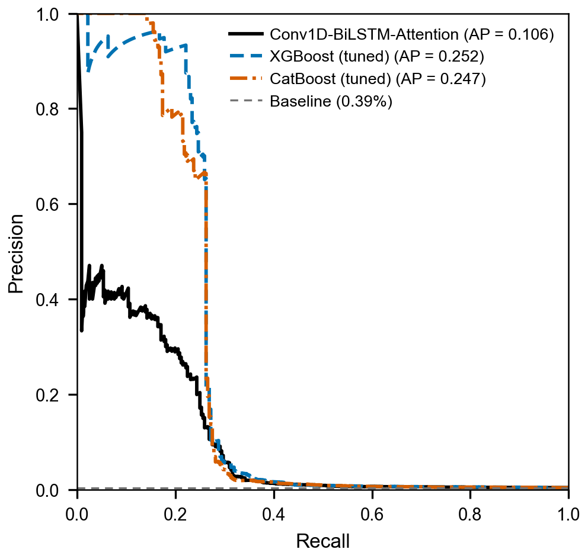
Fig. 1. Precision–recall curves of the three models, computed on the pooled out-of-fold predictions over the five cross-validation test folds (n = 80,883; 316 positive samples). AP denotes average precision (PR-AUC), and the horizontal dashed line indicates the prevalence of nonconforming records (0.39%), the precision expected under random flagging.

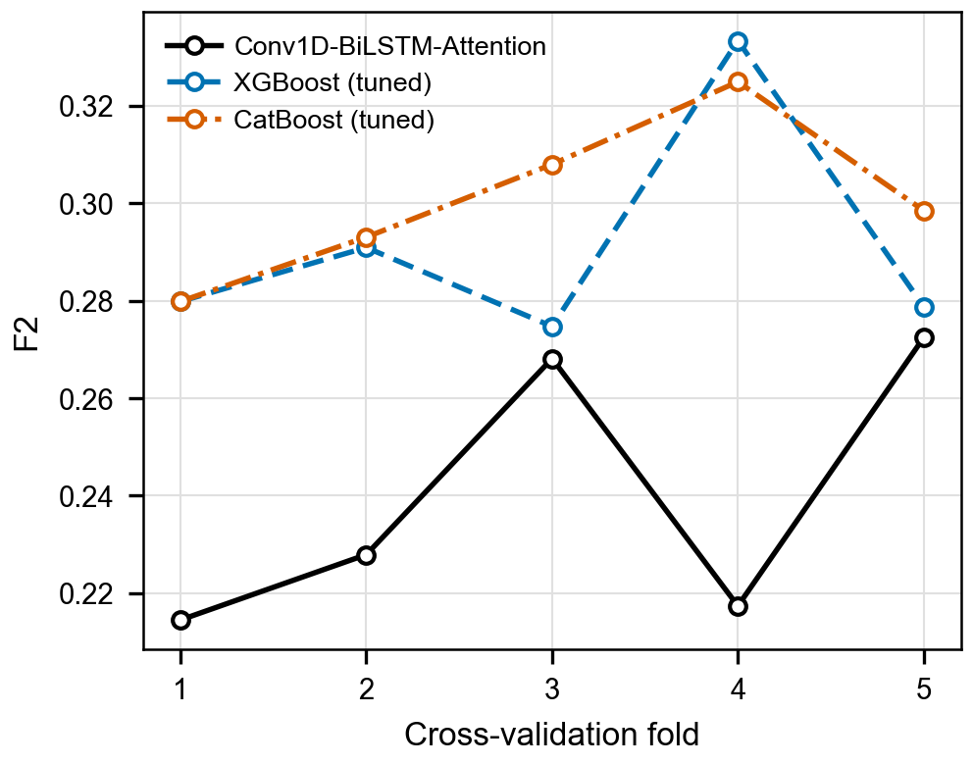
Fig. 2. Fold-wise F2-scores of the three models across the five cross-validation folds. Each tuned boosting model achieved a higher F2-score than the deep learning model in all five folds.

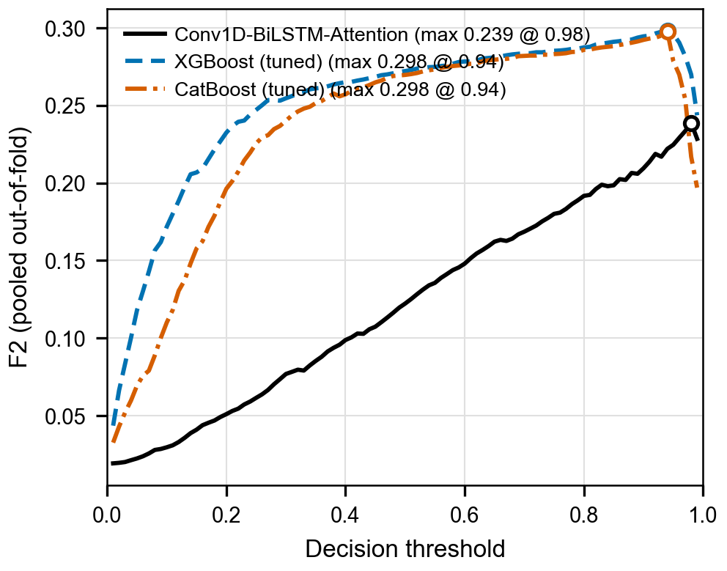
Fig. 3. Pooled F2-score as a function of the decision threshold (0.01–0.99) for the three models. Markers indicate the maximum of each curve: 0.239 at a threshold of 0.98 for the deep learning model, and 0.298 at a threshold of 0.94 for both XGBoost and CatBoost.

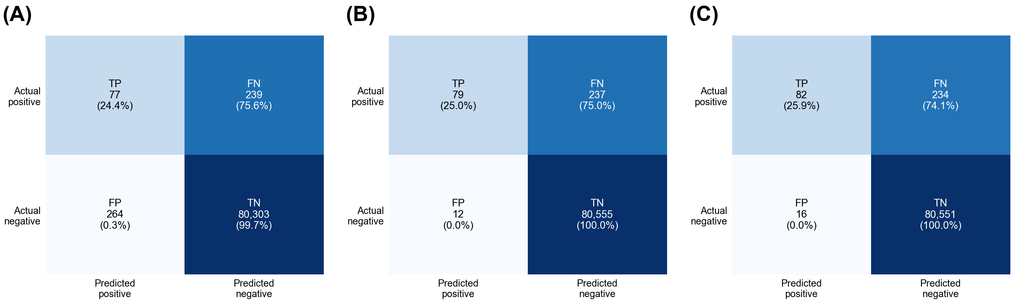
Fig. 4. Confusion matrices pooled over the five cross-validation test folds (n = 80,883; 316 positive samples) at the validation-selected operating points: (A) deep learning model, (B) tuned XGBoost, and (C) tuned CatBoost. Percentages are row-normalized within each actual class.

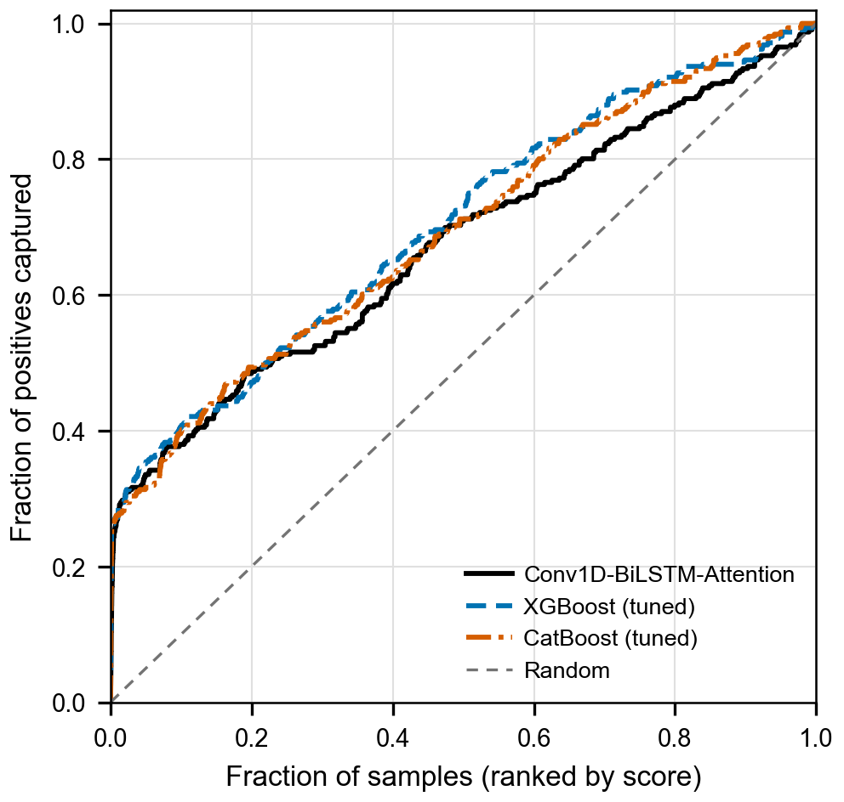
Fig. 5. Cumulative capture curves of the three models. Records were ranked in descending order of predicted probability using the pooled out-of-fold scores, and each curve shows the proportion of the 316 nonconforming records captured within the top-ranked fraction of records. The dashed diagonal indicates random selection.

