Carmen Municipal College
A.Y. 2014-2025

CC103 – Computer Programming 2
Midterm Project

Farm Business Management System
Nehemiah G Balaba
Nico Angelo Jepp J Jamisola

Introduction:

Project Title: Farm Business Management System

Introduction: This project is a simple farm management system implemented in C. It allows users to input data about crops, livestock, and expenses, and then generates a summary report showing total revenue, expenses, and net profit. This project was completed by [Groupmate 1 Name], [Groupmate 2 Name], and [Groupmate 3 Name].

II. Function Description:

The system includes the following functions:
- addCrop() : Adds details of a crop (name, quantity, price per kg).
- Inputs: Crop name (string), quantity (integer), price per kg (float).
- Output: None (updates internal data structure).
- addLivestock() : Adds details of livestock (type, count).
- Inputs: Livestock type (string), count (integer).
- Output: None (updates internal data structure).
- addExpense() : Adds details of an expense (description, amount).
- Inputs: Expense description (string), amount (float).
- Output: None (updates internal data structure).
- displayFarmData() : Displays a summary of all entered data, including total revenue, expenses, and net profit.
- Inputs: None (uses internal data structures).
- Output: Prints a summary report to the console.

III. Code Implementation
(This section would contain the C code, similar to the example provided earlier, but tailored to the specific requirements of the project.)

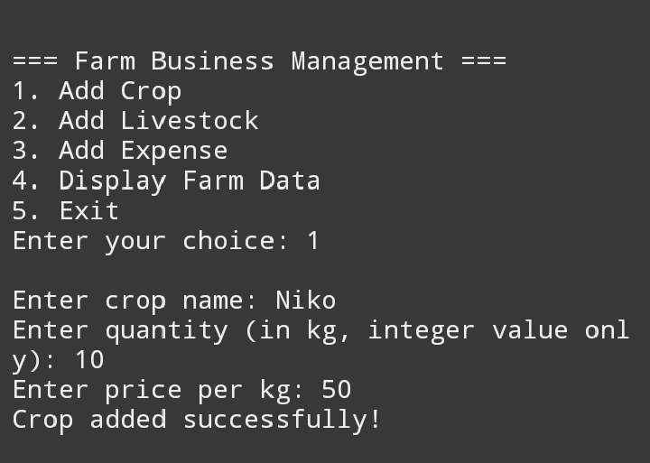
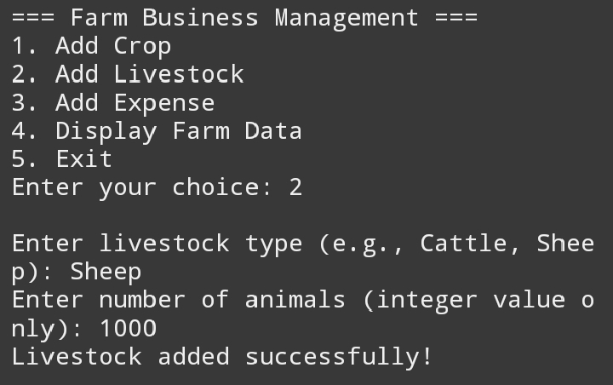
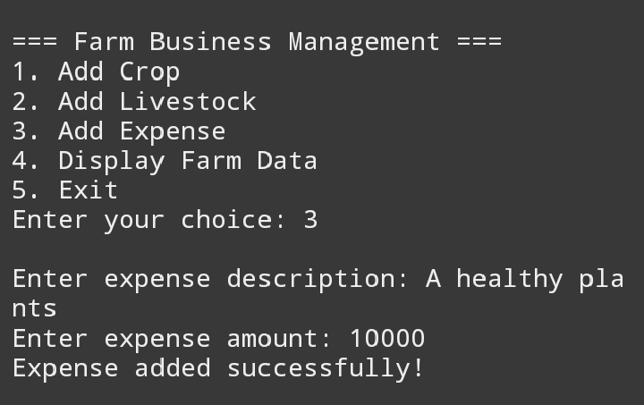

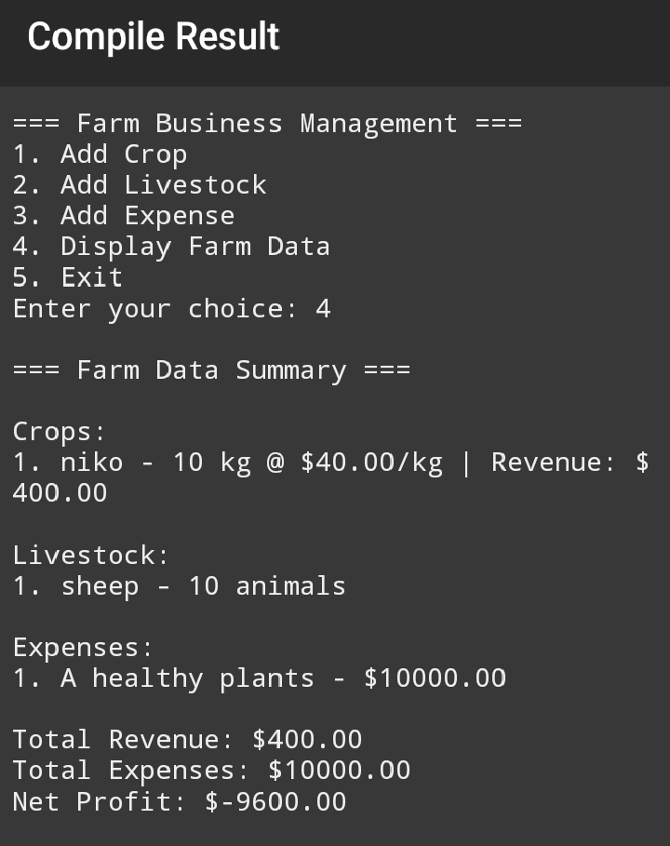

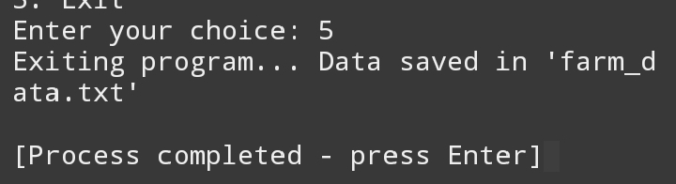
Coding
#include <stdio.h>
#include <stdlib.h>
#include <string.h>
#include <math.h> //Needed for sqrt()

#define MAX_ENTRIES 100 // Maximum number of records

// Efficient primality test
int isPrime(int n) {
if (n <= 1) return 0;
if (n <= 3) return 1;
if (n % 2 == 0 || n % 3 == 0) return 0;
for (int i = 5; i * i <= n; i += 6) {
if (n % i == 0 || n % (i + 2) == 0) return 0;
}
return 1;
}

// Structure to store crop details
struct Crop {
char name[50];
int quantity;
float price;
};

// Structure to store livestock details
struct Livestock {
char type[50];
int count;
};

// Structure to store farm expenses
struct Expense {
char description[100];
float amount;
};

// Using dynamic memory allocation for scalability
struct Crop* crops = NULL;
struct Livestock* livestock = NULL;
struct Expense* expenses = NULL;
int cropCount = 0, livestockCount = 0, expenseCount = 0;
int max_entries = MAX_ENTRIES; //Keep track of the maximum number of entries

// Function to dynamically allocate memory for data structures.
void allocateMemory(){
crops = (struct Crop*)malloc(max_entries * sizeof(struct Crop));
livestock = (struct Livestock*)malloc(max_entries * sizeof(struct Livestock));
expenses = (struct Expense*)malloc(max_entries * sizeof(struct Expense));
if(crops == NULL || livestock == NULL || expenses == NULL){
fprintf(stderr, "Memory allocation failed!\n");
exit(1);
}
}

// Function to add crop details
void addCrop() {
if (cropCount >= max_entries) {
max_entries *= 2; //Double the memory allocation if needed.
crops = (struct Crop*)realloc(crops, max_entries * sizeof(struct Crop));
if(crops == NULL){
fprintf(stderr, "Memory reallocation failed!\n");
exit(1);
}
}

printf("\nEnter crop name: ");
scanf(" %[^\n]", crops[cropCount].name); //Note the space before %[^\n] to consume any leftover newline

while (1) {
printf("Enter quantity (in kg, integer value only): ");
if (scanf("%d", &crops[cropCount].quantity) == 1 && crops[cropCount].quantity >= 0) {
break;
} else {
printf("Invalid input. Please enter a non-negative integer.\n");
while (getchar() != '\n'); //Clear the input buffer
}
}

while (1) {
printf("Enter price per kg: ");
if (scanf("%f", &crops[cropCount].price) == 1 && crops[cropCount].price >= 0) {
break;
} else {
printf("Invalid input. Please enter a non-negative number.\n");
while (getchar() != '\n'); //Clear the input buffer
}
}

FILE *file = fopen("farm_data.txt", "a");
if (file) {
fprintf(file, "Crop: %s, Quantity: %d kg, Price: $%.2f\n", crops[cropCount].name, crops[cropCount].quantity, crops[cropCount].price);
fclose(file);
} else {
fprintf(stderr, "Error opening file!\n");
}

cropCount++;
printf("Crop added successfully!\n");
}

//Similar improvements are needed for addLivestock and addExpense. These functions will be updated accordingly.

void addLivestock() {
if (livestockCount >= max_entries) {
max_entries *= 2;
livestock = (struct Livestock*)realloc(livestock, max_entries * sizeof(struct Livestock));
if(livestock == NULL){
fprintf(stderr, "Memory reallocation failed!\n");
exit(1);
}
}

printf("\nEnter livestock type (e.g., Cattle, Sheep): ");
scanf(" %[^\n]", livestock[livestockCount].type);

while (1) {
printf("Enter number of animals (integer value only): ");
if (scanf("%d", &livestock[livestockCount].count) == 1 && livestock[livestockCount].count >= 0) {
break;
} else {
printf("Invalid input. Please enter a non-negative integer.\n");
while (getchar() != '\n');
}
}

FILE *file = fopen("farm_data.txt", "a");
if (file) {
fprintf(file, "Livestock: %s, Count: %d\n", livestock[livestockCount].type, livestock[livestockCount].count);
fclose(file);
} else {
fprintf(stderr, "Error opening file!\n");
}

livestockCount++;
printf("Livestock added successfully!\n");
}

void addExpense() {
if (expenseCount >= max_entries) {
max_entries *= 2;
expenses = (struct Expense*)realloc(expenses, max_entries * sizeof(struct Expense));
if(expenses == NULL){
fprintf(stderr, "Memory reallocation failed!\n");
exit(1);
}
}

printf("\nEnter expense description: ");
scanf(" %[^\n]", expenses[expenseCount].description);

while (1) {
printf("Enter expense amount: ");
if (scanf("%f", &expenses[expenseCount].amount) == 1 && expenses[expenseCount].amount >= 0) {
break;
} else {
printf("Invalid input. Please enter a non-negative number.\n");
while (getchar() != '\n');
}
}

FILE *file = fopen("farm_data.txt", "a");
if (file) {
fprintf(file, "Expense: %s, Amount: $%.2f\n", expenses[expenseCount].description, expenses[expenseCount].amount);
fclose(file);
} else {
fprintf(stderr, "Error opening file!\n");
}

expenseCount++;
printf("Expense added successfully!\n");
}

// Function to display all farm data
void displayFarmData() {
float totalRevenue = 0, totalExpenses = 0;

printf("\n=== Farm Data Summary ===\n");

// Display crops
printf("\nCrops:\n");
for (int i = 0; i < cropCount; i++) {
float revenue = crops[i].quantity * crops[i].price;
totalRevenue += revenue;
printf("%d. %s - %d kg @ $%.2f/kg | Revenue: $%.2f\n", i + 1, crops[i].name, crops[i].quantity, crops[i].price, revenue);
}

// Display livestock
printf("\nLivestock:\n");
for (int i = 0; i < livestockCount; i++) {
printf("%d. %s - %d animals\n", i + 1, livestock[i].type, livestock[i].count);
}

// Display expenses
printf("\nExpenses:\n");
for (int i = 0; i < expenseCount; i++) {
totalExpenses += expenses[i].amount;
printf("%d. %s - $%.2f\n", i + 1, expenses[i].description, expenses[i].amount);
}

// Net profit calculation
float netProfit = totalRevenue - totalExpenses;
printf("\nTotal Revenue: $%.2f", totalRevenue);
printf("\nTotal Expenses: $%.2f", totalExpenses);
printf("\nNet Profit: $%.2f\n", netProfit);
}

// Main menu function
int main() {
int choice;
allocateMemory(); //Allocate memory at the beginning of the program.

while (1) {
printf("\n=== Farm Business Management ===\n");
printf("1. Add Crop\n");
printf("2. Add Livestock\n");
printf("3. Add Expense\n");
printf("4. Display Farm Data\n");
printf("5. Exit\n");
printf("Enter your choice: ");
scanf("%d", &choice);

switch (choice) {
case 1:
addCrop();
break;
case 2:
addLivestock();
break;
case 3:
addExpense();
break;
case 4:
displayFarmData();
break;
case 5:
printf("Exiting program... Data saved in 'farm_data.txt'\n");
free(crops);
free(livestock);
free(expenses); //Free the dynamically allocated memory before exiting
return 0;
default:
printf("Invalid choice! Please enter again.\n");
}
}
return 0;
}

