**Midterm Project Instructions: Create a System in Pairs**  
Design a simple, functional system in C using if-else, switch, loops, and functions.

1. **Choose a System based on your preference.** Think about a system or application that you would like to build. It could be related to something you’re passionate about, such as gaming, finance, education, or productivity. Here are some ideas to inspire you: Number Guessing Game, Quiz, Banking System, Grade Calculator, etc.
2. **Include Key Features:**
   * **User Interaction:** Use if-else or switch for menus.
   * **Loops:** Use for, while, or do-while for repetition.
   * **Functions:** Break code into functions for input, calculations, and output.
3. **Write an Introduction**: Briefly describe your system’s purpose and functionality.
4. **Describe Functions**: Explain each function’s purpose, inputs, and outputs.
5. **Implement Code**: Provide clean, well-commented C code.
6. **Explain How It Works**: Summarize the system’s workflow step-by-step.
7. **Show Sample Outputs**: Include examples of user interaction and program results.

**Deadline & Project Interview:** After Midterm Exam

Build something cool using **if-else, switch, loops, and functions**! Good luck!

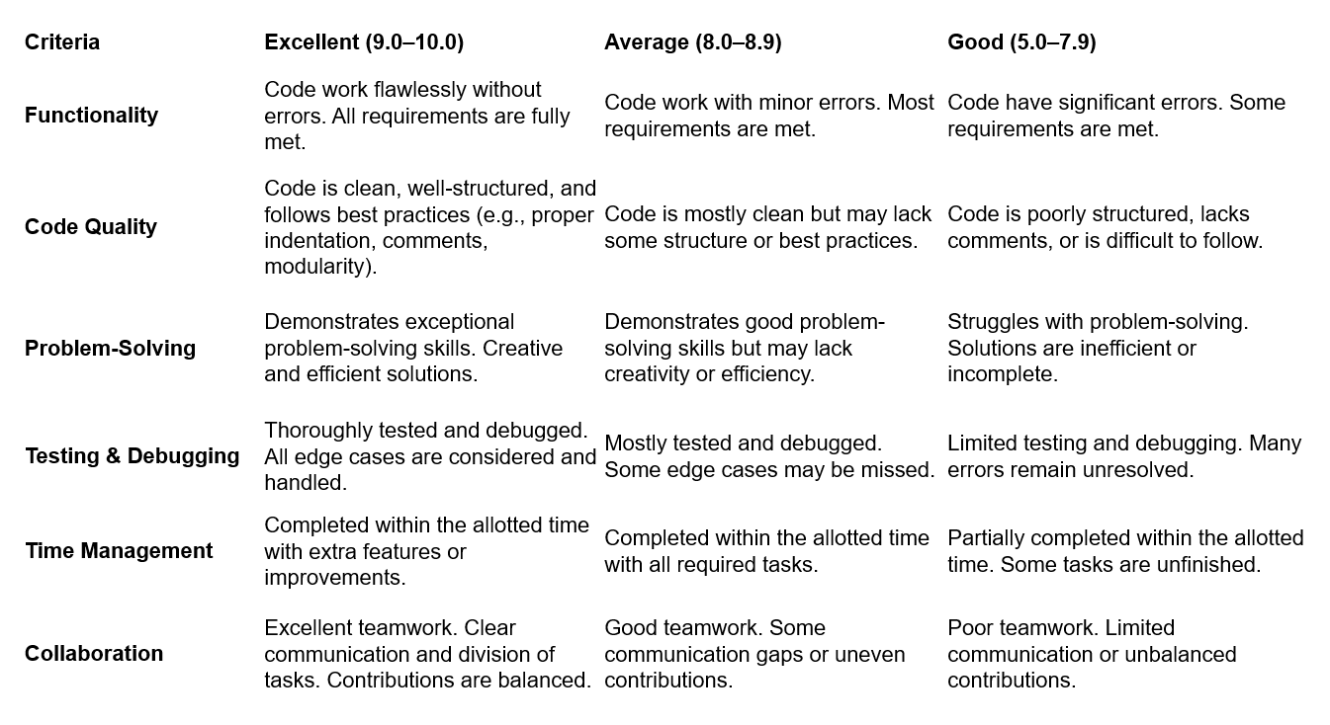

Carmen Municipal College

A.Y. 2014-2025

**Title Here**

CC103 – Computer Programming 2

Midterm Project

LASTNAME, FIRSTNAME

LASTNAME, FIRSTNAME

1. **Introduction**

This project is a basic banking system that allows users to perform common banking operations such as depositing money, withdrawing money, and checking their account balance. The program uses functions to modularize the code and loops to allow the user to perform multiple operations until they choose to exit.

1. **Function Descriptions**

* **void displayMenu():** Displays the main menu with options for the user.
* **void deposit(float balance):** Adds the deposited amount to the account balance.
* **void withdraw(float balance):** Deducts the withdrawn amount from the account balance (if sufficient funds are available).
* **void checkBalance(float balance):** Displays the current account balance.
* **int main():** The main function that drives the program, using a loop to repeatedly display the menu and handle user input.

1. **Code Implementation**

#include <stdio.h>

float balance = 0.0;

void displayMenu() {

printf("\n--- Banking System Menu ---\n");

printf("1. Deposit\n");

printf("2. Withdraw\n");

printf("3. Check Balance\n");

printf("4. Exit\n");

printf("Enter your choice: ");

}

float deposit(float currentBalance) {

float amount;

printf("Enter amount to deposit: ");

scanf("%f", &amount);

if (amount > 0) {

currentBalance += amount;

printf("Deposit successful. New balance: %.2f\n", currentBalance);

} else {

printf("Invalid amount. Deposit failed.\n");

}

return currentBalance;

}

float withdraw(float currentBalance) {

float amount;

printf("Enter amount to withdraw: ");

scanf("%f", &amount);

if (amount > 0 && amount <= currentBalance) {

currentBalance -= amount;

printf("Withdrawal successful. New balance: %.2f\n", currentBalance);

} else {

printf("Invalid amount or insufficient balance. Withdrawal failed.\n");

}

return currentBalance;

}

void checkBalance(float currentBalance) {

printf("Your current balance is: %.2f\n", currentBalance);

}

int main() {

float balance = 0.0;

int choice;

int running = 1;

while (running) {

displayMenu();

scanf("%d", &choice);

switch (choice) {

case 1:

balance = deposit(balance);

break;

case 2:

balance = withdraw(balance);

break;

case 3:

checkBalance(balance);

break;

case 4:

printf("Exiting the banking system. Thank you!\n");

running = 0;

break;

default:

printf("Invalid choice. Please try again.\n");

}

}

return 0;

}

1. **How it works**
2. The program starts with an initial balance of 0.0.
3. The **displayMenu()** function shows the available options.
4. The user selects an option:
   * **Deposit**: Adds money to the balance.
   * **Withdraw**: Deducts money from the balance (if sufficient funds are available).
   * **Check Balance**: Displays the current balance.
   * **Exit**: Terminates the program.
5. The program uses a while loop to keep running until the user chooses to exit.
6. **Sample Output**



