Carmen Municipal College

A.Y. 2014-2025

**Science Quiz Game**

CC103 – Computer Programming 2

Midterm Project

EGAGAMAO, HAZEL JANE

ESPINA, WEND

1. **Introduction**

This program is a Science Quiz Game written in C. It presents multiple-choice science questions to the user and evaluates their responses. The game provides real-time feedback on whether the user’s answers are correct and gives a final score with personalized feedback. The user can choose to start the quiz or exit the game from a menu.

1. **Function Descriptions**

The program consists of the following key functions:

* **displayMenu() –** Displays the main menu options.
* **checkAnswer(char correctAnswer, char userAnswer, int *score)** – Compares the user’s response with the correct answer and updates the score.
* **displayFeedback(int score, int totalQuestions)** – Gives feedback based on the final score.
* **startQuiz()** – Runs the quiz, asking five science-related questions.
* **Main()** – Manages the game loop, allowing the user to start the quiz or exit.

1. **Code Implementation**

#include <stdio.h>

Void displayMenu() {

Printf(“\n--- Science Quiz Game ---\n”);

Printf(“1. Start Quiz\n”);

Printf(“2. Exit\n”);

Printf(“Enter your choice: “);

}

Void checkAnswer(char correctAnswer, char userAnswer, int *score) {

If (userAnswer == correctAnswer) {

Printf(“Correct!\n”);

(*score)++;

} else {

Printf(“Wrong! The correct answer is %c.\n”, correctAnswer);

}

}

Void displayFeedback(int score, int totalQuestions) {

Printf(“\nFinal Score: %d/%d\n”, score, totalQuestions);

If (score == totalQuestions) {

Printf(“Excellent! You got all answers right!\n”);

} else if (score >= totalQuestions / 2) {

Printf(“Good job! Keep improving.\n”);

} else {

Printf(“Better luck next time!\n”);

}

}

Void startQuiz() {

Int score = 0;

Char userAnswer;

Int totalQuestions = 5;

Printf(“\n--- Science Quiz Begins! ---\n”);

For (int I = 1; I <= totalQuestions; i++) {

Switch (i) {

Case 1:

Printf(“\nWhich planet is the largest in the solar system?\n”);

Printf(“A. Mars\nB. Earth\nC. Jupiter\nD. Venus\n”);

Printf(“Enter your answer (A/B/C/D): “);

Scanf(“ %c”, &userAnswer);

checkAnswer(‘C’, userAnswer, &score);

break;

case 2:

printf(“\nWhat is the chemical symbol for water?\n”);

printf(“A. H2O\nB. CO2\nC. O2\nD. HCl\n”);

printf(“Enter your answer (A/B/C/D): “);

scanf(“ %c”, &userAnswer);

checkAnswer(‘A’, userAnswer, &score);

break;

case 3:

printf(“\nWho developed the theory of relativity?\n”);

printf(“A. Newton\nB. Einstein\nC. Galileo\nD. Tesla\n”);

printf(“Enter your answer (A/B/C/D): “);

scanf(“ %c”, &userAnswer);

checkAnswer(‘B’, userAnswer, &score);

break;

case 4:

printf(“\nWhat gas do plants primarily use for photosynthesis?\n”);

printf(“A. Oxygen\nB. Carbon Dioxide\nC. Nitrogen\nD. Hydrogen\n”);

printf(“Enter your answer (A/B/C/D): “);

scanf(“ %c”, &userAnswer);

checkAnswer(‘B’, userAnswer, &score);

break;

case 5:

printf(“\nWhat is the hardest natural substance on Earth?\n”);

printf(“A. Gold\nB. Iron\nC. Diamond\nD. Quartz\n”);

printf(“Enter your answer (A/B/C/D): “);

scanf(“ %c”, &userAnswer);

checkAnswer(‘C’, userAnswer, &score);

break;

}

}

displayFeedback(score, totalQuestions);

}

Int main() {

Int choice;

While (1) {

displayMenu();

scanf(“%d”, &choice);

switch (choice) {

case 1:

startQuiz();

break;

case 2:

printf(“Exiting the game. Goodbye!\n”);

return 0;

default:

printf(“Invalid choice! Please enter 1 or 2.\n”);

}

}

Return 0;

}

1. **How It Works**
2. Displays the Menu

The user is presented with two options:

* 1 → Start the quiz
* 2 → Exit the game

1. Starting the Quiz

* The startQuiz() function runs the quiz, displaying five questions.
* Each question is handled using a switch statement inside a for loop.
* The user’s input is collected using scanf() and compared with the correct answer in checkAnswer().

1. Scoring and Feedback

* Each correct answer increases the score.
* At the end, displayFeedback() gives performance feedback.

1. Game Loop

* After completing the quiz, the menu reappears, allowing the user to play again or exit.

1. 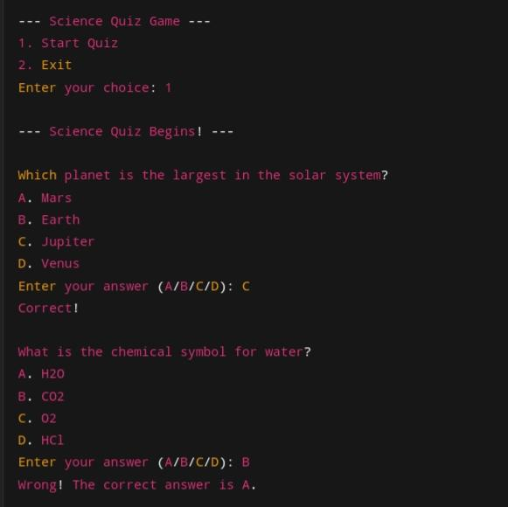**Sample Output**

