Carmen Municipal College

A.Y. 2014-2025

**Ceres Bus Ticketing System in C**

CC103 – Computer Programming 2

Midterm Project

PETITO, ANGEL ANN

BAROY, MHELROSE JANE S.

1. **Introduction**

The Ceres Bus Ticketing System is a simple C program designed to calculate bus fares for passengers traveling from Tagbilaran to various destinations in Bohol. It allows users to select their destination, specify their passenger type (Regular, Senior Citizen, and Student or SP), and process payments accordingly. The system automatically applies discounts for eligible passengers and provides a detailed receipt for each transaction.

1. **Function Description** 
   1. Display Destinations()

Displays the list of available destinations along with their distances from Tagbilaran.

Provides an option to exit the system.

* 1. Get Fare(int distance, int type)

Calculates the fare based on the distance traveled.

Applies discounts for Senior Citizens (-20%) and Students (-15%).

* 1. Display Receipt(int destination, int type, float fare, float payment, float change)

Generates a ticket receipt showing the selected destination, passenger type, fare, payment amount, and change.

* 1. Process Ticket()

Handles user input for destination selection and passenger type.

Ensures valid input and checks if the payment is sufficient.

Calls the appropriate functions to calculate the fare and display the receipt.

1. **Code Implementation**

#include <stdio.h>

#include <string.h>

#define BASE_FARE_PER_KM 2.5 // Fare per km for regular passengers(form tagbilaran)

Struct Stop {

Char name[20];

Int distance;

};

// List of place to go (from Tagbilaran)

Struct Stop stops[] = {

{“Tagbilaran”, 0}, {“Dauis”, 5}, {“Panglao”, 18}, {“Baclayon”, 7}, {“Alburquerque”, 14},

{“Loay”, 21}, {“Loboc”, 29}, {“Bilar”, 42}, {“Carmen”, 59}, {“Batuan”, 72},

{“sierra bullones”, 85}, {“Pilar”, 97}, {“Alicia”, 110}, {“Ubay”, 125}

};

Int totalStops = sizeof(stops) / sizeof(stops[0]);

Void displayDestinations() {

Printf(“\n==== Ceres Bus Ticketing====\n”);

Printf(“Asa ni Ma’am/Sir:\n”);

For (int I = 1; I < totalStops; i++) {

Printf(“%d. %s (%d km)\n”, I, stops[i].name, stops[i].distance);

}

Printf(“0. Exit\n”);

}

Float getFare(int distance, int type) {

Float fare = distance * BASE_FARE_PER_KM;

If (type == 2) fare *= 0.80; // Senior – 20% discount

Else if (type == 3) fare *= 0.90; // Student (SP) – 15% discount

Return fare;

}

Void displayReceipt(int destination, int type, float fare, float payment, float change) {

Printf(“\n=== Ticket Receipt ===\n”);

Printf(“Destination: %s\n”, stops[destination].name);

Printf(“Passenger Type: %s\n”, (type == 1) ? “Regular” : (type == 2) ? “Senior Citizen” : “Student (SP)”);

Printf(“Fare: ₱%.2f\n”, fare);

Printf(“Payment: ₱%.2f\n”, payment);

Printf(“Change: ₱%.2f\n”, change);

Printf(“Okay sunod Wana kinsay walay ticket diraa,if naana tanan type 0 to exit!\n”);

}

Void processTicket() {

Int destination, type;

Float fare, payment, change;

While (1) {

displayDestinations();

printf(“Enter choice: “);

scanf(“%d”, &destination);

if (destination == 0) {

printf(“Thank you sa pag sakay sa Ceres !\n”);

break;

}

If (destination < 1 || destination >= totalStops) {

Printf(“Invalid destination. Try again.\n”);

Continue;

}

Printf(“\nUnsa ni Sir/Ma’am type:\n”);

Printf(“1. Regular\n2. Senior Citizen (20%% discount)\n3. Student (SP – 15%% discount)\n”);

Printf(“Enter type (1-3): “);

Scanf(“%d”, &type);

If (type < 1 || type > 3) {

Printf(“Invalid type! Try again.\n”);

Continue;

}

Fare = getFare(stops[destination].distance, type);

Printf(“\nTotal Fare to %s: ₱%.2f\n”, stops[destination].name, fare);

While (1) {

Printf(“Enter payment amount: ₱”);

Scanf(“%f”, &payment);

If (payment < fare) {

Printf(“Insufficient payment! Try again.\n”);

} else {

Change = payment – fare;

display Receipt(destination, type, fare, payment, change);

break;

}

}

}

}

Int main() {

process Ticket();

return 0;

}

1. **How it’s Work**
   1. The program starts and calls process Ticket(), prompting the user to select a destination from the list.
   2. The user enters their choice, and the program verifies if it’s a valid destination.
   3. The program asks the user to select a passenger type:

Regular (Full Fare)

Senior Citizen (20% Discount)

Student (SP) (15% Discount)

* 1. The system calculates the fare using the get Fare() function.
  2. The user is prompted to enter the payment amount. If the payment is insufficient, they must enter a valid amount.
  3. Once a valid payment is received, the system calculates the change and displays a ticket receipt using display Receipt().

7.The process repeats until the user enters 0 to exit.

1. **Sample Output**

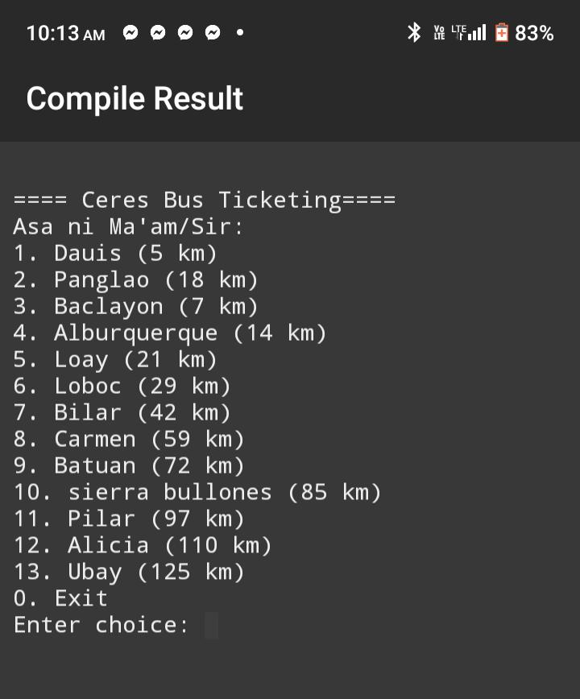

**Other Sample**

