Carmen Municipal College

A.Y. 2024-2025

GLOW HAVEN SKINCARE INVENTORY SYSTEM

CC105- INFORMATION MANAGEMENT

Midterm Project

DAG-UM, SARANNE ASHLEY A.

ORTEGA, JEREMY P.

1. **Introduction**

Managing a skincare business requires an organized system to track product inventory, supplier details, and customer orders. This database will allow Glow Haven Skincare to store product details, monitor stock levels, track supplier information, and manage customer orders. By implementing this system, the business can reduce errors, improve efficiency, and ensure better inventory control.

1. **Entity Relationship Diagram**

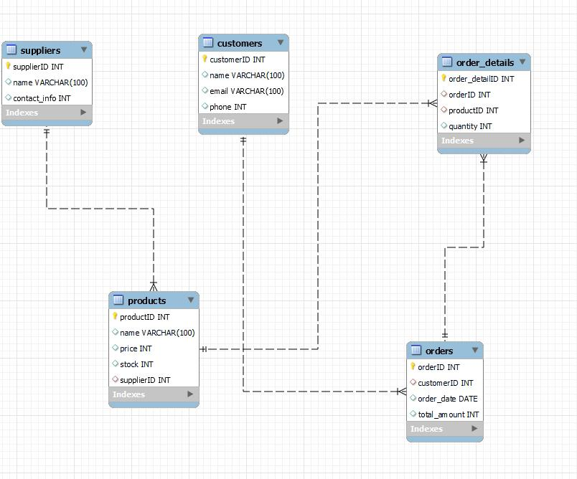

1. **Database**

Table Name : **Products**

This table stores details about skincare products.

|  |  |  |
| --- | --- | --- |
| Fieldname | Type(Size) | Descriptions |
| productID | INT | Unique identifier for the product |
| name | Varchar(100) | Name of the skincare product |
| price | int | Price of the product |
| stock | int | Quantity available |
| supplierID | int | Supplier of the product (Foreign Key) |

Table Name: **Suppliers**

This table links to products and provides supplier contact information.

|  |  |  |
| --- | --- | --- |
| Fieldname | Type(Size) | Descriptions |
| supplierID | int | Unique identifier for the supplier |
| name | Varchar(100) | Supplier’s name |
| contactinfo | int | Contact details of the supplier |

Table Name: **Customers**

This table contains customer details for orders.

|  |  |  |
| --- | --- | --- |
| Fieldname | Type(size) | Descriptions |
| customerID | int | Unique identifier for the customer |
| name | varchar (100) | Customer’s name |
| email | Varchar(100) | Customer’s email |
| phone | int | Customer’s phone number |

Table Name: **Orders**

This table stores order details, linked to customers.

|  |  |  |
| --- | --- | --- |
| Fieldname | Type(size) | Descriptions |
| orderID | int | Unique identifier for the order |
| customerID | int | Customer who placed the order (Foreign Key) |
| order_date | date | Date when the order was placed |
| total_amount | int | Total cost of the order |

Table Name: **Order Details**

This table manages the products included in each order.

|  |  |  |
| --- | --- | --- |
| Fieldname | Type(size) | Descriptions |
| order_detaiID | int | Unique identifier for order details |
| orderID | int | Related order (Foreign Key) |
| productID | int | Product in the order (Foreign Key) |
| quantity | int | Quantity ordered |

1. **Functionalities**

**Creating table**: This code shows the creation of the tables.

CREATE TABLE suppliers (

supplierID INT PRIMARY KEY AUTO_INCREMENT,

name VARCHAR(100),

contactInfo VARCHAR int

) ENGINE = InnoDB;

CREATE TABLE products (

productID INT PRIMARY KEY AUTO_INCREMENT,

name VARCHAR(100),

price int,

stock int,

supplierID int,

foreign key (supplierID) references suppliers(supplierID)

) ENGINE = InnoDB;

CREATE TABLE customers (

customerID INT PRIMARY KEY AUTO_INCREMENT,

name varchar (100),

Email varchar(100),

Phone int

) ENGINE = InnoDB;

CREATE TABLE orders (

orderID INT PRIMARY KEY AUTO_INCREMENT,

customerID int,

orderdate date ,

total_amount int,

foreign key (customerID) references customers(customerID)

) ENGINE = InnoDB;

CREATE TABLE order_details (

Order_detailID INT PRIMARY KEY AUTO_INCREMENT,

orderID int,

productID int,

quantity int,

foreign key (orderID) references orders(orderID),

foreign key (productID) references products(productID)

) ENGINE = InnoDB;

**Inserting Suppliers Information**: this code represents the supplier’s information input.

INSERT INTO Suppliers (Name, ContactInfo) VALUES

(‘Organic Skin Co.’, ‘organic@example.com’),

(‘PureGlow Inc.’, ‘pureglow@example.com’);

**Inserting Product:** this code represents the product details.

INSERT INTO Products (Name, Price, Stock, SupplierID) VALUES

(‘Glow Serum’, 20.99, 50, 1),

(‘Hydrating Cream’, 15.50, 30, 2);

**Inserting Customers:** this code represents the customer’s information.

INSERT INTO Customers (Name, Email, Phone) VALUES

(‘Alice Johnson’, ‘alice@example.com’, ‘123-456-7890’),

(‘John Doe’, ‘john@example.com’, ‘987-654-3210’);

**Inserting Orders:** this code represents the orders of the customers.

INSERT INTO Orders (CustomerID, OrderDate, TotalAmount) VALUES

(1, ‘2025-03-16’, 36.49),

(2, ‘2025-03-15’, 20.99);

**Inserting Order Details:** this code represents the order details of an order.

INSERT INTO OrderDetails (OrderID, ProductID, Quantity) VALUES

(1, 1, 1),

(2, 2, 1);

**DISPLAYING** :

SELECT * FROM customers;

SELECT * FROM suppliers;

SELECT * FROM products;

SELECT * FROM orders;

SELECT * FROM order_details;