

Carmen Municipal College

A.Y. 2024-2025

**HOTEL RESERVATION**

CC105 – Information Management

Midterm Project

MAGALLANES, JAMMAEL

SARTE, BEATRIZ

1. **Introduction**

The Hotel Reservation database system is designed to streamline the process of managing hotel bookings, customer information, and room availability. This system serves as a comprehensive solution for hotel management, allowing for efficient tracking of reservations, customer details, and hotel properties.

The primary purpose of this database is to facilitate seamless interactions between customers and hotel services, ensuring a smooth booking experience.

1. **Entity Relationship Diagram**

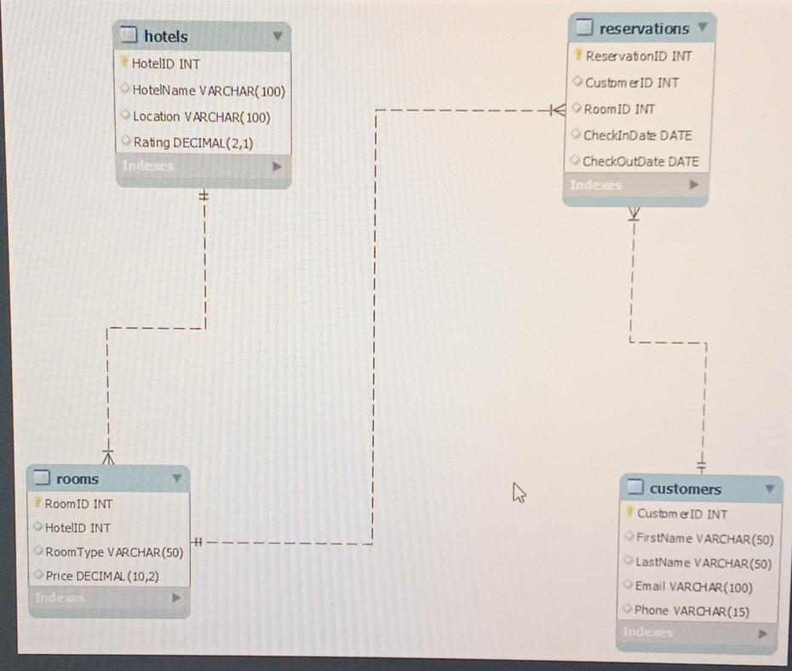

1. **Database**

#### **Table Name: Customers**

This table contains the personal information of the customers.

| Fieldname | Type (size) | Description |
| --- | --- | --- |
| CustomerID | INT AUTO_INCREMENT | Unique identifier for the customer. |
| Firstname | VARCHAR(50) | Customer's first name. |
| Lastname | VARCHAR(50) | Customer's last name. |
| Email | VARCHAR(100) UNIQUE | Customer's email address (Must be unique). |
| Phone | VARCHAR(15) | Customer’s phone number. |

#### **Table Name: Hotels**

This table contains information about hotels.

| Fieldname | Type (size) | Description |
| --- | --- | --- |
| HotelID | INT AUTO_INCREMENT | Unique identifier for the hotel (Primary Key). |
| HotelName | VARCHAR(100) | Name of the hotel |
| Location | VARCHAR(100) | Location of the hotel. |
| Rating | DECIMAL(2,1) | Hotel rating (Range: 1 to 5). |

#### **Table Name: Rooms**

This table contains information about rooms available in hotels.

| Fieldname | Type (size) | Description |
| --- | --- | --- |
| RoomID | INT AUTO_INCREMENT | Unique identifier for the room (Primary Key). |
| HotelID | INT | Identifier for the hotel (Foreign Key: hotels). |
| Room Type | VARCHAR(50) | Type of the room |
| Price | DECIMAL(10,2) | Price of the Room |

#### **Table Name: Reservations**

This table tracks customer reservations for hotel rooms.

| Fieldname | Type (size) | Description |
| --- | --- | --- |
| ReservationID | INT AUTO_INCREMENT | Unique identifier for the reservation(Primary Key). |
| CustomerID | INT | Identifier for the customer (Foreign Key: customers). |
| RoomID | INT | Identifier for the reserved room (Foreign Key: rooms). |
| CheckInDate | DATE | Date of check-in |
| CheckOutDate | DATE | Date of check-out |

1. **Functionalities**

**Creating table:** this code shows the creation of the tables.

CREATE TABLE Customers (

CustomerID INT AUTO_INCREMENT PRIMARY KEY,

FirstName VARCHAR(50),

LastName VARCHAR(50),

Email VARCHAR(100) ,

Phone VARCHAR(15)

) ENGINE = InnoDB;

CREATE TABLE Hotels (

HotelID INT AUTO_INCREMENT PRIMARY KEY,

HotelName VARCHAR(100),

Location VARCHAR(100),

Rating DECIMAL(2,1) CHECK (Rating BETWEEN 1 AND 5)

) ENGINE = InnoDB;

CREATE TABLE Rooms (

RoomID INT AUTO_INCREMENT PRIMARY KEY,

HotelID INT,

RoomType VARCHAR(50),

Price DECIMAL(10,2),

FOREIGN KEY (HotelID) REFERENCES Hotels(HotelID) ON DELETE CASCADE

) ENGINE = InnoDB;

CREATE TABLE Reservations (

ReservationID INT AUTO_INCREMENT PRIMARY KEY,

CustomerID INT,

RoomID INT,

CheckInDate DATE,

CheckOutDate DATE,

FOREIGN KEY (CustomerID) REFERENCES Customers(CustomerID) ON DELETE CASCADE,

FOREIGN KEY (RoomID) REFERENCES Rooms(RoomID) ON DELETE CASCADE

) ENGINE = InnoDB;

**Inserting Customers Information:**

This code represents the customer's information input.

INSERT INTO Customers (FirstName, LastName, Email, Phone)

VALUES ('John', 'Doe', 'john.doe@gmail.com', '1234567890'),

('Jane', 'Smith', 'jane.smith@gmail.com', '0987654321');

**Inserting Hotels:**

This code represents the addition of hotel details.

INSERT INTO Hotels (HotelName, Location, Rating)

VALUES ('Grand Hotel', 'New York', 4.5),

('Beach Resort', 'Miami', 4.0);

**Inserting Rooms:**

This code represents the rooms available in hotels.

INSERT INTO Rooms (HotelID, RoomType, Price)

VALUES (1, 'Deluxe Suite', 250.00),

(1, 'Standard Room', 150.00),

(2, 'Ocean View Room', 200.00);

**Inserting Reservations:**

This code represents customer reservations for hotel rooms.

INSERT INTO Reservations (CustomerID, RoomID, CheckInDate, CheckOutDate)

VALUES (1, 1, '2023-10-01', '2023-10-05'),

(2, 3, '2023-10-10', '2023-10-15');

**Displaying Data:**

This code retrieves filtered information from the database.

SELECT * FROM Customers;

SELECT * FROM Hotels;

SELECT * FROM Rooms;

SELECT * FROM Reservations;

* Retrieve reservation details including customer and hotel information

SELECT r.ReservationID, c.FirstName, c.LastName, h.HotelName, rm.RoomType, r.CheckInDate, r.CheckOutDate

FROM Reservations r

JOIN Customers c ON r.CustomerID = c.CustomerID

JOIN Rooms rm ON r.RoomID = rm.RoomID

JOIN Hotels h ON rm.HotelID = h.HotelID;