**Act Report**

#WeRateDogs



***WeRateDogs* (@dog\_rates) is a Twitter account that rates people's dogs with a humorous comment about the dog. These ratings almost always have a denominator of 10. The numerators, though? Almost always greater than 10. 11/10, 12/10, 13/10, etc. Why? Because "they're good dogs Brent." WeRateDogs has over 4 million followers and has received international media coverage.**

Hmm, above is the main introduction……but maybe you will be curious:

*“which kind of dogs can is popular and have higher rating?”*

Aren’t they alllllllll cute enough?

Fortunately, I’ve done all the data wrangling process (see code [here](https://github.com/cjue25/DA-WeRateDogs)) ! Let’s start the journey to explore the possible reasons and other interesting things!

1. The Best Dogs!

First, let’s have a quick look to see which dog gets the highest favorite, retweet counts, rating and ratio (retweet / favorite) !

|  |  |  |
| --- | --- | --- |
| Highest Retweet = 77943 and Favorite = 156389 | Highest Rating = 14 | Highest Ratio = 0.89 |
| D:\github_cjue25\DA-WeRateDogs\figure\wrangle_act_cell_103_output_5.png | D:\github_cjue25\DA-WeRateDogs\figure\wrangle_act_cell_103_output_1.png | D:\github_cjue25\DA-WeRateDogs\figure\wrangle_act_cell_103_output_13.png |

Note: there are some same rating dogs, I just choose one to show here.

* Yes, you might have guessed, the retweet and favorite counts might have high correlation, that’s why I add the “ratio” variable! But let’s confirm this more seriously.

1. Favorite vs Retweet vs Rating

One can see that favorite and retweet has high positive correlation (R = 0.93). And surely, the high rating is more frequent in the high favorite and retweet (Deep blue color in the Top right region.) (Note: the correlation between ratio and rating is -0.29)

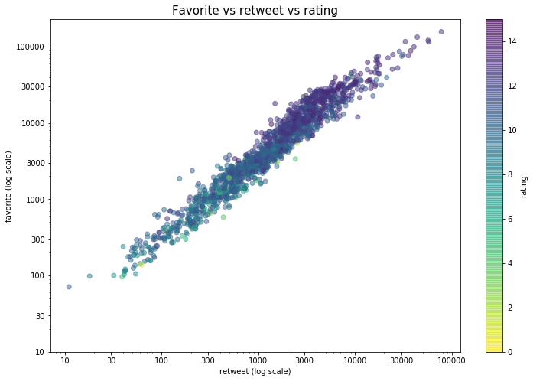

* Don’t worry, it’s just a quick look of our dogs!! At least above is the normal prediction of the human-beings, so that we can trust our data more!

1. Top 10 Dogs

To figure out the properties of the high rating dogs, how about choosing the top 10 dogs? Which means that I take the dogs with >10 rating, and see top 10 breeds in it.

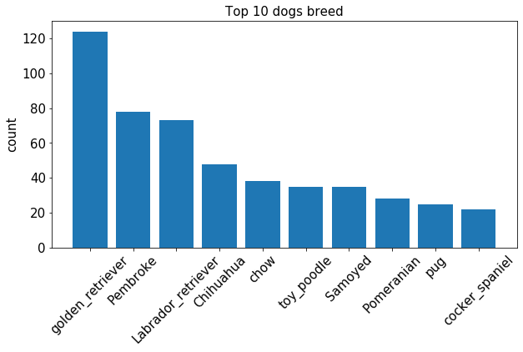

The figure tells us that the **golden retriever**is the maximum!

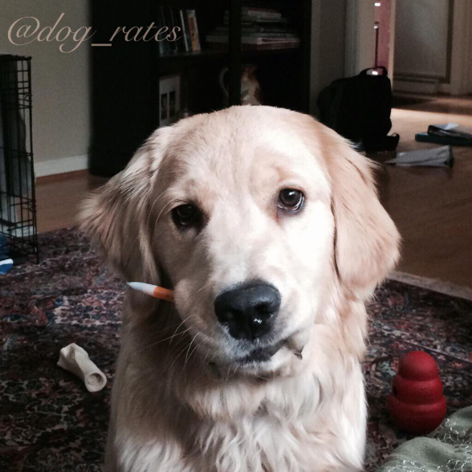

(Golden retriever: “Am I cute?”)

Now, using this breed order, let’s try a comparison.

The first figure shows the favorite, retweet ratio median of the dogs with rating >10.

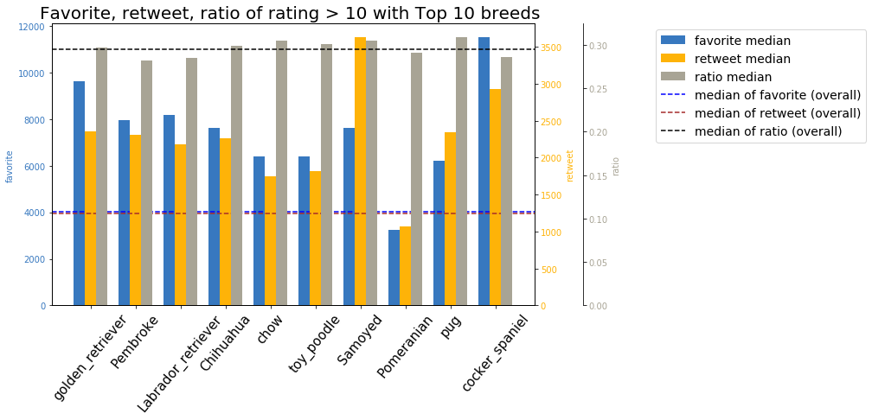

The second figure shows the favorite, retweet ratio median of all the dogs.

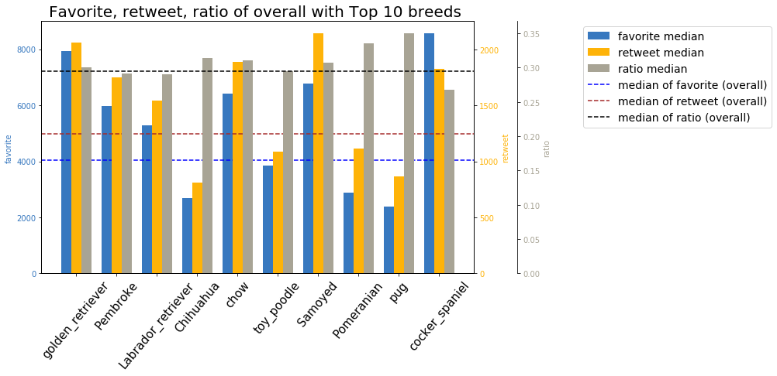

In the first figure, almost all the breeds exceed the median of the three criteria except the **Pomeranian**. We can’t see too many particular properties here.

However, in the second figure, only **golden\_retriever** exceed all the three criteria, which means, if you want to post a dog, **golden\_retriever** is a best choice! You will have high possibility to get larger retweet and favorite. Most people love it!

Furthermore, let’ see the rating.

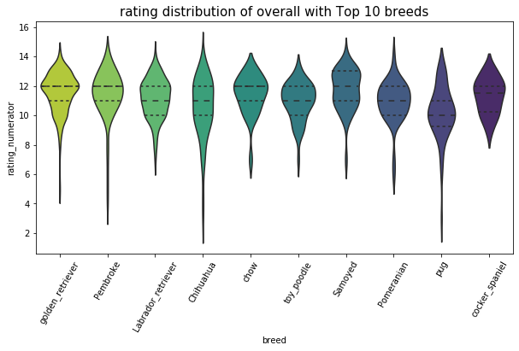

Although the **golden\_retriever** and **Pembroke** have the similar shapes and concentrate on the rating around 12, the former will get more “hearts”. Thus, combining the rating and ratio, we can see that the **golden\_retriever** wins again! It is popular and have higher rating!. (Note: The reason why people like **golden\_retriever** is beyond this scope)

1. Others : Social Interaction

In this part, let’s see the interaction based on the time.

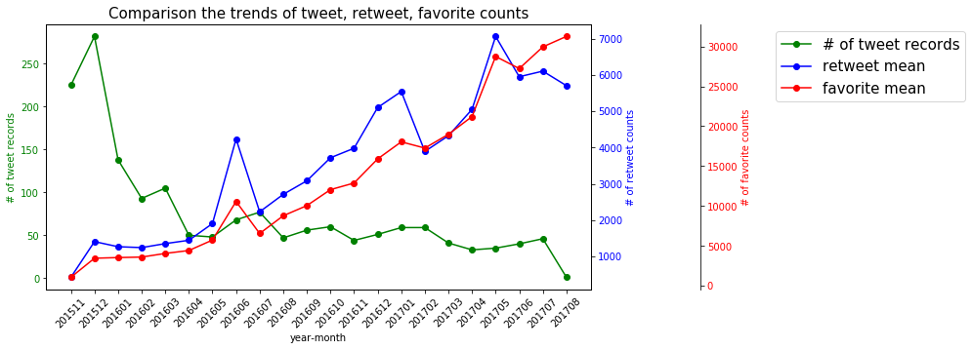

One can see that though the total number of the tweet records decrease, the overall retweet and favorite accounts (mean) increase! This means more and more people attend these post and lovely to interact with the tweeter!

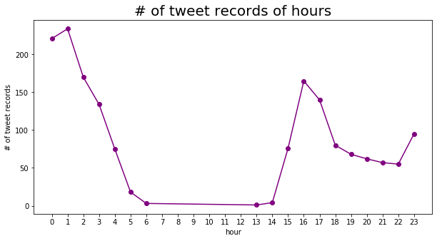

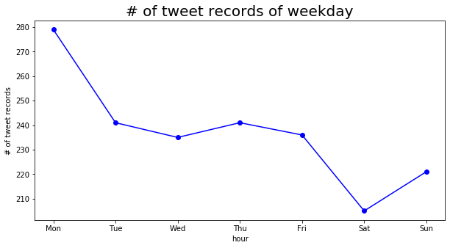

This two figures show interesting behavior of human-beings.

The first one shows that most people loves to post after word (@16) and before sleep (@0~1), and on Monday! The latter might because that people do other longer-time entertainments in the weekend, and update the latest situation on Monday with just a “click and upload” step.