**ODAQ – Expert Listening Test Instructions**

**Introduction**

The purpose of this listening test is to evaluate a broad range of audio processing methods. This is done by comparing multiple stimuli, also known as **conditions**, against a **reference** signal, which is the reference for the perfect quality, as shown by the interface:

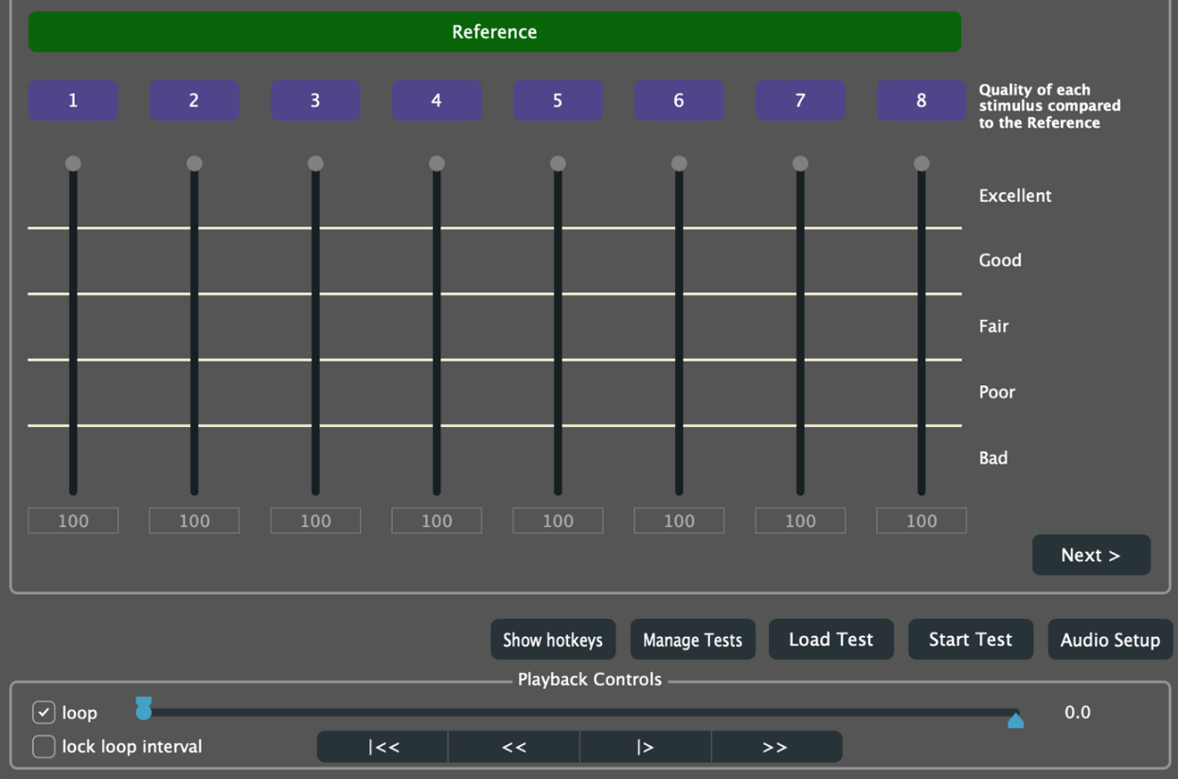

**Overall Sound Quality**

For each condition, your goal is to rate itsoverall sound qualityconsidering any and all detected differences with the reference. The rating is carried out via a continuous scale varying between 0 and 100. Your grades should reflect your subjective judgement of the quality level for the presented sound excerpts. Quality labels (“Excellent,” “Good,” “Fair”…) are provided to interpret the meaning of the numerical values. The reference signal is also present (or “hidden”) among the conditions. Please rate this signal with 100 points.

**Training and Listening Level**

To start with, you are invited to a short training session (“ODAQ_training”). The purpose of this session is to familiarize you with test methodology, user interface, and test conditions. You are invited to pay attention to the proposed training conditions, as they are representative of the audio quality levels that you will encounter later during the actual test. However, we will ignore the scores resulting from this training session, so you do not need to be particularly precise with your ratings during this phase. Also, you can skip the demographic survey for this session. This phase also serves to familiarize with the graphical user interface: please feel very free to ask any question you might have.

A final objective of the training phase is for you to find a **comfortable listening level**: Please adjust the overall reproduction level during this phase, and please do **not** adjust it during the following phase.

**Test Sessions**

The actual test (“ODAQ”) comprises 30 items (or screen). To avoid fatigue, we split it in three sessions, each of 10 items. It should not take longer than one hour of each session to be completed. The interface will tell you when you are done for today. At the beginning of the first session, some demographic questions are displayed. You need to answer these questions only once. However, before each session, we repeat the training session to refresh your mind about what is this all about and to calibrate the overall level to a comfortable level. You can go through the training session quickly if you feel ready to proceed.

**How to Operate the Interface**

The interface program enables to play, pause, or continue the signals by using the corresponding buttons or by pressing the space bar on the keyboard.

By selecting buttons 1 to 8 (you can also use the numbers on your keyboard) and “Reference”, you can switch between the different conditions.

For grading each condition, please move its corresponding slider. This can be done with the mouse or with the arrows ↑ and ↓ on the keyboard. Pressing page up ⇞ and page down ⇟ moves the slider of 20 points. The rating scale is continuous, varying between 0 and 100. Please refer to the quality labels on the right to interpret the meaning of the ratings.

You can set loops to focus on certain parts of the signal by activating the “Loop” button. By pressing the keys “x” and “c” on the keyboard, you can set the beginning and the end of a loop. Alternatively, you can also do this by moving the two cursors with the mouse. You can reset the cursors to the very beginning and end of the signals either with the mouse or by “shift + x” and “shift + c”.

Use the “Next” button at the top left of the screen to listen to the next test set.

A summary of the hotkeys is displayed by clicking on “Show hotkeys.” Press again on the same button to return to your test. A summary is also shown here below:

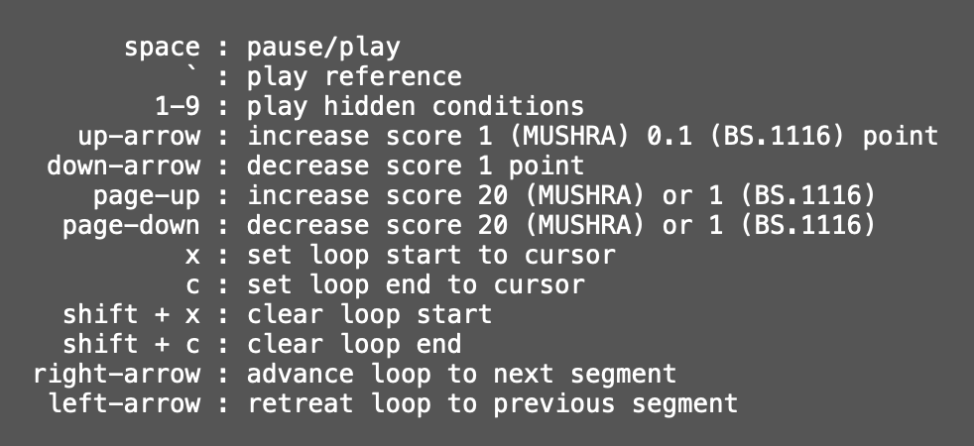

Happy listening and thank you very much for your time ☺