**To be FAIR: Theory Specification Needs an Update**  
Caspar J. Van Lissa, Aaron Peikert, Maximilian S. Ernst, Noah N.N. van Dongen, Felix D. Schönbrodt, & Andreas M. Brandmaier

**Why?**

* Open science has improved hypothesis testing — but **theory development** remains **unaddressed**.
* Psychological theories are often **ambiguous**, **hard to test**, **not cumulatively improved**, and **not incorporated in scientific workflows**

**What is FAIR Theory?**

* **Findable:** Easily located in indexed FAIR-compliant repositories (like Zenodo), with DOI and extensive metadata.
* **Accessible:** Plain-text files, readable by humans and machines, not images in papers locked behind paywalls.
* **Interoperable:** Usable for specific purposes like hypothesis derivation, covariate selection, data simulation, and iterative improvement.
  + Can be interoperable in analysis software (R-package theorytools)
* **Reusable:** Iteratively improvable by the broader community through clear licensing and version control.

**Why Make Theory FAIR?**

* Reduces **research waste**; theories are shared, reused, and improved.
* Enables **meta-research** on structure and evolution of theories.
* Enables **analogical modeling**: applying structure of a theory from one field to problem from another.
* Integrates theory into **reproducible research workflows** (worcs, theorytools).
* Accelerates **cumulative knowledge** acquisition in psychology and beyond.

**How to FAIRify a Theory**

1. **Specify** theory clearly as prose, formula, diagram, or other (formal?) model.
2. **Archive** theory objects in open repositories (e.g., Zenodo) with appropriate metadata.
3. **Version-control** theory development using Git and GitHub.
4. **Use semantic versioning** (MAJOR.MINOR.PATCH) to communicate changes to users.

**Impact**

* Supports **modular publishing**: theory as a standalone, citable artifact.
* Aligns with **open science reforms** and **new research evaluation standards** (e.g., DORA, CoARA).
* Facilitates **team science**, **interdisciplinary work**, and **evidence-based decision-making**.
* Accellerates **theoretically sound research**.

## Downloading and Plotting

[download_theory](https://cjvanlissa.github.io/theorytools/reference/download_theory.html)(<https://doi.org/10.5281/zenodo.14921521>)

[graph_sem](https://cjvanlissa.github.io/tidySEM/reference/graph_sem.html)(tripartite)

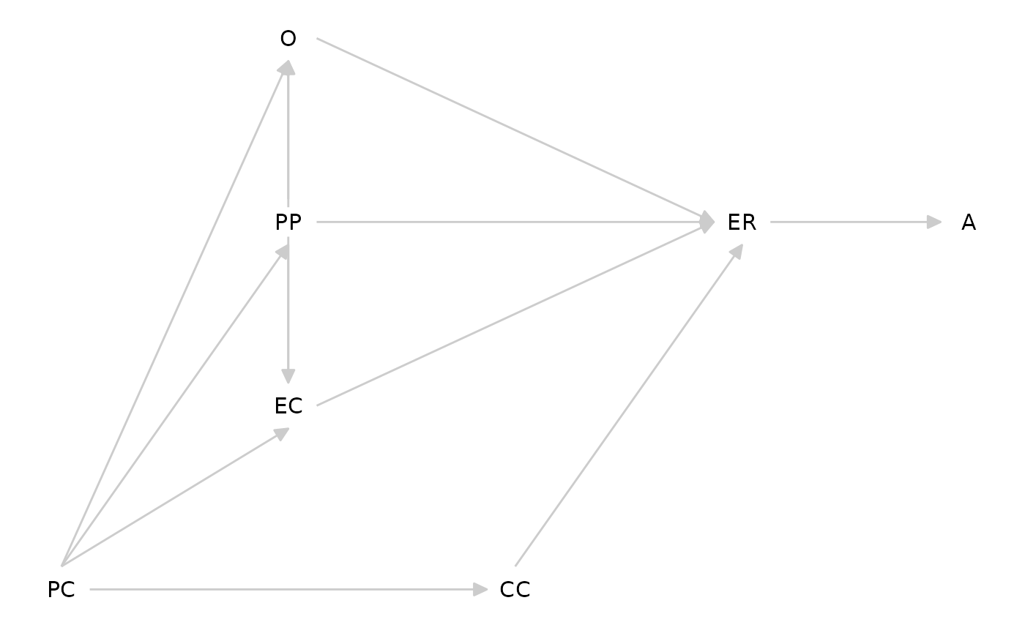

## Morris’ Tripartite Model (2007)

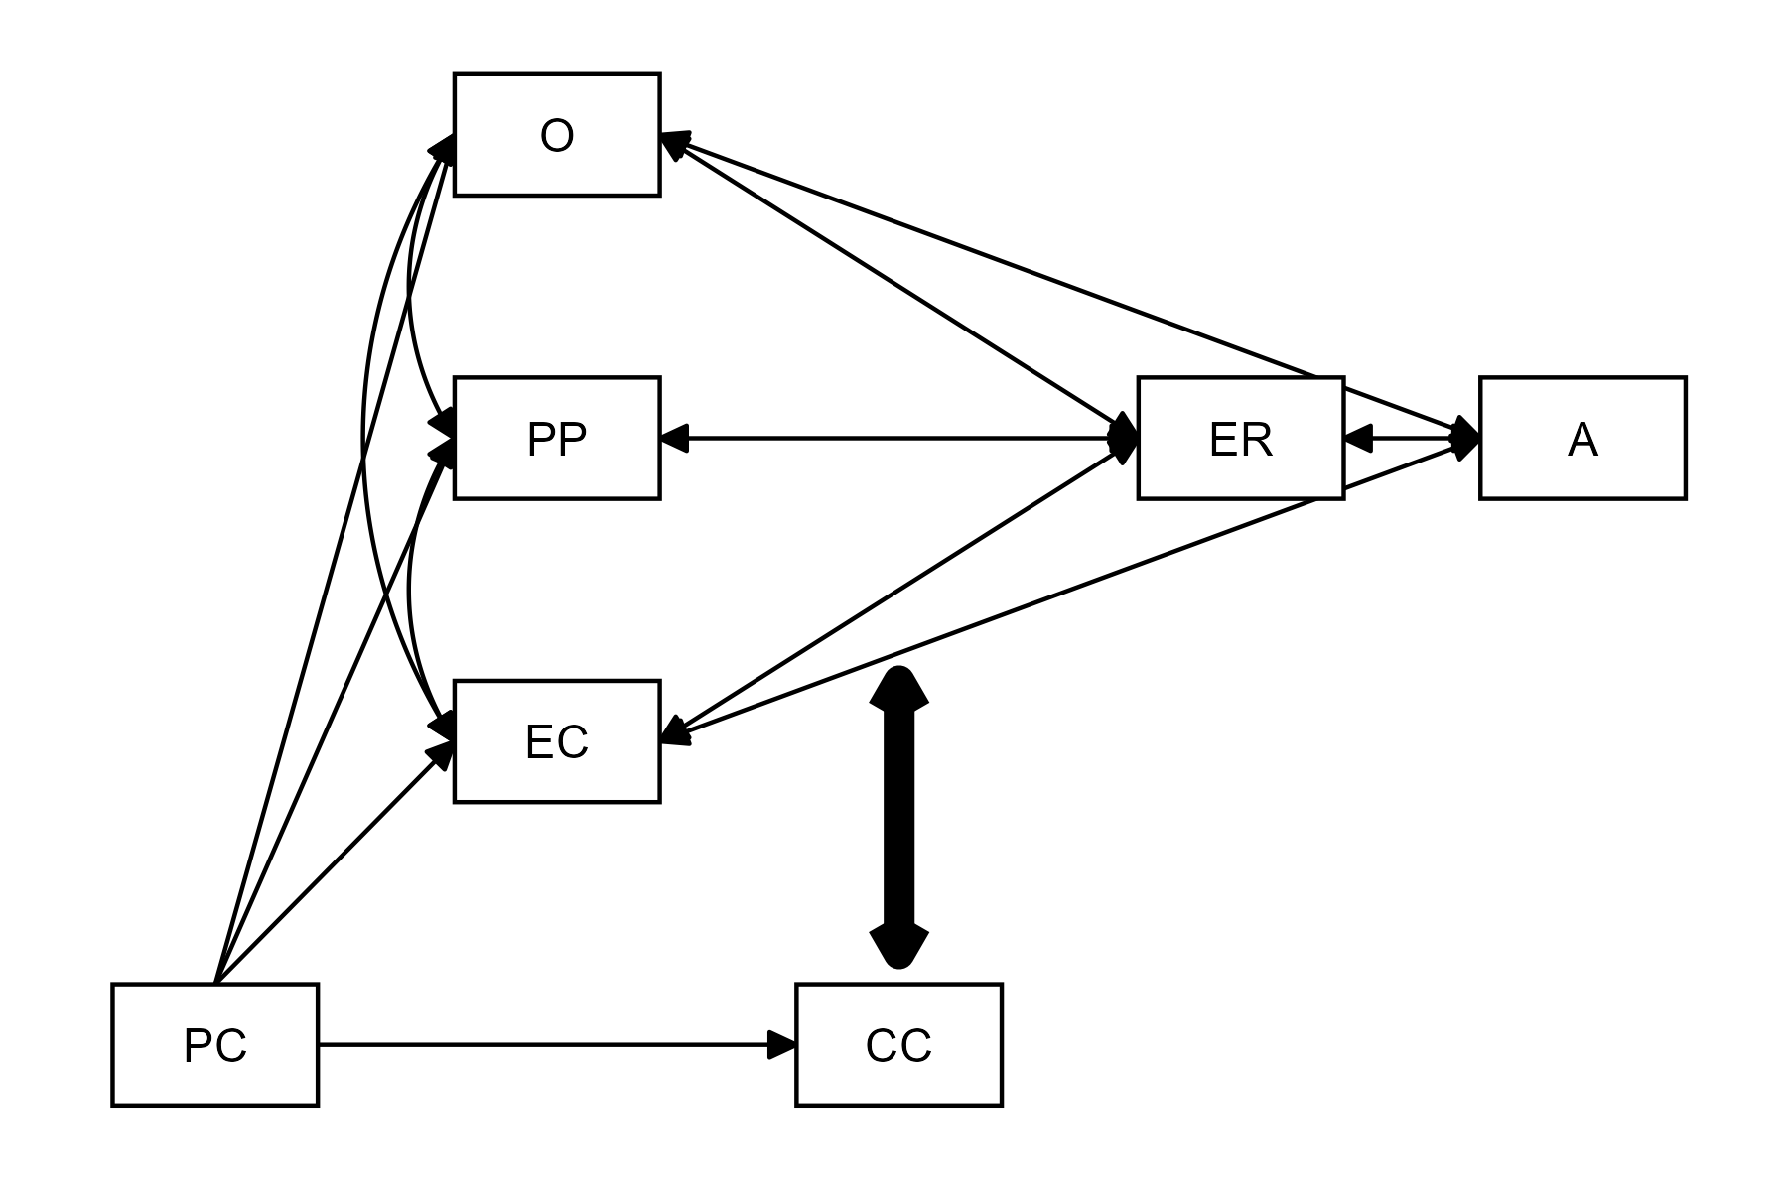

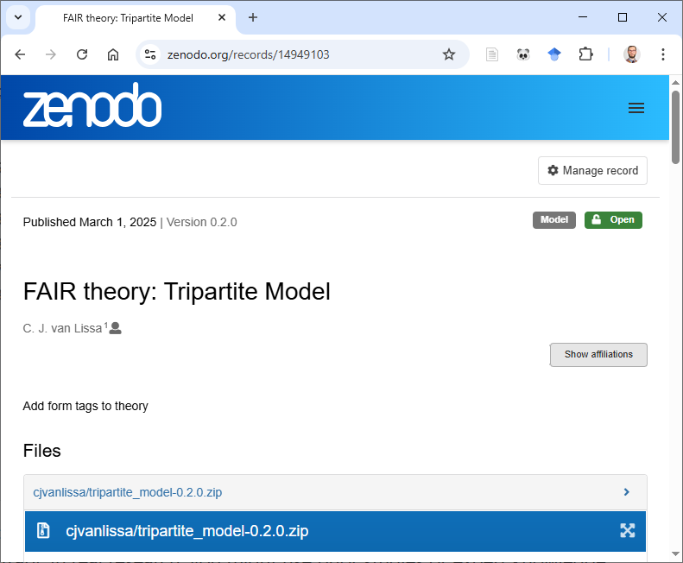**x**

## Interoperability

# Simulate data

df_sim <- [simulate_data](https://cjvanlissa.github.io/theorytools/reference/simulate_data.html)(tripartite, n = 497)

# Power analysis with hypothesized parameter values

tripartite_coef <- [dagitty](https://rdrr.io/pkg/dagitty/man/dagitty.html)('dag {

PC -> CC [beta=.4]

PC -> EC [beta=.2]

PC -> O [beta=0]}')

# Select covariates for causal inference

[adjustmentSets](https://rdrr.io/pkg/dagitty/man/adjustmentSets.html)(tripartite, exposure="O", outcome="ER")

#> { CC, EC, PP }

#> { EC, PC, PP }

## As FAIR Theory

tripartite <- dagitty('dag {

PC -> CC

PC -> EC

PC -> PP

PC -> O

O -> ER

PP -> ER

EC -> ER

ER -> A

CC -> ER [form="CC:O+CC:PP+CC:EC"];

PP -> O

EC -> O

PP -> EC

}')