To be FAIR: Theory Specification Needs an Update
Caspar J. Van Lissa, Aaron Peikert, Maximilian S. Ernst, Noah N.N. van Dongen, Felix D. Schönbrodt, & Andreas M. Brandmaier
Why?
- Open science has improved hypothesis testing — but theory development remains unaddressed.
- Psychological theories are often ambiguous, hard to test, not cumulatively improved, and not incorporated in scientific workflows

What is FAIR Theory?
- Findable: Easily located in indexed FAIR-compliant repositories (like Zenodo), with DOI and extensive metadata.
- Accessible: Plain-text files, readable by humans and machines, not images in papers locked behind paywalls.
- Interoperable: Usable for specific purposes like hypothesis derivation, covariate selection, data simulation, and iterative improvement.
  - Can be interoperable in analysis software (R-package theorytools)
- Reusable: Iteratively improvable by the broader community through clear licensing and version control.

Why Make Theory FAIR?
- Reduces research waste; theories are shared, reused, and improved.
- Enables meta-research on structure and evolution of theories.
- Enables analogical modeling: applying structure of a theory from one field to problem from another.
- Integrates theory into reproducible research workflows (worcs, theorytools).
- Accelerates cumulative knowledge acquisition in psychology and beyond.

How to FAIRify a Theory
- Specify theory clearly as prose, formula, diagram, or other (formal?) model.
- Archive theory objects in open repositories (e.g., Zenodo) with appropriate metadata.
- Version-control theory development using Git and GitHub.
- Use semantic versioning (MAJOR.MINOR.PATCH) to communicate changes to users.

Impact
- Supports modular publishing: theory as a standalone, citable artifact.
- Aligns with open science reforms and new research evaluation standards (e.g., DORA, CoARA).
- Facilitates team science, interdisciplinary work, and evidence-based decision-making.
- Accellerates theoretically sound research.

Downloading and Plotting

download_theory(https://doi.org/10.5281/zenodo.14921521)
graph_sem(tripartite)
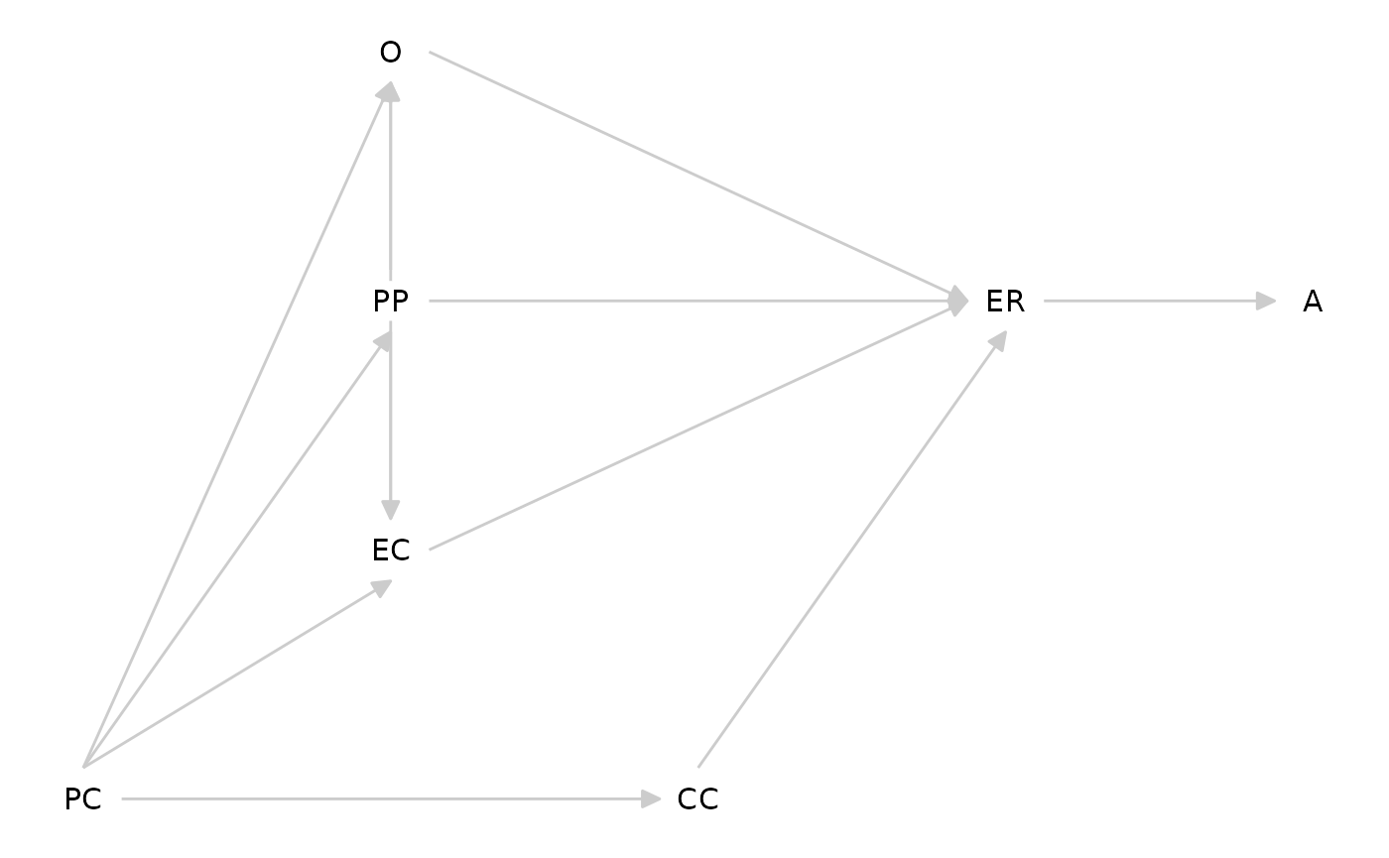

Morris’ Tripartite Model (2007)

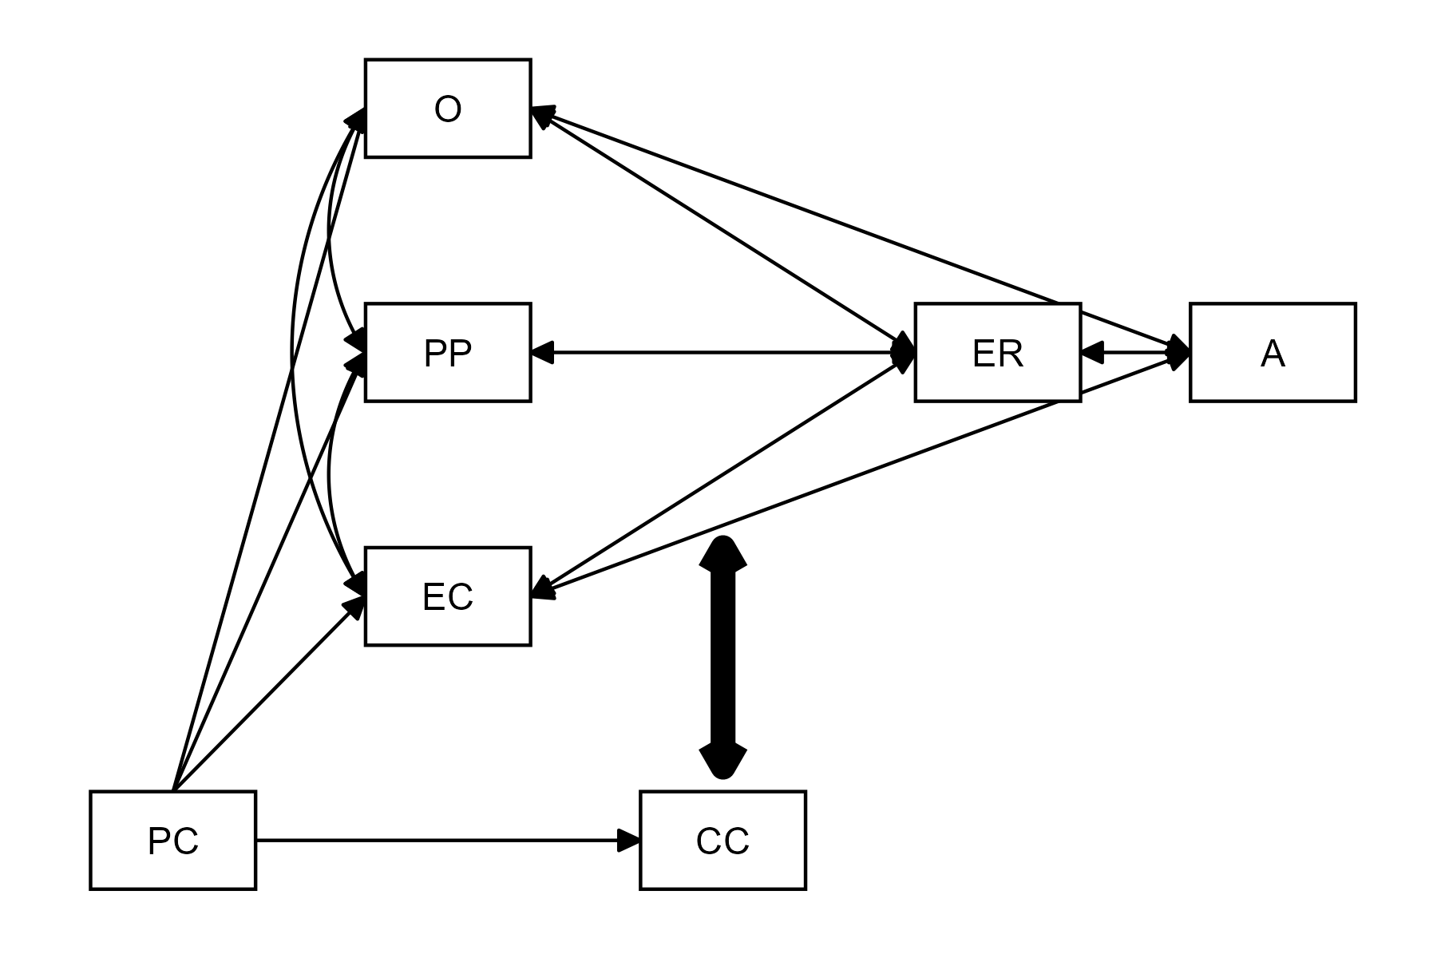
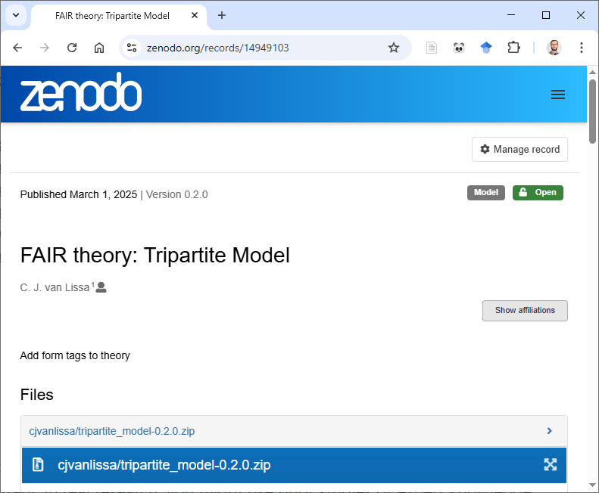
x

Interoperability
# Simulate data
df_sim <- simulate_data(tripartite, n = 497)

# Power analysis with hypothesized parameter values
tripartite_coef <- dagitty('dag {
PC -> CC [beta=.4]
PC -> EC [beta=.2]
PC -> O [beta=0]}')

# Select covariates for causal inference
adjustmentSets(tripartite, exposure="O", outcome="ER")
#> { CC, EC, PP }
#> { EC, PC, PP }

As FAIR Theory

tripartite <- dagitty('dag {
PC -> CC
PC -> EC
PC -> PP
PC -> O
O -> ER
PP -> ER
EC -> ER
ER -> A
CC -> ER [form="CC:O+CC:PP+CC:EC"];
PP -> O
EC -> O
PP -> EC
}')

