

CJW Newsletter
Version 1.0.0

Table of content
1 Introduction 3
1.1 More resources 3
1.2 Contacting eZ 4
1.3 Contacting CJW Network 4
1.4 Requirements 4
2 Installation 6
3 Configuration cjw_newsletter.ini 13
3.1 NewsletterSettings 13
3.2 NewsletterMailSettings 14
4 Using CJW Newsletter 16
4.1 Using CJW Newsletter from the front end 16
4.1.1 Front end: Subscribe to CJW Newsletter 16
4.1.2 Front end: Configure CJW Newsletter 17
4.2 Using CJW Newsletter back-end 17
4.2.1 Log-in in eZ Publish Administration 17
4.2.2 Administration root folder 18
4.2.3 Creating new CJW Newsletter objects/sub items 19
4.2.4 CJW Newsletter Dashboard 20
4.2.5 CJW Newsletter System 22
4.2.6 CJW Newsletter List 22
4.2.7 CJW Newsletter Subscription List 25
4.2.8 Approving a subscription manually 26
4.2.9 CJW Newsletter CSV Import 27
4.2.10 CJW Newsletter Edition 29
4.2.11 Send out control and cronjob abort 33
4.3 Newsletter User List 33
4.3.1 Deleting a user 34
4.3.2 Mailbox Item for Bounce Management 34
4.3.3 Blacklist 34
4.3.4 Import Lists 35
4.3.5 Import Detail Information 35

Introduction
CJW Newsletter is a certified eZ Publish extension that provides enhanced multi-channel marketing functionality for your eZ Publish website. As always clean programming and a seamless technical and usable integration with eZ Publish is provided. It integrates smoothly with the eZ Publish Enterprise and the eZ Community Project releases. ). And in combination with the eZ Publish Enterprise, the CJW Newsletter can be further customized to meet your specific requirements and site structures.
For email handling eZ Components is used. Designed to handle a large number of subscribers and send out thousands of newsletter editions in a short period of time, this extension is suitable for both small and large companies.
This manual is a guide to installing, configuring and using the CJW Newsletter extension. Once you have completed the setup process, the creation of a newsletter edition can be done quickly and easily. You can use it like you use all other parts of eZ Publish: easy.

More resources
For assistance with eZ Publish, refer to the following resources:
- eZ Publish documentation: CJW Newsletter is an extension to eZ Publish. Where appropriate, there are links in this document to the online versions of the eZ Publish documentation, located at http://doc.ez.no/.
- eZ Publish forums: The forums on the eZ Systems website are a valuable community-driven resource, where eZ Publish users provide assistance and support to each other. Accessing the forums is free. The forums are located at http://ez.no/community/forum.
- Support from eZ Partners: eZ Systems global network of partners provides professional assistance for all eZ products. To find a partner, contact sales@ez.no.
- Other eZ solutions: For information about other solutions provided by eZ Systems, refer to http://ez.no/products/solutions.
- Other CJW Network solutions: For information about other solutions provided by CJW Network, refer to
- Training and certification: eZ Systems and eZ Partners offer training courses and certifications for eZ Publish. Contact sales@ez.no or visit http://ez.no/services/training for more information.
- Sending feedback about CJW Newsletter: http://issues.ez.no/CJWnewsletter

Contacting eZ
For non-technical questions regarding eZ Publish or eZ Systems, please contact us:
- http://ez.no/company/contact
- info@ez.no

Contacting CJW Network
For non-technical questions regarding CJW Newsletter please contact us:
- http://www.cjw-network.com/contact
- info [at] cjw-network [dot] com

- http://www.coolscreen.de
- http://www.jac-systeme.de
- http://www.webmanufaktur.ch

Requirements
The CJW Newsletter extension has the following requirements:
- eZ Publish 4.x
- eZ Components
- PHP 5 and PHP 5 cli version with the ability to send out emails.
When the system requirements are met you can download the CJW Newsletter extension from the eZ projects website at http://projects.ez.no/CJW_newsletter. To install the extension follow the steps listed in the chapter "Installation"

Installation
The following steps describes how to install CJW Newsletter:
- When all the requirements are met, download the CJW Newsletter extension from the eZ projects website at http://projects.ez.no/cjw_newsletter.
- Extract the downloaded files to this location:
.../extension
- Activate your CJW Newsletter extension at this location:
settings/override/site.ini.append.php
or
extension/site_example/settings/override/site.ini.append.php
By adding the CJW Newsletter extension:
[ExtensionSettings]
...
ActiveAccessExtensions[]=cjw_newsletter
...
Note: From eZ Publish 4.4 the CJW Newsletter will be part of the new Extension Load Ordering functionality. In 4.4 you will need to enter the metadata for each extension you wish to install in extension/my_extension/extension.xml. Then the extension load ordering will take care of the correct sequential loading of the extensions.
- Next update your autoload settings for this extension. From the command line you could use the following command:
php bin/php/ezpgenerateautoloads.php -e -v
It is also possible to update the autoloads from the Administration Interface. Under the Setup tab, click on the Extensions link in the menu on the left. In the list displayed check the added extension (cjw_newsletter) and press the Regenerate
- autoload arrays for extensions button.
- Add tables to the database used by your eZ Publish instance. If you are using MySQL, you can import the tables from the eZ Publish's root directory with the following command:
mysql -u <user> -p <database_name> < extension/cjw_newsletter/sql/mysql/schema.sql
Don't forget to replace the placeholders <USER> and <DATABASE_NAME> with the actual user name of your database and the name of the database used by eZ Publish.
If you are using another DBMS, the procedure is very similar. Please refer to the documentation of your DBMS if you are experiencing issues.
- For eZ installations < 4.2.0 assign the CJW Newsletter administration design in your administration siteaccess in order to adjust the eZ Publish Administration Interface with the left CJW Newsletter menu. To do this go to settings/siteaccess/<example_admin_en>/site.ini.append.php
or extension/<site_example>/settings/<example_admin_en>/site.ini.append.php
and make the following changes:
# ez version < 4.2.0
[DesignSettings]
SiteDesign=<cjw-example_admin_en>
AdditionalSiteDesignList[]=newsletter_admin_ez4.0.0
AdditionalSiteDesignList[]=admin
# ez version >= 4.3.0
[DesignSettings]
SiteDesign=<cjw-example_admin_en>
AdditionalSiteDesignList[]=admin2
AdditionalSiteDesignList[]=admin
- Check if you have an override menu.ini.append.php in your siteaccess. If so, you should add the new CJW Newsletter tab manually at one of the following locations:
settings/siteaccess/<cjw-example_admin_en/menu.ini.append.php
or
extension/site_example/settings/<example_admin_en>/
menu.ini.append.php
Add the tab as follows:
[TopAdminMenu]
Tabs[]=newsletter
- Now you should clear the cache. The following command can be used:
php bin/php/ezcache.php --clear-id=template-override
Or if you prefer, this can be done from the administrator interface. Under the Setup tab, click on the Cache Management link in the menu on the right. And select the caches to clear.
- Next you should import the CJW Newsletter content classes and demo structure. The package newsletter_classes-1.0.1.ezpkg can be imported to the system, this means you must upload, unpack and place it under an appropriate internal repository within the installation. The following example demonstrates how to import such a site style package:
  - Go to the Setup tab in your administrator interface and then click on the Packages link in the menu on the left side. Choose the local repository and click the Import new package button located under the list of packages (it is marked in red in the next screenshot):
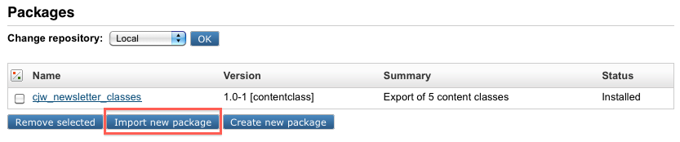
  - Choose the desired file, in this case cjw_newsletter/packages/newsletter_root-1.0.1.ezpkg.ezpkg, on your local computer (as shown in the following screenshot) and click the Import package button.
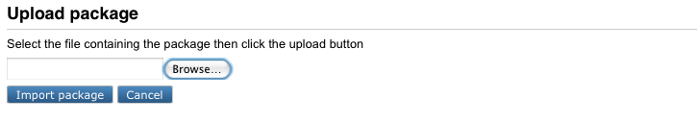
The system will import the package from cjw_newsletter/packages/newsletter_classes-1.0.1.ezpkg
and show it in the list of packages.
- You must now create a CJW Newsletter root folder (for example: Newsletter Root) which is used for all CJW Newsletter content. Follow the procedure below to create a new root folder as a starting point for your newsletter structures:
Please note that you need to create your Newsletter structure in the following sequence - Create a root folder - create a section - assign the section to the root.
  - Create a folder called "Newsletter Root" under the "Content structure" tab
  - Create a section called "CJW Newsletter" in "Setup" - "Sections"
  - Assign the new section to the "Newsletter Root" folder.
  - You have now created a folder called "Newsletter Root". This will appear when you click the "Newsletter" tab. From the "Newsletter Root" you create the new Newsletter structure with Newsletter systems, newsletter lists, newsletter editions and newsletter articles.
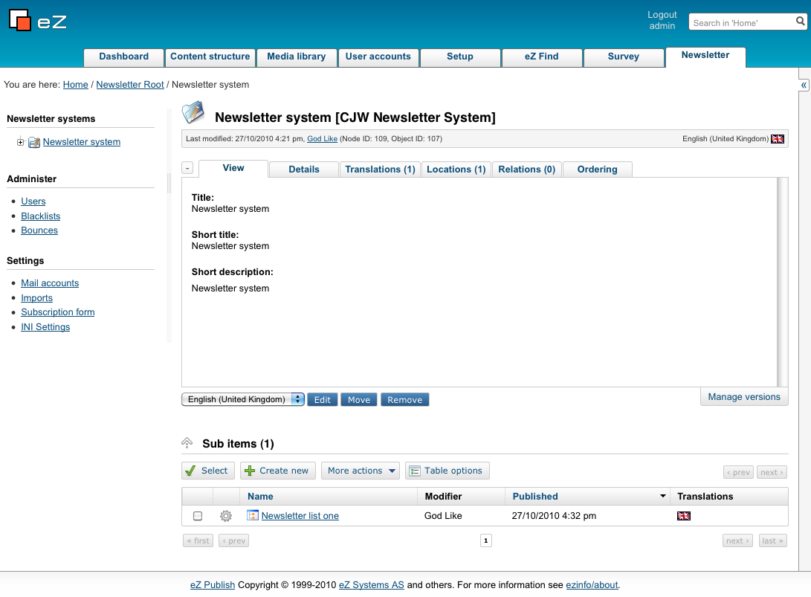

- You can now create the CJW Newsletter structure manually like described in the bullet-points below:
Note: Make sure that you follow this sequence and that every new object is created within the previous structure.
  - At the CJW Newsletter Root (if you need a new newsletter system later start at the root folder again)
  - create your newsletter system (you can create new newsletter systems as the need may be)
  - then create a newsletter list within that system (this will list all newsletters create in this particular newsletter system)
  - create a newsletter edition within the newsletter list (all editions created in this structure will be listed here)
  - In the newsletter edition you can either:
    - create all your articles within the same edition, or
    - create separate articles in a new structure below the newsletter edition.
- Next you check roles for user access. To do this go to the User accounts tab in the Administrator Interface and click on the Roles and Policies link in left hand menu (Access control). Set policies according to your own preferences and necessities.
- Next create a cjw_newsletter.ini.append.php file for the CJW Newsletter settings at the following location:
/settings/override/cjw_newsletter.ini.append.php
or preferred
/extension/site_example/settings/override/cjw_newsletter.ini.append.php
The content could for example look like this:
[NewsletterSettings]
PhpCli=php
AvailableSkinArray[]=default
[NewsletterMailSettings]
# smtp, sendmail, file
TransportMethodCronjob=sendmail
# test newsletter
TransportMethodPreview=sendmail
# subscribe, infomail
TransportMethodDirectly=sendmail
# Configuration for SMTP
SmtpTransportServer=
SmtpTransportPort=25
SmtpTransportUser=
SmtpTransportPassword=
EmailSender=newsletter@example.com
EmailSenderName=Example.com Newsletter
EmailSubjectPrefix=[Newsletter Example.com]
Keep in mind to adjust these settings according to your needs.
- Update the default cjw Newsletter skin or create a new one. By default the CJW Newsletter default skins are located here:
/extension/cjw_newsletter/design/newsletter_design/templates/newsletter/skin/default/outputformat
The files are text.tpl and html.tpl.
Lets say you have designed a custom skin called "my_custom_skin".
The related text.tpl and html.tpl files should be located here:
/extension/cjw_newsletter/design/newsletter_design/templates/newsletter/skin/my_custom_skin/outputformat
The new skin should then be definded in cjw_newsletter.ini.append.php (created in step 13) like this:
[NewsletterSettings]
AvailableSkinArray[]=my_custom_skin
And don't forget to clear the cache after adding new templates!
- Check the SiteURL settings in site.ini of the siteaccess which is used for rendering the newsletter. This setting is used to create absolute links to images:
site.ini.append.php
[SiteSettings]
# URL of site, often used to link to site in emails etc.
SiteURL=example.com
- Next activate the ts files in "cjw_newsletter.ini.append.php"
# this setting you should copy to your siteaccess site.ini
# so you have full control of which ts files are loaded
[RegionalSettings]
TranslationExtensions[]=cjw_newsletter
- To create all mails for a CJW Newsletter edition which are ready to be sent out run, the following command can be used:
php runcronjobs.php -s siteaccess cjw_newsletter_mailqueue_create
- To send out all mails which are in the mail queue created by step 15, the following command can be used:
php runcronjobs.php -s siteaccess cjw_newsletter_mailqueue_process
- Your CJW Newsletter should now be properly installed and ready for use!

Configuration cjw_newsletter.ini
The default CJW Newsletter configuration settings are defined in this file:
/extension/cjw_newsletter/settings/cjw_newsletter.ini
It is highly recommended to create an override configuration file, for example here:
/settings/override/cjw_newsletter.ini.append.php
or preferred:
/extension/site_example/settings/override/ cjw_newsletter.ini.append.php

NewsletterSettings
In the above mentioned override file (cjw_newsletter.ini.append.php) the following settings should be included and configured according to the needs of your site:
[NewsletterSettings]
# Administration interface container NodeID
RootFolderNodeId=66
# Please put here the path to your PHP Cli installation. It is needed for generating the
preview and the views in the send out process
PhpCli=php
# array with all skin names located in design folder
# => design:newsletter/skin/ $skin_name
# You can connect the layout with your newsletter list in the administration interface.
AvailableSkinArray[]
AvailableSkinArray[]=default
AvailableSkinArray[]=ez4you_extended
AvailableSkinArray[]=ez4you_simple

NewsletterMailSettings
It is possible to send your Newsletters with sendmail or SMTP. The file protocol is provided for development reasons only.
Keep in mind that there are three different types of send out mails:
- The subscribe or information mails
- the preview of the CJW Newsletter edition mails
- the CJW Newsletter edition itself.
When you choose SMTP, the SMTP settings in the above mentioned override file (cjw_newsletter.ini.append.php) should be configured as follows:
[NewsletterMailSettings]
# smtp, sendmail, file
# cjw Newsletter edition
TransportMethodCronjob=sendmail
# test cjw Newsletter edition
TransportMethodPreview=sendmail
# subscribe, infomail
TransportMethodDirectly=sendmail
# Configuration for SMTP
SmtpTransportServer=
SmtpTransportPort=25
SmtpTransportUser=
SmtpTransportPassword=
# settings for mail send out by subscribe, unsubscribe
EmailSender=newsletter@localhost.localdomain
EmailSenderName=Localhost Newsletter
# string the subject of all mails is starting with
EmailSubjectPrefix=[Newsletter Localhost]

Using CJW Newsletter

Using CJW Newsletter from the front end

Front end: Subscribe to CJW Newsletter
In the subscription page, you can select the newsletter you would like a subscription to from the CJW Newsletter List, define the format in which you wish to receive it (HTML or text format) and enter your email. You can enter your first and last name and you salutation too if you wish, but this is not mandatory. There is also the possibility to unsubscribe or change your CJW Newsletter list subscriptions. The following screenshot shows an example subscription page. The unsubscribe link (and where you change your profile) is marked with red boxes at the bottom of the page.
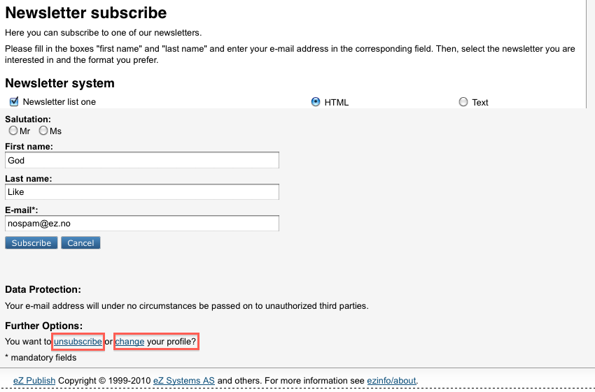
The next screenshot shows that the subscription was successful.
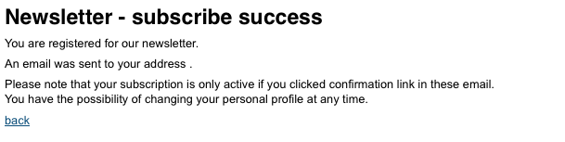

Front end: Configure CJW Newsletter
A subscriber can change his personal settings and CJW Newsletter list subscriptions by using a link provided in every mail that is sent out from the CJW Newsletter system.
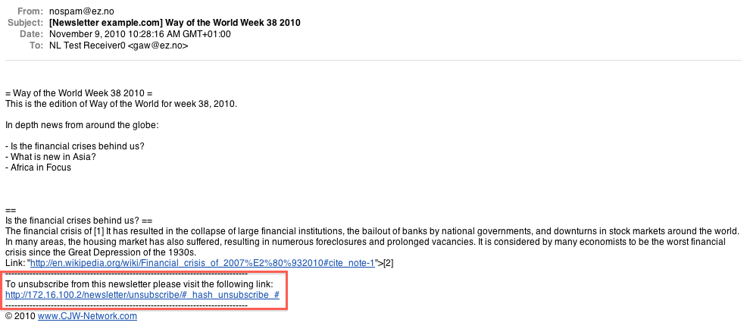

Using CJW Newsletter back-end

Log-in in eZ Publish Administration
Log-in into eZ Publish admin.example.com/ with your administration user name and password in the screen below:
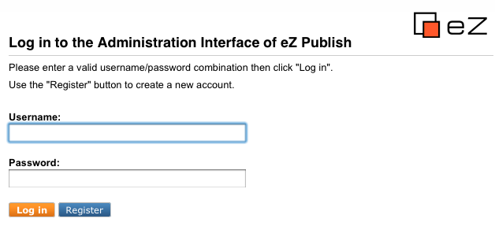

Administration root folder
After log-in you enter the CJW Newsletter Dashboard. If the newsletter system is setup properly and activated on your eZ Publish installation, you will find an additional tab called “Newsletter” and in the left menu the “Newsletter Systems” folder and sub-tree. Please click the “Newsletter” tab.
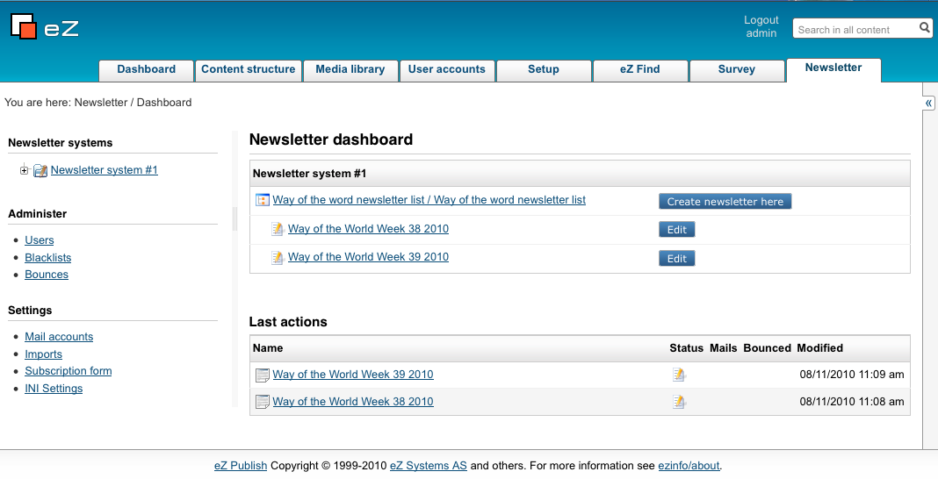
The newsletter dashboard screen
The newsletter dashboard screen is shown above. This is presented when you click the "Newsletter" tab, and it displays the "Newsletter system" folder and sub-tree where you will find all the newsletters you have created. In the "Newsletter dashboard" you will have direct access to your list of newsletters, and you may create a new one or edit the existing newsletters directly from this screen.
In "Last actions" you will find a list of the newsletters or articles you last worked on. You will find the status of this item, whether you have received any mails regarding this item, how many newsletter mailings were bounced, and when was this item last modified (date and time of day).
When you click on the Newsletter folder in the left sub-tree, you will be presented with the "Newsletter root" folder screen as shown below:
Illustration 5: eZ Publish administration interface root folder

Creating new CJW Newsletter objects/sub items
The sub items behaves like in eZ Publish, follow this link to get information on the eZ Administration interface. Specific to the CJW Newsletter functions is that you can create the following types of newsletter objects (shown in the screen below) by clicking the "Create new" button: CJW Newsletter Article, CJW Newsletter Edition, CJW Newsletter List, CJW Newsletter Root, CJW Newsletter System.
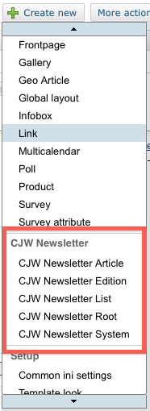

CJW Newsletter Dashboard
The next illustration shows the CJW Newsletter dashboard including an expanded left menu and the CJW Newsletter overview page:
- There is one CJW Newsletter system installed.
- This CJW Newsletter system has one CJW Newsletter list (Way of the World newsletter list).
- This CJW Newsletter list has two CJW Newsletter editions (Way of the World Week 38 and 39 2010).
- The Subscriptions counter in the left menu is 0/2, indicating that 2 users have subscribed to the CJW Newsletters (Way of the World Week 38 and 39 2010).
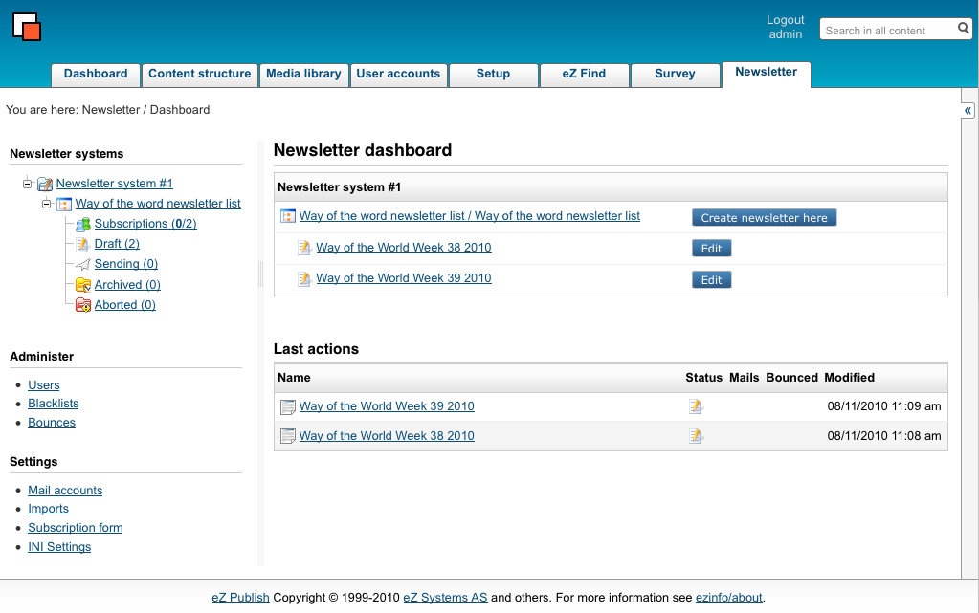
Illustration 6: eZ Publish administration interface CJW Newsletter dashboard
You can have multiple CJW Newsletter systems, CJW Newsletter lists and CJW Newsletter editions. The next screenshot shows the left menu detail view: Under the "Newsletter list one you can see the live cycle of a CJW Newsletter edition and the subscribed user folder with user count (3/4). You can see that two newsletters have the status "Draft" (status draft). You can work on this draft, extend it, control it with previews and test Newsletter editions. After the testing you can mail the Newsletter edition.
After you send out the Newsletter edition, you'll find the example Newsletter edition in the folder “Sending (1)” (status send), after a successful send out, it is in the “Archive” folder (status archive). As an additional help, you can abort a send out manually and then you find the Newsletter edition in the “Abort” folder (status abort).
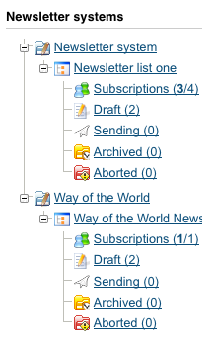
Illustration 7: eZ Publish administration interface left menu detail view

CJW Newsletter System
You have now selected the Newsletter system in the left menu. The concept is that you can run multiple CJW Newsletter systems in one eZ Publish installation. You can consider the CJW Newsletter system as an independent system. The idea behind was a concept for a multinational company with dependent and independent sub-companies. So they are free to use one bigger system for the dependent sub-parts with smaller system for the independent ones.

CJW Newsletter List
Select the "Newsletter List". You will be presented with the following screenshot:
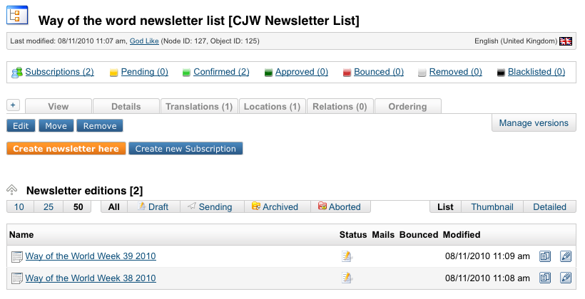
Illustration 9: eZ Publish administration: CJW Newsletter List
In the following screenshot you see the CJW Newsletter list with subscription statistics and with a list of 2 Newsletter editions "Way of the World for Week 38 and 39 in 2010.
Note that it is from this screen that you create a new newsletter.
Please go to the edit screen in the next screenshot to edit the settings:
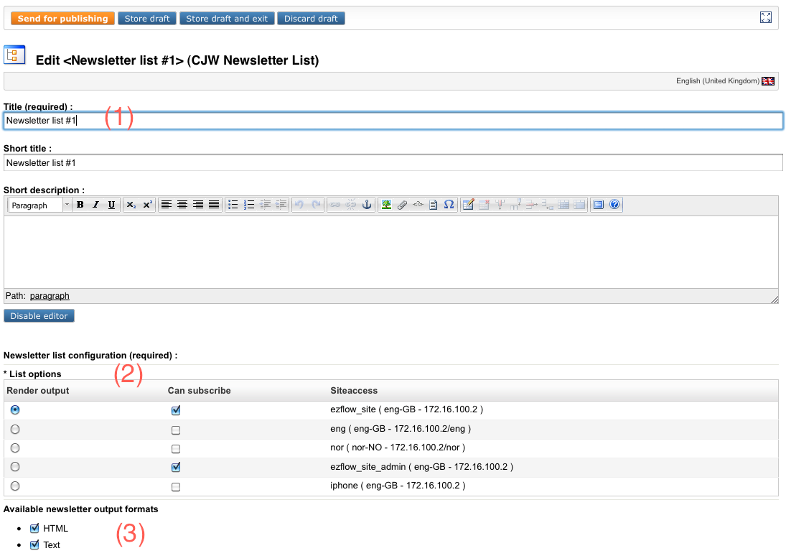
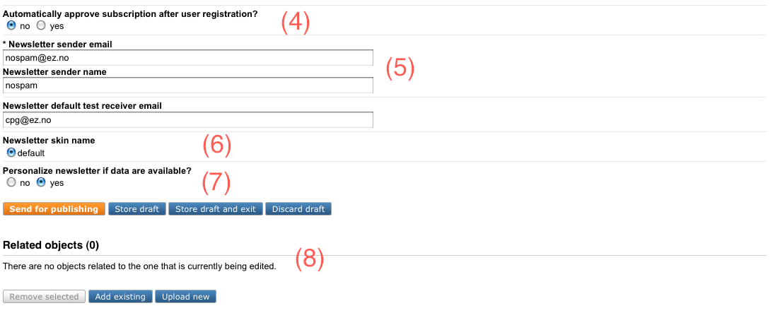
The numbers in the screenshot correspondent to the following descriptions:
[1] The title is visible on the CJW Newsletter subscription page.
[2] In the “List Option” part you can
- make the CJW Newsletter list visible (can subscribe) on subscribtion pages of siteaccesses. As an example: If you have a German and an English CJW Newsletter list, it might be useful that English speaking people can only subscribe the English list on the English eng-GB siteaccess.
- choose the siteaccess for rendering the output. Please keep in mind, that all links and languages are connected to this setting.
- choose the administration siteaccesses for the subscribe page in administration.
[3] The CJW Newsletter has a create once and publish multiple approach. Here you can choose the render options, which the subscriber can choose, too. The HTML is a multipart version and text is plain text. You can add with only little programming and templating additional output formats like SMS, MMS, PDF, fax, mailing, RSS, Twitter, jabber and so on.
[4] Subscriber can be approved with confirmation mail (yes) or directly (no). "No" means that the administrator must manually approve the subscription. "Yes" means that the subscription is confirmed and approved automatically.
[5] Email settings for the CJW Newsletter.
[6] You can choose here different skins. The skins are defined in the "CJW_newsletter.ini":
[NewsletterSettings]
AvailableSkinArray[]
AvailableSkinArray[]=default
AvailableSkinArray[]=ez4you_extended AvailableSkinArray[]=ez4you_simple
[7] You have the possibility to personalize your CJW Newsletter.
[8] Here all objects related to this newsletter list will be listed

CJW Newsletter Subscription List
Select the "Subcriptions" folder in the left menu structure. One CJW Newsletter system can have multiple CJW Newsletter lists in different languages. Subscribers can subscribe to their desired lists in the front end or you can add some by clicking the CJW Newsletter registration form or add multiple subscribers with a csv import. For the csv-import please click on the “Import CSV” button and go to the next chapter in this documentation.
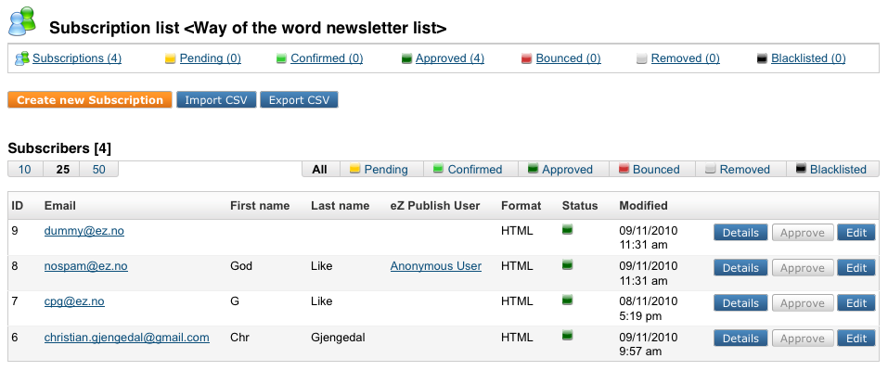
Illustration 10: eZ Publish administration interface: the CJW Newsletter subscription list

Approving a subscription manually
If you set "No" to "Automatically approve subscription after user registration?" in the "Newsletter list" edit screen, you will have to approve the subscription manually. Please do the following:
[1] Select "Subscriptions in the left menu tree. You are presented with the following screen:
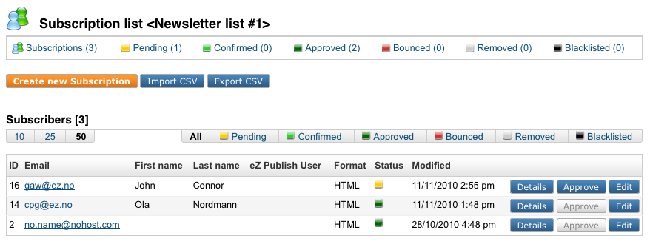
[2] Press the "Approve" button on the user you wish to approve.
[3] You will get a confirmation that the "Subscription was successfully approved" and be presented with the user details of the subscriber as shown below:
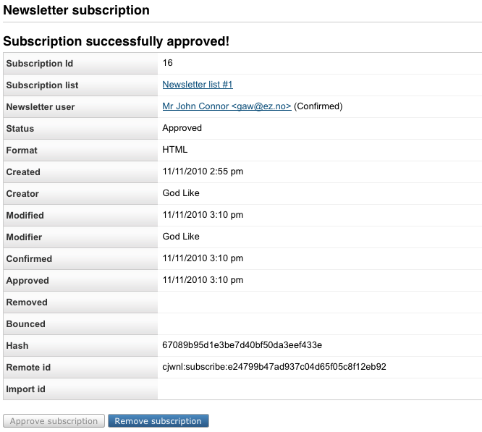

CJW Newsletter CSV Import
Known issue: Please note that there are import limitations:
- If you need to do your csv import over a network connection, please limit the number of users to 1000. The workaround is to do batches of less than 1000 users.
- If you do your csv import on your local host then limit your import to 6000. The workaround is to do batches of less than 6000 users.
The following formatting rules apply to the csv fil:e The salutation number for women is 2 and for men is 1, here is an example CSV file:
"email";"Firstname";"Lastname";"Salutation"
"man@example.com";"Oliver";"Williams";"1"
"woman@example.com";"Elinora";"Williams";"2"
In the screenshot below you can see the fields for the CSV import and by following the numbers you will follow the correct procedure for the import:
[1] Choose your CSV file, [2] with or without label, choose the output format [3] for the subscribers, the CSV field delimiter [4] and click upload. If you made a mistake, you can change and update your settings. After the successful upload you see the path of the file on the server and the control list of subscribers. If you find the list ok, click [5] “Import all”.
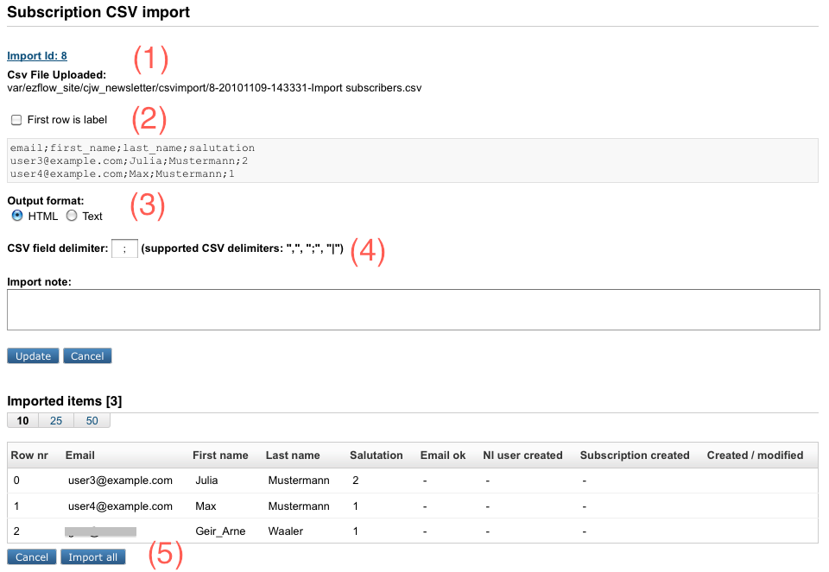
Illustration 11: eZ Publish administration interface: the CSV import
The import was successful. Let's have a look, what happened:
[1] 3 addresses with salutation, one woman and two men
[2] All 3 email addresses were OK.
[3] No users were created, three users were already in the database, so no need for creation.
[4] 3 subscriptions were updated, as the users were already subscribed.
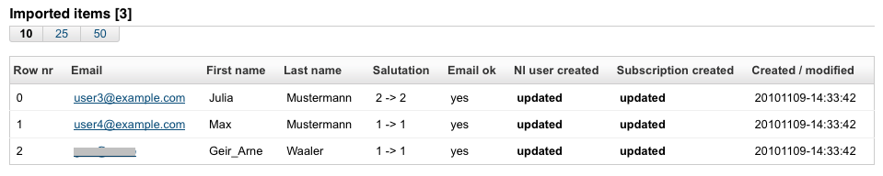
Illustration 12: eZ Publish administration interface: the CJW Newsletter CSV import

CJW Newsletter Edition
Select the CJW Newsletter Edition. Be aware that at this point you can do 2 different things, depending on the configuration and the CJW Newsletter list settings:
- Create a simple CJW Newsletter with only an XML field
- Extended with XML field and children with eZ content objects out of existing classes or eZ content objects out of the CJW Newsletter edition sub item classes.
[1] This sign indicates the status of the CJW Newsletter edition (Way of the World Week 39 2010).
[2] This is the view of your CJW Newsletter edition (Way of the World Week 39 2010). Press "Edit" to update the content. For the simple one, that's all. For the extended, you have to add sub items (children).
[3] You can control your CJW Newsletter edition (Way of the World Week 39 2010) with test send outs, and when it finds your approval you can also also send it out from this screen.
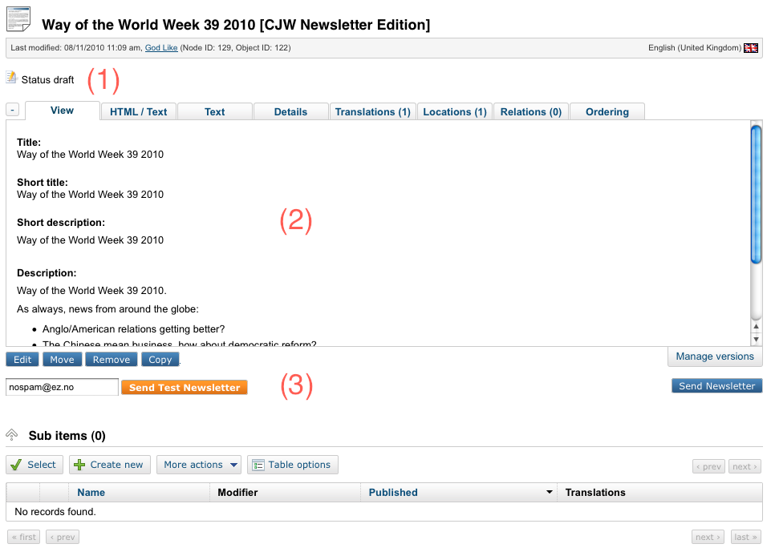
When you press the "Send Newsletter" button you will get this dialogue box asking for confirmation that it is ok to send it out:

Press "Send newsletter" again and with the next cronjob round, the send out starts. The screenshot below shows that the send out is in process and you can see all the statistics and processing info for the send out of your newsletter so far. If you followed the extended way of creating your newsletter edition, the sub items list will list all the children you have created, your articles, images or other objects.
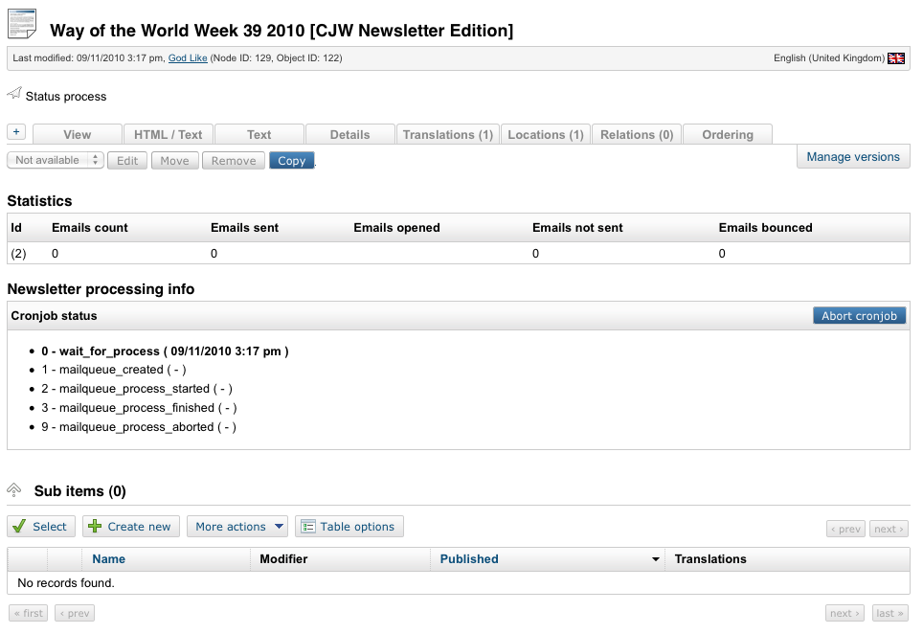
Illustration 13: eZ Publish administration interface: the CJW Newsletter edition
Below you find the "Edit" screen for the newsletter edition. Here you edit the article/newsletter edition.
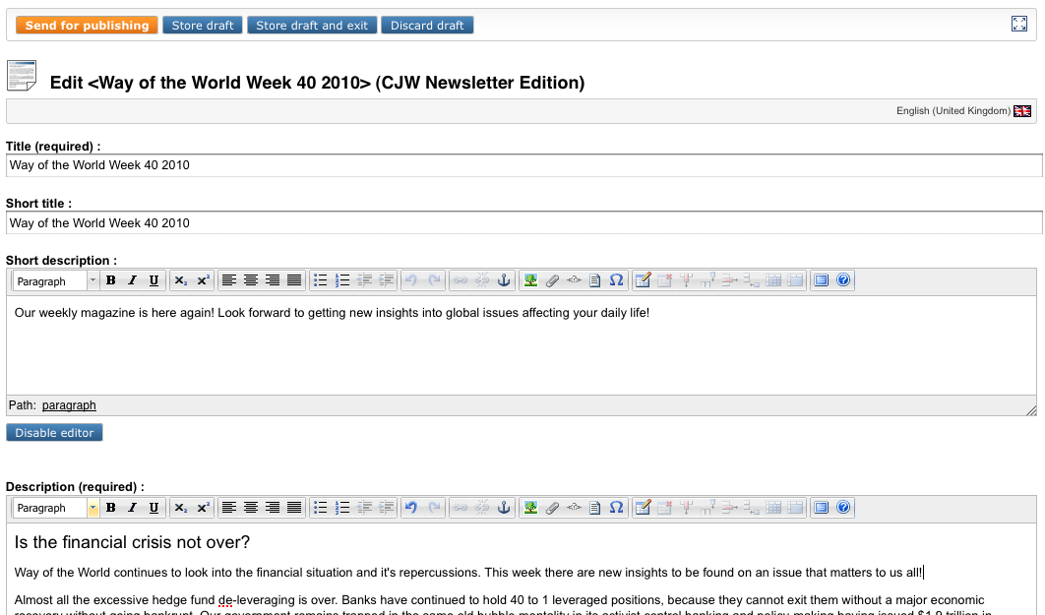
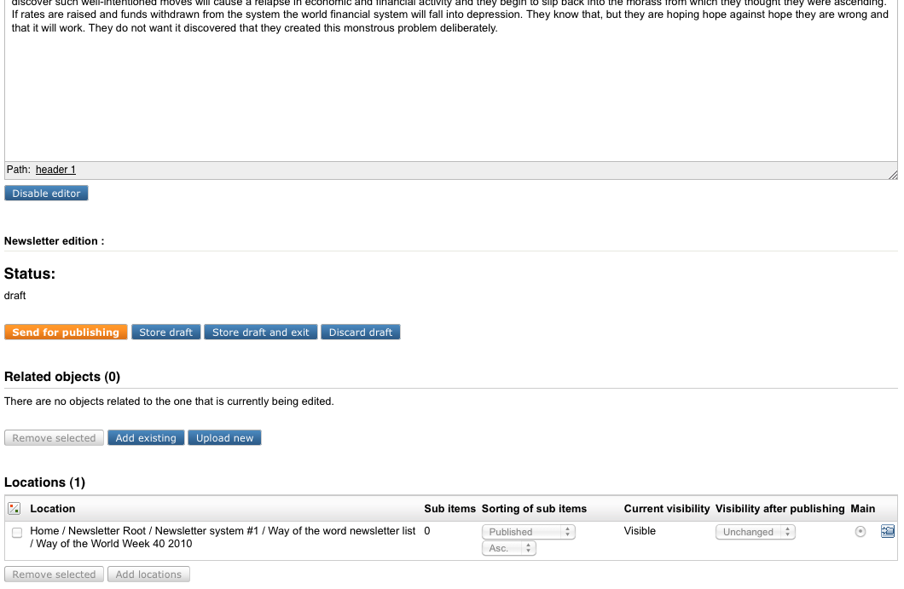
Illustration 14: eZ Publish administration interface: the CJW Newsletter edition edit mode
For editing the CJW Newsletter Edition or Sub items, you have the full possibilities of eZ Publish, like XML-field with WYSIWYG Online Editor.

Send out control and cronjob abort
During the test send outs of your newsletters you will get a report on how the process went in the "Newsletter processing info":
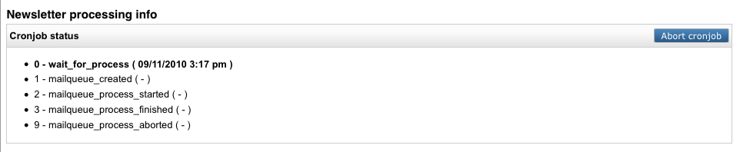
The "Newsletter processing info" gives you the possibility to check that status of what you have sent out. Here you can see all the steps of the CJW Newsletter edition send out and you have the possibility to stop the send out in case of a big mistake. This will reduce the amount of wrong send outs CJW Newsletter editions.

Newsletter User List
In this list you will see all subscriber status informations like confirmation, count of bounces or whether the subscriber is an eZ user as well.
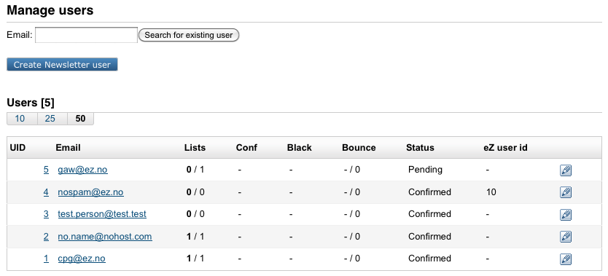
Note that this user list is unique to CJW Newsletter. If you need to manage eZ Publish users, please go to the "User accounts" tab in eZ Publish. If a user occurs in both lists the items will be automatically connected via email matching.

Deleting a user
You can delete a user/subscriber from the CJW Newsletter system in 2 ways:
- either by going to the "Subscriptions" folder in the left menu tree, or
- go to the "User" folder in the left tree menu.
In both cases you are presented with the "User list" screen shown above. Click the email address and you are presented with the user details. Press the "Remove button" to the bottom of the screen. A dialogue screen appears where you need to confirm that this is the user you wish to remove by pressing the "Remove" button again. You will now be taken to the Manage users screen.

Mailbox Item for Bounce Management
There is a CJW Newsletter X-Header Hash for better matching of bounced messages. First you click on collect all mails, and the emails will be collected from the email account with POP3 or IMAP. The settings of these accounts can be configured in “Mailbox list”.
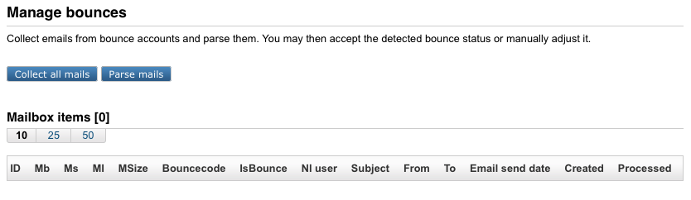

Blacklist
It is important to have the possibility to assure that an email is not used any more. Even with a new subscription request. The blacklist takes care of these cases.
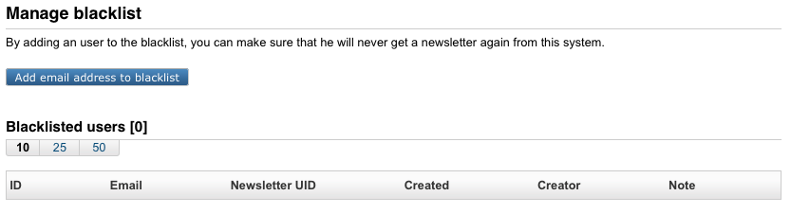

Import Lists
With this function you can import lists of emails addresses that you either have bought, already have in your CRM, your shop or your accounting system. These email addresses can be imported into the CJW Newsletter system easily. Existing eZ users will be automatically connected via email matching.

Import Detail Information
Each import stores detailed information for later use and control.
