Problem #1:

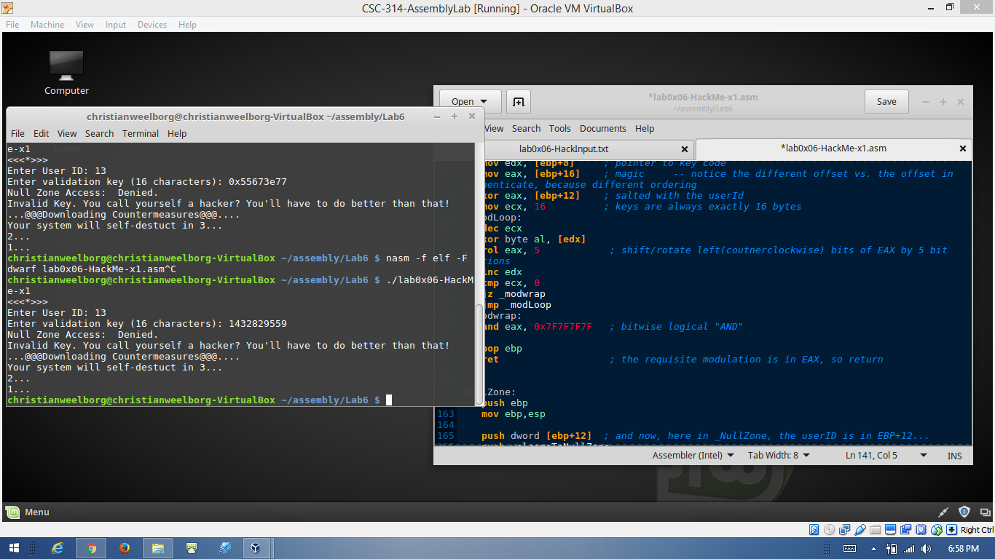

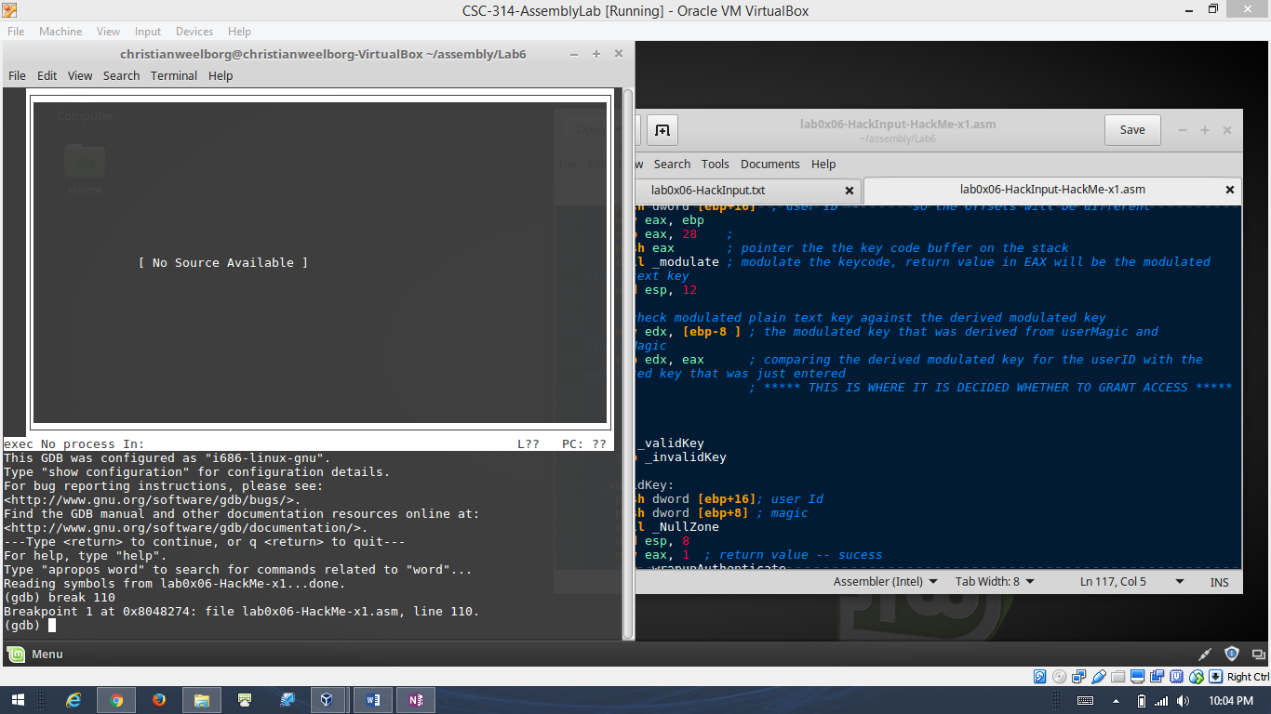

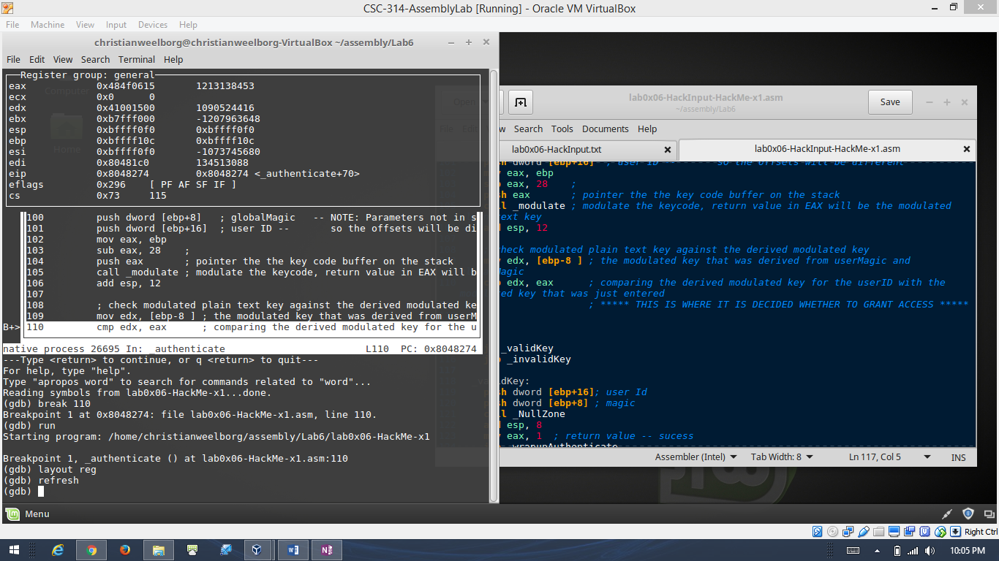

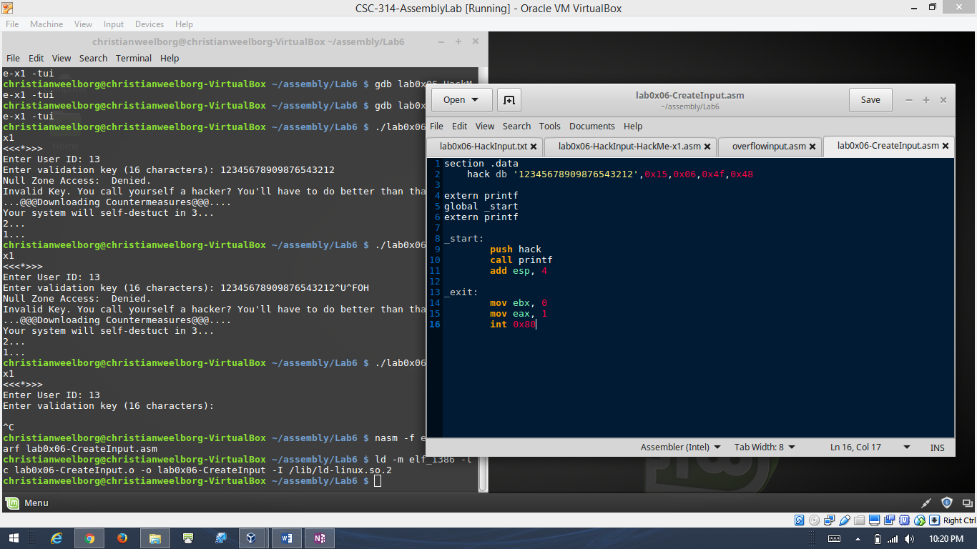

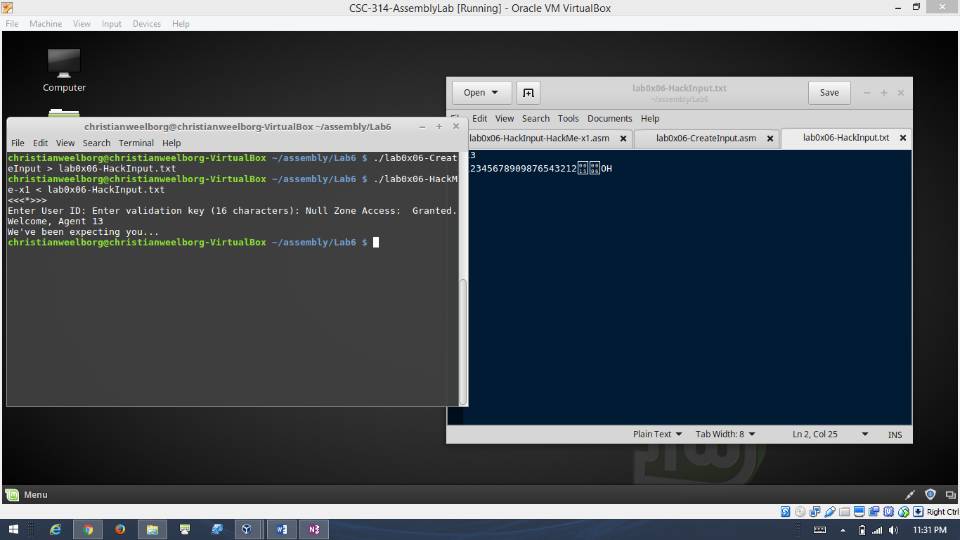

First I looked at the program and analyzed how it worked and tested a few of the inputs. Since we knew the usernames I tested it with the username “13”. I then found the compare that compared the hex value of the modulated key and set a breakpoint in gdb just before the compare to see what was stored in the register eax (The compared register). And I recorded that value and since the bits were reversed and the hex value is equivalent to four different ascii characters, I entered in the four different ascii values in reverse order AFTER I entered 20 bytes of the same validation key. This way I buffer overflowed into the memory that I needed to and replaced it thus giving me access. The screenshots above overview the process I followed in order to print the non-typeable ascii characters and how I made another small assembly program to print them into a input file for the main program.

Problem #2:

