Drought and Flood: NOLA CAREER Project
Connor Whalen
2025-02-18
Table of Contents

Introduction
This file contains all code pertaining to the CAREER project in NOLA’s drought and flood analysis.

Setup

Install packages.

Load packages.

Set up aesthetic for plots
# color palette -- hurricane = #CB87B4, control = #F4B95A, drought = #D84D16, flood = #1BB6AF
# trem = #c9ad79 , meta = #F66387 , mono = #A6E000 , myxo = #07c4c5
connor_theme <- theme(legend.position = "top",
legend.title = element_text(size = 18),
legend.text = element_text(size = 14),
strip.background = element_rect(fill = NA, color = NA),
panel.background = element_rect(fill = NA, color = "white"),
panel.grid.major = element_blank(),
panel.grid.minor = element_blank(),
panel.spacing.x = unit(0, "lines"),
panel.spacing.y = unit(0, "lines"),
axis.text = element_text(size = 8, color = "grey30"),
axis.ticks = element_line(size = 0.2, color = "darkgrey"))

Data prep and cleaning

Load full datasets (parasites collected and NOAA SPI precipitation data) and prep data for analysis

Abundance

Plot raw data (as averages not sums) to identify any trends in the data or inconsistencies.
# how many replicates are in each category --> this is just the number of occurrences, not abundance of parasites
dfa.reps <- drought_flood_df_a %>%
group_by(event, category, psite_type, fish_sp_x) %>%
summarize(observations = n(), .groups = "drop")
# plot how many of each category we have
raw1 <- ggplot(dfa.reps,
aes(x = fish_sp_x, y = observations, fill = psite_type)) +
facet_wrap(~ event) +
geom_col(position = "dodge") +
scale_fill_manual(values = c("trematode_metacercaria" = "#AFDFEF", "monogenean" = "#A6E000", "trematode" = "#c9ad79", "myxozoan" = "#07c3c5")) +
labs(x = "Fish Species", y = "Number of Observations", fill = "Parasite Type", linetype = "Parasite Type") +
connor_theme
# hurricane abundance with parasite type
dfa.bins1 <- drought_flood_df_a %>%
group_by(event, category, psite_type) %>%
summarize(avg.bin = mean(psite_abundance))
# use this as the raw plot of data
raw2 <- ggplot(dfa.bins1,
aes(x = event, y = avg.bin, fill = psite_type)) +
geom_col(position = "dodge") +
scale_fill_manual(values = c("trematode_metacercaria" = "#AFDFEF", "monogenean" = "#A6E000", "trematode" = "#c9ad79", "myxozoan" = "#07c3c5")) +
labs(x = "Event", y = "Estimate", fill = "Parasite Type", linetype = "Parasite Type") +
connor_theme
# hurricane abundance with fish species and parasite type
dfa.bins2 <- drought_flood_df_a %>%
group_by(event, category, psite_type, fish_sp_x) %>%
summarize(avg.bin = mean(psite_abundance))
# use this as the raw plot of data
raw3 <- ggplot(dfa.bins2,
aes(x = fish_sp_x, y = avg.bin, fill = psite_type)) +
facet_wrap(~ event) +
geom_col(position = "dodge") +
scale_fill_manual(values = c("trematode_metacercaria" = "#AFDFEF", "monogenean" = "#A6E000", "trematode" = "#c9ad79", "myxozoan" = "#07c3c5")) +
labs(x = "Fish Species", y = "Estimate", fill = "Parasite Type", linetype = "Parasite Type") +
connor_theme
df_abundance_raw <- ggarrange(raw1, raw2, raw3, common.legend = FALSE, legend = "bottom", labels = c("A", "B", "C"))
plot(df_abundance_raw)
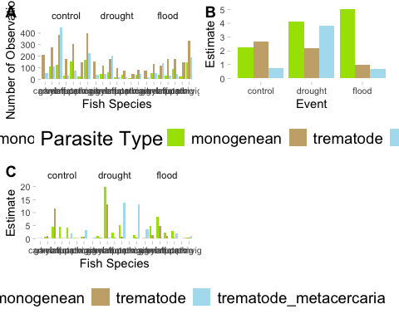

Drop carvel and pervig from analysis since they do not have monos and metas consistently
drought_flood_df_a_only_full <- drought_flood_df_a %>%
filter(!fish_sp_x %in% c("pervig", "carvel"))
# plot new raw data
# how many replicates are in each category--> this is just the number of occurrences, not abundance of parasites
dfa.reps <- drought_flood_df_a_only_full %>%
group_by(event, category, psite_type, fish_sp_x) %>%
summarize(observations = n(), .groups = "drop")
# plot how many of each category we have
raw1_f <- ggplot(dfa.reps,
aes(x = fish_sp_x, y = observations, fill = psite_type)) +
facet_wrap(~ event) +
geom_col(position = "dodge") +
scale_fill_manual(values = c("trematode_metacercaria" = "#AFDFEF", "monogenean" = "#A6E000", "trematode" = "#c9ad79", "myxozoan" = "#07c3c5")) +
labs(x = "Fish Species", y = "Number of Observations", fill = "Parasite Type", linetype = "Parasite Type") +
connor_theme
# hurricane abundance with parasite type --> average abundances
dfa.bins1 <- drought_flood_df_a_only_full %>%
group_by(event, category, psite_type) %>%
summarize(avg.bin = mean(psite_abundance))
# use this as the raw plot of data
raw2_f <- ggplot(dfa.bins1,
aes(x = event, y = avg.bin, fill = psite_type)) +
geom_col(position = "dodge") +
scale_fill_manual(values = c("trematode_metacercaria" = "#AFDFEF", "monogenean" = "#A6E000", "trematode" = "#c9ad79", "myxozoan" = "#07c3c5")) +
labs(x = "Event", y = "Average Parasite Abundance", fill = "Parasite Type", linetype = "Parasite Type") +
connor_theme
# hurricane abundance with fish species and parasite type
dfa.bins2 <- drought_flood_df_a_only_full %>%
group_by(event, category, psite_type, fish_sp_x) %>%
summarize(avg.bin = mean(psite_abundance))
# use this as the raw plot of data
raw3_f <- ggplot(dfa.bins2,
aes(x = fish_sp_x, y = avg.bin, fill = psite_type)) +
facet_wrap(~ event) +
geom_col(position = "dodge") +
scale_fill_manual(values = c("trematode_metacercaria" = "#AFDFEF", "monogenean" = "#A6E000", "trematode" = "#c9ad79", "myxozoan" = "#07c3c5")) +
labs(x = "Fish Species", y = "Average Parasite Abundance", fill = "Parasite Type", linetype = "Parasite Type") +
connor_theme
df_abundance_raw_only_full <- ggarrange(raw1_f, raw2_f, raw3_f, common.legend = FALSE, legend = "bottom", labels = c("A", "B", "C"))
plot(df_abundance_raw_only_full)
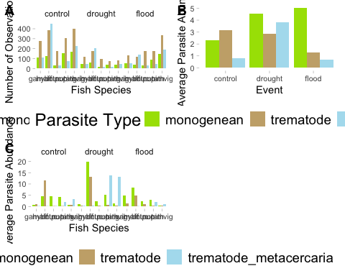 ## Seasonality influencing distribution of abundance
# month and day against number of replicates
hp.season <- drought_flood_df_a %>%
group_by(event, psite_type, fish_sp_x, season, month_day, year_collected) %>%
summarize(observations = n(), .groups = "drop")
# insert a dummy year as an anchor
hp.season <- hp.season %>%
mutate(month_day_date = as.Date(paste0("2025-", month_day), format = "%Y-%m-%d"))
hp.season$month_day_date <- as.Date(format(as.Date(hp.season$month_day_date), "2025-%m-%d"))
range(hp.season$month_day_date)
## [1] "2025-01-02" "2025-12-26"
ggplot(hp.season,
aes(x = month_day_date, y = event, fill = psite_type)) +
geom_violin(scale = "count", trim = FALSE) +
geom_point(position = position_jitter(height = 0.2), shape = 21, size = 3, stroke = 0.2) +
scale_x_date(
limits = as.Date(c("2025-01-03", "2025-12-26")),
date_labels = "%b",
date_breaks = "1 month",
expand = c(0.01, 0)
) +
scale_fill_manual(values = c(
"trematode_metacercaria" = "#AFDFEF",
"monogenean" = "#A6E000",
"trematode" = "#c9ad79",
"myxozoan" = "#07c3c5"
)) +
labs(x = "Month", y = "Event", fill = "Parasite Type") +
connor_theme
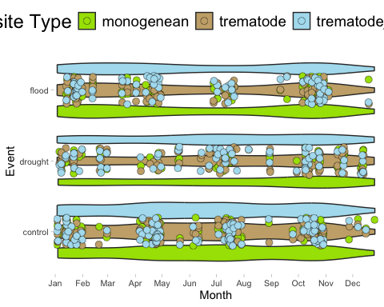

Abundance Models

3 parasite types

Final d/f abundance model
df_abundance_final <- glmmTMB(psite_abundance ~ event*psite_type + ci + (1|catalog_number) + (1|year_collected/season) + (1|fish_psite_combo) + (1|fish_sp_x) + (total_length_mm|fish_psite_combo),
ziformula = ~ event*psite_type + ci + (1|catalog_number) + (1|year_collected/season) + (1|fish_psite_combo) + (1|fish_sp_x) + (total_length_mm|fish_psite_combo),
family = nbinom2, data = drought_flood_df_a_only_full)
simulateResiduals(fittedModel = df_abundance_final, plot = TRUE)
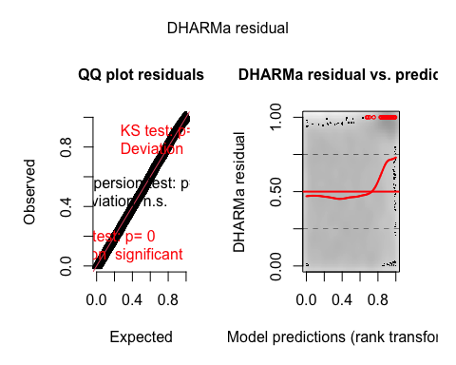
## Object of Class DHARMa with simulated residuals based on 250 simulations with refit = FALSE . See ?DHARMa::simulateResiduals for help.
##
## Scaled residual values: 0.7429804 0.3097278 0.3458804 0.2662832 0.02915258 0.494854 0.4441431 0.2363197 0.6723974 0.3464762 0.5848966 0.8912816 0.3383701 0.9591969 0.7044895 0.01895927 0.630841 0.00233403 0.7468449 0.8888913 ...
summary(df_abundance_final)
## Family: nbinom2 ( log )
## Formula:
## psite_abundance ~ event * psite_type + ci + (1 | catalog_number) +
## (1 | year_collected/season) + (1 | fish_psite_combo) + (1 |
## fish_sp_x) + (total_length_mm | fish_psite_combo)
## Zero inflation:
## ~event * psite_type + ci + (1 | catalog_number) + (1 | year_collected/season) +
## (1 | fish_psite_combo) + (1 | fish_sp_x) + (total_length_mm |
## fish_psite_combo)
## Data: drought_flood_df_a_only_full
##
## AIC BIC logLik deviance df.resid
## 12444.4 12713.6 -6185.2 12370.4 10629
##
## Random effects:
##
## Conditional model:
## Groups Name Variance Std.Dev. Corr
## catalog_number (Intercept) 3.026e-01 5.501e-01
## season.year_collected (Intercept) 3.866e-02 1.966e-01
## year_collected (Intercept) 9.873e-02 3.142e-01
## fish_psite_combo (Intercept) 5.291e-01 7.274e-01
## fish_sp_x (Intercept) 4.636e-09 6.809e-05
## fish_psite_combo.1 (Intercept) 5.237e+00 2.289e+00
## total_length_mm 5.170e-04 2.274e-02 -0.90
## Number of obs: 10666, groups:
## catalog_number, 255; season:year_collected, 115; year_collected, 43; fish_psite_combo, 60; fish_sp_x, 5
##
## Zero-inflation model:
## Groups Name Variance Std.Dev. Corr
## catalog_number (Intercept) 5.536e-01 7.441e-01
## season.year_collected (Intercept) 1.950e-01 4.416e-01
## year_collected (Intercept) 5.745e-08 2.397e-04
## fish_psite_combo (Intercept) 1.167e+00 1.080e+00
## fish_sp_x (Intercept) 6.394e-09 7.996e-05
## fish_psite_combo.1 (Intercept) 1.350e+00 1.162e+00
## total_length_mm 4.890e-04 2.211e-02 -0.11
## Number of obs: 10666, groups:
## catalog_number, 255; season:year_collected, 115; year_collected, 43; fish_psite_combo, 60; fish_sp_x, 5
##
## Dispersion parameter for nbinom2 family (): 0.594
##
## Conditional model:
## Estimate Std. Error z value
## (Intercept) 0.79672 0.51190 1.556
## eventdrought -0.48488 0.24930 -1.945
## eventflood -0.40222 0.22506 -1.787
## psite_typetrematode -0.90324 0.57811 -1.562
## psite_typetrematode_metacercaria -1.34466 0.64944 -2.071
## ciimpact 0.07272 0.13063 0.557
## eventdrought:psite_typetrematode 0.54120 0.27001 2.004
## eventflood:psite_typetrematode 0.28748 0.25542 1.126
## eventdrought:psite_typetrematode_metacercaria 1.85713 0.32523 5.710
## eventflood:psite_typetrematode_metacercaria 0.78747 0.30130 2.614
## Pr(>|z|)
## (Intercept) 0.11961
## eventdrought 0.05178 .
## eventflood 0.07391 .
## psite_typetrematode 0.11819
## psite_typetrematode_metacercaria 0.03840 *
## ciimpact 0.57776
## eventdrought:psite_typetrematode 0.04504 *
## eventflood:psite_typetrematode 0.26037
## eventdrought:psite_typetrematode_metacercaria 1.13e-08 ***
## eventflood:psite_typetrematode_metacercaria 0.00896 **
## ---
## Signif. codes: 0 '***' 0.001 '**' 0.01 '*' 0.05 '.' 0.1 ' ' 1
##
## Zero-inflation model:
## Estimate Std. Error z value
## (Intercept) 1.7157 0.6686 2.566
## eventdrought -0.8043 0.3939 -2.042
## eventflood -0.6492 0.3646 -1.780
## psite_typetrematode 1.2628 0.7865 1.606
## psite_typetrematode_metacercaria 0.5151 0.8369 0.615
## ciimpact 0.1255 0.1751 0.717
## eventdrought:psite_typetrematode 1.0749 0.4287 2.507
## eventflood:psite_typetrematode -0.2574 0.4037 -0.638
## eventdrought:psite_typetrematode_metacercaria 1.4622 0.4789 3.053
## eventflood:psite_typetrematode_metacercaria 0.8047 0.4435 1.815
## Pr(>|z|)
## (Intercept) 0.01028 *
## eventdrought 0.04116 *
## eventflood 0.07500 .
## psite_typetrematode 0.10834
## psite_typetrematode_metacercaria 0.53829
## ciimpact 0.47346
## eventdrought:psite_typetrematode 0.01217 *
## eventflood:psite_typetrematode 0.52369
## eventdrought:psite_typetrematode_metacercaria 0.00226 **
## eventflood:psite_typetrematode_metacercaria 0.06959 .
## ---
## Signif. codes: 0 '***' 0.001 '**' 0.01 '*' 0.05 '.' 0.1 ' ' 1
plot(parameters(df_abundance_final))
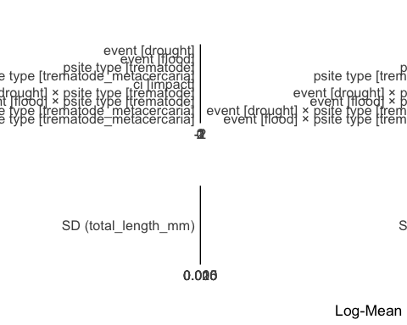 # Plots - abundance
df1a <- ggpredict(df_abundance_final, terms = c("psite_type", "event"))
df1a <- df1a %>%
rename(
psite_type = x,
estimate = predicted,
se = std.error,
lower = conf.low,
upper = conf.high,
event = group)
# add significance bars
meta_sig_df <- data.frame(
group1 = c("control", "control", "control"),
group2 = c("drought", "drought", "flood"),
psite_type = c("trematode", "trematode_metacercaria", "trematode_metacercaria"),
y.position = c(6, 7, 8),
p.value = c(0.04806, 0.0000000147, 0.00559)
)
meta_sig_df <- meta_sig_df %>%
mutate(
stars = cut(p.value,
breaks = c(-Inf, 0.001, 0.01, 0.05, Inf),
labels = c("***", "**", "*", "ns"))
)
dodge_offset <- 0.16
meta_sig_df_dodged <- meta_sig_df %>%
filter(psite_type == "trematode_metacercaria") %>%
mutate(
xmin = as.numeric(factor(group1, levels = c("control", "drought", "flood"))) + dodge_offset,
xmax = as.numeric(factor(group2, levels = c("control", "drought", "flood"))) + dodge_offset
)
meta_sig_df_nododge <- meta_sig_df %>%
filter(psite_type == "trematode") %>%
mutate(
xmin = as.numeric(factor(group1, levels = c("control", "drought", "flood"))),
xmax = as.numeric(factor(group2, levels = c("control", "drought", "flood")))
)
# plot df1a
df1a <- ggplot(df1a,
aes(x = event, y = estimate)) +
geom_errorbar(aes(ymin = lower, ymax = upper, group = psite_type),
width = 0.05,
position = position_dodge(width = 0.5)) +
geom_line(aes(group = psite_type, linetype = psite_type),
position = position_dodge(width = 0.5)) +
geom_point(aes(fill = psite_type, group = psite_type),
pch = 21, size = 5,
position = position_dodge(width = 0.5)) +
scale_fill_manual(values = c("trematode_metacercaria" = "#AFDFEF", "monogenean" = "#A6E000", "trematode" = "#c9ad79", "myxozoan" = "#07c3c5")) +
scale_y_continuous(limits = c(0, 8), breaks = seq(0, 8, by = 2)) +
labs(x = "Event", y = "Estimate", fill = "Parasite Type", linetype = "Parasite Type") +
connor_theme +
stat_pvalue_manual(
data = meta_sig_df_dodged,
label = "stars",
xmin = "xmin",
xmax = "xmax",
y.position = "y.position",
tip.length = 0.01
) +
stat_pvalue_manual(
data = meta_sig_df_nododge,
label = "stars",
xmin = "xmin",
xmax = "xmax",
y.position = "y.position",
tip.length = 0.01
)

Plot abundance model and raw data next to each other
df_abundance_raw_and_model <- ggarrange(df1a, raw2_f, common.legend = FALSE, legend = "bottom", labels = c("A", "B"))
plot(df_abundance_raw_and_model)
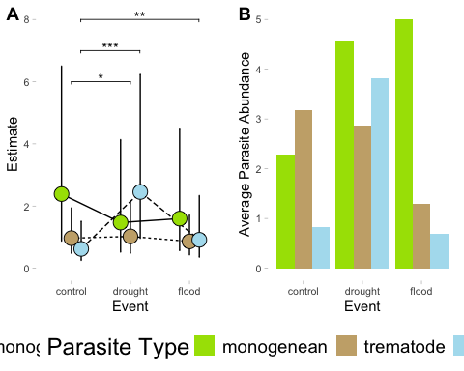
# Why don't raw and modeled data look the same?
# mono result is opposite the raw data
# trem result is roughly the same, but control should be higher than drought in the raw
# meta result is mostly fine, but flood should be higher than control in the raw
# let's look again at our raw data from above
plot(raw3_f)
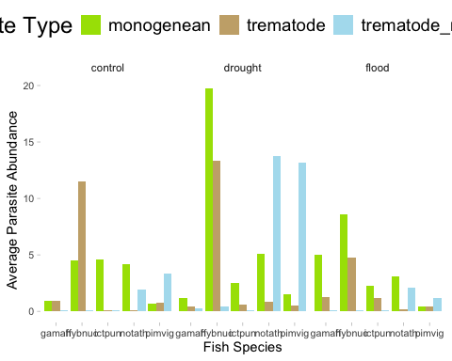
# looks like hybnuc in both drought and flood have very high counts of monogenes, let's remove hybog from the raw data and see if it more closely matches the expected model result
no_hybnuc <- drought_flood_df_a_only_full %>%
group_by(event, category, psite_type, fish_sp_x) %>%
summarize(avg.bin = mean(psite_abundance))
no_hybnuc <- no_hybnuc %>%
filter(!fish_sp_x %in% c("hybnuc"))
no_hn <- ggplot(no_hybnuc,
aes(x = event, y = avg.bin, fill = psite_type)) +
geom_col(position = "dodge") +
scale_fill_manual(values = c("trematode_metacercaria" = "#AFDFEF", "monogenean" = "#A6E000", "trematode" = "#c9ad79", "myxozoan" = "#07c3c5")) +
labs(x = "Event", y = "Average Parasite Abundance", fill = "Parasite Type", linetype = "Parasite Type") +
connor_theme
# plot this no-hybnuc result next to the model plot
df_abundance_raw_and_model_corrected <- ggarrange(df1a, no_hn, common.legend = FALSE, legend = "bottom", labels = c("A", "B"))
plot(df_abundance_raw_and_model_corrected)
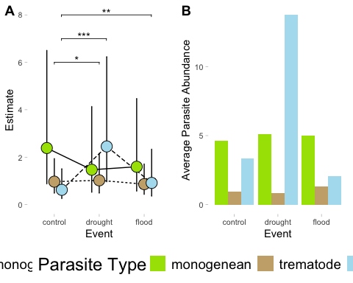
# it helps, but does not fix the problem entirely, but maybe it is ok?

Zero inflated results plotted - abundance
#### A
azi1 <- ggemmeans(df_abundance_final, terms = c("psite_type", "event"), component = "zi")
azi1 <- azi1 %>%
rename(
psite_type = x,
estimate = predicted,
se = std.error,
lower = conf.low,
upper = conf.high,
event = group
)
azi1p <- ggplot(azi1, aes(x = event, y = estimate)) +
geom_errorbar(aes(ymin = lower, ymax = upper, group = psite_type),
width = 0.05,
position = position_dodge(0.5)) +
geom_line(aes(group = psite_type, linetype = psite_type),
position = position_dodge(0.5)) +
geom_point(aes(fill = psite_type, group = psite_type),
pch = 21, size = 5,
position = position_dodge(0.5)) +
scale_fill_manual(values = c("trematode_metacercaria" = "#AFDFEF",
"monogenean" = "#A6E000",
"trematode" = "#c9ad79",
"myxozoan" = "#07c3c5")) +
scale_y_continuous(limits = c(0, 80), breaks = seq(0, 80, 10)) +
labs(x = "Event",
y = "Zero-Inflation Estimate",
fill = "Parasite Type",
linetype = "Parasite Type") +
connor_theme
#### C
azi3 <- ggemmeans(df_abundance_final, terms = c("psite_type", "event"), component = "zi")
azi3 <- azi3 %>%
rename(
psite_type = x,
estimate = predicted,
se = std.error,
lower = conf.low,
upper = conf.high,
event = group
)
azi3 <- azi3 %>%
filter(psite_type %in% c("trematode"))
azi3p <- ggplot(azi3,
aes(x = event, y = estimate)) +
geom_errorbar(aes(ymin = lower, ymax = upper, group = event),
width = 0.05,
position = position_dodge(width = 0.5)) +
geom_line(aes(group = psite_type, linetype = psite_type),
position = position_dodge(width = 0.5)) +
geom_point(aes(fill = psite_type, group = psite_type),
pch = 21, size = 5,
position = position_dodge(width = 0.5)) +
scale_fill_manual(values = c("trematode_metacercaria" = "#AFDFEF", "monogenean" = "#A6E000", "trematode" = "#c9ad79", "myxozoan" = "#07c3c5")) +
scale_y_continuous(limits = c(0, 80), breaks = seq(0, 80, 10)) +
labs(x = "Event", y = "Zero-Inflation Estimate", fill = "Parasite Type", linetype = "Parasite Type") +
connor_theme
#### E
azi5 <- ggemmeans(df_abundance_final, terms = c("psite_type", "event"), component = "zi")
azi5 <- azi5 %>%
rename(
psite_type = x,
estimate = predicted,
se = std.error,
lower = conf.low,
upper = conf.high,
event = group
)
azi5 <- azi5 %>%
filter(psite_type %in% c("trematode_metacercaria"))
azi5p <- ggplot(azi5,
aes(x = event, y = estimate)) +
geom_errorbar(aes(ymin = lower, ymax = upper, group = event),
width = 0.05,
position = position_dodge(width = 0.5)) +
geom_line(aes(group = psite_type, linetype = psite_type),
position = position_dodge(width = 0.5)) +
geom_point(aes(fill = psite_type, group = psite_type),
pch = 21, size = 5,
position = position_dodge(width = 0.5)) +
scale_fill_manual(values = c("trematode_metacercaria" = "#AFDFEF", "monogenean" = "#A6E000", "trematode" = "#c9ad79", "myxozoan" = "#07c3c5")) +
scale_y_continuous(limits = c(0, 60), breaks = seq(0, 60, 10)) +
labs(x = "Event", y = "Zero-Inflation Estimate", fill = "Parasite Type", linetype = "Parasite Type") +
connor_theme
# try to plot only monos
azi6 <- ggemmeans(df_abundance_final, terms = c("psite_type", "event"), component = "zi")
azi6 <- azi6 %>%
rename(
psite_type = x,
estimate = predicted,
se = std.error,
lower = conf.low,
upper = conf.high,
event = group
)
azi6 <- azi6 %>%
filter(psite_type %in% c("monogenean"))
azi6p <- ggplot(azi6,
aes(x = event, y = estimate)) +
geom_errorbar(aes(ymin = lower, ymax = upper, group = event),
width = 0.05,
position = position_dodge(width = 0.5)) +
geom_line(aes(group = psite_type, linetype = psite_type),
position = position_dodge(width = 0.5)) +
geom_point(aes(fill = psite_type, group = psite_type),
pch = 21, size = 5,
position = position_dodge(width = 0.5)) +
scale_fill_manual(values = c("trematode_metacercaria" = "#AFDFEF", "monogenean" = "#A6E000", "trematode" = "#c9ad79", "myxozoan" = "#07c3c5")) +
scale_y_continuous(limits = c(0, 40), breaks = seq(0, 40, 10)) +
labs(x = "Event", y = "Zero-Inflation Estimate", fill = "Parasite Type", linetype = "Parasite Type") +
connor_theme
df_abundance_plot_zi <- ggarrange(azi1p, azi3p, azi5p, azi6p, common.legend = FALSE, legend = "bottom", labels = c("A", "B", "C", "D", "E", "F"))
plot(df_abundance_plot_zi)
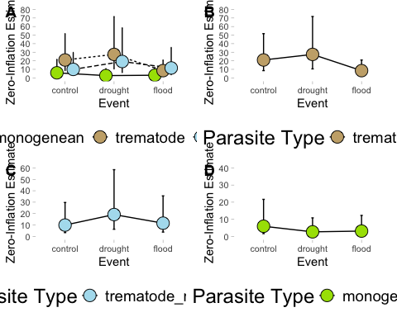

Prevalence
Plot raw data (as averages not sums) to identify any trends in the data or inconsistencies.
# how many replicates are in each category --> this is just the number of occurrences, not abundance of parasites
dfp.reps <- drought_flood_df_m %>%
group_by(event, psite_type, fish_sp_x) %>%
summarize(observations = n(), .groups = "drop")
# plot how many of each category we have
raw1p <- ggplot(dfp.reps,
aes(x = fish_sp_x, y = observations, fill = psite_type)) +
facet_wrap(~ event) +
geom_col(position = "dodge") +
scale_fill_manual(values = c("trematode_metacercaria" = "#AFDFEF", "monogenean" = "#A6E000", "trematode" = "#c9ad79", "myxozoan" = "#07c3c5")) +
labs(x = "Fish Species", y = "Number of Observations", fill = "Parasite Type", linetype = "Parasite Type") +
connor_theme
# hurricane abundance with parasite type
dfp.bins1 <- drought_flood_df_m %>%
group_by(event, psite_type) %>%
summarize(avg.bin = mean(psite_prevalence))
# use this as the raw plot of data
raw2p <- ggplot(dfp.bins1,
aes(x = event, y = avg.bin, fill = psite_type)) +
geom_col(position = "dodge") +
scale_fill_manual(values = c("trematode_metacercaria" = "#AFDFEF", "monogenean" = "#A6E000", "trematode" = "#c9ad79", "myxozoan" = "#07c3c5")) +
labs(x = "Event", y = "Estimate", fill = "Parasite Type", linetype = "Parasite Type") +
connor_theme
# hurricane abundance with fish species and parasite type
dfp.bins2 <- drought_flood_df_m %>%
group_by(event, psite_type, fish_sp_x) %>%
summarize(avg.bin = mean(psite_prevalence))
# use this as the raw plot of data
raw3p <- ggplot(dfp.bins2,
aes(x = fish_sp_x, y = avg.bin, fill = psite_type)) +
facet_wrap(~ event) +
geom_col(position = "dodge") +
scale_fill_manual(values = c("trematode_metacercaria" = "#AFDFEF", "monogenean" = "#A6E000", "trematode" = "#c9ad79", "myxozoan" = "#07c3c5")) +
labs(x = "Fish Species", y = "Estimate", fill = "Parasite Type", linetype = "Parasite Type") +
connor_theme
df_prevalence_raw <- ggarrange(raw1p, raw2p, raw3p, common.legend = FALSE, legend = "bottom", labels = c("A", "B", "C"))
plot(df_prevalence_raw)
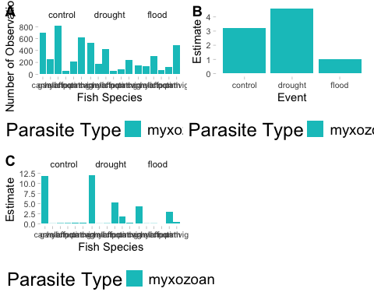
# no myxos in percina -- is already not in the database

Seasonality influencing distribution - prevalence
# month and day against number of replicates
hp.season <- drought_flood_df_m %>%
group_by(event, psite_type, fish_sp_x, season, month_day, year_collected) %>%
summarize(observations = n(), .groups = "drop")
# insert a dummy year as an anchor
hp.season <- hp.season %>%
mutate(month_day_date = as.Date(paste0("2025-", month_day), format = "%Y-%m-%d"))
hp.season$month_day_date <- as.Date(format(as.Date(hp.season$month_day_date), "2025-%m-%d"))
range(hp.season$month_day_date)
## [1] "2025-01-03" "2025-12-26"
ggplot(hp.season,
aes(x = month_day_date, y = event, fill = psite_type)) +
geom_violin(scale = "count", trim = FALSE) +
geom_point(position = position_jitter(height = 0.2), shape = 21, size = 3, stroke = 0.2) +
scale_x_date(
limits = as.Date(c("2025-01-03", "2025-12-26")),
date_labels = "%b",
date_breaks = "1 month",
expand = c(0.01, 0)
) +
scale_fill_manual(values = c(
"trematode_metacercaria" = "#AFDFEF",
"monogenean" = "#A6E000",
"trematode" = "#c9ad79",
"myxozoan" = "#07c3c5"
)) +
labs(x = "Month", y = "Event", fill = "Parasite Type") +
connor_theme
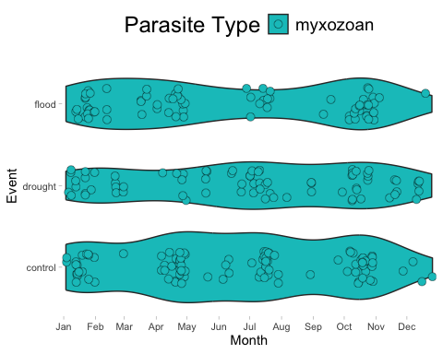 ## Prevalence model validation

Final prevalence model drought/flood
# this model is the best fit
df_prevalence_final <- glmmTMB(psite_prevalence ~ event + ci + (1|catalog_number) + (1|year_collected/season) + (1|fish_sp_x) + offset(log(total_length_mm)),
ziformula = ~ event + ci + (1|catalog_number) + (1|year_collected/season) + (1|fish_sp_x) + offset(sqrt(total_length_mm)),
family = nbinom12, data = drought_flood_df_m)
simulateResiduals(fittedModel = df_prevalence_final, plot = TRUE)
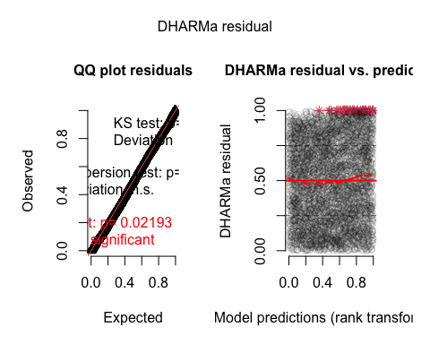
## Object of Class DHARMa with simulated residuals based on 250 simulations with refit = FALSE . See ?DHARMa::simulateResiduals for help.
##
## Scaled residual values: 0.1650445 0.8258987 0.4906368 0.3445184 0.8784017 0.8713615 0.8433402 0.6721203 0.4752281 0.7144619 0.577672 0.265229 0.03668349 0.3493907 0.8633896 0.3156644 0.5930435 0.6409122 0.4153022 0.2005697 ...
summary(df_prevalence_final)
## Family: nbinom12 ( log )
## Formula:
## psite_prevalence ~ event + ci + (1 | catalog_number) + (1 | year_collected/season) +
## (1 | fish_sp_x) + offset(log(total_length_mm))
## Zero inflation:
## ~event + ci + (1 | catalog_number) + (1 | year_collected/season) +
## (1 | fish_sp_x) + offset(sqrt(total_length_mm))
## Data: drought_flood_df_m
##
## AIC BIC logLik deviance df.resid
## 4800.2 4919.1 -2382.1 4764.2 5431
##
## Random effects:
##
## Conditional model:
## Groups Name Variance Std.Dev.
## catalog_number (Intercept) 7.620e-01 0.872930
## season:year_collected (Intercept) 2.730e-01 0.522519
## year_collected (Intercept) 3.740e-06 0.001934
## fish_sp_x (Intercept) 2.634e+00 1.622863
## Number of obs: 5449, groups:
## catalog_number, 306; season:year_collected, 123; year_collected, 43; fish_sp_x, 6
##
## Zero-inflation model:
## Groups Name Variance Std.Dev.
## catalog_number (Intercept) 3.313e-15 5.756e-08
## season:year_collected (Intercept) 8.103e-01 9.001e-01
## year_collected (Intercept) 5.591e-19 7.477e-10
## fish_sp_x (Intercept) 5.306e-01 7.284e-01
## Number of obs: 5449, groups:
## catalog_number, 306; season:year_collected, 123; year_collected, 43; fish_sp_x, 6
##
## Dispersion parameter for nbinom12 family (): 9.06e-09
##
## Conditional model:
## Estimate Std. Error z value Pr(>|z|)
## (Intercept) -4.8425 0.7759 -6.241 4.34e-10 ***
## eventdrought 0.5621 0.4896 1.148 0.251
## eventflood 0.2431 0.4814 0.505 0.614
## ciimpact 0.2440 0.3642 0.670 0.503
## ---
## Signif. codes: 0 '***' 0.001 '**' 0.01 '*' 0.05 '.' 0.1 ' ' 1
##
## Zero-inflation model:
## Estimate Std. Error z value Pr(>|z|)
## (Intercept) -8.5656 0.8707 -9.837 <2e-16 ***
## eventdrought 0.4733 0.7000 0.676 0.499
## eventflood 0.1090 0.7005 0.156 0.876
## ciimpact 0.4163 0.5029 0.828 0.408
## ---
## Signif. codes: 0 '***' 0.001 '**' 0.01 '*' 0.05 '.' 0.1 ' ' 1
plot(parameters(df_prevalence_final))
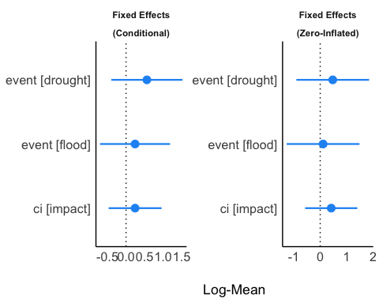

Plots – d/f prevalence
#### prevalence plot
df1p <- ggpredict(df_prevalence_final, terms = c("event"))
df1p <- df1p %>%
rename(
event = x,
estimate = predicted,
se = std.error,
lower = conf.low,
upper = conf.high)
df_f <- ggplot(df1p,
aes(x = event, y = estimate)) +
geom_errorbar(aes(ymin = lower, ymax = upper, group = event),
width = 0.05,
position = position_dodge(width = 0.5)) +
geom_point(aes(fill = event, group = event),
pch = 21, size = 5,
position = position_dodge(width = 0.5)) +
scale_fill_manual(values = c("drought" = "#D84D16", "flood" = "#1BB6AF","control" = "#F4B95A", "impact" = "#FF69B4")) +
scale_y_continuous(limits = c(0, 5), breaks = seq(0, 5, 2)) +
labs(x = "Event", y = "Estimate", fill = "Event") +
connor_theme
PLot prevalence model and raw data together
df_prevalence_raw_and_model <- ggarrange(df_f, raw2p, common.legend = FALSE, legend = "bottom", labels = c("A", "B"))
plot(df_prevalence_raw_and_model)
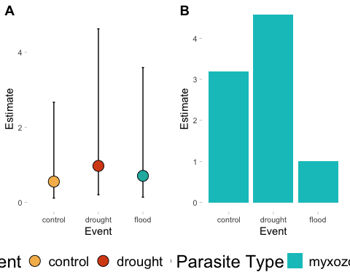
# control and flood do not match raw estimate to predicted (should be flipped)
# let's look again at our raw data from above
plot(raw1p)
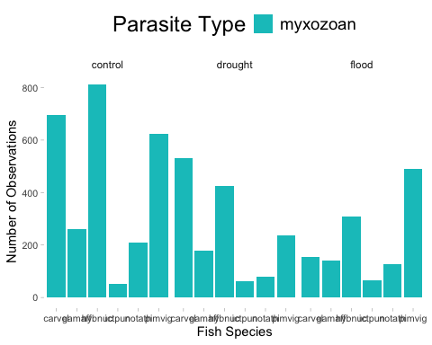
# looks like hybnuc and carvel in control have very high counts of myxos, let's remove hybog from the raw data and see if it more closely matches the expected model result
no_hybnuc <- drought_flood_df_m %>%
group_by(event, category, psite_type, fish_sp_x) %>%
summarize(avg.bin = mean(psite_prevalence))
no_hybnuc <- no_hybnuc %>%
filter(!fish_sp_x %in% c("hybnuc", "carvel"))
no_hn <- ggplot(no_hybnuc,
aes(x = event, y = avg.bin, fill = psite_type)) +
geom_col(position = "dodge") +
scale_fill_manual(values = c("trematode_metacercaria" = "#AFDFEF", "monogenean" = "#A6E000", "trematode" = "#c9ad79", "myxozoan" = "#07c3c5")) +
labs(x = "Event", y = "Average Parasite Abundance", fill = "Parasite Type", linetype = "Parasite Type") +
connor_theme
# plot this no-hybnuc result next to the model plot
df_prevalence_raw_and_model_corrected <- ggarrange(df_f, no_hn, common.legend = FALSE, legend = "bottom", labels = c("A", "B"))
plot(df_prevalence_raw_and_model_corrected)
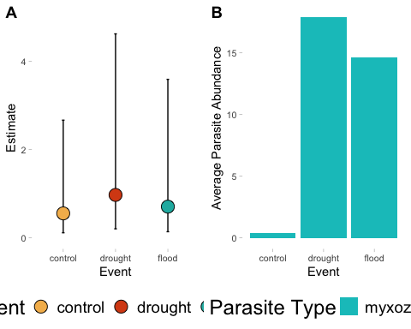
# the data is now technically correct and matches

Zero Inflated prevalence plots
pzi1 <- ggemmeans(df_prevalence_final, terms = c("event"), component = "zi")
pzi1 <- pzi1 %>%
rename(
event = x,
estimate = predicted,
se = std.error,
lower = conf.low,
upper = conf.high,
psite_type = group
) %>%
mutate(psite_type = ifelse(psite_type == "1", "myxozoan", psite_type)) %>%
drop_na()
pzi1p <- ggplot(pzi1,
aes(x = event, y = estimate)) +
geom_errorbar(aes(ymin = lower, ymax = upper, group = event),
width = 0.05,
position = position_dodge(width = 0.5)) +
geom_point(aes(fill = event, group = event),
pch = 21, size = 5,
position = position_dodge(width = 0.5)) +
scale_fill_manual(values = c("drought" = "#D84D16", "flood" = "#1BB6AF","control" = "#F4B95A", "impact" = "#FF69B4")) +
scale_y_continuous(limits = c(0, 5), breaks = seq(0, 5, 2)) +
labs(x = "Event", y = "Zero Inflation Estimate", fill = "Event") +
connor_theme
df_prevalence_plot_zi <- ggarrange(pzi1p, common.legend = FALSE, legend = "bottom", labels = c("A"))
plot(df_prevalence_plot_zi)
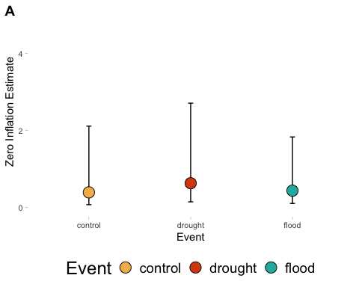 ## Plot Zi and conditional model outputs together – prevalence
df_prevalence_plot_total <- ggarrange(df_f, pzi1p, common.legend = TRUE, legend = "bottom", labels = c("A", "B"))
plot(df_prevalence_plot_total)
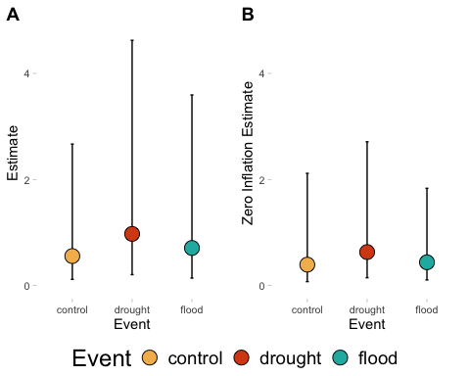

Estimating Biodiversity Changes
Jackknife estimates
# create DF for biodiversity estimates -- drop species that have very low replication, so kick out all cilliate, nematomorph, leech, copepod observations (but lets keep in nematodes, cestodes, and acanths)
# Remove unwanted parasite types and drop their factor levels
df_biodiv_df <- drought_flood_df %>%
filter(!psite_type %in% c("nematomorph", "ciliate", "leech", "copepod")) %>%
droplevels()
# these are already absent from the drought_flood_df
# Get all unique combinations of grouping variables
group_combos <- unique(df_biodiv_df[, c("event", "ci", "psite_type", "fish_sp_x", "psite_spp_y")])
# Empty results data frame
jackknife_results <- data.frame(
event = character(),
ci = character(),
psite_type = character(),
fish_sp_x = character(),
psite_spp_y = character(),
jackknife_mean_richness = numeric(),
total_psite_count = numeric(),
stringsAsFactors = FALSE
)
# Loop over each combination
for (i in 1:nrow(group_combos)) {
event <- group_combos$event[i]
ci <- group_combos$ci[i]
psite <- group_combos$psite_type[i]
fish <- group_combos$fish_sp_x[i]
rich <- group_combos$psite_spp_y[i]
# Safe subsetting using which()
sub_df <- df_biodiv_df[which(
df_biodiv_df$event == event &
df_biodiv_df$ci == ci &
df_biodiv_df$psite_type == psite &
df_biodiv_df$fish_sp_x == fish &
df_biodiv_df$psite_spp_y == rich
), ]
# Remove 0-counts
sub_df <- sub_df[sub_df$psite_count != 0, ]
# Skip if no data
if (nrow(sub_df) == 0) next
# Unique samples
sample_ids <- unique(sub_df$x)
richness_values <- numeric(length(sample_ids))
for (j in seq_along(sample_ids)) {
id_to_leave_out <- sample_ids[j]
df_minus_one <- sub_df[sub_df$x != id_to_leave_out, ]
richness_values[j] <- length(unique(df_minus_one$psite_spp_x))
}
total_count <- sum(sub_df$psite_count, na.rm = TRUE)
jackknife_results <- rbind(jackknife_results, data.frame(
event = event,
ci = ci,
psite_type = as.character(psite),
fish_sp_x = as.character(fish),
psite_spp_y = as.character(rich),
jackknife_mean_richness = mean(richness_values),
total_psite_count = total_count
))
}
# Remove incomplete rows
jackknife_results <- jackknife_results[complete.cases(jackknife_results), ]
# create plots for the variety of combinations of factors we want to investigate
# event
ggplot(jackknife_results,
aes(x = psite_type, y = jackknife_mean_richness, fill = psite_type)) +
geom_col(position = "dodge") +
facet_wrap(~ event) +
theme_minimal(base_size = 12) +
labs(
x = "Fish species",
y = "Mean Parasite Richness (Jackknife)",
fill = "Parasite type"
) + connor_theme
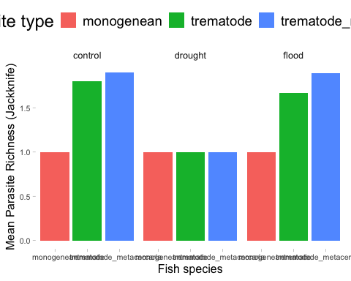

Plot jacknife estimates
ggplot(jackknife_results,
aes(x = psite_type, y = jackknife_mean_richness, fill = psite_spp_y)) +
geom_col(position = "dodge") +
facet_wrap(timing ~ event) +
theme_minimal(base_size = 12) +
labs(
x = "Fish species",
y = "Mean Parasite Richness (Jackknife)",
fill = "Parasite type"
) + connor_theme
# trim df to be one df for each type of parasite
acanths <- jackknife_results %>%
filter(psite_type %in% c("acanthocephalan")) %>%
droplevels()
jk_a <- ggplot(jackknife_results,
aes(x = timing, y = jackknife_mean_richness, fill = psite_spp_y)) +
geom_col(position = "dodge") +
facet_wrap(~ event) +
theme_minimal(base_size = 12) +
labs(
x = "Fish species",
y = "Mean Parasite Richness (Jackknife)",
fill = "Parasite type"
) + connor_theme + guides(fill = "none")
nems <- jackknife_results %>%
filter(psite_type %in% c("nematode")) %>%
droplevels()
jk_n <- ggplot(nems,
aes(x = timing, y = jackknife_mean_richness, fill = psite_spp_y)) +
geom_col(position = "dodge") +
facet_wrap(~ event) +
theme_minimal(base_size = 12) +
labs(
x = "Fish species",
y = "Mean Parasite Richness (Jackknife)",
fill = "Parasite type"
) + connor_theme + guides(fill = "none")
cest <- jackknife_results %>%
filter(psite_type %in% c("cestode")) %>%
droplevels()
jk_c <- ggplot(cest,
aes(x = timing, y = jackknife_mean_richness, fill = psite_spp_y)) +
geom_col(position = "dodge") +
facet_wrap(~ event) +
theme_minimal(base_size = 12) +
labs(
x = "Fish species",
y = "Mean Parasite Richness (Jackknife)",
fill = "Parasite type"
) + connor_theme + guides(fill = "none")
trem <- jackknife_results %>%
filter(psite_type %in% c("trematode")) %>%
droplevels()
jk_t <- ggplot(trem,
aes(x = timing, y = jackknife_mean_richness, fill = psite_spp_y)) +
geom_col(position = "dodge") +
facet_wrap(~ event) +
theme_minimal(base_size = 12) +
labs(
x = "Fish species",
y = "Mean Parasite Richness (Jackknife)",
fill = "Parasite type"
) + connor_theme + guides(fill = "none")
trem_meta <- jackknife_results %>%
filter(psite_type %in% c("trematode_metacercaria")) %>%
droplevels()
jk_tm <- ggplot(trem_meta,
aes(x = timing, y = jackknife_mean_richness, fill = psite_spp_y)) +
geom_col(position = "dodge") +
facet_wrap(~ event) +
theme_minimal(base_size = 12) +
labs(
x = "Fish species",
y = "Mean Parasite Richness (Jackknife)",
fill = "Parasite type"
) + connor_theme + guides(fill = "none")
mono <- jackknife_results %>%
filter(psite_type %in% c("monogenean")) %>%
droplevels()
jk_mono <- ggplot(mono,
aes(x = timing, y = jackknife_mean_richness, fill = psite_spp_y)) +
geom_col(position = "dodge") +
facet_wrap(~ event) +
theme_minimal(base_size = 12) +
labs(
x = "Fish species",
y = "Mean Parasite Richness (Jackknife)",
fill = "Parasite type"
) + connor_theme + guides(fill = "none")
myxo <- jackknife_results %>%
filter(psite_type %in% c("myxozoan")) %>%
droplevels()
jk_myxo <- ggplot(myxo,
aes(x = timing, y = jackknife_mean_richness, fill = psite_spp_y)) +
geom_col(position = "dodge") +
facet_wrap(~ event) +
theme_minimal(base_size = 12) +
labs(
x = "Fish species",
y = "Mean Parasite Richness (Jackknife)",
fill = "Parasite type"
) + connor_theme + guides(fill = "none")
# combine all plots into one
biodiv_plot_hurricane <- ggarrange(jk_a, jk_n, jk_c, jk_t, jk_tm, jk_mono, jk_myxo, common.legend = FALSE, legend = "bottom", labels = c("A", "B", "C", "D", "E", "F", "G"))
plot(biodiv_plot_hurricane)
```
What about overlaying drought flood with hurricane occurances? maybe on some sort of map?

