Chapter 1 Hurricane NOLA CAREER
Connor Whalen
2025-02-18
Table of Contents

Introduction
This file contains all code pertaining to the CAREER project in NOLA’s hurricane analysis.

Setup

Install packages.

Load packages.

Set up aesthetic for plots
# color palette -- hurricane = #CB87B4, control = #F4B95A, drought = #D84D16, flood = #1BB6AF
# trem = #c9ad79 , meta = #F66387 , mono = #A6E000 , myxo = #07c4c5
connor_theme <- theme(legend.position = "top",
legend.title = element_text(size = 18),
legend.text = element_text(size = 14),
strip.background = element_rect(fill = NA, color = NA),
panel.background = element_rect(fill = NA, color = "white"),
panel.grid.major = element_blank(),
panel.grid.minor = element_blank(),
panel.spacing.x = unit(0, "lines"),
panel.spacing.y = unit(0, "lines"),
axis.text = element_text(size = 8, color = "grey30"),
axis.ticks = element_line(size = 0.2, color = "darkgrey"))

Load full datasets (parasites collected and NOAA SPI precipitation data) and prep data for analysis

6 Month Buffer

Control assignment and resampling
# years in which there was no hurricane: 1963 1966 1967 1968 1970 1972 1973 1975 1976 1977 1978 1980 1981 1982 1983 1984 1986 1987 1989 1990 1991 1993 1994 1996 1999 2000 2005
set.seed(123)
# List of no-hurricane years
no_event_years <- c(1963, 1966, 1967, 1968, 1970,
1972, 1973, 1975, 1976, 1977,
1978, 1980, 1981, 1982, 1983,
1984, 1986, 1987, 1989, 1990,
1991, 1993, 1994, 1996, 1999,
2000)
# initial order of random storm placement for controls was determined by tethering a random number to a storm name (this assignment order was used for both 6 month and 3 month buffer periods)
n_hurricanes <- 24
sampled_years <- sample(no_event_years, n_hurricanes, replace = TRUE)
assigned_controls <- data.frame(
random_value = 1:n_hurricanes,
control_year = sampled_years
)
# there are more control years than there are storms, so we sample randomly up to the # of hurricanes and apply NA to all remaining (unsampled) control years
# this randomization will likely be newly random each time this code is run, so as reference, this chunk was applied to the controls df on 6/19/25 and each storm that was given a random control year assignment was sorted numerically by random number and processed downward. Therefore, hurricane camille will receive the first randomly selected control year and so on
# 6/21/25 resampling for control years that overlap with other dates of storms: 10 overlaps
n_hurricanes <- 10
sampled_years <- sample(no_event_years, n_hurricanes, replace = TRUE)
assigned_controls <- data.frame(
random_value = 1:n_hurricanes,
control_year = sampled_years
)
# cannot use 2005, as the sampling will go into 2006 and we only have data up to july of 2005
# 6/21/25 resampling for control years that overlap with other dates of storms: 5 overlaps
n_hurricanes <- 5
sampled_years <- sample(no_event_years, n_hurricanes, replace = TRUE)
assigned_controls <- data.frame(
random_value = 1:n_hurricanes,
control_year = sampled_years
)
# 6/21/25 resampling for control years that overlap with other dates of storms: 1 overlap
n_hurricanes <- 1
sampled_years <- sample(no_event_years, n_hurricanes, replace = TRUE)
assigned_controls <- data.frame(
random_value = 1:n_hurricanes,
control_year = sampled_years
)
# 6/23/25 resampling for control years that overlap with other dates of storms: 4 overlaps
n_hurricanes <- 4
sampled_years <- sample(no_event_years, n_hurricanes, replace = TRUE)
assigned_controls <- data.frame(
random_value = 1:n_hurricanes,
control_year = sampled_years
)
# 6/23/25 resampling for control years that overlap with other dates of storms: 3 overlaps
n_hurricanes <- 3
sampled_years <- sample(no_event_years, n_hurricanes, replace = TRUE)
assigned_controls <- data.frame(
random_value = 1:n_hurricanes,
control_year = sampled_years
)
# 6/23/25 resampling for control years that overlap with other dates of storms: 2 overlaps
n_hurricanes <- 2
sampled_years <- sample(no_event_years, n_hurricanes, replace = TRUE)
assigned_controls <- data.frame(
random_value = 1:n_hurricanes,
control_year = sampled_years
)
# 6/23/25 resampling for control years that overlap with other dates of storms: 2 overlaps
n_hurricanes <- 2
sampled_years <- sample(no_event_years, n_hurricanes, replace = TRUE)
assigned_controls <- data.frame(
random_value = 1:n_hurricanes,
control_year = sampled_years
)
# 6/23/25 resampling for control years that overlap with other dates of storms: 1 overlap
n_hurricanes <- 1
sampled_years <- sample(no_event_years, n_hurricanes, replace = TRUE)
assigned_controls <- data.frame(
random_value = 1:n_hurricanes,
control_year = sampled_years
)
# 6/23/25 resampling for control years that overlap with other dates of storms: 1 overlap
n_hurricanes <- 1
sampled_years <- sample(no_event_years, n_hurricanes, replace = TRUE)
assigned_controls <- data.frame(
random_value = 1:n_hurricanes,
control_year = sampled_years
)

Control troubleshooting
Correct controls by identifying overlaps and reducing the period of control to not overlap with a hurricane event anymore

Hurricane events and Controls Mapping – 6 month
Add actual hurricane timeline parameters for 6 month (6 month meaning a buffer period of 6 months before a hurricane [denoted as pre] and 6 months after a hurricane [denoted post]). These dates for hurricane occurrence are taken from the NOAA hurricane watch website and represent all hurricane events that crossed a 50 mile boundary of the Pearl River from source to sea.
# hurricane events
hurricane_df6 <- full_data %>%
mutate(ewe_type = case_when(
date >= as.Date("1969-02-14") & date <= as.Date("1969-08-14") ~ "pre_5",
date >= as.Date("1969-08-14") & date <= as.Date("1969-08-22") ~ "hurricane_5", #camille
date >= as.Date("1969-08-22") & date <= as.Date("1970-02-22") ~ "post_5",
date >= as.Date("1971-03-05") & date <= as.Date("1971-09-05") ~ "pre_5",
date >= as.Date("1971-09-05") & date <= as.Date("1971-09-15") ~ "hurricane_5", #edith
date >= as.Date("1971-09-15") & date <= as.Date("1972-03-15") ~ "post_5",
date >= as.Date("1992-02-16") & date <= as.Date("1992-08-16") ~ "pre_5",
date >= as.Date("1992-08-16") & date <= as.Date("1992-08-19") ~ "hurricane_5", #andrew
date >= as.Date("1992-08-19") & date <= as.Date("1993-03-19") ~ "post_5",
date >= as.Date("2004-03-02") & date <= as.Date("2004-09-02") ~ "pre_5",
date >= as.Date("2004-09-02") & date <= as.Date("2004-09-25") ~ "hurricane_5", #ivan -- external
date >= as.Date("2004-09-25") & date <= as.Date("2005-03-25") ~ "post_5",
date >= as.Date("1964-03-28") & date <= as.Date("1964-09-28") ~ "pre_4",
date >= as.Date("1964-09-28") & date <= as.Date("1964-10-05") ~ "hurricane_4", #hilda
date >= as.Date("1964-10-05") & date <= as.Date("1965-04-05") ~ "post_4",
date >= as.Date("1965-02-27") & date <= as.Date("1965-08-27") ~ "pre_4",
date >= as.Date("1965-08-27") & date <= as.Date("1965-09-13") ~ "hurricane_4", #betsy
date >= as.Date("1965-09-13") & date <= as.Date("1966-03-13") ~ "post_4",
date >= as.Date("1974-02-28") & date <= as.Date("1974-08-29") ~ "pre_4",
date >= as.Date("1974-08-29") & date <= as.Date("1974-09-10") ~ "hurricane_4", #carmen -- external
date >= as.Date("1974-09-10") & date <= as.Date("1975-03-10") ~ "post_4",
date >= as.Date("1998-03-15") & date <= as.Date("1998-09-15") ~ "pre_4",
date >= as.Date("1998-09-15") & date <= as.Date("1998-10-01") ~ "hurricane_4", #georges
date >= as.Date("1998-10-01") & date <= as.Date("1999-04-01") ~ "post_4",
date >= as.Date("2002-03-21") & date <= as.Date("2002-09-21") ~ "pre_4",
date >= as.Date("2002-09-21") & date <= as.Date("2002-10-04") ~ "hurricane_4", #lili -- external
date >= as.Date("2002-10-04") & date <= as.Date("2003-04-04") ~ "post_4",
date >= as.Date("1985-02-28") & date <= as.Date("1985-08-28") ~ "pre_3",
date >= as.Date("1985-08-28") & date <= as.Date("1985-09-04") ~ "hurricane_3", #elena
date >= as.Date("1985-09-04") & date <= as.Date("1986-03-04") ~ "post_3",
date >= as.Date("2002-03-14") & date <= as.Date("2002-09-14") ~ "pre_3",
date >= as.Date("2002-09-14") & date <= as.Date("2002-09-27") ~ "hurricane_3", #isidore
date >= as.Date("2002-09-27") & date <= as.Date("2003-03-27") ~ "post_3",
date >= as.Date("1979-01-09") & date <= as.Date("1979-07-09") ~ "pre_1",
date >= as.Date("1979-07-09") & date <= as.Date("1979-07-16") ~ "hurricane_1", #bob
date >= as.Date("1979-07-16") & date <= as.Date("1980-01-16") ~ "post_1",
date >= as.Date("1985-02-12") & date <= as.Date("1985-08-12") ~ "pre_1",
date >= as.Date("1985-08-12") & date <= as.Date("1985-08-20") ~ "hurricane_1", #danny -- external
date >= as.Date("1985-08-20") & date <= as.Date("1986-02-20") ~ "post_1",
date >= as.Date("1985-04-26") & date <= as.Date("1985-10-26") ~ "pre_1",
date >= as.Date("1985-10-26") & date <= as.Date("1985-11-03") ~ "hurricane_1", #juan
date >= as.Date("1985-11-03") & date <= as.Date("1986-05-03") ~ "post_1",
date >= as.Date("1988-03-07") & date <= as.Date("1988-09-07") ~ "pre_1",
date >= as.Date("1988-09-07") & date <= as.Date("1988-09-11") ~ "hurricane_1", #florence
date >= as.Date("1988-09-11") & date <= as.Date("1989-03-11") ~ "post_1",
date >= as.Date("1997-01-16") & date <= as.Date("1997-07-16") ~ "pre_1",
date >= as.Date("1997-07-16") & date <= as.Date("1997-07-27") ~ "hurricane_1", #danny
date >= as.Date("1997-07-27") & date <= as.Date("1998-01-27") ~ "post_1",
date >= as.Date("1988-02-07") & date <= as.Date("1988-08-07") ~ "pre_ts",
date >= as.Date("1988-08-08") & date <= as.Date("1988-08-10") ~ "tropical_storm", #beryl
date >= as.Date("1988-08-11") & date <= as.Date("1989-02-11") ~ "post_ts",
date >= as.Date("1998-03-26") & date <= as.Date("1998-09-26") ~ "pre_ts",
date >= as.Date("1998-09-27") & date <= as.Date("1998-09-30") ~ "tropical_storm", #hermine
date >= as.Date("1998-10-01") & date <= as.Date("1999-04-01") ~ "post_ts",
date >= as.Date("2000-12-05") & date <= as.Date("2001-06-05") ~ "pre_ts",
date >= as.Date("2001-06-05") & date <= as.Date("2001-06-20") ~ "tropical_storm", #allison
date >= as.Date("2001-06-20") & date <= as.Date("2002-12-20") ~ "post_ts",
date >= as.Date("2002-02-04") & date <= as.Date("2002-08-04") ~ "pre_ts",
date >= as.Date("2002-08-04") & date <= as.Date("2002-08-09") ~ "tropical_storm", #bertha
date >= as.Date("2002-08-09") & date <= as.Date("2003-02-09") ~ "post_ts",
date >= as.Date("2002-03-12") & date <= as.Date("2002-09-12") ~ "pre_ts",
date >= as.Date("2002-09-12") & date <= as.Date("2002-09-15") ~ "tropical_storm", #hanna
date >= as.Date("2002-09-15") & date <= as.Date("2003-03-15") ~ "post_ts",
date >= as.Date("2002-12-27") & date <= as.Date("2003-06-27") ~ "pre_ts",
date >= as.Date("2003-06-28") & date <= as.Date("2003-07-03") ~ "tropical_storm", #bill
date >= as.Date("2003-07-04") & date <= as.Date("2004-01-04") ~ "post_ts",
date >= as.Date("1965-03-23") & date <= as.Date("1965-09-23") ~ "pre_ts",
date >= as.Date("1965-09-24") & date <= as.Date("1965-09-30") ~ "tropical_storm", #debbie
date >= as.Date("1965-10-01") & date <= as.Date("1966-04-01") ~ "post_ts",
date >= as.Date("1995-01-30") & date <= as.Date("1995-07-30") ~ "pre_double",
date >= as.Date("1995-07-31") & date <= as.Date("1995-10-06") ~ "hurricane_double", #opal (4) and erin (2) combined
date >= as.Date("1995-10-07") & date <= as.Date("1996-04-07") ~ "post_double",
TRUE ~ "no event"
))
# controls with resampling of overlapped dates
hurricane_df6 <- hurricane_df6 %>%
mutate(control = case_when(
date >= as.Date("1993-03-28") & date <= as.Date("1993-09-28") ~ "pre_control",
date >= as.Date("1993-09-28") & date <= as.Date("1993-10-05") ~ "control", #hilda 1993
date >= as.Date("1993-10-05") & date <= as.Date("1994-04-05") ~ "post_control",
date >= as.Date("1982-02-27") & date <= as.Date("1982-08-27") ~ "pre_control",
date >= as.Date("1982-08-27") & date <= as.Date("1982-09-13") ~ "control", #betsy 1982
date >= as.Date("1982-09-13") & date <= as.Date("1983-03-13") ~ "post_control",
date >= as.Date("1983-01-09") & date <= as.Date("1983-07-09") ~ "pre_control",
date >= as.Date("1983-07-09") & date <= as.Date("1983-07-16") ~ "control", #bob 1983
date >= as.Date("1983-07-16") & date <= as.Date("1984-01-16") ~ "post_control",
date >= as.Date("1967-04-26") & date <= as.Date("1967-10-26") ~ "pre_control",
date >= as.Date("1967-10-26") & date <= as.Date("1967-11-03") ~ "control", #juan 1967
date >= as.Date("1967-11-03") & date <= as.Date("1968-05-03") ~ "post_control",
date >= as.Date("1977-03-07") & date <= as.Date("1977-09-07") ~ "pre_control",
date >= as.Date("1977-09-07") & date <= as.Date("1977-09-11") ~ "control", #florence 1977
date >= as.Date("1977-09-11") & date <= as.Date("1978-03-11") ~ "post_control",
date >= as.Date("1978-01-16") & date <= as.Date("1978-07-16") ~ "pre_control",
date >= as.Date("1978-07-16") & date <= as.Date("1978-07-27") ~ "control", #danny 1978
date >= as.Date("1978-07-27") & date <= as.Date("1979-01-27") ~ "post_control",
date >= as.Date("1975-03-12") & date <= as.Date("1975-09-12") ~ "pre_control",
date >= as.Date("1975-09-12") & date <= as.Date("1975-09-15") ~ "control", #hanna 1975
date >= as.Date("1975-09-15") & date <= as.Date("1976-03-15") ~ "post_control",
date >= as.Date("1975-12-27") & date <= as.Date("1976-06-27") ~ "pre_control",
date >= as.Date("1976-06-28") & date <= as.Date("1976-07-03") ~ "control", #bill 1975
date >= as.Date("1976-07-04") & date <= as.Date("1977-01-04") ~ "post_control",
date >= as.Date("1989-03-23") & date <= as.Date("1989-09-23") ~ "pre_control",
date >= as.Date("1989-09-24") & date <= as.Date("1989-09-30") ~ "control", #debbie 1989
date >= as.Date("1989-10-01") & date <= as.Date("1990-04-01") ~ "post_control",
date >= as.Date("1976-01-30") & date <= as.Date("1976-07-30") ~ "pre_control",
date >= as.Date("1976-07-31") & date <= as.Date("1976-10-06") ~ "control", #opal (4) and erin (2) combined 1976
date >= as.Date("1976-10-07") & date <= as.Date("1977-04-07") ~ "post_control",
# resampled due to overlap: and OK
date >= as.Date("1977-12-05") & date <= as.Date("1977-03-04") ~ "pre_control",
date >= as.Date("1977-06-05") & date <= as.Date("1977-06-20") ~ "control", #allison 1977
date >= as.Date("1977-03-16") & date <= as.Date("1978-12-20") ~ "post_control",
date >= as.Date("1980-02-28") & date <= as.Date("1980-08-28") ~ "pre_control",
date >= as.Date("1980-08-28") & date <= as.Date("1980-09-04") ~ "control", #elena 1980
date >= as.Date("1980-09-04") & date <= as.Date("1981-03-04") ~ "post_control",
date >= as.Date("1981-02-28") & date <= as.Date("1981-08-29") ~ "pre_control",
date >= as.Date("1981-08-29") & date <= as.Date("1981-09-10") ~ "control", #carmen -- external 1981
date >= as.Date("1981-09-10") & date <= as.Date("1982-03-10") ~ "post_control",
date >= as.Date("1990-03-14") & date <= as.Date("1990-09-14") ~ "pre_control",
date >= as.Date("1990-09-14") & date <= as.Date("1990-09-27") ~ "control", #isidore 1990
date >= as.Date("1990-09-27") & date <= as.Date("1991-03-27") ~ "post_control",
# resampled 2x but ok
date >= as.Date("1990-03-15") & date <= as.Date("1990-09-15") ~ "pre_control",
date >= as.Date("1990-09-15") & date <= as.Date("1990-10-01") ~ "control", #georges 1990
date >= as.Date("1990-10-01") & date <= as.Date("1991-04-01") ~ "post_control",
date >= as.Date("1976-02-07") & date <= as.Date("1976-08-07") ~ "pre_control",
date >= as.Date("1976-08-08") & date <= as.Date("1976-08-10") ~ "control", #beryl 1976
date >= as.Date("1976-08-11") & date <= as.Date("1977-02-11") ~ "post_control",
date >= as.Date("1991-02-04") & date <= as.Date("1991-08-04") ~ "pre_control",
date >= as.Date("1991-08-04") & date <= as.Date("1991-08-09") ~ "control", #bertha 1991
date >= as.Date("1991-08-09") & date <= as.Date("1992-02-09") ~ "post_control",
date >= as.Date("1977-02-14") & date <= as.Date("1977-08-14") ~ "pre_control",
date >= as.Date("1977-08-14") & date <= as.Date("1977-08-22") ~ "control", #camille 1977
date >= as.Date("1977-08-22") & date <= as.Date("1978-02-22") ~ "post_control",
# resampled 3x but ok
date >= as.Date("1976-03-05") & date <= as.Date("1976-09-05") ~ "pre_control",
date >= as.Date("1976-09-05") & date <= as.Date("1976-09-15") ~ "control", #edith 1976
date >= as.Date("1976-09-15") & date <= as.Date("1977-03-15") ~ "post_control",
# resampled 4x but ok
date >= as.Date("1990-02-16") & date <= as.Date("1990-08-16") ~ "pre_control",
date >= as.Date("1990-08-16") & date <= as.Date("1990-08-19") ~ "control", #andrew 1978
date >= as.Date("1990-08-19") & date <= as.Date("1991-03-19") ~ "post_control",
# resampled 5x but ok
date >= as.Date("1967-03-26") & date <= as.Date("1967-09-26") ~ "pre_control",
date >= as.Date("1967-09-27") & date <= as.Date("1967-09-30") ~ "control", #hermine 1970
date >= as.Date("1967-10-01") & date <= as.Date("1968-04-01") ~ "post_control",
# resampled 7x but ok
date >= as.Date("1980-02-12") & date <= as.Date("1980-08-12") ~ "pre_control",
date >= as.Date("1980-08-12") & date <= as.Date("1980-08-20") ~ "control", #danny -- external 1980
date >= as.Date("1980-08-20") & date <= as.Date("1981-02-20") ~ "post_control",
# resampled 8x but ok
date >= as.Date("1982-03-21") & date <= as.Date("1982-09-21") ~ "pre_control",
date >= as.Date("1982-09-21") & date <= as.Date("1982-10-04") ~ "control", #lili -- external 1973
date >= as.Date("1982-10-04") & date <= as.Date("1983-04-04") ~ "post_control",
# resampled 15x but ok
date >= as.Date("1983-03-02") & date <= as.Date("1983-09-02") ~ "pre_control",
date >= as.Date("1983-09-02") & date <= as.Date("1983-09-25") ~ "control", #ivan -- external 1993
date >= as.Date("1983-09-25") & date <= as.Date("1984-03-25") ~ "post_control",
TRUE ~ "no event"
))
# make a new column for storm intensity
hurricane_df6 <- hurricane_df6 %>%
mutate(storm_intensity = case_when(
str_detect(ewe_type, "1") ~ "one",
str_detect(ewe_type, "2") ~ "two",
str_detect(ewe_type, "3") ~ "three",
str_detect(ewe_type, "4") ~ "four",
str_detect(ewe_type, "5") ~ "five",
str_detect(ewe_type, "ts") ~ "ts",
str_detect(ewe_type, "double") ~ "double",
TRUE ~ "no event"
))
hurricane_df6 <- hurricane_df6 %>%
mutate(event = case_when(
ewe_type == "pre_5" ~ "hurricane",
ewe_type == "post_5" ~ "hurricane",
ewe_type == "pre_4" ~ "hurricane",
ewe_type == "post_4" ~ "hurricane",
ewe_type == "pre_3" ~ "hurricane",
ewe_type == "post_3" ~ "hurricane",
ewe_type == "pre_2" ~ "hurricane",
ewe_type == "post_2" ~ "hurricane",
ewe_type == "pre_1" ~ "hurricane",
ewe_type == "post_1" ~ "hurricane",
ewe_type == "pre_ts" ~ "hurricane",
ewe_type == "post_ts" ~ "hurricane",
ewe_type == "pre_double" ~ "hurricane",
ewe_type == "post_double" ~ "hurricane",
ewe_type == "no event" & control == "pre_control" ~ "control",
ewe_type == "no event" & control == "post_control" ~ "control",
TRUE ~ "NA"
)) %>%
filter(event != "NA")
hurricane_df6 <- hurricane_df6 %>%
mutate(timing = case_when(
ewe_type == "pre_5" ~ "pre",
ewe_type == "post_5" ~ "post",
ewe_type == "pre_4" ~ "pre",
ewe_type == "post_4" ~ "post",
ewe_type == "pre_3" ~ "pre",
ewe_type == "post_3" ~ "post",
ewe_type == "pre_2" ~ "pre",
ewe_type == "post_2" ~ "post",
ewe_type == "pre_1" ~ "pre",
ewe_type == "post_1" ~ "post",
ewe_type == "pre_ts" ~ "pre",
ewe_type == "post_ts" ~ "post",
ewe_type == "pre_double" ~ "pre",
ewe_type == "post_double" ~ "post",
control == "pre_control" ~ "pre",
control == "post_control" ~ "post",
ewe_type == "hurricane_4" ~ "during",
TRUE ~ "NA"
)) %>%
filter(timing != "NA")
hurricane_df6 <- hurricane_df6 %>%
mutate(timing = factor(timing, levels = c("pre", "post"))) %>%
mutate(timing = relevel(timing, ref = "pre")) %>%
mutate(event = factor(event, levels = c("hurricane", "control"))) %>%
mutate(event = relevel(event, ref = "control"))
# ===== filtering for abundance analysis ===== #
# drop low replicate categories
hurricane_df_abundance <- hurricane_df6 %>%
filter(psite_type %in% c("trematode", "trematode_metacercaria", "monogenean")) %>%
dplyr::mutate(psite_type = droplevels(psite_type))
# filter out all remaining NAs from the psite_abundance column --> there are some but shouldn't be
hurricane_df_abundance <- hurricane_df_abundance %>%
filter(!is.na(psite_abundance))
# ===== filtering for prevalence analysis ===== #
# drop low replicate categories
hurricane_df_prevalence <- hurricane_df6 %>%
filter(psite_type %in% c("myxozoan"))
# filter out all remaining NAs from the psite_prevalence column --> there are none
hurricane_df_prevalence <- hurricane_df_prevalence %>%
filter(!is.na(psite_prevalence))
# what are total counts of each parasite type in each category?
summary <- hurricane_df_abundance %>%
group_by(event, timing, psite_type) %>%
summarise(
total_observations = n(),
total_parasite_count = sum(psite_count, na.rm = TRUE), # sum of parasite counts
.groups = "drop"
)
ggplot(summary,
aes(x = event, y = total_observations, fill = psite_type)) +
facet_wrap(~ timing) +
geom_col(position = "dodge") +
scale_fill_manual(values = c("trematode_metacercaria" = "#AFDFEF", "monogenean" = "#A6E000", "trematode" = "#c9ad79", "myxozoan" = "#07c3c5")) +
labs(x = "Event", y = "Total Observations", fill = "Parasite Type") +
connor_theme
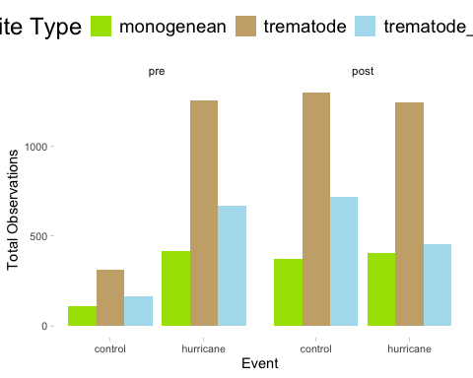
summary <- hurricane_df_prevalence %>%
group_by(event, timing, psite_type) %>%
summarise(
total_observations = n(),
total_parasite_count = sum(psite_count, na.rm = TRUE), # sum of parasite counts
.groups = "drop"
)
ggplot(summary,
aes(x = event, y = total_observations, fill = psite_type)) +
facet_wrap(~ timing) +
geom_col(position = "dodge") +
scale_fill_manual(values = c("trematode_metacercaria" = "#AFDFEF", "monogenean" = "#A6E000", "trematode" = "#c9ad79", "myxozoan" = "#07c3c5")) +
labs(x = "Event", y = "Total Observations", fill = "Parasite Type") +
connor_theme
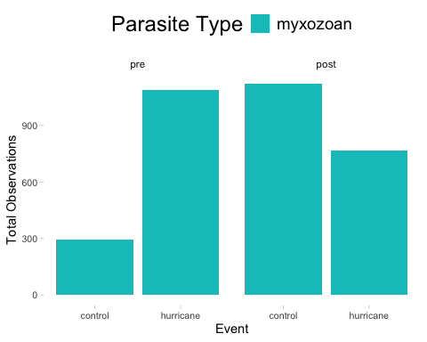
# number of control vs hurricane events by month
summary <- hurricane_df_abundance %>%
group_by(event, timing, psite_type, month_collected) %>%
summarise(
total_observations = n(),
total_parasite_count = sum(psite_count, na.rm = TRUE), # sum of parasite counts
.groups = "drop"
)

Abundance

Plot raw data (as averages not sums) to identify any trends in the data or inconsistencies.
# how many replicates are in each category --> this is just the number of occurrences, not abundance of parasites
ha.reps <- hurricane_df_abundance %>%
group_by(event, timing, psite_type, fish_sp_x) %>%
summarize(observations = n(), .groups = "drop")
# plot how many of each category we have
ggplot(ha.reps,
aes(x = fish_sp_x, y = observations, fill = psite_type)) +
facet_wrap(timing ~ event) +
geom_col(position = "dodge") +
scale_fill_manual(values = c("trematode_metacercaria" = "#AFDFEF", "monogenean" = "#A6E000", "trematode" = "#c9ad79", "myxozoan" = "#07c3c5")) +
labs(x = "Fish Species", y = "Number of Observations", fill = "Parasite Type", linetype = "Parasite Type") +
connor_theme
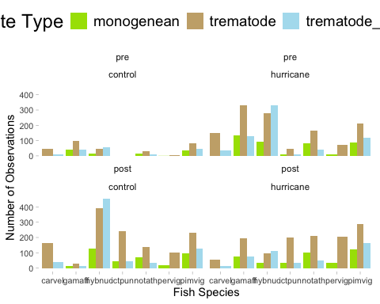
# hurricane abundance with parasite type
ha.bins1 <- hurricane_df_abundance %>%
group_by(event, timing, psite_type) %>%
summarize(avg.bin = mean(psite_abundance))
# use this as the raw plot of data
ggplot(ha.bins1,
aes(x = timing, y = avg.bin, fill = psite_type)) +
facet_wrap( ~ event) +
geom_col(position = "dodge") +
scale_fill_manual(values = c("trematode_metacercaria" = "#AFDFEF", "monogenean" = "#A6E000", "trematode" = "#c9ad79", "myxozoan" = "#07c3c5")) +
labs(x = "Timing", y = "Estimate", fill = "Parasite Type", linetype = "Parasite Type") +
connor_theme
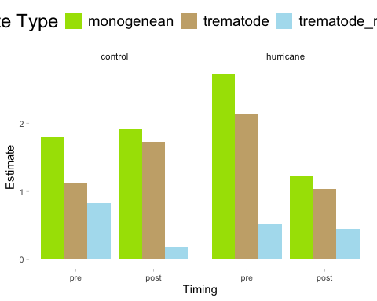
# hurricane abundance with fish species and parasite type
ha.bins2 <- hurricane_df_abundance %>%
group_by(event, timing, psite_type, fish_sp_x) %>%
summarize(avg.bin = mean(psite_abundance))
# use this as the raw plot of data
ggplot(ha.bins2,
aes(x = fish_sp_x, y = avg.bin, fill = psite_type)) +
facet_wrap(timing ~ event) +
geom_col(position = "dodge") +
scale_fill_manual(values = c("trematode_metacercaria" = "#AFDFEF", "monogenean" = "#A6E000", "trematode" = "#c9ad79", "myxozoan" = "#07c3c5")) +
labs(x = "Fish Species", y = "Estimate", fill = "Parasite Type", linetype = "Parasite Type") +
connor_theme
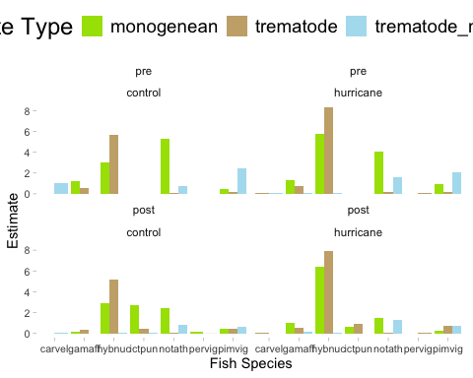

Drop carvel and pervig from analysis since they do not have monos and metas consistently
hurricane_df_abundance_only_full <- hurricane_df_abundance %>%
filter(!fish_sp_x %in% c("pervig", "carvel"))
# plot new raw data
# how many replicates are in each category--> this is just the number of occurrences, not abundance of parasites
ha.reps <- hurricane_df_abundance_only_full %>%
group_by(event, timing, psite_type, fish_sp_x) %>%
summarize(observations = n(), .groups = "drop")
# plot how many of each category we have
ggplot(ha.reps,
aes(x = fish_sp_x, y = observations, fill = psite_type)) +
facet_wrap(timing ~ event) +
geom_col(position = "dodge") +
scale_fill_manual(values = c("trematode_metacercaria" = "#AFDFEF", "monogenean" = "#A6E000", "trematode" = "#c9ad79", "myxozoan" = "#07c3c5")) +
labs(x = "Fish Species", y = "Number of Observations", fill = "Parasite Type", linetype = "Parasite Type") +
connor_theme
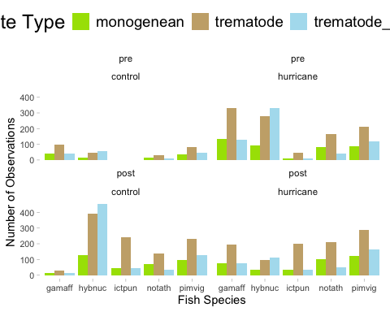
# hurricane abundance with parasite type --> average abundances
hurricane_df_abundance_only_full %>%
group_by(event, timing, psite_type) %>%
summarize(avg.bin = mean(psite_abundance))
## # A tibble: 12 × 4
## # Groups: event, timing [4]
## event timing psite_type avg.bin
## <fct> <fct> <fct> <dbl>
## 1 control pre monogenean 1.81
## 2 control pre trematode 1.34
## 3 control pre trematode_metacercaria 0.816
## 4 control post monogenean 2.00
## 5 control post trematode 2.16
## 6 control post trematode_metacercaria 0.191
## 7 hurricane pre monogenean 2.81
## 8 hurricane pre trematode 2.57
## 9 hurricane pre trematode_metacercaria 0.551
## 10 hurricane post monogenean 1.33
## 11 hurricane post trematode 1.28
## 12 hurricane post trematode_metacercaria 0.464
# use this as the raw plot of data
ggplot(ha.bins1,
aes(x = timing, y = avg.bin, fill = psite_type)) +
facet_wrap( ~ event) +
geom_col(position = "dodge") +
scale_fill_manual(values = c("trematode_metacercaria" = "#AFDFEF", "monogenean" = "#A6E000", "trematode" = "#c9ad79", "myxozoan" = "#07c3c5")) +
labs(x = "Timing", y = "Average Parasite Abundance", fill = "Parasite Type", linetype = "Parasite Type") +
connor_theme
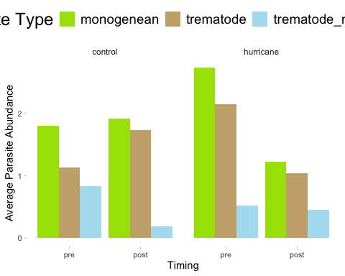
# hurricane abundance with fish species and parasite type
ha.bins2 <- hurricane_df_abundance_only_full %>%
group_by(event, timing, psite_type, fish_sp_x) %>%
summarize(avg.bin = mean(psite_abundance))
# use this as the raw plot of data
ggplot(ha.bins2,
aes(x = fish_sp_x, y = avg.bin, fill = psite_type)) +
facet_wrap(timing ~ event) +
geom_col(position = "dodge") +
scale_fill_manual(values = c("trematode_metacercaria" = "#AFDFEF", "monogenean" = "#A6E000", "trematode" = "#c9ad79", "myxozoan" = "#07c3c5")) +
labs(x = "Fish Species", y = "Average Parasite Abundance", fill = "Parasite Type", linetype = "Parasite Type") +
connor_theme
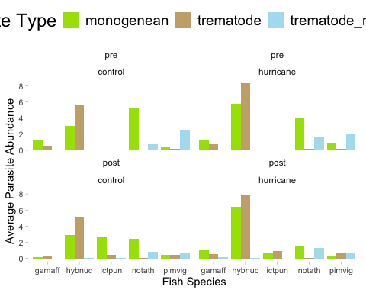 ## Seasonality influencing distribution of abundance The reason there are differences in sampling effort between hurricane and control even though they are coded with the same dates (just with year changed) is because on different years, the sampling dates (the days they phyically went into the field) were different.
# month and day against number of replicates
ha.season <- hurricane_df_abundance_only_full %>%
group_by(event, timing, psite_type, fish_sp_x, season, month_day, year_collected) %>%
summarize(observations = n(), .groups = "drop")
# insert a dummy year as an anchor
ha.season <- ha.season %>%
mutate(month_day_date = as.Date(paste0("2025-", month_day), format = "%Y-%m-%d"))
ha.season$month_day_date <- as.Date(format(as.Date(ha.season$month_day_date), "2025-%m-%d"))
range(ha.season$month_day_date)
## [1] "2025-01-03" "2025-12-26"
ggplot(ha.season,
aes(x = month_day_date, y = event, fill = psite_type)) +
geom_violin(scale = "count", trim = FALSE) +
geom_point(position = position_jitter(height = 0.2), shape = 21, size = 3, stroke = 0.2) +
scale_x_date(
limits = as.Date(c("2025-01-03", "2025-12-26")),
date_labels = "%b",
date_breaks = "1 month",
expand = c(0.01, 0)
) +
scale_fill_manual(values = c(
"trematode_metacercaria" = "#AFDFEF",
"monogenean" = "#A6E000",
"trematode" = "#c9ad79",
"myxozoan" = "#07c3c5"
)) +
labs(x = "Month", y = "Event", fill = "Parasite Type") +
connor_theme
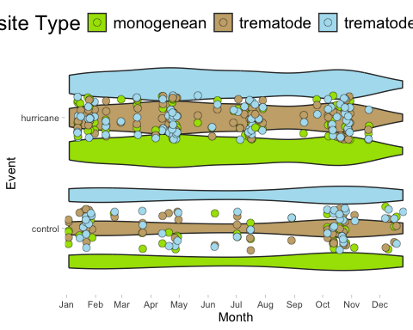
# run a model to see if season has an effect on occurrences
season_model <- glmmTMB(observations ~ season*event, family = nbinom2, data = ha.season)
simulateResiduals(fittedModel = season_model, plot = TRUE)
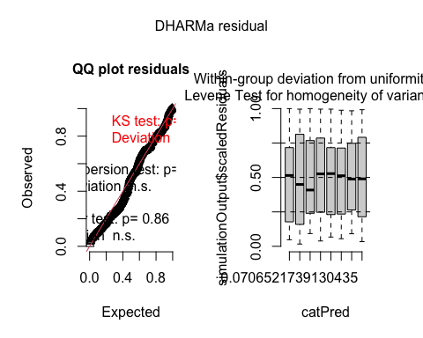
## Object of Class DHARMa with simulated residuals based on 250 simulations with refit = FALSE . See ?DHARMa::simulateResiduals for help.
##
## Scaled residual values: 0.2637998 0.2350498 0.7481052 0.2652062 0.274623 0.1579725 0.2343417 0.3562439 0.4342523 0.3870222 0.6298962 0.6447346 0.984 0.71052 0.7135465 0.4839049 0.5195349 0.7558704 0.8067854 0.8086855 ...
summary(season_model)
## Family: nbinom2 ( log )
## Formula: observations ~ season * event
## Data: ha.season
##
## AIC BIC logLik deviance df.resid
## 2944.6 2980.4 -1463.3 2926.6 387
##
##
## Dispersion parameter for nbinom2 family (): 2.16
##
## Conditional model:
## Estimate Std. Error z value Pr(>|z|)
## (Intercept) 2.79065 0.10455 26.692 <2e-16 ***
## seasonspring 0.10236 0.18876 0.542 0.588
## seasonsummer 0.09353 0.19944 0.469 0.639
## seasonwinter 0.17118 0.14130 1.211 0.226
## eventhurricane -0.19726 0.13566 -1.454 0.146
## seasonspring:eventhurricane 0.18610 0.22432 0.830 0.407
## seasonsummer:eventhurricane 0.15247 0.23749 0.642 0.521
## seasonwinter:eventhurricane -0.23806 0.19517 -1.220 0.223
## ---
## Signif. codes: 0 '***' 0.001 '**' 0.01 '*' 0.05 '.' 0.1 ' ' 1
plot(parameters(season_model))
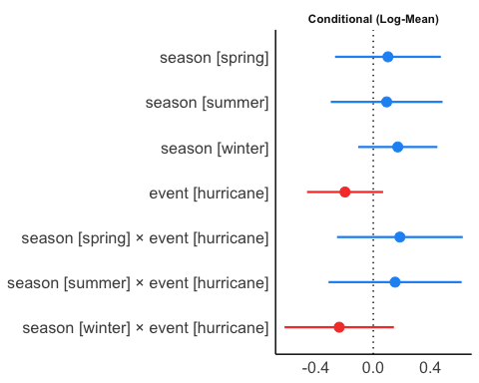
# no effect of seasonality present

Abundance Models

Negative binomial glmmTMB model validation

Final Hurricane Abundance Model
# run model
final_h_abundance <- glmmTMB(psite_abundance ~ event*timing*psite_type + ci + (1|catalog_number) + (1|year_collected/season) + (1|fish_psite_combo) + (1|fish_sp_x) + (total_length_mm|fish_psite_combo),
ziformula = ~ event*timing*psite_type + ci + (1|catalog_number) + (1|year_collected/season) + (1|fish_psite_combo) + (1|fish_sp_x) + (total_length_mm|fish_psite_combo),
family = nbinom2, data = hurricane_df_abundance_only_full)
simulateResiduals(fittedModel = final_h_abundance, plot = TRUE)
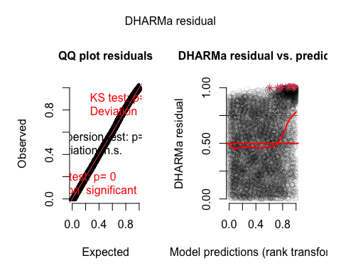
## Object of Class DHARMa with simulated residuals based on 250 simulations with refit = FALSE . See ?DHARMa::simulateResiduals for help.
##
## Scaled residual values: 0.4099813 0.5447445 0.8690329 0.2766709 0.2138633 0.2028718 0.6352286 0.1722343 0.8691017 0.7581907 0.8947095 0.1169414 0.06534755 0.009034736 0.7175001 0.1427711 0.8142106 0.9220805 0.5629225 0.1457583 ...
summary(final_h_abundance)
## Family: nbinom2 ( log )
## Formula:
## psite_abundance ~ event * timing * psite_type + ci + (1 | catalog_number) +
## (1 | year_collected/season) + (1 | fish_psite_combo) + (1 |
## fish_sp_x) + (total_length_mm | fish_psite_combo)
## Zero inflation:
## ~event * timing * psite_type + ci + (1 | catalog_number) + (1 |
## year_collected/season) + (1 | fish_psite_combo) + (1 | fish_sp_x) +
## (total_length_mm | fish_psite_combo)
## Data: hurricane_df_abundance_only_full
##
## AIC BIC logLik deviance df.resid
## 7647.3 7938.5 -3780.7 7561.3 6403
##
## Random effects:
##
## Conditional model:
## Groups Name Variance Std.Dev. Corr
## catalog_number (Intercept) 2.084e-01 4.565e-01
## season.year_collected (Intercept) 2.827e-09 5.317e-05
## year_collected (Intercept) 4.524e-02 2.127e-01
## fish_psite_combo (Intercept) 3.288e-01 5.734e-01
## fish_sp_x (Intercept) 7.607e-09 8.722e-05
## fish_psite_combo.1 (Intercept) 4.277e+00 2.068e+00
## total_length_mm 4.515e-04 2.125e-02 -0.89
## Number of obs: 6446, groups:
## catalog_number, 155; season:year_collected, 77; year_collected, 37; fish_psite_combo, 60; fish_sp_x, 5
##
## Zero-inflation model:
## Groups Name Variance Std.Dev. Corr
## catalog_number (Intercept) 4.823e-01 0.6944869
## season.year_collected (Intercept) 2.991e-01 0.5468880
## year_collected (Intercept) 2.797e-08 0.0001672
## fish_psite_combo (Intercept) 1.186e+00 1.0889897
## fish_sp_x (Intercept) 2.003e-08 0.0001415
## fish_psite_combo.1 (Intercept) 2.703e+00 1.6442138
## total_length_mm 2.040e-03 0.0451678 -0.59
## Number of obs: 6446, groups:
## catalog_number, 155; season:year_collected, 77; year_collected, 37; fish_psite_combo, 60; fish_sp_x, 5
##
## Dispersion parameter for nbinom2 family (): 0.682
##
## Conditional model:
## Estimate Std. Error
## (Intercept) 0.5460 0.5902
## eventhurricane 0.3336 0.3409
## timingpost 0.2941 0.3702
## psite_typetrematode -0.9870 0.6848
## psite_typetrematode_metacercaria -0.0659 0.8740
## ciimpact 0.1403 0.1510
## eventhurricane:timingpost -0.7472 0.4200
## eventhurricane:psite_typetrematode 0.1344 0.4224
## eventhurricane:psite_typetrematode_metacercaria -0.8627 0.6399
## timingpost:psite_typetrematode 0.1426 0.4676
## timingpost:psite_typetrematode_metacercaria -1.4219 0.6968
## eventhurricane:timingpost:psite_typetrematode 0.7670 0.5470
## eventhurricane:timingpost:psite_typetrematode_metacercaria 1.6571 0.8465
## z value Pr(>|z|)
## (Intercept) 0.925 0.3549
## eventhurricane 0.979 0.3278
## timingpost 0.794 0.4270
## psite_typetrematode -1.441 0.1495
## psite_typetrematode_metacercaria -0.075 0.9399
## ciimpact 0.929 0.3527
## eventhurricane:timingpost -1.779 0.0752 .
## eventhurricane:psite_typetrematode 0.318 0.7503
## eventhurricane:psite_typetrematode_metacercaria -1.348 0.1776
## timingpost:psite_typetrematode 0.305 0.7604
## timingpost:psite_typetrematode_metacercaria -2.041 0.0413 *
## eventhurricane:timingpost:psite_typetrematode 1.402 0.1609
## eventhurricane:timingpost:psite_typetrematode_metacercaria 1.958 0.0503 .
## ---
## Signif. codes: 0 '***' 0.001 '**' 0.01 '*' 0.05 '.' 0.1 ' ' 1
##
## Zero-inflation model:
## Estimate Std. Error
## (Intercept) 0.12035 1.02026
## eventhurricane 0.95965 0.75099
## timingpost 1.80143 0.75215
## psite_typetrematode 2.10573 1.16266
## psite_typetrematode_metacercaria 3.38668 1.24655
## ciimpact 0.25319 0.22649
## eventhurricane:timingpost -1.10802 0.83872
## eventhurricane:psite_typetrematode 0.05185 0.86586
## eventhurricane:psite_typetrematode_metacercaria -2.36146 0.94695
## timingpost:psite_typetrematode -1.06346 0.88379
## timingpost:psite_typetrematode_metacercaria -3.12595 1.01458
## eventhurricane:timingpost:psite_typetrematode 0.69106 0.97037
## eventhurricane:timingpost:psite_typetrematode_metacercaria 3.00347 1.19046
## z value Pr(>|z|)
## (Intercept) 0.118 0.90610
## eventhurricane 1.278 0.20130
## timingpost 2.395 0.01662 *
## psite_typetrematode 1.811 0.07012 .
## psite_typetrematode_metacercaria 2.717 0.00659 **
## ciimpact 1.118 0.26362
## eventhurricane:timingpost -1.321 0.18647
## eventhurricane:psite_typetrematode 0.060 0.95225
## eventhurricane:psite_typetrematode_metacercaria -2.494 0.01264 *
## timingpost:psite_typetrematode -1.203 0.22886
## timingpost:psite_typetrematode_metacercaria -3.081 0.00206 **
## eventhurricane:timingpost:psite_typetrematode 0.712 0.47637
## eventhurricane:timingpost:psite_typetrematode_metacercaria 2.523 0.01164 *
## ---
## Signif. codes: 0 '***' 0.001 '**' 0.01 '*' 0.05 '.' 0.1 ' ' 1
plot(parameters(final_h_abundance))
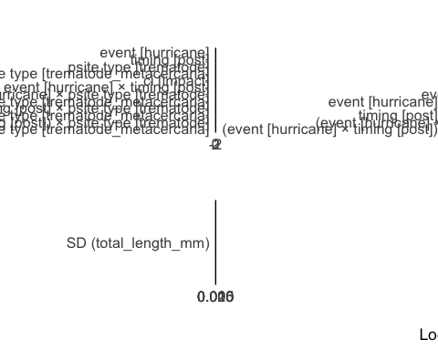

Plots – Abundance
All results
#### A
a1a <- ggpredict(final_h_abundance, terms = c("psite_type", "event"))
a1a <- a1a %>%
rename(
psite_type = x,
estimate = predicted,
se = std.error,
lower = conf.low,
upper = conf.high,
event = group)
a1ap <- ggplot(a1a,
aes(x = event, y = estimate)) +
geom_errorbar(aes(ymin = lower, ymax = upper, group = psite_type),
width = 0.05,
position = position_dodge(width = 0.5)) +
geom_line(aes(group = psite_type, linetype = psite_type),
position = position_dodge(width = 0.5)) +
geom_point(aes(fill = psite_type, group = psite_type),
pch = 21, size = 5,
position = position_dodge(width = 0.5)) +
scale_fill_manual(values = c("trematode_metacercaria" = "#AFDFEF", "monogenean" = "#A6E000", "trematode" = "#c9ad79", "myxozoan" = "#07c3c5")) +
scale_y_continuous(limits = c(0, 8), breaks = seq(0, 8, by = 2)) +
labs(x = "Event", y = "Estimate", fill = "Parasite Type", linetype = "Parasite Type") +
connor_theme
#### B
a1b <- ggpredict(final_h_abundance, terms = c("psite_type", "event"))
a1b <- a1b %>%
rename(
psite_type = x,
estimate = predicted,
se = std.error,
lower = conf.low,
upper = conf.high,
event = group)
a1b <- a1b %>%
filter(psite_type %in% c("trematode"))
a1bp <- ggplot(a1b,
aes(x = event, y = estimate)) +
geom_errorbar(aes(ymin = lower, ymax = upper, group = psite_type),
width = 0.05,
position = position_dodge(width = 0.5)) +
geom_line(aes(group = psite_type, linetype = psite_type),
position = position_dodge(width = 0.5)) +
geom_point(aes(fill = psite_type, group = psite_type),
pch = 21, size = 5,
position = position_dodge(width = 0.5)) +
scale_fill_manual(values = c("trematode_metacercaria" = "#AFDFEF", "monogenean" = "#A6E000", "trematode" = "#c9ad79", "myxozoan" = "#07c3c5")) +
scale_y_continuous(limits = c(0, 4), breaks = seq(0, 4, by = 2)) +
labs(x = "Timing", y = "Estimate", fill = "Parasite Type", linetype = "Parasite Type") +
connor_theme
#### C
a1c <- ggpredict(final_h_abundance, terms = c("psite_type", "event", "timing"))
a1c <- a1c %>%
rename(
psite_type = x,
estimate = predicted,
se = std.error,
lower = conf.low,
upper = conf.high,
event = group,
timing = facet)
a1c <- a1c %>%
filter(psite_type %in% c("trematode"))
a1cp <- ggplot(a1c,
aes(x = timing, y = estimate)) +
facet_wrap(~ event) +
geom_errorbar(aes(ymin = lower, ymax = upper, group = timing),
width = 0.05,
position = position_dodge(width = 0.5)) +
geom_line(aes(group = psite_type, linetype = psite_type),
position = position_dodge(width = 0.5)) +
geom_point(aes(fill = psite_type, group = psite_type),
pch = 21, size = 5,
position = position_dodge(width = 0.5)) +
scale_fill_manual(values = c("trematode_metacercaria" = "#AFDFEF", "monogenean" = "#A6E000", "trematode" = "#c9ad79", "myxozoan" = "#07c3c5")) +
scale_y_continuous(limits = c(0, 4), breaks = seq(0, 4, by = 2)) +
labs(x = "Timing", y = "Estimate", fill = "Parasite Type", linetype = "Parasite Type") +
connor_theme
#### D
a1d <- ggpredict(final_h_abundance, terms = c("psite_type", "event", "timing"))
a1d <- a1d %>%
rename(
psite_type = x,
estimate = predicted,
se = std.error,
lower = conf.low,
upper = conf.high,
event = group,
timing = facet)
a1d <- a1d %>%
filter(psite_type %in% c("trematode_metacercaria"))
a1dp <- ggplot(a1d,
aes(x = timing, y = estimate)) +
facet_wrap(~ event, scales = "free_y") +
geom_errorbar(aes(ymin = lower, ymax = upper, group = timing),
width = 0.05,
position = position_dodge(width = 0.5)) +
geom_line(aes(group = psite_type, linetype = psite_type),
position = position_dodge(width = 0.5)) +
geom_point(aes(fill = psite_type, group = psite_type),
pch = 21, size = 5,
position = position_dodge(width = 0.5)) +
scale_fill_manual(values = c("trematode_metacercaria" = "#AFDFEF", "monogenean" = "#A6E000", "trematode" = "#c9ad79", "myxozoan" = "#07c3c5")) +
scale_y_continuous(limits = c(0, 8), breaks = seq(0, 8, by = 2)) +
labs(x = "Timing", y = "Estimate", fill = "Parasite Type", linetype = "Parasite Type") +
connor_theme
#### E
a1e <- ggpredict(final_h_abundance, terms = c("psite_type", "event"))
a1e <- a1e %>%
rename(
psite_type = x,
estimate = predicted,
se = std.error,
lower = conf.low,
upper = conf.high,
event = group)
a1e <- a1e %>%
filter(psite_type %in% c("trematode_metacercaria"))
a1ep <- ggplot(a1e,
aes(x = event, y = estimate)) +
geom_errorbar(aes(ymin = lower, ymax = upper, group = event),
width = 0.05,
position = position_dodge(width = 0.5)) +
geom_line(aes(group = psite_type, linetype = psite_type),
position = position_dodge(width = 0.5)) +
geom_point(aes(fill = psite_type, group = psite_type),
pch = 21, size = 5,
position = position_dodge(width = 0.5)) +
scale_fill_manual(values = c("trematode_metacercaria" = "#AFDFEF", "monogenean" = "#A6E000", "trematode" = "#c9ad79", "myxozoan" = "#07c3c5")) +
scale_y_continuous(limits = c(0, 10), breaks = seq(0, 10, by = 2)) +
labs(x = "Event", y = "Estimate", fill = "Parasite Type", linetype = "Parasite Type") +
connor_theme
# try to plot only monos
a1m <- ggpredict(final_h_abundance, terms = c("psite_type", "event", "timing"))
a1m <- a1m %>%
rename(
psite_type = x,
estimate = predicted,
se = std.error,
lower = conf.low,
upper = conf.high,
event = group,
timing = facet)
a1m <- a1m %>%
filter(psite_type %in% c("monogenean"))
a1mp <- ggplot(a1m,
aes(x = timing, y = estimate)) +
facet_wrap(~ event, scales = "free_y") +
geom_errorbar(aes(ymin = lower, ymax = upper, group = event),
width = 0.05,
position = position_dodge(width = 0.5)) +
geom_line(aes(group = psite_type, linetype = psite_type),
position = position_dodge(width = 0.5)) +
geom_point(aes(fill = psite_type, group = psite_type),
pch = 21, size = 5,
position = position_dodge(width = 0.5)) +
scale_fill_manual(values = c("trematode_metacercaria" = "#AFDFEF", "monogenean" = "#A6E000", "trematode" = "#c9ad79", "myxozoan" = "#07c3c5")) +
scale_y_continuous(limits = c(0, 10), breaks = seq(0, 10, by = 2)) +
labs(x = "Timing", y = "Estimate", fill = "Parasite Type", linetype = "Parasite Type") +
connor_theme
hurricane_abundance_plot <- ggarrange(a1ap, a1cp, a1dp, a1mp, common.legend = TRUE, legend = "bottom", labels = c("A", "B", "C", "D"))
plot(hurricane_abundance_plot)
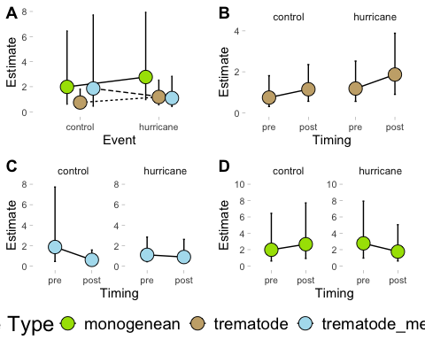 ## Abundance Significant Results Plot the significant result that metas are less abundant in post, and the marginally significant results that post hurricane is less abundant and metas are more abundant post hurricane.
#### metas less abundant in post
as1 <- ggpredict(final_h_abundance, terms = c("psite_type", "timing"))
as1 <- as1 %>%
rename(
psite_type = x,
estimate = predicted,
se = std.error,
lower = conf.low,
upper = conf.high,
timing = group)
as1p <- ggplot(as1,
aes(x = timing, y = estimate)) +
geom_errorbar(aes(ymin = lower, ymax = upper, group = psite_type),
width = 0.05,
position = position_dodge(width = 0.5)) +
geom_line(aes(group = psite_type, linetype = psite_type),
position = position_dodge(width = 0.5)) +
geom_point(aes(fill = psite_type, group = psite_type),
pch = 21, size = 5,
position = position_dodge(width = 0.5)) +
scale_fill_manual(values = c("trematode_metacercaria" = "#AFDFEF", "monogenean" = "#A6E000", "trematode" = "#c9ad79", "myxozoan" = "#07c3c5")) +
scale_y_continuous(limits = c(0, 8), breaks = seq(0, 8, by = 2)) +
labs(x = "Timing", y = "Estimate", fill = "Parasite Type", linetype = "Parasite Type") +
connor_theme
#### post hurricane is less abundant
ams1 <- ggpredict(final_h_abundance, terms = c("timing", "event"))
ams1 <- ams1 %>%
rename(
timing = x,
estimate = predicted,
se = std.error,
lower = conf.low,
upper = conf.high,
event = group)
ams1p <- ggplot(ams1,
aes(x = timing, y = estimate)) +
geom_errorbar(aes(ymin = lower, ymax = upper, group = event),
width = 0.05,
position = position_dodge(width = 0.5)) +
geom_line(aes(group = event, linetype = event),
position = position_dodge(width = 0.5)) +
geom_point(aes(fill = event, group = event),
pch = 21, size = 5,
position = position_dodge(width = 0.5)) +
scale_fill_manual(values = c("hurricane" = "#CB87B4", "control" = "#F4B95A")) +
scale_y_continuous(limits = c(0, 8), breaks = seq(0, 8, by = 2)) +
labs(x = "Timing", y = "Estimate", fill = "Event", linetype = "Event") +
connor_theme
#### metas are more abundant post hurricane
ams2 <- ggpredict(final_h_abundance, terms = c("psite_type", "event", "timing"))
ams2 <- ams2 %>%
rename(
psite_type = x,
estimate = predicted,
se = std.error,
lower = conf.low,
upper = conf.high,
event = group,
timing = facet)
ams2 <- ams2 %>%
filter(psite_type %in% c("trematode_metacercaria")) %>%
filter(event %in% c("hurricane"))
ams2p <- ggplot(ams2,
aes(x = timing, y = estimate)) +
facet_wrap(~ event) +
geom_errorbar(aes(ymin = lower, ymax = upper, group = timing),
width = 0.05,
position = position_dodge(width = 0.5)) +
geom_line(aes(group = psite_type, linetype = psite_type),
position = position_dodge(width = 0.5)) +
geom_point(aes(fill = psite_type, group = psite_type),
pch = 21, size = 5,
position = position_dodge(width = 0.5)) +
scale_fill_manual(values = c("trematode_metacercaria" = "#AFDFEF", "monogenean" = "#A6E000", "trematode" = "#c9ad79", "myxozoan" = "#07c3c5")) +
scale_y_continuous(limits = c(0, 4), breaks = seq(0, 4, by = 2)) +
labs(x = "Timing", y = "Estimate", fill = "Parasite Type", linetype = "Parasite Type") +
connor_theme
hurricane_abundance_plot_sig_only <- ggarrange(as1p, ams1p, ams2p, common.legend = FALSE, legend = "bottom", labels = c("A", "B", "C", "D"))
plot(hurricane_abundance_plot_sig_only)
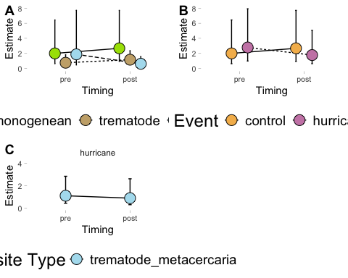

Zero inflated results plotted - abundance
All results
#### A
azi1 <- ggemmeans(final_h_abundance, terms = c("psite_type", "event"), component = "zi")
azi1 <- azi1 %>%
rename(
psite_type = x,
estimate = predicted,
se = std.error,
lower = conf.low,
upper = conf.high,
event = group
)
azi1p <- ggplot(azi1, aes(x = event, y = estimate)) +
geom_errorbar(aes(ymin = lower, ymax = upper, group = psite_type),
width = 0.05,
position = position_dodge(0.5)) +
geom_line(aes(group = psite_type, linetype = psite_type),
position = position_dodge(0.5)) +
geom_point(aes(fill = psite_type, group = psite_type),
pch = 21, size = 5,
position = position_dodge(0.5)) +
scale_fill_manual(values = c("trematode_metacercaria" = "#AFDFEF",
"monogenean" = "#A6E000",
"trematode" = "#c9ad79",
"myxozoan" = "#07c3c5")) +
labs(x = "Event",
y = "Zero-Inflation Estimate",
fill = "Parasite Type",
linetype = "Parasite Type") +
connor_theme
#### B
azi2 <- ggemmeans(final_h_abundance, terms = c("psite_type", "event"), component = "zi")
azi2 <- azi2 %>%
rename(
psite_type = x,
estimate = predicted,
se = std.error,
lower = conf.low,
upper = conf.high,
event = group
)
azi2 <- azi2 %>%
filter(psite_type %in% c("trematode"))
azi2p <- ggplot(azi2,
aes(x = event, y = estimate)) +
geom_errorbar(aes(ymin = lower, ymax = upper, group = psite_type),
width = 0.05,
position = position_dodge(width = 0.5)) +
geom_line(aes(group = psite_type, linetype = psite_type),
position = position_dodge(width = 0.5)) +
geom_point(aes(fill = psite_type, group = psite_type),
pch = 21, size = 5,
position = position_dodge(width = 0.5)) +
scale_fill_manual(values = c("trematode_metacercaria" = "#AFDFEF", "monogenean" = "#A6E000", "trematode" = "#c9ad79", "myxozoan" = "#07c3c5")) +
labs(x = "Timing", y = "Zero-Inflation Estimate", fill = "Parasite Type", linetype = "Parasite Type") +
connor_theme
#### C
azi3 <- ggemmeans(final_h_abundance, terms = c("psite_type", "event", "timing"), component = "zi")
azi3 <- azi3 %>%
rename(
psite_type = x,
estimate = predicted,
se = std.error,
lower = conf.low,
upper = conf.high,
event = group,
timing = facet
)
azi3 <- azi3 %>%
filter(psite_type %in% c("trematode"))
azi3p <- ggplot(azi3,
aes(x = timing, y = estimate)) +
facet_wrap(~ event) +
geom_errorbar(aes(ymin = lower, ymax = upper, group = timing),
width = 0.05,
position = position_dodge(width = 0.5)) +
geom_line(aes(group = psite_type, linetype = psite_type),
position = position_dodge(width = 0.5)) +
geom_point(aes(fill = psite_type, group = psite_type),
pch = 21, size = 5,
position = position_dodge(width = 0.5)) +
scale_fill_manual(values = c("trematode_metacercaria" = "#AFDFEF", "monogenean" = "#A6E000", "trematode" = "#c9ad79", "myxozoan" = "#07c3c5")) +
labs(x = "Timing", y = "Zero-Inflation Estimate", fill = "Parasite Type", linetype = "Parasite Type") +
connor_theme
#### D
azi4 <- ggemmeans(final_h_abundance, terms = c("psite_type", "event", "timing"), component = "zi")
azi4 <- azi4 %>%
rename(
psite_type = x,
estimate = predicted,
se = std.error,
lower = conf.low,
upper = conf.high,
event = group,
timing = facet
)
azi4 <- azi4 %>%
filter(psite_type %in% c("trematode_metacercaria"))
azi4p <- ggplot(azi4,
aes(x = timing, y = estimate)) +
facet_wrap(~ event) +
geom_errorbar(aes(ymin = lower, ymax = upper, group = timing),
width = 0.05,
position = position_dodge(width = 0.5)) +
geom_line(aes(group = psite_type, linetype = psite_type),
position = position_dodge(width = 0.5)) +
geom_point(aes(fill = psite_type, group = psite_type),
pch = 21, size = 5,
position = position_dodge(width = 0.5)) +
scale_fill_manual(values = c("trematode_metacercaria" = "#AFDFEF", "monogenean" = "#A6E000", "trematode" = "#c9ad79", "myxozoan" = "#07c3c5")) +
labs(x = "Timing", y = "Zero-Inflation Estimate", fill = "Parasite Type", linetype = "Parasite Type") +
connor_theme
#### E
azi5 <- ggemmeans(final_h_abundance, terms = c("psite_type", "event"), component = "zi")
azi5 <- azi5 %>%
rename(
psite_type = x,
estimate = predicted,
se = std.error,
lower = conf.low,
upper = conf.high,
event = group
)
azi5 <- azi5 %>%
filter(psite_type %in% c("trematode_metacercaria"))
azi5p <- ggplot(azi5,
aes(x = event, y = estimate)) +
geom_errorbar(aes(ymin = lower, ymax = upper, group = event),
width = 0.05,
position = position_dodge(width = 0.5)) +
geom_line(aes(group = psite_type, linetype = psite_type),
position = position_dodge(width = 0.5)) +
geom_point(aes(fill = psite_type, group = psite_type),
pch = 21, size = 5,
position = position_dodge(width = 0.5)) +
scale_fill_manual(values = c("trematode_metacercaria" = "#AFDFEF", "monogenean" = "#A6E000", "trematode" = "#c9ad79", "myxozoan" = "#07c3c5")) +
scale_y_continuous(limits = c(0, 60), breaks = seq(0, 60, 10)) +
labs(x = "Event", y = "Zero-Inflation Estimate", fill = "Parasite Type", linetype = "Parasite Type") +
connor_theme
# try to plot only monos
azi6 <- ggemmeans(final_h_abundance, terms = c("psite_type", "event", "timing"), component = "zi")
azi6 <- azi6 %>%
rename(
psite_type = x,
estimate = predicted,
se = std.error,
lower = conf.low,
upper = conf.high,
event = group,
timing = facet
)
azi6 <- azi6 %>%
filter(psite_type %in% c("monogenean"))
azi6p <- ggplot(azi6,
aes(x = timing, y = estimate)) +
facet_wrap(~ event, scales = "free_y") +
geom_errorbar(aes(ymin = lower, ymax = upper, group = event),
width = 0.05,
position = position_dodge(width = 0.5)) +
geom_line(aes(group = psite_type, linetype = psite_type),
position = position_dodge(width = 0.5)) +
geom_point(aes(fill = psite_type, group = psite_type),
pch = 21, size = 5,
position = position_dodge(width = 0.5)) +
scale_fill_manual(values = c("trematode_metacercaria" = "#AFDFEF", "monogenean" = "#A6E000", "trematode" = "#c9ad79", "myxozoan" = "#07c3c5")) +
labs(x = "Timing", y = "Zero-Inflation Estimate", fill = "Parasite Type", linetype = "Parasite Type") +
connor_theme
hurricane_abundance_plot_zi <- ggarrange(azi1p, azi3p, azi4p, azi6p, common.legend = TRUE, legend = "bottom", labels = c("A", "B", "C", "D"))
plot(hurricane_abundance_plot_zi)
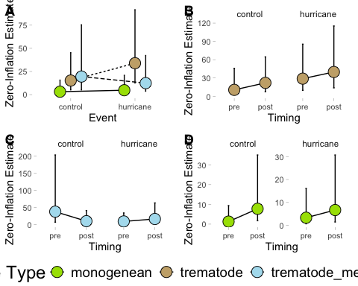 ## Abundance Zero Inflated Significant Results Timing post is more likey to be zero, metas are more likely to be zero, metas less likely to be zero in a hurricane, metas less likely to be zero in post, metas more likely to be zero after a hurricane (not including marginally significant here)
#### post more likely to be zero
azis1 <- ggemmeans(final_h_abundance, terms = c("timing", "event"), component = "zi")
azis1 <- azis1 %>%
rename(
timing = x,
estimate = predicted,
se = std.error,
lower = conf.low,
upper = conf.high,
event = group
)
azis1p <- ggplot(azis1,
aes(x = timing, y = estimate)) +
geom_errorbar(aes(ymin = lower, ymax = upper, group = event),
width = 0.05,
position = position_dodge(0.5)) +
geom_line(aes(group = event, linetype = event),
position = position_dodge(0.5)) +
geom_point(aes(fill = event, group = event),
pch = 21, size = 5,
position = position_dodge(0.5)) +
scale_fill_manual(values = c("hurricane" = "#CB87B4", "control" = "#F4B95A")) +
labs(x = "Timing", y = "Zero-Inflation Estimate", fill = "Event", linetype = "Event") +
connor_theme
#### metas more likely to be zero
azis2 <- ggemmeans(final_h_abundance, terms = c("psite_type"), component = "zi")
azis2 <- azis2 %>%
rename(
psite_type = x,
estimate = predicted,
se = std.error,
lower = conf.low,
upper = conf.high
)
azis2p <- ggplot(azis2,
aes(x = psite_type, y = estimate)) +
geom_errorbar(aes(ymin = lower, ymax = upper, group = psite_type),
width = 0.05,
position = position_dodge(width = 0.5)) +
geom_line(aes(group = psite_type, linetype = psite_type),
position = position_dodge(width = 0.5)) +
geom_point(aes(fill = psite_type, group = psite_type),
pch = 21, size = 5,
position = position_dodge(width = 0.5)) +
scale_fill_manual(values = c("trematode_metacercaria" = "#AFDFEF", "monogenean" = "#A6E000", "trematode" = "#c9ad79", "myxozoan" = "#07c3c5")) +
labs(x = "Parasite Type", y = "Zero-Inflation Estimate", fill = "Parasite Type", linetype = "Parasite Type") +
connor_theme
#### metas less likey to be zero after a hurricane
azis3 <- ggemmeans(final_h_abundance, terms = c("psite_type", "event", "timing"), component = "zi")
azis3 <- azis3 %>%
rename(
psite_type = x,
estimate = predicted,
se = std.error,
lower = conf.low,
upper = conf.high,
event = group,
timing = facet
)
azis3 <- azis3 %>%
filter(psite_type %in% c("trematode_metacercaria")) %>%
filter(event %in% c("hurricane"))
azis3p <- ggplot(azis3,
aes(x = timing, y = estimate)) +
facet_wrap(~ event) +
geom_errorbar(aes(ymin = lower, ymax = upper, group = timing),
width = 0.05,
position = position_dodge(width = 0.5)) +
geom_line(aes(group = psite_type, linetype = psite_type),
position = position_dodge(width = 0.5)) +
geom_point(aes(fill = psite_type, group = psite_type),
pch = 21, size = 5,
position = position_dodge(width = 0.5)) +
scale_fill_manual(values = c("trematode_metacercaria" = "#AFDFEF", "monogenean" = "#A6E000", "trematode" = "#c9ad79", "myxozoan" = "#07c3c5")) +
labs(x = "Timing", y = "Zero-Inflation Estimate", fill = "Parasite Type", linetype = "Parasite Type") +
connor_theme
#### metas less likely to be zero in post
azis4 <- ggemmeans(final_h_abundance, terms = c("psite_type", "timing"), component = "zi")
azis4 <- azis4 %>%
rename(
psite_type = x,
estimate = predicted,
se = std.error,
lower = conf.low,
upper = conf.high,
timing = group
)
azis4 <- azis4 %>%
filter(psite_type %in% c("trematode_metacercaria"))
azis4p <- ggplot(azis4,
aes(x = timing, y = estimate)) +
geom_errorbar(aes(ymin = lower, ymax = upper, group = timing),
width = 0.05,
position = position_dodge(width = 0.5)) +
geom_line(aes(group = psite_type, linetype = psite_type),
position = position_dodge(width = 0.5)) +
geom_point(aes(fill = psite_type, group = psite_type),
pch = 21, size = 5,
position = position_dodge(width = 0.5)) +
scale_fill_manual(values = c("trematode_metacercaria" = "#AFDFEF", "monogenean" = "#A6E000", "trematode" = "#c9ad79", "myxozoan" = "#07c3c5")) +
labs(x = "Timing", y = "Zero-Inflation Estimate", fill = "Parasite Type", linetype = "Parasite Type") +
connor_theme
#### metas more likely to be zero after a hurricane
azis5 <- ggemmeans(final_h_abundance, terms = c("psite_type", "event", "timing"), component = "zi")
azis5 <- azis5 %>%
rename(
psite_type = x,
estimate = predicted,
se = std.error,
lower = conf.low,
upper = conf.high,
event = group,
timing = facet
)
azis5 <- azis5 %>%
filter(psite_type %in% c("trematode_metacercaria")) %>%
filter(event %in% c("hurricane"))
azis5p <- ggplot(azis5,
aes(x = timing, y = estimate)) +
geom_errorbar(aes(ymin = lower, ymax = upper, group = event),
width = 0.05,
position = position_dodge(width = 0.5)) +
geom_line(aes(group = psite_type, linetype = psite_type),
position = position_dodge(width = 0.5)) +
geom_point(aes(fill = psite_type, group = psite_type),
pch = 21, size = 5,
position = position_dodge(width = 0.5)) +
scale_fill_manual(values = c("trematode_metacercaria" = "#AFDFEF", "monogenean" = "#A6E000", "trematode" = "#c9ad79", "myxozoan" = "#07c3c5")) +
scale_y_continuous(limits = c(0, 70), breaks = seq(0, 70, 10)) +
labs(x = "Timing", y = "Zero-Inflation Estimate", fill = "Parasite Type", linetype = "Parasite Type") +
connor_theme
hurricane_abundance_plot_zi_sig_only <- ggarrange(azis1p, azis2p, azis3p, azis4p, azis5p, common.legend = FALSE, legend = "bottom", labels = c("A", "B", "C", "D"))
plot(hurricane_abundance_plot_zi_sig_only)
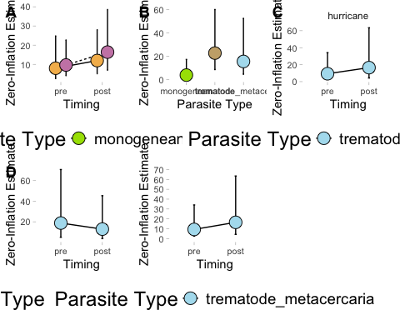

Prevalence
Plot raw data (as averages not sums) to identify any trends in the data or inconsistencies.
# how many replicates are in each category --> this is just the number of occurrences, not abundance of parasites
hp.reps <- hurricane_df_prevalence %>%
group_by(event, timing, psite_type, fish_sp_x) %>%
summarize(observations = n(), .groups = "drop")
# plot how many of each category we have
ggplot(hp.reps,
aes(x = fish_sp_x, y = observations, fill = psite_type)) +
facet_wrap(timing ~ event) +
geom_col(position = "dodge") +
scale_fill_manual(values = c("trematode_metacercaria" = "#AFDFEF", "monogenean" = "#A6E000", "trematode" = "#c9ad79", "myxozoan" = "#07c3c5")) +
labs(x = "Fish Species", y = "Number of Observations", fill = "Parasite Type", linetype = "Parasite Type") +
connor_theme
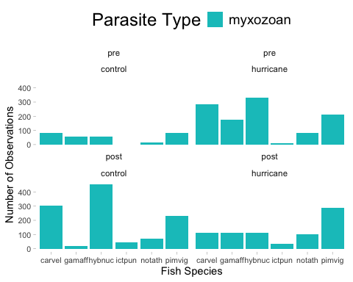
# hurricane abundance with parasite type
hp.bins1 <- hurricane_df_prevalence %>%
group_by(event, timing, psite_type) %>%
summarize(avg.bin = mean(psite_prevalence))
# use this as the raw plot of data
ggplot(hp.bins1,
aes(x = timing, y = avg.bin, fill = psite_type)) +
facet_wrap( ~ event) +
geom_col(position = "dodge") +
scale_fill_manual(values = c("trematode_metacercaria" = "#AFDFEF", "monogenean" = "#A6E000", "trematode" = "#c9ad79", "myxozoan" = "#07c3c5")) +
labs(x = "Timing", y = "Estimate", fill = "Parasite Type", linetype = "Parasite Type") +
connor_theme
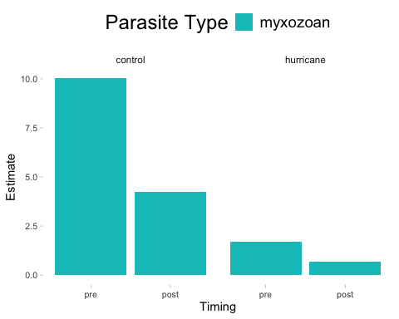
# hurricane abundance with fish species and parasite type
hp.bins2 <- hurricane_df_prevalence %>%
group_by(event, timing, psite_type, fish_sp_x) %>%
summarize(avg.bin = mean(psite_prevalence))
# use this as the raw plot of data
ggplot(hp.bins2,
aes(x = fish_sp_x, y = avg.bin, fill = psite_type)) +
facet_wrap(timing ~ event) +
geom_col(position = "dodge") +
scale_fill_manual(values = c("trematode_metacercaria" = "#AFDFEF", "monogenean" = "#A6E000", "trematode" = "#c9ad79", "myxozoan" = "#07c3c5")) +
labs(x = "Fish Species", y = "Estimate", fill = "Parasite Type", linetype = "Parasite Type") +
connor_theme
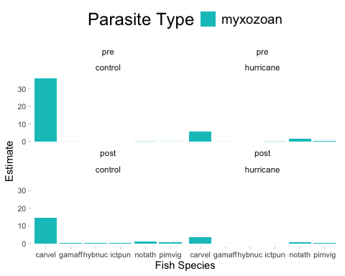

Seasonality influencing distribution - prevalence
# month and day against number of replicates
hp.season <- hurricane_df_prevalence %>%
group_by(event, timing, psite_type, fish_sp_x, season, month_day) %>%
summarize(observations = n(), .groups = "drop")
# insert a dummy year as an anchor
hp.season <- hp.season %>%
mutate(month_day_date = as.Date(paste0("2020-", month_day), format = "%Y-%m-%d"))
ggplot(hp.season,
aes(x = month_day_date, y = event, fill = psite_type)) +
geom_violin() +
geom_point(position = position_jitter(height = 0.2), shape = 21, size = 3, stroke = 0.2) +
scale_x_date(date_labels = "%b %d", date_breaks = "1 month") +
scale_fill_manual(values = c(
"trematode_metacercaria" = "#AFDFEF",
"monogenean" = "#A6E000",
"trematode" = "#c9ad79",
"myxozoan" = "#07c3c5"
)) +
labs(x = "Month-Day", y = "Event", fill = "Parasite Type") +
connor_theme
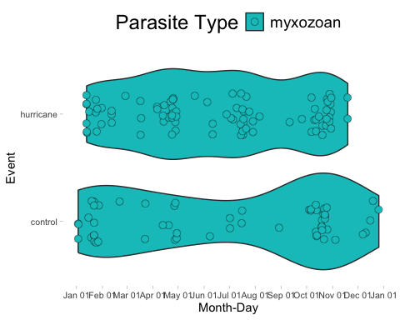
# run a model to see if season has an effect on occurrences
season_model <- glmmTMB(observations ~ season*event, family = nbinom2, data = hp.season)
simulateResiduals(fittedModel = season_model, plot = TRUE)
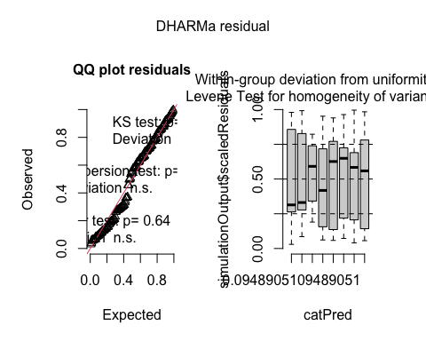
## Object of Class DHARMa with simulated residuals based on 250 simulations with refit = FALSE . See ?DHARMa::simulateResiduals for help.
##
## Scaled residual values: 0.780939 0.5912155 0.5073249 0.3416025 0.3076366 0.8224796 0.6981685 0.6599682 0.1902037 0.1563034 0.7396475 0.77102 0.7171724 0.8406499 0.972 0.8990332 0.916 0.7927078 0.7712735 0.1966676 ...
summary(season_model)
## Family: nbinom2 ( log )
## Formula: observations ~ season * event
## Data: hp.season
##
## AIC BIC logLik deviance df.resid
## 1196.6 1223.5 -589.3 1178.6 138
##
##
## Dispersion parameter for nbinom2 family (): 1.94
##
## Conditional model:
## Estimate Std. Error z value Pr(>|z|)
## (Intercept) 3.3474 0.1619 20.677 < 2e-16 ***
## seasonspring -0.3135 0.2980 -1.052 0.29277
## seasonsummer -0.2564 0.3459 -0.741 0.45863
## seasonwinter -0.1773 0.2297 -0.772 0.44008
## eventhurricane -0.6314 0.2224 -2.839 0.00453 **
## seasonspring:eventhurricane 0.7721 0.3678 2.099 0.03580 *
## seasonsummer:eventhurricane 0.8000 0.4074 1.964 0.04956 *
## seasonwinter:eventhurricane 0.2485 0.3316 0.749 0.45359
## ---
## Signif. codes: 0 '***' 0.001 '**' 0.01 '*' 0.05 '.' 0.1 ' ' 1
plot(parameters(season_model))
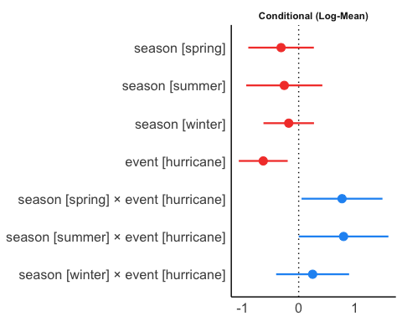
# summer (+), spring (+), and hurricanes (-) have some sort of significant influence on myxo prevalence

Prevalence Models

Final Hurricane Prevalence Model
# prevalence
hurricane_prevalence_final <- glmmTMB(psite_prevalence ~ event*timing + ci + (1|catalog_number) + (1|year_collected/season) + (1|fish_sp_x) + offset(log(total_length_mm)),
ziformula = ~ event*timing + ci + (1|catalog_number) + (1|year_collected/season) + (1|fish_sp_x) + offset(sqrt(total_length_mm)),
family = nbinom2, data = hurricane_df_prevalence)
simulateResiduals(fittedModel = hurricane_prevalence_final, plot = TRUE)
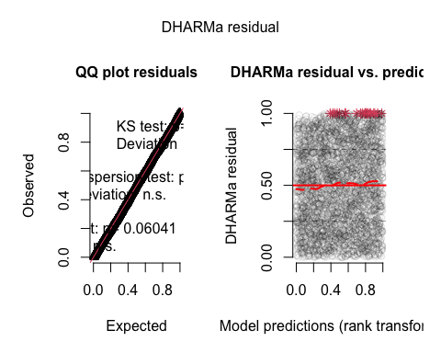
## Object of Class DHARMa with simulated residuals based on 250 simulations with refit = FALSE . See ?DHARMa::simulateResiduals for help.
##
## Scaled residual values: 0.2626876 0.9151207 0.1393101 0.2977359 0.7971293 0.08256216 0.6943764 0.7494877 0.3367258 0.2322965 0.9016023 0.9272858 0.7953329 0.4389858 0.1331236 0.8264859 0.8854684 0.2525382 0.8646443 0.3610307 ...
summary(hurricane_prevalence_final)
## Family: nbinom2 ( log )
## Formula:
## psite_prevalence ~ event * timing + ci + (1 | catalog_number) +
## (1 | year_collected/season) + (1 | fish_sp_x) + offset(log(total_length_mm))
## Zero inflation:
## ~event * timing + ci + (1 | catalog_number) + (1 | year_collected/season) +
## (1 | fish_sp_x) + offset(sqrt(total_length_mm))
## Data: hurricane_df_prevalence
##
## AIC BIC logLik deviance df.resid
## 2982.9 3098.6 -1472.4 2944.9 3250
##
## Random effects:
##
## Conditional model:
## Groups Name Variance Std.Dev.
## catalog_number (Intercept) 7.124e-03 0.0844038
## season:year_collected (Intercept) 2.297e-07 0.0004792
## year_collected (Intercept) 1.438e-07 0.0003791
## fish_sp_x (Intercept) 2.906e+00 1.7048115
## Number of obs: 3269, groups:
## catalog_number, 185; season:year_collected, 82; year_collected, 37; fish_sp_x, 6
##
## Zero-inflation model:
## Groups Name Variance Std.Dev.
## catalog_number (Intercept) 4.099e-05 0.0064027
## season:year_collected (Intercept) 8.640e-02 0.2939320
## year_collected (Intercept) 8.740e-07 0.0009349
## fish_sp_x (Intercept) 3.181e+00 1.7836683
## Number of obs: 3269, groups:
## catalog_number, 185; season:year_collected, 82; year_collected, 37; fish_sp_x, 6
##
## Dispersion parameter for nbinom2 family (): 0.0286
##
## Conditional model:
## Estimate Std. Error z value Pr(>|z|)
## (Intercept) -4.2045 1.0353 -4.061 4.88e-05 ***
## eventhurricane -0.6948 0.6323 -1.099 0.272
## timingpost 0.2562 0.7145 0.359 0.720
## ciimpact 0.3783 0.3431 1.103 0.270
## eventhurricane:timingpost -0.6883 0.8415 -0.818 0.413
## ---
## Signif. codes: 0 '***' 0.001 '**' 0.01 '*' 0.05 '.' 0.1 ' ' 1
##
## Zero-inflation model:
## Estimate Std. Error z value Pr(>|z|)
## (Intercept) -8.8033 1.3138 -6.701 2.08e-11 ***
## eventhurricane -0.7220 1.5426 -0.468 0.6397
## timingpost -1.3267 1.6960 -0.782 0.4341
## ciimpact 1.1386 0.6215 1.832 0.0669 .
## eventhurricane:timingpost 1.7821 2.0973 0.850 0.3955
## ---
## Signif. codes: 0 '***' 0.001 '**' 0.01 '*' 0.05 '.' 0.1 ' ' 1
plot(parameters(hurricane_prevalence_final))
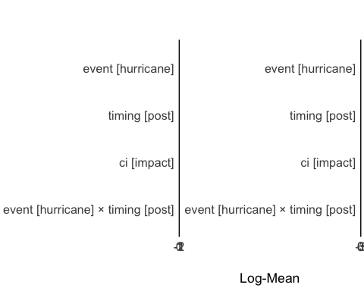
switch things around so that monogenes are not reference category? how do i get stats on the reference level?

Plots – hurricane prevalence

Hurricance prevalence prediction plot
All results. There are no significant results.
#### prevalence plot
p1p <- ggpredict(hurricane_prevalence_final, terms = c("event", "timing"))
p1p <- p1p %>%
rename(
event = x,
estimate = predicted,
se = std.error,
lower = conf.low,
upper = conf.high,
timing = group
) %>%
mutate(psite_type = "myxozoan") %>%
filter(!is.na(estimate), !is.na(lower), !is.na(upper))
ggplot(p1p,
aes(x = timing, y = estimate)) +
facet_wrap(~ event) +
geom_errorbar(aes(ymin = lower, ymax = upper, group = psite_type),
width = 0.05,
position = position_dodge(width = 0.5)) +
geom_line(aes(group = psite_type, linetype = psite_type),
position = position_dodge(width = 0.5)) +
geom_point(aes(fill = psite_type, group = psite_type),
pch = 21, size = 5,
position = position_dodge(width = 0.5)) +
scale_fill_manual(values = c("myxozoan" = "#07c3c5")) +
labs(x = "Event", y = "Estimated Parasite Prevalence", fill = "Parasite Type", linetype = "Parasite Type") +
connor_theme

Zero Inflated prevalence plots
There are no significant results, but ci impact is marginally more likely to be zero
p1ms <- ggemmeans(hurricane_prevalence_final, terms = c("ci"), component = "zi")
p1ms <- p1ms %>%
rename(
ci = x,
estimate = predicted,
se = std.error,
lower = conf.low,
upper = conf.high
) %>%
mutate(psite_type = "myxozoan") %>%
filter(!is.na(estimate), !is.na(lower), !is.na(upper))
ggplot(p1ms,
aes(x = ci, y = estimate)) +
geom_errorbar(aes(ymin = lower, ymax = upper, group = psite_type),
width = 0.05,
position = position_dodge(width = 0.5)) +
geom_line(aes(group = psite_type, linetype = psite_type),
position = position_dodge(width = 0.5)) +
geom_point(aes(fill = psite_type, group = psite_type),
pch = 21, size = 5,
position = position_dodge(width = 0.5)) +
scale_fill_manual(values = c("myxozoan" = "#07c3c5")) +
labs(x = "CI Category", y = "Zero Inflation Estimate", fill = "Parasite Type", linetype = "Parasite Type") +
connor_theme

3 Month Buffer

Control assignment and resampling 3 month
# years in which there was no hurricane: 1963 1966 1967 1968 1970 1972 1973 1975 1976 1977 1978 1980 1981 1982 1983 1984 1986 1987 1989 1990 1991 1993 1994 1996 1999 2000 2005
set.seed(123)
# List of no-hurricane years
no_event_years <- c(1963, 1966, 1967, 1968, 1970,
1972, 1973, 1975, 1976, 1977,
1978, 1980, 1981, 1982, 1983,
1984, 1986, 1987, 1989, 1990,
1991, 1993, 1994, 1996, 1999,
2000)
# initial order of random storm placement for controls was determined by tethering a random number to a storm name (this assignment order was used for both 6 month and 3 month buffer periods)
n_hurricanes <- 24
sampled_years <- sample(no_event_years, n_hurricanes, replace = TRUE)
assigned_controls <- data.frame(
random_value = 1:n_hurricanes,
control_year = sampled_years
)
# there are more control years than there are storms, so we sample randomly up to the # of hurricanes and apply NA to all remaining (unsampled) control years

Control troubleshooting
Correct controls by identifying overlaps and reducing the period of control to not overlap with a hurricane event anymore

Hurricane events and Controls Mapping – 3 month
Add actual hurricane timeline parameters for 3 month (3 month meaning a buffer period of 3 months before a hurricane [denoted as pre] and 3 months after a hurricane [denoted post]). These dates for hurricane occurrence are taken from the NOAA hurricane watch website and represent all hurricane events that crossed a 50 mile boundary of the Pearl River from source to sea.
# hurricane events
hurricane_df3 <- full_data %>%
mutate(ewe_type = case_when(
date >= as.Date("1969-05-14") & date <= as.Date("1969-08-14") ~ "pre_5",
date >= as.Date("1969-08-14") & date <= as.Date("1969-08-22") ~ "hurricane_5", #camille
date >= as.Date("1969-08-22") & date <= as.Date("1969-11-22") ~ "post_5",
date >= as.Date("1971-06-05") & date <= as.Date("1971-09-05") ~ "pre_5",
date >= as.Date("1971-09-05") & date <= as.Date("1971-09-15") ~ "hurricane_5", #edith
date >= as.Date("1971-09-15") & date <= as.Date("1971-12-15") ~ "post_5",
date >= as.Date("1992-05-16") & date <= as.Date("1992-08-16") ~ "pre_5",
date >= as.Date("1992-08-16") & date <= as.Date("1992-08-19") ~ "hurricane_5", #andrew
date >= as.Date("1992-08-19") & date <= as.Date("1992-11-19") ~ "post_5",
date >= as.Date("2004-06-02") & date <= as.Date("2004-09-02") ~ "pre_5",
date >= as.Date("2004-09-02") & date <= as.Date("2004-09-25") ~ "hurricane_5", #ivan -- external
date >= as.Date("2004-09-25") & date <= as.Date("2004-12-25") ~ "post_5",
date >= as.Date("1964-06-28") & date <= as.Date("1964-09-28") ~ "pre_4",
date >= as.Date("1964-09-28") & date <= as.Date("1964-10-05") ~ "hurricane_4", #hilda
date >= as.Date("1964-10-05") & date <= as.Date("1965-01-05") ~ "post_4",
date >= as.Date("1965-05-27") & date <= as.Date("1965-08-27") ~ "pre_4",
date >= as.Date("1965-08-27") & date <= as.Date("1965-09-13") ~ "hurricane_4", #betsy
date >= as.Date("1965-09-13") & date <= as.Date("1965-12-13") ~ "post_4",
date >= as.Date("1974-05-28") & date <= as.Date("1974-08-29") ~ "pre_4",
date >= as.Date("1974-08-29") & date <= as.Date("1974-09-10") ~ "hurricane_4", #carmen -- external
date >= as.Date("1974-09-10") & date <= as.Date("1974-12-10") ~ "post_4",
date >= as.Date("1998-06-15") & date <= as.Date("1998-09-15") ~ "pre_4",
date >= as.Date("1998-09-15") & date <= as.Date("1998-10-01") ~ "hurricane_4", #georges
date >= as.Date("1998-10-01") & date <= as.Date("1999-01-01") ~ "post_4",
date >= as.Date("2002-06-21") & date <= as.Date("2002-09-21") ~ "pre_4",
date >= as.Date("2002-09-21") & date <= as.Date("2002-10-04") ~ "hurricane_4", #lili -- external
date >= as.Date("2002-10-04") & date <= as.Date("2003-01-04") ~ "post_4",
date >= as.Date("1985-05-28") & date <= as.Date("1985-08-28") ~ "pre_3",
date >= as.Date("1985-08-28") & date <= as.Date("1985-09-04") ~ "hurricane_3", #elena
date >= as.Date("1985-09-04") & date <= as.Date("1985-12-04") ~ "post_3",
date >= as.Date("2002-06-14") & date <= as.Date("2002-09-14") ~ "pre_3",
date >= as.Date("2002-09-14") & date <= as.Date("2002-09-27") ~ "hurricane_3", #isidore
date >= as.Date("2002-09-27") & date <= as.Date("2002-12-27") ~ "post_3",
date >= as.Date("1979-04-09") & date <= as.Date("1979-07-09") ~ "pre_1",
date >= as.Date("1979-07-09") & date <= as.Date("1979-07-16") ~ "hurricane_1", #bob
date >= as.Date("1979-07-16") & date <= as.Date("1979-10-16") ~ "post_1",
date >= as.Date("1985-05-12") & date <= as.Date("1985-08-12") ~ "pre_1",
date >= as.Date("1985-08-12") & date <= as.Date("1985-08-20") ~ "hurricane_1", #danny -- external
date >= as.Date("1985-08-20") & date <= as.Date("1985-11-20") ~ "post_1",
date >= as.Date("1985-07-26") & date <= as.Date("1985-10-26") ~ "pre_1",
date >= as.Date("1985-10-26") & date <= as.Date("1985-11-03") ~ "hurricane_1", #juan
date >= as.Date("1985-11-03") & date <= as.Date("1986-02-03") ~ "post_1",
date >= as.Date("1988-06-07") & date <= as.Date("1988-09-07") ~ "pre_1",
date >= as.Date("1988-09-07") & date <= as.Date("1988-09-11") ~ "hurricane_1", #florence
date >= as.Date("1988-09-11") & date <= as.Date("1988-12-11") ~ "post_1",
date >= as.Date("1997-04-16") & date <= as.Date("1997-07-16") ~ "pre_1",
date >= as.Date("1997-07-16") & date <= as.Date("1997-07-27") ~ "hurricane_1", #danny
date >= as.Date("1997-07-27") & date <= as.Date("1997-10-27") ~ "post_1",
date >= as.Date("1988-05-07") & date <= as.Date("1988-08-07") ~ "pre_ts",
date >= as.Date("1988-08-08") & date <= as.Date("1988-08-10") ~ "tropical_storm", #beryl
date >= as.Date("1988-08-11") & date <= as.Date("1988-11-11") ~ "post_ts",
date >= as.Date("1998-06-26") & date <= as.Date("1998-09-26") ~ "pre_ts",
date >= as.Date("1998-09-27") & date <= as.Date("1998-09-30") ~ "tropical_storm", #hermine
date >= as.Date("1998-10-01") & date <= as.Date("1999-01-01") ~ "post_ts",
date >= as.Date("2001-03-05") & date <= as.Date("2001-06-05") ~ "pre_ts",
date >= as.Date("2001-06-05") & date <= as.Date("2001-06-20") ~ "tropical_storm", #allison
date >= as.Date("2001-06-20") & date <= as.Date("2001-09-20") ~ "post_ts",
date >= as.Date("2002-05-04") & date <= as.Date("2002-08-04") ~ "pre_ts",
date >= as.Date("2002-08-04") & date <= as.Date("2002-08-09") ~ "tropical_storm", #bertha
date >= as.Date("2002-08-09") & date <= as.Date("2002-11-09") ~ "post_ts",
date >= as.Date("2002-06-12") & date <= as.Date("2002-09-12") ~ "pre_ts",
date >= as.Date("2002-09-12") & date <= as.Date("2002-09-15") ~ "tropical_storm", #hanna
date >= as.Date("2002-09-15") & date <= as.Date("2002-12-15") ~ "post_ts",
date >= as.Date("2003-03-27") & date <= as.Date("2003-06-27") ~ "pre_ts",
date >= as.Date("2003-06-28") & date <= as.Date("2003-07-03") ~ "tropical_storm", #bill
date >= as.Date("2003-07-04") & date <= as.Date("2003-10-04") ~ "post_ts",
date >= as.Date("1965-06-23") & date <= as.Date("1965-09-23") ~ "pre_ts",
date >= as.Date("1965-09-24") & date <= as.Date("1965-09-30") ~ "tropical_storm", #debbie
date >= as.Date("1965-10-01") & date <= as.Date("1966-01-01") ~ "post_ts",
date >= as.Date("1995-04-30") & date <= as.Date("1995-07-30") ~ "pre_double",
date >= as.Date("1995-07-31") & date <= as.Date("1995-10-06") ~ "hurricane_double", #opal (4) and erin (2) combined
date >= as.Date("1995-10-07") & date <= as.Date("1996-01-07") ~ "post_double",
TRUE ~ "no event"
))
# controls with resampling of overlapped dates
hurricane_df3 <- hurricane_df3 %>%
mutate(control = case_when(
date >= as.Date("1983-06-28") & date <= as.Date("1983-09-28") ~ "pre_control",
date >= as.Date("1983-09-28") & date <= as.Date("1983-10-05") ~ "control", #hilda
date >= as.Date("1983-10-05") & date <= as.Date("1984-01-05") ~ "post_control",
date >= as.Date("1989-05-27") & date <= as.Date("1989-08-27") ~ "pre_control",
date >= as.Date("1989-08-27") & date <= as.Date("1989-09-13") ~ "control", #betsy
date >= as.Date("1989-09-13") & date <= as.Date("1989-12-13") ~ "post_control",
date >= as.Date("1982-04-09") & date <= as.Date("1982-07-09") ~ "pre_control",
date >= as.Date("1982-07-09") & date <= as.Date("1982-07-16") ~ "control", #bob
date >= as.Date("1982-07-16") & date <= as.Date("1982-10-16") ~ "post_control",
date >= as.Date("1967-07-26") & date <= as.Date("1967-10-26") ~ "pre_control",
date >= as.Date("1967-10-26") & date <= as.Date("1967-11-03") ~ "control", #juan
date >= as.Date("1967-11-03") & date <= as.Date("1968-02-03") ~ "post_control",
date >= as.Date("1977-06-07") & date <= as.Date("1977-09-07") ~ "pre_control",
date >= as.Date("1977-09-07") & date <= as.Date("1977-09-11") ~ "control", #florence
date >= as.Date("1977-09-11") & date <= as.Date("1977-12-11") ~ "post_control",
date >= as.Date("1987-04-16") & date <= as.Date("1987-07-16") ~ "pre_control",
date >= as.Date("1987-07-16") & date <= as.Date("1987-07-27") ~ "control", #danny
date >= as.Date("1987-07-27") & date <= as.Date("1987-10-27") ~ "post_control",
date >= as.Date("1993-06-12") & date <= as.Date("1993-09-12") ~ "pre_control",
date >= as.Date("1993-09-12") & date <= as.Date("1993-09-15") ~ "control", #hanna
date >= as.Date("1993-09-15") & date <= as.Date("1993-12-15") ~ "post_control",
date >= as.Date("1978-03-27") & date <= as.Date("1978-06-27") ~ "pre_control",
date >= as.Date("1978-06-28") & date <= as.Date("1978-07-03") ~ "control", #bill
date >= as.Date("1978-07-04") & date <= as.Date("1978-10-04") ~ "post_control",
date >= as.Date("1970-06-23") & date <= as.Date("1970-09-23") ~ "pre_control",
date >= as.Date("1970-09-24") & date <= as.Date("1970-09-30") ~ "control", #debbie
date >= as.Date("1970-10-01") & date <= as.Date("1971-01-01") ~ "post_control",
date >= as.Date("1990-04-30") & date <= as.Date("1990-07-30") ~ "pre_control",
date >= as.Date("1990-07-31") & date <= as.Date("1990-10-06") ~ "control", #opal (4) and erin (2) combined
date >= as.Date("1990-10-07") & date <= as.Date("1991-01-07") ~ "post_control",
date >= as.Date("1982-03-05") & date <= as.Date("1982-06-05") ~ "pre_control",
date >= as.Date("1982-06-05") & date <= as.Date("1982-06-20") ~ "control", #allison
date >= as.Date("1982-06-20") & date <= as.Date("1982-09-20") ~ "post_control",
date >= as.Date("1993-05-28") & date <= as.Date("1993-08-28") ~ "pre_control",
date >= as.Date("1993-08-28") & date <= as.Date("1993-09-04") ~ "control", #elena
date >= as.Date("1993-09-04") & date <= as.Date("1993-12-04") ~ "post_control",
date >= as.Date("1999-05-28") & date <= as.Date("1999-08-29") ~ "pre_control",
date >= as.Date("1999-08-29") & date <= as.Date("1999-09-10") ~ "control", #carmen -- external
date >= as.Date("1999-09-10") & date <= as.Date("1999-12-10") ~ "post_control",
date >= as.Date("2000-06-14") & date <= as.Date("2000-09-14") ~ "pre_control",
date >= as.Date("2000-09-14") & date <= as.Date("2000-09-27") ~ "control", #isidore
date >= as.Date("2000-09-27") & date <= as.Date("2000-12-27") ~ "post_control",
date >= as.Date("1970-06-15") & date <= as.Date("1970-09-15") ~ "pre_control",
date >= as.Date("1970-09-15") & date <= as.Date("1970-10-01") ~ "control", #georges
date >= as.Date("1970-10-01") & date <= as.Date("1971-01-01") ~ "post_control",
date >= as.Date("1989-05-07") & date <= as.Date("1989-08-07") ~ "pre_control",
date >= as.Date("1989-08-08") & date <= as.Date("1989-08-10") ~ "control", #beryl
date >= as.Date("1989-08-11") & date <= as.Date("1989-11-11") ~ "post_control",
date >= as.Date("1999-05-04") & date <= as.Date("1999-08-04") ~ "pre_control",
date >= as.Date("1999-08-04") & date <= as.Date("1999-08-09") ~ "control", #bertha
date >= as.Date("1999-08-09") & date <= as.Date("1999-11-09") ~ "post_control",
date >= as.Date("1999-05-14") & date <= as.Date("1999-08-14") ~ "pre_control",
date >= as.Date("1999-08-14") & date <= as.Date("1999-08-22") ~ "control", #camille
date >= as.Date("1999-08-22") & date <= as.Date("1999-11-22") ~ "post_control",
date >= as.Date("1976-06-05") & date <= as.Date("1976-09-05") ~ "pre_control",
date >= as.Date("1976-09-05") & date <= as.Date("1976-09-15") ~ "control", #edith
date >= as.Date("1976-09-15") & date <= as.Date("1976-12-15") ~ "post_control",
date >= as.Date("1967-05-16") & date <= as.Date("1967-08-16") ~ "pre_control",
date >= as.Date("1967-08-16") & date <= as.Date("1967-08-19") ~ "control", #andrew
date >= as.Date("1967-08-19") & date <= as.Date("1967-11-19") ~ "post_control",
date >= as.Date("1975-06-26") & date <= as.Date("1975-09-26") ~ "pre_control",
date >= as.Date("1975-09-27") & date <= as.Date("1975-09-30") ~ "control", #hermine
date >= as.Date("1975-10-01") & date <= as.Date("1976-01-01") ~ "post_control",
date >= as.Date("2000-05-12") & date <= as.Date("2000-08-12") ~ "pre_control",
date >= as.Date("2000-08-12") & date <= as.Date("2000-08-20") ~ "control", #danny -- external
date >= as.Date("2000-08-20") & date <= as.Date("2000-11-20") ~ "post_control",
date >= as.Date("1973-06-21") & date <= as.Date("1973-09-21") ~ "pre_control",
date >= as.Date("1973-09-21") & date <= as.Date("1973-10-04") ~ "control", #lili -- external
date >= as.Date("1973-10-04") & date <= as.Date("1974-01-04") ~ "post_control",
date >= as.Date("1977-06-02") & date <= as.Date("1977-09-02") ~ "pre_control",
date >= as.Date("1977-09-02") & date <= as.Date("1977-09-25") ~ "control", #ivan -- external
date >= as.Date("1977-09-25") & date <= as.Date("1977-12-25") ~ "post_control",
TRUE ~ "no event"
))
# make a new column for storm intensity
hurricane_df3 <- hurricane_df3 %>%
mutate(storm_intensity = case_when(
str_detect(ewe_type, "1") ~ "one",
str_detect(ewe_type, "2") ~ "two",
str_detect(ewe_type, "3") ~ "three",
str_detect(ewe_type, "4") ~ "four",
str_detect(ewe_type, "5") ~ "five",
str_detect(ewe_type, "ts") ~ "ts",
str_detect(ewe_type, "double") ~ "double",
TRUE ~ "no event"
))
hurricane_df3 <- hurricane_df3 %>%
mutate(event = case_when(
ewe_type == "pre_5" ~ "hurricane",
ewe_type == "post_5" ~ "hurricane",
ewe_type == "pre_4" ~ "hurricane",
ewe_type == "post_4" ~ "hurricane",
ewe_type == "pre_3" ~ "hurricane",
ewe_type == "post_3" ~ "hurricane",
ewe_type == "pre_2" ~ "hurricane",
ewe_type == "post_2" ~ "hurricane",
ewe_type == "pre_1" ~ "hurricane",
ewe_type == "post_1" ~ "hurricane",
ewe_type == "pre_ts" ~ "hurricane",
ewe_type == "post_ts" ~ "hurricane",
ewe_type == "pre_double" ~ "hurricane",
ewe_type == "post_double" ~ "hurricane",
ewe_type == "no event" & control == "pre_control" ~ "control",
ewe_type == "no event" & control == "post_control" ~ "control",
TRUE ~ "NA"
)) %>%
filter(event != "NA")
hurricane_df3 <- hurricane_df3 %>%
mutate(timing = case_when(
ewe_type == "pre_5" ~ "pre",
ewe_type == "post_5" ~ "post",
ewe_type == "pre_4" ~ "pre",
ewe_type == "post_4" ~ "post",
ewe_type == "pre_3" ~ "pre",
ewe_type == "post_3" ~ "post",
ewe_type == "pre_2" ~ "pre",
ewe_type == "post_2" ~ "post",
ewe_type == "pre_1" ~ "pre",
ewe_type == "post_1" ~ "post",
ewe_type == "pre_ts" ~ "pre",
ewe_type == "post_ts" ~ "post",
ewe_type == "pre_double" ~ "pre",
ewe_type == "post_double" ~ "post",
control == "pre_control" ~ "pre",
control == "post_control" ~ "post",
ewe_type == "hurricane_4" ~ "during",
TRUE ~ "NA"
)) %>%
filter(timing != "NA")
hurricane_df3 <- hurricane_df3 %>%
mutate(timing = factor(timing, levels = c("pre", "post"))) %>%
mutate(timing = relevel(timing, ref = "pre")) %>%
mutate(event = factor(event, levels = c("hurricane", "control"))) %>%
mutate(event = relevel(event, ref = "control"))
# ===== filtering for abundance analysis ===== #
# drop low replicate categories
hurricane_df3_abundance <- hurricane_df3 %>%
filter(psite_type %in% c("trematode", "trematode_metacercaria", "monogenean")) %>%
dplyr::mutate(psite_type = droplevels(psite_type))
# filter out all remaining NAs from the psite_abundance column --> there are some but shouldn't be
hurricane_df3_abundance <- hurricane_df3_abundance %>%
filter(!is.na(psite_abundance))
# ===== filtering for prevalence analysis ===== #
# drop low replicate categories
hurricane_df3_prevalence <- hurricane_df3 %>%
filter(psite_type %in% c("myxozoan"))
# filter out all remaining NAs from the psite_prevalence column --> there are none
hurricane_df3_prevalence <- hurricane_df3_prevalence %>%
filter(!is.na(psite_prevalence))
# what are total counts of each parasite type in each category?
summary <- hurricane_df3_abundance %>%
group_by(event, timing, psite_type) %>%
summarise(
total_observations = n(),
total_parasite_count = sum(psite_count, na.rm = TRUE), # sum of parasite counts
.groups = "drop"
)
ggplot(summary,
aes(x = event, y = total_observations, fill = psite_type)) +
facet_wrap(~ timing) +
geom_col(position = "dodge") +
scale_fill_manual(values = c("trematode_metacercaria" = "#AFDFEF", "monogenean" = "#A6E000", "trematode" = "#c9ad79", "myxozoan" = "#07c3c5")) +
labs(x = "Event", y = "Total Observations", fill = "Parasite Type") +
connor_theme
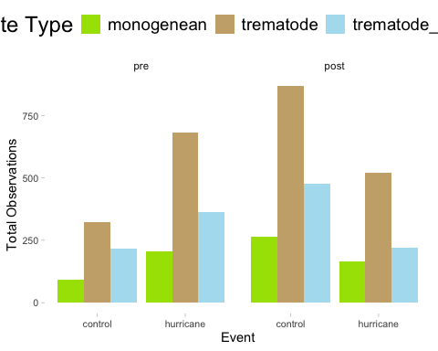
summary <- hurricane_df3_prevalence %>%
group_by(event, timing, psite_type) %>%
summarise(
total_observations = n(),
total_parasite_count = sum(psite_count, na.rm = TRUE), # sum of parasite counts
.groups = "drop"
)
ggplot(summary,
aes(x = event, y = total_observations, fill = psite_type)) +
facet_wrap(~ timing) +
geom_col(position = "dodge") +
scale_fill_manual(values = c("trematode_metacercaria" = "#AFDFEF", "monogenean" = "#A6E000", "trematode" = "#c9ad79", "myxozoan" = "#07c3c5")) +
labs(x = "Event", y = "Total Observations", fill = "Parasite Type") +
connor_theme
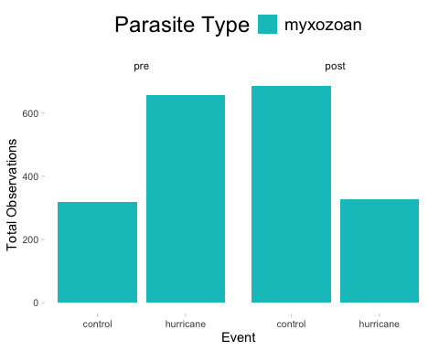
# number of control vs hurricane events by month
summary <- hurricane_df3_abundance %>%
group_by(event, timing, psite_type, month_collected) %>%
summarise(
total_observations = n(),
total_parasite_count = sum(psite_count, na.rm = TRUE), # sum of parasite counts
.groups = "drop"
)

Abundance

Plot raw data (as averages not sums) to identify any trends in the data or inconsistencies.
# how many replicates are in each category --> this is just the number of occurrences, not abundance of parasites
ha3.reps <- hurricane_df3_abundance %>%
group_by(event, timing, psite_type, fish_sp_x) %>%
summarize(observations = n(), .groups = "drop")
# plot how many of each category we have
ggplot(ha3.reps,
aes(x = fish_sp_x, y = observations, fill = psite_type)) +
facet_wrap(timing ~ event) +
geom_col(position = "dodge") +
scale_fill_manual(values = c("trematode_metacercaria" = "#AFDFEF", "monogenean" = "#A6E000", "trematode" = "#c9ad79", "myxozoan" = "#07c3c5")) +
labs(x = "Fish Species", y = "Number of Observations", fill = "Parasite Type", linetype = "Parasite Type") +
connor_theme
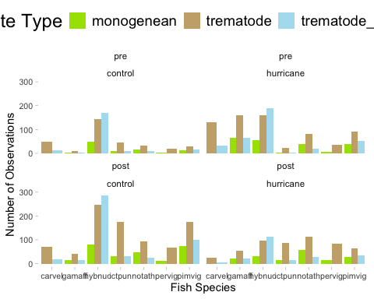
# hurricane abundance with parasite type
ha3.bins1 <- hurricane_df3_abundance %>%
group_by(event, timing, psite_type) %>%
summarize(avg.bin = mean(psite_abundance))
# use this as the raw plot of data
ggplot(ha3.bins1,
aes(x = timing, y = avg.bin, fill = psite_type)) +
facet_wrap( ~ event) +
geom_col(position = "dodge") +
scale_fill_manual(values = c("trematode_metacercaria" = "#AFDFEF", "monogenean" = "#A6E000", "trematode" = "#c9ad79", "myxozoan" = "#07c3c5")) +
labs(x = "Timing", y = "Estimate", fill = "Parasite Type", linetype = "Parasite Type") +
connor_theme
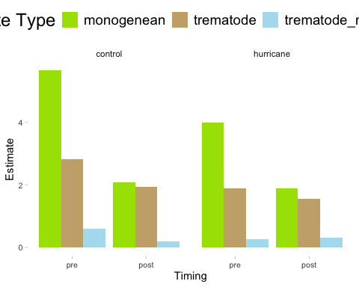
# hurricane abundance with fish species and parasite type
ha3.bins2 <- hurricane_df3_abundance %>%
group_by(event, timing, psite_type, fish_sp_x) %>%
summarize(avg.bin = mean(psite_abundance))
# use this as the raw plot of data
ggplot(ha3.bins2,
aes(x = fish_sp_x, y = avg.bin, fill = psite_type)) +
facet_wrap(timing ~ event) +
geom_col(position = "dodge") +
scale_fill_manual(values = c("trematode_metacercaria" = "#AFDFEF", "monogenean" = "#A6E000", "trematode" = "#c9ad79", "myxozoan" = "#07c3c5")) +
labs(x = "Fish Species", y = "Estimate", fill = "Parasite Type", linetype = "Parasite Type") +
connor_theme
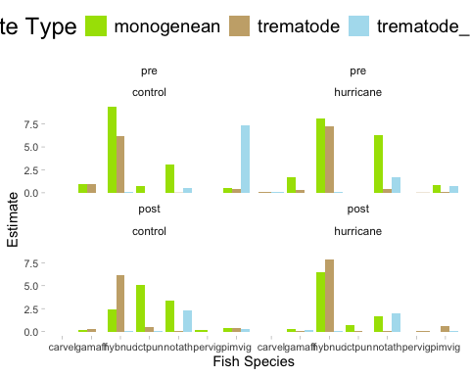

Drop carvel, pervig, ictpun, and gamaff from analysis since they do not have monos and metas consistently or they have super low replicate counts (<50 total parasites per category)
hurricane_df3_abundance_only_full <- hurricane_df3_abundance %>%
filter(!fish_sp_x %in% c("pervig", "carvel"))
# plot new raw data
# how many replicates are in each category--> this is just the number of occurrences, not abundance of parasites
ha3.reps <- hurricane_df3_abundance_only_full %>%
group_by(event, timing, psite_type, fish_sp_x) %>%
summarize(observations = n(), .groups = "drop")
# plot how many of each category we have
ggplot(ha3.reps,
aes(x = fish_sp_x, y = observations, fill = psite_type)) +
facet_wrap(timing ~ event) +
geom_col(position = "dodge") +
scale_fill_manual(values = c("trematode_metacercaria" = "#AFDFEF", "monogenean" = "#A6E000", "trematode" = "#c9ad79", "myxozoan" = "#07c3c5")) +
labs(x = "Fish Species", y = "Number of Observations", fill = "Parasite Type", linetype = "Parasite Type") +
connor_theme
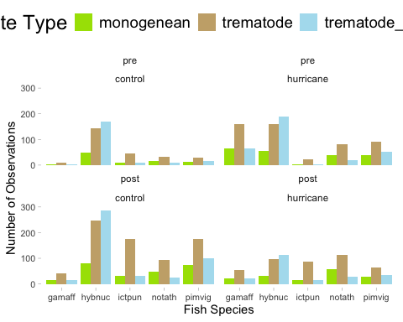
# how many replicates are in each category without concern for parasite type
ha3.reps <- hurricane_df3_abundance_only_full %>%
group_by(event, timing, fish_sp_x) %>%
summarize(observations = n(), .groups = "drop")
# gamaff and and ictpun both have total replication counts (all parasite types combined) below 50 (and the model wont converge, which I think is due to these low replicate counts), so we should drop these two species from the model
hurricane_df3_abundance_only_full <- hurricane_df3_abundance %>%
filter(!fish_sp_x %in% c("pervig", "carvel", "ictpun", "gamaff"))
ha3.reps <- hurricane_df3_abundance_only_full %>%
group_by(event, timing, psite_type, fish_sp_x) %>%
summarize(observations = n(), .groups = "drop")
ggplot(ha3.reps,
aes(x = fish_sp_x, y = observations, fill = psite_type)) +
facet_wrap(timing ~ event) +
geom_col(position = "dodge") +
scale_fill_manual(values = c("trematode_metacercaria" = "#AFDFEF", "monogenean" = "#A6E000", "trematode" = "#c9ad79", "myxozoan" = "#07c3c5")) +
labs(x = "Fish Species", y = "Number of Observations", fill = "Parasite Type", linetype = "Parasite Type") +
connor_theme
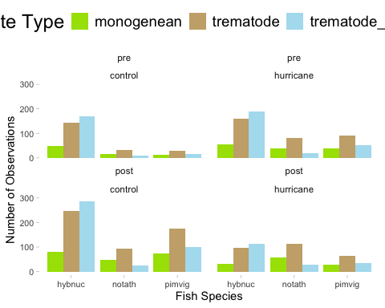
# hurricane abundance with parasite type --> average abundances
ha.bins1 <- hurricane_df3_abundance_only_full %>%
group_by(event, timing, psite_type) %>%
summarize(avg.bin = mean(psite_abundance))
# use this as the raw plot of data
ggplot(ha3.bins1,
aes(x = timing, y = avg.bin, fill = psite_type)) +
facet_wrap( ~ event) +
geom_col(position = "dodge") +
scale_fill_manual(values = c("trematode_metacercaria" = "#AFDFEF", "monogenean" = "#A6E000", "trematode" = "#c9ad79", "myxozoan" = "#07c3c5")) +
labs(x = "Timing", y = "Average Parasite Abundance", fill = "Parasite Type", linetype = "Parasite Type") +
connor_theme
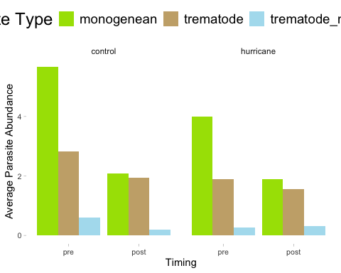
# hurricane abundance with fish species and parasite type
ha3.bins2 <- hurricane_df3_abundance_only_full %>%
group_by(event, timing, psite_type, fish_sp_x) %>%
summarize(avg.bin = mean(psite_abundance))
# use this as the raw plot of data
ggplot(ha3.bins2,
aes(x = fish_sp_x, y = avg.bin, fill = psite_type)) +
facet_wrap(timing ~ event) +
geom_col(position = "dodge") +
scale_fill_manual(values = c("trematode_metacercaria" = "#AFDFEF", "monogenean" = "#A6E000", "trematode" = "#c9ad79", "myxozoan" = "#07c3c5")) +
labs(x = "Fish Species", y = "Average Parasite Abundance", fill = "Parasite Type", linetype = "Parasite Type") +
connor_theme
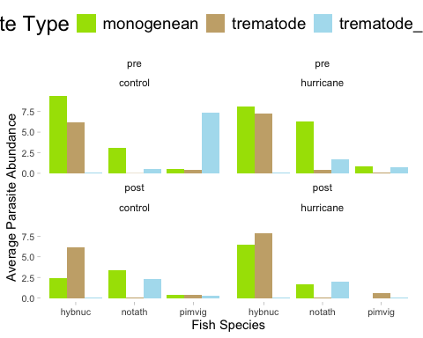 ## Seasonality influencing distribution of abundance
# month and day against number of replicates
ha3.season <- hurricane_df3_abundance_only_full %>%
group_by(event, timing, psite_type, fish_sp_x, season, month_day, year_collected) %>%
summarize(observations = n(), .groups = "drop")
# insert a dummy year as an anchor
ha3.season <- ha3.season %>%
mutate(month_day_date = as.Date(paste0("2025-", month_day), format = "%Y-%m-%d"))
ha3.season$month_day_date <- as.Date(format(as.Date(ha3.season$month_day_date), "2025-%m-%d"))
range(ha3.season$month_day_date)
## [1] "2025-01-03" "2025-12-26"
ggplot(ha3.season,
aes(x = month_day_date, y = event, fill = psite_type)) +
geom_violin(scale = "count", trim = FALSE) +
geom_point(position = position_jitter(height = 0.2), shape = 21, size = 3, stroke = 0.2) +
scale_x_date(
limits = as.Date(c("2025-01-03", "2025-12-26")),
date_labels = "%b",
date_breaks = "1 month",
expand = c(0.01, 0)
) +
scale_fill_manual(values = c(
"trematode_metacercaria" = "#AFDFEF",
"monogenean" = "#A6E000",
"trematode" = "#c9ad79",
"myxozoan" = "#07c3c5"
)) +
labs(x = "Month", y = "Event", fill = "Parasite Type") +
connor_theme
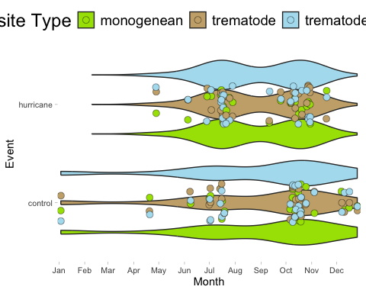
# run a model to see if season has an effect on occurrences
season_model <- glmmTMB(observations ~ season*event, family = nbinom2, data = ha3.season)
simulateResiduals(fittedModel = season_model, plot = TRUE)
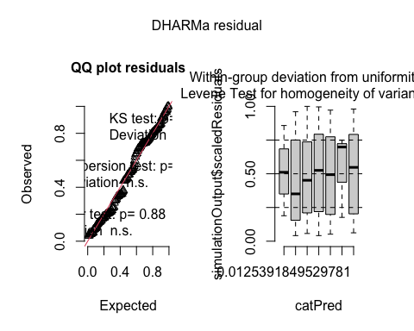
## Object of Class DHARMa with simulated residuals based on 250 simulations with refit = FALSE . See ?DHARMa::simulateResiduals for help.
##
## Scaled residual values: 0.1768335 0.1408587 0.1666519 0.1881994 0.491384 0.1532718 0.2087099 0.3468993 0.6980541 0.6877567 0.7263672 0.642931 0.956 0.4955727 0.5195876 0.7775387 0.7485363 0.7708148 0.8135273 0.7898181 ...
summary(season_model)
## Family: nbinom2 ( log )
## Formula: observations ~ season * event
## Data: ha3.season
##
## AIC BIC logLik deviance df.resid
## 1257.4 1282.4 -620.7 1241.4 160
##
##
## Dispersion parameter for nbinom2 family (): 2.58
##
## Conditional model:
## Estimate Std. Error z value Pr(>|z|)
## (Intercept) 2.90592 0.10652 27.281 <2e-16 ***
## seasonspring 0.08985 0.39659 0.227 0.8208
## seasonsummer 0.06449 0.17217 0.375 0.7080
## seasonwinter 0.09258 0.18884 0.490 0.6240
## eventhurricane -0.37071 0.14989 -2.473 0.0134 *
## seasonspring:eventhurricane -0.39152 0.57739 -0.678 0.4977
## seasonsummer:eventhurricane 0.32842 0.22820 1.439 0.1501
## seasonwinter:eventhurricane NA NA NA NA
## ---
## Signif. codes: 0 '***' 0.001 '**' 0.01 '*' 0.05 '.' 0.1 ' ' 1
plot(parameters(season_model))
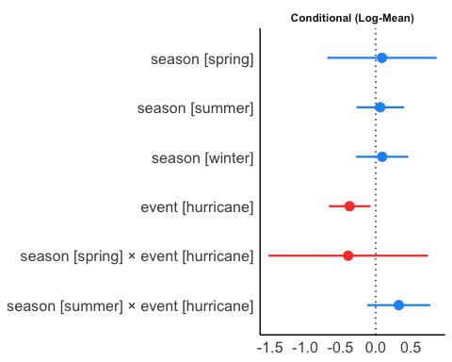
# hurricanes have a negative effect, BUT there are no observations for hurricanes in winter, so we may need to drop that from the model
# why are there no winter occurances of parasites in hurricane?
season_only <- hurricane_df3 %>%
filter(season %in% c("winter")) %>%
filter(!fish_sp_x %in% c("pervig", "carvel", "ictpun", "gamaff"))
# there are just no observations in winter for hurricane for these species
season_only <- hurricane_df3 %>%
filter(season %in% c("winter")) %>%
filter(event %in% c("hurricane"))
# all winter hurricane observations of fishes are in pervig, no hurricane observations in winter are present for any other species of fish -- perhaps there is some seasonality to the presence of fish in the river?

Abundance Models

Negative binomial glmmTMB model validation

Final Hurricane Abundance Model
# run model
final_h_abundance3 <- glmmTMB(psite_abundance ~ event*timing*psite_type + ci + (1|catalog_number) + (1|year_collected/season) + (1|fish_psite_combo) + (1|fish_sp_x) + (total_length_mm|fish_psite_combo),
ziformula = ~ event*timing*psite_type + ci + (1|catalog_number) + (1|year_collected/season) + (1|fish_psite_combo) + (1|fish_sp_x) + (total_length_mm|fish_psite_combo),
family = nbinom1(link = "sqrt"), data = hurricane_df3_abundance_only_full)
simulateResiduals(fittedModel = final_h_abundance3, plot = TRUE)
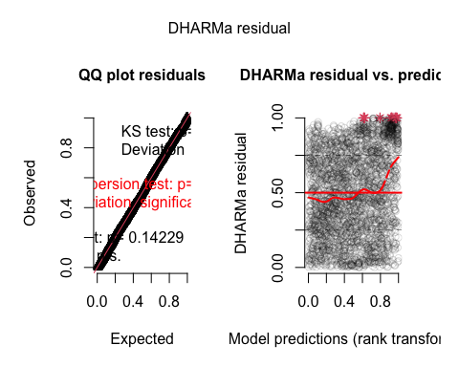
## Object of Class DHARMa with simulated residuals based on 250 simulations with refit = FALSE . See ?DHARMa::simulateResiduals for help.
##
## Scaled residual values: 0.1004305 0.4340645 0.02450148 0.2061712 0.838437 0.7791843 0.3442941 0.5008547 0.9268203 0.2330204 0.3721566 0.5718235 0.4204922 0.643896 0.2758173 0.4046419 0.7602816 0.4292365 0.3635366 0.2936704 ...
summary(final_h_abundance3)
## Family: nbinom1 ( sqrt )
## Formula:
## psite_abundance ~ event * timing * psite_type + ci + (1 | catalog_number) +
## (1 | year_collected/season) + (1 | fish_psite_combo) + (1 |
## fish_sp_x) + (total_length_mm | fish_psite_combo)
## Zero inflation:
## ~event * timing * psite_type + ci + (1 | catalog_number) + (1 |
## year_collected/season) + (1 | fish_psite_combo) + (1 | fish_sp_x) +
## (total_length_mm | fish_psite_combo)
## Data: hurricane_df3_abundance_only_full
##
## AIC BIC logLik deviance df.resid
## 4397.3 4654.0 -2155.7 4311.3 2846
##
## Random effects:
##
## Conditional model:
## Groups Name Variance Std.Dev. Corr
## catalog_number (Intercept) 2.023e+00 1.4221845
## season.year_collected (Intercept) 1.444e-01 0.3799484
## year_collected (Intercept) 1.045e-07 0.0003232
## fish_psite_combo (Intercept) 3.524e-01 0.5936197
## fish_sp_x (Intercept) 3.254e-08 0.0001804
## fish_psite_combo.1 (Intercept) 1.812e+01 4.2562678
## total_length_mm 4.834e-03 0.0695251 -0.95
## Number of obs: 2889, groups:
## catalog_number, 61; season:year_collected, 33; year_collected, 23; fish_psite_combo, 36; fish_sp_x, 3
##
## Zero-inflation model:
## Groups Name Variance Std.Dev. Corr
## catalog_number (Intercept) 4.845e-01 0.6960783
## season.year_collected (Intercept) 2.454e-01 0.4954285
## year_collected (Intercept) 2.829e-01 0.5318416
## fish_psite_combo (Intercept) 2.834e+00 1.6834713
## fish_sp_x (Intercept) 2.785e-08 0.0001669
## fish_psite_combo.1 (Intercept) 3.385e+00 1.8399037
## total_length_mm 1.087e-03 0.0329688 -0.32
## Number of obs: 2889, groups:
## catalog_number, 61; season:year_collected, 33; year_collected, 23; fish_psite_combo, 36; fish_sp_x, 3
##
## Dispersion parameter for nbinom1 family (): 28.5
##
## Conditional model:
## Estimate Std. Error
## (Intercept) 2.4591 0.9623
## eventhurricane -1.8190 0.8511
## timingpost -1.8968 0.8964
## psite_typetrematode -1.8600 0.9491
## psite_typetrematode_metacercaria -1.8177 1.0090
## ciimpact 0.7931 0.4480
## eventhurricane:timingpost -2.6372 1.2612
## eventhurricane:psite_typetrematode 2.7384 0.6718
## eventhurricane:psite_typetrematode_metacercaria -0.3703 0.6952
## timingpost:psite_typetrematode 2.0796 0.6805
## timingpost:psite_typetrematode_metacercaria 2.8037 0.7694
## eventhurricane:timingpost:psite_typetrematode 1.9469 1.0940
## eventhurricane:timingpost:psite_typetrematode_metacercaria 3.1456 1.1273
## z value Pr(>|z|)
## (Intercept) 2.555 0.010606 *
## eventhurricane -2.137 0.032579 *
## timingpost -2.116 0.034355 *
## psite_typetrematode -1.960 0.050040 .
## psite_typetrematode_metacercaria -1.801 0.071626 .
## ciimpact 1.770 0.076699 .
## eventhurricane:timingpost -2.091 0.036528 *
## eventhurricane:psite_typetrematode 4.076 4.58e-05 ***
## eventhurricane:psite_typetrematode_metacercaria -0.533 0.594235
## timingpost:psite_typetrematode 3.056 0.002243 **
## timingpost:psite_typetrematode_metacercaria 3.644 0.000269 ***
## eventhurricane:timingpost:psite_typetrematode 1.780 0.075138 .
## eventhurricane:timingpost:psite_typetrematode_metacercaria 2.790 0.005264 **
## ---
## Signif. codes: 0 '***' 0.001 '**' 0.01 '*' 0.05 '.' 0.1 ' ' 1
##
## Zero-inflation model:
## Estimate Std. Error
## (Intercept) 0.5893 1.3458
## eventhurricane -1.3562 1.1872
## timingpost 0.7533 1.0940
## psite_typetrematode 1.8715 1.5833
## psite_typetrematode_metacercaria 1.4149 1.5889
## ciimpact 0.5095 0.4784
## eventhurricane:timingpost 1.7207 1.5060
## eventhurricane:psite_typetrematode 2.1959 1.2239
## eventhurricane:psite_typetrematode_metacercaria 0.7210 1.2318
## timingpost:psite_typetrematode -0.9460 1.1761
## timingpost:psite_typetrematode_metacercaria -0.9221 1.2047
## eventhurricane:timingpost:psite_typetrematode -1.8290 1.6579
## eventhurricane:timingpost:psite_typetrematode_metacercaria -1.0030 1.7074
## z value Pr(>|z|)
## (Intercept) 0.438 0.6615
## eventhurricane -1.142 0.2533
## timingpost 0.689 0.4911
## psite_typetrematode 1.182 0.2372
## psite_typetrematode_metacercaria 0.890 0.3732
## ciimpact 1.065 0.2868
## eventhurricane:timingpost 1.143 0.2532
## eventhurricane:psite_typetrematode 1.794 0.0728 .
## eventhurricane:psite_typetrematode_metacercaria 0.585 0.5583
## timingpost:psite_typetrematode -0.804 0.4212
## timingpost:psite_typetrematode_metacercaria -0.765 0.4440
## eventhurricane:timingpost:psite_typetrematode -1.103 0.2699
## eventhurricane:timingpost:psite_typetrematode_metacercaria -0.588 0.5569
## ---
## Signif. codes: 0 '***' 0.001 '**' 0.01 '*' 0.05 '.' 0.1 ' ' 1
plot(parameters(final_h_abundance3))
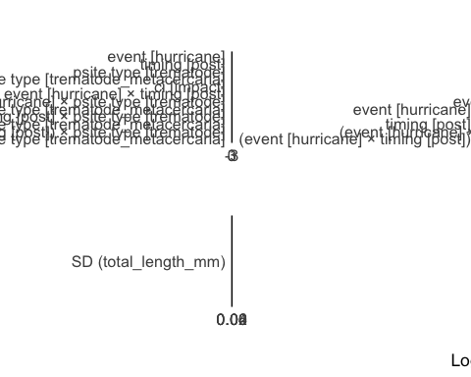

Plots – Abundance 3 month
All results
#### A
a1a <- ggpredict(final_h_abundance3, terms = c("psite_type", "event"))
a1a <- a1a %>%
rename(
psite_type = x,
estimate = predicted,
se = std.error,
lower = conf.low,
upper = conf.high,
event = group)
a1ap <- ggplot(a1a,
aes(x = event, y = estimate)) +
geom_errorbar(aes(ymin = lower, ymax = upper, group = psite_type),
width = 0.05,
position = position_dodge(width = 0.5)) +
geom_line(aes(group = psite_type, linetype = psite_type),
position = position_dodge(width = 0.5)) +
geom_point(aes(fill = psite_type, group = psite_type),
pch = 21, size = 5,
position = position_dodge(width = 0.5)) +
scale_fill_manual(values = c("trematode_metacercaria" = "#AFDFEF", "monogenean" = "#A6E000", "trematode" = "#c9ad79", "myxozoan" = "#07c3c5")) +
labs(x = "Event", y = "Estimate", fill = "Parasite Type", linetype = "Parasite Type") +
connor_theme
#### B
a1b <- ggpredict(final_h_abundance3, terms = c("psite_type", "event"))
a1b <- a1b %>%
rename(
psite_type = x,
estimate = predicted,
se = std.error,
lower = conf.low,
upper = conf.high,
event = group)
a1b <- a1b %>%
filter(psite_type %in% c("trematode"))
a1bp <- ggplot(a1b,
aes(x = event, y = estimate)) +
geom_errorbar(aes(ymin = lower, ymax = upper, group = psite_type),
width = 0.05,
position = position_dodge(width = 0.5)) +
geom_line(aes(group = psite_type, linetype = psite_type),
position = position_dodge(width = 0.5)) +
geom_point(aes(fill = psite_type, group = psite_type),
pch = 21, size = 5,
position = position_dodge(width = 0.5)) +
scale_fill_manual(values = c("trematode_metacercaria" = "#AFDFEF", "monogenean" = "#A6E000", "trematode" = "#c9ad79", "myxozoan" = "#07c3c5")) +
labs(x = "Timing", y = "Estimate", fill = "Parasite Type", linetype = "Parasite Type") +
connor_theme
#### C
a1c <- ggpredict(final_h_abundance3, terms = c("psite_type", "event", "timing"))
a1c <- a1c %>%
rename(
psite_type = x,
estimate = predicted,
se = std.error,
lower = conf.low,
upper = conf.high,
event = group,
timing = facet)
a1c <- a1c %>%
filter(psite_type %in% c("trematode"))
a1cp <- ggplot(a1c,
aes(x = timing, y = estimate)) +
facet_wrap(~ event) +
geom_errorbar(aes(ymin = lower, ymax = upper, group = timing),
width = 0.05,
position = position_dodge(width = 0.5)) +
geom_line(aes(group = psite_type, linetype = psite_type),
position = position_dodge(width = 0.5)) +
geom_point(aes(fill = psite_type, group = psite_type),
pch = 21, size = 5,
position = position_dodge(width = 0.5)) +
scale_fill_manual(values = c("trematode_metacercaria" = "#AFDFEF", "monogenean" = "#A6E000", "trematode" = "#c9ad79", "myxozoan" = "#07c3c5")) +
labs(x = "Timing", y = "Estimate", fill = "Parasite Type", linetype = "Parasite Type") +
connor_theme
#### D
a1d <- ggpredict(final_h_abundance3, terms = c("psite_type", "event", "timing"))
a1d <- a1d %>%
rename(
psite_type = x,
estimate = predicted,
se = std.error,
lower = conf.low,
upper = conf.high,
event = group,
timing = facet)
a1d <- a1d %>%
filter(psite_type %in% c("trematode_metacercaria"))
a1dp <- ggplot(a1d,
aes(x = timing, y = estimate)) +
facet_wrap(~ event, scales = "free_y") +
geom_errorbar(aes(ymin = lower, ymax = upper, group = timing),
width = 0.05,
position = position_dodge(width = 0.5)) +
geom_line(aes(group = psite_type, linetype = psite_type),
position = position_dodge(width = 0.5)) +
geom_point(aes(fill = psite_type, group = psite_type),
pch = 21, size = 5,
position = position_dodge(width = 0.5)) +
scale_fill_manual(values = c("trematode_metacercaria" = "#AFDFEF", "monogenean" = "#A6E000", "trematode" = "#c9ad79", "myxozoan" = "#07c3c5")) +
labs(x = "Timing", y = "Estimate", fill = "Parasite Type", linetype = "Parasite Type") +
connor_theme
#### E
a1e <- ggpredict(final_h_abundance3, terms = c("psite_type", "event"))
a1e <- a1e %>%
rename(
psite_type = x,
estimate = predicted,
se = std.error,
lower = conf.low,
upper = conf.high,
event = group)
a1e <- a1e %>%
filter(psite_type %in% c("trematode_metacercaria"))
a1ep <- ggplot(a1e,
aes(x = event, y = estimate)) +
geom_errorbar(aes(ymin = lower, ymax = upper, group = event),
width = 0.05,
position = position_dodge(width = 0.5)) +
geom_line(aes(group = psite_type, linetype = psite_type),
position = position_dodge(width = 0.5)) +
geom_point(aes(fill = psite_type, group = psite_type),
pch = 21, size = 5,
position = position_dodge(width = 0.5)) +
scale_fill_manual(values = c("trematode_metacercaria" = "#AFDFEF", "monogenean" = "#A6E000", "trematode" = "#c9ad79", "myxozoan" = "#07c3c5")) +
labs(x = "Event", y = "Estimate", fill = "Parasite Type", linetype = "Parasite Type") +
connor_theme
# try to plot only monos
a1m <- ggpredict(final_h_abundance3, terms = c("psite_type", "event", "timing"))
a1m <- a1m %>%
rename(
psite_type = x,
estimate = predicted,
se = std.error,
lower = conf.low,
upper = conf.high,
event = group,
timing = facet)
a1m <- a1m %>%
filter(psite_type %in% c("monogenean"))
a1mp <- ggplot(a1m,
aes(x = timing, y = estimate)) +
facet_wrap(~ event, scales = "free_y") +
geom_errorbar(aes(ymin = lower, ymax = upper, group = event),
width = 0.05,
position = position_dodge(width = 0.5)) +
geom_line(aes(group = psite_type, linetype = psite_type),
position = position_dodge(width = 0.5)) +
geom_point(aes(fill = psite_type, group = psite_type),
pch = 21, size = 5,
position = position_dodge(width = 0.5)) +
scale_fill_manual(values = c("trematode_metacercaria" = "#AFDFEF", "monogenean" = "#A6E000", "trematode" = "#c9ad79", "myxozoan" = "#07c3c5")) +
labs(x = "Timing", y = "Estimate", fill = "Parasite Type", linetype = "Parasite Type") +
connor_theme
hurricane_abundance3_plot <- ggarrange(a1ap, a1cp, a1dp, a1mp, common.legend = TRUE, legend = "bottom", labels = c("A", "B", "C", "D"))
plot(hurricane_abundance3_plot)
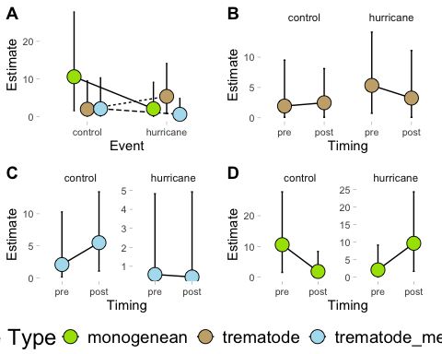
Significant results only
#### hurricanes decrease abundance
a1s1 <- ggpredict(final_h_abundance3, terms = c("event"))
a1s1 <- a1s1 %>%
rename(
event = x,
estimate = predicted,
se = std.error,
lower = conf.low,
upper = conf.high)
a1s1p <- ggplot(a1s1,
aes(x = event, y = estimate)) +
geom_errorbar(aes(ymin = lower, ymax = upper, group = event),
width = 0.05,
position = position_dodge(width = 0.5)) +
geom_line(aes(group = event, linetype = event),
position = position_dodge(width = 0.5)) +
geom_point(aes(fill = event, group = event),
pch = 21, size = 5,
position = position_dodge(width = 0.5)) +
scale_fill_manual(values = c("trematode_metacercaria" = "#AFDFEF", "monogenean" = "#A6E000", "trematode" = "#c9ad79", "myxozoan" = "#07c3c5","hurricane" = "#CB87B4", "control" = "#F4B95A")) +
labs(x = "Event", y = "Estimate", fill = "Parasite Type", linetype = "Parasite Type") +
connor_theme
#### post decrease abundance
a1s3 <- ggpredict(final_h_abundance3, terms = c("timing"))
a1s3 <- a1s3 %>%
rename(
timing = x,
estimate = predicted,
se = std.error,
lower = conf.low,
upper = conf.high)
a1s3p <- ggplot(a1s3,
aes(x = timing, y = estimate)) +
geom_errorbar(aes(ymin = lower, ymax = upper, group = timing),
width = 0.05,
position = position_dodge(width = 0.5)) +
geom_line(aes(group = timing, linetype = timing),
position = position_dodge(width = 0.5)) +
geom_point(aes(fill = timing, group = timing),
pch = 21, size = 5,
position = position_dodge(width = 0.5)) +
scale_fill_manual(values = c("trematode_metacercaria" = "#AFDFEF", "monogenean" = "#A6E000", "trematode" = "#c9ad79", "myxozoan" = "#07c3c5","hurricane" = "#CB87B4", "control" = "#F4B95A")) +
labs(x = "Event", y = "Estimate", fill = "Parasite Type", linetype = "Parasite Type") +
connor_theme
#### hurricane + post all decrease abundance (this doesn't match what is plotted)
a1s <- ggpredict(final_h_abundance3, terms = c("timing", "event"))
a1s <- a1s %>%
rename(
timing = x,
estimate = predicted,
se = std.error,
lower = conf.low,
upper = conf.high,
event = group)
a1sp <- ggplot(a1s,
aes(x = timing, y = estimate)) +
geom_errorbar(aes(ymin = lower, ymax = upper, group = event),
width = 0.05,
position = position_dodge(width = 0.5)) +
geom_line(aes(group = event, linetype = event),
position = position_dodge(width = 0.5)) +
geom_point(aes(fill = event, group = event),
pch = 21, size = 5,
position = position_dodge(width = 0.5)) +
scale_fill_manual(values = c("trematode_metacercaria" = "#AFDFEF", "monogenean" = "#A6E000", "trematode" = "#c9ad79", "myxozoan" = "#07c3c5","hurricane" = "#CB87B4", "control" = "#F4B95A")) +
labs(x = "Event", y = "Estimate", fill = "Parasite Type", linetype = "Parasite Type") +
connor_theme
#### hurricane and trematode is more abundant
a1sb <- ggpredict(final_h_abundance3, terms = c("psite_type", "event"))
a1sb <- a1sb %>%
rename(
psite_type = x,
estimate = predicted,
se = std.error,
lower = conf.low,
upper = conf.high,
event = group)
a1sb <- a1sb %>%
filter(psite_type %in% c("trematode"))
a1sbp <- ggplot(a1sb,
aes(x = event, y = estimate)) +
geom_errorbar(aes(ymin = lower, ymax = upper, group = psite_type),
width = 0.05,
position = position_dodge(width = 0.5)) +
geom_line(aes(group = psite_type, linetype = psite_type),
position = position_dodge(width = 0.5)) +
geom_point(aes(fill = psite_type, group = psite_type),
pch = 21, size = 5,
position = position_dodge(width = 0.5)) +
scale_fill_manual(values = c("trematode_metacercaria" = "#AFDFEF", "monogenean" = "#A6E000", "trematode" = "#c9ad79", "myxozoan" = "#07c3c5","hurricane" = "#CB87B4", "control" = "#F4B95A")) +
labs(x = "Timing", y = "Estimate", fill = "Parasite Type", linetype = "Parasite Type") +
connor_theme
#### post and trematode is more abundant
a1sc <- ggpredict(final_h_abundance3, terms = c("psite_type", "timing"))
a1sc <- a1sc %>%
rename(
psite_type = x,
estimate = predicted,
se = std.error,
lower = conf.low,
upper = conf.high,
timing = group)
a1sc <- a1sc %>%
filter(psite_type %in% c("trematode"))
a1scp <- ggplot(a1sc,
aes(x = timing, y = estimate)) +
geom_errorbar(aes(ymin = lower, ymax = upper, group = psite_type),
width = 0.05,
position = position_dodge(width = 0.5)) +
geom_line(aes(group = psite_type, linetype = psite_type),
position = position_dodge(width = 0.5)) +
geom_point(aes(fill = psite_type, group = psite_type),
pch = 21, size = 5,
position = position_dodge(width = 0.5)) +
scale_fill_manual(values = c("trematode_metacercaria" = "#AFDFEF", "monogenean" = "#A6E000", "trematode" = "#c9ad79", "myxozoan" = "#07c3c5","hurricane" = "#CB87B4", "control" = "#F4B95A")) +
labs(x = "Timing", y = "Estimate", fill = "Parasite Type", linetype = "Parasite Type") +
connor_theme
#### post and meta is more abundant
a1sd <- ggpredict(final_h_abundance3, terms = c("psite_type", "timing"))
a1sd <- a1sd %>%
rename(
psite_type = x,
estimate = predicted,
se = std.error,
lower = conf.low,
upper = conf.high,
timing = group)
a1sd <- a1sd %>%
filter(psite_type %in% c("trematode_metacercaria"))
a1sdp <- ggplot(a1sd,
aes(x = timing, y = estimate)) +
geom_errorbar(aes(ymin = lower, ymax = upper, group = timing),
width = 0.05,
position = position_dodge(width = 0.5)) +
geom_line(aes(group = psite_type, linetype = psite_type),
position = position_dodge(width = 0.5)) +
geom_point(aes(fill = psite_type, group = psite_type),
pch = 21, size = 5,
position = position_dodge(width = 0.5)) +
scale_fill_manual(values = c("trematode_metacercaria" = "#AFDFEF", "monogenean" = "#A6E000", "trematode" = "#c9ad79", "myxozoan" = "#07c3c5")) +
labs(x = "Timing", y = "Estimate", fill = "Parasite Type", linetype = "Parasite Type") +
connor_theme
#### hurricane and post and meta is more abundant -- post estimate falls below the lower bound of the error, why?
a1se <- ggpredict(final_h_abundance3, terms = c("psite_type", "event", "timing"))
# raw counts of metas:
meta_count <- hurricane_df3_abundance_only_full %>%
group_by(event, timing, psite_type) %>%
summarize(observations = n(), .groups = "drop") %>%
filter(psite_type %in% c("trematode_metacercaria"))
view(meta_count) # there seem to be plenty of observations in the category, not a convergence issue
a1se <- a1se %>%
rename(
psite_type = x,
estimate = predicted,
se = std.error,
lower = conf.low,
upper = conf.high,
event = group,
timing = facet)
a1se <- a1se %>%
filter(psite_type %in% c("trematode_metacercaria")) %>%
filter(event %in% c("hurricane"))
a1sep <- ggplot(a1se,
aes(x = timing, y = estimate)) +
geom_errorbar(aes(ymin = lower, ymax = upper, group = psite_type),
width = 0.05,
position = position_dodge(width = 0.5)) +
geom_line(aes(group = psite_type, linetype = psite_type),
position = position_dodge(width = 0.5)) +
geom_point(aes(fill = psite_type, group = psite_type),
pch = 21, size = 5,
position = position_dodge(width = 0.5)) +
scale_fill_manual(values = c("trematode_metacercaria" = "#AFDFEF", "monogenean" = "#A6E000", "trematode" = "#c9ad79", "myxozoan" = "#07c3c5","hurricane" = "#CB87B4", "control" = "#F4B95A")) +
labs(x = "Timing", y = "Estimate", fill = "Parasite Type", linetype = "Parasite Type") +
connor_theme
hurricane_abundance3_plot <- ggarrange(a1s1p, a1s3p, a1sp, a1sbp, a1scp, a1sdp, a1sep, common.legend = FALSE, legend = "bottom", labels = c("A", "B", "C", "D", "E", "F", "G"))
plot(hurricane_abundance3_plot)
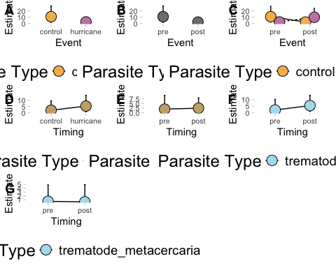 ## Marginally significant results trematode less abundant, meta less abundant, impact more abundant, hurricane and post and trematode more abundant
#### trematodes are less abundant and metas are less abundant
a1ms1 <- ggpredict(final_h_abundance3, terms = c("psite_type"))
a1ms1 <- a1ms1 %>%
rename(
psite_type = x,
estimate = predicted,
se = std.error,
lower = conf.low,
upper = conf.high)
a1ms1p <- ggplot(a1ms1,
aes(x = psite_type, y = estimate)) +
geom_errorbar(aes(ymin = lower, ymax = upper, group = psite_type),
width = 0.05,
position = position_dodge(width = 0.5)) +
geom_line(aes(group = psite_type, linetype = psite_type),
position = position_dodge(width = 0.5)) +
geom_point(aes(fill = psite_type, group = psite_type),
pch = 21, size = 5,
position = position_dodge(width = 0.5)) +
scale_fill_manual(values = c("trematode_metacercaria" = "#AFDFEF", "monogenean" = "#A6E000", "trematode" = "#c9ad79", "myxozoan" = "#07c3c5","hurricane" = "#CB87B4", "control" = "#F4B95A")) +
labs(x = "Event", y = "Estimate", fill = "Parasite Type", linetype = "Parasite Type") +
connor_theme
#### impact category is more abundant
a1ms3 <- ggpredict(final_h_abundance3, terms = c("ci"))
a1ms3 <- a1ms3 %>%
rename(
ci = x,
estimate = predicted,
se = std.error,
lower = conf.low,
upper = conf.high)
a1ms3p <- ggplot(a1ms3,
aes(x = ci, y = estimate)) +
geom_errorbar(aes(ymin = lower, ymax = upper, group = ci),
width = 0.05,
position = position_dodge(width = 0.5)) +
geom_line(aes(group = ci, linetype = ci),
position = position_dodge(width = 0.5)) +
geom_point(aes(fill = ci, group = ci),
pch = 21, size = 5,
position = position_dodge(width = 0.5)) +
scale_fill_manual(values = c("trematode_metacercaria" = "#AFDFEF", "monogenean" = "#A6E000", "trematode" = "#c9ad79", "myxozoan" = "#07c3c5","hurricane" = "#CB87B4", "control" = "#F4B95A", "impact" = "#C21")) +
labs(x = "Event", y = "Estimate", fill = "Parasite Type", linetype = "Parasite Type") +
connor_theme
#### hurricane and post and trematode more abundant
a1ms4 <- ggpredict(final_h_abundance3, terms = c("timing", "event", "psite_type"))
a1ms4 <- a1ms4 %>%
rename(
timing = x,
estimate = predicted,
se = std.error,
lower = conf.low,
upper = conf.high,
event = group,
psite_type = facet)
a1ms4 <- a1ms4 %>%
filter(psite_type %in% c("trematode"))
a1ms4p <- ggplot(a1ms4,
aes(x = timing, y = estimate)) +
facet_wrap(~ event) +
geom_errorbar(aes(ymin = lower, ymax = upper, group = psite_type),
width = 0.05,
position = position_dodge(width = 0.5)) +
geom_line(aes(group = psite_type, linetype = psite_type),
position = position_dodge(width = 0.5)) +
geom_point(aes(fill = psite_type, group = psite_type),
pch = 21, size = 5,
position = position_dodge(width = 0.5)) +
scale_fill_manual(values = c("trematode_metacercaria" = "#AFDFEF", "monogenean" = "#A6E000", "trematode" = "#c9ad79", "myxozoan" = "#07c3c5","hurricane" = "#CB87B4", "control" = "#F4B95A")) +
labs(x = "Event", y = "Estimate", fill = "Parasite Type", linetype = "Parasite Type") +
connor_theme
hurricane_abundance3_plot_ms <- ggarrange(a1ms1p, a1s3p, a1ms4p, common.legend = FALSE, legend = "bottom", labels = c("A", "B", "C"))
plot(hurricane_abundance3_plot_ms)
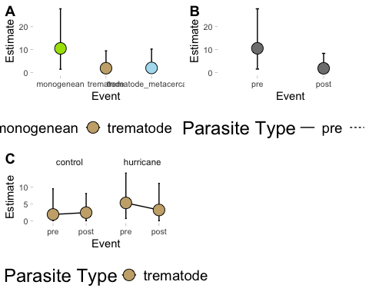

Zero inflated results plotted - abundance 3 months
All results
#### A
azi1 <- ggemmeans(final_h_abundance3, terms = c("psite_type", "event"), component = "zi")
azi1 <- azi1 %>%
rename(
psite_type = x,
estimate = predicted,
se = std.error,
lower = conf.low,
upper = conf.high,
event = group
)
azi1p <- ggplot(azi1, aes(x = event, y = estimate)) +
geom_errorbar(aes(ymin = lower, ymax = upper, group = psite_type),
width = 0.05,
position = position_dodge(0.5)) +
geom_line(aes(group = psite_type, linetype = psite_type),
position = position_dodge(0.5)) +
geom_point(aes(fill = psite_type, group = psite_type),
pch = 21, size = 5,
position = position_dodge(0.5)) +
scale_fill_manual(values = c("trematode_metacercaria" = "#AFDFEF",
"monogenean" = "#A6E000",
"trematode" = "#c9ad79",
"myxozoan" = "#07c3c5")) +
labs(x = "Event",
y = "Zero-Inflation Estimate",
fill = "Parasite Type",
linetype = "Parasite Type") +
connor_theme
#### B
azi2 <- ggemmeans(final_h_abundance3, terms = c("psite_type", "event"), component = "zi")
azi2 <- azi2 %>%
rename(
psite_type = x,
estimate = predicted,
se = std.error,
lower = conf.low,
upper = conf.high,
event = group
)
azi2 <- azi2 %>%
filter(psite_type %in% c("trematode"))
azi2p <- ggplot(azi2,
aes(x = event, y = estimate)) +
geom_errorbar(aes(ymin = lower, ymax = upper, group = psite_type),
width = 0.05,
position = position_dodge(width = 0.5)) +
geom_line(aes(group = psite_type, linetype = psite_type),
position = position_dodge(width = 0.5)) +
geom_point(aes(fill = psite_type, group = psite_type),
pch = 21, size = 5,
position = position_dodge(width = 0.5)) +
scale_fill_manual(values = c("trematode_metacercaria" = "#AFDFEF", "monogenean" = "#A6E000", "trematode" = "#c9ad79", "myxozoan" = "#07c3c5")) +
labs(x = "Timing", y = "Zero-Inflation Estimate", fill = "Parasite Type", linetype = "Parasite Type") +
connor_theme
#### C
azi3 <- ggemmeans(final_h_abundance3, terms = c("psite_type", "event", "timing"), component = "zi")
azi3 <- azi3 %>%
rename(
psite_type = x,
estimate = predicted,
se = std.error,
lower = conf.low,
upper = conf.high,
event = group,
timing = facet
)
azi3 <- azi3 %>%
filter(psite_type %in% c("trematode"))
azi3p <- ggplot(azi3,
aes(x = timing, y = estimate)) +
facet_wrap(~ event) +
geom_errorbar(aes(ymin = lower, ymax = upper, group = timing),
width = 0.05,
position = position_dodge(width = 0.5)) +
geom_line(aes(group = psite_type, linetype = psite_type),
position = position_dodge(width = 0.5)) +
geom_point(aes(fill = psite_type, group = psite_type),
pch = 21, size = 5,
position = position_dodge(width = 0.5)) +
scale_fill_manual(values = c("trematode_metacercaria" = "#AFDFEF", "monogenean" = "#A6E000", "trematode" = "#c9ad79", "myxozoan" = "#07c3c5")) +
labs(x = "Timing", y = "Zero-Inflation Estimate", fill = "Parasite Type", linetype = "Parasite Type") +
connor_theme
#### D
azi4 <- ggemmeans(final_h_abundance3, terms = c("psite_type", "event", "timing"), component = "zi")
azi4 <- azi4 %>%
rename(
psite_type = x,
estimate = predicted,
se = std.error,
lower = conf.low,
upper = conf.high,
event = group,
timing = facet
)
azi4 <- azi4 %>%
filter(psite_type %in% c("trematode_metacercaria"))
azi4p <- ggplot(azi4,
aes(x = timing, y = estimate)) +
facet_wrap(~ event) +
geom_errorbar(aes(ymin = lower, ymax = upper, group = timing),
width = 0.05,
position = position_dodge(width = 0.5)) +
geom_line(aes(group = psite_type, linetype = psite_type),
position = position_dodge(width = 0.5)) +
geom_point(aes(fill = psite_type, group = psite_type),
pch = 21, size = 5,
position = position_dodge(width = 0.5)) +
scale_fill_manual(values = c("trematode_metacercaria" = "#AFDFEF", "monogenean" = "#A6E000", "trematode" = "#c9ad79", "myxozoan" = "#07c3c5")) +
labs(x = "Timing", y = "Zero-Inflation Estimate", fill = "Parasite Type", linetype = "Parasite Type") +
connor_theme
#### E
azi5 <- ggemmeans(final_h_abundance3, terms = c("psite_type", "event"), component = "zi")
azi5 <- azi5 %>%
rename(
psite_type = x,
estimate = predicted,
se = std.error,
lower = conf.low,
upper = conf.high,
event = group
)
azi5 <- azi5 %>%
filter(psite_type %in% c("trematode_metacercaria"))
azi5p <- ggplot(azi5,
aes(x = event, y = estimate)) +
geom_errorbar(aes(ymin = lower, ymax = upper, group = event),
width = 0.05,
position = position_dodge(width = 0.5)) +
geom_line(aes(group = psite_type, linetype = psite_type),
position = position_dodge(width = 0.5)) +
geom_point(aes(fill = psite_type, group = psite_type),
pch = 21, size = 5,
position = position_dodge(width = 0.5)) +
scale_fill_manual(values = c("trematode_metacercaria" = "#AFDFEF", "monogenean" = "#A6E000", "trematode" = "#c9ad79", "myxozoan" = "#07c3c5")) +
scale_y_continuous(limits = c(0, 60), breaks = seq(0, 60, 10)) +
labs(x = "Event", y = "Zero-Inflation Estimate", fill = "Parasite Type", linetype = "Parasite Type") +
connor_theme
# try to plot only monos
azi6 <- ggemmeans(final_h_abundance3, terms = c("psite_type", "event", "timing"), component = "zi")
azi6 <- azi6 %>%
rename(
psite_type = x,
estimate = predicted,
se = std.error,
lower = conf.low,
upper = conf.high,
event = group,
timing = facet
)
azi6 <- azi6 %>%
filter(psite_type %in% c("monogenean"))
azi6p <- ggplot(azi6,
aes(x = timing, y = estimate)) +
facet_wrap(~ event, scales = "free_y") +
geom_errorbar(aes(ymin = lower, ymax = upper, group = event),
width = 0.05,
position = position_dodge(width = 0.5)) +
geom_line(aes(group = psite_type, linetype = psite_type),
position = position_dodge(width = 0.5)) +
geom_point(aes(fill = psite_type, group = psite_type),
pch = 21, size = 5,
position = position_dodge(width = 0.5)) +
scale_fill_manual(values = c("trematode_metacercaria" = "#AFDFEF", "monogenean" = "#A6E000", "trematode" = "#c9ad79", "myxozoan" = "#07c3c5")) +
labs(x = "Timing", y = "Zero-Inflation Estimate", fill = "Parasite Type", linetype = "Parasite Type") +
connor_theme
hurricane_abundance3_plot_zi <- ggarrange(azi1p, azi3p, azi4p, azi6p, common.legend = FALSE, legend = "bottom", labels = c("A", "B", "C", "D"))
plot(hurricane_abundance3_plot_zi)
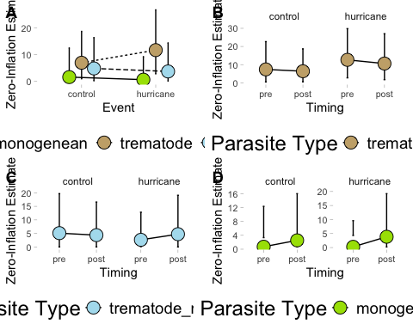 ## Zero inflated results plotted - abundance 3 months Significant results only – no significant results
# Hurricane marginally increased trematode likelihood of being zero
azis1 <- ggemmeans(final_h_abundance3, terms = c("psite_type", "event"), component = "zi")
azis1 <- azis1 %>%
rename(
psite_type = x,
estimate = predicted,
se = std.error,
lower = conf.low,
upper = conf.high,
event = group
)
azis1 <- azis1 %>%
filter(psite_type %in% c("trematode"))
ggplot(azis1,
aes(x = event, y = estimate)) +
geom_errorbar(aes(ymin = lower, ymax = upper, group = psite_type),
width = 0.05,
position = position_dodge(0.5)) +
geom_line(aes(group = psite_type, linetype = psite_type),
position = position_dodge(0.5)) +
geom_point(aes(fill = psite_type, group = psite_type),
pch = 21, size = 5,
position = position_dodge(0.5)) +
scale_fill_manual(values = c("trematode_metacercaria" = "#AFDFEF",
"monogenean" = "#A6E000",
"trematode" = "#c9ad79",
"myxozoan" = "#07c3c5")) +
labs(x = "Event",
y = "Zero-Inflation Estimate",
fill = "Parasite Type",
linetype = "Parasite Type") +
connor_theme
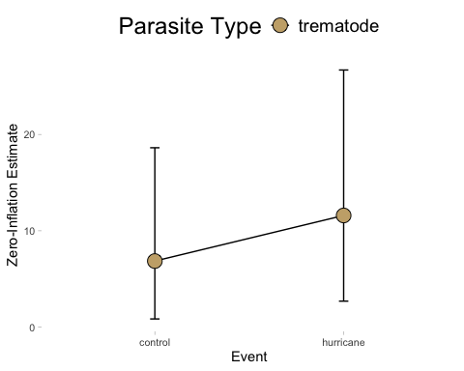

Prevalence
Plot raw data (as averages not sums) to identify any trends in the data or inconsistencies.
# how many replicates are in each category --> this is just the number of occurrences, not abundance of parasites
hp3.reps <- hurricane_df3_prevalence %>%
group_by(event, timing, psite_type, fish_sp_x) %>%
summarize(observations = n(), .groups = "drop")
# plot how many of each category we have
raw1p <- ggplot(hp3.reps,
aes(x = fish_sp_x, y = observations, fill = psite_type)) +
facet_wrap(timing ~ event) +
geom_col(position = "dodge") +
scale_fill_manual(values = c("trematode_metacercaria" = "#AFDFEF", "monogenean" = "#A6E000", "trematode" = "#c9ad79", "myxozoan" = "#07c3c5")) +
labs(x = "Fish Species", y = "Number of Observations", fill = "Parasite Type", linetype = "Parasite Type") +
connor_theme
# hurricane abundance with parasite type
hp3.bins1 <- hurricane_df3_prevalence %>%
group_by(event, timing, psite_type) %>%
summarize(avg.bin = mean(psite_prevalence))
# use this as the raw plot of data
raw2p <- ggplot(hp3.bins1,
aes(x = timing, y = avg.bin, fill = psite_type)) +
facet_wrap( ~ event) +
geom_col(position = "dodge") +
scale_fill_manual(values = c("trematode_metacercaria" = "#AFDFEF", "monogenean" = "#A6E000", "trematode" = "#c9ad79", "myxozoan" = "#07c3c5")) +
labs(x = "Timing", y = "Estimate", fill = "Parasite Type", linetype = "Parasite Type") +
connor_theme
# hurricane abundance with fish species and parasite type
hp3.bins2 <- hurricane_df3_prevalence %>%
group_by(event, timing, psite_type, fish_sp_x) %>%
summarize(avg.bin = mean(psite_prevalence))
# use this as the raw plot of data
raw3p <- ggplot(hp3.bins2,
aes(x = fish_sp_x, y = avg.bin, fill = psite_type)) +
facet_wrap(timing ~ event) +
geom_col(position = "dodge") +
scale_fill_manual(values = c("trematode_metacercaria" = "#AFDFEF", "monogenean" = "#A6E000", "trematode" = "#c9ad79", "myxozoan" = "#07c3c5")) +
labs(x = "Fish Species", y = "Estimate", fill = "Parasite Type", linetype = "Parasite Type") +
connor_theme
hurricane_prevalence3_raw <- ggarrange(raw1p, raw2p, raw3p, common.legend = FALSE, legend = "bottom", labels = c("A", "B", "C"))
plot(hurricane_prevalence3_raw)
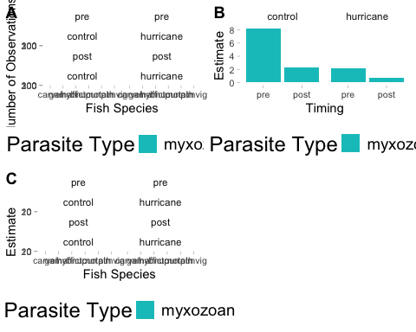
# no myxos in percina -- is already not in the database

Seasonality influencing distribution - prevalence
# month and day against number of replicates
hp3.season <- hurricane_df3_prevalence %>%
group_by(event, timing, psite_type, fish_sp_x, season, month_day) %>%
summarize(observations = n(), .groups = "drop")
# insert a dummy year as an anchor
hp3.season <- hp3.season %>%
mutate(month_day_date = as.Date(paste0("2020-", month_day), format = "%Y-%m-%d"))
ggplot(hp3.season,
aes(x = month_day_date, y = event, fill = psite_type)) +
geom_violin() +
geom_point(position = position_jitter(height = 0.2), shape = 21, size = 3, stroke = 0.2) +
scale_x_date(date_labels = "%b %d", date_breaks = "1 month") +
scale_fill_manual(values = c(
"trematode_metacercaria" = "#AFDFEF",
"monogenean" = "#A6E000",
"trematode" = "#c9ad79",
"myxozoan" = "#07c3c5"
)) +
labs(x = "Month-Day", y = "Event", fill = "Parasite Type") +
connor_theme
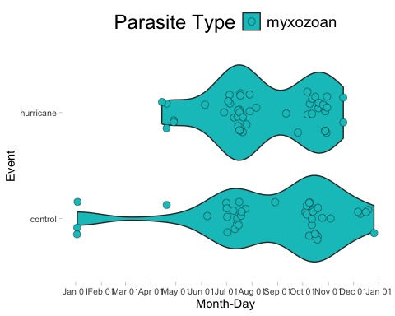
# run a model to see if season has an effect on occurrences
season_model <- glmmTMB(observations ~ season*event, family = nbinom2, data = hp3.season)
simulateResiduals(fittedModel = season_model, plot = TRUE)
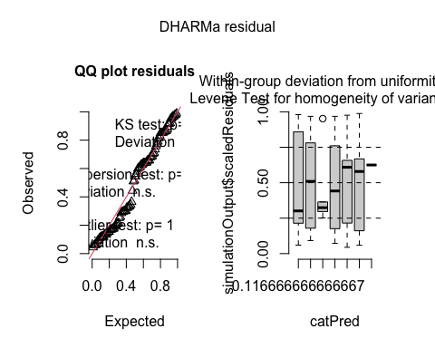
## Object of Class DHARMa with simulated residuals based on 250 simulations with refit = FALSE . See ?DHARMa::simulateResiduals for help.
##
## Scaled residual values: 0.8601631 0.8504374 0.5093791 0.168023 0.6249178 0.7110796 0.7898921 0.7715448 0.968 0.09744047 0.1137766 0.1902052 0.2076285 0.757694 0.8543174 0.9587104 0.1703816 0.2100149 0.6796258 0.5791385 ...
summary(season_model)
## Family: nbinom2 ( log )
## Formula: observations ~ season * event
## Data: hp3.season
##
## AIC BIC logLik deviance df.resid
## 738.1 758.1 -361.0 722.1 82
##
##
## Dispersion parameter for nbinom2 family (): 1.88
##
## Conditional model:
## Estimate Std. Error z value Pr(>|z|)
## (Intercept) 3.28998 0.17321 18.994 <2e-16 ***
## seasonspring 0.04222 0.77363 0.055 0.9565
## seasonsummer -0.31786 0.26256 -1.211 0.2260
## seasonwinter -0.20463 0.31987 -0.640 0.5223
## eventhurricane -0.56213 0.24477 -2.297 0.0216 *
## seasonspring:eventhurricane 0.21561 0.86318 0.250 0.8028
## seasonsummer:eventhurricane 0.86027 0.35325 2.435 0.0149 *
## seasonwinter:eventhurricane NA NA NA NA
## ---
## Signif. codes: 0 '***' 0.001 '**' 0.01 '*' 0.05 '.' 0.1 ' ' 1
plot(parameters(season_model))
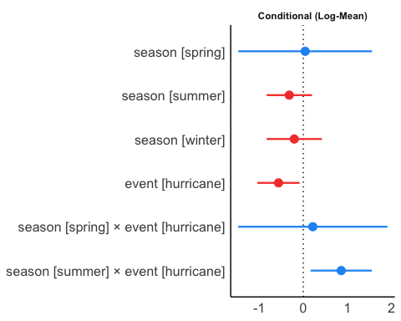
# summer and hurricanes have some sort of significant influence on myxo prevalence -- there are not enough observations in winter to make comments about

Prevalence Models

Final Hurricane Prevalence Model
# prevalence
hurricane_prevalence3_final <- glmmTMB(psite_prevalence ~ event*timing + ci + (1|catalog_number) + (1|year_collected/season) + (1|fish_sp_x) + offset(log(total_length_mm)),
ziformula = ~ event*timing + ci + (1|catalog_number) + (1|year_collected/season) + (1|fish_sp_x) + offset(sqrt(total_length_mm)),
family = nbinom2, data = hurricane_df3_prevalence)
simulateResiduals(fittedModel = hurricane_prevalence3_final, plot = TRUE)
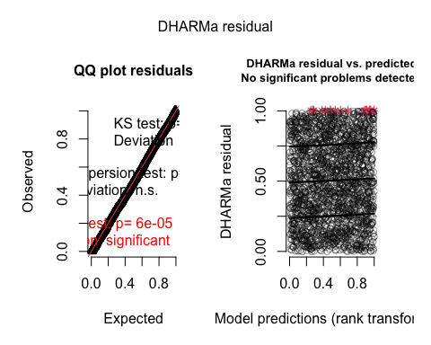
## Object of Class DHARMa with simulated residuals based on 250 simulations with refit = FALSE . See ?DHARMa::simulateResiduals for help.
##
## Scaled residual values: 0.09027887 0.1503529 0.5459099 0.4779603 0.3131891 0.2540077 0.7110767 0.6084838 0.253982 0.9190595 0.732153 0.001910672 0.1268708 0.7789201 0.09368637 0.5939829 0.5154856 0.831997 0.06817733 0.9373449 ...
summary(hurricane_prevalence3_final)
## Family: nbinom2 ( log )
## Formula:
## psite_prevalence ~ event * timing + ci + (1 | catalog_number) +
## (1 | year_collected/season) + (1 | fish_sp_x) + offset(log(total_length_mm))
## Zero inflation:
## ~event * timing + ci + (1 | catalog_number) + (1 | year_collected/season) +
## (1 | fish_sp_x) + offset(sqrt(total_length_mm))
## Data: hurricane_df3_prevalence
##
## AIC BIC logLik deviance df.resid
## 1750.5 1856.8 -856.3 1712.5 1971
##
## Random effects:
##
## Conditional model:
## Groups Name Variance Std.Dev.
## catalog_number (Intercept) 9.635e-16 3.104e-08
## season:year_collected (Intercept) 1.482e-08 1.218e-04
## year_collected (Intercept) 7.742e-11 8.799e-06
## fish_sp_x (Intercept) 3.047e+00 1.745e+00
## Number of obs: 1990, groups:
## catalog_number, 110; season:year_collected, 45; year_collected, 29; fish_sp_x, 6
##
## Zero-inflation model:
## Groups Name Variance Std.Dev.
## catalog_number (Intercept) 5.065e-08 2.251e-04
## season:year_collected (Intercept) 1.218e-11 3.491e-06
## year_collected (Intercept) 2.101e-01 4.584e-01
## fish_sp_x (Intercept) 8.814e-01 9.388e-01
## Number of obs: 1990, groups:
## catalog_number, 110; season:year_collected, 45; year_collected, 29; fish_sp_x, 6
##
## Dispersion parameter for nbinom2 family (): 0.0283
##
## Conditional model:
## Estimate Std. Error z value Pr(>|z|)
## (Intercept) -4.23986 1.06736 -3.972 7.12e-05 ***
## eventhurricane -0.61964 0.67517 -0.918 0.359
## timingpost -0.06776 0.66622 -0.102 0.919
## ciimpact 0.22949 0.48492 0.473 0.636
## eventhurricane:timingpost -0.96348 0.95170 -1.012 0.311
## ---
## Signif. codes: 0 '***' 0.001 '**' 0.01 '*' 0.05 '.' 0.1 ' ' 1
##
## Zero-inflation model:
## Estimate Std. Error z value Pr(>|z|)
## (Intercept) -8.8099 1.8959 -4.647 3.37e-06 ***
## eventhurricane 1.0302 1.5032 0.685 0.493
## timingpost -0.3800 1.3498 -0.282 0.778
## ciimpact 0.1318 0.8889 0.148 0.882
## eventhurricane:timingpost 0.3019 1.8281 0.165 0.869
## ---
## Signif. codes: 0 '***' 0.001 '**' 0.01 '*' 0.05 '.' 0.1 ' ' 1
plot(parameters(hurricane_prevalence3_final))
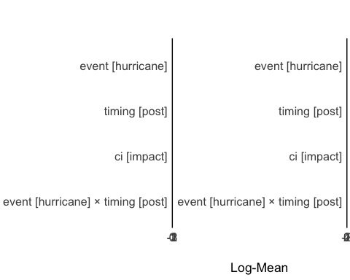
switch things around so that monogenes are not reference category? how do i get stats on the reference level?

Plots – hurricane prevalence 3 month

Hurricance prevalence prediction plot 3 month
All results – no significant or marginally significant results
#### prevalence plot
p1p <- ggpredict(hurricane_prevalence3_final, terms = c("event", "timing"))
p1p <- p1p %>%
rename(
event = x,
estimate = predicted,
se = std.error,
lower = conf.low,
upper = conf.high,
timing = group
) %>%
mutate(psite_type = "myxozoan") %>%
filter(!is.na(estimate), !is.na(lower), !is.na(upper))
hpp_f <- ggplot(p1p,
aes(x = timing, y = estimate)) +
facet_wrap(~ event) +
geom_errorbar(aes(ymin = lower, ymax = upper, group = psite_type),
width = 0.05,
position = position_dodge(width = 0.5)) +
geom_line(aes(group = psite_type, linetype = psite_type),
position = position_dodge(width = 0.5)) +
geom_point(aes(fill = psite_type, group = psite_type),
pch = 21, size = 5,
position = position_dodge(width = 0.5)) +
scale_fill_manual(values = c("myxozoan" = "#07c3c5")) +
labs(x = "Event", y = "Estimated Parasite Prevalence", fill = "Parasite Type", linetype = "Parasite Type") +
connor_theme
final_prevalence3_plot <- ggarrange(hpp_f, common.legend = FALSE, legend = "bottom", labels = c("A"))
plot(final_prevalence3_plot)

Zero Inflated prevalence plots 3 month
All results – no significant or marginally significant results
azi1 <- ggemmeans(hurricane_prevalence3_final, terms = c("event", "timing"), component = "zi")
azi1 <- azi1 %>%
rename(
event = x,
estimate = predicted,
se = std.error,
lower = conf.low,
upper = conf.high,
timing = group
) %>%
mutate(psite_type = "myxozoan") %>%
filter(!is.na(estimate), !is.na(lower), !is.na(upper))
azi1p <- ggplot(azi1,
aes(x = timing, y = estimate)) +
facet_wrap(~ event) +
geom_errorbar(aes(ymin = lower, ymax = upper, group = event),
width = 0.05,
position = position_dodge(width = 0.5)) +
geom_line(aes(group = psite_type, linetype = psite_type),
position = position_dodge(width = 0.5)) +
geom_point(aes(fill = psite_type, group = event),
pch = 21, size = 5,
position = position_dodge(width = 0.5)) +
scale_fill_manual(values = c("trematode_metacercaria" = "#AFDFEF", "monogenean" = "#A6E000", "trematode" = "#c9ad79", "myxozoan" = "#07c3c5")) +
labs(x = "Timing", y = "Zero Inflation Estimate", fill = "Event") +
connor_theme
hurricane_prevalence3_plot_zi <- ggarrange(azi1p, common.legend = FALSE, legend = "bottom", labels = c("A"))
plot(hurricane_prevalence3_plot_zi)

Estimating Biodiversity Changes
Jackknife estimates - all parasites
# create DF for biodiversity estimates -- drop species that have very low replication, so kick out all cilliate, nematomorph, leech, copepod observations (but lets keep in nematodes, cestodes, and acanths)
# Remove unwanted parasite types and drop their factor levels
biodiv_df <- hurricane_df6 %>%
filter(!psite_type %in% c("nematomorph", "ciliate", "leech", "copepod")) %>%
droplevels()
# Get all unique combinations of grouping variables
group_combos <- unique(biodiv_df[, c("event", "timing", "ci", "psite_type", "fish_sp_x", "psite_spp_y")])
# Empty results data frame
jackknife_results <- data.frame(
event = character(),
timing = character(),
ci = character(),
psite_type = character(),
fish_sp_x = character(),
psite_spp_y = character(),
jackknife_mean_richness = numeric(),
total_psite_count = numeric(),
stringsAsFactors = FALSE
)
# Loop over each combination
for (i in 1:nrow(group_combos)) {
event <- group_combos$event[i]
timing <- group_combos$timing[i]
ci <- group_combos$ci[i]
psite <- group_combos$psite_type[i]
fish <- group_combos$fish_sp_x[i]
rich <- group_combos$psite_spp_y[i]
# Safe subsetting using which()
sub_df <- biodiv_df[which(
biodiv_df$event == event &
biodiv_df$timing == timing &
biodiv_df$ci == ci &
biodiv_df$psite_type == psite &
biodiv_df$fish_sp_x == fish &
biodiv_df$psite_spp_y == rich
), ]
# Remove 0-counts
sub_df <- sub_df[sub_df$psite_count != 0, ]
# Skip if no data
if (nrow(sub_df) == 0) next
# Unique samples
sample_ids <- unique(sub_df$x)
richness_values <- numeric(length(sample_ids))
for (j in seq_along(sample_ids)) {
id_to_leave_out <- sample_ids[j]
df_minus_one <- sub_df[sub_df$x != id_to_leave_out, ]
richness_values[j] <- length(unique(df_minus_one$psite_spp_x))
}
total_count <- sum(sub_df$psite_count, na.rm = TRUE)
jackknife_results <- rbind(jackknife_results, data.frame(
event = event,
timing = timing,
ci = ci,
psite_type = as.character(psite),
fish_sp_x = as.character(fish),
psite_spp_y = as.character(rich),
jackknife_mean_richness = mean(richness_values),
total_psite_count = total_count
))
}
# Remove incomplete rows
jackknife_results <- jackknife_results[complete.cases(jackknife_results), ]
# create plots for the variety of combinations of factors we want to investigate
# event
ggplot(jackknife_results,
aes(x = psite_type, y = jackknife_mean_richness, fill = psite_type)) +
geom_col(position = "dodge") +
facet_wrap(timing ~ event) +
theme_minimal(base_size = 12) +
labs(
x = "Fish species",
y = "Mean Parasite Richness (Jackknife)",
fill = "Parasite type"
) + connor_theme
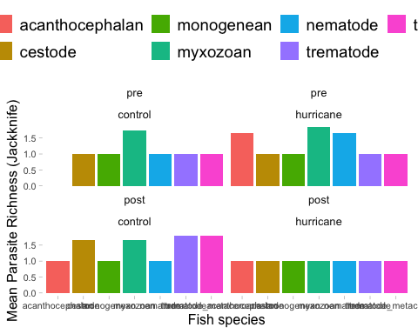

Plot jacknife estimates
ggplot(jackknife_results,
aes(x = psite_type, y = jackknife_mean_richness, fill = psite_spp_y)) +
geom_col(position = "dodge") +
facet_wrap(timing ~ event) +
theme_minimal(base_size = 12) +
labs(
x = "Fish species",
y = "Mean Parasite Richness (Jackknife)",
fill = "Parasite type"
) + connor_theme
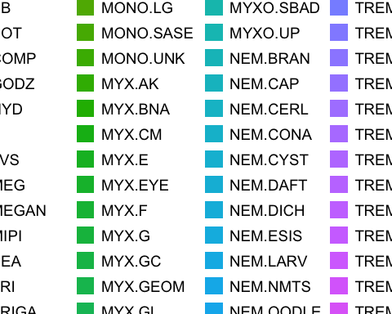
# trim df to be one df for each type of parasite
acanths <- jackknife_results %>%
filter(psite_type %in% c("acanthocephalan")) %>%
droplevels()
jk_a <- ggplot(jackknife_results,
aes(x = timing, y = jackknife_mean_richness, fill = psite_spp_y)) +
geom_col(position = "dodge") +
facet_wrap(~ event) +
theme_minimal(base_size = 12) +
labs(
x = "Fish species",
y = "Mean Parasite Richness (Jackknife)",
fill = "Parasite type"
) + connor_theme + guides(fill = "none")
nems <- jackknife_results %>%
filter(psite_type %in% c("nematode")) %>%
droplevels()
jk_n <- ggplot(nems,
aes(x = timing, y = jackknife_mean_richness, fill = psite_spp_y)) +
geom_col(position = "dodge") +
facet_wrap(~ event) +
theme_minimal(base_size = 12) +
labs(
x = "Fish species",
y = "Mean Parasite Richness (Jackknife)",
fill = "Parasite type"
) + connor_theme + guides(fill = "none")
cest <- jackknife_results %>%
filter(psite_type %in% c("cestode")) %>%
droplevels()
jk_c <- ggplot(cest,
aes(x = timing, y = jackknife_mean_richness, fill = psite_spp_y)) +
geom_col(position = "dodge") +
facet_wrap(~ event) +
theme_minimal(base_size = 12) +
labs(
x = "Fish species",
y = "Mean Parasite Richness (Jackknife)",
fill = "Parasite type"
) + connor_theme + guides(fill = "none")
trem <- jackknife_results %>%
filter(psite_type %in% c("trematode")) %>%
droplevels()
jk_t <- ggplot(trem,
aes(x = timing, y = jackknife_mean_richness, fill = psite_spp_y)) +
geom_col(position = "dodge") +
facet_wrap(~ event) +
theme_minimal(base_size = 12) +
labs(
x = "Fish species",
y = "Mean Parasite Richness (Jackknife)",
fill = "Parasite type"
) + connor_theme + guides(fill = "none")
trem_meta <- jackknife_results %>%
filter(psite_type %in% c("trematode_metacercaria")) %>%
droplevels()
jk_tm <- ggplot(trem_meta,
aes(x = timing, y = jackknife_mean_richness, fill = psite_spp_y)) +
geom_col(position = "dodge") +
facet_wrap(~ event) +
theme_minimal(base_size = 12) +
labs(
x = "Fish species",
y = "Mean Parasite Richness (Jackknife)",
fill = "Parasite type"
) + connor_theme + guides(fill = "none")
mono <- jackknife_results %>%
filter(psite_type %in% c("monogenean")) %>%
droplevels()
jk_mono <- ggplot(mono,
aes(x = timing, y = jackknife_mean_richness, fill = psite_spp_y)) +
geom_col(position = "dodge") +
facet_wrap(~ event) +
theme_minimal(base_size = 12) +
labs(
x = "Fish species",
y = "Mean Parasite Richness (Jackknife)",
fill = "Parasite type"
) + connor_theme + guides(fill = "none")
myxo <- jackknife_results %>%
filter(psite_type %in% c("myxozoan")) %>%
droplevels()
jk_myxo <- ggplot(myxo,
aes(x = timing, y = jackknife_mean_richness, fill = psite_spp_y)) +
geom_col(position = "dodge") +
facet_wrap(~ event) +
theme_minimal(base_size = 12) +
labs(
x = "Fish species",
y = "Mean Parasite Richness (Jackknife)",
fill = "Parasite type"
) + connor_theme + guides(fill = "none")
# combine all plots into one
biodiv_plot_hurricane <- ggarrange(jk_a, jk_n, jk_c, jk_t, jk_tm, jk_mono, jk_myxo, common.legend = FALSE, legend = "bottom", labels = c("A", "B", "C", "D", "E", "F", "G"))
plot(biodiv_plot_hurricane)
