Laravel Configuration

Introduction:
All of the configuration files for the Laravel framework are stored in the config directory. Each option is documented, so feel free to look through the files and get familiar with the options available to you.
These configuration files allow you to configure things like your database connection information, your mail server information, as well as various other core configuration values such as your application URL and encryption key.

The about Command
Laravel can display an overview of your application's configuration, drivers, and environment via the about Artisan command.
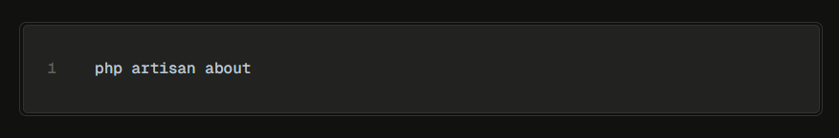

If you're only interested in a particular section of the application overview output, you may filter for that section using the --only option:


Or, to explore a specific configuration file's values in detail, you may use the config:show Artisan command:


Environment Configuration
Environment variables are those which provide a list of web services to your web application. All the environment variables are declared in the .env file which includes the parameters required for initializing the configuration.
Laravel utilizes the DotEnv PHP library. In a fresh Laravel installation, the root directory of your application will contain a .env.example file that defines many common environment variables. During the Laravel installation process, this file will automatically be copied to .env.

By default, the .env file includes following parameters –
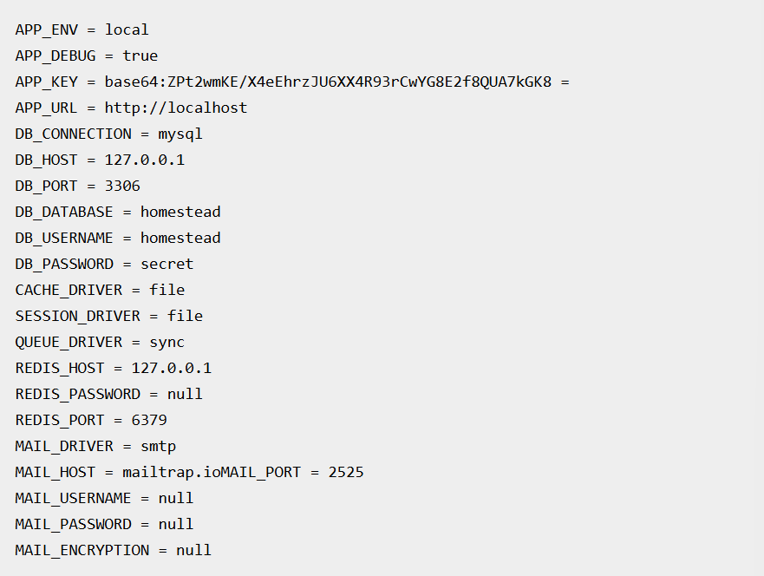

Environment File Security
- The .env file should not be committed to the application source control, since each developer or user has some predefined environment configuration for the web application.

- For backup options, the development team should include the .env.example file, which should contain the default configuration.

Environment Variable Types
All variables in your .env files are typically parsed as strings, so some reserved values have been created to allow you to return a wider range of types from the env() function:
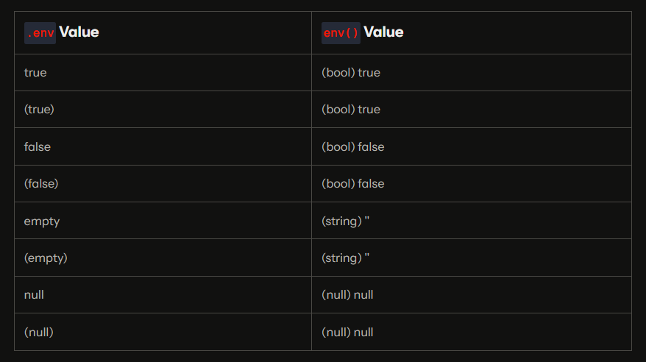

If you need to define an environment variable with a value that contains spaces, you may do so by enclosing the value in double quotes:
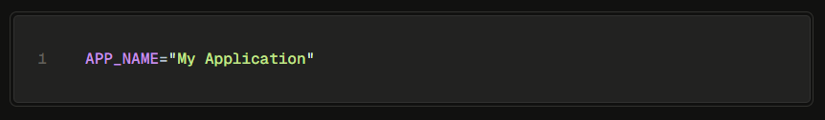

Retrieval of Environment Variables
All the environment variables declared in the .env file can be accessed by env-helper functions which will call the respective parameter. These variables are also listed into $_ENV global variable whenever application receives a request from the user end. You can access the environment variable as shown below –
env-helper functions are called in the app.php file included in the config folder. The above given example is calling for the basic local parameter.

Determining the Current Environment
The current application environment is determined via the APP_ENV variable from your .env file. You may access this value via the environment method on the App facade:
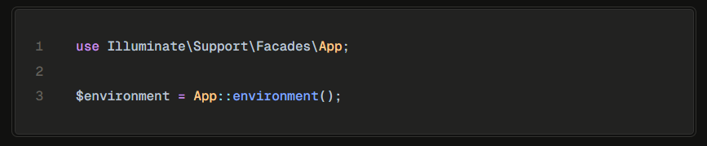

You may also pass arguments to the environment method to determine if the environment matches a given value. The method will return true if the environment matches any of the given values:
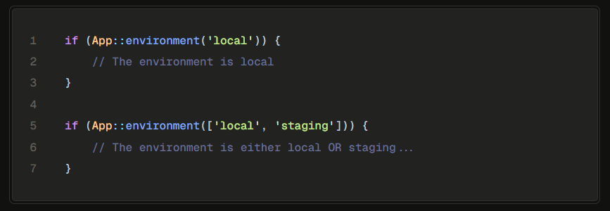

Encrypting Environment Files
Unencrypted environment files should never be stored in source control. However, Laravel allows you to encrypt your environment files so that they may safely be added to source control with the rest of your application.
Encryption
To encrypt an environment file, you may use the env:encrypt command:

Running the env:encrypt command will encrypt your .env file and place the encrypted contents in an .env.encrypted file.

If you would like to provide your own encryption key you may use the --key option when invoking the command:


Decryption
To decrypt an environment file, you may use the env:decrypt command. This command requires a decryption key, which Laravel will retrieve from the LARAVEL_ENV_ENCRYPTION_KEY environment variable:

Or, the key may be provided directly to the command via the --key option:


Accessing Configuration Values
You may easily access your configuration values using the Config facade or global config function from anywhere in your application. The configuration values may be accessed using "dot" syntax, which includes the name of the file and option you wish to access. A default value may also be specified and will be returned if the configuration option does not exist:
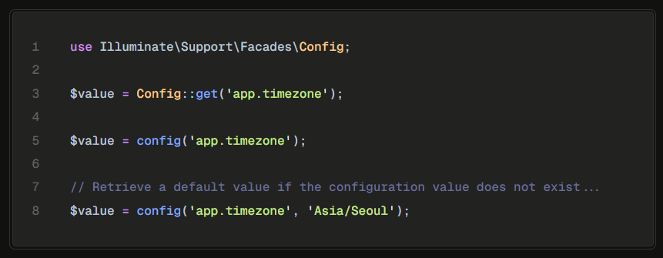

To set configuration values at runtime, you may invoke the Config facade's set method or pass an array to the config function:
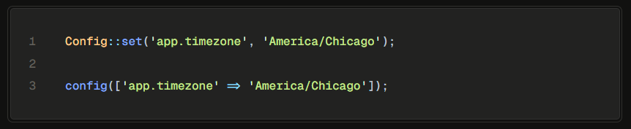

Caching of Configuration
To increase the performance and to boost the web application, it is important to cache all the configuration values. The command for caching the configuration values is –

The following screenshot shows caching in a systematic approach –
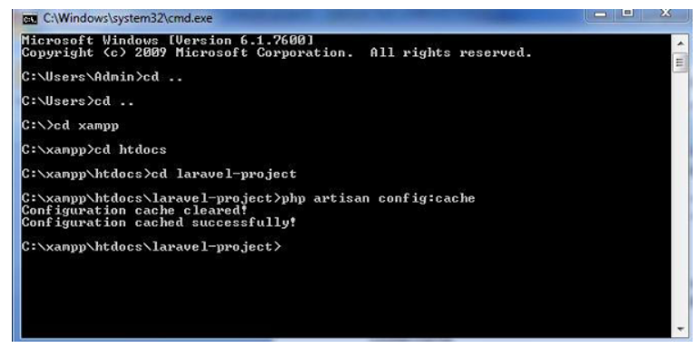

Maintenance Mode
Sometimes you may need to update some configuration values or perform maintenance on your website. In such cases, keeping it in maintenance mode, makes it easier for you. Such web applications which are kept in maintenance mode, throw an exception namely MaintenanceModeException with a status code of 503.

You can enable the maintenance mode on your Laravel web application using the following command –
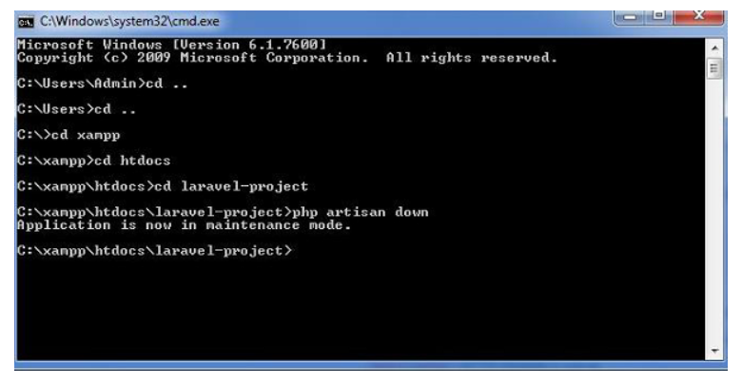

The following screenshot shows how the web application looks when it is down –


Once you finish working on updates and other maintenance, you can disable the maintenance mode on your web application using following command –
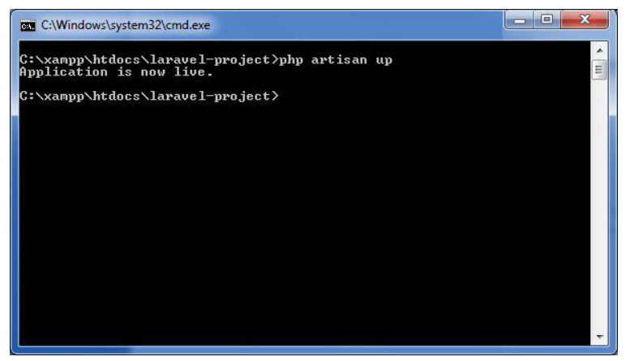

Now, you can find that the website shows the output with proper functioning and depicting that the maintenance mode is now removed as shown below –


Importance of Configuration
- Security – Protect sensitive information
- Flexibility – Switch environments easily
- Performance – Faster through caching
- Maintainability – Centralized settings

Best Practices
- Never commit .env file
- Use env vars for credentials
- Run config:cache in production
- Use default values for safety
- Keep config files clean and organized

THANK YOU!

