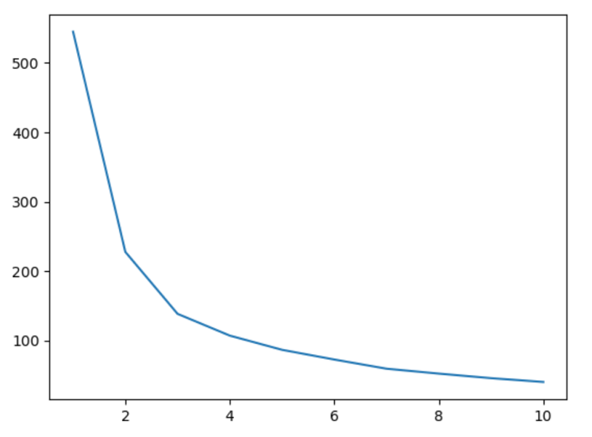

Figure 1. Elbow plot generated from CPTAC protein data. Average dispersion is on the y-axis and “K” is on the x-axis – this plot was used to determine that 3 clusters (K = 3) is the optimal choice of clusters for this set of data.

Figure 2. K-means plot generated from CPTAC protein data. This plot examines the clustering of patients when comparing their upregulation/downregulation of A2M and A1BG proteins.

Figure 3. PCA plot generated from TCGA patient/RNA data. Patients were colored by what stage of cancer they were diagnosed with, and clustered using the PCA method.

Figure 4. UMAP plot generated from TCGA RNA data. 3 clusters were used to group patients, as this was determined to be optimal via an elbow plot (not shown). The running k-means from Figures 1 & 2 were used to create this UMAP plot.

Figure 5. UMAP plot generated from the TCGA RNA counts data for A1M and A1BG RNA. 2 clusters were used in this plot to group patients as their A1M and A1BG levels were observed and plotted.