**Beijing Jiaotong University**

**Academic Year 2011/2012 2nd Semester Exam B**

**Course Name： Software Architecture**

**Lecturers： Ji Zhenyan, Wang Hongliang, Chen Sheng**

**Major: _ Class: _ _____**

**Name: ___ ___ Student ID:_______**

|  |  |  |  |
| --- | --- | --- | --- |
| **Section** | **I** | **II** | **Sum** |
| **Points** |  |  |  |

-------------------------------------------------------

**Section I (3 points for each question, 24 points in total). Please select correct answers.**

1. What can Liskov principle guarantee for us? ( )

vA. Well-designed inheritance

B. Well-designed interface

C. High Cohesion in one component

D. Loose coupling between components

2. which design pattern can ensure that only one instance of a class is created? ( )

A Command Pattern

vB Singleton Pattern

C Simple Factory Pattern

D Abstract Factory pattern

1. If we want to break the cyclic dependency as below, normally which principles should be implemented?

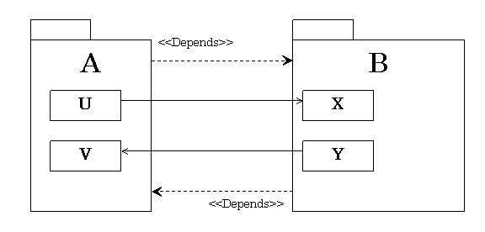

* 1. Liskov Substitution Principle (LSP)
  2. Single Responsibility Principle (SRP)
  3. Dependence Inversion Principle (DIP) v
  4. Law of Demeter(LoD)
  5. Open-Closed Principle (OCP)
  6. Composition/Aggregation Reuse Principle(CARP)

1. What descriptions below about Architecture Style are NOT correct?
   1. Architectural Style is a High Level Design Pattern
   2. Architectural style is a named collection of architectural design decisions that are applicable in a given development context
   3. Architectural style constrain architectural design decisions that are specific to a particular system within that context
   4. Architectural style is a reusable set of libraries or classes for a software system (or subsystem)
2. Which principles are related to package cohesion? ( )
   1. The Stable Abstractions Principle (SAP)
   2. The Common Reuse Principle (CRP) v
   3. The Acyclic Dependencies Principle (ADP)
   4. The Stable Dependencies Principle (SDP)
   5. The Common Closure Principle (CCP) v
   6. The Release Reuse Equivalency Principle (REP) v
3. Which principles are related to package coupling? ( )
   1. A) The Stable Abstractions Principle (SAP)
   2. The Common Reuse Principle (CRP)
   3. The Acyclic Dependencies Principle (ADP) v
   4. The Stable Dependencies Principle (SDP) v
   5. The Common Closure Principle (CCP)
   6. The Release Reuse Equivalency Principle (REP)
4. Which are structural pattern?
   1. Bridge Pattern v
   2. Factory Method
   3. Decorator Pattern v
   4. Observer Pattern
   5. Adapter Pattern v
   6. Proxy Pattern
5. About quality attributes, which sentences are not correct?()
   1. Quality attributes don’t need to be measurable.
   2. Achieving quality attributes is only considered during requirements analysis.
   3. Quality attributes never conflict with each other. v
   4. Latency, throughput and deadline can be used to measure performance of a software system.
   5. Usability is concerned with how easy it is for the user to accomplish a desired task and the kind of user support provided.

**Section II (6 points for each question, 36 points in total). Please answer the questions briefly.**

1. What is the definition of **Software Architecture**? Why is Software Architecture important?

2, We need deploy an application on different Os, for example Windows or Linux. In this circumstance we need create different series of UI controls (e.g. Buttons, Labels, etc.) for each OS. But we want the UI creation module is close for modification no matter what OS we use. Which pattern we can use to meet this requirement? Please draw its class diagram and list critical classes or interfaces in your design.

3. Please give an example that violates ISP (Interface-Segregation Principle) and explain why? How to modify it to comply with ISP?

4. Please compare Strategy Pattern and State Pattern and tell their differences.

5. Name the 3 essential parts of MVC model and their responsibilities. What is the difference between MVC model and 3-tiers model?

6. What are the benefits to develop a software system with **Software Product Line?**

**Section III (40 points in total). Please read the following system description and answer the questions.**

The web-based e-bookstore system provides many services:

1. A customer can create a new account, and view the related account information;

2. A customer can select and put the book to his/her cart;

3. Books can take different promotion policies individually.

4. A customer can update/renew his order;

5. A customer can pay the bill online (by external e-bank API) or offline;

6. A customer can cancel his order;

7. The services are always available. (i.e. the system have high availability.)

Tasks:

1. (8 points) what architectural style/pattern will you use to implement the system? Why?

2. (10 points) please draw the architecture diagram for the whole system and give necessary explanation.

3. (12 points) which design patterns can be used to implement the system? Please explain how to use them in your system? Please give four design patterns at least.

4. (10 points) which quality attributes must be achieved in this system? How to achieve the quality attributes?