**Software Quality Assurance and Testing Technology Assignment 3**

**White Box Testing & Unit Testing**

**Q1: White Box Testing**

Here is a part of program code shown in Table.1

Please draw the control flow graph of the following code and provide the cyclomatic complexity V(G) of the control flow graph;

Please provide the Basis Path set of the control flow graph;

Please provide the All-du-paths (ADUP) of the code (all the variables should be included);

**Table 1: Part of Program Code**

1 public List<List<Integer>> permuteUnique(int[] nums)

2 {

3         ArrayList<List<Integer>> rst = new ArrayList<List<Integer>>();

4         if (nums == null) {

5             return rst;

6         }

7         if (nums.length == 0){

8             rst.add(new ArrayList<Integer>());

9             return rst;

10         }

11         Arrays.sort(nums);

12         ArrayList<Integer> list = new ArrayList<Integer>();

13         int[] visited = new int[nums.length];

14         for (int i = 0; i < visited.length; i++) {

15             visited[i] = 0;

16         }

17         helper(rst, list, visited, nums);

18         return rst;

19     }

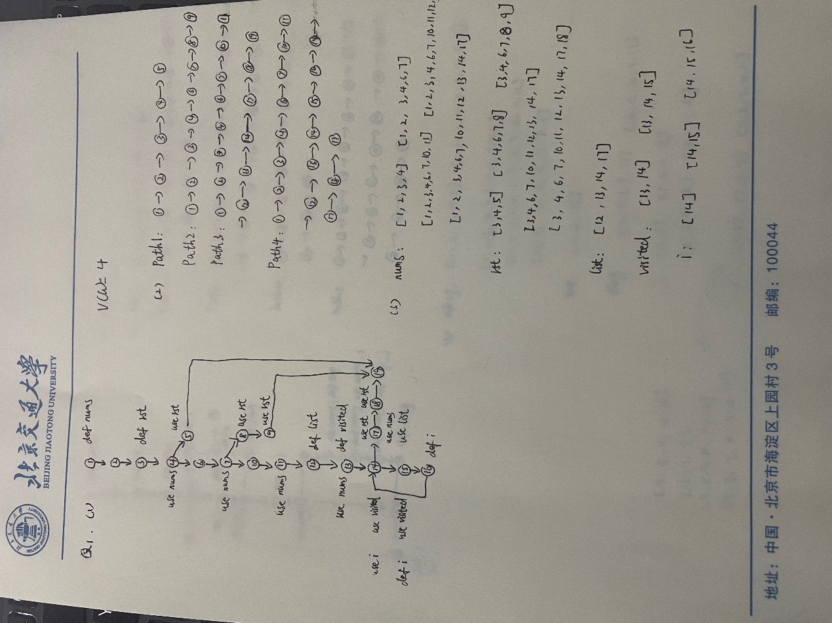

**Q2: White Box Testing**

Here is a part of program code shown in Table.2

Please draw the control flow graph of the following code and provide the cyclomatic complexity V(G) of the control flow graph;

Please provide the Basis Path set of the control flow graph;

Please provide the All-du-paths (ADUP) of the code (all the variables should be included);

**Table 2: Part of Program Code**

1 public static void bubbleSort(int[] array)

2 {

3           int tmp;

4           boolean flag = false;

5           for(int i = array.length-1;i >= 0;i--)

6 {

7                for(int j=0;j<i;j++)

8 {

9                    if(array[j]>array[j+1])

10 {

11                        tmp = array[j];

12                        array[j] = array[j+1];

13                        array[j+1] = tmp;

14                        flag = true;

15                     }

16                 }

17              if(!flag)  break;

18             }

19        }

