Peter Essman HW#3 CS3560

Create a new git repo from scratch:

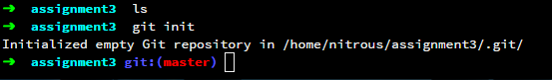

Add three subfolders to the working tree, each subfolder should have two files:

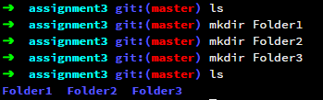

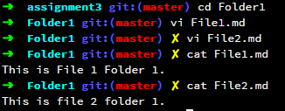

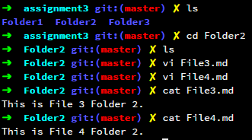

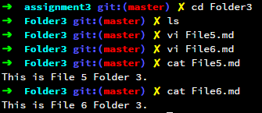

Add README.md to the root folder:

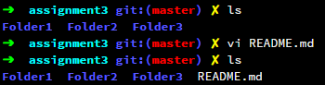

Commit Repo:

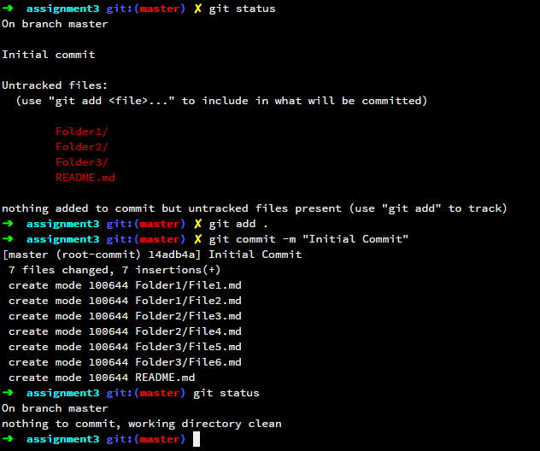

Add Tag:

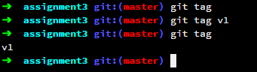

Create a new branch:

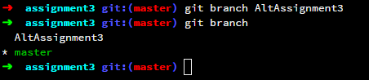

Add new sub folder and 1 file to that folder:

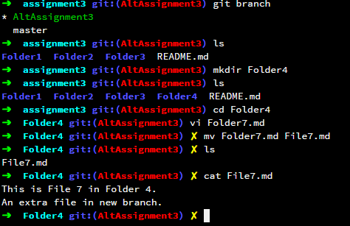

Delete a sub folder:

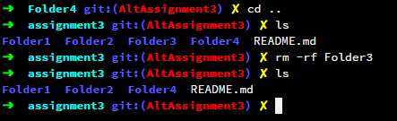

Revise README.md file:

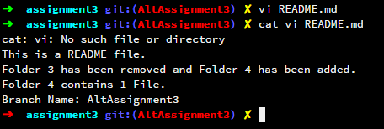

Commit Changes:

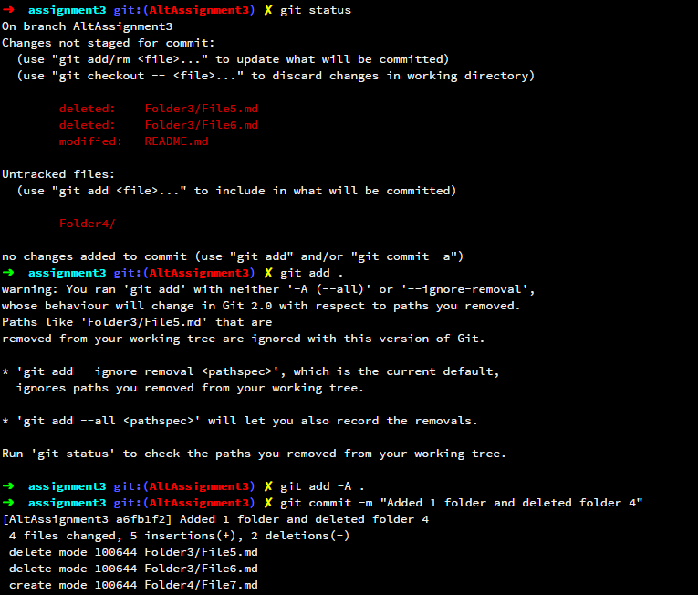

Add tag v2 with message:

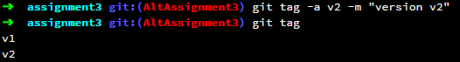

Switch to old Branch:

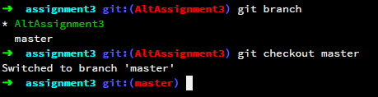

Revise README.md:

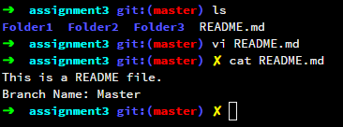

Commit Changes:

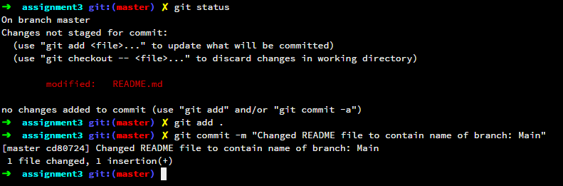

Create Tag v1.1:

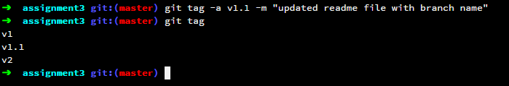

Switch to other branch again and update README file again:

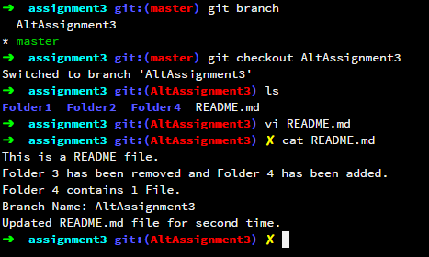

Commit and tag changes:

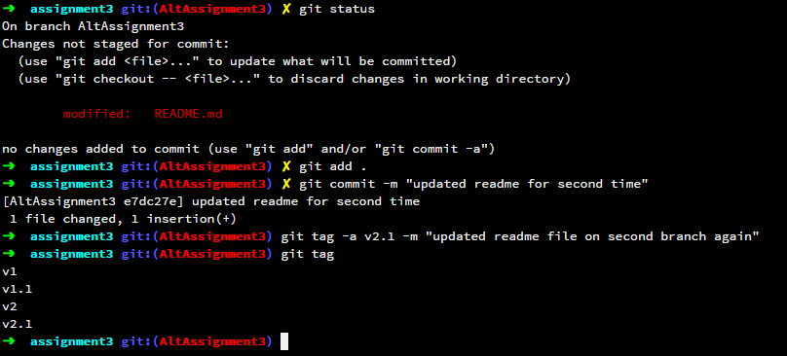

Screenshots of branches and tags from GUI:

