ASSIGNMENT 3 – Git
Software Engineering Tools – 9/22/2015
Gus Oberdick
- Create a new git repo from scratch (tip: git init)
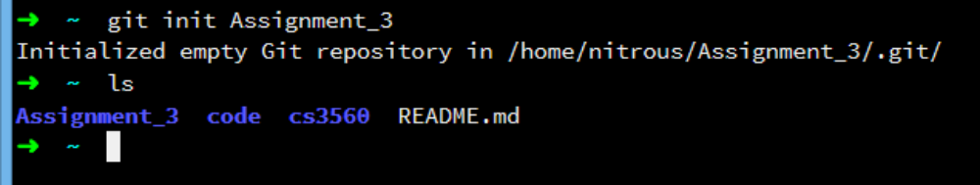
- Add three subfolders to the working tree. Each subfolder has two files in it.
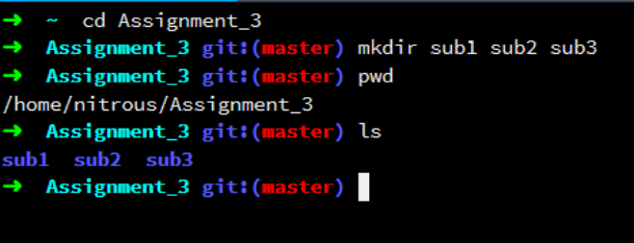The creation of sub1, sub2, sub3
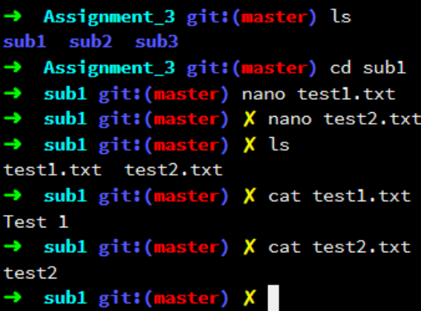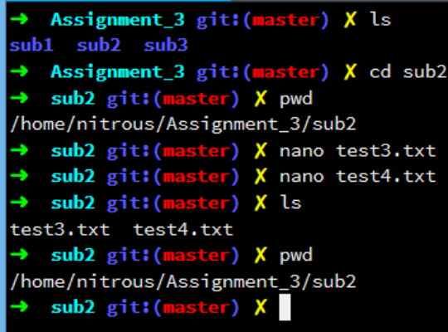
Creating test1.txt and test2.txt in sub1 Creating test3.txt and test4.txt in sub2
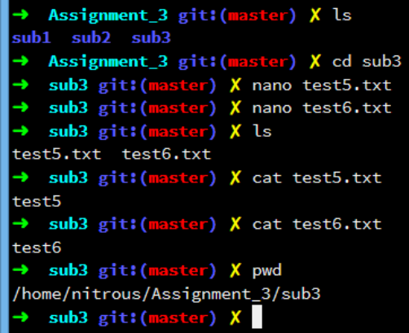 Create test5.txt and test6.txt in sub3
- Add README.md to the root folder.
Created README.md within the master directory
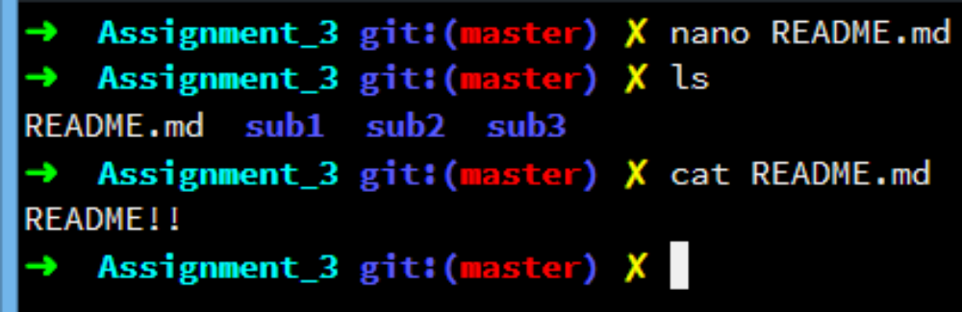
- Commit all files. Create a tag named "v1".
After committing the change I created the tag v1
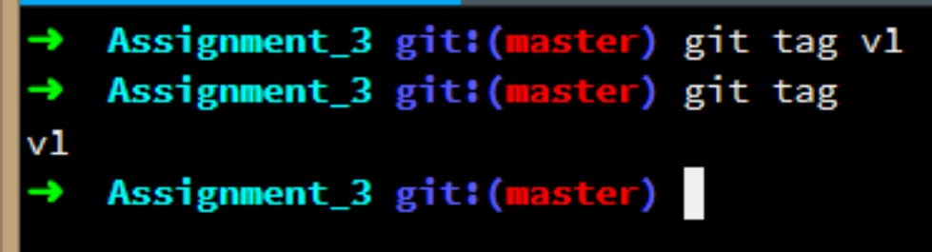
- Create a new branch. Add a new subfolder and at least one new file in the new subfolder. Delete one subfolder. Revise the README file to state the name of the new branch. Commit the changes. Create a tag named "v2". Use "-m" to add a message to the tag.
Now I created a new branch called “branch1” and switched to it using “checkout”
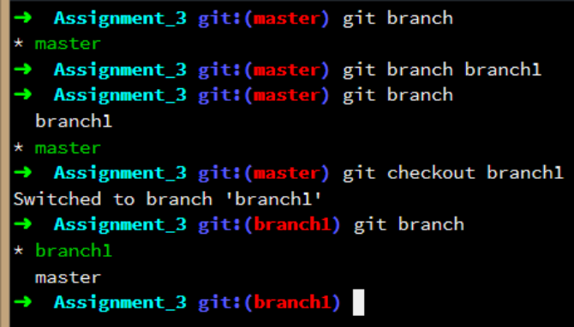
Now I deleted sub1 and then created an additional file within sub4, all within “branch1”. I also made a mistake here and didn’t actually delete sub1.
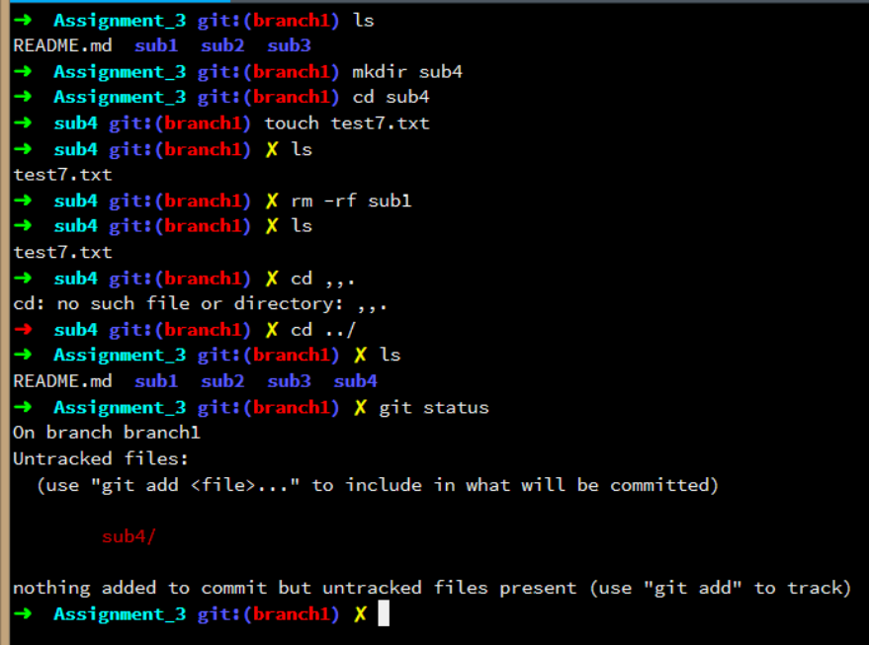
I edited the read me by adding the branch name
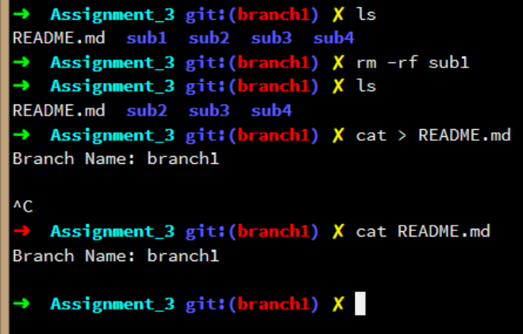
I committed changes to “branch1”
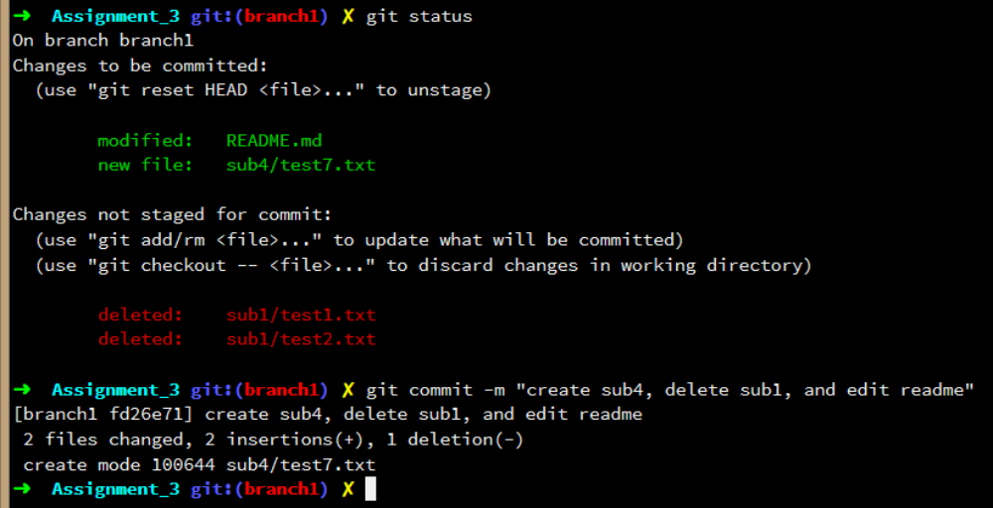
Once I committed all the changes, and created the tag v2
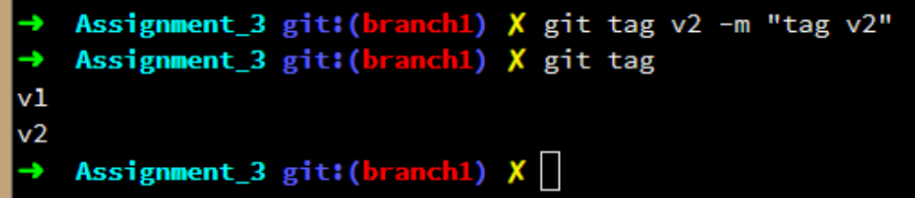
- Switch to the old branch. Revise the README file to state the name of this branch. Commit the changes. Create a tag name "v1.1"
I switched back to the “master” branch, and changed the README.md file to show the “master” branch name
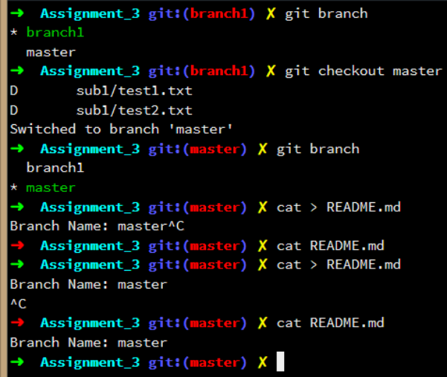
This is me creating the v1.1 tag
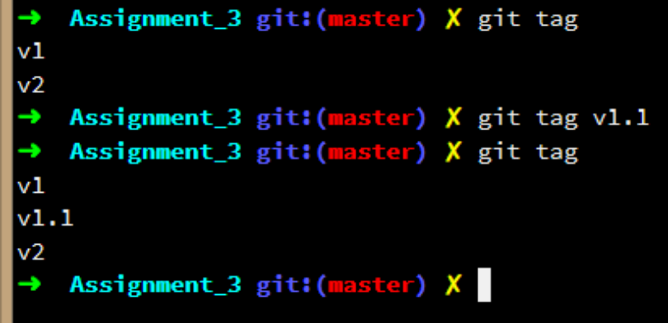
- Switch back to the other branch. Revise the README file again and commit the changes. Create a tag named "v2.1".
I switched back to the “master” branch
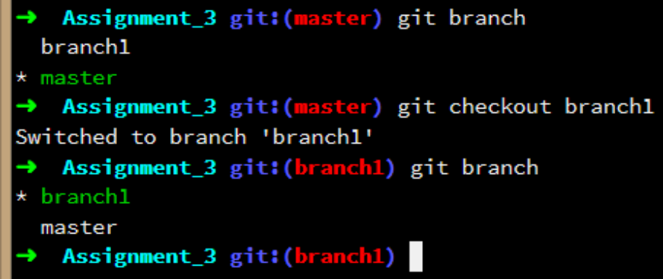
Then I revised the README.md file and then proceeded to commit the changes
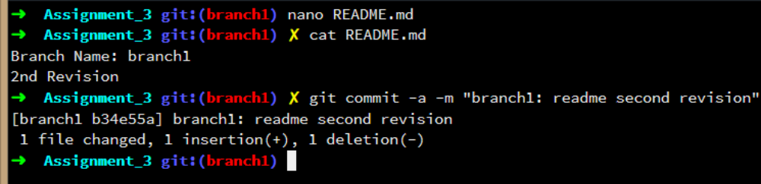

Finally, I created the tag v2.1
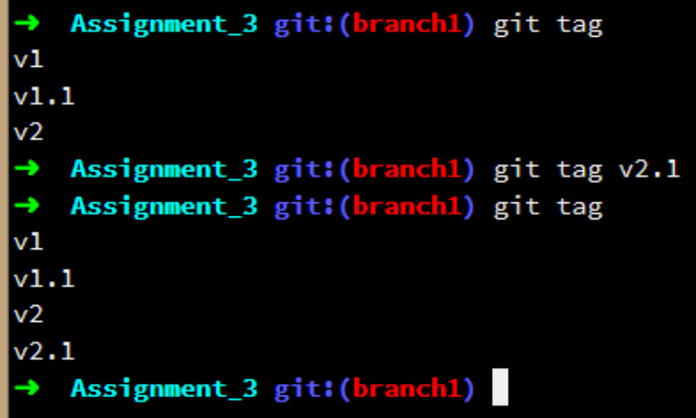
- Open the Git repo in SourceTree or Github GUI Client software. Take screenshots to show the two branches and the tags.
I decided to download the SourceTree GUI for git. I actually have both SourceTree and GitHub GUI, but I prefer the SourceTree interface
